**Machine learning-enabled digital twins for diagnostic and therapeutic purposes**

*Neel Shah1, Jayansh Nagar2, Dr. Nirav Bhatt3, Dr. Nikita Bhatt4, Dr. Hiren Mewada5*

*1,2,3Department of Artificial Intelligence And Machine Learning, Chandubhai S. Patel Institute of Technology,*

*Charotar University of Science and Technology, Changa, India*

*4Department of Computer Engineering, Chandubhai S. Patel Institute of Technology,*

*Charotar University of Science and Technology, Changa, India*

*5Prince Mohammad Bin Fahd University, Kingdom of Saudi Arabia*

*Email:* [*neeldevenshah@gmail.com*](mailto:neeldevenshah@gmail.com)*,* [*jayanshnagar@gmail.com*](mailto:jayanshnagar@gmail.com)*,* [*niravbhatt.it@charusat.ac.in*](mailto:niravbhatt.it@charusat.ac.in)*,* [*nikitabhatt.ce@charusat.ac.in*](mailto:nikitabhatt.ce@charusat.ac.in)*, hmewada@pmu.edu.sa*

Abstract — Digital twins offer virtual representations of patients by integrating diverse data modalities to enable personalized diagnostics and treatments. This chapter explores augmenting patient digital twins with machine learning for enhanced clinical decision support. Beginning with the fundamental concepts around digital twin technology and machine learning techniques, the discussion ranges to the discussion of state-of-the-art digital twins and machine learning models used in the field of diagnostic and therapeutics. Fusing high-fidelity digital profiling with complex pattern recognition using machine neural networks establishes a powerful platform for data-driven precision medicine. This synergistic approach allows for gaining a comprehensive understanding of individual patients for granular risk assessment. Personalized digital twins equipped with machine learning additionally enable the recommendation of optimal therapeutic interventions tailored to the specific needs of each patient. Combining multipartite patient simulations with artificial intelligence offers the next paradigm for preventative and participatory medicine centered around the individual. The immense promise along with challenges and opportunities are covered to provide a holistic perspective on this emerging interdisciplinary technology converging human medicine, virtual modeling, and artificial intelligence.

Keywords — Artificial Intelligence, Digital Twins, Machine learning, Healthcare, Medicine, Diagnostic, Therapeutic

1. INTRODUCTION

Diagnostics and therapeutic industry is entering an era where abundant biomedical data plays an increasingly important role. Precision medicine, for example, attempts to “ensure that the right treatment is given to the right patient at the right time” by taking into account molecular characteristics, environment, health records, and lifestyle of each patient. However, generating actionable insights and knowledge from high-dimensional, complex, and heterogeneous biomedical data remains a major challenge in the diagnostics and therapeutic industry.

Some of the key challenges in the diagnostic and therapeutic process are limited understanding of disease mechanisms, difficulty in diagnosing complex conditions, predicting treatment outcomes, mitigating medical risks, managing chronic diseases, and many others, and the solution to this and other millions of problems in the diagnostics and therapeutic industry is the machine learning enabled digital twin [37].

The integration of patient-specific digital twins with powerful machine learning has the potential to transform the diagnostics and therapeutic industry by enabling personalized precision medicine. Machine learning methods like deep learning and reinforcement learning can assimilate multidimensional patient data into sophisticated digital twin models that provide actionable insights unattainable through traditional analytics. These digital replicas embedded with machine intelligence can unravel mechanisms behind multifactorial diseases, assist in the early diagnosis of complex conditions, accurately predict outcomes of tailored treatment regimens, virtually optimize high-risk interventions to improve safety, and dynamically manage chronic illnesses by adjusting care to an individual’s evolving needs [37].

Machine-learning empowered digital twins can continuously gather data from sensors and wearables to update their representation of each patient’s unique systems biology and environmental factors influencing their health. While adoption faces barriers, such AI-based digital profiling of patients promises to mitigate many uncertainties in current diagnoses and therapies by complementing clinical evaluations with data-driven analytics [52]. This can pave the path toward a democratized diagnostics and therapeutic industry that is more preventative, predictive, and precision-focused for meeting the needs of underserved communities.

Deep learning a subset of machine learning has the potential to address many of these challenges and enable new possibilities for biomedical data analysis. In particular, deep learning allows end-to-end learning schemes and automatic complex feature representation learning directly from raw data, without the need for explicit data preprocessing or feature crafting [52]. Deep learning models composed of multiple layers of information processing can automatically learn hierarchical representations and patterns in the data. With sufficient model complexity and data, deep learning has been shown to uncover intricate structures in large data sets using backpropagation to incrementally change its internal parameters.

In the diagnostics and therapeutic industry, deep learning has shown promising results across various applications, including medical imaging, electronic health records, genomics, and drug discovery. In medical imaging, deep learning can accurately detect abnormalities and diseases from imaging modalities like X-rays, CT scans, and MRI images. Deep learning natural language processing can extract insights from unstructured clinical notes and identify risk factors from lengthy patient histories. In genomics and pharmaceuticals, deep learning enables efficient analysis of large genetic and molecular datasets to help develop personalized medicine and accelerate drug discovery [37].

However, there are still many open challenges in applying deep learning for the diagnostics and therapeutic industry. These include handling missing and inaccurate data in real-world records, ensuring patient data security and privacy regulations are met, explaining the predictions and decisions of complex deep learning models to doctors and patients, and continuously updating models to keep pace with evolving medical knowledge and maintain predictive accuracy over time. Designing solutions that are scalable to large diagnostics and therapeutic industry systems with resource constraints is also essential for real clinical adoption and impact [52].

This chapter explores the use of machine learning-powered digital twins in the diagnostic and therapeutic industry across seven sections. The introduction provides background on digital twins and machine learning models and their potential for transforming health outcomes. Section 2 offers an in-depth conceptualization of how these technologies technically function and interact. Current state-of-the-art works on digital twins, deep learning, and reinforcement learning are reviewed in Section 3. Section 4 discusses specific applications of these advanced systems for diagnosis and treatment across health fields. The remaining challenges to implementation and adoption are analyzed in Section 5. Section 6 considers the future outlook and opportunities for innovation in this space. Finally, the concluding remarks summarize the promise of digital twins enabled by machine learning to revolutionize precision, personalized medicine through accurate patient models that inform tailored therapeutic interventions. This structure progresses from foundational principles to real-world examples to prospects for these potentially disruptive paradigms across the diagnostic and therapeutic landscape.

2. Conceptualization Of Digital Twin And Machine Learning

2.1 Digital Twins

A "digital twin" refers to a virtual replica of a physical asset or system that is used to understand and optimize its functions throughout its life cycle. Digital twins are intricate computer models that leverage real-time data and other information sources to enable continuous learning, reasoning, and dynamic recalibration of the system being represented [1]. In essence, digital twins serve as living digital profiles that can be continually modified, updated, and refined to mirror changes in their real-world counterparts.

In the diagnostics and therapeutic industry, digital twins hold tremendous potential across the entire spectrum of applications, from basic research to clinical practice and public health. Digital twins of individual patients, for instance, can assimilate multi-modal health data including medical images, genetics, electronic health records, and wearable device outputs. Advanced simulation of an individual’s biological processes, combined with machine learning and reasoning on pertinent available data, allows patient digital twins to serve as platforms for conducting virtual clinical trials, predicting future health trajectories, and optimizing interventions in a testbed environment with minimized risks [55]. Beyond the individual level, digital twins can also be created for larger-scale diagnostics and therapeutic industry ecosystems like hospitals, cities, and entire populations. Here the focus shifts from personalization to holistic optimization of resource allocation, process enhancement, and policy planning leveraging system-wide vantage.

A major competitive advantage of digital twins in driving diagnostics and therapeutic industry transformations, compared to traditional analytical approaches. The main advantage of the digital twin is in their ability to uncover hidden insights through high-fidelity emulation combined with modern artificial intelligence. The innate support for continuously recording, monitoring, and controlling the digital profile as new data emerges allows digital twins to leap beyond static analysis [55]. Predictive and prescriptive techniques powered by AI on this dynamic foundation opens endless possibilities for forecasting risk events, preemptively identifying failures and complications, testing potential solutions ahead of time, and enabling self-correcting mechanisms without real-world perturbation. In effect, digital twins elevate the diagnostics and therapeutic industry from reactive fire-fighting to scientifically grounded preventative care.

Concretely, numerous promising use cases and early successes of diagnostics and therapeutic digital twins are already emerging across preventative and precision medicine. Digital therapeutics integrate patient twin profiles with AI-based interventions for data-driven disease management and lifestyle coaching. Digital twins show immense potential in expediting pharmaceutical research, enabling in-silico virtual drug trials with iterable experimentation. Surgical training and assistance can be augmented via digital twins simulating personalized anatomical models reconstructed from medical imaging along with customizable scenarios.

2.1.1 Working Of The Digital Twins

The concept of the digital twin (DT) was originally promoted by Tuegel et al. [20]. Other researchers such as [36] and [10] have proposed using DT as a "virtual sensor" to predict the lifetime of an aircraft structure and ensure structural integrity. This previous research has led to the definition of the DT airframe, which is a computational model of individual aircraft. As suggested by [1], these individualized models have the potential to improve aircraft management throughout their life cycle by enabling configuration checks through simulation and by acting as a virtual health monitor to predict future maintenance needs for each plane.

It is important to understand that while a digital twin is an intelligent system, it is not necessarily completely autonomous [1]. Indeed, AI-based applications and digital twins continue to be widely used by many people, specifically in scenarios that require intervention to test new features, change physical properties, or provide answers such as diagnosis or treatment. DT technology includes continuous advances in artificial intelligence. It refers to unsupervised and supervised learning algorithms whose predictive competencies are refined by processing continuous sensory data obtained from physical twins and their encircled environment. This virtual mind uses predictive, descriptive, and prescriptive algorithms to carry out a sequence of tasks as a brilliant product [1].

There are mainly three types of digital twins [2]:

i. Product twinning: It provides a virtual physical connection to analyze how a product performs under various conditions and make adjustments in the virtual world to ensure that the physical product will perform exactly as planned in the field.

ii. Process twinning: It is used to improve processes and workflows by allowing managers to tweak inputs and see how outputs are affected without the risk of upending existing workflows.

iii. System or performance digital twins: It captures, analyzes, and acts on operational data, providing insights for informed decisions to maintain effective interactions among the components of the system at the system level.

There are three forms of transmission channels that should be anticipated for digital twins [1]:

i. Among physical and virtual twins

ii. Among ambient DT and isolated DT

iii. Among the DT and the domain specialists who engage with and control the DT

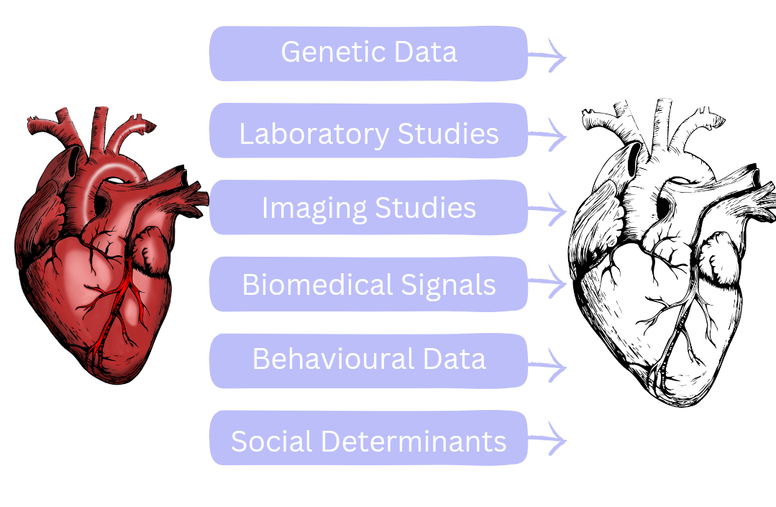

FIGURE I. EXPLAINING THE GENERATION PROCESS OF THE DIGITAL TWIN

According to [1], the data exchanged between a physical asset and a digital twin needs to be stored on a data storage machine to ensure easy accessibility. In addition to dynamic data reflecting current conditions, this storage contains historical data that mirrors the physical twin's memory and records of past specialist and operational data. It also stores descriptive static data documenting essential, time-invariant characteristics of the physical twin. Overall, compiled data storage enables the digital twin model to reflect both the present state and cumulative historical profile of its corresponding physical twin.

Digital twins possess abilities in self-adaptation and self-parameterization, enabling them to mimic physical twins throughout their lifecycle [7], [8]. To facilitate this resemblance, digital twins are designed in a highly parameterized and modular manner. As [8] describes, modularity isolates changes within modules to avoid widespread effects, while parameterization enables adaptable adjustments to the digital twin. Additionally, handling the high-dimensional data involved necessitates powerful decoding and analytics techniques. Data fusion algorithms, superior to those of individual sources, allow the integration of multiple data inputs to yield enhanced information quality and utility.

Digital twins utilize predictive analytics techniques [11], [12] to forecast future states and upcoming needs like potential failures over a product's lifecycle. Building on predictive outputs, prescriptive analytics [13] then suggests applicable actions or alternatives given complex objectives, requirements, and limitations. As [35] notes, optimization algorithms enable the identification of optimal solutions while accounting for data uncertainty. Beyond predictive and prescriptive functionalities, digital twins also encode the resulting prescriptions and optimization schemes using appropriate methodologies to represent high-dimensional characteristics. This encoding facilitates feedback sharing with both the physical twin and other nearby digital twins. Additionally, the interactive interface allows intended users to leverage the generated insights and monitor the digital twin's status.

Ref. [1] describes two possible DT life cycles, from their design to their disposal.

● The first life cycle refers to an entity that does not yet exist, and in this scenario, the design

workflow concurrently creates each of the physical twin and its digital twin.

● The second lifecycle refers to an entity that already exists but has no DT in place, and in this

scenario, the design workflow focuses on extending the entity to be attached.

Both life cycles share a common timeline. That is, first the design stage, then the development stage, the exploitation stage, and finally the disposal stage. In this first case, the DT begins to exist earlier than the physical entity as a prototype and is utilized by the designer in the design stage of the prototype entity [1]. At the beginning of the design stage, the prototype is utilized as if it were an actual entity, simulating, testing, modifying, and finally validating the design choices until a satisfactory result is determined. At some stage in this design cycle, designers use the following things:

i. Historical data: The data that the prototype obtains from different existing DTs associated with similar

entities

ii. Static data: The data describing the past state of a DT; information about other connected DTs

iii. The outcomes of simulations performed by the prototype, the prediction results calculated by the

prototype, and its recommendations and optimization schema.

Once an entity falls out of use due to obsolescence or other factors, the dismantling phase initiates. At this stage, the historical data archived within the product's digital twin is secured and granted to other digital twins and field experts. As such, designers and other specialists can leverage the accrued insights to refine and optimize future device production [1].

The second scenario differs in that the physical entity has already been deployed yet lacks a corresponding digital twin. Here, the design phase entails engineering new prototypes that undergo testing, refinement, and validation procedures. Next, the development stage establishes integrations linking the tangible asset and the emerging digital twin model. Subsequently, during operations the prototype engages in real-time monitoring as it mirrors the physical twin over the latter's useful life. Ultimately, the digital embodiment ceases activity upon the asset's decommissioning and dismantling.

2.2 Machine Learning

The analysis of complex physiological data for enhanced diagnostics and therapeutics has been an active area of medical research for decades. Early approaches relied heavily on traditional statistical learning techniques such as regression, clustering, and Bayesian modeling to find patterns in limited datasets. However, these conventional machine learning methods have key limitations around manual feature engineering and model oversimplification that constrain performance in real-world clinical applications involving multivariate, nonlinear data [56].

Machine learning refers to algorithms that have the ability to learn from data without being explicitly programmed. Within the field of machine learning deep learning, and reinforcement learning represent more advanced techniques that can overcome some of the limitations of more basic machine learning approaches [57], The schematic representation of the interconnections between artificial intelligence, machine learning, and deep learning is shown in figure 2.

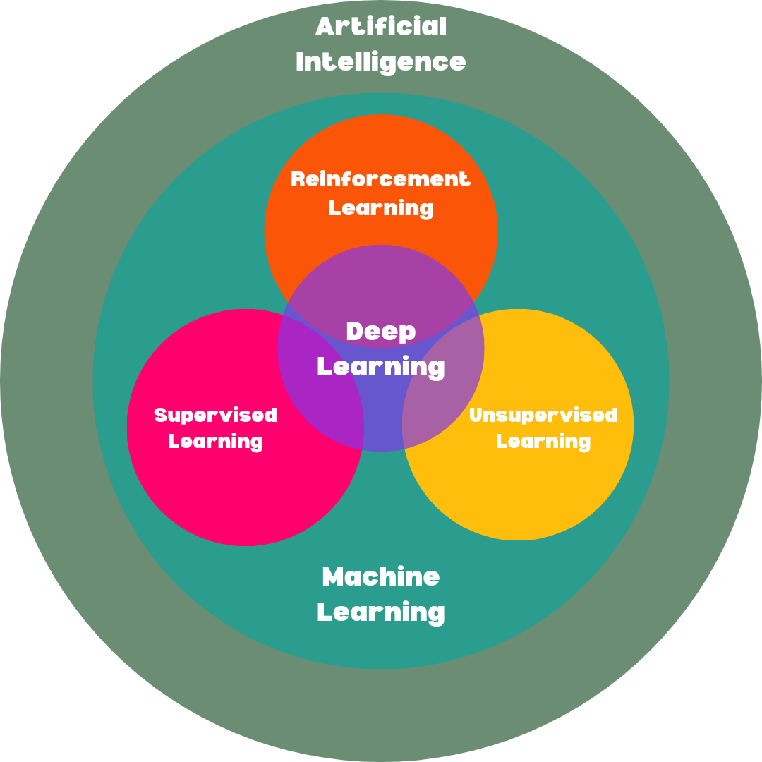

FIGURE II. SCHEMATIC REPRESENTATION OF THE INTERCONNECTIONS BETWEEN MACHINE LEARNING, DEEP LEARNING, AND MACHINE LEARNING

Specifically, traditional machine learning relies on human-engineered feature extraction and selection. This manual process results in machine learning models that are confined by the creativity and foresight of their designers. In contrast, deep learning employs sophisticated neural network architectures with many layers to automatically learn feature representations directly from raw data [57]. This eliminates much of the manual effort while capturing intricate structures and patterns in the data.

Deep learning has emerged over the last decade as a promising avenue to overcome many limitations of earlier machine learning approaches. Inspired by artificial neural networks, deep learning models compose multiple processing layers to automatically learn hierarchical representations and semantic patterns within large, raw datasets. In the diagnostics and therapeutic industry, these unique advantages have translated into major performance gains as deep learning algorithms continue to push state-of-the-art results across various challenges. Some examples include detecting cancer metastases, analyzing retina disease progression, predicting cardiovascular risk factors, and accelerating pharmaceutical research, all unlocking invaluable insights from rich medical imaging, electronic records, genomics, and other physiological datasets [57, 37]. Beyond improved prognostics, deep learning also shows promising capabilities around diagnostic image analysis and tracking personalized treatment response over time. Real-time analytics at the point of care tailored to individual patients further enables personalized prescriptions powered by deep learning.

Additionally, most conventional machine learning algorithms are focused on pattern recognition, classification, and mapping static inputs to outputs. Reinforcement learning goes beyond actively interacting with a dynamic environment to determine optimal behaviors based on maximizing long-term rewards [57]. This makes reinforcement learning more applicable to real-world scenarios like medical treatment optimization, game strategy development, and robotic control.

2.2.1 Deep Learning

The past decade has seen explosive growth in diagnostics and therapeutic industry applications leveraging deep learning to unlock actionable insights from increasingly abundant medical data. Across modalities like medical imaging, electronic health records, genomics, and wearable outputs, deep learning has become integral to data-driven clinical decision-making and transforming nearly every facet of patient care.

In diagnostics, one major advantage of deep learning is the capability to automate the analysis of complex physiological signals and unstructured data that previously required specialized expertise. For example, deep learning algorithms can now identify diabetic retinopathy from retinal fundus images and classify skin lesions as malignant or benign with performance rivaling experienced specialists. Such intelligent screening and triage assistants can help overcome shortages of subspeciality experts especially in underserved communities. Deep learning applied on histopathology slides can accurately grade prostate cancer severity or segment brain tumors guided by sensor and sequencing data, demonstrating the integrative power of these versatile models [37].

Beyond automation, deep learning opens new modalities for enhanced diagnostics by uncovering previously inaccessible insights. Models trained on raw waveform data can diagnose cardiac arrhythmia or sleep disorders where handcrafted features only achieved limited accuracy previously. Deep learning also enables “theranostics”, fusing imaging data with genomic markers in cancer to predict immunotherapy response and personalize optimal treatment plans. Multi-modal neural networks combining images, text reports, and structured lab results show additional performance gains, learning robust data representations transferrable across related tasks [52, 53, 54].

Such prognostic capabilities combined with personalization via patient “digital twins” tackle the longstanding challenge of phenotypic heterogeneity, where clinical presentation differs greatly even for the same underlying condition. By accommodating diverse risk profiles and forecasting outcomes under variable scenarios, deep learning is poised to enable true precision medicine.

A great example of the practical application of deep learning and digital twins is shown in the [31], authors have presented a novel AI-assisted framework called ReconGAN to generate realistic digital twins of patient vertebrae that can be used to assess the risk of vertebral fractures. ReconGAN utilizes a deep convolutional generative adversarial network (DCGAN) that is trained on micro-CT images of cadaveric bone samples to reconstruct the trabecular microarchitecture. This synthesized bone microstructure is then integrated into a vertebral model extracted from the patient’s CT scans using finite element-based shape optimization techniques. This creates a high-fidelity digital twin of the patient vertebra that mirrors the internal trabecular structure and outer cortical shell. Sophisticated fracture simulation analyses can then be run on this digital twin under various loading conditions using continuum damage models, Deep learning with the digital twin is used for many other such use cases and some of them are mentioned in Table 3 in section 3.

2.2.2 Reinforcement Learning

Reinforcement learning (RL) has emerged as a promising technique for enabling precision diagnostics and therapeutics and powering digital twin applications. In precision diagnostics and therapeutic industry, RL can be used to optimize treatment plans and interventions for patients in a way that maximizes long-term health outcomes on an individual basis. For example, RL agents can learn optimal medication dosing strategies that balance efficacy with minimizing side effects for a specific patient. They can also learn to titrate therapies and make changes over the course of an illness. The ability to tailor interventions through a continuous learning process makes RL well-suited for precision medicine’s goal of customized care [40].

Reinforcement learning (RL) is a type of machine learning that involves an agent interacting with an environment to achieve a goal by maximizing rewards over time [43]. The agent makes sequential decisions that influence the state of the environment. This decision-making process can be modeled as a Markov decision process (MDP) [45], which has four main components: states representing the environment, actions taken by the agent, transition probabilities between states, and a reward function that provides feedback. The solution to the MDP is an optimal policy that maps states to actions to maximize reward.

Specifically, at each timestep the RL agent observes the current state and chooses an action based on past experience. The action influences the next state based on stochastic transition dynamics. The agent receives evaluative feedback on its action in the form of a scalar reward signal. Through repeated trial-and-error experiences the agent can learn to select actions that tend to produce higher long-term reward [44]. The goal is to optimize the policy for selecting actions to maximize expected cumulative future reward. RL is well-suited for goal-oriented learning problems where an agent must learn behaviors from interactively exploring and influencing its environment.

Reinforcement learning shows promise for improving critical care in the ICU. The large volume and granular nature of patient data in the ICU is well-suited for reinforcement learning models that can analyze sequences of treatment decisions and outcomes [46]. By exploring different treatment trajectories through repeated simulation, reinforcement learning agents can discover personalized treatment protocols that optimize long-term patient outcomes such as survival probability. A key advantage of reinforcement learning is the ability to automatically derive insights into effective treatment sequencing and timing without being explicitly programmed with clinical domain knowledge. As digital records grow to capture multi-scale patient dynamics, reinforcement learning has emerging potential both to recommend therapies for new ICU cases and to elucidate relationships between care pathways and outcomes using observational patient data.

Digital twins powered by RL have also shown potential for transforming precision diagnostics and the therapeutic industry. RL can enable the digital twin to serve as an artificial patient for in silico clinical trials to predict the outcomes of interventions in ways that replicate real-world variability across patient populations. Researchers have already demonstrated using RL-enhanced digital twins of cardiac patients for testing personalized treatment plans to find the best ones for specific individuals before having patients undergo them [42].

RL and digital twins can be integrated for online adaptation of care as a patient’s illness progresses [41]. The digital twin provides a risk-free virtual environment for the RL agent to continuously explore updated interventions in line with the evolution of the patient’s condition and preferences, as telehealth data informs the model updates. This allows for the intelligent optimization of tailored precision treatments over longer periods. Such a framework could even support shared decision-making in which the human provider collaborates with the AI system in choosing the best care pathway. Over time, as more patient digital twins get implemented, the RL models can expand their datasets to make recommendations better informed by broader evidence.

2.2.2.1 Structure Of The Reinforcement Learning System With Digital Twin

Reinforcement learning can be a useful technique for developing machine learning-enabled digital twins for diagnostic and therapeutic purposes. Here is one way/example for which it could be applied [41], and is described in brief and also shown in the pictorial form in Figure 3:

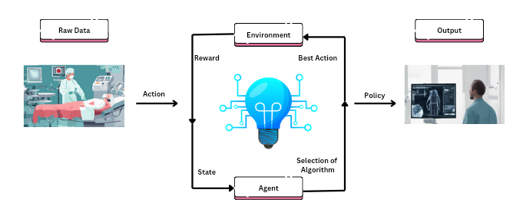

FIGURE III. FIGURE EXPLAINING REINFORCEMENT LEARNING PROCESS WITH AN EXAMPLE

* Environment: The digital twin of the patient which is continuously updated with sensor data to mirror the state of the real patient. This serves as the environment that the reinforcement learning agent interacts with.
* Actions: Different therapeutic interventions that can be applied to the patient (e.g. drug dosages, device settings, lifestyle recommendations). The agent needs to learn which actions to take to achieve an optimal outcome.
* Reward: A measure of how well the patient is responding to the treatment. This serves as the reward signal for the reinforcement learning algorithm. Examples include measures of symptoms, functioning, biomarkers, etc. The agent aims to maximize this over the course of treatment.
* Policy: The strategy used by the agent to select the next action based on the current state of the digital twin. The reinforcement learning algorithm optimizes this policy to maximize the reward.
* State: Snapshot of all the data about the patient captured in the digital twin at any given time. This includes symptoms, test results, vitals, adherence levels, etc. Used to select the next action.

The workflow for the reinforcement learning-enabled digital twin would be like this initially: The digital twin is created by integrating diverse patient data. The reinforcement learning agent then interacts with the digital twin by taking therapeutic actions. The digital twin is then updated based on data reflecting the outcomes of those actions, and the agent receives a reward signal reflecting the impact on the patient's condition. After some iterations of this iterative process, the policy is optimized to choose those actions that maximize patient rewards over time [41].

While RL-based precision diagnostics and therapeutics powered by digital twins show promise, there are still challenges to overcome. Patient health data can be complex, subjective, and sparse, especially early in an illness. This can make developing useful digital twin models difficult. There are also barriers in implementing model updates from disparate data sources like wearables and electronic health records.

3. State-Of-The-Art Works

Digital twins with integration with machine learning(artificial intelligence) are poised to transform the modern diagnostics and therapeutic industry through advanced simulation capabilities. Digital twins create virtual patient models integrating multi-modal data including medical records, genetics, and sensor streams. These living digital profiles enable highly personalized care through predictive diagnostics, tailored treatments, and continuous risk monitoring specific to the individual. Meanwhile, machine learning handles complex physiological data analysis to uncover early indicators across imaging, omics, and electronic health records for enhanced precision medicine.

Table 1 provides a comprehensive overview of several cutting-edge deep learning models that are transforming and advancing various areas within the diagnostics and therapeutics industry. In particular, the table summarizes key details about innovative deep-learning approaches across medical imaging, electronic health records, genomics, and drug discovery.

TABLE I. STATE-OF-THE-ART DEEP LEARNING MODELS IN THE DIAGNOSTIC AND THERAPEUTIC INDUSTRY

| **References** | **Authors** | **Year** | **Brief Description** |
| --- | --- | --- | --- |
| [3] | Torkamannia et al. | 2023 | The study presented an advanced method for forecasting synergy in drug combinations, utilizing a diverse set of information such as physicochemical properties, genomic data, protein-protein interactions, and protein-metabolite interactions. This comprehensive approach indicates a thorough exploration of the factors influencing synergistic effects in various drug combinations. |
| [6] | Mustafa et al. | 2023 | The study proposed a novel method of predicting cancer survival, categorizing it into two groups: long-term and short-term survival. |
| [5] | Teng et al. | 2023 | This study presents a deep learning-based approach for dose distribution prediction in radiotherapy planning for head and neck cancer. |
| [4] | Ju et al. | 2021 | The study presented a sophisticated deep-learning algorithm for identifying subtypes of pancreatic ductal adenocarcinoma (PDAC), a type of pancreatic cancer, based on their prognosis. The model has been developed to detect two subtypes of cancer and to predict the likelihood of disease progression and recovery chances for the patients. |
| [9] | Alves et al. | 2021 | The study presents a fully automated deep-learning framework for detecting pancreatic ductal adenocarcinoma (PDAC) on contrast-enhanced computed tomography (CE-CT) scans. |

Table 2 provides a comprehensive overview of cutting-edge digital twins that are driving major advancements across the diagnostics and therapeutic industry. Key examples include cardiac digital twins for predicting heart failure, brain network twins for neurodegenerative conditions, and replication of the airflow in the human lungs.

TABLE II. STATE-OF-THE-ART DIGITAL TWINS IN THE DIAGNOSTIC AND THERAPEUTIC INDUSTRY

| **References** | **Authors** | **Year** | **Brief Description** |
| --- | --- | --- | --- |
| [18] | Baillarget al. | 2014 | The study presents a state-of-the-art simulator for a four-chamber human heart model based on computer topography and magnetic resonance images. The study visualizes electrical potential and mechanical deformation throughout the cardiac cycle. |
| [19] | Feng et al. | 2017 | The study utilized a sophisticated computational model called Computational Fluid-Particle Dynamics (CFPD) to simulate the flow of air in three different configurations of the human lung airways. The main objective of the research was to identify the morphological factors that significantly influence the airflow patterns and the movement of nanoparticles in the respiratory system. |
| [38] | Grieb et al. | 2023 | The study presents an innovative digital twin model called Multiple Myeloma Digital Twin (MMDT), which is aimed at providing evidence-based clinical decision support for the treatment of multiple myeloma (MM). The primary goal of the MMDT is to predict therapeutic outcomes and distinguish effective treatment options from the ones that might not work. One significant feature of the model is its focus on explainability and interpretability while evaluating treatment outcomes. |
| [39] | Cen et al. | 2023 | The study introduces a new method called "digital twin" for precision medicine in people with multiple sclerosis (MS). The focus is on modeling the occurrence of disease-specific brain atrophy through brain MRI. To achieve this, the study uses longitudinal data and a well-fitted spline model derived from a large cross-sectional dataset on normal aging. The study also compares various mixed spline models to identify the ideal fit for the research purpose. |

Table 3 provides a comprehensive overview of pioneering digital twin systems powered by integrated deep learning for transforming the diagnostics and therapeutics industry. These combined platforms harness the strengths of physics-based simulations and data-driven AI for enhanced insights.

TABLE III. STATE-OF-THE-ART COMBINATIONS OF DIGITAL TWIN AND DEEP LEARNING MODELS IN THE DIAGNOSTIC AND THERAPEUTIC INDUSTRY

| **References** | **Authors** | **Year** | **Brief Description** |
| --- | --- | --- | --- |
| [37] | Shah et al. | 2023 | This study proposed a state-of-the-art technology that combines a large language model(for example chatGPT) and a digital twin that can be used to create models specific to patients to help with diagnosis, treatment planning, therapy planning, checking the effectiveness of drugs on individuals, and many other cases. |
| [31] | Ahmadiet al. | 2022 | The study describes a new framework called ReconGAN which uses AI to create a realistic digital twin of the human vertebra. The framework also predicts the risk of vertebral fractures (VF). The study shows that using digital twins generated by the ReconGAN framework can predict the risk of VF. The feasibility study involved a cancer patient with spinal metastasis. |
| [14] | Lal et al. | 2020 | The study presents validated digital twin models of critically ill patients that use an artificial intelligence approach to predict treatment responses in the first 24 hours of sepsis. The models define causal relationships among organ systems and specific treatments using directed acyclic graphs, thereby enhancing the precision and reliability of the predictions. |

Table 4 provides a comprehensive overview of pioneering digital twin systems powered by integrated reinforcement learning for transforming the diagnostics and therapeutics industry. These combined platforms harness the strengths of physics-based simulations and data-driven AI for enhanced insights.

TABLE IV. STATE-OF-THE-ART REINFORCEMENT LEARNING MODELS IN THE DIAGNOSTIC AND THERAPEUTIC INDUSTRY

| **References** | **Authors** | **Year** | **Brief Description** |
| --- | --- | --- | --- |
| [49] | Jalalimanesh et al. | 2017 | This study puts forward a simulation optimization method for radiotherapy. It combines agent-based modeling and reinforcement learning techniques. |
| [47] | Wang et al. | 2023 | This study develops a multi-objectives adjustment policy network (MOAPN) trained using a multi-agent deep reinforcement learning (DRL) approach. The MOAPN learns to optimize multiple objectives in the Eclipse treatment planning system. |
| [48] | Treesatayapun et al. | 2023 | This study develops a reinforcement learning control approach to optimize drug dosing for cancer treatment. The treatment is modeled as an unknown discrete-time system where only the drug dose (input) and tumor cell count (output) data are used to design the controller. |
| [50] | Gong et al. | 2023 | This study explores using deep reinforcement learning to enhance medical decision-making for sepsis treatment in intensive care settings. A deep deterministic policy gradient algorithm is implemented to optimize treatment strategies. |
| [51] | Ghita et al. | 2022 | This study presents a closed-loop control approach for an anesthesia and hemodynamic system using a MIMO model. The method accounts for subsystem interactions and is designed to be robust and meet clinical targets. |

4. Applications Of Digital Twins Enabled With Deep Learning Models And Reinforcement Learning

* Emerging precision medicine approaches tailor diagnostics and treatments to patient genetics, biomarkers, phenotypes, and psychosocial factors [16]. Digital twins (DTs) promise to expand this personalization through patient-specific modeling and simulation.
* Spine fracture risk assessments integrate patient imaging into neural network DT models [31]. DTs also show early potential in helping patients manage mental health conditions like depression and stress [34]. The AnyBody Modeling System DT simulates personalized movement dynamics and quantifies muscle forces, joint contacts, metabolism, and more [17]. The Virtual Physiological Human DT creates patient-twin models to test treatments in silico before clinical deployment [21].
* Cardiology DTs anticipate hypertension risks from patient data-driven blood flow models [28, 29] and optimize interventions on scan-derived cardiac models [18]. Oncology DTs predict treatment responses by mapping patient genetic, protein, and cellular networks [30] as well as anticipating radiation therapy reliability [26]. Neural network DTs also inform head and neck cancer patient treatment sequencing [27].
* DTs are also demonstrated to be a precious predictive tool in oncology, the study of most cancers. Many research has been conducted using DTs to better apprehend cancer development and its effects [15], [22], [23], [24]. DTs are also used to model cancer remedies [25]. As an example, research uses modeling and digital truth techniques to create DTs of radiotherapy systems and examine their reliability and person-friendliness [26].
* Other active areas include personalized aneurysm rupture risk assessments, sepsis treatment response forecasts [14], diabetes management through food-insulin response DTs [32], inhaled drug particle dynamics optimizations [19], gastrointestinal DT drug assays [33], and nuclear plant employee health monitoring [35]. Patient-specific DT adoption promises substantial gains in clinical decision support, predictive power, and treatment personalization across medical specialties.

Patient-specific digital twins show increasing utility in guiding precision medicine by modeling personalized disease development, dynamics, and treatment responses based on integrated patient multi-omics, imaging, and sensor data [37]. As computational power and medical data availability continue improving, machine learning-driven digital twin adoption promises to transform clinical decision support across diverse areas—from risk assessments to predictive diagnostics/prognostics, to validation of optimized therapeutic interventions without solely relying on lengthy and costly randomized controlled trials.

5. Limitations And Challenges

Some of the limitations and challenges in the field of diagnostic and therapeutic processes related to the implementation of machine learning-enabled digital twins are shown in Figure 4 And also further discussed in the brief [1, 37].

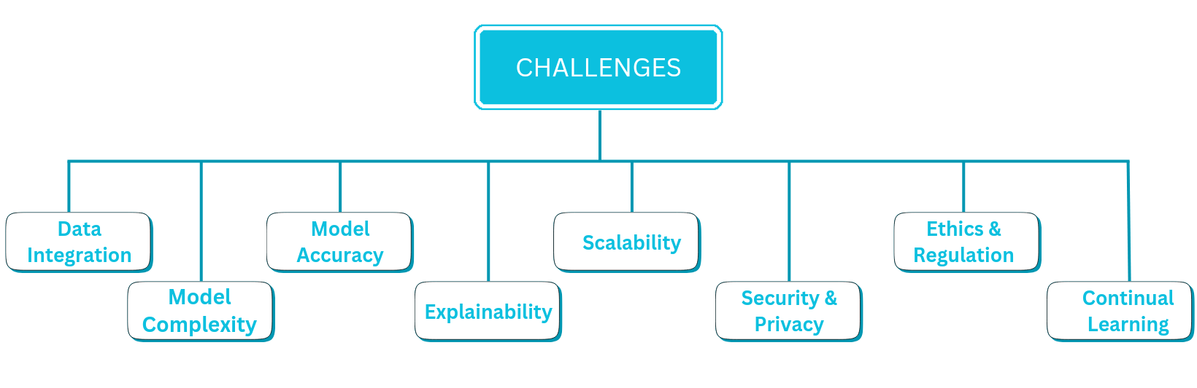

FIGURE IV. FIGURE WITH BRIEF OVERVIEW OF KEY LIMITATIONS AND CHALLENGES FACED WHILE INTEGRATING MACHINE LEARNING CAPABILITIES INTO DIGITAL TWINS FOR PROGNOSTICS AND DIAGNOSTICS

* Data Integration

Integrating diverse data types like medical images, genetics, lab results, and sensor streams into informative digital patient profiles poses significant interoperability and pre-processing barriers before useful modeling can occur. Resolving syntactic, semantic, and procedural differences across data sources to provide reliable and timely federation into digital twins is non-trivial.

* Model Complexity

Capturing the intricate physiological interactions and dynamics in human bodies requires architecting sophisticated simulated environments underpinning digital twins. Factoring various scales - molecular, cellular, tissue, organ, systemic, environmental – into high-fidelity models that maintain performant execution requires deliberate and modular system designs.

* Model Accuracy

Ensuring the behaviors and outputs of digital twin models accurately reflect the actual patient's timestamped dynamics and interactions is imperative. Lacking realism risks incorrect or even dangerous clinical decisions when acting on model recommendations. Rigorous validation using gold-standard real patient data across populations is crucial.

* Explainability

Interpreting and explaining the model behaviors, predictions, and insights builds trust and confidence for clinicians before acting on digital twin outputs. Patient outcomes necessitate holding models to high bars around traceability and auditability through explainable AI techniques.

* Scalability

The promise of precision medicine and personalized care requires instantiating high-quality digital twins at a massive population scale. Optimized model architectures and inferencing pipeline that maintain usefulness while prioritizing interactivity and real-time analytics are thus necessary.

* Security & Privacy

Guarding highly sensitive patient data like medical history and genomic profiles while still allowing aggregate population learning necessitates robust and provable protections in twin architectures. Techniques like federated learning and differential privacy provide promising foundations here.

* Ethics & Regulation

Several dilemmas around accountability, unconscious bias, and continually evolving applications of digital twins must be tackled. Establishing regulatory clarity in lockstep with technological progress is key to preventing losing public trust.

* Continual Learning

Updating digital twin models alongside new medical understanding, diagnostics/treatment advancements, and best practices evolution is imperative for prolonged usefulness. Ensuring reliable knowledge transfer and modular expandability via techniques like master learning paradigms is thus impactful.

Other than those mentioned above many other challenges are being faced while implementing an end-to-end machine learning-enabled digital twin. The main challenge while implementing the digital twin is the low availability of open-source resources related to the practical implementation of the digital twins. Most of the available content on the internet related to the digital twin is for only the designing and the conception of the digital twin, but very little content can be found for the practical implementation of the digital twin.

6. Opportunities / Future Scope

* The digital twin with machine learning can be utilized in pharmaceutical research for experimenting with different medicines and vaccines and getting feedback based on the effects of the digital twin.
* The digital twin with machine learning can also be utilized in precision medicine to set the dosage of any medicine according to the patient’s immune system. With the help of this technology, one can know how medicine is affecting the patient and can change the dosage of that medicine instead of using the current methodology in which these types of experiments are performed on the patient.
* The digital twin with machine learning can also be utilized in the diagnostics and therapeutic industry for the curation of life-threatening diseases such as Parkinson's, cancer, Alzheimer's, etc.
* Development and improvement of existing protocols, regulations, and ethical guidelines for the use of the proposed technology in precision diagnostics and therapeutic industry can also be done.
* Integration of reinforcement learning with the digital twin can be done with the help of which it can learn by itself without requiring additional training so that this technology would be able to deal with circumstances that did not happen earlier.

7. Concluding Remarks

In conclusion, this chapter explored the immense potential of merging machine learning methodologies with digital twin technologies to transform next-generation diagnostics and therapy delivery. Digital twins serve as high-fidelity virtual replicas of patients by assimilating diverse physiological, phenotypic, and environmental data streams. Augmenting these digital profiles with machine learning engenders clinical decision support systems that can gain comprehensive insights about the patient, predict future outcomes, and recommend optimal therapeutic interventions tailored to the individual.

Several use cases highlight the promising capabilities unlocked by this synergistic approach spanning personalized diagnostics, virtual clinical trials, surgical assistance, and connected health. Impactful examples covered include anomaly detection for rapid diagnoses, risk forecasting for preventative intervention, modeling disease trajectories under variable scenarios, dynamically adapting treatment regimens, and accelerating pharmaceutical innovation through in-silico experimentation. However, realizing widespread adoption faces critical ethical, clinical, and technical challenges that necessitate deliberate designs. One should also ensure patient data security and confidentiality while enabling aggregate learning necessitates federated approaches.

References

[1] Barricelli, Barbara Rita, Elena Casiraghi, and Daniela Fogli. "A survey on digital twin: Definitions, characteristics, applications, and design implications." IEEE access 7 (2019): 167653-167671.

[2] Elkefi, Safa, and Onur Asan. "Digital Twins for Managing Health Care Systems: Rapid Literature Review." Journal of medical Internet research 24.8 (2022): e37641.

[3] Torkamannia, Anna, Yadollah Omidi, and Reza Ferdousi. "SYNDEEP: a deep learning approach for the prediction of cancer drugs synergy." Scientific Reports 13.1 (2023): 6184.

[4] Ju, Jie, et al. "Robust deep learning model for prognostic stratification of pancreatic ductal adenocarcinoma patients." Iscience 24.12 (2021).

[5] Teng, L et al. *Nan fang yi ke da xue xue bao = Journal of Southern Medical University* vol. 43,6 (2023): 1010-1016. doi:10.12122/j.issn.1673-4254.2023.06.17

[6] Mustafa, Ehzaz, et al. "An Ensembled Framework for Human Breast Cancer Survivability Prediction Using Deep Learning." Diagnostics 13.10 (2023): 1688.

[7] Talkhestani, Behrang Ashtari, et al. "Consistency check to synchronize the Digital Twin of manufacturing automation based on anchor points." Procedia Cirp 72 (2018): 159-164.

[8] Schleich, Benjamin, et al. "Shaping the digital twin for design and production engineering." CIRP annals 66.1 (2017): 141-144.

[9] Alves, Natalia, et al. "Fully automatic deep learning framework for pancreatic ductal adenocarcinoma detection on computed tomography." Cancers 14.2 (2022): 376.

[10] Gockel, Brian, et al. "Challenges with structural life forecasting using realistic mission profiles." 53rd AIAA/ASME/ASCE/AHS/ASC structures, structural dynamics and materials conference 20th AIAA/ASME/AHS adaptive structures conference 14th AIAA. 2012.

[11] Abbott, Dean. Applied predictive analytics: Principles and techniques for the professional data analyst. John Wiley & Sons, 2014.

[12] Gandomi, Amir, and Murtaza Haider. "Beyond the hype: Big data concepts, methods, and analytics." International journal of information management 35.2 (2015): 137-144.

[13] Poornima, Shakthi, and Mullur Pushpalatha. "A journey from big data towards prescriptive analytics." ARPN J. Eng. Appl. Sci 11.19 (2016): 11465-11474.

[14] Lal, Amos, et al. "Development and verification of a digital twin patient model to predict specific treatment response during the first 24 hours of sepsis." Critical care explorations 2.11 (2020).

[15] Greenspan, Emily, et al. "CAFCW 113 Digital Twins for Predictive Cancer Care: an HPC-Enabled Community Initiative." (2019).

[16] Jameson, J. Larry, and Dan L. Longo. "Precision medicine—personalized, problematic, and promising." Obstetrical & gynecological survey 70.10 (2015): 612-614.

[17] Clapworthy, Gordon, et al. "The virtual physiological human: building a framework for computational biomedicine I. Editorial." Philosophical transactions. Series A, Mathematical, Physical, and Engineering Sciences 366.1878 (2008): 2975-2978.

[18] Baillargeon, Brian, et al. "The living heart project: a robust and integrative simulator for human heart function." European Journal of Mechanics-A/Solids 48 (2014): 38-47.

[19] Feng, Yu, et al. "An in silico subject-variability study of upper airway morphological influence on the airflow regime in a tracheobronchial tree." Bioengineering 4.4 (2017): 90.

[20] Tuegel, Eric J., et al. "Reengineering aircraft structural life prediction using a digital twin." International Journal of Aerospace Engineering 2011 (2011).

[21] Marshall, T. "VPH: The Ultimate stage before your own medical Digital Twin." (2019).

[22] Poon, Hoifung, et al. "Precision Health in the Age of Large Language Models." Proceedings of the 29th ACM SIGKDD Conference on Knowledge Discovery and Data Mining. 2023.

[23] Ahmadi-Assalemi, Gabriela, et al. "Digital twins for precision healthcare." Cyber defence in the age of AI, Smart societies and augmented humanity (2020): 133-158.

[24] HamlAbadi, Kamran Gholizadeh, et al. "Digital Twins in cancer: State-of-the-art and open research." 2021 IEEE/ACM Conference on Connected Health: Applications, Systems and Engineering Technologies (CHASE). IEEE, 2021.

[25] Ahmadian, Hossein, et al. "A digital twin for simulating the vertebroplasty procedure and its impact on mechanical stability of vertebra in cancer patients." International Journal for Numerical Methods in Biomedical Engineering 38.6 (2022): e3600.

[26] Rod’ko, I. I., et al. "The concept of a digital twin of a radiotherapy system." Biomedical Engineering 53 (2020): 421-424.

[27] Tardini, Elisa, et al. "Optimal treatment selection in sequential systemic and locoregional therapy of oropharyngeal squamous carcinomas: deep Q-learning with a patient-physician digital twin dyad." Journal of medical Internet research 24.4 (2022): e29455.

[28] Bodin, Oleg N., et al. "Visualization of a Digital Twin of the Heart." 2021 IEEE 22nd International Conference of Young Professionals in Electron Devices and Materials (EDM). IEEE, 2021.

[29] Golse, Nicolas, et al. "Predicting the risk of post-hepatectomy portal hypertension using a digital twin: A clinical proof of concept." Journal of Hepatology 74.3 (2021): 661-669.

[30] Björnsson, Bergthor, et al. "Digital twins to personalize medicine." Genome medicine 12 (2020): 1-4.

[31] Ahmadian, Hossein, et al. "Toward an artificial intelligence‐assisted framework for reconstructing the digital twin of vertebra and predicting its fracture response." International journal for numerical methods in biomedical engineering 38.6 (2022): e3601.

[32] Shamanna, Paramesh, et al. "Type 2 diabetes reversal with digital twin technology-enabled precision nutrition and staging of reversal: a retrospective cohort study." Clinical Diabetes and Endocrinology 7.1 (2021): 1-8.

[33] Schütt, Michael, et al. "Simulating the hydrodynamic conditions of the human ascending colon: a digital twin of the dynamic colon model." Pharmaceutics 14.1 (2022): 184.

[34] Maes, Michael. "Precision nomothetic medicine in depression research: a new depression model, and new endophenotype classes and pathway phenotypes, and a digital self." Journal of personalized medicine 12.3 (2022): 403.

[35] Baranov, Leonid I., et al. "Experience of Creating Digital Twins as a Result of Monitoring the Health of Industrial Personnel." International Scientific and Practical Conference Strategy of Development of Regional Ecosystems “Education-Science-Industry”(ISPCR 2021). Atlantis Press, 2022.

[36] Tuegel, Eric. "The airframe digital twin: some challenges to realization." 53rd AIAA/ASME/ASCE/AHS/ASC structures, structural dynamics and materials conference 20th AIAA/ASME/AHS adaptive structures conference 14th AIAA. 2012.

[37] Bhatt, Neel Shah Dr. Nirav Bhatt, Dr. Nikita. “Future of Large Language Models and Digital Twins in Precision Healthcare: A Symmetric Literature Review.” *www.propulsiontechjournal.com*, 7 Dec. 2023, https://doi.org/10.52783/tjjpt.v44.i5.2910.

[38] Grieb N, Schmierer L, Kim HU, Strobel S, Schulz C, Meschke T, Kubasch AS, Brioli A, Platzbecker U, Neumuth T, Merz M, Oeser A. A digital twin model for evidence-based clinical decision support in multiple myeloma treatment. Front Digit Health. 2023 Dec 20;5:1324453. doi: 10.3389/fdgth.2023.1324453. PMID: 38173909; PMCID: PMC10761485.

[39] Cen, Steven, et al. “Toward Precision Medicine Using a ‘Digital Twin’ Approach: Modeling the Onset of Disease-specific Brain Atrophy in Individuals With Multiple Sclerosis.” Scientific Reports, vol. 13, no. 1, 28 Sept. 2023, <https://doi.org/10.1038/s41598-023-43618-5>.

[40]Liu, Siqi, et al. "Reinforcement learning for clinical decision support in critical care: comprehensive review." Journal of medical Internet research 22.7 (2020): e18477.

[41]Abdellatif, Alaa Awad, et al. "Reinforcement learning for intelligent healthcare systems: A comprehensive survey." arXiv preprint arXiv:2108.04087 (2021).

[42] Eckardt, Jan-Niklas, et al. "Reinforcement learning for precision oncology." Cancers 13.18 (2021): 4624.

[43] Montague, P. Read. "Reinforcement learning: an introduction, by Sutton, RS and Barto, AG." Trends in cognitive sciences 3.9 (1999): 360.

[44] Kiumarsi, Bahare, et al. "Optimal and autonomous control using reinforcement learning: A survey." IEEE transactions on neural networks and learning systems 29.6 (2017): 2042-2062.

[45]Howard, Ronald A. "Dynamic programming and markov processes." (1960).

[46] Komorowski, Matthieu, et al. "The artificial intelligence clinician learns optimal treatment strategies for sepsis in intensive care." Nature medicine 24.11 (2018): 1716-1720.

[47] Hanlin, Wang., Xue, Bai., Yajuan, Wang., Yanfei, Lu., Binbing, Wang. "An integrated solution of deep reinforcement learning for automatic IMRT treatment planning in non-small-cell lung cancer." Frontiers in Oncology, undefined (2023). doi: 10.3389/fonc.2023.1124458

[48] Chidentree, Treesatayapun., Aldo, Jonathan, Muñoz-Vázquez. "Optimal drug-dosing of cancer dynamics with fuzzy reinforcement learning and discontinuous reward function." Engineering Applications of Artificial Intelligence, undefined (2023). doi: 10.1016/j.engappai.2023.105851

[49] Jalalimanesh, Ammar, et al. "Simulation-based optimization of radiotherapy: Agent-based modeling and reinforcement learning." Mathematics and Computers in Simulation 133 (2017): 235-248.

[50] Jianbing, Gong., Rundong, Tan., Lijun, Wang., Y., Pan., Junhui, Gao. "A dosing strategy model of deep deterministic policy gradient algorithm for sepsis patients." BMC Medical Informatics and Decision Making, undefined (2023). doi: 10.1186/s12911-023-02175-7

[51] "Closed-loop control of multi-drug infusion for anesthesia and hemodynamic management." undefined (2022). doi: 10.1109/ccta49430.2022.9966032

[52] Miotto, Riccardo et al. “Deep learning for healthcare: review, opportunities and challenges.” Briefings in bioinformatics vol. 19,6 (2018): 1236-1246. doi:10.1093/bib/bbx044

[53] Cai, Xiaoyan, et al. "Chestxraybert: A pretrained language model for chest radiology report

summarization." IEEE Transactions on Multimedia (2021).

[54] Alsharid, Mohammad, et al. "Gaze-assisted automatic captioning of fetal ultrasound videos using three-

way multi-modal deep neural networks." Medical Image Analysis 82 (2022): 102630.

[55] Sun, Tianze et al. “Digital twin in healthcare: Recent updates and challenges.” Digital health vol. 9 20552076221149651. 3 Jan. 2023, doi:10.1177/20552076221149651

[56] Habehh, Hafsa, and Suril Gohel. “Machine Learning in Healthcare.” Current genomics vol. 22,4 (2021): 291-300. doi:10.2174/1389202922666210705124359

[57] Fahad Mon, Bisni, et al. "Reinforcement Learning in Education: A Literature Review." Informatics. Vol. 10. No. 3. MDPI, 2023.