**The Future of Manufacturing with AI and Data Analytics**

*Neel Shah1, Sneh Shah2, Janvi Bhanushali3, Kesha Desai4, Manav5, Dr. Nirav Bhatt6, Dr. Nikita Bhatt7, Dr. Hiren Mewada8*

*1,2,3,4,6Department of Artificial Intelligence And Machine Learning, Chandubhai S. Patel Institute of Technology,*

*Charotar University of Science and Technology, Changa, India*

*5,7Department of Computer Engineering, Chandubhai S. Patel Institute of Technology,*

*Charotar University of Science and Technology, Changa, India*

*8Prince Mohammad Bin Fahd University, Kingdom of Saudi Arabia*

*Email:* [*neeldevenshah@gmail.com*](mailto:neeldevenshah@gmail.com)*,* [*snehs5483@gmail.com*](mailto:snehs5483@gmail.com)*,* [*janvibhanushali249@gmail.com*](mailto:janvibhanushali249@gmail.com)[*desaikesha13@gmail.com*](mailto:desaikesha13@gmail.com)*, …*[*@gmail.com*](mailto:jayanshnagar@gmail.com)*,* [*niravbhatt.it@charusat.ac.in*](mailto:niravbhatt.it@charusat.ac.in)*,* [*nikitabhatt.ce@charusat.ac.in*](mailto:nikitabhatt.ce@charusat.ac.in)*, hmewada@pmu.edu.sa*

Abstract — This chapter explores the potential of applying AI and data analytics to transform manufacturing. It provides an overview of new research trends in smart manufacturing, including the use of IoT, big data, and advanced AI technologies like machine learning and digital twins. The conceptual background of relevant AI approaches is discussed, including deep learning, reinforcement learning, unsupervised learning, and state-of-the-art models. A key focus is examining the role of AI in predictive maintenance through data-driven techniques for remaining useful life estimation, anomaly detection, prognostics, and optimizing maintenance strategies. Challenges and limitations such as noisy data, imbalanced datasets, and high computational requirements are addressed. The opportunities enabled by AI in manufacturing are highlighted, spanning synthetic data generation, real-time prediction, and enhancing asset utilization. The chapter concludes that transformative gains in productivity, sustainability, and resilience will arise from thoughtfully leveraging AI and data to inform decision-making in industrial settings. Adoption remains in early stages, and realizing the full potential will require interdisciplinary collaboration and purposeful innovati

Keywords — Artificial Intelligence, Machine learning, Modern Manufacturing, Predictive Analysis, IoT, IIoT, Synthetic Data Generation

1. INTRODUCTION

Manufacturing is undergoing a digital transformation. Advanced technologies like artificial intelligence (AI), machine learning, data analytics, and digital twins are enabling manufacturers to enhance productivity, reduce downtime, cut costs, and improve overall equipment effectiveness. This technology-driven shift towards smart and connected manufacturing is often referred to as Industry 4.0 or the fourth industrial revolution. At its core, it utilizes data and analytics to gain insights that facilitate predictive maintenance, better decision-making, and innovation.

This chapter explores how AI, big data analytics, prognostics, digital twin technologies [18], and other Industry 4.0 innovations are modernizing the manufacturing sector. Specifically, it focuses on how these technologies allow for predictive maintenance and overall equipment health monitoring to minimize unplanned downtime and boost productivity. The use of simulations, digital thread, and digital twin models for virtual design, prototyping, and process optimization is also discussed [8, 19].

By applying data driven analytic approaches, it is then possible to find important results for strategic decision-making, providing advantages such as: maintenance cost reduction, machine fault reduction, spare parts inventory reduction and increased production. Maintenance plays an important role in industrial sector, since its costs may represent a significant percentage of an enterprise’s pro­duction costs [2-1]. Effective maintenance strategies avoid unexpected production stops, reduce the costs, and may even increase the useful lifetime of industrial machines. For these reasons, maintenance ap­proaches have suffered transformations in the result of the concern and efforts of researchers, engineers, technicians and experts.

Predictive maintenance is one of the most impactful applications of AI and data analytics in smart manufacturing. It utilizes a range of technologies including sensors, IoT platforms, analytics, and machine learning algorithms to continuously monitor equipment health and performance. By analyzing telemetry data from machines and production lines, manufacturers can detect early warning signs of potential failures and schedule proactive maintenance before any breakdown actually occurs [2].

Predictive maintenance solutions can detect anomalies in vibration, temperature or other sensor data that may indicate wears, cracks, contamination or misalignments [1]. Advanced machine learning algorithms compare real-time operating conditions to baseline models to flag deviations from normal behavior. By combining historical maintenance logs with sensor data, AI models can estimate remaining useful life of equipment based on deterioration patterns. This shift from routine or reactive repairs to predictive maintenance boosted by data and analytics promises reduced downtime, better asset utilization, cost savings from breakdown avoidance and optimized spare parts management [1, 4].

In summary, this chapter explores the ongoing revolution in manufacturing driven by AI, machine learning, prognostics, digital twins and advanced analytics. The introductory section presents the background and motivation behind this trend towards data-driven smart manufacturing. The next sections provide an overview of maintenance strategies, research directions, and key technologies powering Industry 4.0 innovations. Details on the conception and implementation of predictive maintenance using AI along with its limitations and challenges follow. The chapter culminates in a discussion of the promising future opportunities enabled through these advanced technologies and their ongoing adoption to optimize manufacturing operations, equipment health, quality assurance, and global competitiveness. In totality, it underlines the transformative nature of data-driven, IIoT, and AI-based smarter manufacturing taking shape through Industry 4.0 developments in factories across the industrial spectrum.

2. Different Types Of Maintenance Strategies

Maintenance is a critical aspect of industrial equipment management impacting overall availability, performance and operational expenditure. While traditional maintenance was reactive and breakdown-focused, modern smart manufacturing facilities are leveraging connectivity, analytics and automation capabilities to adopt more proactive, optimized and intelligent maintenance approaches. The four overarching equipment maintenance methodologies include [4, 13, 33]:

* Reactive Maintenance

Reactive maintenance also known as corrective or run-to-failure maintenance, this conventional maintenance tactic involves operating equipment until failure and then repairing or replacing it reactively. No actions are taken to detect or prevent impending failures. Reactive maintenance allows maximizing equipment lifetime usage without investment in predictive capabilities. However, process downtimes and costs of secondary equipment or product damage from unexpected breakdowns remain high [4, 13].

* Preventive Maintenance

Preventive maintenance or time-based maintenance relies on scheduled overhaul, parts replacement or lubrication based on historic failure patterns rather than actual condition. While this improves upon purely reactive approaches, activities are not necessarily aligned to needs of an asset. Performing maintenance too frequently drives inefficiency through excess downtime disruption. Infrequent maintenance can still risk unexpected failures. Real-time condition visibility remains low [4, 13].

* Predictive Maintenance

Predictive maintenance leverages Internet of Things sensors, equipment monitoring, diagnostics software and analytics to identify failure patterns or degradation rates of in-service equipment. By recognizing when equipment needs maintenance before failure, issues can be addressed proactively to minimize downtime. Machine learning algorithms comparing real-time data to baseline models of equipment health play a key role here. While implementation requires upfront investment in monitoring infrastructure, efficiencies through failure avoidance provide ROI in months [4, 13].

* Prescriptive Maintenance

This AI-enabled maintenance strategy provides specific decision support recommendations for when and how to best maintain assets. By combining predictive capabilities with optimization algorithms, prescriptive maintenance improves upon predictive outputs to calculate and suggest the most cost-efficient maintenance actions dynamically. This shifts maintenance from preventive schedules or reactionary practices to data-based, optimized decisions balancing uptime, spend and lifespan [13, 33].

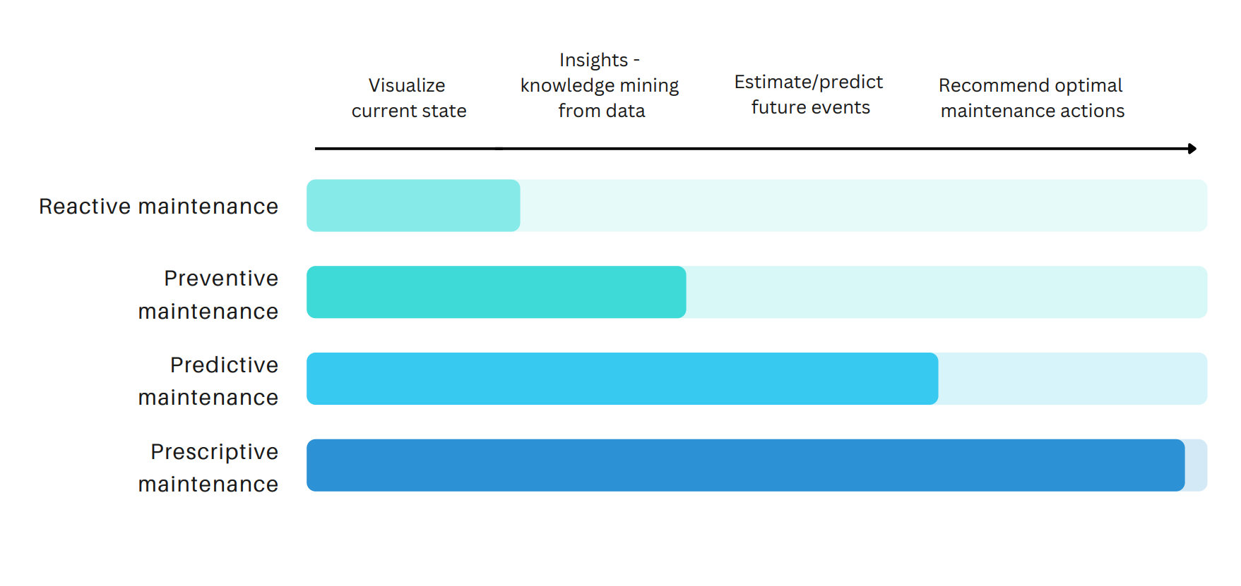

FIGURE III. FIGURE EXPLAINING REINFORCEMENT LEARNING PROCESS WITH AN EXAMPLE

While both predictive and prescriptive maintenance strategies rely on data and analytics to improve upon conventional maintenance approaches in manufacturing, there is a key difference between the two methodologies is that the predictive maintenance focuses just on projection of impending failures based on digital models and diagnostic analytics while prescriptive maintenance supplements reliability estimations with actionable and scenario-specific decision support for maintenance teams [33]. The evolution from predictive to prescriptive strategies marks a shift towards AI optimizing the true end goal – maximizing manufacturing productivity and performance through minimized downtime and maintenance costs .

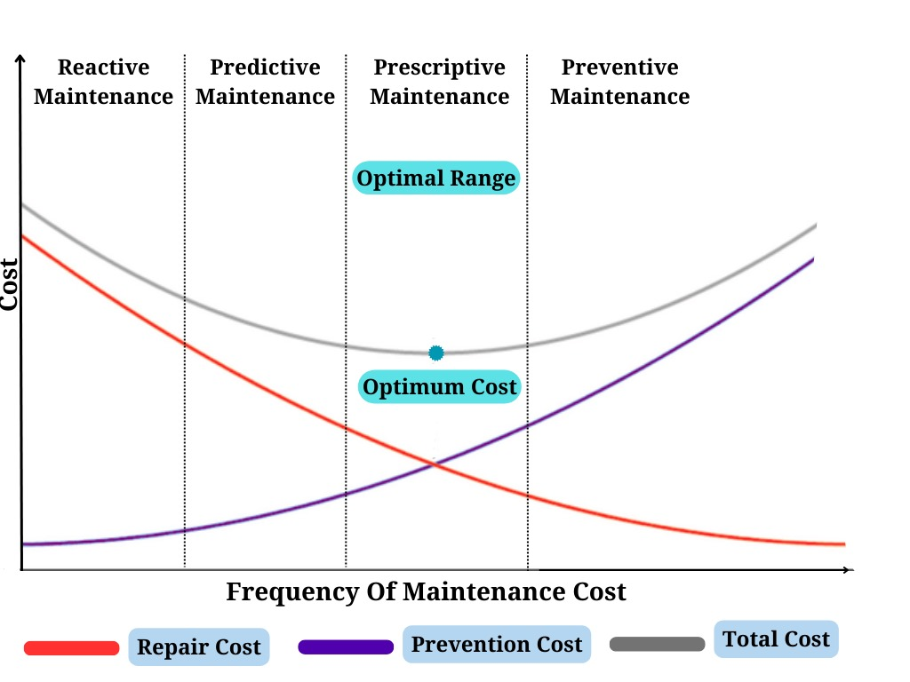

FIGURE III. FIGURE EXPLAINING REINFORCEMENT LEARNING PROCESS WITH AN EXAMPLE

3. New Research Trends In Manufacturing

Artificial Intelligence represents the next wave of smart technology advancing manufacturing through increasingly connected, transparent, and autonomous operations. From computer vision for flawless quality control to machine learning algorithms optimizing complex supply chains, AI and data analytics are enabling a new era - the cyber-physical production system. Internet of Things (IoT) sensors linked across plant infrastructure and equipment feed enterprise data lakes. Advanced analytics extract embedded insights to drive predictive capabilities, while machine learning automation handles intricate manufacturing tasks [34, 35]. Together, AI and Big Data fuel the self-correcting smart factory. They grant manufacturers the flexibility to cost-effectively address demand fluctuations, customization appetite, and sustainability imperatives [36].

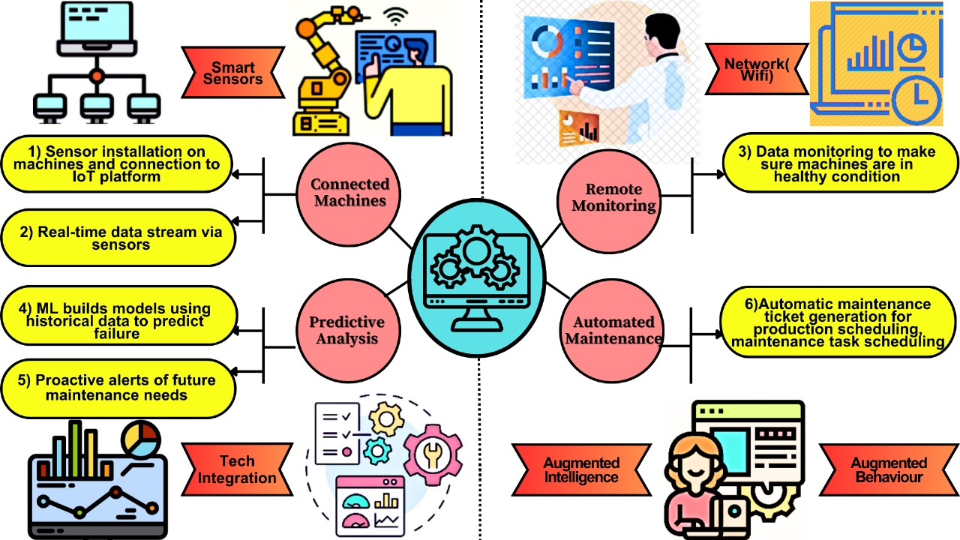

FIGURE III. FIGURE EXPLAINING REINFORCEMENT LEARNING PROCESS WITH AN EXAMPLE

3.1 Usage Of IoT In Modern Manufacturing

The proliferation of low-cost sensors, connectivity, and cloud analytics has fueled the expansion of the industrial internet of things (IIoT) across factory floors. Networked sensors embedded throughout manufacturing infrastructure, equipment, and products generate immense volumes of previously inaccessible data. These IIoT devices measure, collect, and transmit operational statistics, machine health indicators, product locations, temperatures, vibrations, and more [34].

Connecting legacy manufacturing environments into data-rich, observability-enhanced operations unlocks game-changing opportunities alongside new challenges. While historically manufacturers lacked visibility into inefficiencies, emerging IIoT platforms provide the foundation to reveal bottlenecks, quality issues, impending equipment failures, supply chain tribulations, and suboptimal energy usage. However, deriving value from burgeoning IIoT data requires analyzing unwieldy, complex information streams using modern techniques like cloud-based machine learning and artificial intelligence [35].

Overall, the dawn of IIoT marks the beginning of a manufacturing industry transformation - from dated production limited by data scarcity to analytics-optimized, intelligent, flexible manufacturing guided by abundant, meaningful insights extracted from IIoT sensor flows. When contextualized using advanced analytics, this high-fidelity visibility promises to propel manufacturing towards new horizons of quality, reliability, and efficiency [36].

3.2 Usage Of Big Data In Modern Manufacturing

The manufacturing industry is undergoing a silent revolution fueled by an unlikely source: big data. This vast ocean of information, encompassing everything from sensor readings to customer feedback, is transforming the way products are designed, built, and delivered [37].

Modern manufacturing generates a cacophony of data - sensor readings, machine logs, production metrics, customer feedback, even environmental data. This unstructured data, traditionally ignored, holds hidden gems. Big data tools like Hadoop and Spark tame this chaos, enabling analysis and extraction of valuable insights.

Traditional manufacturing relied on historical data, often lagging behind reality. Big data platforms like Apache Kafka and RabbitMQ enable real-time data streaming, feeding insights directly into production processes. Imagine machines adjusting parameters based on live sensor readings, or predictive maintenance triggered by real-time anomaly detection [37, 38].

Big data is the conductor of the IoT orchestra, where sensors embedded in machines, products, and even the environment generate a continuous stream of data. This data feeds the algorithms, enabling real-time monitoring, optimization, and automation of entire production lines. Rather than an isolated trend, big data represents the foundational enabler spurring the emergence of intelligent manufacturing [4].

3.3 Development Of AI Technologies In Manufacturing

The field of artificial intelligence has experienced rapid transformations over the past decade. Advances in computational power, the availability of large datasets, and innovations in machine learning algorithms have led to AI solutions that rival or exceed human capabilities in a range of focused tasks.

Within manufacturing, AI leverages the proliferation of industrial internet-of-things (IIoT) sensors as well industry data sets to deliver next-generation capabilities. Two prime use cases are applying computer vision for automating quality control assessment and leveraging deep learning algorithms to accurately forecast equipment failures and recommend predictive maintenance actions. AI can be divided into the machine learning, deep learning and reinforcement learning [4]. There are also many diverse technologies in the AI that are used in the modern manufacturing industry, some of them are shown in the image below. And The AI is further discussed in detail in section 4.

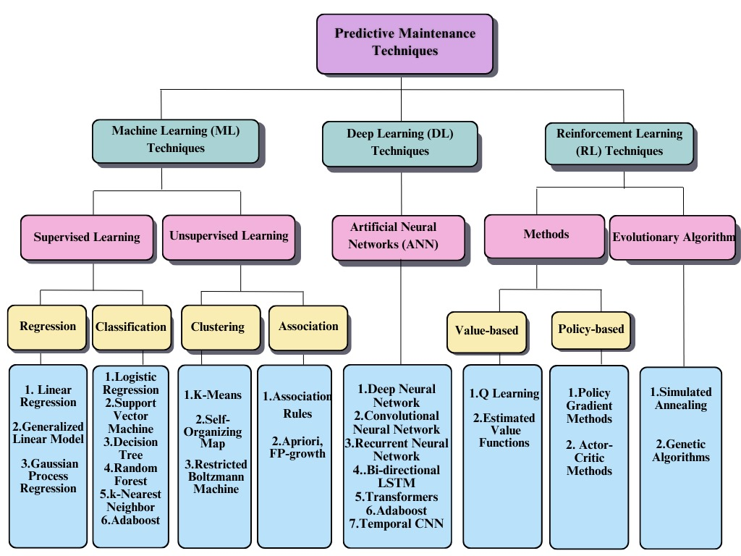

FIGURE III. FIGURE EXPLAINING REINFORCEMENT LEARNING PROCESS WITH AN EXAMPLE

3.4 Digital Twin

Digital twins are emerging as a pivotal technology for enabling predictive maintenance and driving operational excellence. These virtual models mirror physical manufacturing assets, replicating behaviors based on real-time data from their counterparts on the factory floor. Digital twins leverage tens of thousands of IoT sensors plus computer vision, vibration monitoring, and other inputs to simulate component conditions and overall machine health. Advanced analytics extract insights from these ever-updating virtual constructs to identify signs of future failures and degradation far earlier than reactive approaches. Digital Twin is further discussed in section 5.

4. Conception Of Different AI Technologies

4.1 Artificial Intelligence And Machine Learning

Artificial intelligence (AI) refers to computer systems that can perform tasks that typically require human intelligence, such as visual perception, speech recognition, and decision-making. AI is revolutionizing products, services, and scientific discovery through technologies that learn and improve based on data and experience. Core AI capabilities power a range of applications from digital assistants to self-driving vehicles [15].

A subset field within artificial intelligence that has seen immense innovation in recent years is machine learning. Machine learning refers to algorithms and statistical models that learn patterns from data in order to make predictions or decisions without being explicitly programmed to perform that task. The algorithms iteratively learn from data, find insights, and improve their analytical ability over time [12].

Machine learning has unlocked solutions previously thought impossible across industries including manufacturing, healthcare, and finance. Within the field of machine learning deep learning, and reinforcement learning represent more advanced techniques that can overcome some of the limitations of more basic machine learning approaches [4, 12], The schematic representation of the interconnections between artificial intelligence, machine learning, and deep learning is shown in figure <TODO>.

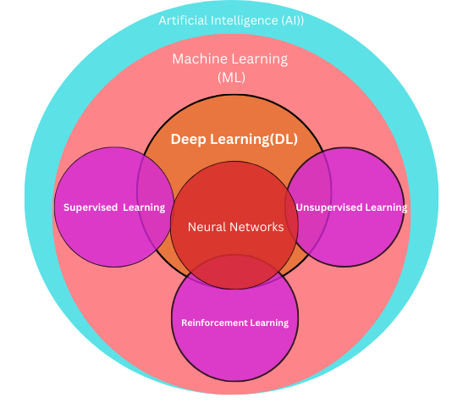

FIGURE III. FIGURE EXPLAINING REINFORCEMENT LEARNING PROCESS WITH AN EXAMPLE

4.2 Deep Learning

Deep learning has emerged as a breakthrough technique for automatically learning complex patterns from large datasets. Inspired by the neural networks of the human brain, deep learning models use multiple layers of processing to incrementally extract higher-level features from raw input data. This hierarchical learning approach sets deep learning apart from earlier machine learning methods reliance on human-engineered feature extraction [12, 14].

For manufacturers, deep learning presents transformative opportunities to utilize data from sensors embedded across production operations and industrial IoT deployments. Specific manufacturing applications benefiting from deep neural networks include predicting equipment failures through machine vibration and temperature analysis, optimizing energy efficiency across facilities, dynamically scheduling production runs, and automating quality assurance through automated visual inspection of products.

Convolutional neural networks represent the most widespread deep learning architecture adopted for manufacturing use cases. With a structure optimized for processing pixel imagery input, convolutional neural networks can effectively analyze scans and photographs to identify production defects and maintenance issues without any need for human assistance [12, 4]. Companies are already realizing millions of dollars in savings from convolutional neural network-enabled scrap reduction and quality improvements.

While showing great promise, deep learning poses multiple challenges including data preprocessing requirements, intense computational demands for training complex models, and interpretability issues around how models reach conclusions.

Some of the widely used models like the convolution layers and the transformer architectures are explained briefly in th following sections.

4.2.1 Convolution Layers

Convolutional Neural Network (CNN) is one of the most notable deep learning models due to its shared weights and ability of local field representation [4-204, 4-205]. CNN can extract the local features of the input data and combine them layer by layer to generate high-level features. As illustrated in Fig. <TODO>, a typical CNN structure basically consists of input layer, convolution layer, pooling layer, and fully connected layer.

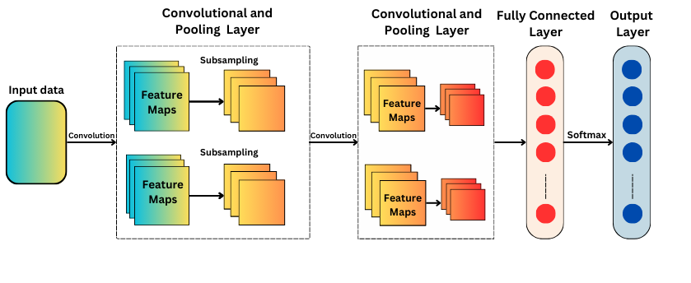

FIGURE III. FIGURE EXPLAINING REINFORCEMENT LEARNING PROCESS WITH AN EXAMPLE

The input layer can be presented in a two dimensional manner such as time-frequency spectrum or a one-dimensional manner such as time series data, e.g., the input data can be represent as X ∈ RA×B , where A and B are the dimensions of the input data [4, 39]. In the convolution layer, the convolution kernel (filter) convolutes the input data from the previous layer through a set of weights and composes a feature output, generally called as a feature map. The output of the convolutional layer can be calculated as:



where “*” represents an operator of convolution, cn denotes the number of convolution filters, Wcn is the weight matrix of cn-th filter kernel, bcn is the filter kernel bias and f is an activation function such as rectified linear units (ReLU) [4]. The essence of pooling operation is sampling, which is used to reduce model parameters and retain effective information. At the same time, overfitting can be avoided in some extent and training speed can be improved. The most commonly used pooling layer is max-pooling layer, which can extract max value from Ycn as follows [39]:



where S M×N is a scale matrix of pooling, M and N are the dimension of S. After several combination forms of convolution layer and pooling layer, multiple fully-connected layers will follow, which can convert the matrix in filter to a column or a row. Finally, a classification or regression layer can be added to achieve specific aims.

4.2.2 Transformer Architecture

Although deep learning approaches have proven to be a quite effective solutions to the problem, one of the open research challenges remains – the design of PdM methods that are computationally efficient, and most importantly, applicable in real-world internet of things (IoT) scenarios, where they are required to be executable directly on the limited devices’ hardware. With their attention mechanism and parallelizability in transformer blocks, transformers are a neural architecture that bridges the gap between compute efficiency and representational power – unlocking deep learning scalability for manufacturing [3].

Transformers are a novel neural network architecture first proposed in a literarure by [24] that have become ubiquitous across natural language processing tasks and are now being adapted for image, video, signal processing use cases. Transformers introduced the transformer block - a component built solely using attention mechanisms without convolution or recurrence. Attention enables models to focus processing only on relevant parts of a large input vector, significantly improving computational efficiency.

The standard transformer contains an encoder and decoder stack. The encoder maps an input sequence into a continuous vector representation while the decoder generates the target sequence elements one state at a time from the encoder outputs. Each utilize transformer blocks applying multi-headed attention - running multiple parallel attention layers to connect distant input signals [3]. Transformers also employ residual connections adding the block input to its output as well as layer normalization stabilizing the internal layers’ activations.

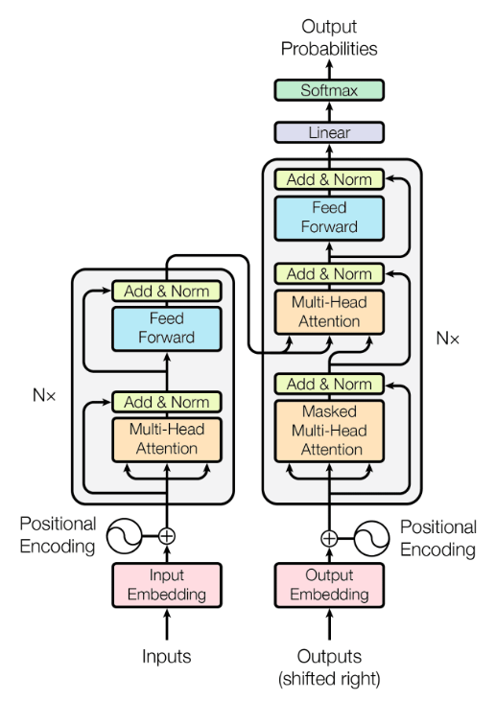

FIGURE III. FIGURE EXPLAINING REINFORCEMENT LEARNING PROCESS WITH AN EXAMPLE

The major novelty behind the transformer architecture is to leverage a multi-head attention mechanism to obtain both high results in terms of RUL estimation and low memory model storage requirements, providing the basis for a possible implementation directly on the equipment hardware [3]. The attention mechanism has gained a lot of popularity in last years for its better capacities in several analytics tasks (e.g. NLP) in terms of achieved results and model complexity than recurrent models.

For manufacturing researcher community, transformers present exciting opportunities. Early manufacturing investigations successfully show accuracy improvements on fault diagnosis classification and retrieval-based on technical service bulletins. Transformers have also demonstrated aptitude for handling sensor measurements over time for predictive maintenance forecasting.

4.3 Reinforcement Learning

Reinforcement learning algorithms can make decisions by interacting with an environment. This means an AI applied to predictive manufacturing maintenance can learn directly from the observations and outcomes experienced in the actual production facility. It can experiment with different maintenance policies to minimize total downtime over the long run [13].

By formalizing the maintenance planning challenge as a reinforcement learning problem, the objective becomes optimizing a reward function. This reward function can incorporate factors like maximizing uptime, minimizing technician time and costs, or planning around fluctuations in product demand [13]. The AI learns which conditions should trigger a maintenance action through its past experiences and incremental improvements.

Pairing deep neural network models with reinforcement learning, a predictive maintenance engine could learn complex representations of sensor data and operational conditions leading to equipment failures. These modern techniques hold promise to uncover subtle patterns in the relationship between machine deterioration, environmental factors, usage profiles and ultimate breakdown events. Rather than relying on simple threshold rules, reinforcement learning allows the development of flexible predictive maintenance policies robust to the variability found in real-world manufacturing environments [13, 15].

Here is one way/example for which reinforcement learning can be utilized for optimizing predictive manufacturing maintenance, and is described in brief and also shown in the pictorial form in Figure <TODO>.

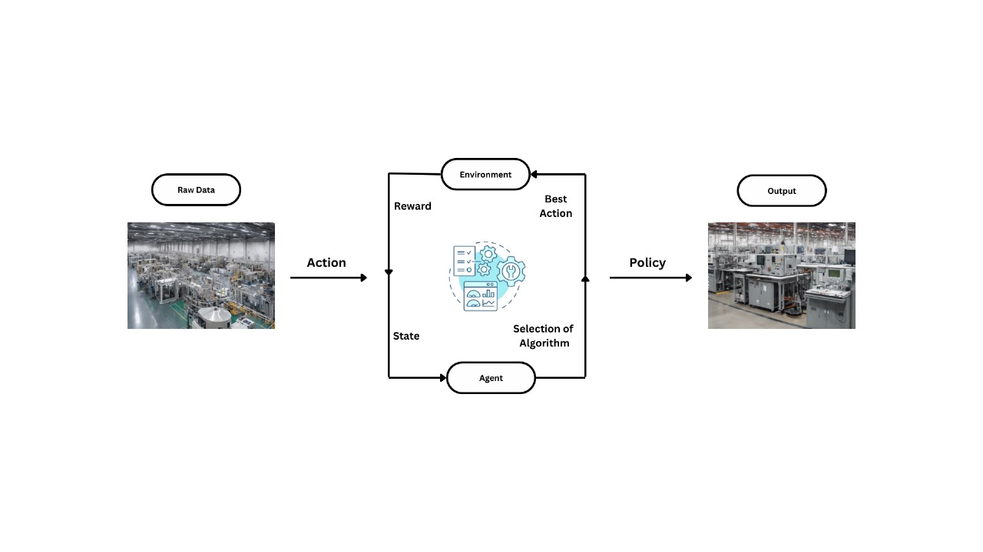

FIGURE III. FIGURE EXPLAINING REINFORCEMENT LEARNING PROCESS WITH AN EXAMPLE

Environment - The environment consists of the manufacturing system the agent must learn to operate in. This includes the machines, production schedule, sensors collecting data on equipment condition, maintenance technicians, repair parts inventories, etc. The environment evolves dynamically over time, presenting new situations to the learning agent.

States - The state represents the current condition of the environment as perceived by the learning agent. The state encodes salient information useful for maintenance decisions - e.g. machine temperature or vibration thresholds crossed, time since service on components, availability of technicians, downtime costs, etc. The state evolves based on the environment and actions taken.

Actions - Possible actions could include scheduling/canceling maintenance work orders, assigning limited technician resources, ordering replacement parts, changing operating conditions, making no changes or continuing monitoring, etc. The policy will determine what action the agent takes in each state encountered.

Policy - The policy defines the agent's strategy for which action to take given the current state. Improving this predictive maintenance policy to maximize long-run reward is the objective of reinforcement learning.

Rewards - A reward function assigns a numeric value representing the desirability of outcomes to provide feedback to the agent. Positive rewards could come from minimizing machine downtime and repair costs. Negative rewards may result from excessive preventive maintenance or unplanned breakdowns. The updates guide the agent toward an optimal policy.

Reinforcement learning (RL) addresses limitations of traditional control and planning methods for complex systems like PdM [13-1]. RL builds optimal solutions without needing a model of the system, making it suitable for non-linear processes characteristic of PdM [13-1]. RL is better suited for complex systems than analytical methods because it learns from interaction and feedback, not labels or models [13-7]. The RL "feedback loop" involves the agent taking actions, receiving rewards, and adapting its policy, effectively learning through trial and error [13-7]. The PdM "agent" is the planner, and the "environment" includes sensors, operators, and external data, emphasizing the real-world context of RL for predictive maintenance [13-7].

Some of the key advantages of using reinforcement learning are:

1. Adaptability: Where traditional approaches might fail, RL agents can learn to navigate complicated, dynamic settings.

2. Scalability: RL algorithms are applicable to a broad range of activities and domains, irrespective of the problem's complexity or magnitude.

3. Sample efficiency: Compared to supervised learning techniques, RL agents can learn from a minimal quantity of data.

4.4 Un-Supervised Learning

While much AI focus goes to supervised techniques like deep learning, unsupervised methods hold significant transformative potential for discovering hidden insights in manufacturing data [3]. Unsupervised learning aims to model the underlying structure of data without labeled examples guiding model training. Key unsupervised approaches include cluster analysis for grouping similar datapoints and dimensionality reduction for visualizing complex data spaces [12].

For manufacturers, clustering offers value in extracting new product families, customer segments, or profiles of high-performing production machines from otherwise undifferentiated data pools. Dimensionality reduction enables process engineers to interactively visualize multi-sensor machine operating data to qualitatively assess operating state commonalities. Combined with anomaly detection methods, reducing manufacturing data also shows promise for predictive maintenance to accurately pinpoint emerging equipment faults without tightly supervised failure data.

More nascent generative modeling methods like restricted Boltzmann machines, variational autoencoders, and generative adversarial networks represent the frontier of unsupervised industrial AI [3, 12]. By learning to generate synthetic manufacturing data streams, models can address monitoring limitations like lack of low probability failure mode training data while preserving production line privacy and IP. As algorithms mature, enhanced simulation will provide decision support for production planning and optimization scenarios difficult to recreate offline.

As discussed one of the issues related to supervised PdM applications is the lack of an adequate amount of labeled data. To challenge this problem, [23] investigated the effect of unsupervised pre-training in RUL predictions utilizing a semi-supervised setup. Specifically, in the first layer a restricted Boltzmann machine (RBM) was utilized as an unsupervised pre-training stage in order to automatically learn abstract features from raw unlabeled input data and to initialize the weights in a region near a good starting point before supervised fine-tuning of the whole architecture was conducted.

4.5 Trasfer Learning

Transfer learning usually aims to handle the issue of lack of annotated data for the target objects or systems. As we know, the deep learning based approaches usually requires a lot of examples of both normal behaviour (of which we often have a lot of) and examples of failures to achieve good performance. However, for a production system, failure events are rare due to the unaffordable and serious consequences when machines running under fault conditions and the potential time-consuming degradation process before desired failure happens [4].

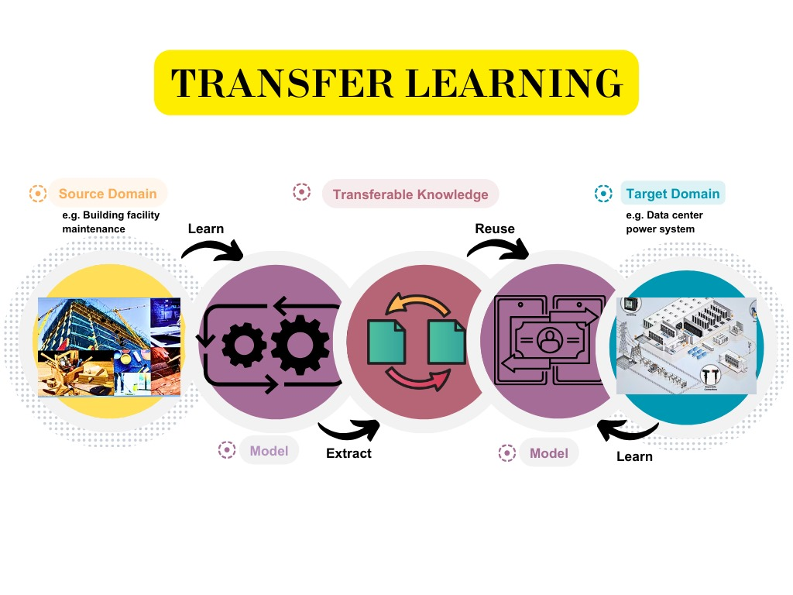

FIGURE III. FIGURE EXPLAINING REINFORCEMENT LEARNING PROCESS WITH AN EXAMPLE

To solve this issue, one method is to use the data augmentation technique – GAN to generate the training data from a dataset that is indistinguishable from the original data as discussed in the previous subsection. Another method is to employ transfer learning [4-261]. A popular method among all types of transfer learning approaches is domain adaptation which can transfer knowledge from one source domain or a set of source domains to a target domain, as shown in Fig. <TODO> [12, 4]. Whenever the tasks share some fundamental drivers, the transferred knowledge can be used to the target domain and significantly improve its performance (e.g., by reducing the number of samples needed to achieve a nearly optimal performance).

Therefore, with labeled data from source domain and unlabeled data from target domain, the distribution discrepancy between the two domains can be mitigated by domain adaptation algorithms. One of the commonly used domain adaptation methods is representation adaptation which tries to align the distributions of the representations from the source domain and target domain by reducing the distribution discrepancy.

For manufacturers, using a pre-trained deep learning model eliminates the need to build extensive labeled datasets to train complex models from scratch. Instead, with just a small manufacturing-specific dataset, a few added neural network layers can be trained to adapt the imported feature maps and knowledge to the target predictive maintenance, quality assurance or forecasting tasks [4].

As computing capabilities have increased, transfer learning has fueled growth in industrial AI applications by minimizing data barriers. Pre-trained models encapsulate versatile representations on extensive general knowledge that bootstrap manufacturing analytics. With quality data still a limiting factor for AI adoption on the factory floor, leveraging transfer learning's versatility will be instrumental as manufacturers continue automating processes with data-driven intelligence.

4.6 State-Of-The-Art Models

TABLE I. STATE-OF-THE-ART ARTIFICIAL LEARNING MODELS IN THE MANUFACTURING INDUSTRY

| **References** | **Authors** | **Year** | **Brief Description** |
| --- | --- | --- | --- |
| [25] | Jin et al. | 2023 | The paper proposes an optimized IoT Big Data ecosystem for predictive maintenance in smart manufacturing, incorporating edge computing and an autoencoder-based deep learning technique. |
| [26] | Murugiah et al. | 2023 | In this paper , a new predictive manufacturing system in Industry 4.0 for examining the machines is proposed, where deep features are extracted through the multi-scale Dilation Attention Convolutional Neural Network (MSDA•CNN) and weighted features are given to the Optimized Hybrid Fault Detection (OHFD) that is performed by the deep neural network (DNN) and Deep Belief Network (DBN). |
| [27] | Netisopakul et al. | 2022 | In this article , the authors applied artificial intelligence technology to a manufacturing industry, specifically, to forecast temperature and insulation values of motors from the CNC machine, and found that the Bi-LSTM yielded the lowest RMSE and MAE numbers, hence, the best model to be selected. |
| [28] | Suawa et al. | 2023 | In this paper , a noisy training method was used to improve the robustness and accuracy of convolutional deep learning models for industrial equipment monitoring, achieving an accuracy of 95% despite adding noise in the test phase. |
| [29] | Shoorkand et al. | 2023 | The paper proposes an integrated framework for production planning and predictive maintenance using deep learning. It uses a long short-term memory model to accurately predict the health condition of the machine for selecting preventive maintenance actions. |
| [30] | Chen et al. | 2023 | The paper proposes a predictive maintenance strategy using an ensemble model of deep learning techniques, including deep autoencoder (DAE) and long short-term memory (LSTM), for system failure prediction. |

5. Digital Twins

A Digital twin is the virtual representation that serves as the real-timeAI digital counterpart of a physical object or process. Unlike many other tools, there is a keen focus on text analysis over raw sensor data, analyzing maintenance logs, and visualizing analytics on a smart dashboard alongside other analytics. Recently, a paradigm hybrid system of combining multiphysical modeling with data-driven analytics was proposed [16-99] . Using a digital twin, the system would continually adapt to operational changes using collected sensor data of industrial equipment in real time to increase autonomy.

Digital Twin (DT) concept provides an eﬀective solution for the implementation of hybrid predictive maintenance approach [17]. DT is an enabling method of cyber-physical systems (CPS) [17-12, 17-13, 17-14], which contains physical model, real-time sensing data and historical running data. DT contains a high ﬁdelity digital model of physical equipment based on physical laws, which acquires real-time sensing data during the operation of equipment and stores the historical running data for further utilization. Meanwhile, DT can provide reliable data through intelligent context aware and data mining, at the same time achieve high ﬁdelity and dynamic model through multi-domain modeling along with model consistency maintenance strategy.

The use of highly accurate digital twin models of industrial machines enables manufacturers to shift to more proactive, predictive maintenance strategies. By mirroring the real-time status and performance of equipment based on sensor data from its physical counterpart, the digital twin provides the necessary visibility.

Trends and patterns extracted from a digital twin allow manufacturers to detect subtle changes and indications of future failures. This could involve noting signs of reduced efficiency, increased friction, overheating components, and other precursors to more serious issues. The digital simulation essentially acts as an early warning system based on real-time equipment health monitoring [17, 32].

As problems are spotted through predictive analytics of digital twin data, manufacturers can act ahead of time to schedule maintenance at the optimal point. Technicians are equipped with insights on the likely root cause, location, and other specifics to streamline addressing the issue thanks to the intelligence within the digital twin [32]. The result is less downtime and greater productivity due to prevention of equipment failures before they escalate or cause line stoppages.

Prognostics analysis and simulations using the ever-updating digital twin model also facilitates prediction of the remaining useful life of industrial assets. Planning the next cycles of predictive maintenance and capital replacement becomes less guesswork [32]. As digital twin accuracy improves with more data over time, their role in driving predictive maintenance will continue expanding across manufacturing.

TABLE I. STATE-OF-THE-ART DEEP LEARNING MODELS IN THE DIAGNOSTIC AND THERAPEUTIC INDUSTRY

| **References** | **Authors** | **Year** | **Brief Description** |
| --- | --- | --- | --- |
| [17] | Luo et al. | 2020 | The paper proposes a hybrid approach for predictive maintenance of CNC machine tools using a Digital Twin model and data. It includes a case study on cutting tool life prediction. |
| [31] | Siddiqi et al. | 2023 | In this article , a predictive maintenance algorithm is proposed that can be used to detect anomalies in the automation system to avoid asset failure, where Artificial Intelligence enabled Digital Twin model is employed to detect early anomalies to avoid catastrophic effects of equipment failure. |
| [32] | Mourtzis et al. | 2023 | The paper proposes a method for robotic cell reliability optimization based on digital twin and predictive maintenance. It mentions the use of a digital twin for simulation and near-real-time monitoring of the robot, along with predictive maintenance approaches for detecting and classifying component malfunctions. |

6. Role of Artificial Intelligence In Predictive Maintenance

There are five pivotal areas where artificial intelligence is moving predictive maintenance forward. First, is processing the explosion of diverse data from sensors, imagery, and measurements related to equipment health and performance. Second, is leveraging synthetic data generation techniques such as generative adversarial networks and diffusion models to expand limited real-world training data. The third applies prognostic health management methods fueled by AI to estimate remaining useful life and end-of-life for components. The fourth area focuses on various machine learning algorithms for anomaly detection that identify deviations in sensor streams, computer vision outputs, or other monitoring sources that may indicate emerging reliability issues. Together - data diversity, synthetic modeling, health forecasts, and anomaly alerts - these four domains capture how artificial intelligence is elevating manufacturing predictive maintenance through more sophisticated capabilities in extracting insights from equipment data. This enables increased uptime and optimized operational decision making. And the fifth area focuses on the maintenance strategy optimization, i.e. artificial intelligence system can dynamically adjust maintenance schedules, allocating resources where they are most urgently required.

6.1 Types Of Data Used For The Predictive Maintenance

Emphasizing the multifaceted nature of manufacturing data, the section explores four key data types: time series, natural language, knowledge graph, and image-based data [16, ]. Time series data provides a chronological sequence of events, offering insights into machinery performance over time. Natural language data facilitates the integration of textual information, enabling the analysis of maintenance reports and documentation. Knowledge graphs contribute to a holistic understanding of interconnected data points, fostering predictive insights. Additionally, image-based data is pivotal for visual analysis, allowing for the identification of equipment anomalies and defects.

TABLE I. TABLE FOR THE MOST COMMON TYPE OF THE DATA USED FOR THE PREDICTVE MAINTENANCE

| Data type | Sample Usage of data type | References in which data types used |
| --- | --- | --- |
| Time Series | Sensor data (temperature, pressure, vibration, etc.) recorded over time from equipment and machines. This can show patterns and trends that indicate potential issues. | [16-19], [16-20] |
| Natural language | Operator logs and technician notes documenting observed issues with machines or quality problems. Natural Language Processing can extract insights. | [16-21] |
| Knowledge Graph | Structured data on machine and component relationships, configurations, and hierarchies on the factory floor. Allows tracking issues propagating between connected equipment. | [7], [18], [16-22] |
| Image Based | Camera feeds monitoring production lines, equipment, and products can supply images and video to AI systems to detect defects, abnormalities etc. | [1], [42] |

6.2 Synthetic Data Generation

With the wider adoption of sensors and industrial internet-of-things (IIoT) devices, manufacturers have greater access than ever before to detailed operations data. However, developing accurate machine learning models for predictive maintenance requires abundant quality data covering all potential failure modes – which rarely exists in the necessary volumes [5]. Synthetic data generation offers a solution for producing large supplemental datasets that can augment real-world histories and improve reliability predictions.

One approach to synthetic data generation would be adversarial networks (GANs) - deep learning models which implicitly learn to model complex distributions from limited seed data [5]. Leading researchers have developed GAN architectures specialized for industrial predictive maintenance that can effectively multiply small real-world sensor datasets.

Synthetically generated machine operating data unlocks multiple benefits for industrial predictive maintenance. It allows the training of more robust models for rarely occurring failure modes where real data is lacking [5]. As analytics model requirements grow more demanding, high-fidelity synthetic data promises to be an essential tool for improving failure forecasting performance.

6.2.1 Generative Adversarial Net (GAN)

Generative adversarial network (GAN) was initially introduced in [4-251]. A typical GAN framework consists of a generator (G) and a discriminator (D), as illustrated in Fig. <TODO>. The generator (G) generates fake samples (e.g., time series with sequences) from a random latent space as its inputs, and feeds the generated samples to the discriminator (D), which will try to distinguish the generated (i.e. fake) samples from the original dataset [4]. The concept of GAN is based on the idea of competition, in which G and D are competing to outsmart each other and improve their own capability of imitation and discrimination respectively.

GAN is firstly utilized as a data augmentation technique to address the class imbalance issue in the field of PdM. In [4-252], the authors illustrated that GAN is able to generate adequate oversampled data when an imbalance ratio is minor. Also, a hybrid oversampling method combining adaptive synthetic sampling (ADASYN) with GAN is designed to resolve the inability of the GAN generator to create meaningful data when the original sample data is scarce.

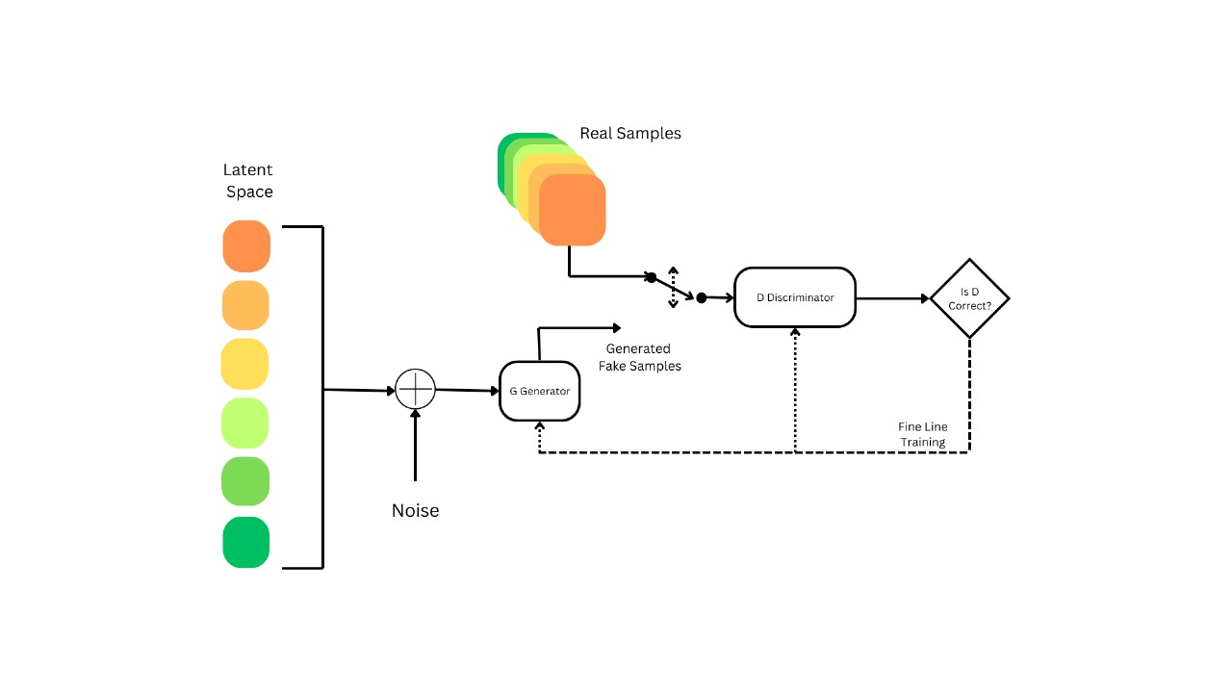

FIGURE III. FIGURE EXPLAINING REINFORCEMENT LEARNING PROCESS WITH AN EXAMPLE

Besides generating synthetic samples, GAN also can be directly trained for fault identification. In [4-257] authors propose a generic anomaly detection architecture called GANomaly. GANomaly employs an encoder-decoder-encoder sub-network and three loss functions in the generator to capture distinguishing features in both input images and latent space. At inference time, a larger distance metric from this learned data distribution indicates an anomaly.

6.2.2 Diffusion Models

While generative adversarial networks (GANs) have shown promise for generating synthetic data useful for training AI models, diffusion models are emerging as an alternative generation approach with some distinct advantages [41]. Diffusion models work by adding noise to real data over repeated iterations and learning these noise distributions to allow “denoising” back to realistic outputs. This offers greater control, interpretability, and the ability for conditional steering not found in GANs [40].

Diffusion-based augmentation with tight conditioning guardrails results in high-quality synthetic images, signals, and data that maintains the integrity and distributions of real documented examples from the factory floor [40]. This leads to safer and more effective adoption of AI for critical predictive maintenance tasks. As algorithms evolve, diffusion models are expected to become an essential data synthesis method within smart factories - significantly multiplying scarce real-world examples into abundant quality data for powering advanced predictive maintenance driven by AI.

6.3 Prognostic And Health management (PHM)

PHM refers to techniques that enable predicting and preventing unexpected equipment failures through proactive condition monitoring and diagnostics. In manufacturing, PHM uses data from sensors on industrial machines as well as histories of operation and failure to ascertain equipment health and anticipating maintenance needs before breakdowns occur. This avoids costly downtime and prevents secondary damage from failures [2 ,4].

For example vibration sensors on motors or pumps connected to cloud analytics that identify increasing vibration thresholds indicating wearing bearings or introduction of friction - allowing for proactive repair or part replacement before failure.

6.3.1 Remainging Useful Time (RUL)

RUL represents the length of time a system or component is likely to operate before degradation reaches a critical threshold that necessitates maintenance or replacement. In manufacturing predictive maintenance, AI algorithms analyze all available data on usage, wear and tear indicators, operating conditions etc. to dynamically estimate component RUL at any given point. Understanding RUL enables optimal upkeep scheduling [4, 16].

For example, machine learning estimation that forecasts an industrial molding machine can safely operate for another 180 days before requiring preventative maintenance based on indicators of loosening hydraulic pressure and minor oil leaks. This enables optimum work order scheduling.

6.3.2 End Of Life (EOL)

EOL refers to when an equipment part or system reaches the end of its effective operational life based on its design parameters or usable lifespan considering found damage, fatigue and applied stress over time. In manufacturing, predictive analytics tracking degradation can forecast EOL and cue replacement ordering, migrations etc. while the system is still functioning without issue. This buffers against end of runtime surprises [4, 16].

For example sensors noting a sharp increase in miniscule cracks on a turbine blade, with computer vision and predictive analysis judging the metal fatigue has 2 days before probable fracture based on failure models - requiring imminent replacement.

6.4 Anomaly Detection

Anomaly detection is concerned with identifying data values that are considerably deviated from a typical behavior [2]. The anomaly may be caused by several factors; some of them are related to errors in the acquisition system, such as sensor malfunction, low battery, er­rors during data transmission, while other anomalies may be caused due to an industrial equipment malfunction, or event, such as changes in the production line or a curative stop [2-14]. While anomalies caused by machinery’s events have relevant information for the analyzer, anomalies caused by sensor errors do not provide any relevant information, and could lead to misinterpretation of data. These anomalies may be designated as noise, however, as discussed by [2-15], the characterization of anomalies and noise is different for different types of data.

Typically anomalies may be classified in: point anomalies, when one data point is considerably different from its neighbors; behavioral or collective anomalies, when a data pattern is different from an expected behavior; and contextual anomalies, when a data pattern may be expected but in a different context [2, 2-14,2-16].

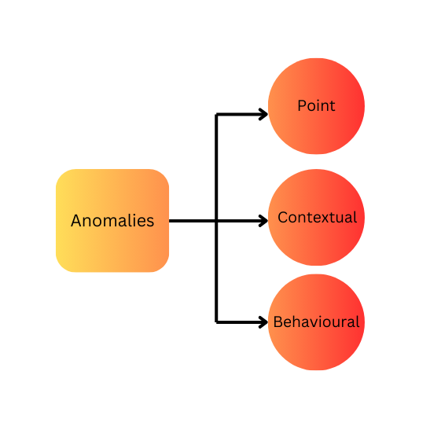

FIGURE III. FIGURE EXPLAINING REINFORCEMENT LEARNING PROCESS WITH AN EXAMPLE

Since there are different types of anomalies, and they may be triggered by several factors, most of recent researches employ data from several sensors and exploit the correlation between them

[2-16,2-18, 2–24]. The exploited correlations may be temporal [2-20,2-21], spatial [2-16], or multi-variate [2-18,2-19].

A key capability provided by AI and advanced analytics is automated anomaly detection on the manufacturing floor [2-26, 2-31, 2-33]. Rather than relying solely on human monitoring and vigilance to spot equipment issues or product defects, anomaly detection algorithms leverage sensor streams, imaging, and other data to flag abnormalities.

Computer vision techniques enable scrutinizing video feeds of production lines for shape, color or finish flaws invisible to the human eye. The vision systems automatically recognize and report aberrations as they occur to speed remediation. AI introspection spots inconsistencies in quality control test results indicating potential instrumentation drifts.

6.5 Maintenance Strategy Optimization

The integration of AI in maintenance strategy optimization introduces real-time monitoring capabilities that continuously assess the health and performance of manufacturing assets. Sensors and IoT devices feed a constant stream of data into AI algorithms, allowing for the detection of anomalies and subtle patterns indicative of potential issues. In response to these insights, AI systems can dynamically adjust maintenance schedules, allocating resources where they are most urgently required. This adaptive approach not only maximizes operational uptime but also enhances overall system reliability [43].

AI-driven maintenance strategy optimization goes beyond mere prediction by incorporating advanced decision-making capabilities. Machine learning models analyze vast datasets to identify optimal maintenance strategies based on factors such as equipment condition, historical performance, and production demands. This data-driven decision-making process ensures that resources are allocated efficiently, reducing unnecessary maintenance costs while maintaining the integrity of critical assets. As a result, manufacturers can achieve a delicate balance between minimizing expenses and maximizing the reliability of their production infrastructure [4, 5].

7. Limitations And Challenges

This section examines the limitations and challenges by presenting a balanced view, this section contributes to a comprehensive understanding of the multifaceted implications of integrating AI into manufacturing, highlighting the need for strategic considerations and careful implementation to navigate both the advantages and obstacles in this transformative journey.

* Synthetic Dataset: Generating representative synthetic datasets for training AI models in manufacturing scenarios poses a significant challenge. Ensuring that synthetic data accurately reflects the complexities and nuances of real-world manufacturing processes is crucial for the effectiveness of AI algorithms.
* Prediction for Complex Systems: Shifting from predicting outcomes for individual components to predicting behaviors within complex manufacturing systems presents a substantial challenge. The intricacies of interdependent processes require AI models to adapt and account for multifaceted interactions, demanding advanced modeling techniques and increased computational resources.
* High-End Computation Required: The implementation of AI in manufacturing, especially for data analytics on a large scale, demands substantial computational power. The need for high-performance computing infrastructure to process and analyze vast datasets in real-time adds a layer of complexity and cost to the integration of AI technologies.
* Non-Realtime Prediction: Achieving real-time prediction in manufacturing environments remains a challenge due to the inherent complexities and rapid dynamics of industrial processes. Delays in prediction may impact decision-making, limiting the immediate responsiveness that is often crucial in manufacturing settings.
* Unbalanced/Less Heterogeneity of the Data: The availability of diverse and representative datasets is crucial for training AI models effectively. Challenges arise when the data lacks heterogeneity or is unbalanced, potentially leading to biased models and suboptimal performance, especially when faced with unexpected scenarios or outliers.
* Noisy Data: Manufacturing environments are prone to noisy data, characterized by inaccuracies, inconsistencies, or outliers. Managing and filtering out such noise poses a challenge for AI algorithms, as it can affect the reliability and accuracy of predictions, necessitating robust preprocessing techniques and model adaptability.

8. Opportunities And Future Scope

As the integration of AI technologies continues to advance, manufacturing processes stand to benefit from increased efficiency, predictive maintenance, and optimized resource allocation. The synergy of AI and data analytics holds the potential to revolutionize production workflows, enabling real-time decision-making and adaptive manufacturing systems. Emphasizing the transformative impact of AI on the manufacturing sector, this section delves into the myriad possibilities for innovation and growth, heralding a new era where intelligent technologies drive the future of manufacturing.

* Large dataset: The performance of AI-based PdM extremely relies on the scale and quality of the used datasets. However, data collection is time-consuming and costly, it is impractical for some researchers to collect their interested dataset for a specific research target. Therefore, it is meaningful for the PdM community to collect and share large-scale datasets.
* Maintenance strategy: Most of the existing works are devoted to fault diagnosis and prognosis by applying AI techniques, and rarely focus on optimizing maintenance strategy. However, it is significant to properly schedule the maintenance activities by applying AI technologies for maintenance automation, cost saving as well as downtime reduction.
* Class imbalance issue: For a production system, failure events are rare due to the unaffordable and serious consequences when machines running under fault conditions and the potential time-consuming degradation process before desired failure happens. Therefore, the collected data usually faces the class imbalance issue.
* Digital twin for PdM: A digital twin continuously updated to mirror the states of their real-life twin. These new paradigms enable us to obtain extensive data regarding run-to-failure data of critical and relevant components. This will be highly beneficial and necessary for successful implementations of fault detection and prediction.
* Usage of reinforcement learning: Reinforcement learning is a promising technique for enabling more proactive and cost-effective predictive maintenance in manufacturing. By allowing systems to learn optimal maintenance policies based on experience. The system learns by interacting with the equipment and environment. As it receives feedback on the outcomes of different actions (such as conducting or delaying maintenance), the system continually updates its understanding of the optimal approach. This enables predictive maintenance systems based on reinforcement learning to adapt in real-time to changing equipment health and operating contexts.
* PdM for multi-component systems: With the fast growth of the economy and the development of advanced technologies, manufacturing systems are becoming more and more complex, which usually involve a high number of components. However, most of the existing AI-based approaches only focus on the fault diagnosis and prognosis for a specific component. Multiple components and their dependencies will increase the complexity and difficulty of an AI-based PdM algorithm. Therefore, how to design an effective AI-based PdM algorithm for multi-component systems is still an open issue.

9. Concluding Remarks

This chapter has explored the tremendous potential for AI to transform manufacturing through predictive maintenance, process optimization, quality control, and beyond. When thoughtfully implemented, these technologies can provide invaluable insights from data to enhance decision-making, asset utilization, and sustainability. However, successfully leveraging AI in manufacturing will require interdisciplinary collaboration. Domain experts must partner with data scientists and ML engineers to properly frame business challenges, curate quality datasets, and iteratively refine AI solutions. While AI adoption in manufacturing remains in early stages, rapid advances in enabling technologies are unfolding. The concepts and use cases surveyed in this chapter illustrate the art of the possible. By combining strengths in applications, algorithms, and infrastructure, manufacturers can traverse the AI maturity curve in manageable steps.

References

[1]

…

[17]

[18] Hansen, E.B. and Bøgh, S. (2021), “Artificial intelligence and internet of things in small and medium-

sized enterprises: a survey”, Journal of Manufacturing Systems, Vol. 58, pp. 362-372.

[19] Zhang, W., Yang, D. and Wang, H. (2019), “Data-driven methods for predictive maintenance of

industrial equipment: a survey”, IEEE Systems Journal, Vol. 13 No. 3, pp. 2213-2227.

[20] O. Etzioni, M. Banko, S. Soderland, and D. S. Weld, “Open information extraction from the web,” Communications of the ACM, vol. 51, no. 12, pp. 68–74, 2008.

[21] X. Han, Research on Key Issues of Intelligent Mine Information Standardization System, China University of Mining and Technology, Beijing, China, 2016.

[23] Ellefsen, André Listou, et al. “Remaining Useful Life Predictions for Turbofan Engine Degradation Using Semi-supervised Deep Architecture.” Reliability Engineering & System Safety, vol. 240–251, 1 Mar. 2019, https://doi.org/10.1016/j.ress.2018.11.027.

[24] Vaswani, Ashish, et al. "Attention is all you need." Advances in neural information processing systems 30 (2017).

[25] Wen, Jin, Yu., Yuehua, Liu., Tharam, S., Dillon., Wenny, Rahayu. "Edge Computing-Assisted IoT Framework With an Autoencoder for Fault Detection in Manufacturing Predictive Maintenance." IEEE Transactions on Industrial Informatics, undefined (2023). doi: 10.1109/TII.2022.3178732

[26] Premkumar, Murugiah., Akila, Muthuramalingam., S., Anandamurugan. "A design of predictive manufacturing system in IoT‐assisted Industry 4.0 using heuristic‐derived deep learning." International Journal of Communication Systems, undefined (2023). doi: 10.1002/dac.5432

[27] Ponrudee, Netisopakul., Nawarat, Phumee. "AI-Enhanced Predictive Maintenance in Manufacturing Processes." undefined (2022). doi: 10.23919/ICCAS55662.2022.10003774

[28] Priscile, Suawa., M., Jongmanns. "Noise-Robust Machine Learning Models for Predictive Maintenance Applications." IEEE Sensors Journal, undefined (2023). doi: 10.1109/JSEN.2023.3273458

[29] Hassan, Dehghan, Shoorkand., Mustapha, Nourelfath., Adnène, Hajji. "A deep learning approach for integrated production planning and predictive maintenance." International Journal of Production Research, undefined (2023). doi: 10.1080/00207543.2022.2162618

[30] Chen, Chuang, et al. "A Predictive Maintenance Strategy Using Deep Learning Quantile Regression and Kernel Density Estimation for Failure Prediction." IEEE Transactions on Instrumentation and Measurement 72 (2023): 1-12.

[31] Mustafa, Ashique, Siddiqui., Gayan, Kahandawa., H.S., Hewawasam. "Artificial Intelligence Enabled Digital Twin For Predictive Maintenance in Industrial Automation System: A Novel Framework and Case Study." undefined (2023). doi: 10.1109/ICM54990.2023.10101971

[32] Dimitris, Mourtzis., John, D., Angelopoulos. "Robotic Cell Reliability Optimization Based on Digital Twin and Predictive Maintenance." Electronics, undefined (2023). doi: 10.3390/electronics12091999

[33] Esa, Mohd Adha Mat, and Masdi Muhammad. "Adoption of prescriptive analytics for naval vessels risk-based maintenance: A conceptual framework." Ocean Engineering 278 (2023): 114409.

[34] Bi, Zhuming, et al. "Internet of things (IoT) and big data analytics (BDA) for digital manufacturing (DM)." International Journal of Production Research 61.12 (2023): 4004-4021.

[35] Khan, Sohail Imran, et al. "Implementation of cloud based IoT technology in manufacturing industry for smart control of manufacturing process." International Journal on Interactive Design and Manufacturing (IJIDeM) (2023): 1-13.

[36] Rath, Kali Charan, Alex Khang, and Debanik Roy. "The Role of Internet of Things (IoT) Technology in Industry 4.0 Economy." Advanced IoT Technologies and Applications in the Industry 4.0 Digital Economy. CRC Press, 2024. 1-28.

[37] Juma, Mazen, Fuad Alattar, and Basim Touqan. 2023. "Securing Big Data Integrity for Industrial IoT in Smart Manufacturing Based on the Trusted Consortium Blockchain (TCB)" IoT 4, no. 1: 27-55. <https://doi.org/10.3390/iot4010002>

[38] Schmitt, Marc. "Big Data Analytics in the Metaverse: Business Value Creation with Artificial Intelligence and Data-Driven Decision Making." Available at SSRN 4385347 (2023).

[39] Li, Zewen, et al. "A survey of convolutional neural networks: analysis, applications, and prospects." IEEE transactions on neural networks and learning systems (2021).

[40] Wang, Huaqing, et al. "A bearing fault diagnosis method with an improved residual Unet diffusion model under extreme data imbalance." Measurement Science and Technology 35.4 (2024): 046113.

[41] Stypułkowski, Michał, et al. "Diffused heads: Diffusion models beat gans on talking-face generation." Proceedings of the IEEE/CVF Winter Conference on Applications of Computer Vision. 2024.

[42] Kiangala, Kahiomba Sonia, and Zenghui Wang. "An effective predictive maintenance framework for conveyor motors using dual time-series imaging and convolutional neural network in an industry 4.0 environment." Ieee Access 8 (2020): 121033-121049.

[43] Hesabi, Hadis, Mustapha Nourelfath, and Adnène Hajji. "A deep learning predictive model for selective maintenance optimization." Reliability Engineering & System Safety 219 (2022): 108191.