**The Future of Manufacturing with AI and Data Analytics**

*Neel Shah1, Sneh Shah2, Janvi Bhanushali3, Kesha Desai4, Manav Vashi5, Dr. Nirav Bhatt6, Dr. Nikita Bhatt7, Dr. Hiren Mewada8*

*1,2,3,4,6Department of Artificial Intelligence And Machine Learning, Chandubhai S. Patel Institute of Technology,*

*Charotar University of Science and Technology, Changa, India*

*5,7Department of Computer Engineering, Chandubhai S. Patel Institute of Technology,*

*Charotar University of Science and Technology, Changa, India*

*8Prince Mohammad Bin Fahd University, Kingdom of Saudi Arabia*

*Email:* [*neeldevenshah@gmail.com*](mailto:neeldevenshah@gmail.com)*,* [*snehs5483@gmail.com*](mailto:snehs5483@gmail.com)*,* [*janvibhanushali249@gmail.com*](mailto:janvibhanushali249@gmail.com)[*desaikesha13@gmail.com*](mailto:desaikesha13@gmail.com)*, …*[*@gmail.com*](mailto:jayanshnagar@gmail.com)*,* [*niravbhatt.it@charusat.ac.in*](mailto:niravbhatt.it@charusat.ac.in)*,* [*nikitabhatt.ce@charusat.ac.in*](mailto:nikitabhatt.ce@charusat.ac.in)*, hmewada@pmu.edu.sa*

Abstract — This chapter explores the potential of applying AI and data analytics to transform manufacturing. It provides an overview of new research trends in smart manufacturing, including the use of IoT, big data, and advanced AI technologies like machine learning and digital twins. The conceptual background of relevant AI approaches is discussed, including deep learning, reinforcement learning, unsupervised learning, and state-of-the-art models. A key focus is examining the role of AI in predictive maintenance through data-driven techniques for remaining useful life estimation, anomaly detection, prognostics, and optimizing maintenance strategies. Challenges and limitations such as noisy data, imbalanced datasets, and high computational requirements are addressed. The opportunities enabled by AI in manufacturing are highlighted, spanning synthetic data generation, real-time prediction, and enhancing asset utilization. The chapter concludes that transformative gains in productivity, sustainability, and resilience will arise from thoughtfully leveraging AI and data to inform decision-making in industrial settings. Adoption remains in the early stages, and realizing the full potential will require interdisciplinary collaboration and purposeful innovation

Keywords — Artificial Intelligence, Machine learning, Modern Manufacturing, Predictive Analysis, IoT, IIoT, Synthetic Data Generation

1. INTRODUCTION

Manufacturing is undergoing a digital transformation. Cutting-edge technologies such as artificial intelligence (AI), machine learning, data analytics, and digital twins are enabling manufacturers to enhance productivity, reduce downtime, cut costs, and improve overall equipment effectiveness. The transformation driven by technology toward intelligent and interconnected manufacturing is commonly denoted as Smart manufacturing (Industry 4.0). At its core, it utilizes data and analytics to gain insights that facilitate predictive maintenance, better decision-making, and innovation.

This chapter explores how AI, big data analytics, prognostics, digital twin technologies [18], and other Industry 4.0 innovations are modernizing the manufacturing sector. Specifically, it focuses on how these technologies allow for predictive maintenance and overall equipment health monitoring to minimize unplanned downtime and boost productivity. The use of simulations, digital thread, and digital twin models for virtual design, prototyping, and process optimization is also discussed [8, 19].

By employing data-driven analytical methods, it becomes feasible to discover crucial findings for strategic decision-making, offering benefits such as decreased maintenance costs, reduced machine faults, minimized spare parts inventory, and heightened production. Maintenance assumes a pivotal role in the industrial sector, as its expenditures may constitute a substantial portion of a company's production costs [44]. Efficient maintenance strategies mitigate unexpected production halts, lower costs, and potentially extend the operational lifespan of industrial machinery. Due to these considerations, maintenance approaches have transformed as a result of the dedication and efforts of researchers, engineers, technicians, and experts.

Predictive maintenance is one of the most impactful applications of AI and data analytics in smart manufacturing. Predictive maintenance solutions can detect anomalies in vibration, temperature, or other sensor data that may indicate wear, cracks, contamination, or misalignments [1]. Advanced machine learning algorithms compare real-time operating conditions to baseline models to flag deviations from normal behavior.

In summary, this chapter explores the ongoing revolution in manufacturing driven by AI, machine learning, prognostics, digital twins, and advanced analytics. The introductory section presents the background and motivation behind this trend towards data-driven smart manufacturing. The next sections provide an overview of maintenance strategies, research directions, and key technologies powering Industry 4.0 innovations. Details on the conception and implementation of predictive maintenance using AI along with its limitations and challenges follow. The chapter culminates in a discussion of the promising future opportunities enabled through these advanced technologies and their ongoing adoption to optimize manufacturing operations, equipment health, quality assurance, and global competitiveness. In totality, it underlines the transformative nature of data-driven, IIoT, and AI-based smarter manufacturing taking shape through Industry 4.0 developments in factories across the industrial spectrum.

2. Different Types Of Maintenance Strategies

Maintenance is a critical aspect of industrial equipment management impacting overall availability, performance, and operational expenditure. While traditional maintenance was reactive and breakdown-focused, modern smart manufacturing facilities are leveraging connectivity, analytics, and automation capabilities to adopt more proactive, optimized, and intelligent maintenance approaches. Fig. 1 shows the abstract benefits and the difference between the maintenance methods and Fig. 2 shows the relationship between maintenance frequency and cost, and how prescriptive maintenance can help to optimize both. The four overarching equipment maintenance methodologies are discussed [4, 13, 33]:

* Reactive Maintenance

Reactive maintenance also known as corrective or run-to-failure maintenance, is a conventional maintenance tactic that involves operating equipment until failure and then repairing or replacing it reactively. No actions are taken to detect or prevent impending failures. Reactive maintenance allows for maximizing equipment lifetime usage without investment in predictive capabilities. However, process downtimes and costs of secondary equipment or product damage from unexpected breakdowns remain high [4, 13].

* Preventive Maintenance

Preventive maintenance or time-based maintenance relies on scheduled overhaul, parts replacement, or lubrication based on historic failure patterns rather than the actual condition. While this improves upon purely reactive approaches, activities are not necessarily aligned with the needs of an asset. Performing maintenance too frequently drives inefficiency through excess downtime disruption. Infrequent maintenance can still risk unexpected failures. Real-time condition visibility remains low [4, 13].

* Predictive Maintenance

It leverages the Internet of Things sensors, equipment monitoring, diagnostics software, and analytics to identify failure patterns or degradation rates of in-service equipment. By recognizing when equipment needs maintenance before failure, issues can be addressed proactively to minimize downtime. Machine learning algorithms comparing real-time data to baseline models of equipment health play a key role here. While implementation requires upfront investment in monitoring infrastructure, efficiencies through failure avoidance provide ROI in months [4, 13].

* Prescriptive Maintenance

This AI-enabled maintenance strategy provides specific decision support recommendations for when and how to best maintain assets. By combining predictive capabilities with optimization algorithms, prescriptive maintenance improves upon predictive outputs to calculate and suggest the most cost-efficient maintenance actions dynamically. This shifts maintenance from preventive schedules or reactionary practices to data-based, optimized decisions balancing uptime, spending, and lifespan [13, 33].

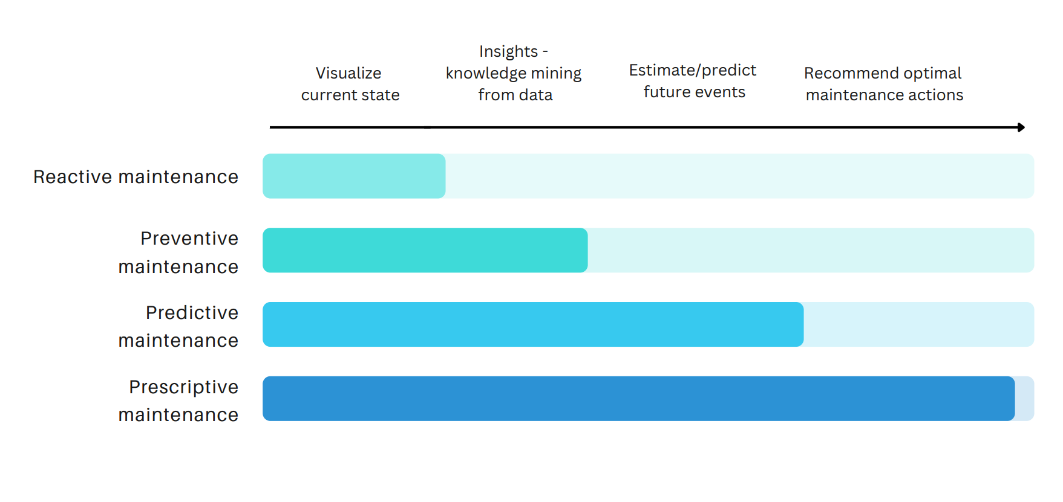

FIGURE 1. SCHEMATIC REPRESENTATION FOR DIFFERENT TYPE OF MAINTENANCE WITH POTENTIAL BENEFITS

While both predictive and prescriptive maintenance strategies rely on data and analytics to improve upon conventional maintenance approaches in manufacturing, there is a key difference between the two methodologies that predictive maintenance focuses just on the projection of impending failures based on digital models and diagnostic analytics while prescriptive maintenance supplements reliability estimations with actionable and scenario-specific decision support for maintenance teams [33]. The evolution from predictive to prescriptive strategies marks a shift towards AI optimizing the true end goal – maximizing manufacturing productivity and performance through minimized downtime and maintenance costs.

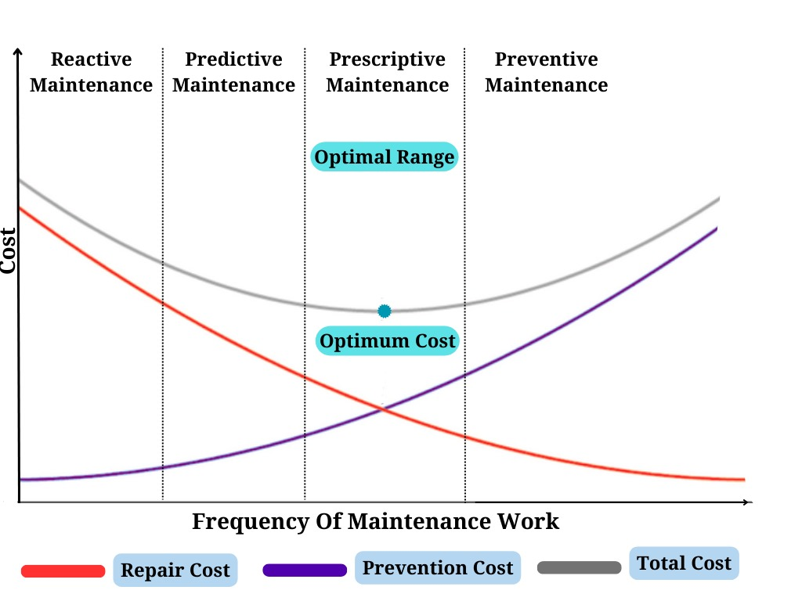

FIGURE 2. SCHEMATIC REPRESENTATION OF THE FREQUENCY OF THE WORK VS COST FOR DIFFERENT TYPES OF MAINTENANCE

3. New Research Trends In Manufacturing

AI represents the next wave of smart technology advancing manufacturing through increasingly connected, transparent, and autonomous operations. From computer vision for flawless quality control to machine learning algorithms optimizing complex supply chains, AI and data analytics are enabling a new era - the cyber-physical production system. Internet of Things (IoT) sensors linked across plant infrastructure and equipment feed enterprise data lakes. Advanced analytics extract embedded insights to drive predictive capabilities, while machine learning automation handles intricate manufacturing tasks [34, 35]. Together, AI and Big Data fuel the self-correcting smart factory. They grant manufacturers the flexibility to cost-effectively address demand fluctuations, customization appetite, and sustainability imperatives [36]. Fig. 3 highlights the potential of automated maintenance to optimize equipment health using sensor data and AI methods to proactively predict and prevent failures, reducing downtime and maintenance costs.

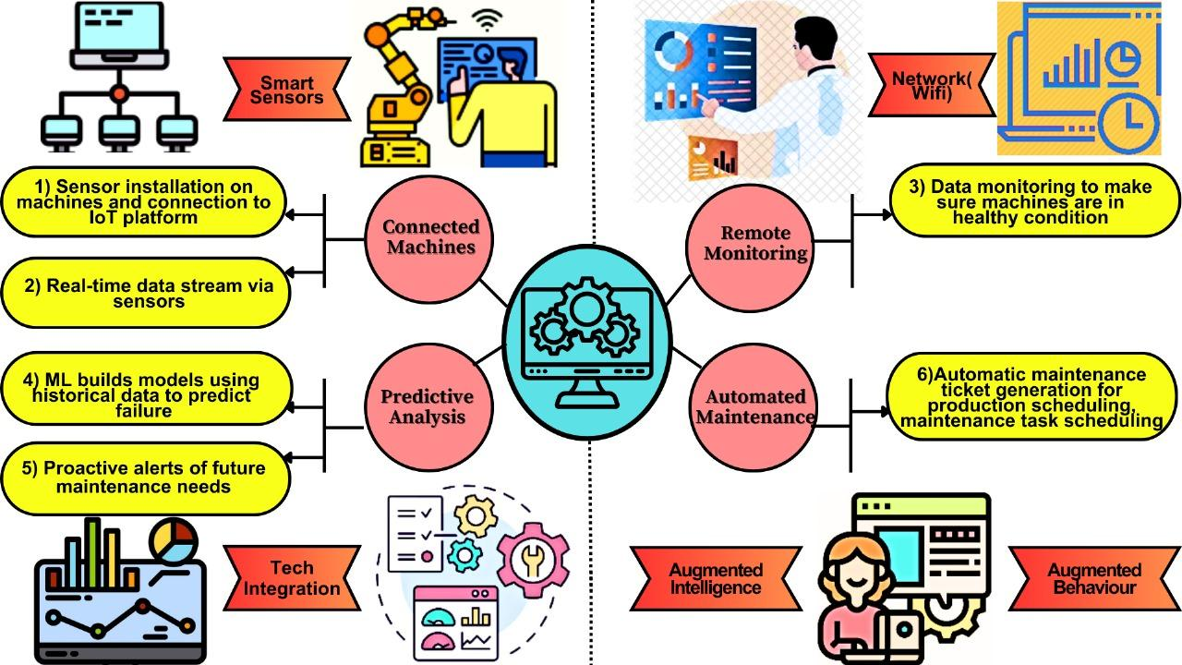

FIGURE 3. SCHEMATIC REPRESENTATION OF AN AUTOMATED MAINTENANCE PROCESS USING IIOT, BIG DATA, AND AI TO PREDICT AND PREVENT EQUIPMENT FAILURES.

3.1 Usage Of IoT In Modern Manufacturing

The proliferation of low-cost sensors, connectivity, and cloud analytics has fueled the expansion of the industrial Internet of Things (IIoT) across factory floors. Networked sensors embedded throughout manufacturing infrastructure, equipment, and products generate immense volumes of previously inaccessible data. These IIoT devices measure, collect, and transmit operational statistics, machine health indicators, product locations, temperatures, vibrations, and more [34].

The dawn of IIoT marks the beginning of a manufacturing industry transformation - from dated production limited by data scarcity to analytics-optimized, intelligent, flexible manufacturing guided by abundant, meaningful insights extracted from IIoT sensor flows. When contextualized using advanced analytics, this high-fidelity visibility promises to propel manufacturing toward new horizons of quality, reliability, and efficiency [36].

3.2 Usage Of Big Data In Modern Manufacturing

The manufacturing industry is undergoing a silent revolution fueled by an unlikely source: big data. This vast ocean of information, encompassing everything from sensor readings to customer feedback, is transforming the way products are designed, built, and delivered [37].

Modern manufacturing generates a cacophony of data - sensor readings, machine logs, production metrics, customer feedback, and even environmental data. This unstructured data, traditionally ignored, holds hidden gems. Big data tools like Hadoop and Spark tame this chaos, enabling analysis and extraction of valuable insights.

Traditional manufacturing relied on historical data, often lagging behind reality. Big data platforms like Apache Kafka and RabbitMQ enable real-time data streaming, feeding insights directly into production processes. Imagine machines adjusting parameters based on live sensor readings, or predictive maintenance triggered by real-time anomaly detection [37, 38].

3.3 Development Of AI Technologies In Manufacturing

The field of AI has experienced rapid transformations over the past decade. Advances in computational power, the availability of large datasets, and innovations in machine learning algorithms have led to AI solutions that rival or exceed human capabilities in a range of focused tasks.

Within manufacturing, AI leverages the proliferation of industrial internet-of-things (IIoT) sensors as well as industry data sets to deliver next-generation capabilities. Two prime use cases are applying computer vision for automating quality control assessment and leveraging deep learning algorithms to accurately forecast equipment failures and recommend predictive maintenance actions. AI can be divided into machine learning, deep learning, and reinforcement learning [4]. There are also many diverse technologies in AI that are used in the modern manufacturing industry, some of which are shown in Fig. 4. The AI is further discussed in detail in section 4.

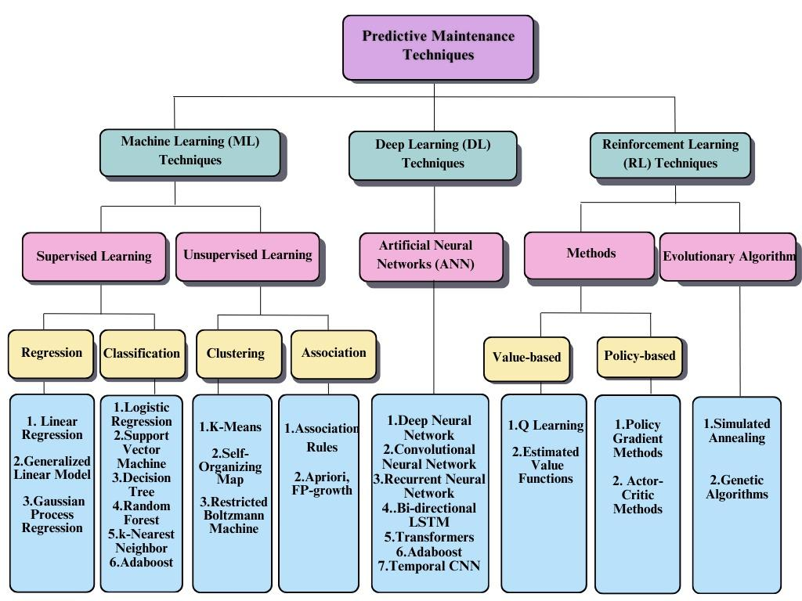

FIGURE 4. SCHEMATIC REPRESENTATION SHOWING THE HIERARCHY OF DIFFERENT AI METHODS USED IN DIFFERENT LITERATURE FOR PREDICTIVE MAINTENANCE FOR THE MANUFACTURING INDUSTRY

3.4 Digital Twin

Digital twins are emerging as a pivotal technology for enabling predictive maintenance and driving operational excellence. These virtual models mirror physical manufacturing assets, replicating behaviors based on real-time data from their counterparts on the factory floor. Digital twins leverage tens of thousands of IoT sensors plus computer vision, vibration monitoring, and other inputs to simulate component conditions and overall machine health. Advanced analytics extract insights from these ever-updating virtual constructs to identify signs of future failures and degradation far earlier than reactive approaches. Digital Twin is further discussed in section 5.

4. Conception Of Different AI Technologies

4.1 Artificial Intelligence And Machine Learning

AI pertains to computer systems capable of executing functions that usually necessitate human intelligence. AI is revolutionizing products, services, and scientific discovery through technologies that learn and improve based on data and experience [15]. In recent years, a subfield within AI that has witnessed substantial innovation is machine learning. Machine learning involves algorithms and statistical models capable of learning patterns from data, enabling them to make predictions or decisions without explicit programming for those tasks. These algorithms iteratively learn from data, discover insights, and enhance their analytical capabilities over time [12].

Machine learning has enabled solutions that were once deemed unattainable across various sectors, such as manufacturing, healthcare, and finance. Within the field of machine learning deep learning, and reinforcement learning represent more advanced techniques that can overcome some of the limitations of more basic machine learning approaches [4, 12], The schematic representation of the interconnections between AI, machine learning, and deep learning is shown in figure 5.

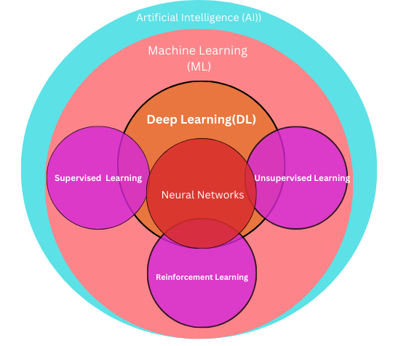

FIGURE 5. SCHEMATIC REPRESENTATION SHOWING A BRIEF OVERVIEW OF THE DIFFERENT BRANCHES OF AI AND THE RELATION BETWEEN SUB-BRANCHES

4.2 Deep Learning

Deep learning has emerged as a revolutionary method for autonomously acquiring intricate patterns from extensive datasets. Drawing inspiration from the neural networks in the human brain, deep learning models employ multiple layers of processing to gradually extract more advanced features from raw input data. This hierarchical learning strategy distinguishes deep learning from earlier machine learning approaches that depended on human-engineered feature extraction [12, 14].

Convolutional neural networks represent the most widespread deep learning architecture adopted for manufacturing use cases. With a structure optimized for processing pixel imagery input, convolutional neural networks can effectively analyze scans and photographs to identify production defects and maintenance issues without any need for human assistance [12, 4]. Companies are already realizing millions of dollars in savings from convolutional neural network-enabled scrap reduction and quality improvements.

While showing great promise, deep learning poses multiple challenges including data preprocessing requirements, intense computational demands for training complex models, and interpretability issues. Some of the widely used models like the convolution layers and the transformer architectures are explained briefly in the following sections.

4.2.1 Convolution Layers (CNNs)

The Convolutional Neural Network (CNN) is a well-known deep learning model, acknowledged for its utilization of shared weights and effectiveness in representing local fields [45, 46]. It demonstrates expertise in extracting local features from input data and iteratively combining them through different layers to generate high-level features. As illustrated in Fig. 6, a conventional CNN structure usually includes an input layer, convolutional layer, pooling layer, and fully connected layer.

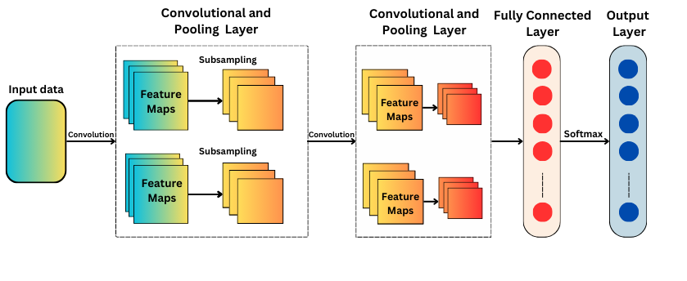

FIGURE 6. SCHEMATIC REPRESENTATION SHOWING BRIEF WORKING OF THE CONVOLUTIONAL NEURAL NETWORK (CNN)

The input layer can be represented in a two-dimensional format, such as a time-frequency spectrum, or a one-dimensional format, such as time series data. For instance, the input data can be denoted as *X* ∈ R *A*×*B*, where *A* and *B* are the dimensions of the input data [4, 39]. In the convolutional layer, the convolution kernel (filter) convolves the input data from the previous layer using a set of weights, producing a feature output commonly referred to as a feature map. The output of the convolutional layer can be computed as

In this context, the symbol "*" represents a convolution operator, where "cn" denotes the number of convolution filters. The weight matrix of the "cn"th filter kernel is denoted by Wcn, the bias is denoted by bcn, and an activation function, such as rectified linear units (ReLU) [4], is denoted by "f." The pooling operation involves sampling, which is employed to reduce model parameters while retaining essential information. This simultaneous reduction helps prevent overfitting to some extent and enhances training speed. The frequently used pooling layer is the max-pooling layer, which extracts the maximum value from Ycn as outlined [39].

Here, S is an M x N scale matrix used in pooling. M and N denote the dimensions of S. Following various combinations of convolutional and pooling layers, multiple fully-connected layers are employed. These layers are responsible for converting the filter matrix into either a column or a row format. Ultimately, a classification or regression layer can be appended to accomplish specific objectives.

4.2.2 Transformer Architecture

While deep learning methods have demonstrated effectiveness in addressing the issue, an ongoing research challenge involves developing Predictive Maintenance (PdM) techniques that are not only computationally efficient but, more crucially, suitable for real-world IoT scenarios. In such scenarios, the methods need to be executable directly on the limited hardware of devices. With their attention mechanism and parallelizability in transformer blocks, transformers are a neural architecture that bridges the gap between compute efficiency and representational power – unlocking deep learning scalability for manufacturing [3].

Transformers are a novel neural network architecture first proposed in the literature by [24] that have become ubiquitous across natural language processing tasks and are now being adapted for image, video, and signal processing use cases. Transformers introduced the transformer block - a component built solely using attention mechanisms without convolution or recurrence. Attention enables models to focus processing only on relevant parts of a large input vector, significantly improving computational efficiency. The architecture of the transformer is illustrated in Fig. 7.

The conventional transformer comprises both an encoder and decoder stack. The encoder transforms an input sequence into a continuous vector representation, and the decoder produces the elements of the target sequence incrementally based on the encoder outputs. Each utilizes transformer blocks applying multi-headed attention - running multiple parallel attention layers to connect distant input signals [3]. Transformers also employ residual connections adding the block input to its output as well as layer normalization stabilizing the internal layers’ activations.

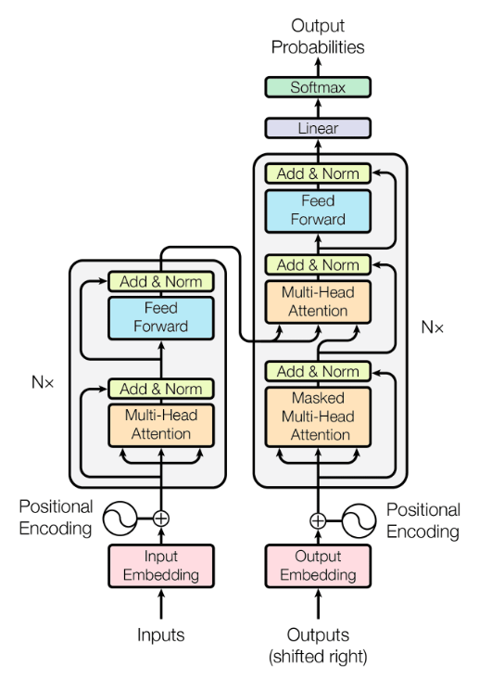

FIGURE 7. SCHEMATIC REPRESENTATION SHOWING TRANSFORMER ARCHITECTURE INTRODUCED IN [24]

For the research community in manufacturing, transformers offer promising possibilities. Early manufacturing investigations successfully show accuracy improvements in fault diagnosis classification and retrieval based on technical service bulletins. Transformers have also demonstrated an aptitude for handling sensor measurements over time for predictive maintenance forecasting.

4.3 Reinforcement Learning

Reinforcement learning algorithms can make decisions by interacting with an environment. This means an AI applied to predictive manufacturing maintenance can learn directly from the observations and outcomes experienced in the actual production facility. It can experiment with different maintenance policies to minimize total downtime over the long run [13].

By formalizing the maintenance planning challenge as a reinforcement learning problem, the objective becomes optimizing a reward function. This reward function can incorporate factors like maximizing uptime, minimizing technician time and costs, or planning around fluctuations in product demand [13]. The AI learns which conditions should trigger a maintenance action through its past experiences and incremental improvements.

Here is one way/example for which reinforcement learning can be utilized for optimizing predictive manufacturing maintenance, and is described in brief and also shown in the pictorial form in Figure 8.

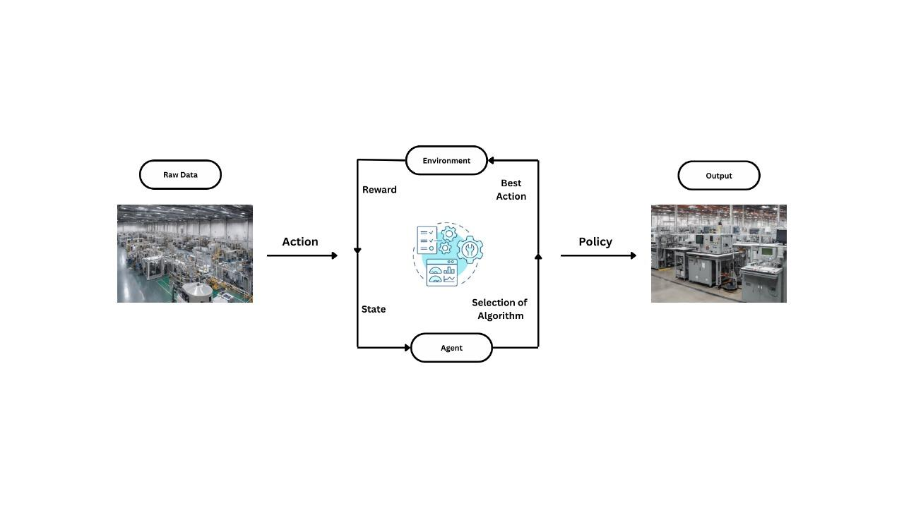

FIGURE 8. ILLUSTRATION OF AN APPROACH WHERE REINFORCEMENT LEARNING (RL) CAN BE UTILIZED FOR PREDICTIVE MAINTENANCE

Environment - The environment consists of the manufacturing system the agent must learn to operate in. This includes the machines, production schedule, sensors collecting data on equipment condition, maintenance technicians, repair parts inventories, etc. The environment evolves dynamically over time, presenting new situations to the learning agent.

States - The state portrays the current state of the environment as observed by the learning agent. The state encodes salient information useful for maintenance decisions - e.g. machine temperature or vibration thresholds crossed, time since service on components, availability of technicians, downtime costs, etc. The state evolves based on the environment and actions taken.

Actions - Possible actions could include scheduling/canceling maintenance work orders, assigning limited technician resources, ordering replacement parts, changing operating conditions, making no changes continuing monitoring, etc. The policy will determine what action the agent takes in each state encountered.

Policy - The policy defines the agent's strategy for which action to take given the current state. Improving this predictive maintenance policy to maximize long-run reward is the objective of reinforcement learning.

Rewards - A reward function assigns a numeric value representing the desirability of outcomes to provide feedback to the agent. Positive rewards could come from minimizing machine downtime and repair costs. Negative rewards may result from excessive preventive maintenance or unplanned breakdowns. The updates guide the agent toward an optimal policy.

Reinforcement learning (RL) addresses the limitations of traditional control and planning methods for complex systems like PdM [13]. RL builds optimal solutions without needing a model of the system, making it suitable for non-linear processes characteristic of PdM [13]. RL is better suited for complex systems than analytical methods because it learns from interaction and feedback, not labels or models [13]. The RL "feedback loop" involves the agent taking actions, receiving rewards, and adapting its policy, effectively learning through trial and error [13]. The PdM "agent" is the planner, and the "environment" includes sensors, operators, and external data, emphasizing the real-world context of RL for predictive maintenance [13].

Some of the key advantages of using reinforcement learning are:

1. Adaptability: Where traditional approaches might fail, RL agents can learn to navigate complicated, dynamic settings.

2. Scalability: RL algorithms are applicable to a broad range of activities and domains, irrespective of the problem's complexity or magnitude.

3. Sample efficiency: Compared to supervised learning techniques, RL agents can learn from a minimal quantity of data.

4.4 Un-Supervised Learning

While much AI focus goes on supervised techniques like deep learning, unsupervised methods hold significant transformative potential for discovering hidden insights in manufacturing data [3]. Unsupervised learning aims to model the underlying structure of data without labeled examples guiding model training. Key unsupervised approaches include cluster analysis for grouping similar data points and dimensionality reduction for visualizing complex data spaces [12].

Combined with anomaly detection methods, reducing manufacturing data also shows promise for predictive maintenance to accurately pinpoint emerging equipment faults without tightly supervised failure data. Emerging generative modeling techniques such as variational autoencoders, generative adversarial networks, and restricted Boltzmann machines are at the forefront of unsupervised industrial AI [3, 12]. By learning to generate synthetic manufacturing data streams, models can address monitoring limitations like the lack of low probability failure mode training data while preserving production line privacy and IP. As algorithms mature, the enhanced simulation will provide decision support for production planning and optimization scenarios difficult to recreate offline.

As mentioned earlier, a hurdle in supervised Predictive Maintenance (PdM) applications is the limited availability of labeled data. To tackle this challenge, a study [23] explored the influence of unsupervised pre-training on Remaining Useful Life (RUL) predictions through a semi-supervised method. More precisely, they utilized a restricted Boltzmann machine (RBM) as the unsupervised pre-training stage in the initial layer. This facilitated the automatic acquisition of abstract features from unlabeled input data and the initialization of weights near an optimal starting point before proceeding with the supervised fine-tuning of the overall architecture.

4.5 Transfer Learning

Transfer learning commonly tackles the issue of limited annotated data for target objects or systems. Deep learning methods usually require abundant examples of both normal behavior (which are often plentiful) and instances of failures for optimal performance. Nevertheless, in a production system, the rarity of failure events arises from the severe consequences and unaffordability of machines operating under fault conditions. Additionally, the potentially time-consuming degradation process leading to the desired failure further contributes to the infrequency of these events [4].

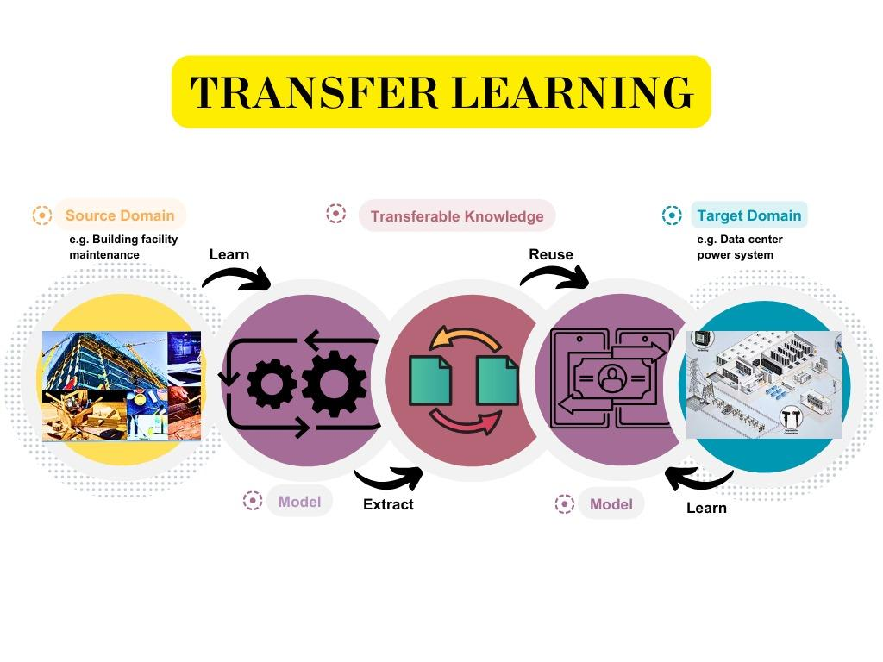

FIGURE 9. SCHEMATIC REPRESENTATION ILLUSTRATING THE CONCEPT OF TRANSFER LEARNING

To address this challenge, one approach involves transfer learning. In transfer learning the tasks share underlying principles, the transferred knowledge can enhance the performance of the target domain, for instance, by reducing the required number of samples to achieve near-optimal performance. The concept of transfer learning can be visualized by referring to Fig. 9.

Therefore, utilizing labeled data from the source domain along with unlabeled data from the target domain enables domain adaptation algorithms to mitigate the distribution mismatch between the two domains. Manufacturers benefit from employing a pre-trained deep learning model, eliminating the necessity to construct extensive labeled datasets for training complex models from the ground up. Instead, by using a modest manufacturing-specific dataset, it is possible to train a few additional neural network layers to adjust the imported feature maps and knowledge for the target tasks of predictive maintenance, quality assurance, or forecasting [4]. With the advancement of computing capabilities, transfer learning has played a key role in fostering growth in industrial AI applications by reducing data-related hurdles.

4.6 State-Of-The-Art Models

Some of the state-of-the-art models and approaches used for predictive maintenance are described in Table 1.

TABLE I. STATE-OF-THE-ART AI MODELS AND APPROACHES UTILIZED IN THE MANUFACTURING INDUSTRY

| **References** | **Authors** | **Year** | **Brief Description** |
| --- | --- | --- | --- |
| [25] | Jin et al. | 2023 | The article suggests an optimized IoT Big Data ecosystem designed for predictive maintenance in smart manufacturing, integrating edge computing and a deep learning technique based on autoencoders. |
| [26] | Murugiah et al. | 2023 | This paper introduces a novel predictive manufacturing system for examining machines in Industry 4.0. The system utilizes a multi-scale Dilation Attention Convolutional Neural Network (MSDA•CNN) to extract deep features. These features are then weighted and provided to the Optimized Hybrid Fault Detection (OHFD) process, which is carried out by both a deep neural network (DNN) and a Deep Belief Network (DBN). |
| [27] | Netisopakul et al. | 2022 | In this paper, AI technology was utilized in the manufacturing sector, specifically to predict the temperature and insulation values of motors from the CNC machine. The authors discovered that the Bi-LSTM model produced the lowest RMSE and MAE values, making it the preferred choice. |
| [28] | Suawa et al. | 2023 | In this study, a technique involving noisy training was employed to enhance the resilience and precision of convolutional deep learning models in monitoring industrial equipment. Despite introducing noise during the test phase, the approach achieved an accuracy level of 95%. |
| [29] | Shoorkand et al. | 2023 | The article suggests a consolidated framework for production planning and predictive maintenance through the application of deep learning. It employs a long short-term memory model to precisely forecast the machine's health status, aiding in the identification of suitable preventive maintenance measures. |
| [30] | Chen et al. | 2023 | The paper proposes a predictive maintenance strategy using an ensemble model of deep learning techniques, including deep autoencoder (DAE) and long short-term memory (LSTM), for system failure prediction. |

5. Digital Twins

A digital twin is a virtual representation that functions as the real-time AI counterpart of a physical object or process. In contrast to various tools, there is a specific emphasis on text analysis rather than raw sensor data, involving the examination of maintenance logs and the presentation of analytics on a smart dashboard, among other analytical tools. A recent proposal introduces a hybrid system paradigm that combines metaphysical modeling with data-driven analytics [48]. Through the utilization of a digital twin, the system continuously adjusts to operational changes by leveraging real-time sensor data from industrial equipment, enhancing autonomy.

The concept of the Digital Twin (DT) presents an effective solution for implementing a hybrid predictive maintenance approach [17]. Integrated within cyber-physical systems (CPS) [67, 68, 69], DT consists of a physical model, real-time sensor data, and historical operational data. It features a detailed digital representation of physical equipment based on physical laws, capturing real-time sensor data during equipment operation and storing historical operational data for future reference. Furthermore, DT can furnish reliable data through intelligent context awareness and data mining, ensuring high fidelity and dynamic modeling through multi-domain modeling along with a model consistency maintenance strategy.

Utilizing highly precise digital twin models of industrial machines enables manufacturers to shift to more proactive, predictive maintenance strategies. By mirroring the real-time status and performance of equipment based on sensor data from its physical counterpart, the digital twin provides the necessary visibility.

As problems are spotted through predictive analytics of digital twin data, manufacturers can act ahead of time to schedule maintenance at the optimal point. Technicians are equipped with insights on the likely root cause, location, and other specifics to streamline addressing the issue thanks to the intelligence within the digital twin [32]. The result is less downtime and greater productivity due to the prevention of equipment failures before they escalate or cause line stoppages. Table 2 contains some of the approaches that have implemented the digital twins for predictive maintenance in the manufacturing industry.

TABLE 2. STATE-OF-THE-ART DIGITAL TWINS UTILIZED IN THE MANUFACTURING INDUSTRY

| **References** | **Authors** | **Year** | **Brief Description** |
| --- | --- | --- | --- |
| [17] | Luo et al. | 2020 | The study presents a hybrid method for predictive maintenance of CNC machine tools by leveraging a Digital Twin model and data. It encompasses a case study focusing on predicting the life of cutting tools. |
| [31] | Siddiqi et al. | 2023 | This article introduces a predictive maintenance algorithm designed for detecting anomalies in automation systems to prevent asset failure. It utilizes an AI-powered Digital Twin model to identify early anomalies, thereby mitigating the potentially catastrophic effects of equipment failure. |
| [32] | Mourtzis et al. | 2023 | The paper introduces an approach for optimizing the reliability of robotic cells through the integration of digital twin technology and predictive maintenance. It discusses leveraging a digital twin for simulation and near-real-time monitoring of the robot, combined with predictive maintenance strategies to identify and categorize component malfunctions. |

6. Role of Artificial Intelligence In Predictive Maintenance

AI is advancing predictive maintenance in manufacturing in five key areas: 1) Processing diverse data from sensors and imagery related to equipment health; 2) Using generative techniques like GANs to expand limited real-world training data; 3) Applying prognostic health models to estimate component life; 4) Detecting anomalies in sensor streams and vision outputs that may indicate emerging issues; 5) Optimizing maintenance strategies by dynamically adjusting schedules and allocating resources. Together, these AI capabilities allow for increased uptime and optimized decisions through sophisticated analysis of equipment data and insights. All of these areas are discussed in brief in the following sub-sections.

6.1 Types Of Data Used For The Predictive Maintenance

Emphasizing the multifaceted nature of manufacturing data, the section explores four key data types: time series, natural language, knowledge graph, and image-based data [16, ]. Time series data provides a chronological sequence of events, offering insights into machinery performance over time. Natural language data facilitates the integration of textual information, enabling the analysis of maintenance reports and documentation. Knowledge graphs contribute to a holistic understanding of interconnected data points, fostering predictive insights. Additionally, image-based data is pivotal for visual analysis, allowing for the identification of equipment anomalies and defects. Furthermore, table 3 contains an example of how one can utilize the specific data type for some cases with reference to the literature that has used them.

TABLE 3. TABLE ILLUSTRATING DIFFERENT DATA TYPES UTILIZED FOR THE PREDICTIVE MAINTENANCE APPROACH IN MANUFACTURING INDUSTRY

| Data type | Sample Usage of Data Type | References in which data types used |
| --- | --- | --- |
| Time Series | Sensor data (temperature, pressure, vibration, etc.) recorded over time from equipment and machines. This can show patterns and trends that indicate potential issues. | [49], [50] |
| Natural language | Operator logs and technician notes documenting observed issues with machines or quality problems. Natural Language Processing can extract insights. | [51] |
| Knowledge Graph | Structured data on machine and component relationships, configurations, and hierarchies on the factory floor. Allows tracking issues propagating between connected equipment. | [7], [18], [52] |
| Image Based | Camera feeds monitor production lines, equipment, and products and can supply images and video to AI systems to detect defects, abnormalities, etc. | [1], [42] |

6.2 Synthetic Data Generation

With the wider adoption of sensors and industrial internet-of-things (IIoT) devices, manufacturers have greater access than ever before to detailed operations data. However, developing accurate machine learning models for predictive maintenance requires abundant quality data covering all potential failure modes – which rarely exists in the necessary volumes [5]. Synthetic data generation offers a solution for producing large supplemental datasets that can augment real-world histories and improve reliability predictions.

6.2.1 Generative Adversarial Net (GAN)

A method for generating synthetic data involves the use of a Generative Adversarial Network (GAN), initially introduced in [53]. The typical GAN framework consists of a generator (G) and a discriminator (D), as illustrated in Figure 10. The generator (G) creates fake samples (such as time series with sequences) from a random latent space as input and provides these samples to the discriminator (D). The discriminator (D) is tasked with distinguishing between the generated (i.e., fake) samples and the original dataset [4]. GAN operates on the competitive principle, wherein G and D engage in a competition to outperform each other and enhance their respective abilities of imitation and discrimination.

Initially, GAN was utilized as a method for data augmentation to address the class imbalance issue in the domain of Predictive Maintenance (PdM). In [54], researchers showcased that GAN can effectively generate oversampled data when the imbalance ratio is minimal. Additionally, they introduced a hybrid oversampling approach that combines adaptive synthetic sampling (ADASYN) with GAN to overcome the limitation of the GAN generator in producing meaningful data when the original sample data is restricted.

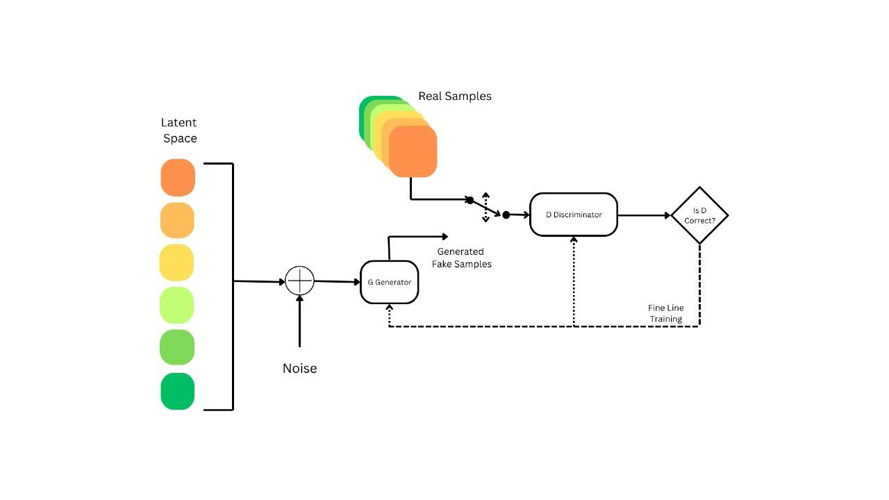

FIGURE 10. SCHEMATIC REPRESENTATION ILLUSTRATING ARCHITECTURE OF THE GENERATIVE ADVERSARIAL NETS (GANs)

6.2.2 Diffusion Models

While GANs have shown promise for generating synthetic data useful for training AI models, diffusion models are emerging as an alternative generation approach with some distinct advantages [41]. Diffusion models work by adding noise to real data over repeated iterations and learning these noise distributions to allow “denoising” back to realistic outputs. This offers greater control, interpretability, and the ability for conditional steering not found in GANs [40].

Diffusion-based augmentation with tight conditioning guardrails results in high-quality synthetic images, signals, and data that maintain the integrity and distributions of real documented examples from the factory floor [40]. This leads to safer and more effective adoption of AI for critical predictive maintenance tasks. As algorithms evolve, diffusion models are expected to become an essential data synthesis method within smart factories - significantly multiplying scarce real-world examples into abundant quality data for powering advanced predictive maintenance driven by AI.

6.3 Prognostic And Health Management (PHM)

PHM refers to techniques that enable predicting and preventing unexpected equipment failures through proactive condition monitoring and diagnostics. In manufacturing, PHM uses data from sensors on industrial machines as well as histories of operation and failure to ascertain equipment health and anticipate maintenance needs before breakdowns occur. This avoids costly downtime and prevents secondary damage from failures [2,4].

For example vibration sensors on motors or pumps connected to cloud analytics that identify increasing vibration thresholds indicating wearing bearings or introduction of friction - allowing for proactive repair or part replacement before failure.

6.3.1 REMAINING Useful Time (RUL)

RUL signifies the duration during which a system or component is expected to function before reaching a critical degradation level that requires maintenance or replacement. In manufacturing predictive maintenance, AI algorithms analyze all available data on usage, wear, and tear indicators, operating conditions, etc. to dynamically estimate component RUL at any given point [4, 16].

6.3.2 End Of Life (EOL)

EOL refers to when an equipment part or system reaches the end of its effective operational life based on its design parameters or usable lifespan considering found damage, fatigue and applied stress over time. In manufacturing, predictive analytics tracking degradation can forecast EOL and cue replacement ordering, migrations, etc. while the system is still functioning without issue. This buffers against end of runtime surprises [4, 16].

6.4 Anomaly Detection

Anomaly detection involves identifying data values that significantly deviate from typical behavior [2]. Anomalies can result from various factors, including errors in the acquisition system like sensor malfunction, low battery, or transmission errors. Additionally, anomalies may arise from malfunctions in industrial equipment or events such as changes in the production line or necessary stops [56]. While anomalies caused by machinery events contain pertinent information for analysis, those resulting from sensor errors do not provide relevant insights and may lead to data misinterpretation. These anomalies are often classified as noise; however, as discussed in [57], the differentiation between anomalies and noise varies depending on the type of data under analysis.

A key capability provided by AI is automated anomaly detection on the manufacturing floor [63, 65, 66]. Rather than relying solely on human monitoring and vigilance to spot equipment issues or product defects, anomaly detection algorithms leverage sensor streams, imaging, and other data to flag abnormalities. Computer vision techniques enable scrutinizing video feeds of production lines for shape, color, or finish flaws invisible to the human eye. The vision systems automatically recognize and report aberrations as they occur to speed remediation. AI introspection spots inconsistencies in quality control test results indicating potential instrumentation drifts.

6.5 Maintenance Strategy Optimization

The integration of AI in maintenance strategy optimization introduces real-time monitoring capabilities that continuously assess the health and performance of manufacturing assets. Sensors and IoT devices feed a constant stream of data into AI algorithms, allowing for the detection of anomalies and subtle patterns indicative of potential issues. In response to these insights, AI systems can dynamically adjust maintenance schedules, allocating resources where they are most urgently required. This adaptive approach not only maximizes operational uptime but also enhances overall system reliability [43].

AI-driven maintenance strategy optimization goes beyond mere prediction by incorporating advanced decision-making capabilities. AI models analyze vast datasets to identify optimal maintenance strategies based on factors such as equipment condition, historical performance, and production demands. This data-driven decision-making process ensures that resources are allocated efficiently, reducing unnecessary maintenance costs while maintaining the integrity of critical assets. As a result, manufacturers can achieve a delicate balance between minimizing expenses and maximizing the reliability of their production infrastructure [4, 5].

7. Limitations And Challenges

This section examines the limitations and challenges by presenting a balanced view, this section contributes to a comprehensive understanding of the multifaceted implications of integrating AI into manufacturing, highlighting the need for strategic considerations and careful implementation to navigate both the advantages and obstacles in this transformative journey.

* Synthetic Dataset: Creating realistic synthetic datasets for training AI models in manufacturing is challenging, requiring accurate representation of real-world processes.
* Complex Systems Prediction: Shifting from predicting individual components to behaviors in complex manufacturing systems demands AI models to adapt and account for multifaceted interactions, demanding advanced modeling techniques and increased computational resources.
* High-End Computation: AI implementation in manufacturing, especially for large-scale data analytics, requires significant computational power, adding complexity and cost.
* Non-Realtime Prediction: Achieving real-time prediction in manufacturing is hindered by complexities and rapid dynamics, impacting immediate responsiveness.
* Data Heterogeneity Issues: Effective AI model training depends on diverse datasets; challenges arise when data lacks diversity or is unbalanced, potentially leading to biased models.
* Noisy Data in Manufacturing: Noisy data, with inaccuracies or outliers, is common in manufacturing environments, posing a challenge for AI algorithms and requiring robust preprocessing techniques.

8. Opportunities And Future Scope

As AI technologies advance, manufacturing processes can gain efficiency, predictive maintenance, and optimized resource allocation. The synergy of AI and data analytics has the potential to revolutionize production workflows, enabling real-time decision-making and adaptive manufacturing systems. This section emphasizes the transformative impact of AI on manufacturing, exploring myriad possibilities for innovation and growth in a new era driven by intelligent technologies.

* Collaborative Dataset Efforts: Enhancing the effectiveness of PdM relies on extensive datasets, but data collection can be challenging. Collaborative efforts within the PdM community to gather and share large-scale datasets are crucial for overcoming this obstacle.
* Optimization of Maintenance Strategies: While current research focuses on fault diagnosis and prognosis, there is a need to optimize maintenance strategies. Efficient planning of maintenance activities using AI can lead to automation, cost reduction, and minimized downtime.
* Addressing Class Imbalance: In production systems, class imbalance due to infrequent failure events poses a challenge. Addressing this issue in data collection is essential for robust AI-based PdM models.
* Digital Twin Integration: Utilizing constantly refreshed digital twins provides valuable run-to-failure data for crucial components, enhancing fault detection and prediction capabilities in PdM.
* Reinforcement Learning for Proactive Maintenance: Applying reinforcement learning for proactive and cost-effective PdM in manufacturing allows systems to learn optimal maintenance strategies through experiential learning, adapting in real-time to changing equipment health and operating contexts.
* Multi-component System Challenges: With the increasing complexity of manufacturing systems involving numerous components, existing AI approaches often focus on individual components. Developing proficient AI-based PdM algorithms for multi-component systems remains a significant unresolved concern, presenting opportunities for future research.

9. Concluding Remarks

This chapter has delved into the immense possibilities that AI presents for revolutionizing the manufacturing sector. Through applications such as predictive maintenance, process enhancement, and quality assurance, AI has the capability to significantly reshape the industry and its operations. When thoughtfully implemented, these technologies can provide invaluable insights from data to enhance decision-making, asset utilization, and sustainability. However, successfully leveraging AI in manufacturing will require interdisciplinary collaboration. Domain experts must partner with data scientists and ML engineers to properly frame business challenges, curate quality datasets, and iteratively refine AI solutions. While AI adoption in manufacturing remains in the early stages, rapid advances in enabling technologies are unfolding. By combining strengths in applications, algorithms, and infrastructure, manufacturers can traverse the AI maturity curve in manageable steps.

References

[1] Shin, Won, Jeongyun Han, and Wonjong Rhee. "AI-assistance for predictive maintenance of renewable energy systems." *Energy* 221 (2021): 119775.

[2] Nunes, P., J. Santos, and E. Rocha. "Challenges in predictive maintenance–A review." CIRP Journal of Manufacturing Science and Technology 40 (2023): 53-67.

[3] De Luca, Roberto, et al. "A deep attention based approach for predictive maintenance applications in IoT scenarios." Journal of Manufacturing Technology Management 34.4 (2023): 535-556.

[4] Ran, Yongyi, et al. "A survey of predictive maintenance: Systems, purposes and approaches." arXiv preprint arXiv:1912.07383 (2019).

[5] Klein, Patrick, and Ralph Bergmann. "Generation of Complex Data for AI-based Predictive Maintenance Research with a Physical Factory Model." ICINCO (1). 2019.

[6] Chomklin, Amonpan, Saichon Jaiyen, and Niwan Wattanakitrungroj. "A Survey of AI Techniques based on Predictive Maintenance in Lean Manufacturing." *Science, Technology, and Social Sciences Procedia* 2023.4 (2023): CiM03-CiM03.

[7] Zhang, Guozhen, Xiangang Cao, and Mengyuan Zhang. "A Knowledge Graph System for the Maintenance of Coal Mine Equipment." Mathematical Problems in Engineering 2021 (2021): 1-13.

[8] Singh, R. Raja, et al. "Building a digital twin powered intelligent predictive maintenance system for industrial AC machines." Machines 11.8 (2023): 796.

[9] Nasser, Ahmed, and Huthaifa Al-Khazraji. "A hybrid of convolutional neural network and long short-term memory network approach to predictive maintenance." Int. J. Electr. Comput. Eng.(IJECE) 12.1 (2022): 721-730.

[10] Pandey, Rick, et al. "Towards Deploying DNN Models on Edge for Predictive Maintenance Applications." *Electronics* 12.3 (2023): 639.

[11] Lou, Ping, et al. "Knowledge Graph Construction Based on a Joint Model for Equipment Maintenance." *Mathematics* 11.17 (2023): 3748.

[12] Arena, Fabio, et al. "Predictive maintenance in the automotive sector: A literature review." Mathematical and Computational Applications 27.1 (2021): 2.

[13] Siraskar, Rajesh, et al. "Reinforcement learning for predictive maintenance: a systematic technical review." Artificial Intelligence Review (2023): 1-63.

[14] Mohamed Almazrouei, Salama, et al. "A review on the advancements and challenges of artificial intelligence based models for predictive maintenance of water injection pumps in the oil and gas industry." SN Applied Sciences 5.12 (2023): 391.

[15] Çınar, Zeki Murat, et al. "Machine learning in predictive maintenance towards sustainable smart manufacturing in industry 4.0." Sustainability 12.19 (2020): 8211.

[16] Stanton, Izaak, et al. "Predictive maintenance analytics and implementation for aircraft: Challenges and opportunities." Systems Engineering 26.2 (2023): 216-237.

[17] Luo, Weichao, et al. "A hybrid predictive maintenance approach for CNC machine tool driven by Digital Twin." Robotics and Computer-Integrated Manufacturing 65 (2020): 101974.

[18] Hansen, E.B. and Bøgh, S. (2021), “Artificial intelligence and internet of things in small and medium-

sized enterprises: a survey”, Journal of Manufacturing Systems, Vol. 58, pp. 362-372.

[19] Zhang, W., Yang, D. and Wang, H. (2019), “Data-driven methods for predictive maintenance of

industrial equipment: a survey”, IEEE Systems Journal, Vol. 13 No. 3, pp. 2213-2227.

[20] O. Etzioni, M. Banko, S. Soderland, and D. S. Weld, “Open information extraction from the web,” Communications of the ACM, vol. 51, no. 12, pp. 68–74, 2008.

[21] X. Han, Research on Key Issues of Intelligent Mine Information Standardization System, China University of Mining and Technology, Beijing, China, 2016.

[23] Ellefsen, André Listou, et al. “Remaining Useful Life Predictions for Turbofan Engine Degradation Using Semi-supervised Deep Architecture.” Reliability Engineering & System Safety, vol. 240–251, 1 Mar. 2019, https://doi.org/10.1016/j.ress.2018.11.027.

[24] Vaswani, Ashish, et al. "Attention is all you need." Advances in neural information processing systems 30 (2017).

[25] Wen, Jin, Yu., Yuehua, Liu., Tharam, S., Dillon., Wenny, Rahayu. "Edge Computing-Assisted IoT Framework With an Autoencoder for Fault Detection in Manufacturing Predictive Maintenance." IEEE Transactions on Industrial Informatics, undefined (2023). doi: 10.1109/TII.2022.3178732

[26] Premkumar, Murugiah., Akila, Muthuramalingam., S., Anandamurugan. "A design of predictive manufacturing system in IoT‐assisted Industry 4.0 using heuristic‐derived deep learning." International Journal of Communication Systems, undefined (2023). doi: 10.1002/dac.5432

[27] Ponrudee, Netisopakul., Nawarat, Phumee. "AI-Enhanced Predictive Maintenance in Manufacturing Processes." undefined (2022). doi: 10.23919/ICCAS55662.2022.10003774

[28] Priscile, Suawa., M., Jongmanns. "Noise-Robust Machine Learning Models for Predictive Maintenance Applications." IEEE Sensors Journal, undefined (2023). doi: 10.1109/JSEN.2023.3273458

[29] Hassan, Dehghan, Shoorkand., Mustapha, Nourelfath., Adnène, Hajji. "A deep learning approach for integrated production planning and predictive maintenance." International Journal of Production Research, undefined (2023). doi: 10.1080/00207543.2022.2162618

[30] Chen, Chuang, et al. "A Predictive Maintenance Strategy Using Deep Learning Quantile Regression and Kernel Density Estimation for Failure Prediction." IEEE Transactions on Instrumentation and Measurement 72 (2023): 1-12.

[31] Mustafa, Ashique, Siddiqui., Gayan, Kahandawa., H.S., Hewawasam. "Artificial Intelligence Enabled Digital Twin For Predictive Maintenance in Industrial Automation System: A Novel Framework and Case Study." undefined (2023). doi: 10.1109/ICM54990.2023.10101971

[32] Dimitris, Mourtzis., John, D., Angelopoulos. "Robotic Cell Reliability Optimization Based on Digital Twin and Predictive Maintenance." Electronics, undefined (2023). doi: 10.3390/electronics12091999

[33] Esa, Mohd Adha Mat, and Masdi Muhammad. "Adoption of prescriptive analytics for naval vessels risk-based maintenance: A conceptual framework." Ocean Engineering 278 (2023): 114409.

[34] Bi, Zhuming, et al. "Internet of things (IoT) and big data analytics (BDA) for digital manufacturing (DM)." International Journal of Production Research 61.12 (2023): 4004-4021.

[35] Khan, Sohail Imran, et al. "Implementation of cloud based IoT technology in manufacturing industry for smart control of manufacturing process." International Journal on Interactive Design and Manufacturing (IJIDeM) (2023): 1-13.

[36] Rath, Kali Charan, Alex Khang, and Debanik Roy. "The Role of Internet of Things (IoT) Technology in Industry 4.0 Economy." Advanced IoT Technologies and Applications in the Industry 4.0 Digital Economy. CRC Press, 2024. 1-28.

[37] Juma, Mazen, Fuad Alattar, and Basim Touqan. 2023. "Securing Big Data Integrity for Industrial IoT in Smart Manufacturing Based on the Trusted Consortium Blockchain (TCB)" IoT 4, no. 1: 27-55. <https://doi.org/10.3390/iot4010002>

[38] Schmitt, Marc. "Big Data Analytics in the Metaverse: Business Value Creation with Artificial Intelligence and Data-Driven Decision Making." Available at SSRN 4385347 (2023).

[39] Li, Zewen, et al. "A survey of convolutional neural networks: analysis, applications, and prospects." IEEE transactions on neural networks and learning systems (2021).

[40] Wang, Huaqing, et al. "A bearing fault diagnosis method with an improved residual Unet diffusion model under extreme data imbalance." Measurement Science and Technology 35.4 (2024): 046113.

[41] Stypułkowski, Michał, et al. "Diffused heads: Diffusion models beat gans on talking-face generation." Proceedings of the IEEE/CVF Winter Conference on Applications of Computer Vision. 2024.

[42] Kiangala, Kahiomba Sonia, and Zenghui Wang. "An effective predictive maintenance framework for conveyor motors using dual time-series imaging and convolutional neural network in an industry 4.0 environment." Ieee Access 8 (2020): 121033-121049.

[43] Hesabi, Hadis, Mustapha Nourelfath, and Adnène Hajji. "A deep learning predictive model for selective maintenance optimization." Reliability Engineering & System Safety 219 (2022): 108191.

[44] Bevilacqua, Maurizio, and Marcello Braglia. "The analytic hierarchy process applied to maintenance strategy selection." Reliability Engineering & System Safety 70.1 (2000): 71-83.

[45] LeCun, Yann, Yoshua Bengio, and Geoffrey Hinton. "Deep learning." nature 521.7553 (2015): 436-444.

[46] LeCun, Yann, et al. "Handwritten digit recognition with a back-propagation network." Advances in neural information processing systems 2 (1989).

[47] Pan, Sinno Jialin, and Qiang Yang. "A survey on transfer learning." IEEE Transactions on knowledge and data engineering 22.10 (2009): 1345-1359.

[48] Liu, Zheng, Norbert Meyendorf, and Nezih Mrad. "The role of data fusion in predictive maintenance using digital twin." AIP conference proceedings. Vol. 1949. No. 1. AIP Publishing, 2018.

[49] Liu, Xiaolei, et al. "A hybrid method of remaining useful life prediction for aircraft auxiliary power unit." IEEE Sensors Journal 20.14 (2020): 7848-7858.

[50] Liao, Linxia, Wenjing Jin, and Radu Pavel. "Enhanced restricted Boltzmann machine with prognosability regularization for prognostics and health assessment." IEEE Transactions on Industrial Electronics 63.11 (2016): 7076-7083.

[51] Dangut, Maren David, Zakwan Skaf, and Ian K. Jennions. "An integrated machine learning model for aircraft components rare failure prognostics with log-based dataset." ISA transactions 113 (2021): 127-139.

[52] Doğru, Anil, et al. "Using convolutional neural networks to automate aircraft maintenance visual inspection." Aerospace 7.12 (2020): 171.

[53] Goodfellow, Ian, et al. "Generative adversarial nets." Advances in neural information processing systems 27 (2014).

[54] Lee, Yong Oh, Jun Jo, and Jongwoon Hwang. "Application of deep neural network and generative adversarial network to industrial maintenance: A case study of induction motor fault detection." 2017 IEEE international conference on big data (big data). IEEE, 2017.

[55] S. Akcay, A. Atapour-Abarghouei, and T. P. Breckon, “Ganomaly: Semi-supervised anomaly detection via adversarial training,” in Asian Conference on Computer Vision, pp. 622–637. Springer, 2018.

[56] Erhan, Laura, et al. "Smart anomaly detection in sensor systems: A multi-perspective review." Information Fusion 67 (2021): 64-79.

[57] Keogh, Eamonn, Jessica Lin, and Ada Fu. "Hot sax: Efficiently finding the most unusual time series subsequence." Fifth IEEE International Conference on Data Mining (ICDM'05). Ieee, 2005.

[58] Zhao, Bo, et al. "An area-context-based credibility detection for big data in IoT." *Mobile Information Systems* 2020 (2020): 1-12.

[59] Li, Zijue, Xiaoou Ding, and Hongzhi Wang. "An effective constraint-based anomaly detection approach on multivariate time series." Asia-Pacific Web (APWeb) and Web-Age Information Management (WAIM) Joint International Conference on Web and Big Data. Cham: Springer International Publishing, 2020.

[60] Catalan, Marisa, Bernat Gaston, and Marc Roig. "Ensembled Outlier Detection using Multi-Variable Correlation in WSN through Unsupervised Learning Techniques." 4th International Conference on Internet of Things, Big Data and Security. Scitepress, 2019.

[61] Yoo, YoungJun. "Data-driven fault detection process using correlation based clustering." Computers in Industry 122 (2020): 103279.

[62] Liu, Yuehua, et al. "Noise removal in the presence of significant anomalies for industrial IoT sensor data in manufacturing." IEEE Internet of Things Journal 7.8 (2020): 7084-7096.

[63] Ripley, Brian D. Pattern recognition and neural networks. Cambridge university press, 2007.

[64] Cauteruccio, Francesco, et al. "Short-long term anomaly detection in wireless sensor networks based on machine learning and multi-parameterized edit distance." Information Fusion 52 (2019): 13-30.

[65] Bezdek, James C., Robert Ehrlich, and William Full. "FCM: The fuzzy c-means clustering algorithm." *Computers & geosciences* 10.2-3 (1984): 191-203.

[66] Labrín, Caterina, and Francisco Urdinez. "Principal component analysis." R for Political Data Science. Chapman and Hall/CRC, 2020. 375-393.

[67] Alam, Kazi Masudul, and Abdulmotaleb El Saddik. "C2PS: A digital twin architecture reference model for the cloud-based cyber-physical systems." IEEE access 5 (2017): 2050-2062.

[68] Negri, Elisa, Luca Fumagalli, and Marco Macchi. "A review of the roles of digital twin in CPS-based production systems." Procedia manufacturing 11 (2017): 939-948.

[69] Tao, Fei, and Qinglin Qi. "Make more digital twins." Nature 573.7775 (2019): 490-491.