1. **Package Statement :** The first statement allowed in a java file is a package statement. This statement declares a package name and informs the compiler that the classes defined here belong to this package.

Example: package student;

1. **Import Statements :** The next thing after a package statement (but before any class definations) may be a number of import statements.

import student.test;

1. **Interface Statement :** An interface is like a class but includes a group of method declarations. This is also an optional section and is used only when one wish to implement the multiple inheritance feature in program, Since in java class can not have multiple inheritance
2. **Classes Definition** :A java program may contain multiple class definitions. Classes are the primary and essential element of a java program. These classes is used to map the objects of real-world problems, **In java the name if the class always start from capital Alphabet and the file in which it is present is stored by the name of the class only**
3. **Main Method Class :** Since every java standalone program requires a main method as its starting point, this class is the essential part of a java program, A simple java program may contain only this part. The main method creates object of various classes and establishes communications between them. On reaching end of main, the program terminates and the control passes back to the operating system

public static void main(String [] args) {

1. **Calling of an class :** Injava the class is called by first importing it if it is on the other package and than by first initializing it first in the place where we are using it and than we can access the methods of that class
2. 🡺Example of the initialization of the Rectangle class

Rectangle rect=new Rectangle();

1. 🡺Calling of method

rect.<method-name>;

1. 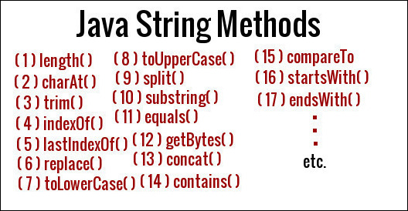
2. **Annotations** : Java annotations are metadata (data about data) for our program source code.They provide additional information about the program to the compiler but are not part of the program itself. These annotations do not affect the execution of the compiled program.

Annotations start with @. Its syntax is:

🡪There are many types of annotations like @Overide, Single element annotations, maker’s name annotations, multiple elment annotations, suppress warning annotations, and many more

Eaxmple: @override, @AnnotationName(element1 = "value1", element2 = "value2")

1. 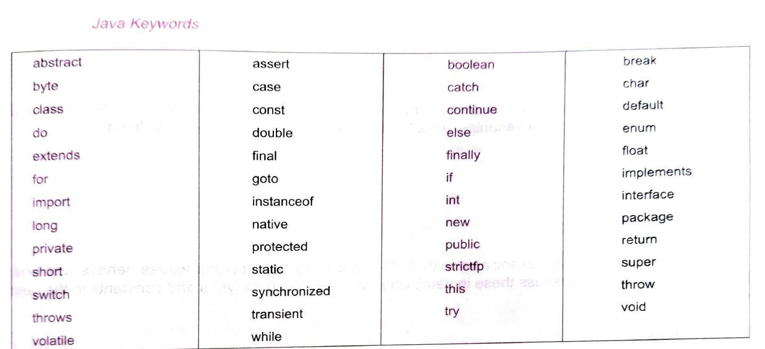
2. 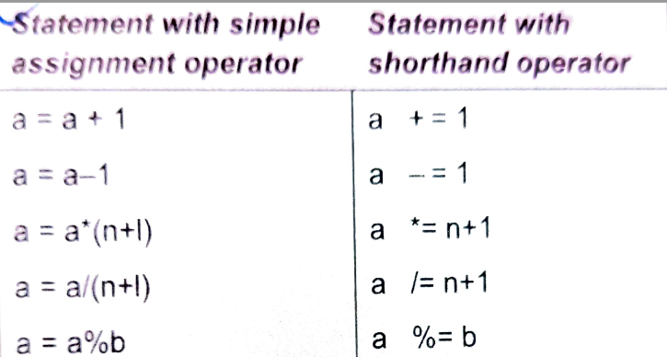
3. If we want to inherit only one class than use the extends and if we want to implement more than one class than use interface which will use the implements instead of the extends
4. String to the Integer by: int name=Integer.parseInt(<DataType-Name>);
5. Integer to String by : “”+<Int-Name> OR <Int-Name>.toString();
6. Character to String by : String name=Character.toString(s1);
7. For the length of the list we have size() method but for the length of the String we have length() method