**Streamlit**

1. Refer streamlite both the api doc and learner doc both are good one. In this tutorial i have followed them only.
2. First while starting i got the error with the setup of the vscode with my conda environment and for solving of it i have used the short cut **ctrl+shift+p**, And than i have gone to anaconda named folder and than i have setted my env by name of the base so that i have selected the thumbs up button on it and it started working.

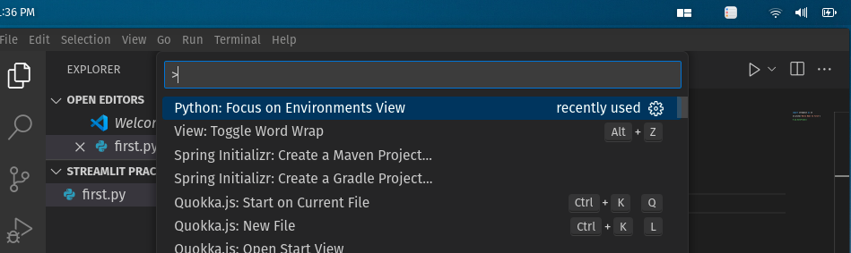

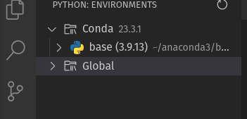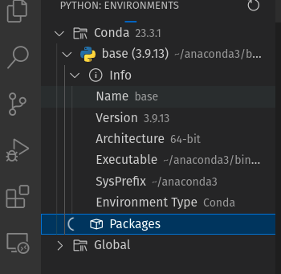

1. First code for checking if the streamlite is running or not is

**Streamlit hello**

1. Than i started with the basic code that is

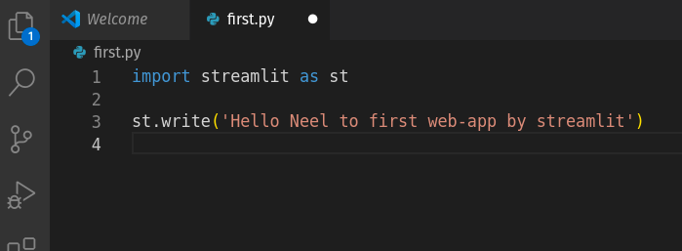

→ And than to run it we have used:

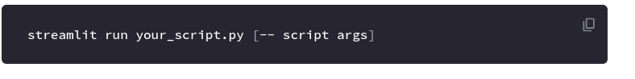

⇒ And the output was like:

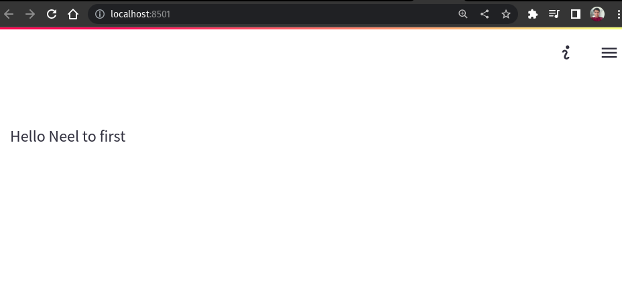

1. Now, For the further information refer the 30 days challenge the link of it is:

**https://30days-tmp.streamlit.app/?challenge**

1. I also created new conda environment by help of the



→ Note that i have created it by going on to the location of the folder where i want to create an environment, and also one can change the name of the env which here is the dashboard_env to any one as per their desire.

1. And by writing like the below statement it will create the environment with the libraries related to the python already installed



→ We can use this method for any of the language or any thing

1. While creating it will ask the things like below, Give y

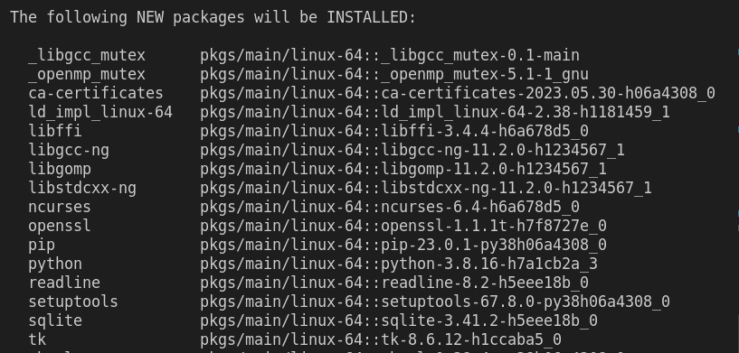

1. We can easily manage our env in the vscode by pressing ctrl+shift+p
2. Than to activate our environment we will use the:

Conda activate <env-name>

→And it will transfer current env to the dashboard env, As shown in the figure below:



1. Than we will install different things by help of the pip, One example is as shown below:



1. Streamlit has the great system to cache the data, So that it caches the data so that it does not loads data every time we do an refresh

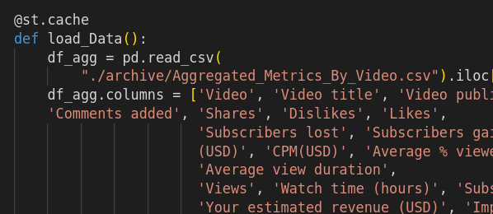

1. For making the columns and keeping the particular data in the particular columns

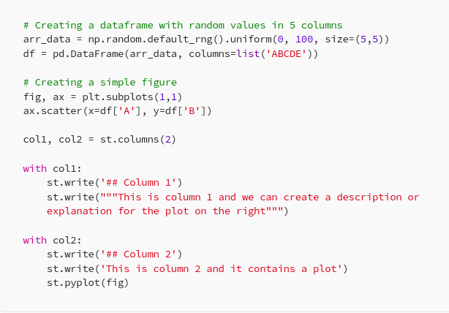

⇒ We can put the any data in the any particular columns as per our requirement.

1. Streamlit Component

⇒ Components are third-party modules that extend what’s possible with Streamlit. They couldn't be simpler to use, just a pip-install away.

## **What Streamlit components are available?**

There are several dozens of Streamlit components featured on Streamlit's website [[2](https://streamlit.io/components)].

Fanilo (a Streamlit Creator) curated an amazing list of Streamlit components on a wiki post [[3](https://discuss.streamlit.io/t/streamlit-components-community-tracker/4634)] that lists about 85 Streamlit components as of April 2022.

⇒ **How to use?**

Streamlit components are just a pip-install away?

→ For example we will use the streamlit pandas profiling

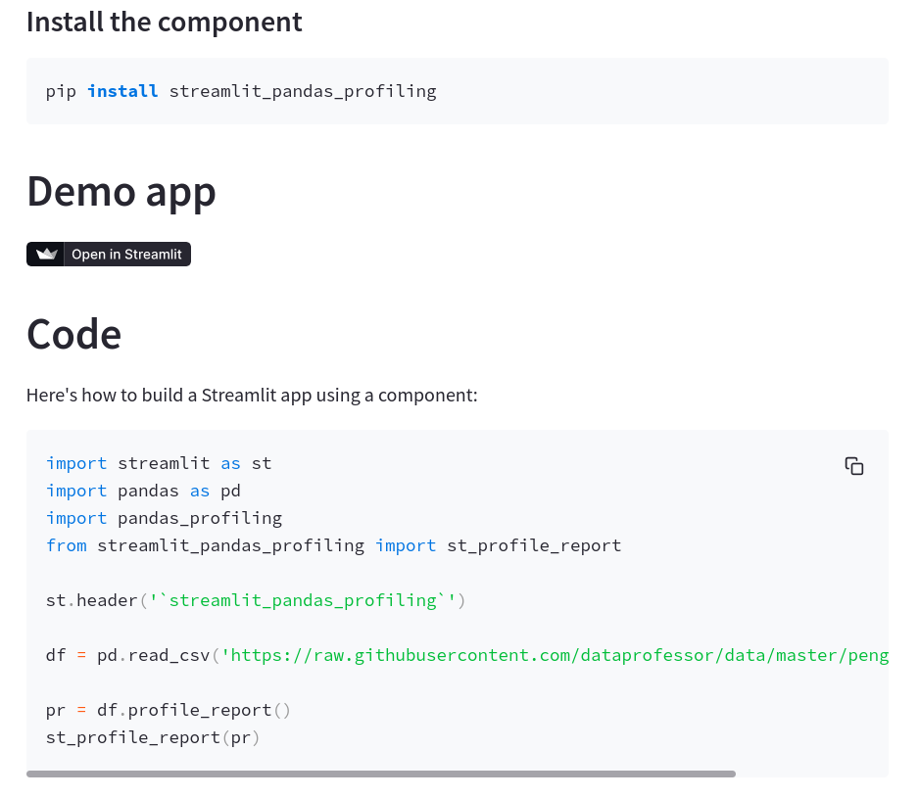

1. Now, Follow the 30 days of streamlit which is great, I have followed it and an repository on the github is also made of its practice
2. Link of course: https://30days-tmp.streamlit.app/?challenge
3. Link of github repo: https://github.com/NeelDevenShah/streamlit-practice