What Is Monotonicity?
→ Monotonicity is essential to build trust in decision models used in regulated industries such as lending. Here’s the connection: monotonicity helps ensure palatable (reasonable and acceptable) model behavior, an absolute requirement for gaining the confidence of lenders, customers and regulators in the machine learning models deployed in today’s financial decisioning environments.
→ In an analytic model, a monotonic relationship occurs when an input value is increased and the output value either only increases (positively constrained) or only decreases (negatively constrained), and vice versa. For example, if the ratio of payment to balance owed on a loan or credit card increases, we would expect that the credit risk score should improve (lower risk of default). Figure 1 shows a positively constrained monotonic relationship between these two variables.
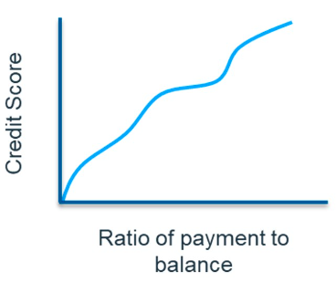

What Exactly Is Palatability?
→ When using decision models in industries like lending, banks often need to demonstrate their palatability (reasonable and acceptable behavior) to a regulator. Palatability, a fuzzy gray concept, can be difficult to achieve with machine learning models if the training algorithms are not constrained. To demonstrate palatability we need to first, as always, show that the internal learned model features are not biased. This requires an ability to demonstrate nonlinear relationships learned by the machine learning model. Second, we show that the model behavior is reasonable, given changes in the model inputs.
→ With “black box” machine learning models, demonstrating palatability becomes even more difficult. To address this challenge, many decision models historically utilize “white box” models such as scorecards, which are transparent. Specifically, scorecards demonstrate, in a straightforward and definitive manner, how each input variable is related to the final decision, and how monotonicity can be enforced in the design of the model features and associated weight of evidence as the feature values change.
→ However, despite these advantages of scorecards, their data scientist proponents are increasingly aware of the need to use more machine learning to drive higher decisioning performance. Thus, the rub: with traditional machine learning models it’s often impossible, other than by dumb luck, to have a fully monotonic model. To meet monotonicity requirements we need to apply constraints. It’s a critical step because, historically, a lack of decision transparency and palatability has impeded machine learning model adoption.

What is a Generative Model?
What does "generative" mean in the name "Generative Adversarial Network"? "Generative" describes a class of statistical models that contrasts with discriminative models.
Informally:
- Generative models can generate new data instances.
- Discriminative models discriminate between different kinds of data instances.
A generative model could generate new photos of animals that look like real animals, while a discriminative model could tell a dog from a cat. GANs are just one kind of generative model.
More formally, given a set of data instances X and a set of labels Y:
- Generative models capture the joint probability p(X, Y), or just p(X) if there are no labels.
- Discriminative models capture the conditional probability p(Y | X).
A generative model includes the distribution of the data itself, and tells you how likely a given example is. For example, models that predict the next word in a sequence are typically generative models (usually much simpler than GANs) because they can assign a probability to a sequence of words.
A discriminative model ignores the question of whether a given instance is likely, and just tells you how likely a label is to apply to the instance.
Note that this is a very general definition. There are many kinds of generative model. GANs are just one kind of generative model.

Generative Models Are Hard
Generative models tackle a more difficult task than analogous discriminative models. Generative models have to model more.
A generative model for images might capture correlations like "things that look like boats are probably going to appear near things that look like water" and "eyes are unlikely to appear on foreheads." These are very complicated distributions.
In contrast, a discriminative model might learn the difference between "sailboat" or "not sailboat" by just looking for a few tell-tale patterns. It could ignore many of the correlations that the generative model must get right.
Discriminative models try to draw boundaries in the data space, while generative models try to model how data is placed throughout the space. For example, the following diagram shows discriminative and generative models of handwritten digits:
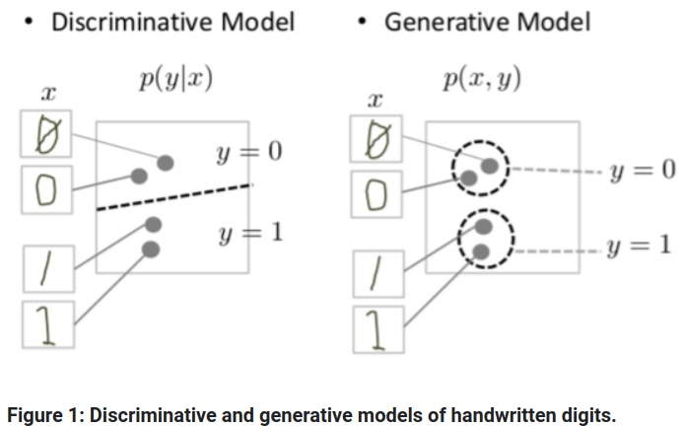

The discriminative model tries to tell the difference between handwritten 0's and 1's by drawing a line in the data space. If it gets the line right, it can distinguish 0's from 1's without ever having to model exactly where the instances are placed in the data space on either side of the line.
In contrast, the generative model tries to produce convincing 1's and 0's by generating digits that fall close to their real counterparts in the data space. It has to model the distribution throughout the data space.
GANs offer an effective way to train such rich models to resemble a real distribution. To understand how they work we'll need to understand the basic structure of a GAN.

Restricted Boltzmann Machine
Restricted Boltzmann Machine (RBM) is a type of artificial neural network that is used for unsupervised learning. It is a type of generative model that is capable of learning a probability distribution over a set of input data.

RBM was introduced in the mid-2000s by Hinton and Salakhutdinov as a way to address the problem of unsupervised learning. It is a type of neural network that consists of two layers of neurons – a visible layer and a hidden layer. The visible layer represents the input data, while the hidden layer represents a set of features that are learned by the network.
The RBM is called “restricted” because the connections between the neurons in the same layer are not allowed. In other words, each neuron in the visible layer is only connected to neurons in the hidden layer, and vice versa. This allows the RBM to learn a compressed representation of the input data by reducing the dimensionality of the input.
The RBM is trained using a process called contrastive divergence, which is a variant of the stochastic gradient descent algorithm. During training, the network adjusts the weights of the connections between the neurons in order to maximize the likelihood of the training data. Once the RBM is trained, it can be used to generate new samples from the learned probability distribution.
RBM has found applications in a wide range of fields, including computer vision, natural language processing, and speech recognition. It has also been used in combination with other neural network architectures, such as deep belief networks and deep neural networks, to improve their performance.
What are Boltzmann Machines?
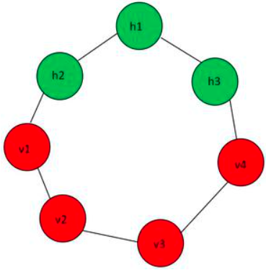
It is a network of neurons in which all the neurons are connected to each other. In this machine, there are two layers named visible layer or input layer and hidden layer. The visible layer is denoted as v and the hidden layer is denoted as the h. In Boltzmann machine, there is no output layer. Boltzmann machines are random and generative neural networks capable of learning internal representations and are able to represent and (given enough time) solve tough combinatoric problems.

What are Restricted Boltzmann Machines (RBM)?
A restricted term refers to that we are not allowed to connect the same type layer to each other. In other words, the two neurons of the input layer or hidden layer can’t connect to each other. Although the hidden layer and visible layer can be connected to each other.
As in this machine, there is no output layer so the question arises how we are going to identify, adjust the weights and how to measure the that our prediction is accurate or not. All the questions have one answer, that is Restricted Boltzmann Machine.
t has seen wide applications in different areas of supervised/unsupervised machine learning such as feature learning, dimensionality reduction, classification, collaborative filtering, and topic modeling.
Consider the example movie rating discussed in the recommender system section.
Movies like Avengers, Avatar, and Interstellar have strong associations with the latest fantasy and science fiction factor. Based on the user rating RBM will discover latent factors that can explain the activation of movie choices. In short, RBM describes variability among correlated variables of input dataset in terms of a potentially lower number of unobserved variables.
The energy function is given by
Applications of Restricted Boltzmann Machine

Restricted Boltzmann Machines (RBMs) have found numerous applications in various fields, some of which are:

Collaborative filtering: RBMs are widely used in collaborative filtering for recommender systems. They learn to predict user preferences based on their past behavior and recommend items that are likely to be of interest to the user.
- Image and video processing: RBMs can be used for image and video processing tasks such as object recognition, image denoising, and image reconstruction. They can also be used for tasks such as video segmentation and tracking.
- Natural language processing: RBMs can be used for natural language processing tasks such as language modeling, text classification, and sentiment analysis. They can also be used for tasks such as speech recognition and speech synthesis.
- Bioinformatics: RBMs have found applications in bioinformatics for tasks such as protein structure prediction, gene expression analysis, and drug discovery.
- Financial modeling: RBMs can be used for financial modeling tasks such as predicting stock prices, risk analysis, and portfolio optimization.
- Anomaly detection: RBMs can be used for anomaly detection tasks such as fraud detection in financial transactions, network intrusion detection, and medical diagnosis.
- It is used in Filtering.
- It is used in Feature Learning.
- It is used in Classification.
- It is used in Risk Detection.
- It is used in Business and Economic analysis.
How do Restricted Boltzmann Machines work?
In RBM there are two phases through which the entire RBM works:
1st Phase: In this phase, we take the input layer and using the concept of weights and biased we are going to activate the hidden layer. This process is said to be Feed Forward Pass. In Feed Forward Pass we are identifying the positive association and negative association.
Feed Forward Equation:
- Positive Association — When the association between the visible unit and the hidden unit is positive.
- Negative Association — When the association between the visible unit and the hidden unit is negative.
2nd Phase: As we don’t have any output layer. Instead of calculating the output layer, we are reconstructing the input layer through the activated hidden state. This process is said to be Feed Backward Pass. We are just backtracking the input layer through the activated hidden neurons. After performing this we have reconstructed Input through the activated hidden state. So, we can calculate the error and adjust weight in this way:
Feed Backward Equation:
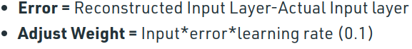

After doing all the steps we get the pattern that is responsible to activate the hidden neurons. To understand how it works:
Let us consider an example in which we have some assumption that V1 visible unit activates the h1 and h2 hidden unit and V2 visible unit activates the h2 and h3 hidden. Now when any new visible unit let V5 has come into the machine and it also activates the h1 and h2 unit. So, we can back trace the hidden units easily and also identify that the characteristics of the new V5 neuron is matching with that of V1. This is because V1 also activated the same hidden unit earlier.
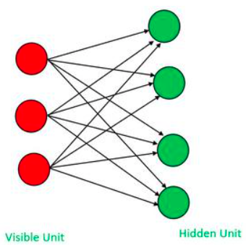

Types of RBM :
There are mainly two types of Restricted Boltzmann Machine (RBM) based on the types of variables they use:
- Binary RBM: In a binary RBM, the input and hidden units are binary variables. Binary RBMs are often used in modeling binary data such as images or text.
- Gaussian RBM: In a Gaussian RBM, the input and hidden units are continuous variables that follow a Gaussian distribution. Gaussian RBMs are often used in modeling continuous data such as audio signals or sensor data.
Apart from these two types, there are also variations of RBMs such as:
- Deep Belief Network (DBN): A DBN is a type of generative model that consists of multiple layers of RBMs. DBNs are often used in modeling high-dimensional data such as images or videos.
- Convolutional RBM (CRBM): A CRBM is a type of RBM that is designed specifically for processing images or other grid-like structures. In a CRBM, the connections between the input and hidden units are local and shared, which makes it possible to capture spatial relationships between the input units.
- Temporal RBM (TRBM): A TRBM is a type of RBM that is designed for processing temporal data such as time series or video frames. In a TRBM, the hidden units are connected across time steps, which allows the network to model temporal dependencies in the data.

What is Stride (Machine Learning)?
Stride is a component of convolutional neural networks, or neural networks tuned for the compression of images and video data. Stride is a parameter of the neural network's filter that modifies the amount of movement over the image or video. For example, if a neural network's stride is set to 1, the filter will move one pixel, or unit, at a time. The size of the filter affects the encoded output volume, so stride is often set to a whole integer, rather than a fraction or decimal.
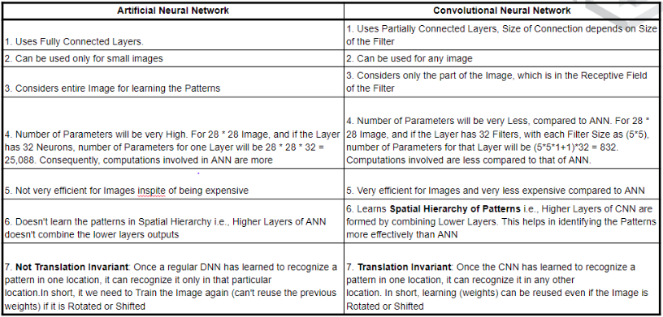
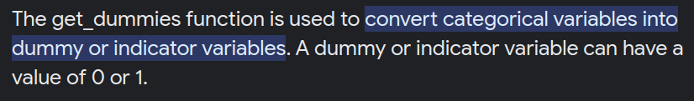
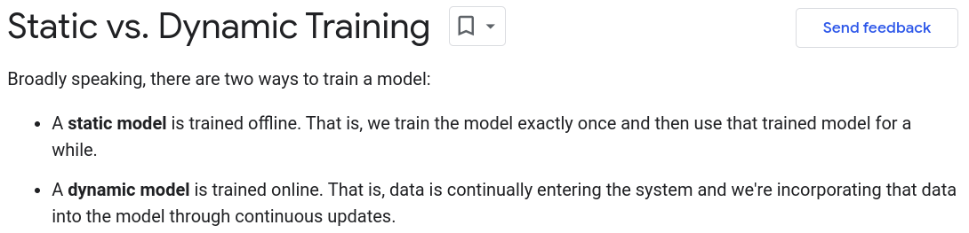
Stochastic Gradient Descent (SGD)
Stochastic Gradient Descent (SGD) is a simple yet very efficient approach to fitting linear classifiers and regressors under convex loss functions such as (linear) Support Vector Machines and Logistic Regression. Even though SGD has been around in the machine learning community for a long time, it has received a considerable amount of attention just recently in the context of large-scale learning.
SGD has been successfully applied to large-scale and sparse machine learning problems often encountered in text classification and natural language processing. Given that the data is sparse, the classifiers in this module easily scale to problems with more than 10^5 training examples and more than 10^5 features.
The advantages of Stochastic Gradient Descent are:
- Efficiency.
- Ease of implementation (lots of opportunities for code tuning).
The disadvantages of Stochastic Gradient Descent include:
- SGD requires a number of hyperparameters such as the regularization parameter and the number of iterations.
- SGD is sensitive to feature scaling.

Logistic Regression in Machine Learning
- Logistic regression predicts the output of a categorical dependent variable. Therefore the outcome must be a categorical or discrete value. It can be either Yes or No, 0 or 1, true or False, etc. but instead of giving the exact value as 0 and 1, it gives the probabilistic values which lie between 0 and 1.
- Logistic Regression is much similar to the Linear Regression except that how they are used. Linear Regression is used for solving Regression problems, whereas Logistic regression is used for solving the classification problems.
- In Logistic regression, instead of fitting a regression line, we fit an "S" shaped logistic function, which predicts two maximum values (0 or 1).

Type of Logistic Regression:
On the basis of the categories, Logistic Regression can be classified into three types:
- Binomial: In binomial Logistic regression, there can be only two possible types of the dependent variables, such as 0 or 1, Pass or Fail, etc.
- Multinomial: In multinomial Logistic regression, there can be 3 or more possible unordered types of the dependent variable, such as "cat", "dogs", or "sheep"
- Ordinal: In ordinal Logistic regression, there can be 3 or more possible ordered types of dependent variables, such as "low", "Medium", or "High".
TSVMSC (Transductive Support Vector Machine Algorithm)
For the question that transductive support vector machine algorithm (TSVM) is with a low classification precision and an unstable learning performance, in this paper, a transductive support vector machine algorithm based on spectral clustering (TSVMSC) is proposed.
Regularization Methods
In order to create less complex (parsimonious) model when you have a large number of features in your dataset, some of the Regularization techniques used to address over-fitting and feature selection are:
1. L1 Regularization
2. L2 Regularization
A regression model that uses L1 regularization technique is called Lasso Regression and model which uses L2 is called Ridge Regression.
The key difference between these two is the penalty term.
Ridge regression adds “squared magnitude” of coefficient as penalty term to the loss function. Here the highlighted part represents L2 regularization element.
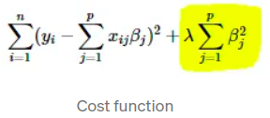

Here, if lambda is zero then you can imagine we get back OLS. However, if lambda is very large then it will add too much weight and it will lead to under-fitting. Having said that it’s important how lambda is chosen. This technique works very well to avoid over-fitting issue.
Lasso Regression (Least Absolute Shrinkage and Selection Operator) adds “absolute value of magnitude” of coefficient as penalty term to the loss function.
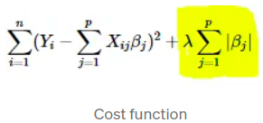

Again, if lambda is zero then we will get back OLS whereas very large value will make coefficients zero hence it will under-fit.
key difference between these techniques is that Lasso shrinks the less important feature’s coefficient to zero thus, removing some feature altogether. So, this works well for feature selection in case we have a huge number of features.
Traditional methods like cross-validation, stepwise regression to handle overfitting and perform feature selection work well with a small set of features but these techniques are a great alternative when we are dealing with a large set of features.

What is adversarial machine learning?
Adversarial machine learning is a technique used in machine learning to fool or misguide a model with malicious input. While adversarial machine learning can be used in a variety of applications, this technique is most commonly used to execute an attack or cause a malfunction in a machine learning system. The same instance of an attack can be changed easily to work on multiple models of different data sets or architectures.
Adversarial machine learning can be considered as either a white or black box attack. In a white box attack, the attacker knows the inner workings of the model being used and in a black box attack, the attacker only knows the outputs of the model.
Machine learning models are trained using large data sets pertaining to the subject being learned about. As an example, if an automotive company wanted to teach their automated car how to identify a stop sign, then that company may feed thousands of pictures of stop signs through a machine learning algorithm. A malicious attack such as adversarial machine learning could be employed against that machine learning algorithm, exploiting the algorithms input data (in this case images of stop signs) to misinterpret that data, causing the overall system to then misidentify stop signs when deployed in either practice or production.

Types of adversarial machine learning attacks
Adversarial machine learning attacks can be classified as either misclassification inputs or data poisoning. Misclassification inputs are the more common variant, where attackers hide malicious content in the filters of a machine learning algorithm. The goal of this attack is for the system to misclassify a specific data set. Backdoor Trojan attacks can be used to do this after a systems deployment.
Data poisoning is when an attacker attempts to modify the machine learning process by placing inaccurate data into a data set, making the outputs less accurate. The goal of this type of attack is to compromise the machine learning process and to minimize the algorithm’s usefulness.

Defenses against adversarial machine learning
Currently, there is not a concrete way for defending against adversarial machine learning; however, there are a few techniques which can help prevent an attack of this type from happening. Such techniques include adversarial training, defensive distillation.
Adversarial training is a process where examples adversarial instances are introduced to the model and labeled as threatening. This process can be useful in preventing further adversarial machine learning attacks from occurring, but require large amounts of maintenance.
Defensive distillation aims to make a machine learning algorithm more flexible by having one model predict the outputs of another model which was trained earlier. This approach can identify unknown threats. It is similar in thought to generative adversarial networks (GAN), which sets up two neural networks together to speed up machine learning processes -- in the idea that two machine learning models are used together.

ARIMA
ARIMA (“autoregressive integrated moving average”) models can be considered a special type of regression model.
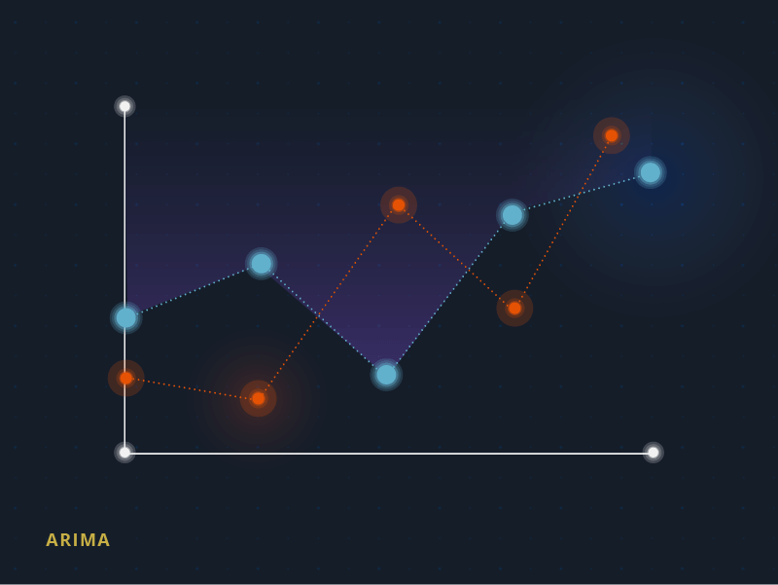
It allows you to explore time-dependent data points because it understands data points as a sequence, rather than as independent from one another. For this reason, ARIMA models are especially useful for conducting time-series analyses, for example, demand and price forecasting.

Agglomerative & divisive clustering
Agglomerative clustering is a method used for finding hierarchal relationships for data clusters.
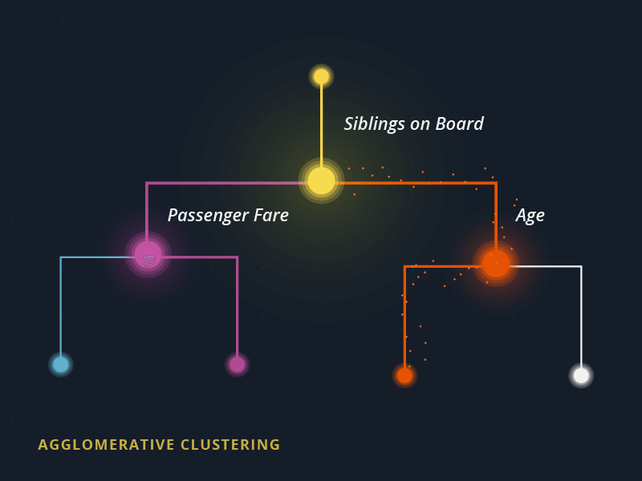
It uses a bottom-up approach, putting each individual data point into its own cluster, and then merging similar clusters together. By contrast, divisive clustering takes the opposite approach, and assumes all the data points are in the same cluster and then divides similar clusters from there.
A timely use case for these clustering algorithms is tracking viruses. By using DNA analysis, scientists are able to better understand mutation rates and transmission patterns.

Poisson Distribution Definition
The Poisson distribution is a discrete probability function that means the variable can only take specific values in a given list of numbers, probably infinite. A Poisson distribution measures how many times an event is likely to occur within “x” period of time. In other words, we can define it as the probability distribution that results from the Poisson experiment. A Poisson experiment is a statistical experiment that classifies the experiment into two categories, such as success or failure. Poisson distribution is a limiting process of the binomial distribution.
A Poisson random variable “x” defines the number of successes in the experiment. This distribution occurs when there are events that do not occur as the outcomes of a definite number of outcomes. Poisson distribution is used under certain conditions. They are:
- The number of trials “n” tends to infinity
- Probability of success “p” tends to zero
- np = 1 is finite

Poisson Distribution Formula
The formula for the Poisson distribution function is given by:
f(x) =(e– λ λx)/x!
Where,
e is the base of the logarithm
x is a Poisson random variable
λ is an average rate of value

Poisson Distribution Examples
An example to find the probability using the Poisson distribution is given below:
Example 1:
A random variable X has a Poisson distribution with parameter λ such that P (X = 1) = (0.2) P (X = 2). Find P (X = 0).
Solution:
For the Poisson distribution, the probability function is defined as:
P (X =x) = (e– λ λx)/x!, where λ is a parameter.
Given that, P (x = 1) = (0.2) P (X = 2)
(e– λ λ1)/1! = (0.2)(e– λ λ2)/2!
⇒λ = λ2/ 10
⇒λ = 10
Now, substitute λ = 10, in the formula, we get:
P (X =0 ) = (e– λ λ0)/0!
P (X =0) = e-10 = 0.0000454
Thus, P (X= 0) = 0.0000454
Example 2:
Telephone calls arrive at an exchange according to the Poisson process at a rate λ= 2/min. Calculate the probability that exactly two calls will be received during each of the first 5 minutes of the hour.
Solution:
Assume that “N” be the number of calls received during a 1 minute period.
Therefore,
P(N= 2) = (e-2. 22)/2!
P(N=2) = 2e-2.
Now, “M” be the number of minutes among 5 minutes considered, during which exactly 2 calls will be received. Thus “M” follows a binomial distribution with parameters n=5 and p= 2e-2.
P(M=5) = 32 x e-10
P(M =5) = 0.00145, where “e” is a constant, which is approximately equal to 2.718.

What is a Poisson distribution?
A Poisson distribution is defined as a discrete frequency distribution that gives the probability of the number of independent events that occur in the fixed time.

When do we use Poisson distribution?
Poisson distribution is used when the independent events occurring at a constant rate within the given interval of time are provided.

What is the difference between the Poisson distribution and normal distribution?
The major difference between the Poisson distribution and the normal distribution is that the Poisson distribution is discrete whereas the normal distribution is continuous. If the mean of the Poisson distribution becomes larger, then the Poisson distribution is similar to the normal distribution.

Multinomial Distribution
A multinomial experiment is almost identical with one main difference: a binomial experiment can have two outcomes, while a multinomial experiment can have multiple outcomes.
Example: You roll a die ten times to see what number you roll. There are 6 possibilities (1, 2, 3, 4, 5, 6), so this is a multinomial experiment. If you rolled the die ten times to see how many times you roll a three, that would be a binomial experiment (3 = success, 1, 2, 4, 5, 6 = failure).
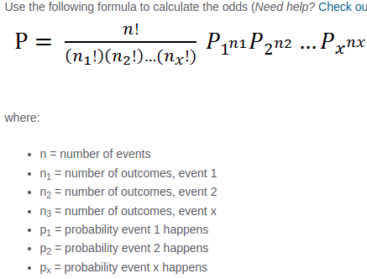

Gamma Function
Many probability distributions are defined by using the gamma function — such as Gamma distribution, Beta distribution, Dirichlet distribution, Chi-squared distribution, and Student’s t-distribution, etc.
For data scientists, machine learning engineers, researchers, the Gamma function is probably one of the most widely used functions because it is employed in many distributions. These distributions are then used for Bayesian inference, stochastic processes (such as queueing models), generative statistical models (such as Latent Dirichlet Allocation), and variational inference. Therefore, if you understand the Gamma function well, you will have a better understanding of a lot of applications in which it appears!
Why do we need the Gamma function?
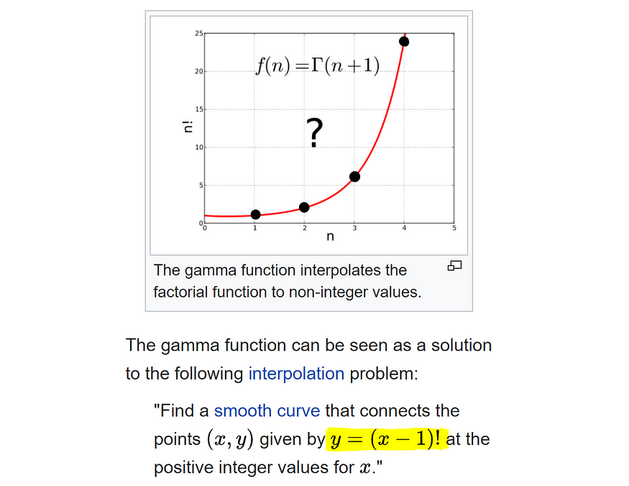
f(1) = 1, f(2) = 2!, f(3) = 3!, f(4) = 4!, … https://en.wikipedia.org/wiki/Gamma_function
The factorial function is defined only for discrete points (for positive integers — black dots in the graph above), but we wanted to connect the black dots. We want to extend the factorial function to all complex numbers. The simple formula for the factorial, x! = 1 * 2 * … * x, cannot be used directly for fractional values because it is only valid when x is a whole number.
So mathematicians had been searching for…
“What kind of functions will connect these dots smoothly and give us factorials of all real values?”
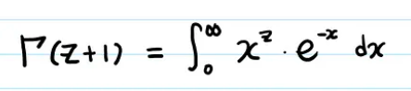

Gamma function is one commonly used extension of the factorial function to complex numbers. The gamma function is defined for all complex numbers except the non-positive integers.

Topic Modeling:
Topic modeling is a way of abstract modeling to discover the abstract ‘topics’ that occur in the collections of documents. The idea is that we will perform unsupervised classification on different documents, which find some natural groups in topics. We can answer the following question using topic modeling.
- What is the topic/main idea of the document?
- Given a document, can we find another document with a similar topic?
- How do topics field change over time?
Topic modeling can help in optimizing the search process. In this article, we will be discussing Latent Dirichlet Allocation, a topic modeling process.
Latent Dirichlet Allocation
Latent Dirichlet allocation is one of the most popular methods for performing topic modeling. Each document consists of various words and each topic can be associated with some words. The aim behind the LDA to find topics that the document belongs to, on the basis of words contains in it. It assumes that documents with similar topics will use a similar group of words. This enables the documents to map the probability distribution over latent topics and topics are probability distribution.

Setting up Generative Model:
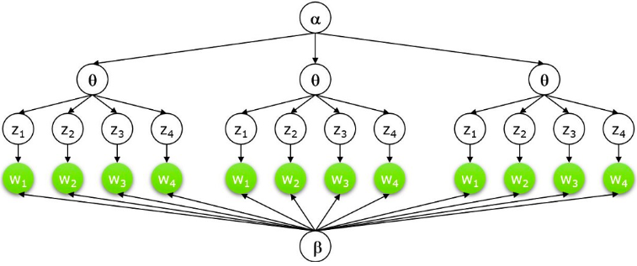
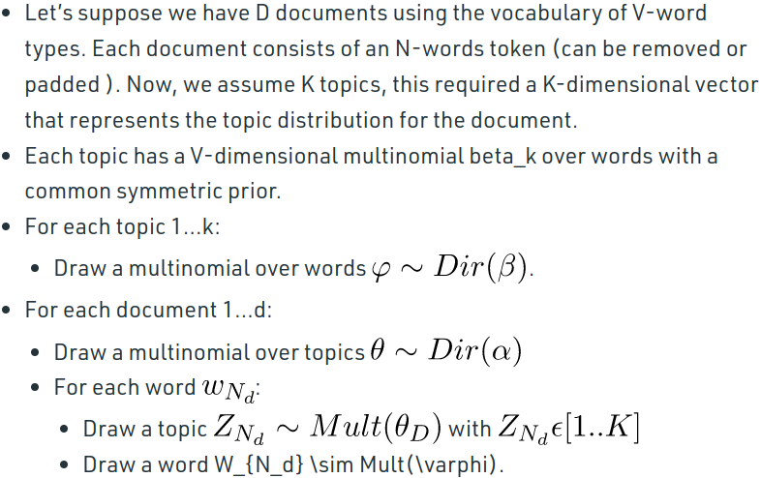
Dirichlet Distribution
- Dirichlet’s distribution can be defined as a probability density for a vector-valued input having the same characteristics as our multinomial parameter . It has non-zero values such that:
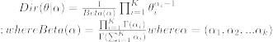
- The Dirichlet distribution is parameterized by the vector α, which has the same number of elements K as the multinomial parameter θ.
- We can interpret p(θ|α) as answering the question “what is the probability density associated with multinomial distribution θ, given that our Dirichlet distribution has parameter α?”.
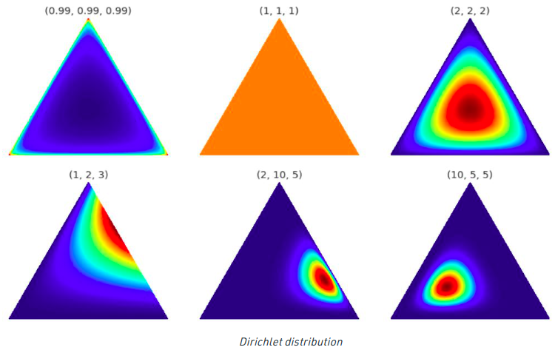
- Above is the visualization of the Dirichlet distribution, for our purpose, we can assume that corners/vertices represent the topics with words inside the triangle (the word is closer to the topic if it frequently relates with it. ) or vice-versa.
- This distribution can be extended to more than 3-dimensions. For 4-dimension we can use tetrahedron and for further dimension. We can use k-1 dimensions simplex.
Collaborative Filtering
To address some of the limitations of content-based filtering, collaborative filtering uses similarities between users and items simultaneously to provide recommendations. This allows for serendipitous recommendations; that is, collaborative filtering models can recommend an item to user A based on the interests of a similar user B. Furthermore, the embeddings can be learned automatically, without relying on hand-engineering of features.
→ Example a movie recommendation system.
Explicit Functions and Implicit functions
In machine learning, an explicit function is one that is defined explicitly by an equation or algorithm. For example, a linear regression model is an explicit function because it has a specific equation that describes the relationship between the input and output variables. On the other hand, an implicit function is one that is defined implicitly by data. For example, a neural network is an implicit function because it does not have a specific equation that describes the relationship between the input and output variables. Instead, it learns the relationship by training on a dataset.
Explicit functions are generally simpler and easier to understand, but they can be limited in their ability to model complex relationships. Implicit functions, on the other hand, can model complex relationships but they can be more difficult to understand and interpret.
In summary, explicit functions are defined by an equation while implicit functions are defined by the data. Explicit functions are simple but can't model complex relationships while Implicit functions can model complex relationships but are harder to understand and interpret.

Downsampling
After reading the name of this technique one intuitively gets an idea that it has got something to do with the downscaling of the image. Well True! The idea is right, we have to someone downscale the image for various reasons like:
- It makes the data of a more manageable size
- Reduces the dimensionality of the data thus enabling in faster processing of the data (image)
- Reducing the storage size of the data
There are also some other uses of this technique depending on the usage.
It is sometimes confused with image compression which is a different thing and serves a different use altogether. Here we are concerned with just the shrinking of the image. Well, what does that mean? That essentially means throwing away some of the (non-essential) information.
From this, we can draw a hint that we need to discard some of the rows and/or columns from the image. We need to give away some of the information.
There are many algorithms used in various techniques for downsampling, namely:
- Mipmap
- Box Sampling
- Sinc

Upsampling
Upsampling, on the other hand, is nothing but the inverse objective of that of downsampling: . This can be used in several cases like the one used in GANs (Generative Adversarial Network) where the intention is to construct an image out of random vector sample mimicking an image from the ground-truth or real distribution. There are many others like improving the quality of the image and so on. Let’s discuss this in more detail.
When downsampling, our intention was fairly simple and clear but with upsampling it is not that simple. We need to somehow increase the dimensions of the image and fill in the gaps (columns/rows). Suppose you want to upsample the original image by a factor of 3, this means, you need to add 2 more rows/columns for each row/column in the image using some logic. One way could be to just repeat each column/row in the original image.
A sensible approach to adding the new columns will be to interpolate the new data between the rows/columns which provide a reasonably accurate intermediate value using some advanced mathematical produces.
Examples of some of these algorithms are:
- Nearest Neighbour Interpolation
- Bilinear Interpolation
- Bicubic Spline Interpolation
- Generalized Bicubic Interpolation

A pixon is a generalized pixel and basic unit for image reconstruction.

