CHAROTAR UNIVERSITY OF SCIENCE & TECHNOLOGY
FACULTY OF TECHNOLOGY & ENGINEERING
DEVANG PATEL INSTITUE OF ADVANCE TECHNOLOGY AND RESEARCH

Subject: CE246: Database Management System
Semester: IV ID: 19DCE056 Academic Year: 2020-21
PRACTICAL - 1
AIM: Evaluation of Database (File System, DBMS, RDBMS, DDBMS)
THEORY:
- File System: File system is basically a way of arranging the files in a storage medium like hard disk. File system organizes the files and helps in retrieval of files when they are required. File systems consists of different files which are grouped into directories. The directories further contain other folders and files. File system performs basic operations like management, file naming, giving access rules etc.
Example:
NTFS (New Technology File System), EXT (Extended File System).
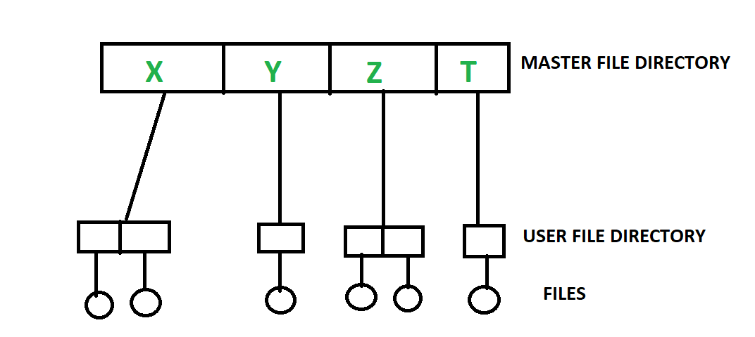

- DBMS (Database Management System): Database Management System is basically a software that manages the collection of related data. It is used for storing data and retrieving the data effectively when it is needed. It also provides proper security measures for protecting the data from unauthorized access. In Database Management System the data can be fetched by SQL queries and relational algebra. It also provides mechanisms for data recovery and data backup.
Example:
Oracle, MySQL, MS SQL server.
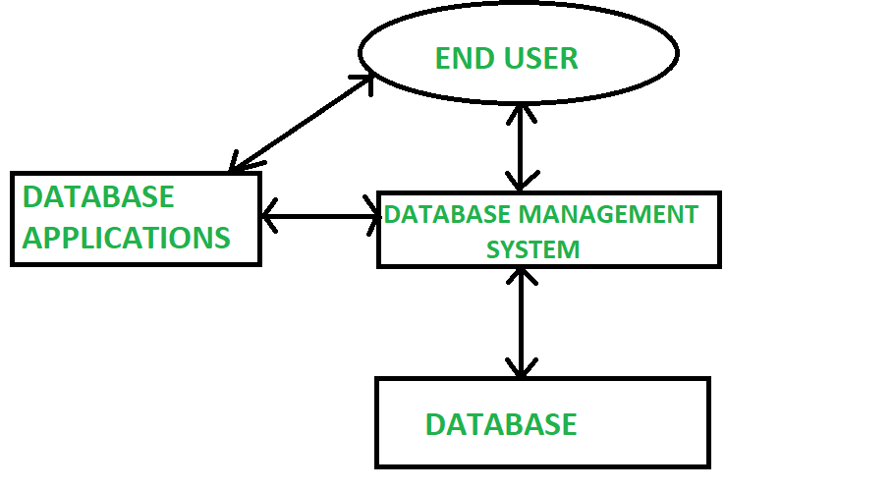

- RDBMS: RDBMS stands for Relational Database Management System and it implements SQL. In the real-world scenario, people use the Relational Database Management System to collect information and process it, to provide service. E.g., In a ticket processing system, details about us (e.g., age, gender) and our journey (e.g. source, destination), are collected, and the ticket is provided to us.
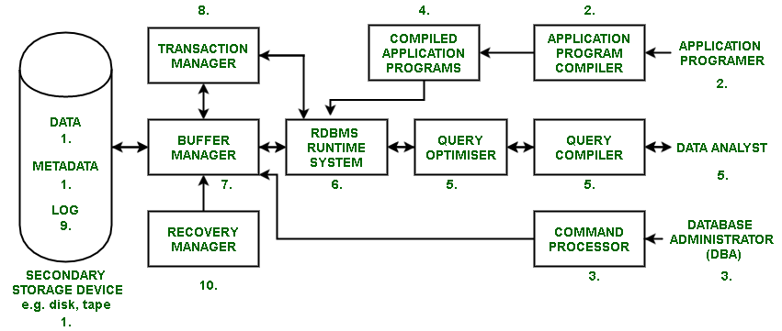
RDBMS Architecture:
- DDBMS:
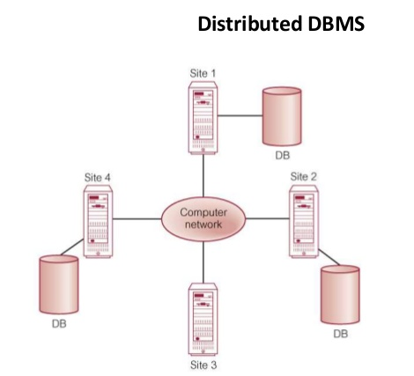
A distributed database is basically a database that is not limited to one system, it is spread over different sites, i.e., on multiple computers or over a network of computers. A distributed database system is located on various sited that don’t share physical components. This may be required when a particular database needs to be accessed by various users globally. It needs to be managed such that for the users it looks like one single database.
CONCLUSION: From this practical we learned about File System, DBMS, RDBMS, DDBMS.
REFERENCE:
- https://www.geeksforgeeks.org/difference-between-file-system-and-dbms/
- https://www.geeksforgeeks.org/rdbms-architecture/
- https://www.tutorialspoint.com/distributed_dbms/index.htm

PRACTICAL - 2
AIM: Introduction to Oracle (step by step installation, introduction of sql, plsql).
THEORY:
1) Download Oracle 10g from below link:
https://drive.google.com/file/d/1Y6ghDOEfVorTNrzWgF1UKaENHjeGgrHG/view
2) Install it by double clicking .exe which you have downloaded
3) Click on Next button
4) Accept license agreement and click on next button
5) Click on next button
6) Enter password and confirm password for SYS and SYSTEM user. Please remember
it because once installation will be over you have to enter it. To make it easy to
remember give password as: “oracle”
7) Click on install button
8) Click on finish button.
9) Enter username as SYS OR SYSTEM and enter your password (Entered in step: 6)
10) Click on Administration
11) Now click on “database user drop down button”. From that click on “create user”.
12) Enter your college roll no in username and give password (NEW) and confirm
password. Don’t check expire password, make account status unblocked if it is not.
Give all privileges to your user. Finally click on “create” button.
13) This page will be shown to you. Now click on “logout” button.
14) Click on login
15) Enter username and password that you just created and click on “login” button
16) Click on SQL
17) Click on SQL Commands
18) Congratulation!!! Now you are ready to code SQL and PLSQL.
Introduction to SQL: Structured Query Language (SQL) is a standard Database language which is used to create, maintain and retrieve the relational database.
Introduction to PL/SQL: PL/SQL is a block structured language that enables developers to combine the power of SQL with procedural statements. All the statements of a block are passed to oracle engine all at once which increases processing speed and decreases the traffic. PL/SQL stands for “Procedural language extensions to SQL.” PL/SQL is a database-oriented programming language that extends SQL with procedural capabilities. It was developed by Oracle Corporation within the early 90’s to boost the capabilities of SQL.
PL/SQL adds selective (i.e., if…then…else…) and iterative constructs (i.e., loops) to SQL. PL/SQL is most helpful to put in writing triggers and keep procedures. Stored procedures square measure units of procedural code keep during a compiled type inside the info.
CONCLUSION: From this practical we installed Oracle 10 g learned about sql and pl/sql.
REFERENCE:
- https://www.geeksforgeeks.org/structured-query-language/
- https://www.geeksforgeeks.org/plsql-introduction/

PRACTICAL – 3
AIM: To study DDL-create and DML-insert commands.
COMMANDS:
CREATE TABLE DEPOSIT(ACTNO VARCHAR2(5),CNAME VARCHAR2(18),BNAME VARCHAR2(18),AMOUNT NUMBER(8,2),ADATE DATE);
CREATE TABLE BRANCH(BNAME VARCHAR2(18),CITY VARCHAR2(18));
CREATE TABLE CUSTOMERS(CNAME VARCHAR2(18),CITY VARCHAR2(18));
CREATE TABLE BORROW(LOANNO VARCHAR2(5),CNAME VARCHAR2(18),BNAME VARCHAR2(18),AMOUNT NUMBER(8,2));
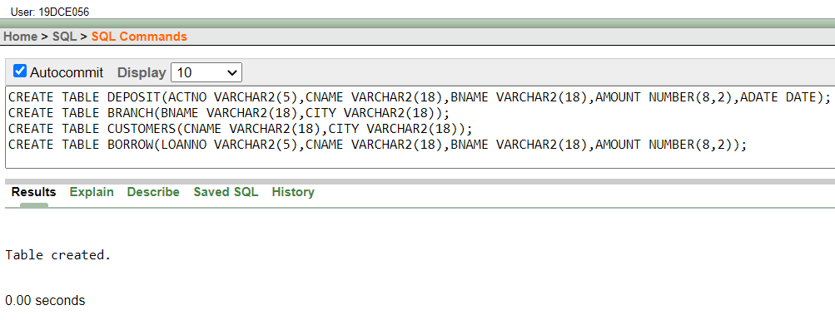
INSERT INTO DEPOSIT VALUES('100','ANIL','VRCE',1000.0,DATE '1995-03-01');
INSERT INTO DEPOSIT VALUES('101','SUNIL','AJNI',5000.0,DATE '1996-01-04');
INSERT INTO DEPOSIT VALUES('102','MEHUL','KAROLBAGH',3500.0,DATE '1995-11-17');
INSERT INTO DEPOSIT VALUES('104','MADHURI','CHANDI',1200.0,DATE '1995-12-17');
INSERT INTO DEPOSIT VALUES('105','PRAMOD','M.G.ROAD',3000.0,DATE '1996-03-27');
INSERT INTO DEPOSIT VALUES('106','SANDIP','ANDHERI',2000.0,DATE '1996-03-31');
INSERT INTO DEPOSIT VALUES('107','SHIVANI','VIRAR',1000.0,DATE '1995-09-05');
INSERT INTO DEPOSIT VALUES('108','KRANTI','NEHRU PLACE',5000.0,DATE '1995-07-02');
INSERT INTO DEPOSIT VALUES('109','MINU','POWAI',7000.0,DATE '1995-08-10');
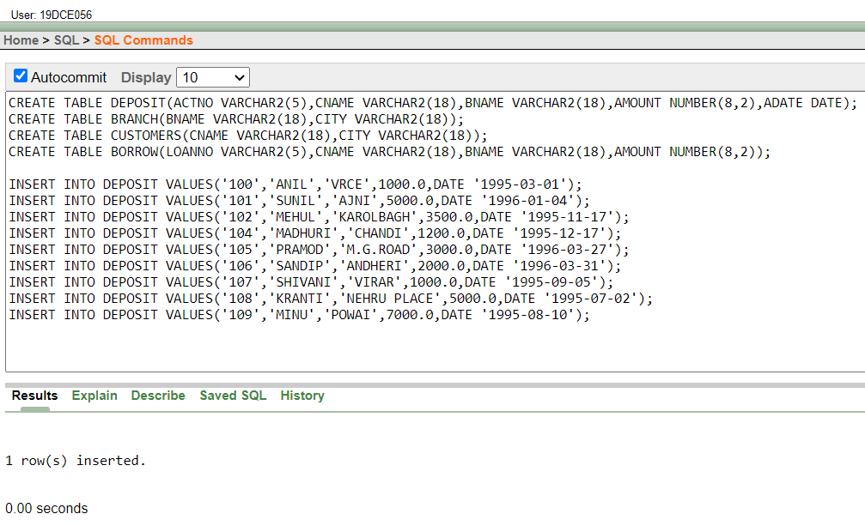
INSERT INTO BRANCH VALUES('VRCE','NAGPUR');
INSERT INTO BRANCH VALUES('AJNI','NAGPUR');
INSERT INTO BRANCH VALUES('KAROLBAGH','DELHI');
INSERT INTO BRANCH VALUES('CHANDI','DELHI');
INSERT INTO BRANCH VALUES('DHARAMPETH','NAGPUR');
INSERT INTO BRANCH VALUES('M.G.ROAD','BANGLORE');
INSERT INTO BRANCH VALUES('ANDHERI','BOMBAY');
INSERT INTO BRANCH VALUES('VIRAR','BOMBAY');
INSERT INTO BRANCH VALUES('NEHRU PLACE','BOMBAY');
INSERT INTO BRANCH VALUES('POWAI','BOMBAY');
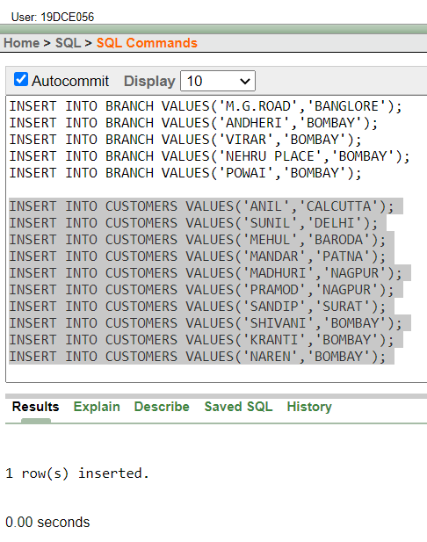
INSERT INTO CUSTOMERS VALUES('ANIL','CALCUTTA');
INSERT INTO CUSTOMERS VALUES('SUNIL','DELHI');
INSERT INTO CUSTOMERS VALUES('MEHUL','BARODA');
INSERT INTO CUSTOMERS VALUES('MANDAR','PATNA');
INSERT INTO CUSTOMERS VALUES('MADHURI','NAGPUR');
INSERT INTO CUSTOMERS VALUES('PRAMOD','NAGPUR');
INSERT INTO CUSTOMERS VALUES('SANDIP','SURAT');
INSERT INTO CUSTOMERS VALUES('SHIVANI','BOMBAY');
INSERT INTO CUSTOMERS VALUES('KRANTI','BOMBAY');
INSERT INTO CUSTOMERS VALUES('NAREN','BOMBAY');
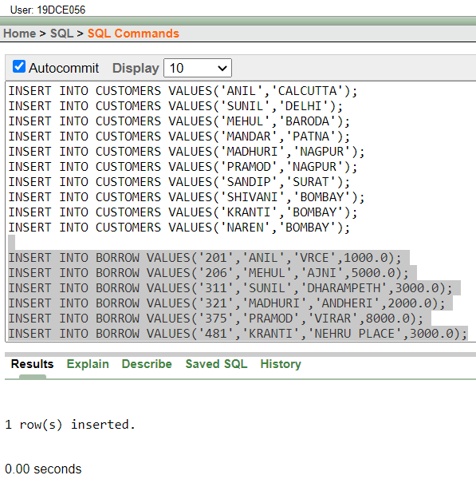

INSERT INTO BORROW VALUES('201','ANIL','VRCE',1000.0);
INSERT INTO BORROW VALUES('206','MEHUL','AJNI',5000.0);
INSERT INTO BORROW VALUES('311','SUNIL','DHARAMPETH',3000.0);
INSERT INTO BORROW VALUES('321','MADHURI','ANDHERI',2000.0);
INSERT INTO BORROW VALUES('375','PRAMOD','VIRAR',8000.0);
INSERT INTO BORROW VALUES('481','KRANTI','NEHRU PLACE',3000.0);
DESC DEPOSIT;
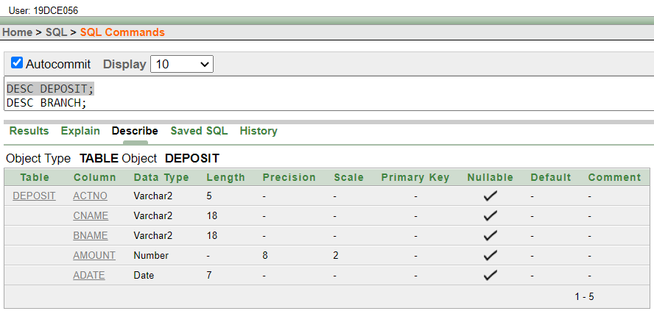
DESC BRANCH;
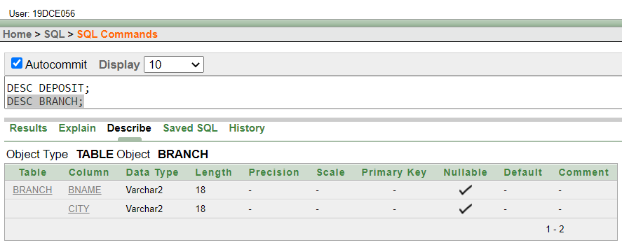
DESC CUSTOMERS;
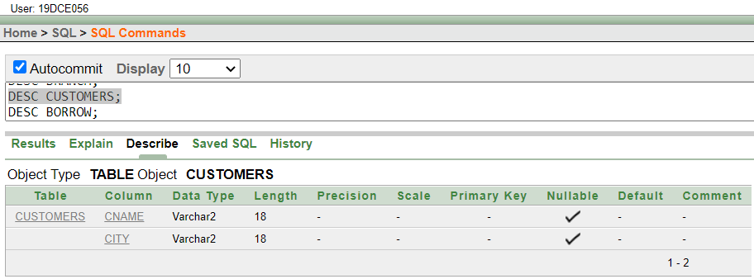
DESC BORROW;
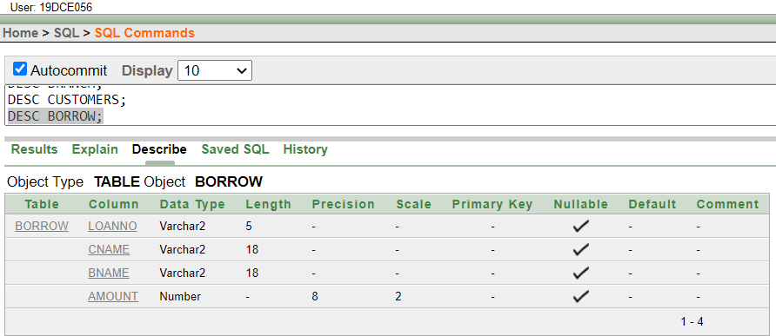
SELECT * FROM DEPOSIT;
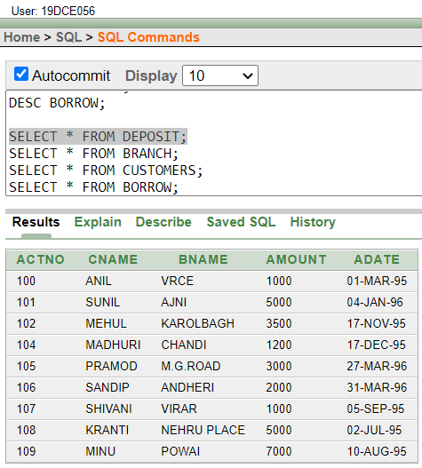
SELECT * FROM BRANCH;
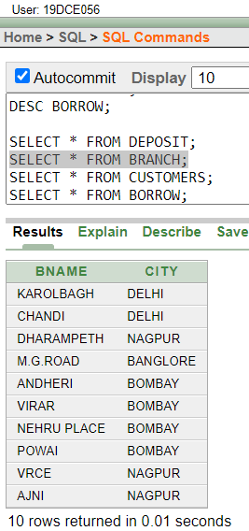
SELECT * FROM CUSTOMERS;
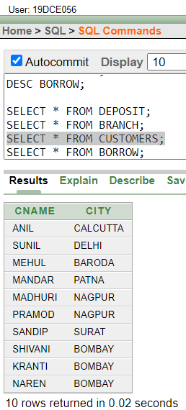
SELECT * FROM BORROW;
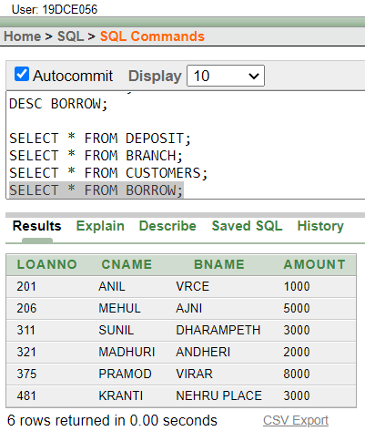
SELECT ACTNO,AMOUNT FROM DEPOSIT;
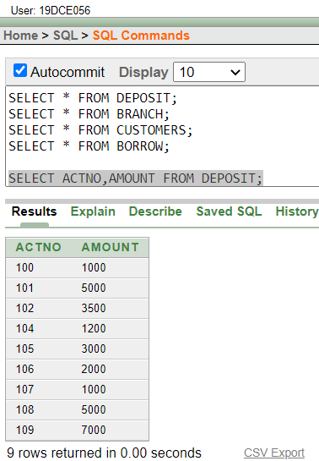
SELECT * FROM DEPOSIT WHERE AMOUNT>4000;
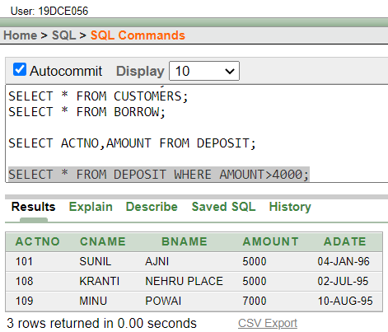
SELECT CNAME FROM DEPOSIT WHERE ADATE>DATE '1996-12-01';
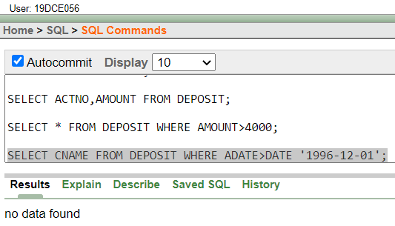
SELECT CITY FROM BRANCH WHERE BNAME='KAROLBAGH';
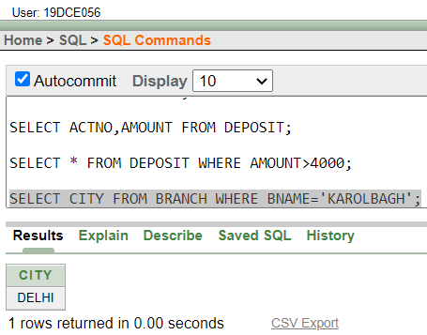
SELECT ACTNO,AMOUNT FROM DEPOSIT WHERE ADATE BETWEEN DATE '1996-12-01' AND DATE '1996-06-01';
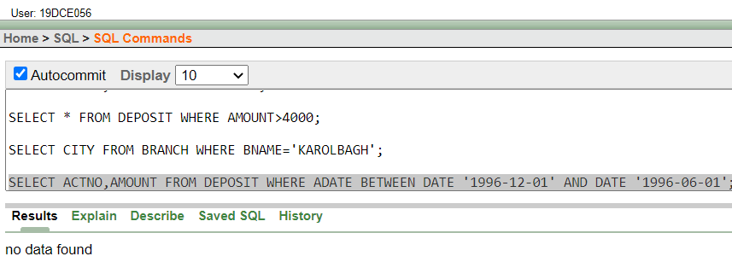
SELECT CNAME FROM DEPOSIT WHERE BNAME='VRCE';
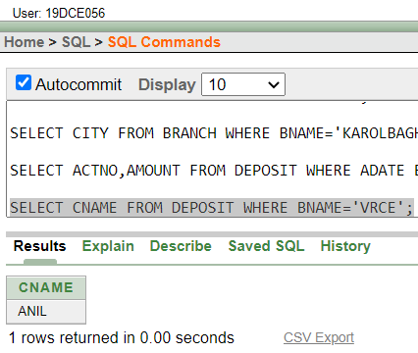
CONCLUSION: From this practical, we understood DDL commands and basic DML commands.

PRACTICAL – 4
AIM: Create the below given table and insert the data accordingly. Perform following queries and study various options of LIKE predicate
COMMANDS:
CREATE TABLE JOB(JOB_ID VARCHAR2(15), JOB_TITLE VARCHAR2(20), MIN_SAL NUMBER(7,2), MAX_SAL NUMBER(7,2));
CREATE TABLE EMPLOYEE(EMP_NO NUMBER(3), EMP_NAME VARCHAR2(30), EMP_SAL NUMBER(8,2), EMP_COM NUMBER(6,1), DEPT_NO NUMBER(3), L_NAME VARCHAR2(30), DEPT_NAME VARCHAR2(30), JOB_ID VARCHAR2(15),LOCATION VARCHAR2(15),MANAGER_ID NUMBER,(5)HIREDATE DATE);
INSERT INTO EMPLOYEE(EMP_NO, EMP_NAME, EMP_SAL, DEPT_NO, L_NAME, DEPT_NAME, JOB_ID, LOCATION, MANAGER_ID, HIREDATE) VALUES(101, 'SMITH', 800, 20, 'SHAH', 'MACHINE LEARNING', 'FI_MGR', 'TORONTO', 105, '9-AUG-96')
INSERT ALL
INTO EMPLOYEE(EMP_NO, EMP_NAME, EMP_SAL, EMP_COM, DEPT_NO, L_NAME, DEPT_NAME, JOB_ID, LOCATION, HIREDATE) VALUES(102, 'SNEHAL', 1600, 300, 25, 'GUPTA', 'DATA SCIENCE', 'LEC', 'LAS VEGAS', '14-MAR-96')
INTO EMPLOYEE VALUES(103, 'ADAMA', 1100, 0, 20, 'WALES', 'MACHINE LEARNING', 'MK_MGR', 'ONTARIO', 105, '30-NOV-95')
INTO EMPLOYEE(EMP_NO, EMP_NAME, EMP_SAL, DEPT_NO, L_NAME, DEPT_NAME, JOB_ID, LOCATION, MANAGER_ID, HIREDATE) VALUES(104, 'AMAN', 3000, 15, 'SHARMA', 'VIRUAL REALITY', 'COMP_OP', 'MEXICO', 12, '2-NOV-97')
INTO EMPLOYEE VALUES(105, 'ANITA', 5000, 50000, 10, 'PATEL', 'BIG DATA ANALYTICS', 'COMP_OP', 'GERMANY', 107, '01-JAN-98')
INTO EMPLOYEE VALUES(106, 'SNEHA', 2450, 24500, 10, 'JOSEPH', 'BIG DATA ANALYTICS', 'FI_ACC', 'MELBOURNE', 105, '26-sep-97')
INTO EMPLOYEE(EMP_NO, EMP_NAME, EMP_SAL, DEPT_NO, L_NAME, DEPT_NAME, JOB_ID, LOCATION, HIREDATE) VALUES(107, 'ANAMIKA', 2975, 30, 'JHA', 'ARTIFICIAL INTELLEGENCE', 'IT_PROG', 'NEW YORK', '15-JUL-97')
SELECT * FROM DUAL;
INSERT INTO JOB(JOB_ID, JOB_TITLE, MIN_SAL, MAX_SAL) VALUES('IT_PROG', 'Programmer', 4000, 10000)
INSERT ALL
INTO JOB VALUES('MK_MGR', 'Marketing Manager', 9000, 15000)
INTO JOB VALUES('FI_MGR', 'Finance Manager', 8200, 12000)
INTO JOB VALUES('FI_ACC', 'Account', 4200, 9000)
INTO JOB VALUES('LEC', 'Lecturer', 6000, 17000)
INTO JOB VALUES('COMP_OP', 'Computer Operator', 1500, 3000)
SELECT * FROM DUAL;
CREATE TABLE DEPOSIT1(A_NO VARCHAR2(5), CNAME VARCHAR2(15), BNAME VARCHAR2(10),AMOUNT NUMBER(7,2), A_DATE DATE)
INSERT ALL
INTO DEPOSIT1 VALUES('101', 'ANIL', 'ANDHERI', 7000, '1-JAN-06')
INTO DEPOSIT1 VALUES('102', 'SUNIL', 'VIRAR', 5000,'15-JUL-06')
INTO DEPOSIT1 VALUES('103', 'JAY', 'VILLEPARLE', 6500, '12-MAR-06')
INTO DEPOSIT1 VALUES('104', 'VIJAY', 'ANDHERI', 8000, '17-SEP-06')
INTO DEPOSIT1 VALUES('105', 'KEYUR', 'DADAR', 7500, '19-NOV-06')
INTO DEPOSIT1 VALUES('106', 'MAYUR', 'BORIVALI', 5500, '21-DEC-06')
SELECT * FROM DUAL;
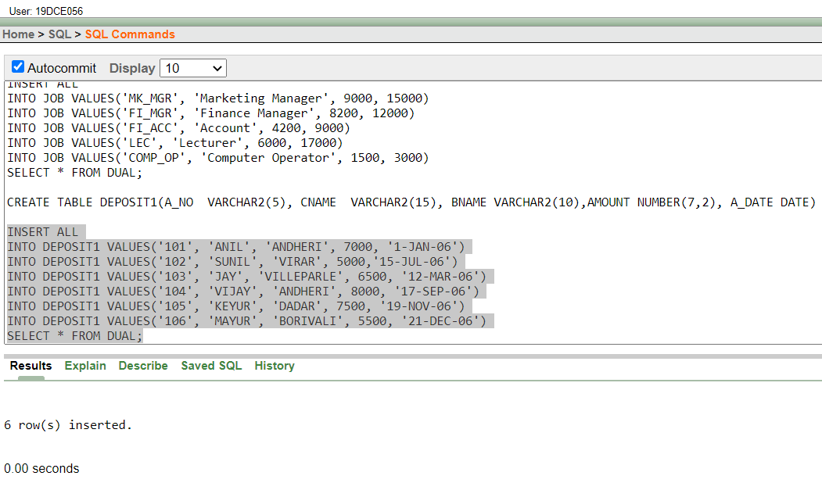
SELECT * FROM EMPLOYEE
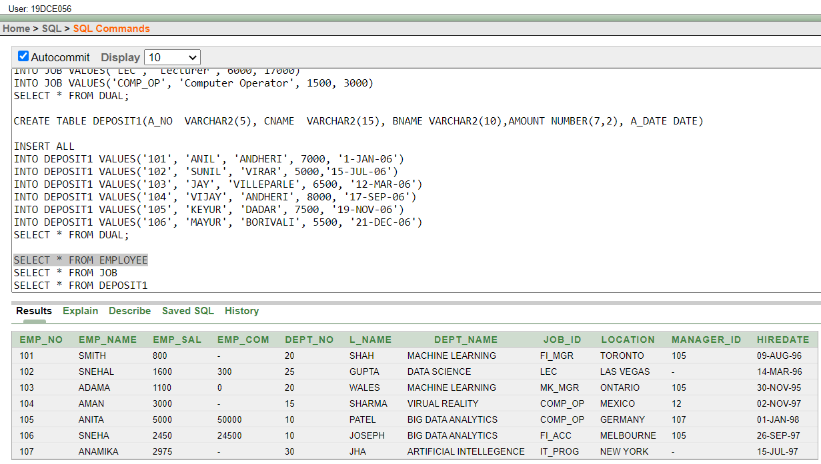
SELECT * FROM JOB
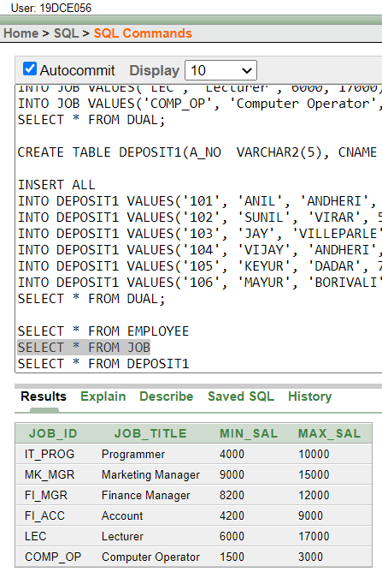
SELECT * FROM DEPOSIT1
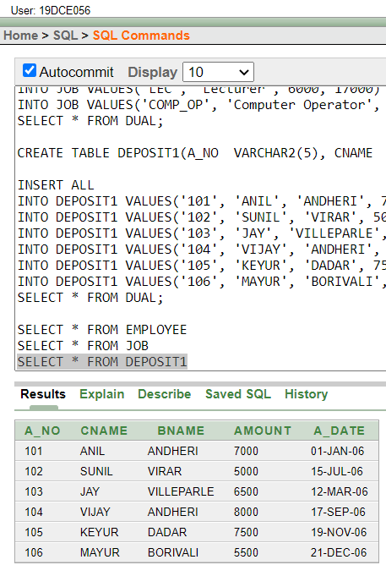
SELECT A_NO,AMOUNT FROM DEPOSIT1 WHERE A_DATE BETWEEN '01-JAN-06' AND '25-JUL-06'
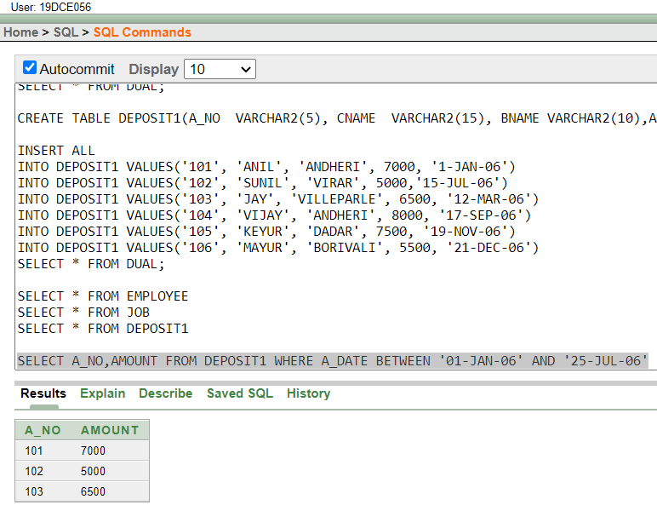
SELECT * FROM JOB WHERE MIN_SAL>4000
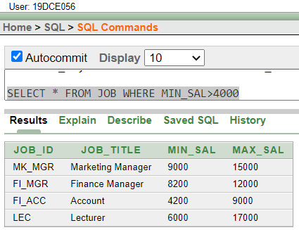

SELECT EMP_NAME "EMPLOYEE",EMP_SAL "SALARY" FROM EMPLOYEE WHERE DEPT_NO=20
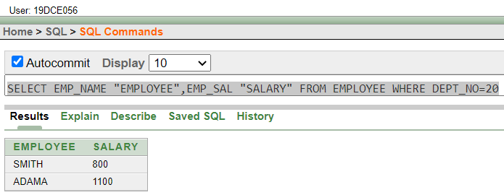
SELECT EMP_NO, EMP_NAME, DEPT_NAME FROM EMPLOYEE WHERE DEPT_NO BETWEEN 10 AND 20
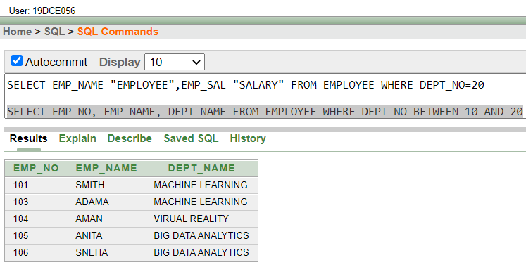
SELECT CNAME||AMOUNT "DATA" FROM DEPOSIT1 WHERE AMOUNT!=8000
SELECT CONCAT(CNAME, AMOUNT) AS DATA FROM DEPOSIT1 WHERE AMOUNT!=8000
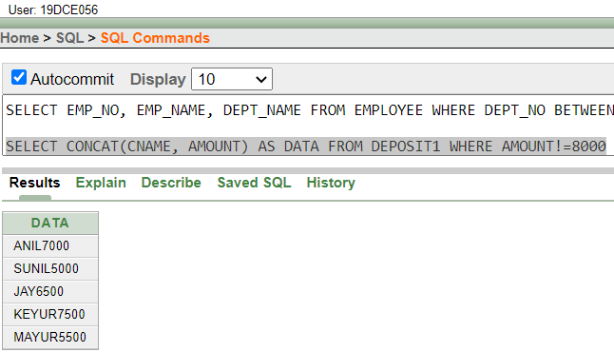
SELECT * FROM EMPLOYEE WHERE EMP_COM IS NOT NULL AND MANAGER_ID IS NOT NULL
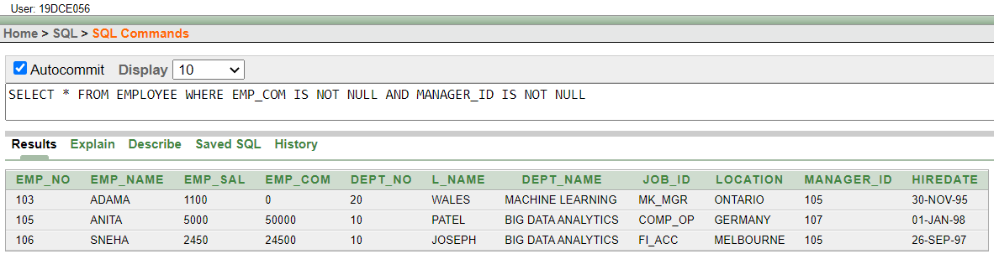
SELECT * FROM EMPLOYEE WHERE EMP_NAME LIKE 'A_a%'
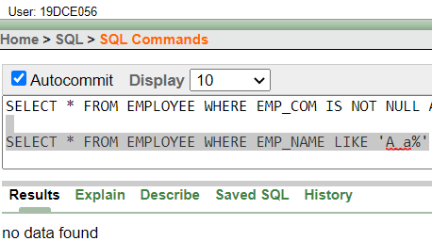
SELECT EMP_NAME, EMP_NO, EMP_SAL FROM EMPLOYEE WHERE EMP_NAME LIKE 'ANI__%'
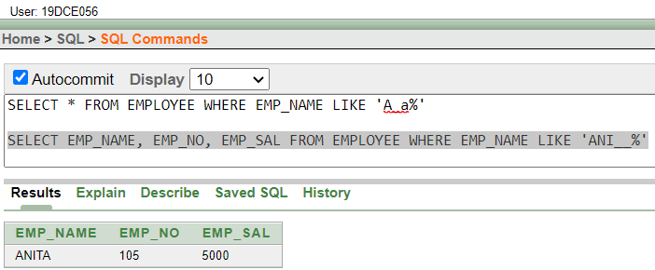
SELECT * FROM EMPLOYEE WHERE EMP_NAME LIKE '_N%' OR EMP_NAME LIKE '_M%'
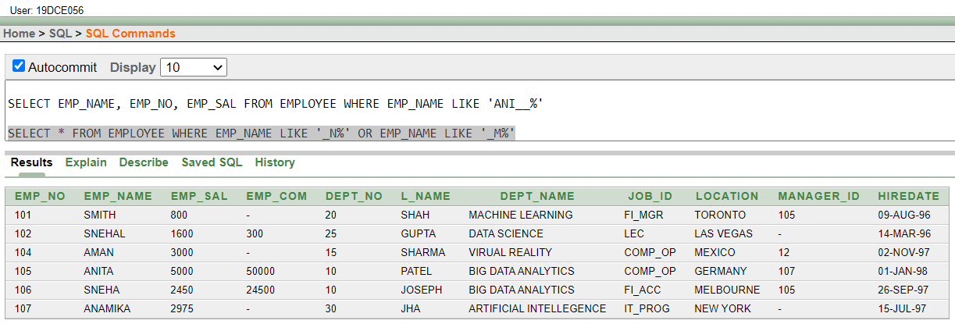
SELECT CNAME FROM DEPOSIT1 WHERE BNAME='ANDHERI' OR BNAME='DADAR' OR BNAME='VIRAR'
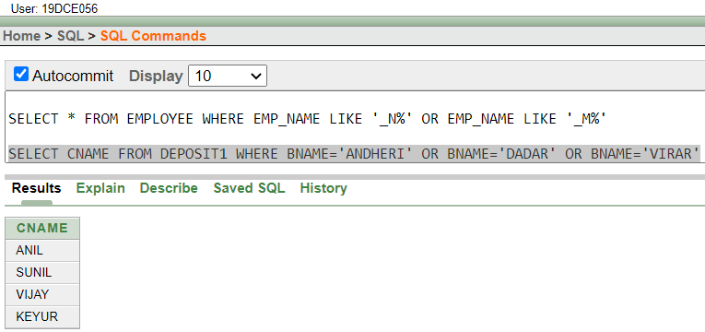
SELECT JOB_TITLE FROM JOB WHERE JOB_ID LIKE 'FI_%'
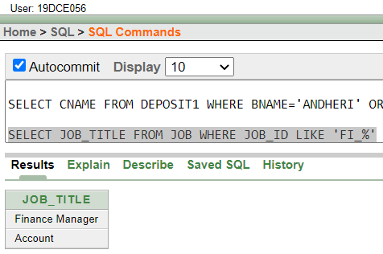
SELECT JOB_TITLE FROM JOB WHERE JOB_ID LIKE '%_MGR' AND MAX_SAL>12000
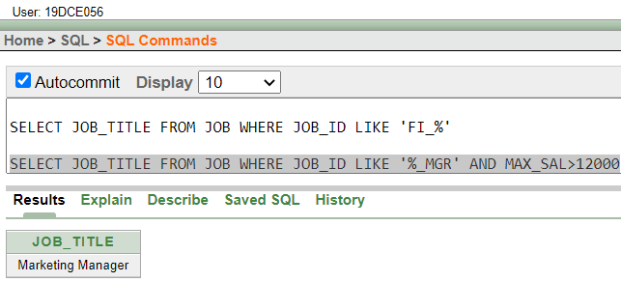
SELECT * FROM EMPLOYEE WHERE EMP_NAME LIKE '_N___'
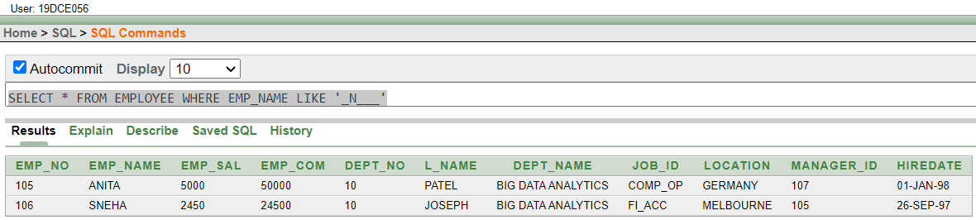
SELECT EMP_COM,MANAGER_ID FROM EMPLOYEE WHERE EMP_COM IS NULL AND MANAGER_ID IS NULL AND EMP_NAME LIKE '__A%'
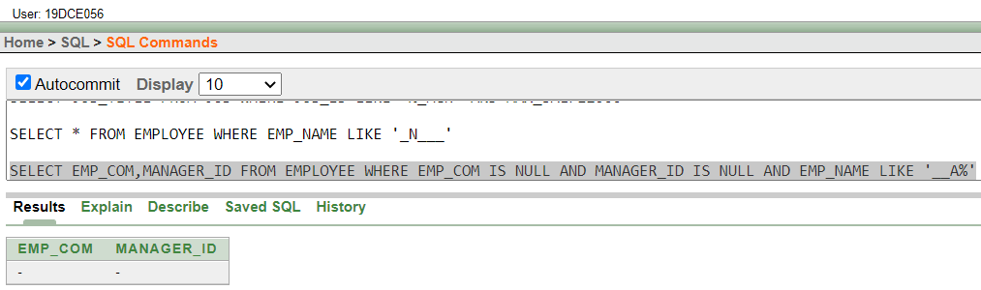
SELECT * FROM JOB WHERE JOB_ID LIKE '%\_%' ESCAPE '\'
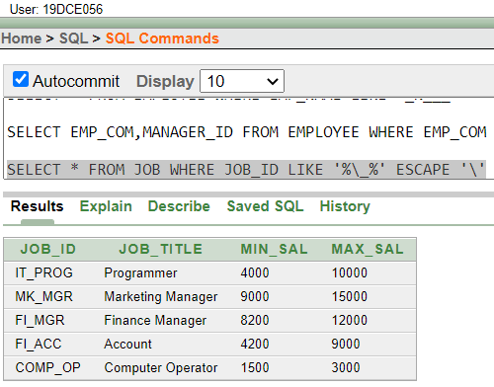
CONCLUSION: After performing this practical, we understood the use of LIKE predicate and its variations.

PRACTICAL – 5
AIM: To Perform various data manipulation commands, aggregate functions and sorting concept on all created tables.
COMMANDS:
SELECT SUM(AMOUNT) FROM DEPOSIT
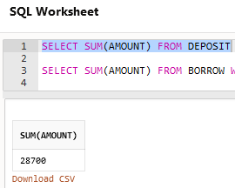
SELECT SUM(AMOUNT) FROM BORROW WHERE BNAME = 'karolbagh'
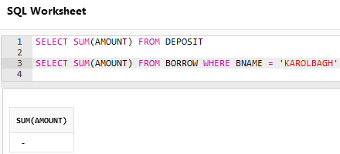
SELECT max (AMOUNT) FROM BORROW WHERE BNAME = 'vrce'

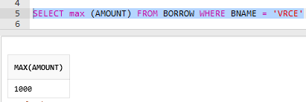
SELECT COUNT (CNAME) FROM CUSTOMERS

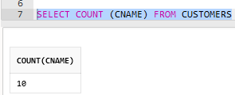
SELECT COUNT (DISTINCT CITY) FROM CUSTOMERS
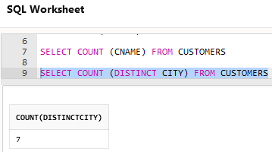
CREATE TABLE SUPPLIER AS SELECT * FROM EMPLOYEE
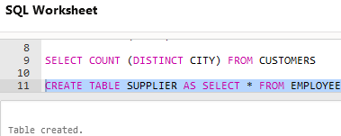
CREATE TABLE SUP1 AS (SELECT EMP_NO , EMP_NAME FROM EMPLOYEE)
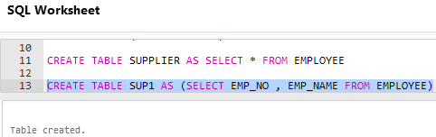
CREATE TABLE SUPPLIER AS SELECT * FROM EMPLOYEE WHERE EMP_NAME ='NO NAME'
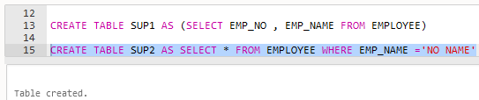
INSERT INTO SUP2 SELECT * FROM EMPLOYEE WHERE EMP_NAME LIKE '_n___'
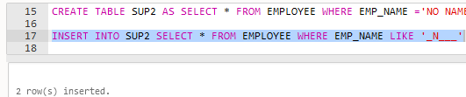
DELETE SUP1
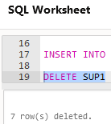
DELETE FROM SUP1 WHERE EMP_NO = 103
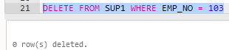
RENAME SUP2 TO SUPP0
ALTER TABLE SUP2 RENAME TO SUPP0
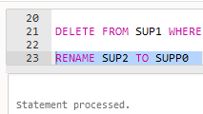
DROP TABLE SUP1
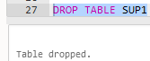
UPDATE EMPLOYEE SET DEPT_NO=10 WHERE EMP_NAME LIKE '_M%'
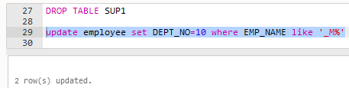
UPDATE EMPLOYEE SET EMP_NAME='UPDATED NAME' WHERE EMP_NO = 103
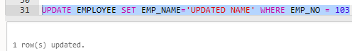

ALTER TABLE EMPLOYEE ADD PHONE NUMBER(10)
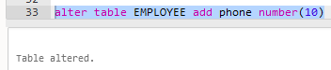
ALTER TABLE EMPLOYEE MODIFY EMP_NAME VARCHAR2(30)
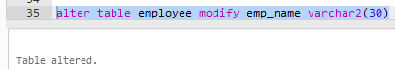
SELECT COUNT(DISTINCT DEPT_NO) FROM EMPLOYEE WHERE EMP_SAL > 1000
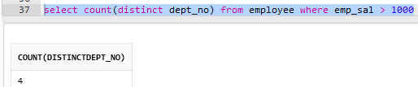
SELECT * FROM EMPLOYEE ORDER BY EMP_NAME ASC , EMP_NO DESC
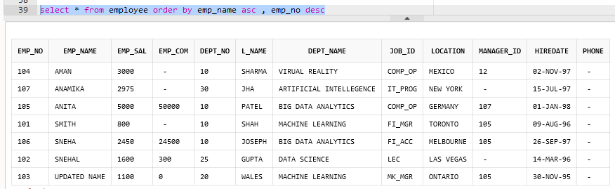
SELECT DISTINCT DEPT_NO FROM EMPLOYEE ORDER BY DEPT_NO ASC
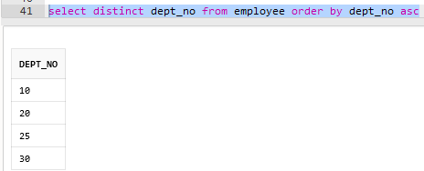

SELECT EMP_COMM FROM EMPLOYEE ORDER BY EMP_COMM DESC NULLS LAST
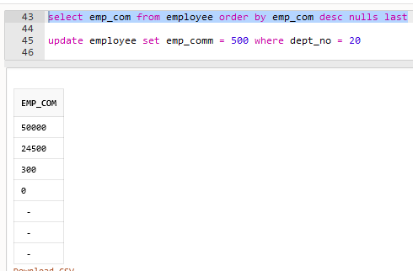
UPDATE EMPLOYEE SET EMP_COMM = 500 WHERE DEPT_NO = 20
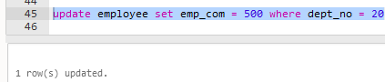
SELECT EMP_COMM FROM EMPLOYEE ORDER BY EMP_COMM ASC NULLS FIRST
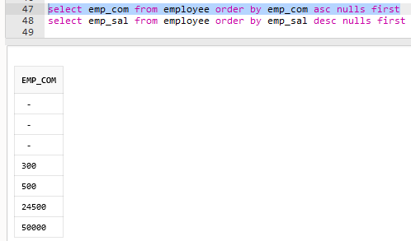

SELECT EMP_SAL FROM EMPLOYEE ORDER BY EMP_SAL DESC NULLS FIRST
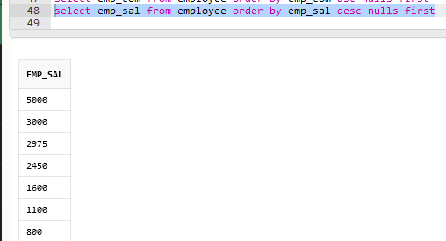
CONCLUSION: After performing this practical, we understood various DML commands, aggregate functions and sorting concept on all created tables.

PRACTICAL – 6
AIM: To study Single-row functions.
COMMANDS:
SELECT SYSDATE FROM DUAL
SELECT CURRENT_DATE FROM DUAL
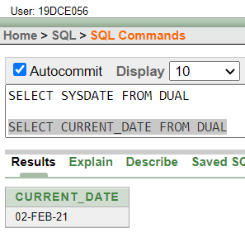
SELECT EMP_NAME, EMP_SAL, ROUND(EMP_SAL*1.15,0) "NEW_SAL" FROM EMPLOYEE
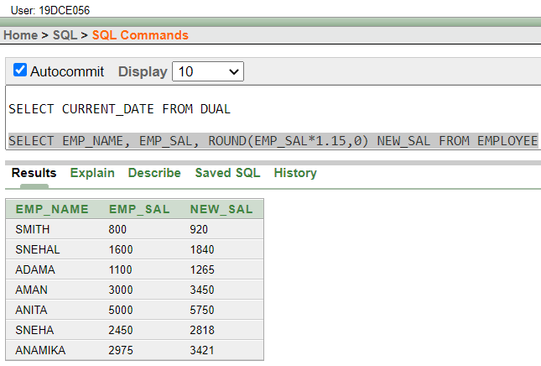
SELECT EMP_NAME, EMP_SAL, ROUND(EMP_SAL*1.15,0)-EMP_SAL "INC" FROM EMPLOYEE
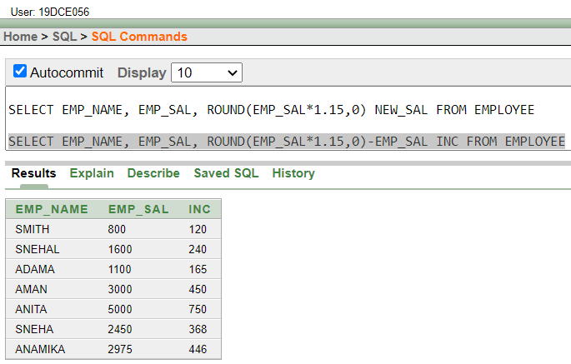
SELECT INITCAP(EMP_NAME) "NAME", LENGTH(EMP_NAME) "LENGTH" FROM EMPLOYEE WHERE EMP_NAME LIKE 'A%' OR EMP_NAME LIKE 'J%' OR EMP_NAME LIKE 'M%' ORDER BY L_NAME
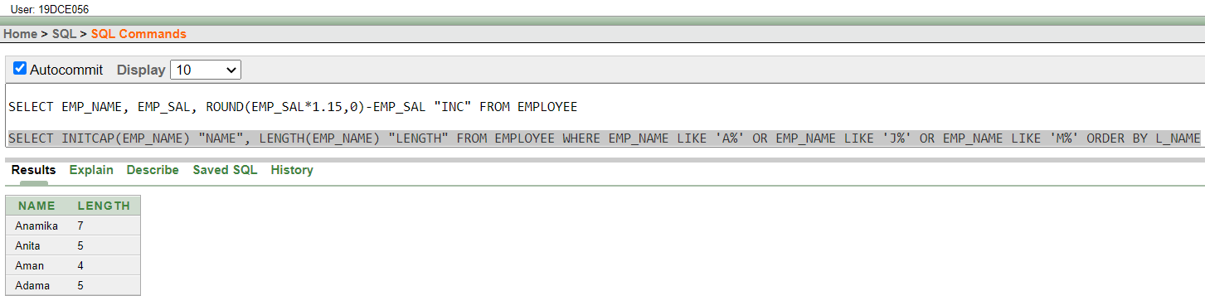
SELECT EMP_NAME || ' earns ' || EMP_SAL || ' monthly' "STRING" FROM EMPLOYEE
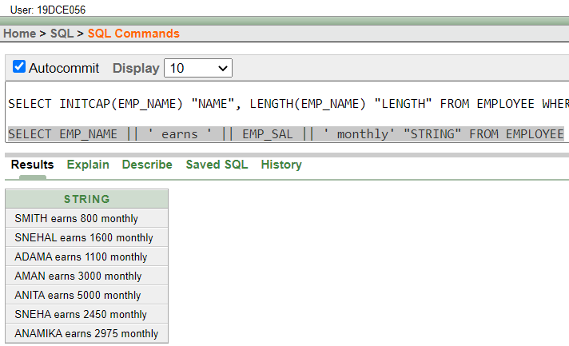
SELECT CNAME, A_DATE, ROUND(MONTHS_BETWEEN('8-FEB-2021', A_DATE)) "MONTHS", TO_CHAR(A_DATE, 'DAY') "DAY OF WEEK" FROM DEPOSIT1 ORDER BY (A_DATE-NEXT_DAY(A_DATE,'MONDAY'))
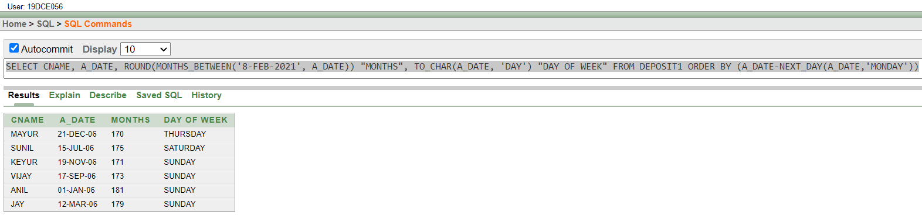
SELECT TO_CHAR(A_DATE, 'FMDDSPTH') || ' OF ' || TO_CHAR(A_DATE, 'MONTH') || ' ' || EXTRACT(YEAR FROM A_DATE) || ' ' || TO_CHAR(A_DATE, 'HH:MM:SS AM') "DATE OF JOINING" FROM DEPOSIT1
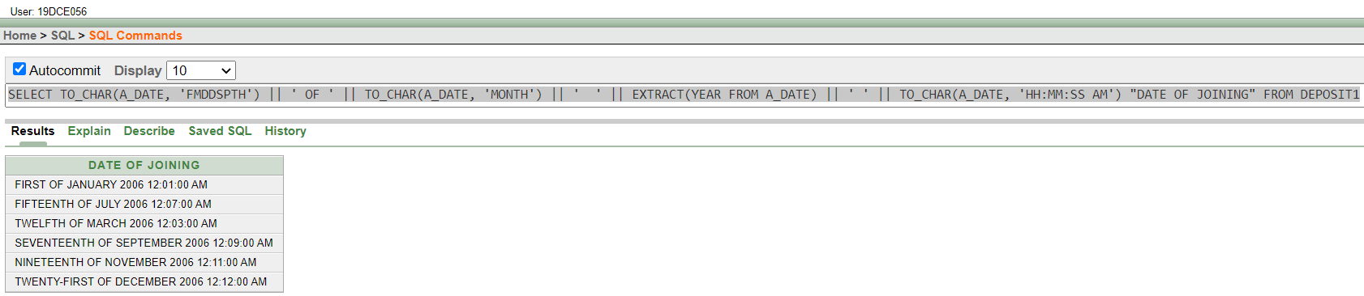
SELECT EMP_NAME,EMP_SAL+NVL(EMP_COM,0) "INCOME" FROM EMPLOYEE
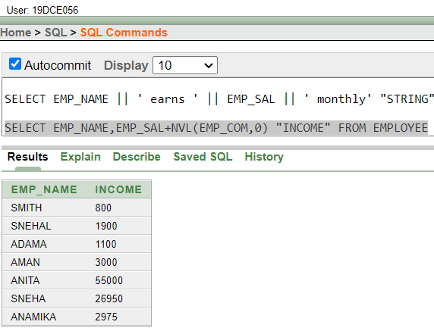
CONCLUSION: After performing this practical, we understood single-row functions in SQL such as TO_CHAR, ROUND, INITCAP etc.

PRACTICAL – 7
AIM: Displaying data from Multiple Tables (join)
COMMANDS:
SELECT * FROM BORROW NATURAL JOIN CUSTOMERS NATURAL JOIN DEPOSIT WHERE CNAME='ANIL'
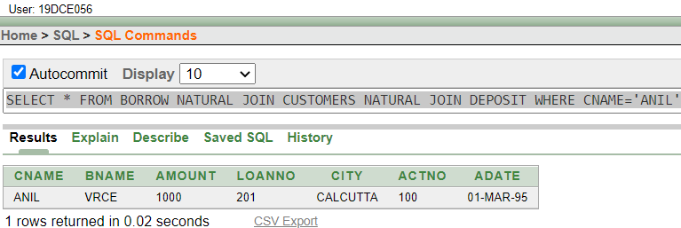
SELECT CNAME FROM BORROW JOIN CUSTOMERS USING(CNAME) JOIN DEPOSIT USING(CNAME) WHERE CITY='NAGPUR'
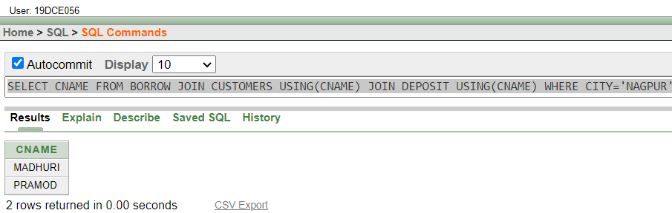
SELECT CUSTOMERS.CNAME FROM CUSTOMERS,BRANCH WHERE CUSTOMERS.CITY=BRANCH.CITY
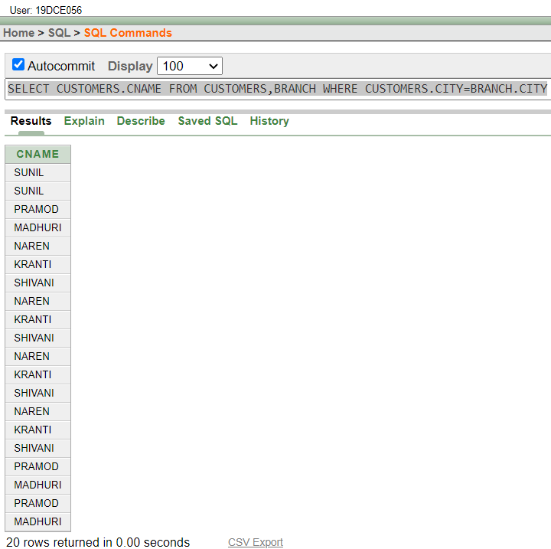
SELECT DEPT_NO,L_NAME,DEPT_NAME FROM EMPLOYEE
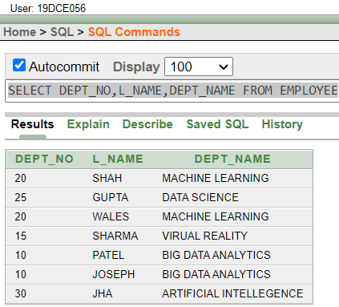
SELECT * FROM JOB JOIN EMPLOYEE USING(JOB_ID) WHERE DEPT_NO=30
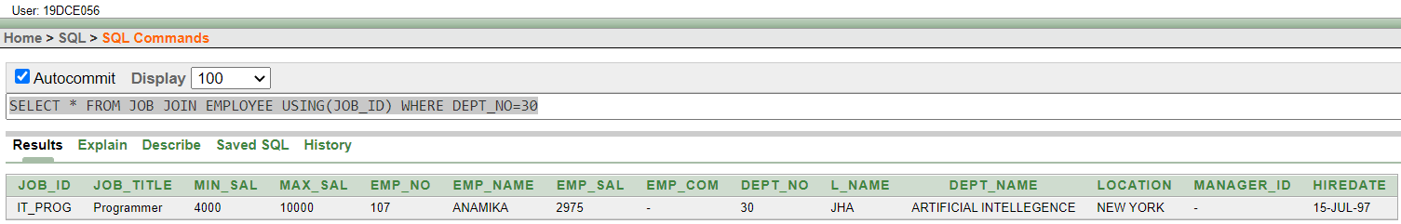
SELECT EMP_NAME,DEPT_NO,DEPT_NAME FROM EMPLOYEE WHERE LOCATION='NEW YORK'
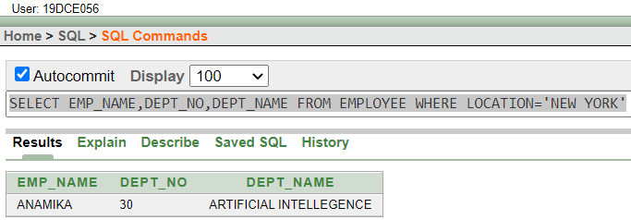
SELECT E1.EMP_NO,E1.L_NAME,E2.EMP_NO,E2.L_NAME FROM EMPLOYEE E1 JOIN EMPLOYEE E2 ON E1.MANAGER_ID=E2.EMP_NO
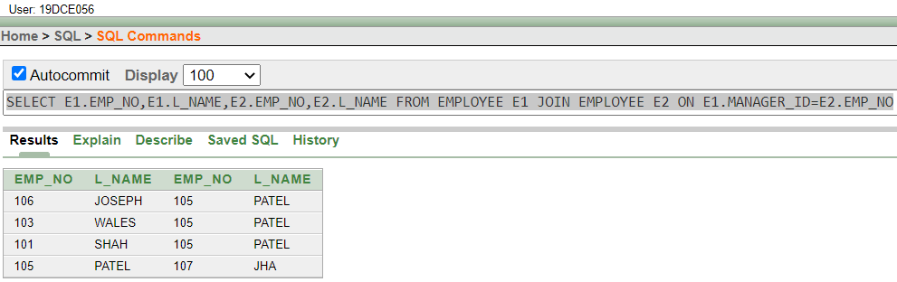
SELECT EMP_NAME,HIREDATE FROM EMPLOYEE WHERE HIREDATE> (SELECT HIREDATE FROM EMPLOYEE WHERE EMP_NAME='SMITH')
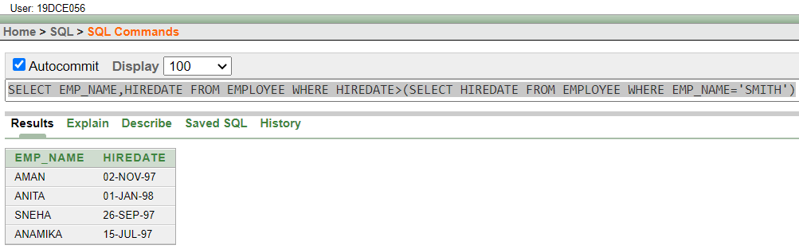
CONCLUSION: After performing this practical, we understood various types of JOIN in SQL.

PRACTICAL – 8
AIM: To apply the concept of Aggregating Data using Group functions.
COMMANDS:
SELECT SUM(AMOUNT) FROM DEPOSIT WHERE ADATE > '1-JAN-96';
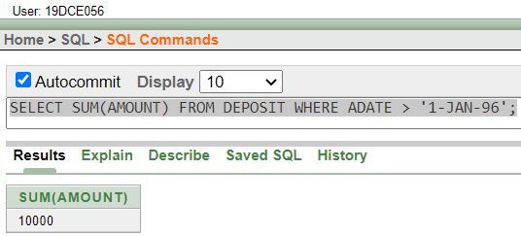
SELECT SUM(DEPOSIT.AMOUNT) FROM CUSTOMERS JOIN DEPOSIT ON CUSTOMERS.CNAME=DEPOSIT.CNAME WHERE CITY='NAGPUR';
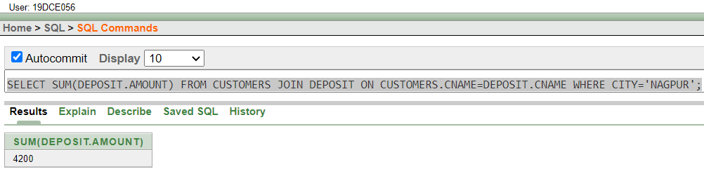
SELECT MAX(DEPOSIT.AMOUNT) FROM CUSTOMERS JOIN DEPOSIT ON CUSTOMERS.CNAME=DEPOSIT.CNAME WHERE CITY='BOMBAY';
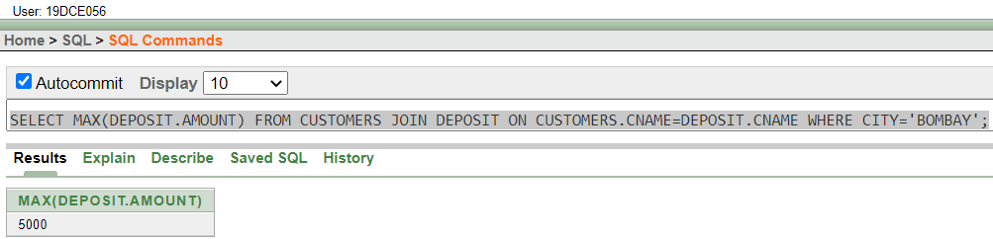
SELECT ROUND (AVG(EMP_SAL)) "Average", MAX(EMP_SAL) "Maximum" , MIN(EMP_SAL) "Minimum", SUM(EMP_SAL) "Sum" FROM EMPLOYEE;
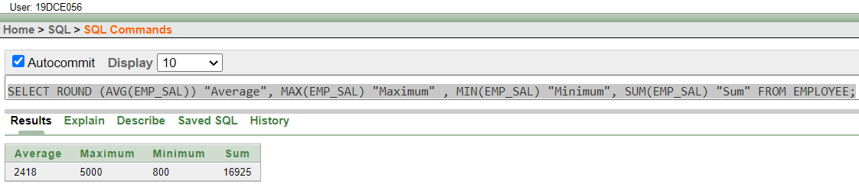
SELECT MAX(EMP_SAL)-MIN(EMP_SAL) "DIFFERENCE" FROM EMPLOYEE;
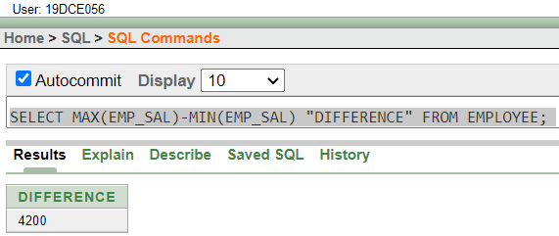
SELECT TO_CHAR(HIREDATE, 'YYYY'), COUNT(EMP_NO) FROM EMPLOYEE GROUP BY TO_CHAR(HIREDATE, 'YYYY')
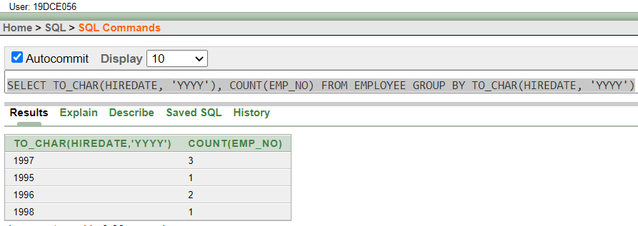
SELECT AVG (EMP_SAL), DEPT_NO FROM EMPLOYEE GROUP BY DEPT_NO;
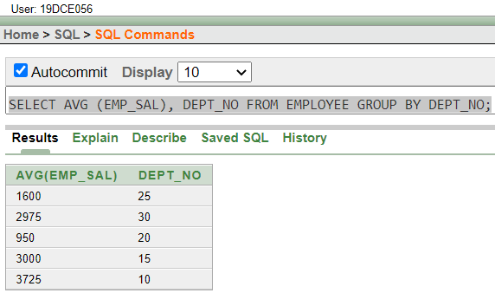
SELECT DEPT_NO,JOB_ID,SUM(EMP_SAL) FROM EMPLOYEE GROUP BY DEPT_NO,JOB_ID;
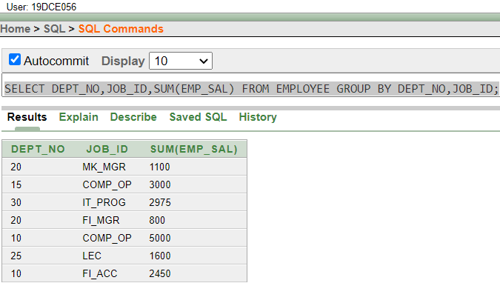
SELECT ROUND(AVG(EMP_SAL)) FROM EMPLOYEE GROUP BY DEPT_NO HAVING AVG(EMP_SAL) > 2000
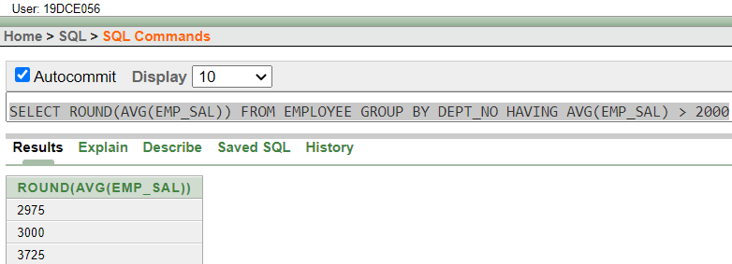
SELECT JOB_ID, SUM(EMP_SAL) FROM EMPLOYEE GROUP BY JOB_ID HAVING SUM(EMP_SAL) > 3000 ORDER BY SUM(EMP_SAL)
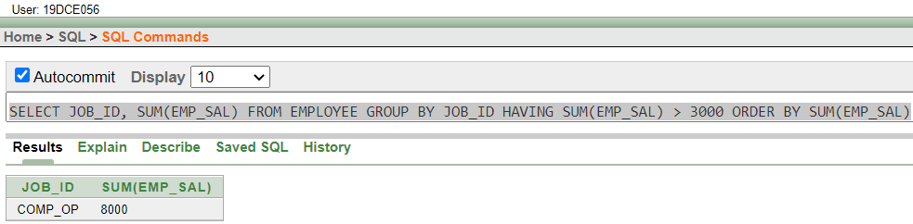
SELECT DEPOSIT.BNAME, SUM(DEPOSIT.AMOUNT) FROM DEPOSIT JOIN BRANCH ON DEPOSIT.BNAME = BRANCH.BNAME WHERE BRANCH.CITY = 'BOMBAY' GROUP BY DEPOSIT.BNAME HAVING SUM(DEPOSIT.AMOUNT) > 5000
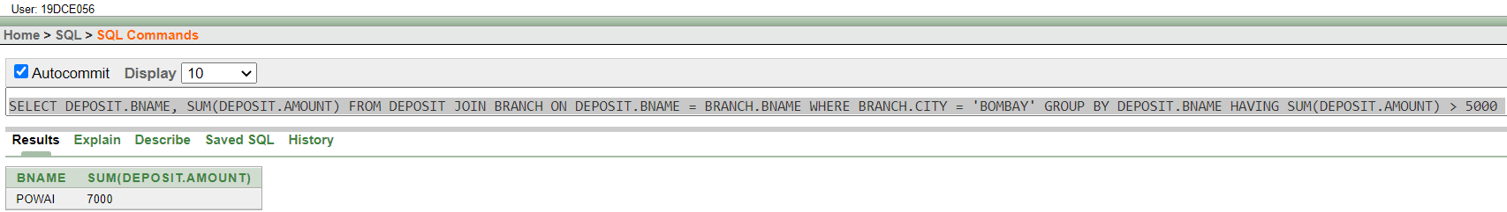
CONCLUSION: After performing this practical, we understood the concept of group and various aggregate functions.

PRACTICAL – 9
AIM: To solve queries using the concept of sub query.
COMMANDS:
select l_name from employee where dept_name = (select dept_name from employee where emp_name = 'SMITH') and emp_name <> 'SMITH'
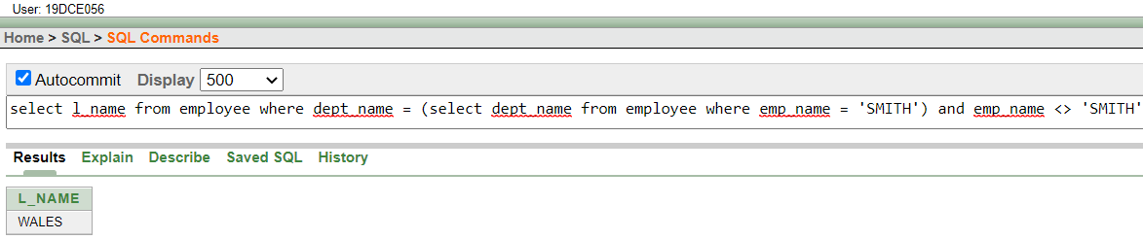
SELECT CNAME FROM DEPOSIT WHERE BNAME = (SELECT BNAME FROM DEPOSIT WHERE CNAME = 'SUNIL')
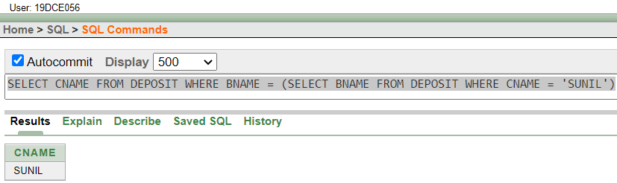
SELECT D.* FROM DEPOSIT D JOIN BORROW B ON B.BNAME = (SELECT BNAME FROM DEPOSIT WHERE CNAME = 'PRAMOD')
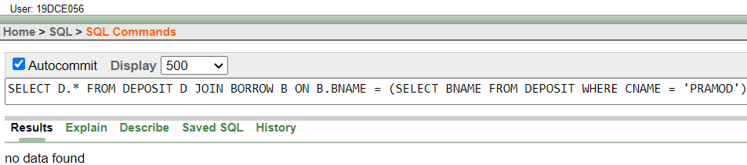
SELECT EMP_NAME,L_NAME FROM EMPLOYEE WHERE EMP_SAL > (SELECT AVG(EMP_SAL) FROM EMPLOYEE)
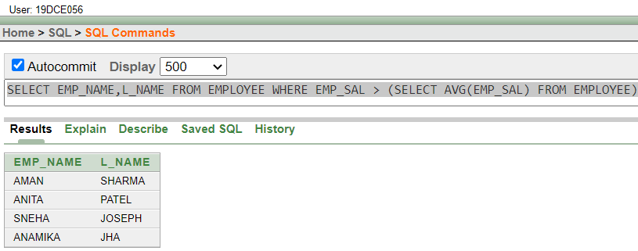
SELECT CNAME FROM DEPOSIT WHERE BNAME = (SELECT BNAME FROM DEPOSIT WHERE CNAME = 'ANIL') AND AMOUNT > 2000
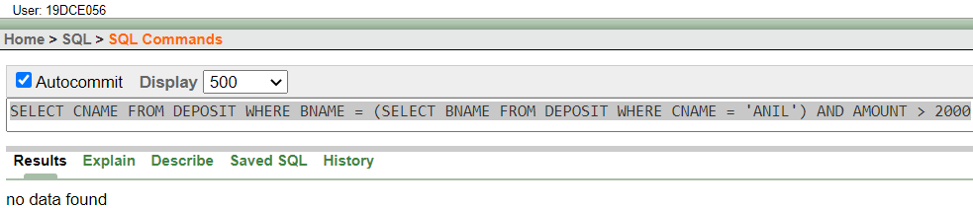
SELECT L_NAME,EMP_SAL FROM EMPLOYEE WHERE MANAGER_ID = (SELECT EMP_NO FROM EMPLOYEE WHERE EMP_NAME = 'Ford')
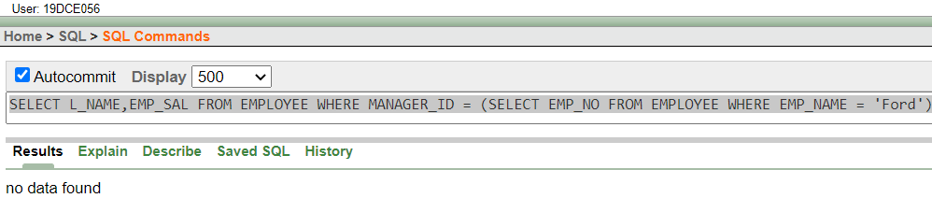
SELECT E.DEPT_NAME,E.EMP_NAME,E.JOB_ID FROM EMPLOYEE E WHERE E.JOB_ID = (SELECT JOB_ID FROM JOB WHERE JOB_TITLE = 'Account')
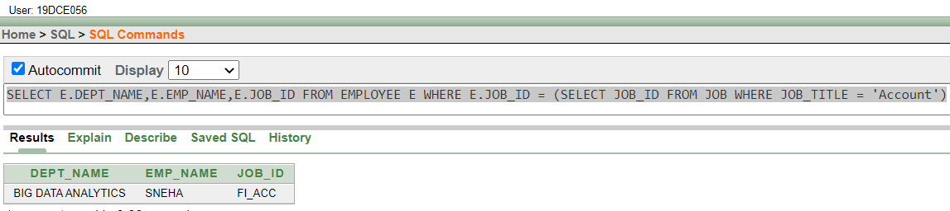
SELECT D1.BNAME FROM DEPOSIT D1 GROUP BY D1.BNAME HAVING COUNT(D1.BNAME) >= ALL(SELECT COUNT(D2.BNAME) FROM DEPOSIT D2 GROUP BY D2.BNAME)
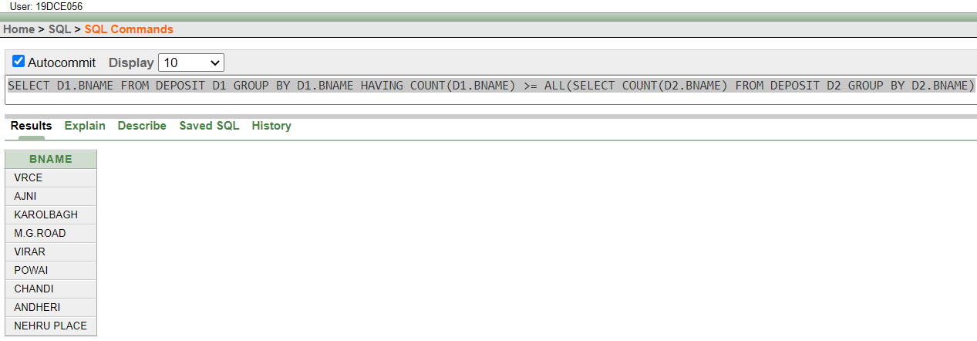
SELECT CITY FROM BRANCH GROUP BY CITY HAVING COUNT(BRANCH.BNAME) >= ALL(SELECT COUNT(BNAME) FROM BRANCH GROUP BY CITY)
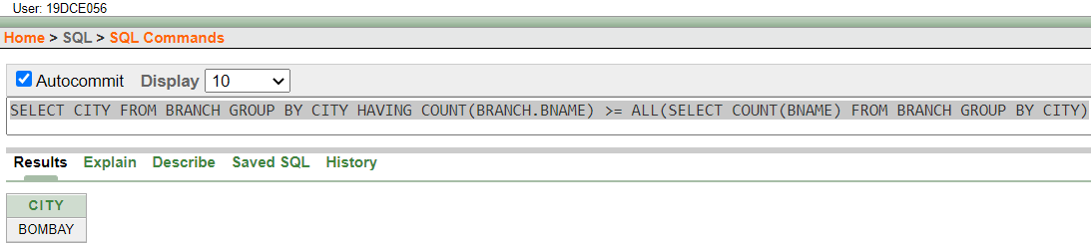
SELECT CNAME FROM CUSTOMERS WHERE CITY=(SELECT CITY FROM DEPOSIT1 JOIN BRANCH ON DEPOSIT1.BNAME = BRANCH.BNAME GROUP BY BRANCH.CITY HAVING COUNT(CITY) >= ALL(SELECT COUNT(CITY) FROM DEPOSIT1 JOIN BRANCH ON DEPOSIT1.BNAME = BRANCH.BNAME GROUP BY BRANCH.CITY))
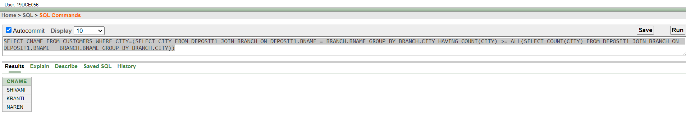
CONCLUSION: After performing this practical, we understood the concept of sub query.

PRACTICAL – 10
AIM: To solve queries using the concept of Data Manipulation.
COMMANDS:
ALTER TABLE DEPOSIT ADD INTEREST NUMBER(5) DEFAULT 0
UPDATE DEPOSIT SET INTEREST = AMOUNT * 0.10
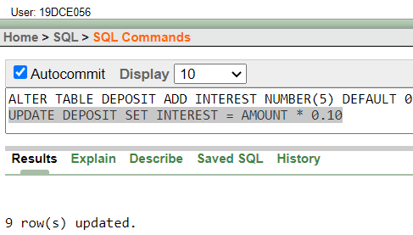
UPDATE DEPOSIT SET INTEREST = AMOUNT*0.1 WHERE DEPOSIT.BNAME = 'VRCE'
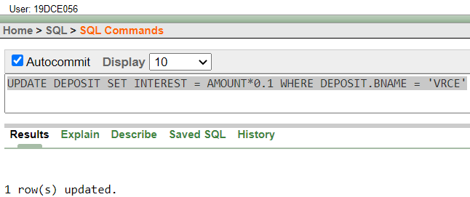
UPDATE DEPOSIT SET INTEREST = AMOUNT*0.10 WHERE BNAME = ANY(SELECT BNAME FROM BRANCH WHERE CITY = 'NAGPUR' OR CITY = 'BOMBAY')
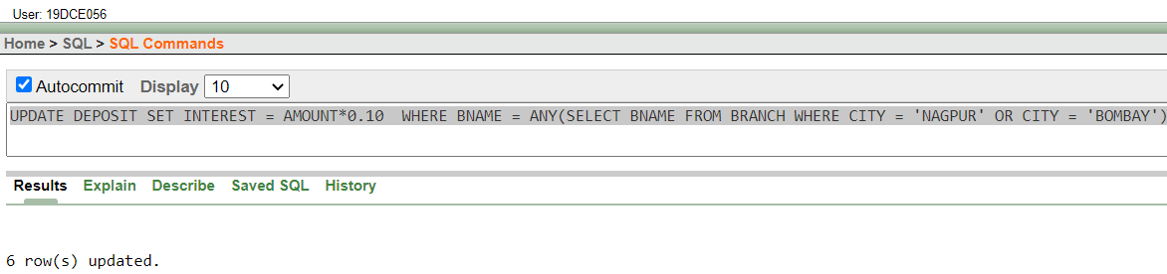
UPDATE EMPLOYEE SET DEPT_NO = (SELECT DEPT_NO FROM EMPLOYEE WHERE EMP_NO = 7844) WHERE EMP_NO = 7788
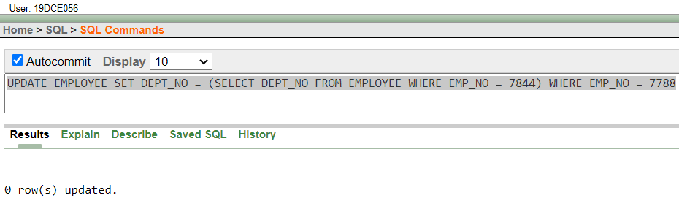
update deposit set amount = amount - 10 where cname = 'ANIL' AND BNAME = (SELECT BNAME FROM DEPOSIT WHERE CNAME = 'SUNIL')
update deposit set amount = amount + 10 where cname = 'SUNIL' AND BNAME = (SELECT BNAME FROM DEPOSIT WHERE CNAME = 'ANIL')
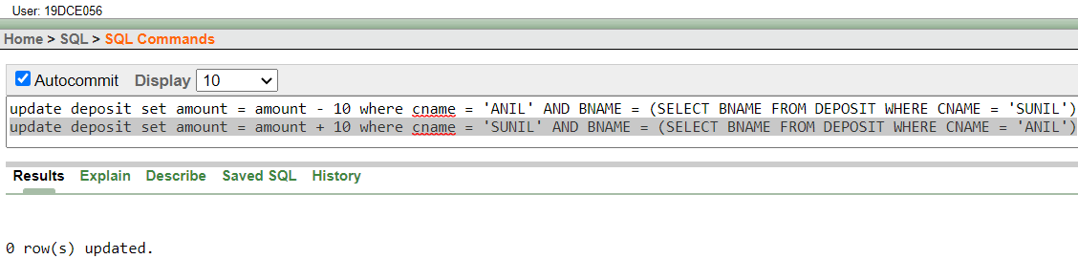
update deposit set amount = amount + 100 where (bname,amount) in (select bname,max(amount) from deposit group by bname)
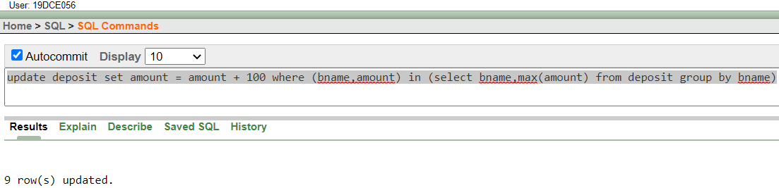
delete from deposit where 3 >= any(select count(cname) from deposit group by bname)
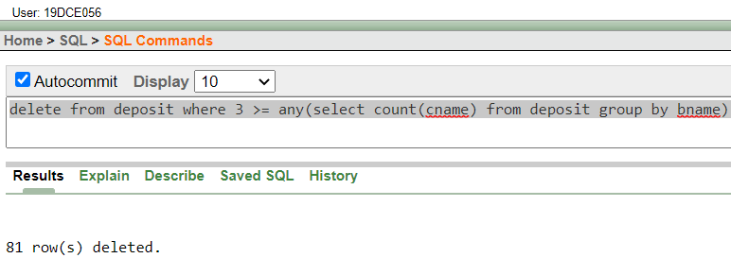
delete from deposit where cname = 'vijay'
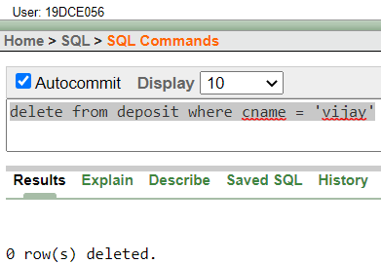
delete from borrow where amount < 1000
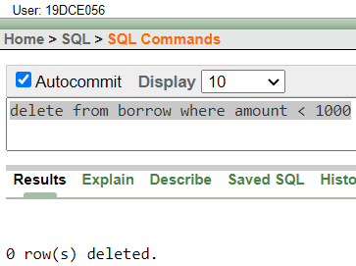
CONCLUSION: After performing this practical, we understood the DML part of DBMS.

PRACTICAL – 11
AIM: To solve queries using the concept of constraints.
COMMANDS:
alter table job add constraint adding_to_job_id primary key (job_id)
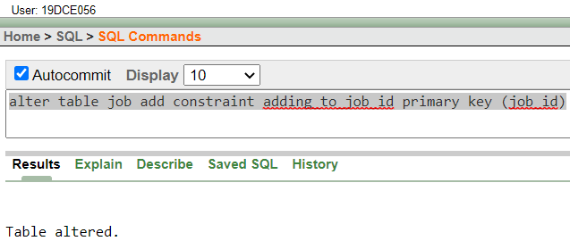
ALTER TABLE EMPLOYEE ADD CONSTRAINT ADDING_FK FOREIGN KEY (JOB_ID) REFERENCES JOB(JOB_ID)
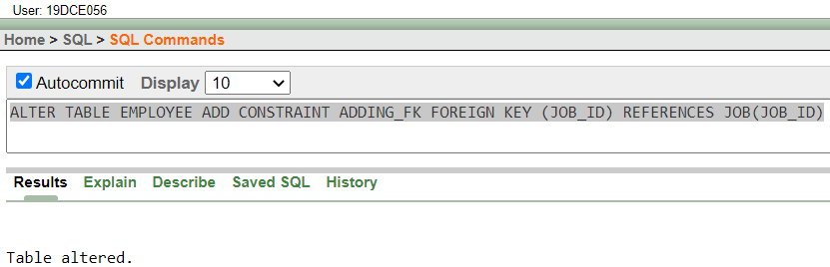
CREATE TABLE VALID_LOCK( C1 NUMBER(3) , C2 NUMBER(3) , CONSTRAINT TWO_COLS_AS_PK PRIMARY KEY(C1,C2))
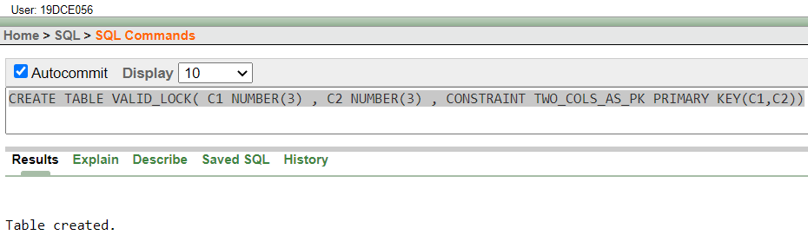
5. ALTER TABLE EMPLOYEE DROP CONSTRAINT ADDING_FK
4. ALTER TABLE JOB DROP PRIMARY KEY
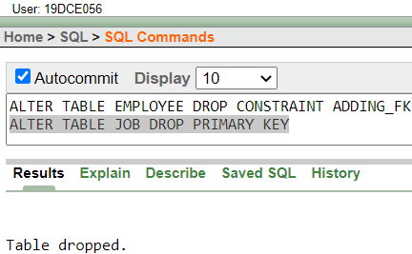
CONCLUSION: After performing this practical, we understood the concept of constraints.

PRACTICAL – 12
AIM: Data Dictionary and E-R Diagram
COMMANDS:
DATA DICTIONARY
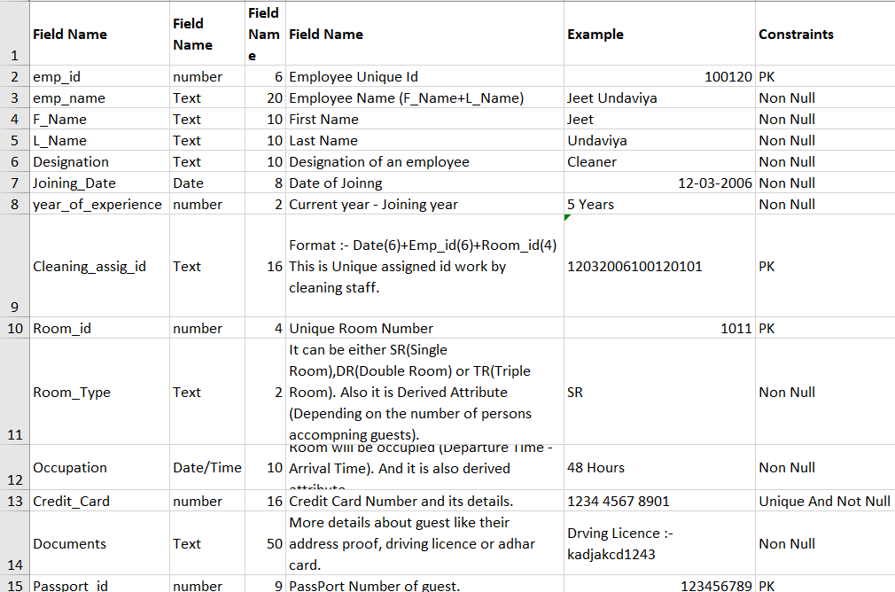
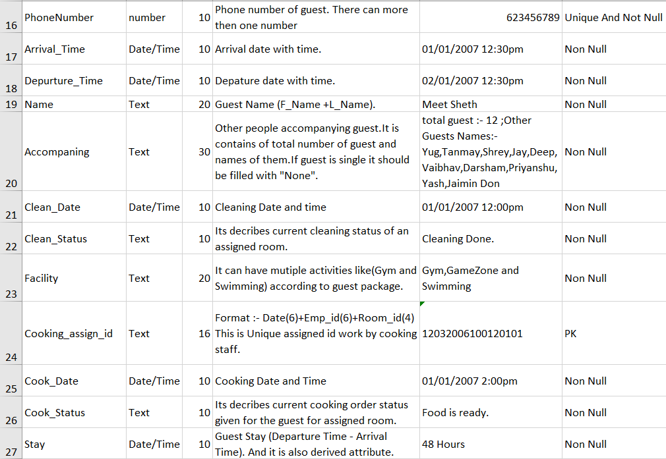
ER Diagram
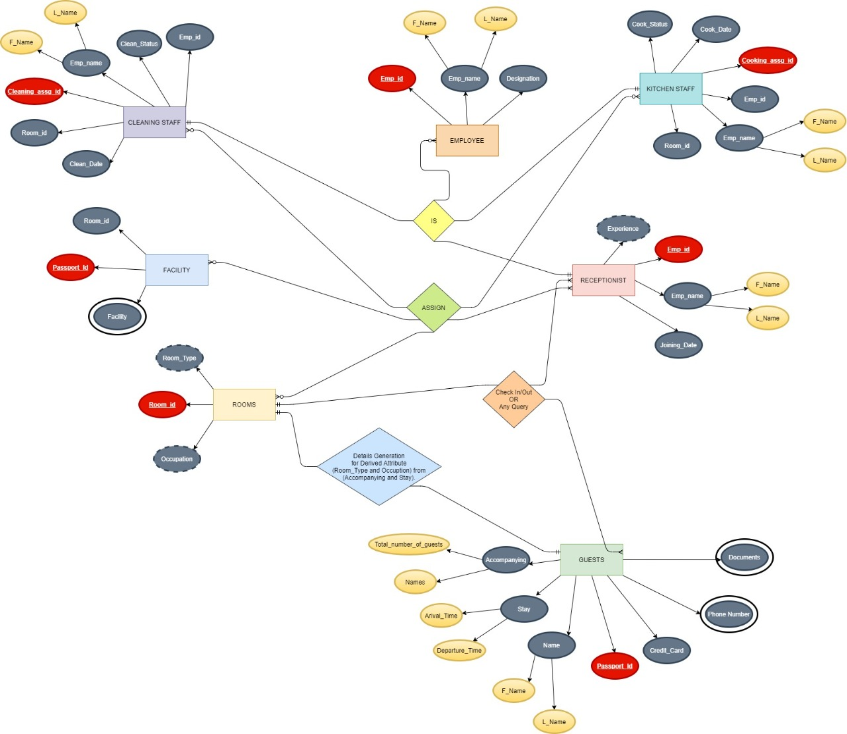
CONCLUSION: After performing this practical, we understood the concepts like data dictionary and ER-diagrams.

PRACTICAL – 13
AIM: Write a PL-SQL block to find Sum and average of three numbers.
COMMANDS:
declare
n1 number := :Enter_Number_1;
n2 number := :Enter_Number_2;
n3 number := :Enter_Number_3;

begin
dbms_output.put_line('Sum : ' || (n1+n2+n3));
dbms_output.put_line('Average : ' || (n1+n2+n3)/3);
end;
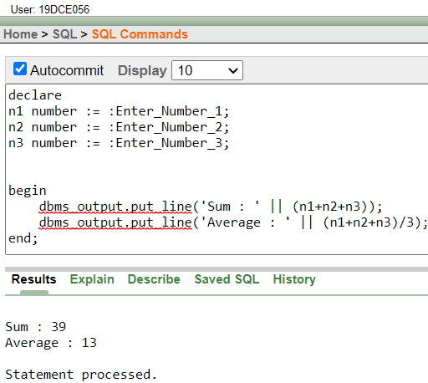
CONCLUSION: After Performing this practical, we understood the basic concepts of PL/SQL.

PRACTICAL – 14
AIM: Find the factorial of a number in pl/sql using for, While and Simple Loop.
COMMANDS:
declare
n1 number := :Enter_Number;
fact number := 1;
temp number;

begin
temp := n1;

loop
fact := fact*temp;
temp := temp-1;
if temp=1 then
exit;
end if;
end loop;

dbms_output.put_line('Factorial : ' || fact);

fact := 1;
temp := n1;
while temp>0 loop
fact := fact*temp;
temp := temp-1;
end loop;

dbms_output.put_line('Factorial : ' || fact);

fact := 1;
for i in 1..n1 loop
fact := fact*i;
end loop;

dbms_output.put_line('Factorial : ' || fact);
end;
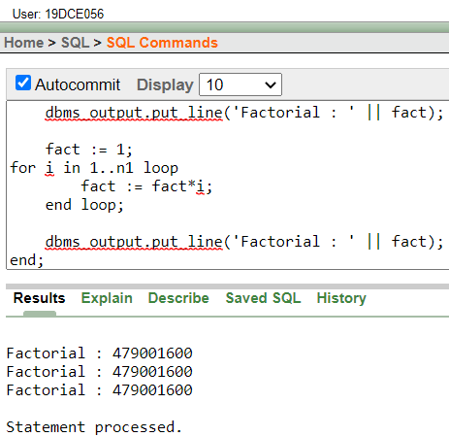
CONCLUSION: After Performing this practical, we understood the concept of Loop in PL/SQL.

PRACTICAL – 15
AIM: To understand the concept of “select into” and “% type” attribute.
COMMANDS:
DECLARE
MIN_EMP_NO EMPLOYEE.EMP_NO%TYPE;
MAX_EMP_NO EMPLOYEE.EMP_NO%TYPE;
NO_STAR NUMBER;
STAR_STR VARCHAR2(20);

BEGIN
SELECT MAX(EMP_NO) INTO MAX_EMP_NO FROM EMPLOYEE;
SELECT MIN(EMP_NO) INTO MIN_EMP_NO FROM EMPLOYEE;
FOR i IN MIN_EMP_NO .. MAX_EMP_NO LOOP
SELECT ROUND(EMP_SAL/1000) INTO NO_STAR FROM EMPLOYEE WHERE EMP_NO = i;

IF NO_STAR > 0 THEN
STAR_STR := '';
FOR j IN 1 .. NO_STAR LOOP
STAR_STR := STAR_STR || '*';
END LOOP;
END IF;
UPDATE EMPLOYEE SET STARS = STAR_STR WHERE EMP_NO = i ;
END LOOP;
END;
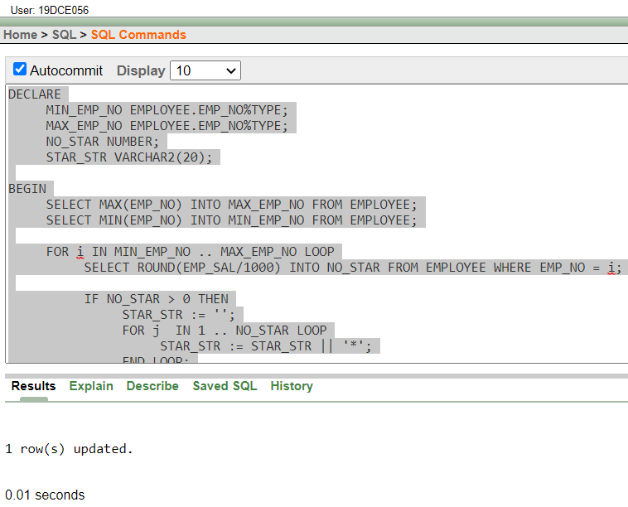
CONCLUSION: After performing this practical, we understood the concept of select into and %type in PL/SQL.
PRACTICAL – 16
AIM: To understand the concept of cursor.
COMMANDS:
(A)
DECLARE
CURSOR GETALLDETAILS IS SELECT * FROM EMPLOYEE;
VAR EMPLOYEE%ROWTYPE;

BEGIN
dbms_output.put_line('ALL DETAILS ARE AS FOLLOWS :- ');
for I in GETALLDETAILS LOOP
VAR := I;
dbms_output.put_line(VAR.EMP_NO||' '|| VAR.EMP_NAME||' '||VAR.EMP_SAL||' '||VAR.EMP_COM||' '||VAR.DEPT_NO||' '||VAR.L_NAME||' '||VAR.DEPT_NAME||' '||VAR.JOB_ID||' '||VAR.LOCATION||' '||VAR.MANAGER_ID||' '||VAR.HIREDATE);
END LOOP;
END;
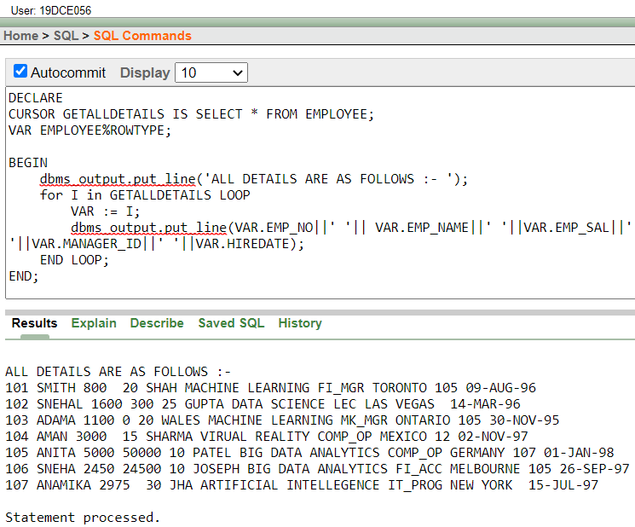

(B)
DECLARE
DEPT_NUMBER NUMBER := :ENTER_DEPT_NO_;
CURSOR GETBYDEPT IS SELECT EMP_NAME,L_NAME, EMP_SAL, MANAGER_ID FROM EMPLOYEE WHERE DEPT_NO = DEPT_NUMBER;

BEGIN
FOR I IN GETBYDEPT LOOP
IF I.EMP_SAL < 1000 AND (I.MANAGER_ID = 7902 OR I.MANAGER_ID = 7839) THEN
DBMS_OUTPUT.PUT_LINE(I.L_NAME || ', DUE FOR A RAISE.');
ELSE
DBMS_OUTPUT.PUT_LINE(I.L_NAME || ', NOT DUE FOR A RAISE.');
END IF;
END LOOP;
END;
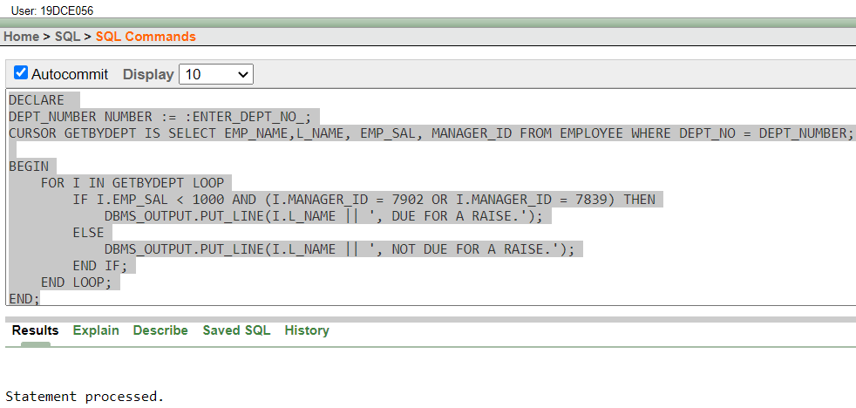
CONCLUSION: After performing this practical, we understood the concept of cursor in PL/SQL.

PRACTICAL – 17
AIM: To perform the concept of trigger.
COMMANDS:
CREATE TABLE ORG_EMP AS SELECT * FROM EMPLOYEE WHERE EMP_NAME = 'NO_NAME'

CREATE OR REPLACE TRIGGER ONUPDATE
BEFORE UPDATE OF EMP_SAL ON EMPLOYEE
FOR EACH ROW
BEGIN
IF :OLD.DEPT_NO = 10 THEN
INSERT INTO ORG_EMP (EMP_NO,EMP_SAL)VALUES(:OLD.EMP_NO ,:OLD.EMP_SAL);
END IF;
END;
UPDATE EMPLOYEE SET EMP_SAL = 99 WHERE DEPT_NO = 10
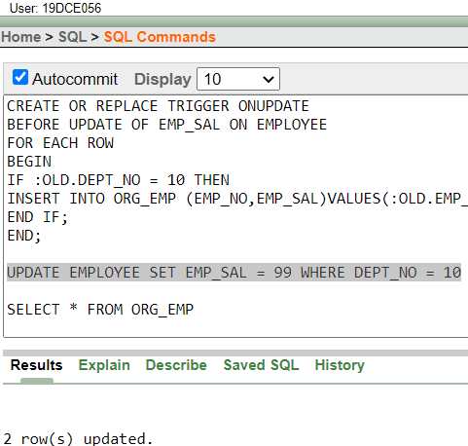
SELECT * FROM ORG_EMP
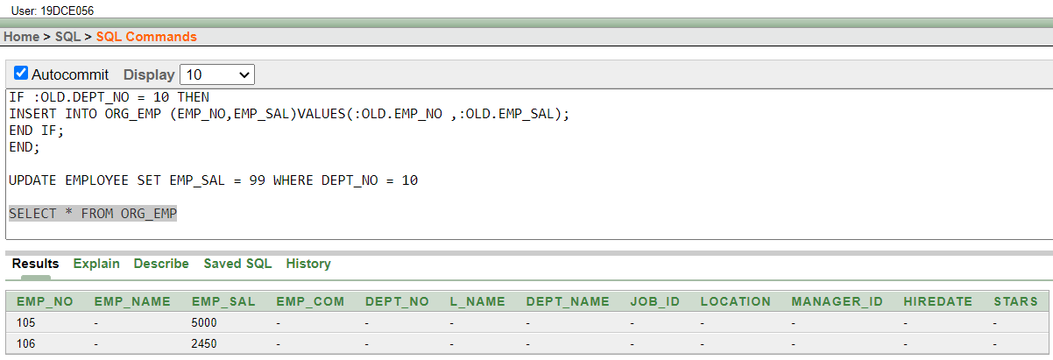
CONCLUSION: After performing this practical, we understood the concept of trigger in PL/SQL.
PRACTICAL – 18
AIM: To solve queries using concept of view.
COMMANDS:
create view accemploc as select * from employee where location = 'NEW YORK'
select * from accemploc
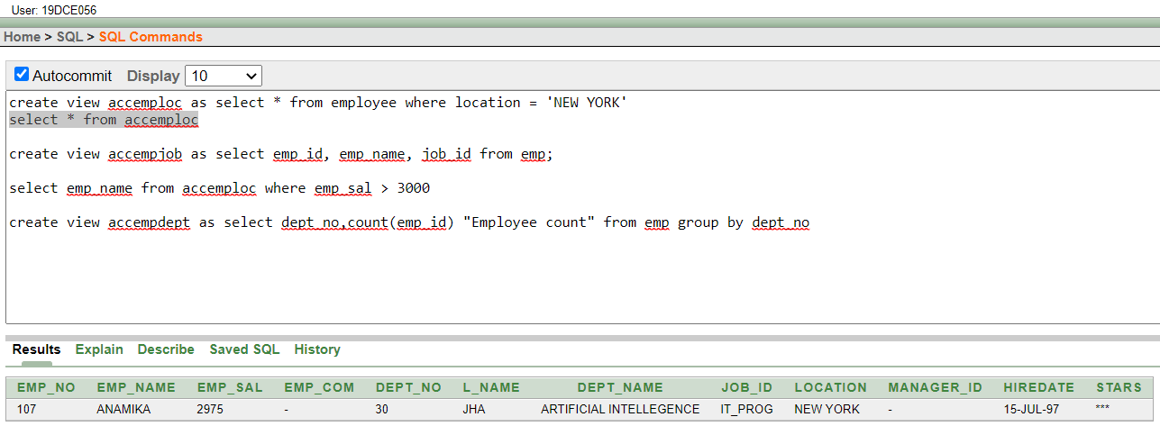
create view accempjob as select emp_no, emp_name, job_id from employee;
select emp_name from accemploc where emp_sal > 3000
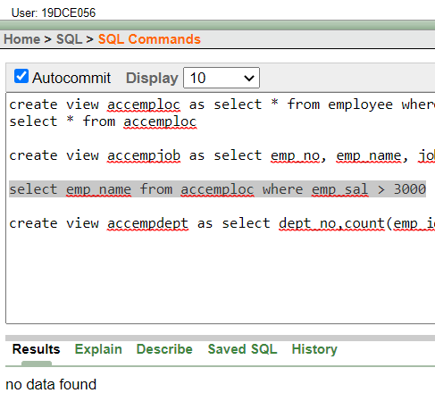

create view accempdept as select dept_no,count(emp_no) "Employee count" from employee group by dept_no
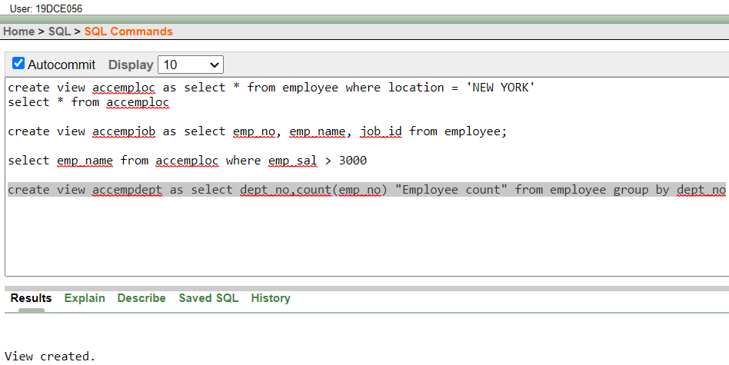
CONCLUSION: After performing this practical, we understood the concept of view in PL/SQL.

PRACTICAL – 19
To perform the concept of function and procedure.
COMMANDS:
create or replace procedure update_emp_sal(empid number,newsal number) is
row_updated number;
begin
update employee set emp_sal = newsal where emp_no = empid;
row_updated := SQL%rowcount;
if row_updated = 0 then
dbms_output.put_line('Salary not updated ! No employee with Emp_no '||empid||' found !');
else
dbms_output.put_line('Salary updated for employee with Emp_no '||empid||'.');
end if;
end;
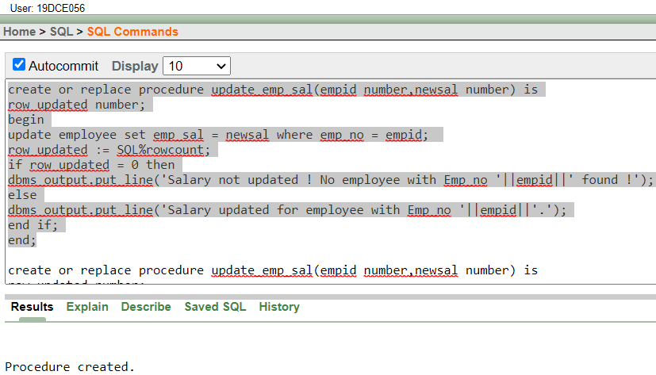
create or replace procedure update_emp_sal(empid number,newsal number) is
row_updated number;
begin
update employee set emp_sal = newsal where emp_no = empid;
row_updated := SQL%rowcount;
if row_updated = 0 then
dbms_output.put_line('Salary not updated ! No employee with Emp_no '||empid||' found !');
else
dbms_output.put_line('Salary updated for employee with Emp_no '||empid||'.');
end if;
end;
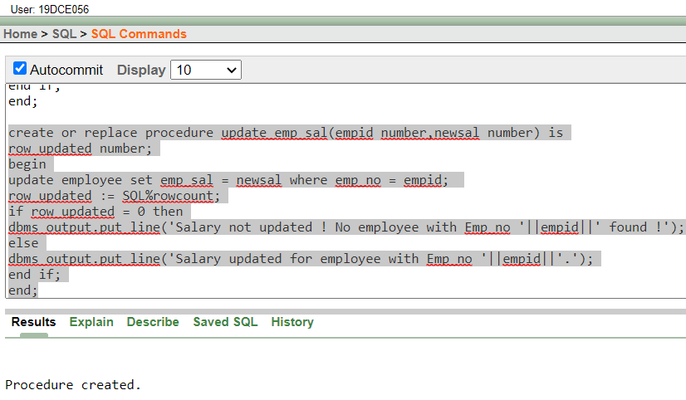
CONCLUSION: After performing this practical, we understood the concept of function and procedure in PL/SQL.

PRACTICAL – 20
To perform the concept of exception handler.
COMMANDS:
create or replace function add100(amount number) return number is
begin
return amount+100;
end;
create or replace function sub100(amount number) return number is
begin
return -100;
end;

declare
id number := :Enter_ID;
amount number := 0;
excep_amt_negative exception;
begin
select emp_sal into amount from employee where emp_no = id;
amount := sub100(amount);
if amount < 0 then
raise excep_amt_negative;
end if;
update employee set emp_sal = amount where emp_no =id;
dbms_output.put_line(amount);
exception when excep_amt_negative then
dbms_output.put_line('Amount is negative.');
end;
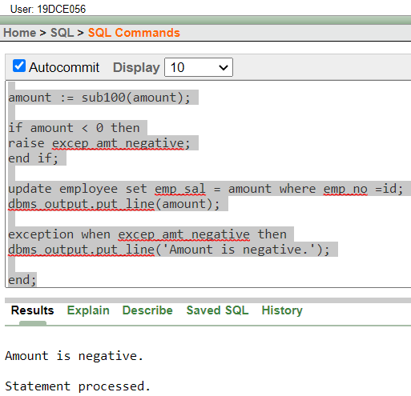
CONCLUSION: After performing this practical, we understood the concept of exception handler in PL/SQL.
PRACTICAL – 21
To perform the concept of package.
COMMANDS:
create or replace package pkg is
this_is_var varchar2(10):='Variables';

procedure this_is_procedure;

function this_is_function return number;
end;
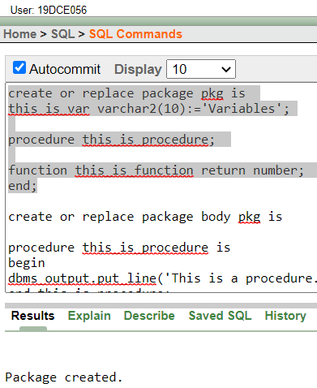
create or replace package body pkg is

procedure this_is_procedure is
begin
dbms_output.put_line('This is a procedure.');
end this_is_procedure;

function this_is_function return number is
begin
dbms_output.put_line('This is a function returning 0.');
return 0;
end this_is_function;
end pkg;
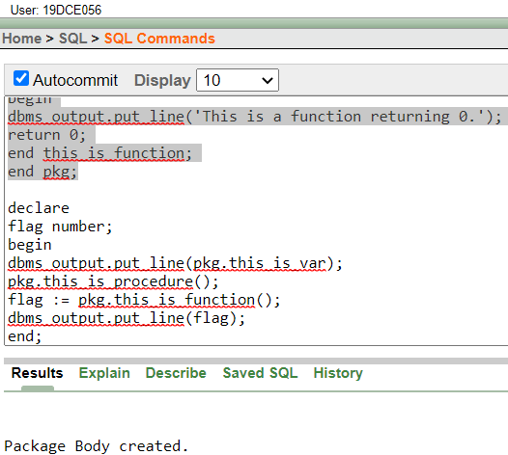
declare
flag number;
begin
dbms_output.put_line(pkg.this_is_var);
pkg.this_is_procedure();
flag := pkg.this_is_function();
dbms_output.put_line(flag);
end;
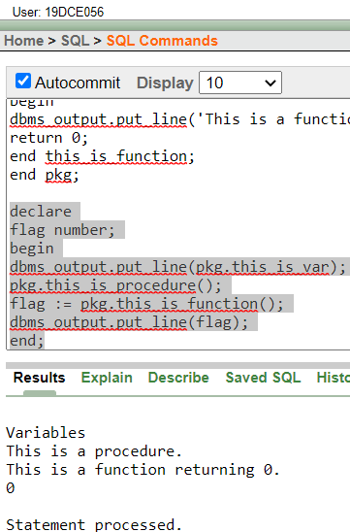
CONCLUSION: After performing this practical, we understood the concept of package in PL/SQL.

