Business Problem
Effective inventory and sales management are critical for optimizing profitability in the retail and wholesale industry. Companies need to ensure that they are not incurring losses due to inefficient pricing, poor inventory turnover, or vendor dependency. The goal of this analysis is to:
- Identify underperforming brands that require promotional or pricing adjustments.
- Determine top vendors contributing to sales and gross profit.
- Analyze the impact of bulk purchasing on unit costs.
- Assess inventory turnover to reduce holding costs and improve efficiency.
- Investigate the profitability variance between high-performing and low-performing vendors.

Exploratory Data Analysis Insights
 | count | mean | std | min | 25% | 50% | 75% | max
VendorNumber | 10692.0 | 1.065065e+04 | 18753.519148 | 2.00 | 3951.000000 | 7153.000000 | 9552.000000 | 2.013590e+05
Brand | 10692.0 | 1.803923e+04 | 12662.187074 | 58.00 | 5793.500000 | 18761.500000 | 25514.250000 | 9.063100e+04
PurchasePrice | 10692.0 | 2.438530e+01 | 109.269375 | 0.36 | 6.840000 | 10.455000 | 19.482500 | 5.681810e+03
ActualPrice | 10692.0 | 3.564367e+01 | 148.246016 | 0.49 | 10.990000 | 15.990000 | 28.990000 | 7.499990e+03
Volume | 10692.0 | 8.473605e+02 | 664.309212 | 50.00 | 750.000000 | 750.000000 | 750.000000 | 2.000000e+04
TotalPurchaseQuantity | 10692.0 | 3.140887e+03 | 11095.086769 | 1.00 | 36.000000 | 262.000000 | 1975.750000 | 3.376600e+05
TotalPurchaseDollars | 10692.0 | 3.010669e+04 | 123067.799627 | 0.71 | 453.457500 | 3655.465000 | 20738.245000 | 3.811252e+06
TotalSalesDollars | 10692.0 | 4.223907e+04 | 167655.265984 | 0.00 | 729.220000 | 5298.045000 | 28396.915000 | 5.101920e+06
TotalSalesPrice | 10692.0 | 1.879378e+04 | 44952.773386 | 0.00 | 289.710000 | 2857.800000 | 16059.562500 | 6.728193e+05
TotalSalesQuantity | 10692.0 | 3.077482e+03 | 10952.851391 | 0.00 | 33.000000 | 261.000000 | 1929.250000 | 3.349390e+05
TotalExciseTax | 10692.0 | 1.774226e+03 | 10975.582240 | 0.00 | 4.800000 | 46.570000 | 418.650000 | 3.682428e+05
TotalFreightCost | 10692.0 | 6.143376e+04 | 60938.458032 | 0.09 | 14069.870000 | 50293.620000 | 79528.990000 | 2.570321e+05
GrossProfit | 10692.0 | 1.213238e+04 | 46224.337964 | -52002.78 | 52.920000 | 1399.640000 | 8660.200000 | 1.290668e+06
ProfitMargin | 10692.0 | -inf | NaN | -inf | 13.324515 | 30.405457 | 39.956135 | 9.971666e+01
StockTurnover | 10692.0 | 1.706793e+00 | 6.020460 | 0.00 | 0.807229 | 0.981529 | 1.039342 | 2.745000e+02
SalestoPurchaseRatio | 10692.0 | 2.504390e+00 | 8.459067 | 0.00 | 1.153729 | 1.436894 | 1.665449 | 3.529286e+02

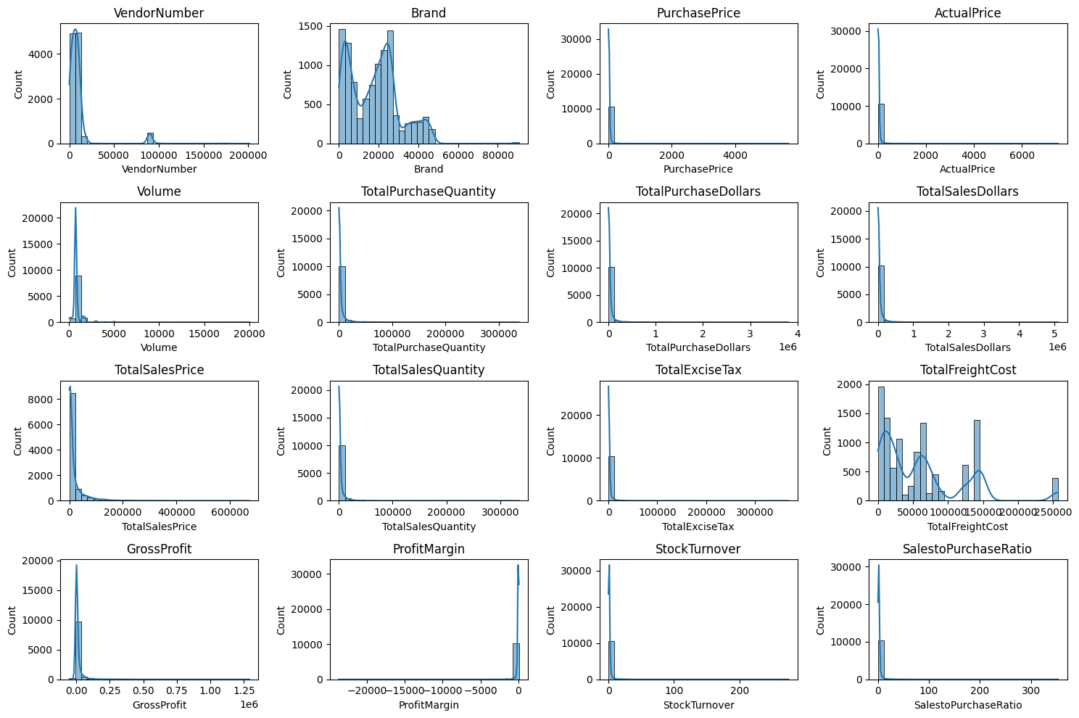

Negative & Zero Values:
Gross Profit: Minimum of -52,002.78, indicating potential losses due to high costs or heavy discounts. This could be due to selling products at lower prices than their purchase costs.
Profit Margin: Has a minimum of $-\infty$, which suggests instances where revenue is zero or even lower than the total cost, leading to extreme negative profit margins.
Total Sales Quantity & Sales Dollars: Some products show zero sales, indicating they were purchased but never sold. These may be slow-moving or obsolete stock, leading to inventory inefficiencies.
Outliers Detected by High Standard Deviations:
Purchase & Actual Prices: The maximum values (5,681.81 & 7,499.99) are significantly higher than the mean (24.39 & 35.64), indicating premium product offerings.

Exploratory Data Analysis Insights

Initial Data Observations
Freight Cost: Extreme variation from 0.09 to 257,032.07 suggests logistics inefficiencies, bulk shipments, or erratic shipping costs across different products.
Stock Turnover: Ranges from 0 to 274.5, suggesting some products sell rapidly while others remain unsold for long periods. A value greater than 1 indicates that sales for a product exceed the purchased quantity due to older stock fulfilling orders.

Data Filtering
To enhance the reliability of the insights, we removed inconsistent data points where:
- Gross Profit ≤0 (to exclude transactions leading to losses).
- Profit Margin ≤0 (to ensure analysis focuses on profitable transactions).
- Total Sales Quantity =0 (to eliminate inventory that was never sold).

Correlation Insights
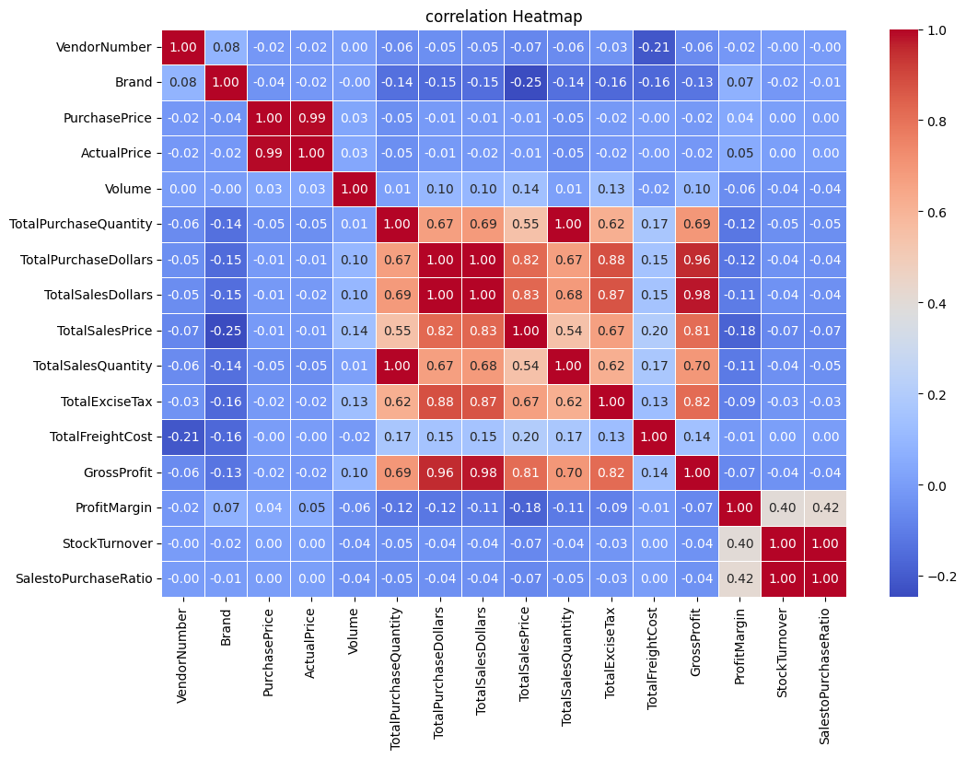
Purchase Price vs. Total Sales Dollars & Gross Profit: Weak correlation (−0.012 and −0.016), indicating that price variations do not significantly impact sales revenue or profit.
Total Purchase Quantity vs. Total Sales Quantity: Strong correlation (0.999), confirming efficient inventory turnover.
Profit Margin vs. Total Sales Price: Negative correlation (−0.179), suggesting increasing sales prices may lead to reduced margins, possibly due to competitive pricing pressures.
Stock Turnover vs. Gross Profit & Profit Margin: Weak negative correlation (−0.038 & −0.055), indicating that faster stock turnover does not necessarily equate to higher profitability.

Research Questions & key Findings
1. Brands for Promotional or Pricing Adjustments
Brands with low Sales but High Profit Margins:
 | Description | TotalSalesDollars | ProfitMargin
6199 | Santa Rita Organic Svgn Bl | 9.99 | 66.466466
2369 | Debauchery Pnt Nr | 11.58 | 65.975820
2070 | Concannon Glen Ellen Wh Zin | 15.95 | 83.448276
2188 | Crown Royal Apple | 27.86 | 89.806174
6237 | Sauza Sprklg Wild Berry Marg | 27.96 | 82.153076
... | ... | ... | ...
5074 | Nanbu Bijin Southern Beauty | 535.68 | 76.747312
2271 | Dad's Hat Rye Whiskey | 538.89 | 81.851584
57 | A Bichot Clos Marechaudes | 539.94 | 67.740860
6245 | Sbragia Home Ranch Merlot | 549.75 | 66.444748
3326 | Goulee Cos d'Estournel 10 | 558.87 | 69.434752

198 brands exhibit lower sales but higher profit margins, which could benefit from targeted marketing, promotions, or price optimizations to increase volume without compromising profitability.
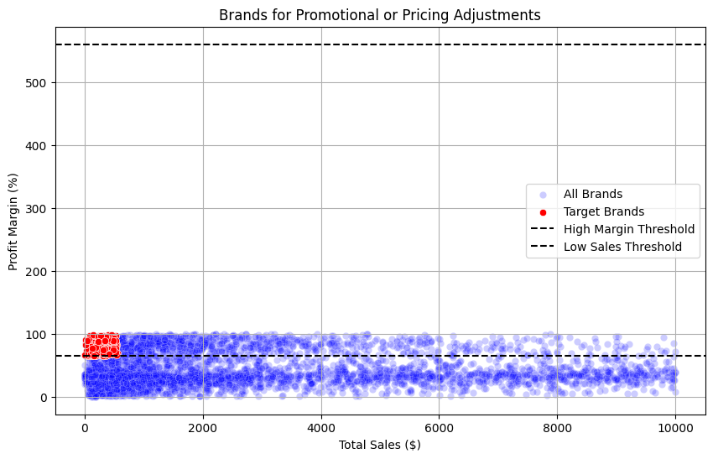
2. Top Vendors by Sales & Purchase Contribution
The top 10 vendors contribute 65.34% of total purchase, while the remaining vendors contribute only 34.7%. This over-reliance on a few vendors may introduce risks such as supply chain disruptions, indicating a need for diversification.
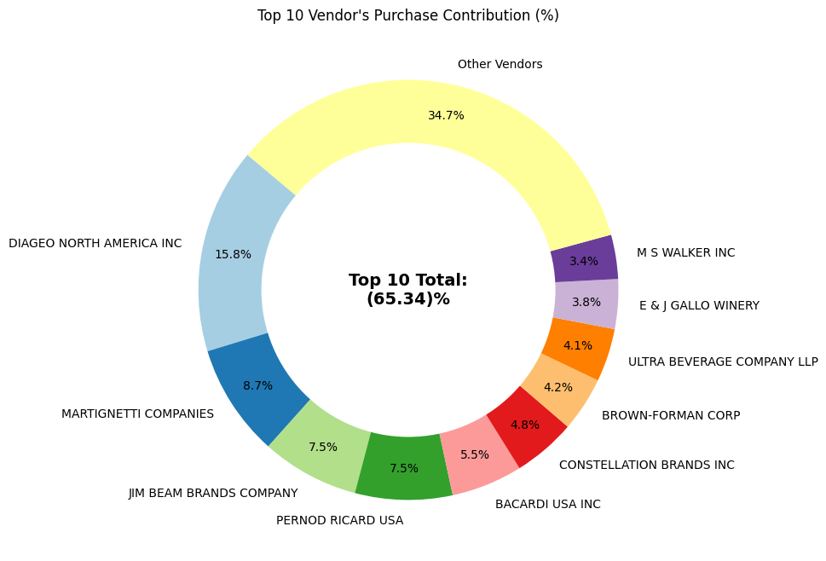
3. Impacts of Bulk Purchasing on Cost Savings
Vendors buying in large quantities receive a 72% lower unit cost ($11.30 per unit vs. higher unit costs in smaller orders).
Bulk pricing strategies encourage larger orders, increase total sales while maintaining profitability.
OrderSize | UnitPurchasePrice
Small | 43.776954
Medium | 17.894005
Large | 11.308807

4. Identifying Vendors with Low Inventory Turnover
Total unsold inventory capital: $2.71M
Slow-moving inventory increase storage costs, reduces Cash flow efficiency, and affects overall profitability.
Identifying vendors with low inventory turnover enables better stock management, minimizing financial strain.
VendorName | StockTurnover | Vendor  Name | UnsoldInventoryValue
AAPER ALCOHOL & CHEMICAL CO | 0.000000 | 28 | DIAGEO NORTH AMERICA INC | 980.09K
LAUREATE IMPORTS CO | 0.000000 | 63 | MARTIGNETTI COMPANIES | 928.99K
TRUETT HURST | 0.041667 | 50 | JIM BEAM BRANDS COMPANY | 857.80K
IRA GOLDMAN AND WILLIAMS, LLP | 0.075000 | 114 | ULTRA BEVERAGE COMPANY LLP | 780.27K
HIGHLAND WINE MERCHANTS LLC | 0.148920 | 73 | PERFECTA WINES | 571.81K
UNCORKED | 0.217238 | 74 | PERNOD RICARD USA | 554.74K
MILTONS DISTRIBUTING CO | 0.236111 | 59 | M S WALKER INC | 469.96K
VINEYARD BRANDS LLC | 0.256241 | 125 | WILLIAM GRANT & SONS INC | 436.49K
LOYAL DOG WINERY | 0.308333 | 33 | E & J GALLO WINERY | 315.20K
BLACK COVE BEVERAGES | 0.340588 | 14 | BROWN-FORMAN CORP | 284.91K

5. Profit Margin Comparison: High vs. Low-Performing
Top Vendors' Profit Margin (95% CI): (30.74%, 31.61%), Mean: 31.17% Low Vendors' Profit Margin (95% CI): (40.48%, 42.62%), Mean: 41.55%
Low-performing vendors maintain higher margins but struggle with sales volumes, indicating potential pricing inefficiencies or market reach issues.
Actionable Insights:
- Top-performing vendors: Optimize profitability by adjusting pricing, reducing operational costs, or offering bundled promotions.
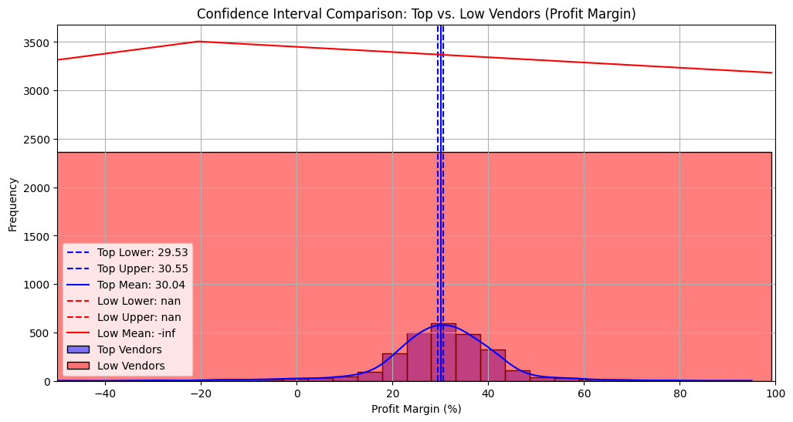

6. Statistical Validation of Profit Margin Differences
Hypothesis Testing:
H0​ (Null Hypothesis): No significant difference in profit margins between top and low-performing vendors.
H1​ (Alternative Hypothesis): A significant difference exists in profit margins between the two vendor groups.
Result: The null hypothesis is rejected, confirming that the two groups operate under distinctly different profitability models.
Implication: High-margin vendors may benefit from better pricing strategies, while top-selling vendors could focus on cost efficiency.

Further Recommendations
- Diversify vendor partnerships to reduce dependency on a few suppliers and mitigate supply chain risks.
- Leverage bulk purchasing advantages to maintain competitive pricing while optimizing inventory management.
- Optimize slow-moving inventory by adjusting purchase quantities, launching clearance sales, or revising storage strategies.
- Enhance marketing and distribution strategies for low-performing vendors to drive higher sales volumes without compromising profit margins.
- By implementing these recommendations, the company can achieve sustainable profitability, mitigate risks, and enhance overall operational efficiency.

