Game Design Document

Fill up the following document

1. Write the title of your project.

Shadow Fight Arena

1. What is the goal of the game?

The goal of the game is to defeat your shadow opponent

1. Write a brief story of your game.

You were a great warrior having a vision to conquer the world. But as you approached a desert, you opened the gate of shadow monsters. To take a revenge and to accomplish your original dream, you have to fight and win against every other shadow warrior.

1. Which are the playing characters of this game?

* Playing characters are the ones who respond to the user based on the input from the user.
* Cars, monkeys, dinos, wizards, etc., are the playing characters in the game.

|  |  |  |
| --- | --- | --- |
| Number | Character Name | What can this character do? |
| 1 | Shadow warrior (you) | Jump, kick, attack, move |
| 2 | Shadow warrior (opponent) | Jump, kick, attack, move |
| 3 |  |  |
| 4 |  |  |
| 5 |  |  |
| 6 |  |  |
| 7 |  |  |
| 8 |  |  |

1. Which are the Non-Playing Characters of this game?

* Non-Playing characters are the ones that don't have an action or behavior when the user interacts with the game.
* Hurdles, stones, bananas, coins, etc., are non-playing characters in the game.

|  |  |  |
| --- | --- | --- |
| Number | Character Name | What can this character do? |
| 1 | Background | - |
| 2 |  |  |
| 3 |  |  |
| 4 |  |  |
| 5 |  |  |
| 6 |  |  |
| 7 |  |  |
| 8 |  |  |

Draw your imagination of this game. What does this game look like?

* Draw the game either on your computer or on paper.
* Add images of the game scenes to show each of the playing and non-playing characters at least once.

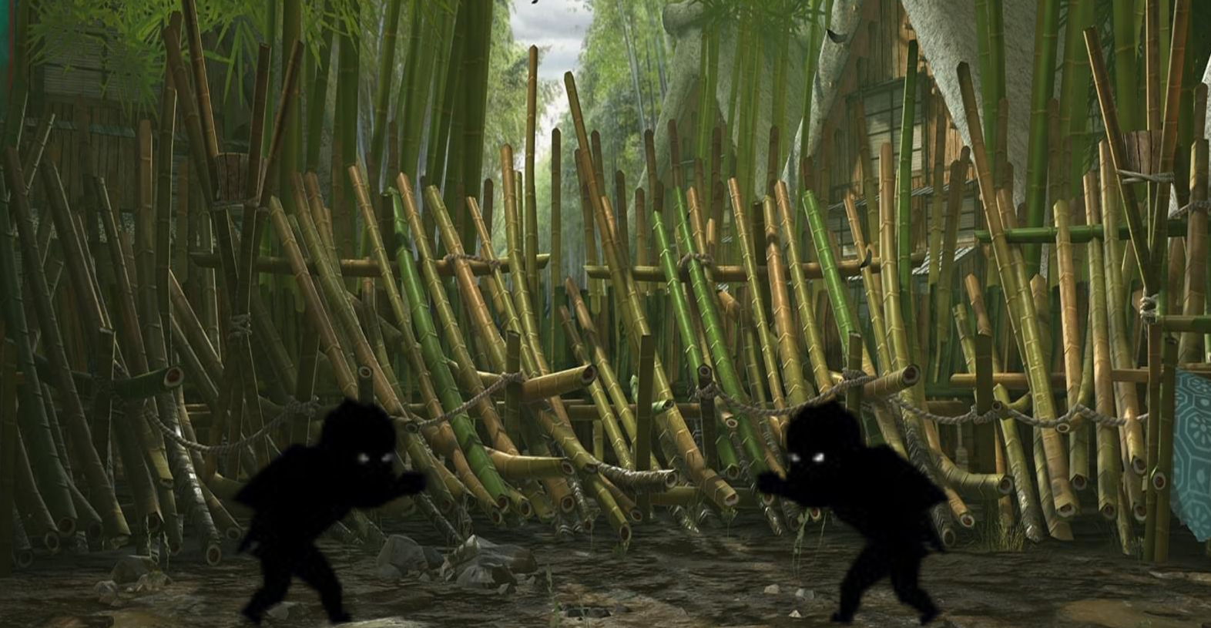

How do you plan to make your game engaging?

By making it multiplayer, adding different attacks, and maybe in the future adding stuff like customization, weapons, moves and levels.