Twin Deficits Hypothesis
Has the link between the U.S. budget deficit and the current account weakened?
Undergraduate research proposal with preliminary evidence | Neel Nanavati

1. Research question
Has the "twin deficits" relation continued to hold in recent times, or has the empirical connection between the U.S. government budget deficit and the current account deficit become weaker?

2. Key idea
National accounting implies that the current account equals national saving minus investment, so it can be written as the sum of the private sector balance (private saving minus investment) and the government balance. An increase in the government budget deficit must therefore be offset by higher private saving, lower domestic investment, or a larger current account deficit. Standard macroeconomic theory suggests that higher government borrowing should worsen the external balance. If so, the current account should have a positive slope on the fiscal balance: a more negative fiscal balance goes with a more negative current account.
Over recent years, trade and the current account have also been shaped by global supply chain dynamics, exchange rate movements, and trade policy such as tariffs. The project asks whether the government deficit still moves together with the external balance, or whether other factors now dominate.

3. Data and methodology

3.1 Data
The proposal calls for quarterly U.S. data from FRED covering the federal fiscal balance, the current account, private saving and the real exchange rate. The preliminary analysis reported here uses annual data (1980-2024, % of GDP) and adds two comparison countries, to test the relationship before moving to the quarterly design.
- Fiscal balance: government net lending (+) / net borrowing (-), % of GDP. Germany and Japan: IMF World Economic Outlook (code GGXCNL_NGDP). U.S.: BEA national accounts, total government net lending (FRED series AD01RC1A027NBEA) divided by nominal GDP, because the IMF U.S. series only starts in 2001.
- Current account: current account balance, % of GDP, IMF World Economic Outlook (code BCA_NGDPD), for all three countries.
- Consistency check: over 2001-2024 the BEA and IMF U.S. series correlate at 0.986. BEA is on average about 0.9 points of GDP more negative, and the gap shrinks in recent years.

3.2 Empirical methods (R)
- OLS regressions of the current account on the fiscal balance, in levels and in first differences, with Newey-West standard errors.
- Robustness checks: excluding 2020-2021, adding a COVID dummy, and comparing a common sample with each country's full sample.
- Early versus late period correlations (split at 2012) and 10-year rolling correlations.
- ADF unit-root tests and the Phillips-Ouliaris cointegration test, to judge whether levels results could be spurious.

4. Preliminary evidence

4.1 The series over time
Figure 1 plots the fiscal balance and the current account for each country. The U.S. fiscal balance swings widely (about +0.4% of GDP in 2000 to about -15% in 2020), while the U.S. current account stays negative, between about 0% and -6%, and is much less volatile. Germany combines a fiscal balance near zero with a current account that rises to roughly +8-9% of GDP by 2016. Japan runs persistent fiscal deficits alongside a current account surplus. In none of the three does the current account simply mirror the budget balance.
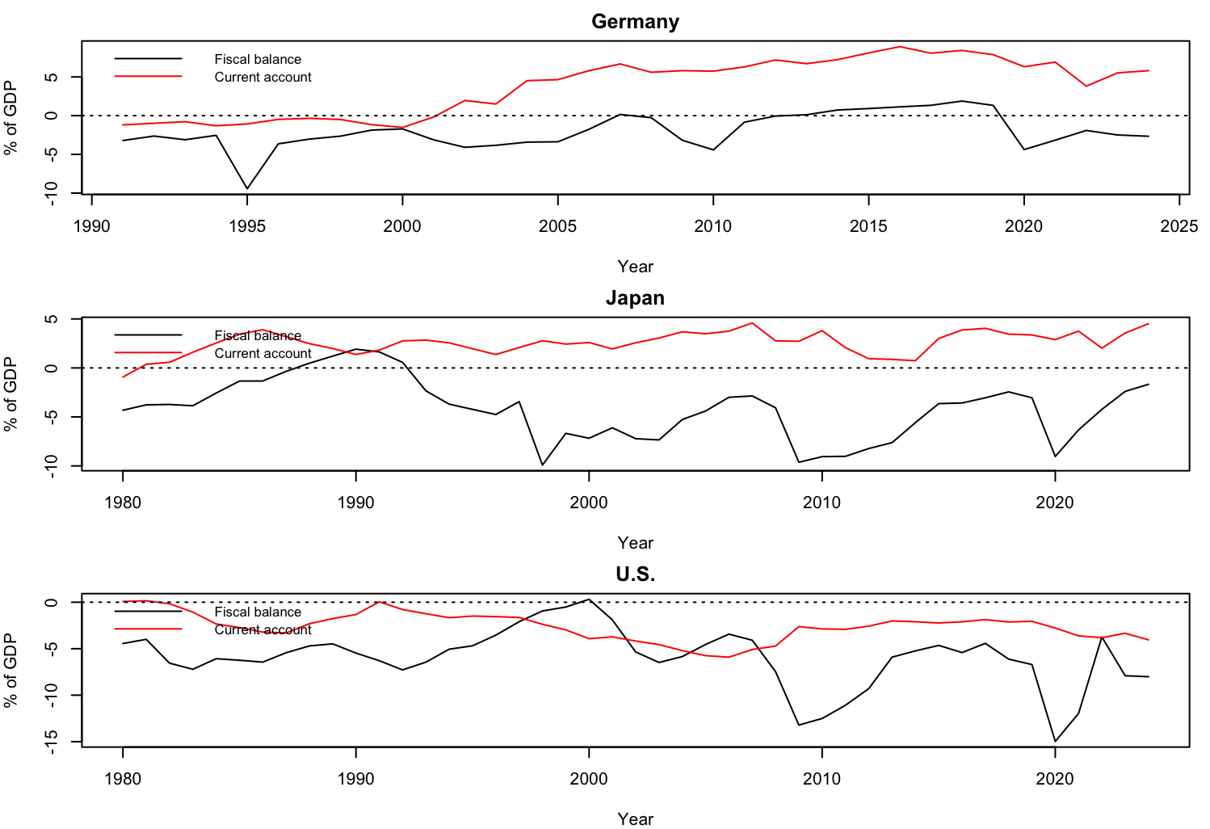
Figure 1. Fiscal balance (black) and current account (red), % of GDP. Germany 1991-2024; Japan and U.S. 1980-2024.

4.2 Regression results
Table 1 reports the slope of the current account on the fiscal balance, with Newey-West p-values in brackets. Twin deficits predicts a positive slope.
Sample | Levels | First differences | Levels excl. 2020-21 | Diff. excl. 2020-21
Germany, 2001-2024 | 0.741 (0.002) | 0.156 (0.150) | 0.885 (<0.001) | -0.015 (0.931)
Japan, 2001-2024 | 0.223 (0.012) | 0.113 (0.020) | 0.254 (0.017) | 0.106 (0.186)
U.S., 2001-2024 | -0.100 (0.196) | -0.043 (0.460) | -0.128 (0.138) | -0.082 (0.219)
Germany, 1991-2024 | 0.968 (<0.001) | 0.063 (0.357) | 1.071 (<0.001) | -0.010 (0.869)
Japan, 1980-2024 | 0.032 (0.576) | 0.038 (0.459) | 0.047 (0.458) | 0.008 (0.891)
U.S., 1980-2024 | -0.002 (0.976) | -0.052 (0.359) | -0.028 (0.677) | -0.088 (0.169)
Table 1. Slope of current account on fiscal balance (p-value). Source: author's calculations.
- U.S.: slopes are small, negative and statistically insignificant in every specification. The data give no support for a stable twin deficits relationship.
- Germany: a strong positive slope in levels that disappears in first differences (0.063, p = 0.357 for the full sample). This pattern is typical of shared trends rather than a direct effect of the budget on the current account.
- Japan: a small positive first-difference slope for 2001-2024 (about 0.11, p = 0.020), but nothing over the full 1980-2024 sample.
- Time-series properties: ADF tests mostly fail to reject a unit root and the cointegration p-values are all 0.11 or higher (the tseries package reports values only up to 0.15). There is no clear sign of a stable long-run relationship, so levels results should be read with caution.

4.3 Is the relationship stable over time?
Figure 2 shows 10-year rolling correlations. For Germany the correlation is near zero until the mid-2000s and then settles at about 0.6-0.9. For Japan it is unstable before 2007 and positive (about 0.3-0.7) afterwards. For the U.S. it moves from close to -0.9 (windows ending around 2000 and 2011-2012) to above +0.9 (windows ending around 2018-2019), then falls to about 0.3 by 2024.
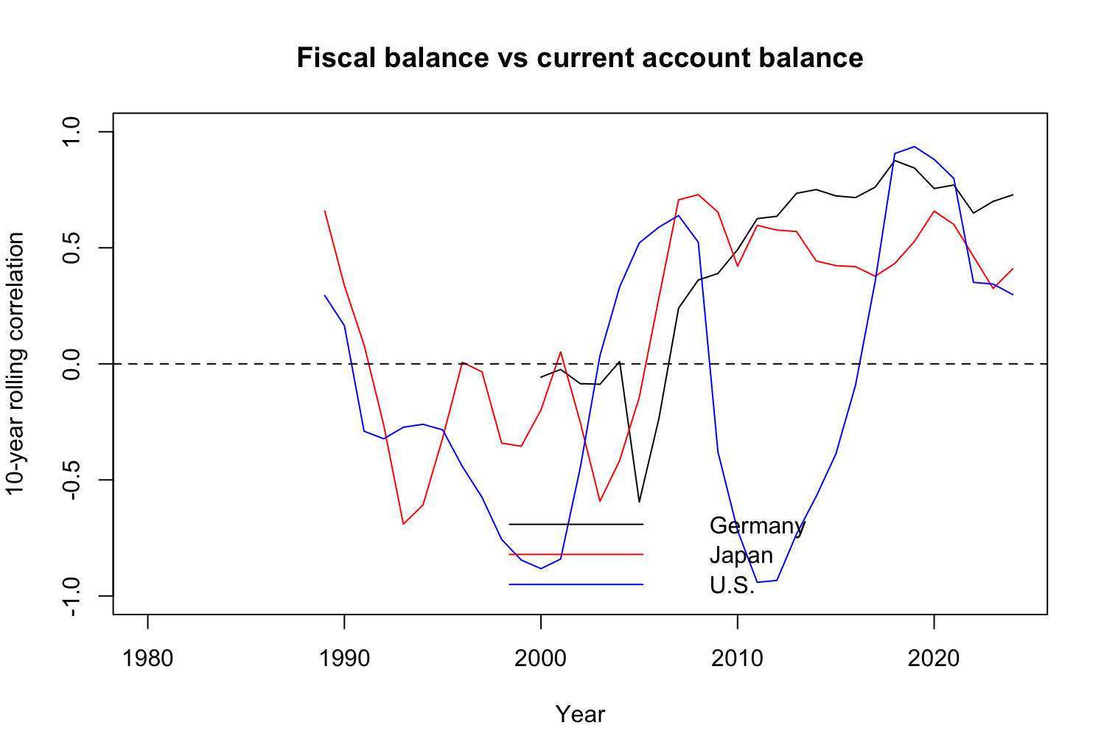
Figure 2. 10-year rolling correlation between fiscal balance and current account (levels).
For the U.S. this answers the research question only partly. The link is not strong and not stable. The rolling correlation reached its highest values around 2018-2019 and has declined since, which is consistent with a weakening in recent years, but each window has only 10 observations and neighbouring windows overlap, so this should be treated as descriptive.

5. Interpretation
Taken together, the preliminary results suggest that the budget deficit does not reliably explain U.S. current account movements over 1980-2024. Where a positive relationship appears (Germany in levels, Japan in differences after 2001), it is either not robust to differencing or limited to recent years. This fits the view that other factors, such as private saving and investment, the exchange rate, global demand and trade policy, play a large role. These results are correlations, not causal estimates.

6. Limitations
- Small annual samples (24 to 45 observations), so p-values are approximate and unit-root and cointegration tests have low power.
- No control variables yet. The business cycle can move both balances at once.
- The U.S. fiscal series (BEA) and the Germany and Japan series (IMF) come from different sources, although they are conceptually similar.

7. Next steps (to complete the proposal)
- Move to quarterly U.S. data from FRED covering roughly the past 20-25 years.
- Add controls named in the proposal: private saving, investment and the real exchange rate.
- Use a cyclically adjusted fiscal balance to remove business-cycle effects.
- Test formally for structural breaks and estimate rolling regression coefficients.
- Examine whether tariffs and supply chain disruptions change the relationship in recent years.

8. Data sources and code
- International Monetary Fund, World Economic Outlook database (indicators GGXCNL_NGDP and BCA_NGDPD).
- U.S. Bureau of Economic Analysis, Net lending or net borrowing (-), NIPAs: Government [AD01RC1A027NBEA], and nominal GDP, retrieved from FRED, Federal Reserve Bank of St. Louis.
- Analysis code and documentation: Twin_deficit_Final.R and README.md (see the project repository).

