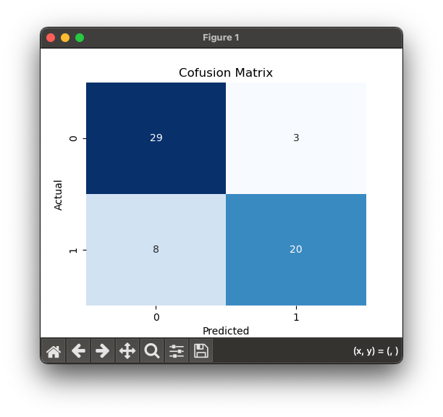
Confusion Matrix
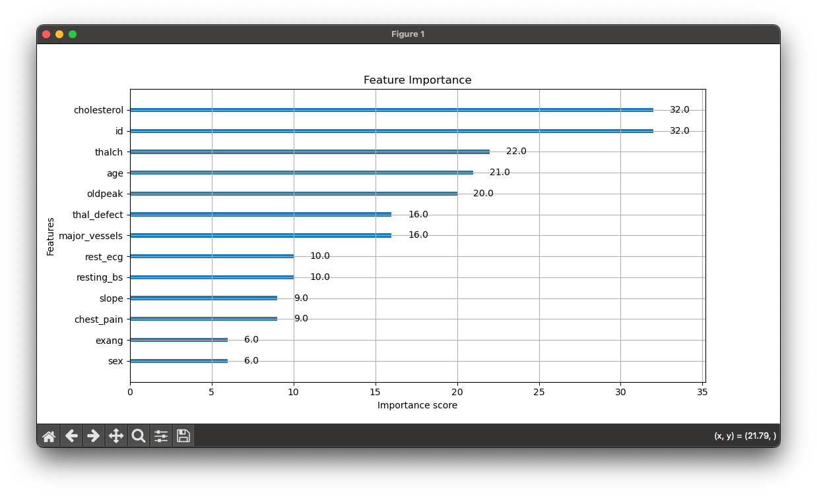
Feature Importance graph

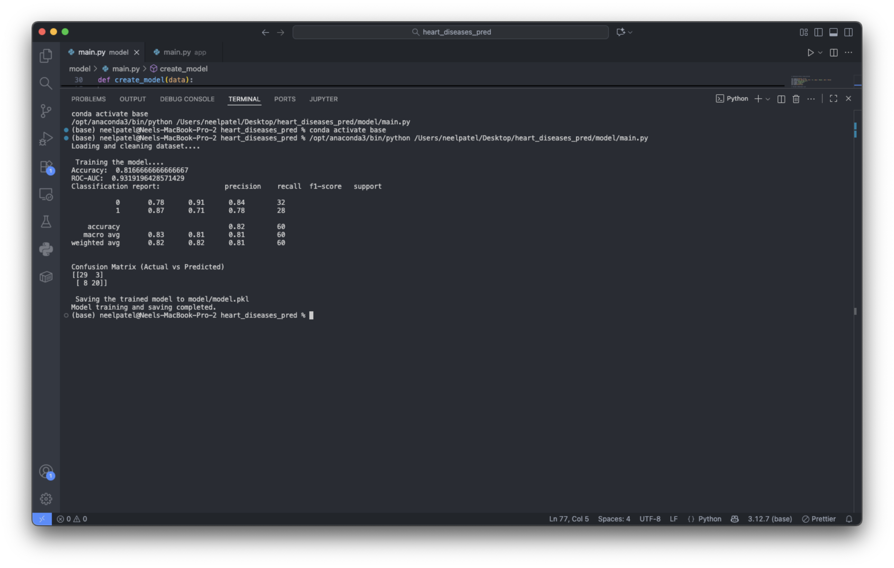
Model performance after removing states and readmission rates.
Accuracy: 0.82
ROC-AUC: 0.93
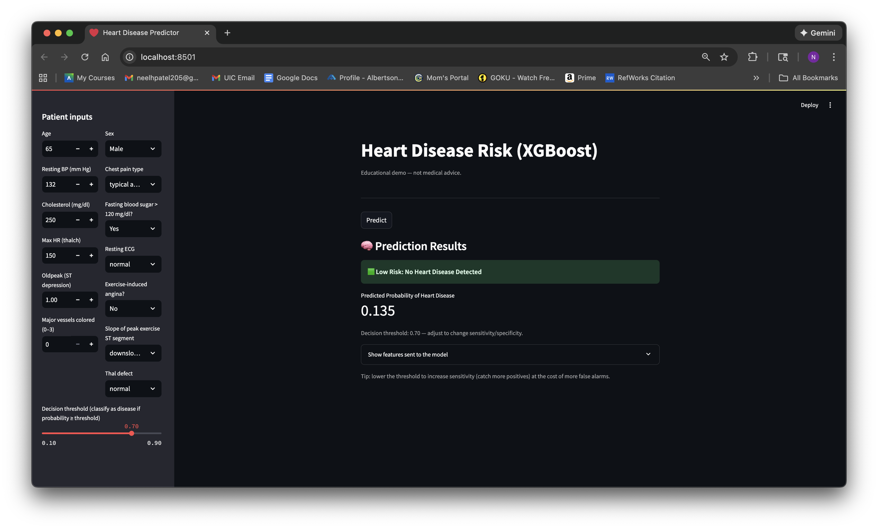
First Draft of the front-end UI built in Streamlit.
On the left side, all the features are available for users to either select from a dropdown or input their desired values.
There is a decision threshold slider below the inputs, which allows users to set their desired threshold for classifying diseases. If the probability exceeds this threshold, it will indicate a disease.
In the middle of the screen, the prediction result is displayed only after pressing the predict button. We then receive the predicted probability of heart diseases.
We can also see the values that were sent to the model, which influenced its decision.

