PRACTICAL-1

Part A — Practice Programs
Work these in your lab-NN/ folder before the project: do the first one or two in the lab.

1. Vending machine (VendingMachine.java, main in this file)
(a) Define an enum Coin with constants ONE, TWO, FIVE, TEN.
(b) In main, set a snack price of 15 and a running total of 0; create a Scanner.
(c) Loop: read a coin name, use a switch expression to convert the Coin to its value
(ONE→1, TWO→2, FIVE→5, TEN→10), add it to the total, and print the total so
far.
(d) Stop the loop once the total reaches 15 or more.
(e) Print the change to return (total − 15).
Expected output: TEN then FIVE prints “Paid. Change: 0”; TEN then TEN prints
“Paid. Change: 5”.

CODE:

import java.util.*;
public class P1_partA_1 {
enum Coin{
ONE,
TWO,
FIVE,
TEN
}
public static void main(String []args){
int snackprice=15;
int Total=0;
Scanner sc=new Scanner(System.in);

while(Total<snackprice){
System.out.println("Enter Coin(ONE,TWO,FIVE,TEN):");
Coin coin=Coin.valueOf(sc.next().toUpperCase());

int value=switch(coin){
case ONE -> 1;
case TWO -> 2;
case FIVE -> 5;
case TEN -> 10;
};

Total=Total+value;
System.out.println("Your total is:" + Total);
}
System.out.println("Your Change is:"+(Total-snackprice));
sc.close();
}
}

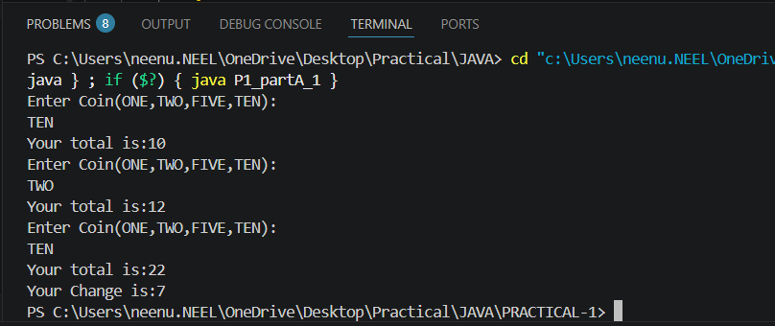

2. Toll booth (TollBooth.java, main in this file)
(a) Define a record Vehicle(String number, String type).
(b) In main, keep a running toll total and three counters (bike, car, truck).
(c) Loop until the user types “done” for the number: build a Vehicle, use a switch
expression on its type for the toll (bike→20, car→50, truck→150), add to the total,
and increment that type’s counter.
(d) After the loop, print the total toll and the type with the highest count.
Expected output: two cars + one bike → “Total toll: 120”, “Most frequent: car”.

CODE:

import java.util.*;

record Vehicle(String number,String type){}

public class P1_partA_2{
public static void main(String[] args){
Scanner sc=new Scanner(System.in);

int total=0;
int bike=0;
int car=0;
int truck=0;

while(true){
System.out.print("Enter vehicle number (done to stop):");
String number=sc.next();

if(number.equalsIgnoreCase("done")){
break;
}

System.out.print("Enter vehicle type (bike/car/truck):");
String type=sc.next().toLowerCase();

Vehicle v=new Vehicle(number,type);

int toll=switch(type){
case "bike"->20;
case "car"->50;
case "truck"->150;
default->0;
};

total+=toll;

if(type.equals("bike")){
bike++;
}else if(type.equals("car")){
car++;
}else if(type.equals("truck")){
truck++;
}
}

System.out.println("Total toll: "+ total);

if(bike>car&&bike>truck)
{
System.out.println("Most frequent: bike");
}
else if(car>bike&&car>truck)
{
System.out.println("Most frequent: car");
}
else
{
System.out.println("Most frequent: truck");
}
sc.close();
}
}
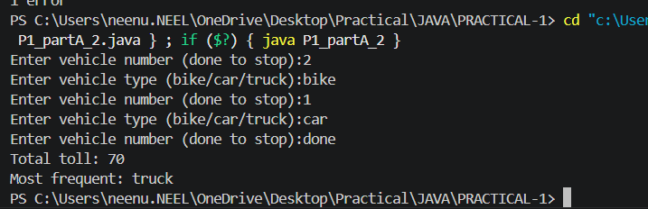

Part B — Project Work (Hour 2): MiniBank
MiniBank is the console banking application you will build across the whole semester. In
this first lab you set up your tools and create the project and its menu shell — the screen the
user navigates. Every later lab attaches one real banking feature behind these menu options.
1. Set up your environment: open the project in GitHub Codespaces (or install JDK 17+ and
an IDE locally), and create a private GitHub repository named oop-minibank-<rollno>;
add the faculty as a collaborator.
2. Create a public class named MiniBank that contains the main method.
3. Define a record named BankInfo with two String fields, name and branch (a record is a
short, read-only class; Java auto-generates its constructor and field accessors). Print one
BankInfo object as the application header.
4. Define an enum named MenuOption with the constants OPEN_ACCOUNT, DEPOSIT,
WITHDRAW, TRANSFER and EXIT — these are the actions MiniBank will offer.
5. Display the numbered menu to the user and read the chosen number with a Scanner.
6. Use a switch expression on the choice to print a short placeholder for that option (for
example, “Deposit — to be implemented in a later lab”). Keep showing the menu in a
loop until the user selects EXIT, then print a goodbye message.

CODE:

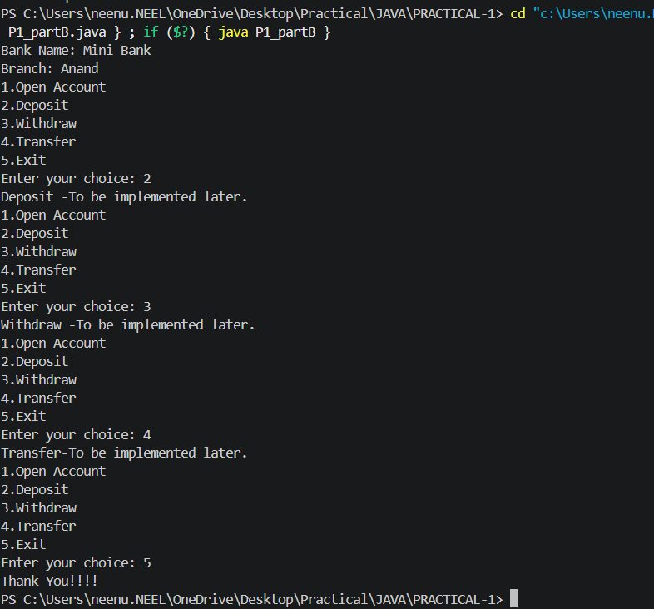

KEY QUESTION:

- What is the role of the JVM, and what file does the javac compiler produce?
=>The JVM runs Java bytecode, and the javac compiler converts the .java source file into a .class file containing bytecode.

- How does a switch expression differ from a traditional switch statement?
=>A switch expression returns a value and can use yield, while a traditional switch statement performs actions without directly returning a value.

- Why is an enum a good choice for a fixed set of menu options, and a record for read-only data?
=>An enum is good for a fixed set of menu options because it provides predefined constants, while a record is suitable for read-only data because it is compact and automatically provides final fields, constructors, and accessors.

