PRACTICAL-3

Part A — Practice Programs (Hour 1)
Work these in your lab-NN/ folder before the project: do the first one or two in the lab.

1. Distinct points (Point.java + Driver.java with main)
(a) Create class Point with private int x, y and a constructor.
(b) Override toString() to return “(x, y)”.
(c) Override equals(Object) to be true when both x and y match, and hashCode() to agree
(e.g. Objects.hash(x, y)).
(d) In Driver.main: build a Point[] with some repeated coordinates.
(e) Count distinct points: for each point, use equals() to check whether it already
appeared earlier; count those that did not.
(f) Print “Distinct: N”.
Expected output: 5 points with 2 repeats → “Distinct: 3”.

Code:

// Point.java

public class P3_partA_1_point {
private int x;
private int y;

P3_partA_1_point(int x,int y) {
this.x=x;
this.y=y;
}

public String toString() {
return "(" + x + ", " + y + ")";
}

public boolean equals(Object o) {
P3_partA_1_point p=(P3_partA_1_point)o;

if(x==p.x && y==p.y)
return true;

return false;
}

public int hashCode() {
return x*31+y;
}
}

// driver.java

public class P3_partA_1_driver {
public static void main(String[] args) {
P3_partA_1_point[] arr={
new P3_partA_1_point(1,2),
new P3_partA_1_point(3,4),
new P3_partA_1_point(1,2),
new P3_partA_1_point(5,6),
new P3_partA_1_point(3,4)
};

int count=0;

for(int i=0;i<arr.length;i++) {
boolean found=false;

for(int j=0;j<i;j++) {
if(arr[i].equals(arr[j])) {
found=true;
break;
}
}

if(found==false)
count++;
}

System.out.println("Distinct: " + count);
}
}

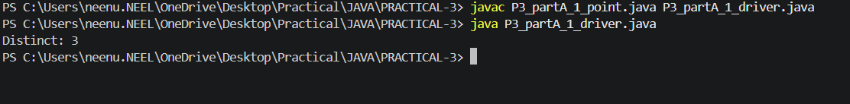

2. Duplicate card check (Card.java + Driver.java)
(a) Create class Card with private String rank, suit and a constructor.
(b) Override toString() to return rank + “ of ” + suit (e.g. “Queen of Hearts”).
(c) Override equals()/hashCode() by rank + suit.
(d) In Driver.main: add cards to a Card[] one at a time; before adding each, use equals()
to check it against the earlier cards.
(e) Print “Duplicate found: <card>” the first time a repeat appears.
Expected output: a second “Ace of Spades” → “Duplicate found: Ace of Spades”

Code:

//card.java

public class P3_partA_2_card {
private String rank;
private String suit;

P3_partA_2_card(String rank,String suit) {
this.rank=rank;
this.suit=suit;
}

public String toString() {
return rank + " of " + suit;
}

public boolean equals(Object o) {
P3_partA_2_card c=(P3_partA_2_card)o;

if(rank.equals(c.rank) && suit.equals(c.suit))
return true;

return false;
}

public int hashCode() {
return rank.hashCode()+suit.hashCode();
}
}

//driver.java

public class P3_partA_2_driver {
public static void main(String[] args) {
P3_partA_2_card[] cards={
new P3_partA_2_card("Ace","Hearts"),
new P3_partA_2_card("King","Spades"),
new P3_partA_2_card("Ace","Spades"),
new P3_partA_2_card("Queen","Hearts"),
new P3_partA_2_card("Ace","Spades")
};

for(int i=0;i<cards.length;i++) {
for(int j=0;j<i;j++) {
if(cards[i].equals(cards[j])) {
System.out.println("Duplicate found: " + cards[i]);
return;
}
}
}
}
}

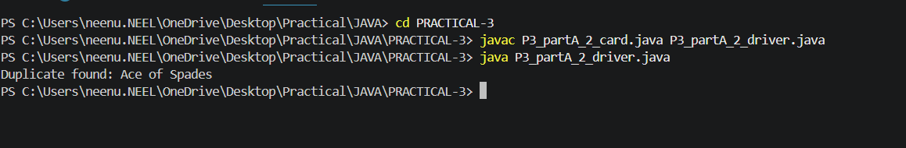

Part B — Project Work (Hour 2): MiniBank
In Practical 2 you created the Account and Customer classes. Here you make their objects
behave correctly — they print as readable text (toString) and are compared by account
number (equals/hashCode) — and you add a nested Address class. Correct equals/hashCode
is essential because Practical 12 will store accounts in collections that rely on it.
1. In Account, override the toString() method to return a readable line containing
accountNumber, ownerName and balance.
2. In Account, override equals(Object o) and hashCode() so that two accounts are equal
when their accountNumber values are equal.
3. In Customer, add a public static nested class named Address with String fields line, city
and pincode plus getters; add an Address field to Customer and a getAddress() method.
4. In Customer, add a clone() method (implement Cloneable) that returns a copy of the
customer.
5. In main, print accounts using toString(), compare two Account objects with equals(), and
use instanceof to check an object’s type.

Code:

public class P3_partB {

static class Account {
private String ac;
private String name;
private double balance;

Account(String ac,String name,double balance) {
this.ac=ac;
this.name=name;
this.balance=balance;
}

public String toString() {
return ac + " " + name + " " + balance;
}

public boolean equals(Object o) {
if(!(o instanceof Account))
return false;

Account a=(Account)o;
return ac.equals(a.ac);
}

public int hashCode() {
return ac.hashCode();
}
}

static class Customer implements Cloneable {
private String name;
private String email;
private String mobile;
private Address addr;

Customer(String name,String email,String mobile,Address addr) {
this.name=name;
this.email=email;
this.mobile=mobile;
this.addr=addr;
}

public Address getAddress() {
return addr;
}

public Customer clone() {
try {
return (Customer)super.clone();
}
catch(CloneNotSupportedException e) {
return null;
}
}

static class Address {
private String line;
private String city;
private String pin;

Address(String line,String city,String pin) {
this.line=line;
this.city=city;
this.pin=pin;
}

public String getLine() {
return line;
}

public String getCity() {
return city;
}

public String getPincode() {
return pin;
}
}
}

public static void main(String[] args) {
Account a1=new Account("A101","Neel",5000);
Account a2=new Account("A102","Selvy",7000);
Account a3=new Account("A101","Neel",5000);
System.out.println(a1);
System.out.println(a2);

System.out.println(a1.equals(a2));
System.out.println(a1.equals(a3));

Customer.Address addr=new Customer.Address("Sanskardham","Ankleshwar","393001");

Customer c1=new Customer("Neel","neenpatel00@gmail.com","9726138765",addr);
Customer c2=c1.clone();

System.out.println(c2.getAddress().getCity());

Object o=a1;

if(o instanceof Account)
System.out.println("It is an Account");
}
}

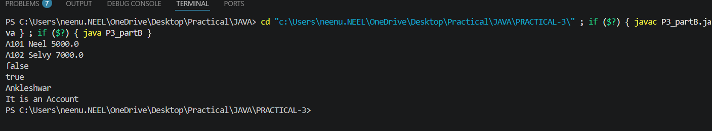

KEY QUESTION:

- Why must equals() and hashCode() be overridden together?
=>Because if two objects are equal using equals(), they must return the same hashCode() so collections like HashMap and HashSet work correctly.

- What does the default Object.toString() return, and why override it?
=>The default Object.toString() returns the class name followed by the object's hash code; we override it to display meaningful and readable object information.

- What is the difference between a static nested class and an inner class?
=>A static nested class does not need an object of the outer class, while an inner class needs an outer class object and can access its instance members.

