PRACTICAL-4

Part A — Practice Programs (Hour 1)
Work these in your lab-NN/ folder before the project: do the first one or two in the lab.

1. Password strength (PasswordChecker.java + Driver.java)
(a) In PasswordChecker, check four rules — length ≥ 8, contains an uppercase letter,
contains a digit, contains a special character — using regex (e.g. “.*[A-Z].*”) or
String methods.
(b) Write strength(String pw) that counts how many rules pass and returns “Weak” (0–1), “Medium” (2–3) or “Strong” (4).
(c) In Driver.main: test several passwords; for each, print which rules passed and the
final label.
Expected output: “abc” → Weak; “Abcd1234!” → Strong.

Code:

// PasswordChecker.java
public class P4_partA_1_PasswordChecker {
public static String strength(String pw) {
int count=0;
boolean length=pw.length()>=8;
boolean upper=pw.matches(".*[A-Z].*");
boolean digit=pw.matches(".*[0-9].*");
boolean special=pw.matches(".*[^a-zA-Z0-9].*");
if(length) count++;
if(upper) count++;
if(digit) count++;
if(special) count++;
System.out.println("Password: " + pw);
System.out.println("Length >= 8: " + length);
System.out.println("Uppercase: " + upper);
System.out.println("Digit: " + digit);
System.out.println("Special character: " + special);
if(count<=1)
return "Weak";
else if(count<=3)
return "Medium";
else
return "Strong";
}
}

// driver.java

public class P4_partA_1_driver {
public static void main(String[] args) {
String[] passwords={
"abc",
"abcdefghi",
"Abcd1234",
"Abcd1234!"
};
for(String pw:passwords) {
String result=P4_partA_1_PasswordChecker.strength(pw);
System.out.println("Strength: " + result);
System.out.println();
}
}
}
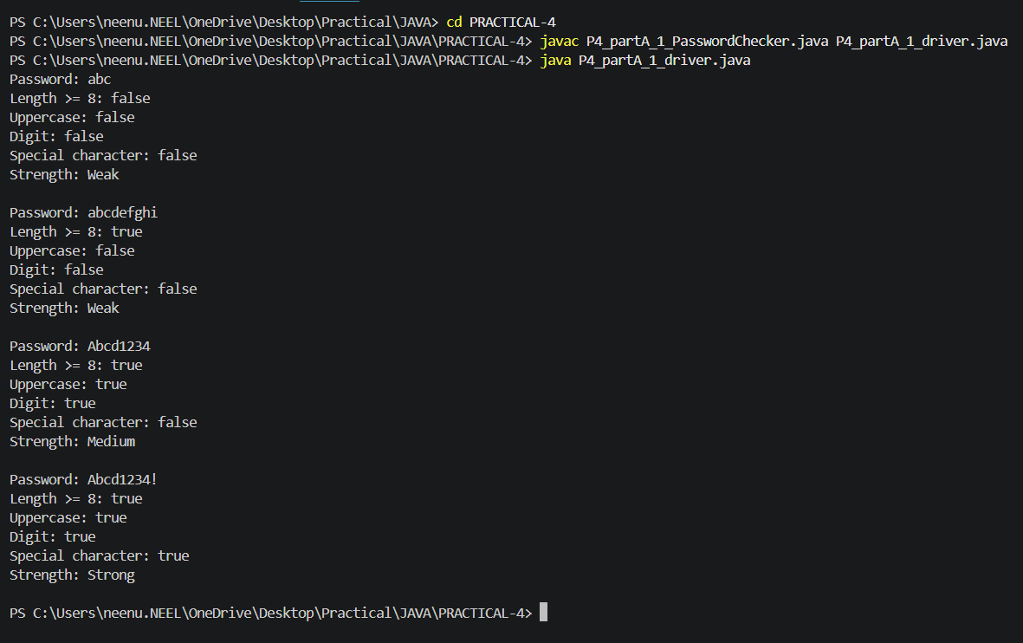

2. Chat-log filter (ChatFilter.java + Driver.java)
(a) In Driver.main, define a String[] of log lines like “10:05 alice Hello there” (include
one malformed line with fewer than 3 parts).
(b) Read a keyword from the user.
(c) For each line, split into time/user/message with split(“ ”, 3); skip lines that do not
have 3 parts.
(d) If the message contains the keyword (case-insensitive), increment a counter and
append “time user: message” to a StringBuilder.
(e) Print “Matches: N” and the built report.
Expected output: keyword “hello” over 3 lines (1 malformed) → “Matches: 1” and
the matching line.

Code:

//ChatFilter.java

public class P4_partA_2_chatfilter {
public static void filter(String[] logs,String key) {
int count=0;
StringBuilder report=new StringBuilder();
for(String line:logs) {
String[] p=line.split(" ",3);
if(p.length<3)
continue;
String time=p[0];
String user=p[1];
String msg=p[2];
if(msg.toLowerCase().contains(key.toLowerCase())) {
count++;
report.append(time+" "+user+": "+msg+"\n");
}
}
System.out.println("Matches: "+count);
System.out.print(report);
}
}

//driver.java

import java.util.Scanner;
public class P4_partA_2_driver {
public static void main(String[] args) {
Scanner sc=new Scanner(System.in);
String[] logs={
"10:05 Neel Hello..!! there..",
"10:10 Kavy How are you?",
"10:15",
"10:20 Neel Good morning"
};
System.out.print("Enter keyword: ");
String key=sc.nextLine();
P4_partA_2_chatfilter.filter(logs,key);
}
}

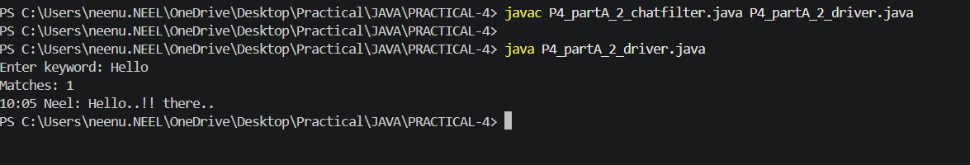

Part B — Project Work (Hour 2): MiniBank
Your classes exist, but the bank must never trust raw user input. In this lab you build
MiniBank’s validation and command-parsing layer — regex checks for mobile, email, PAN
and IFSC, and a parser that turns a typed line such as “DEPOSIT AC0001 500” into a
Command object. Practical 14 will run every menu action through this layer.
1. Create a class named Validator with public static methods that use compiled regular
expressions (Pattern): isValidMobile(String), isValidEmail(String), isValidPan(String)
and isValidIfsc(String); each returns a boolean.
2. Define an enum named TransactionType with the constants DEPOSIT, WITHDRAW
and TRANSFER. Then define a record named Command with three fields: a
TransactionType type, a String accountNumber and a long amount.
3. Create a class named CommandParser with a public static method parse(String line) that
splits a line such as “DEPOSIT AC0001 500” with split(), converts the parts, and returns
a Command object.
4. Create a class named StatementFormatter with a public static method
buildStatement(Account account) that uses a StringBuilder to assemble a multi-line
account statement string.
5. In main, test each validator with one correct and one wrong input, then parse a sample
command and print its three parts.

Code:
import java.util.regex.Pattern;
enum TransactionType
{
DEPOSIT,
WITHDRAW,
TRANSFER
}
record Command(TransactionType type,String accountNumber,long amount){}
public class P4_partB {
static class Validator
{
static Pattern mobile=Pattern.compile("^[6-9][0-9]{9}$");
static Pattern email=Pattern.compile("^[A-Za-z0-9+_.-]+@[A-Za-z0-9.-]+$");
static Pattern pan=Pattern.compile("^[A-Z]{5}[0-9]{4}[A-Z]$");
static Pattern ifsc=Pattern.compile("^[A-Z]{4}0[A-Z0-9]{6}$");
public static boolean isValidMobile(String s)
{
return mobile.matcher(s).matches();
}
public static boolean isValidEmail(String s)
{
return email.matcher(s).matches();
}
public static boolean isValidPan(String s)
{
return pan.matcher(s).matches();
}
public static boolean isValidIfsc(String s)
{
return ifsc.matcher(s).matches();
}
}
static class CommandParser
{
public static Command parse(String line)
{
String[] a=line.split(" ");
TransactionType type=TransactionType.valueOf(a[0]);
String acc=a[1];
long amount=Long.parseLong(a[2]);
return new Command(type,acc,amount);
}
}
static class Account
{
String acc;
String name;
long balance;
Account(String acc,String name,long balance)
{
this.acc=acc;
this.name=name;
this.balance=balance;
}
}
static class StatementFormatter
{
public static String buildStatement(Account ac)
{
StringBuilder s=new StringBuilder();
s.append("Account Statement\n");
s.append("Account Number: "+ac.acc+"\n");
s.append("Name: "+ac.name+"\n");
s.append("Balance: "+ac.balance+"\n");
return s.toString();
}
}
public static void main(String[] args)
{
System.out.println("Mobile:");
System.out.println(Validator.isValidMobile("9726137865"));
System.out.println(Validator.isValidMobile("12345"));
System.out.println("Email:");
System.out.println(Validator.isValidEmail("neelpatel00@gmail.com"));
System.out.println(Validator.isValidEmail("abc@"));
System.out.println("PAN:");
System.out.println(Validator.isValidPan("VYNEE2405S"));
System.out.println(Validator.isValidPan("PQR303"));
System.out.println("IFSC:");
System.out.println(Validator.isValidIfsc("UBIN0204671"));
System.out.println(Validator.isValidIfsc("UBIN543"));
Command c=CommandParser.parse("DEPOSIT AC0001 500");
System.out.println("\nCommand:");
System.out.println("Type: "+c.type());
System.out.println("Account: "+c.accountNumber());
System.out.println("Amount: "+c.amount());
Account ac=new Account("AC001","Neel",20000);
System.out.println();
System.out.print(StatementFormatter.buildStatement(ac));
}
}

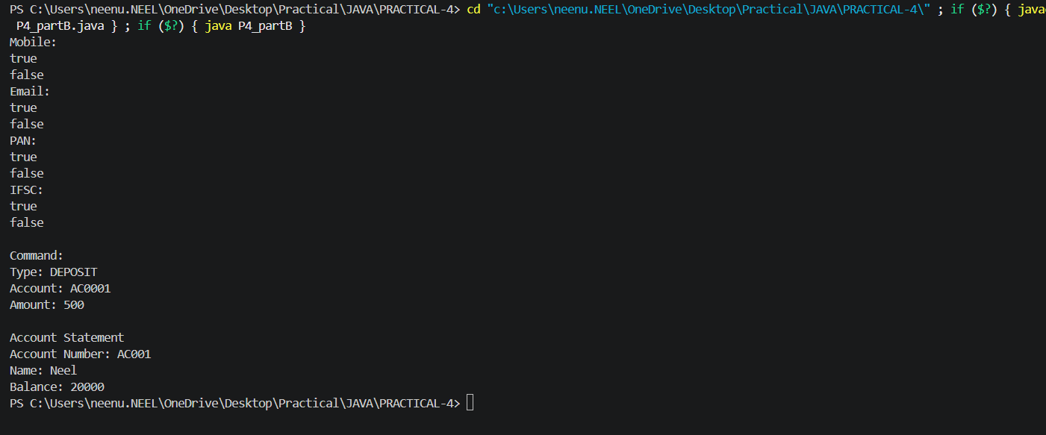

KEY QUESTION:

- What is the difference between String, StringBuilder and StringBuffer, and when is eachpreferred?
=>String is immutable, StringBuilder is mutable and faster for frequent changes, and StringBuffer is mutable and thread-safe; use String for fixed text, StringBuilder for single-threaded modifications, and StringBuffer for multi-threaded modifications.

- What does the regular expression [6-9][0-9]{9} match, and why use anchors?
=>[6-9][0-9]{9} matches a 10-digit mobile number starting with 6, 7, 8, or 9. Anchors ^ and $ are used to ensure the entire input matches the pattern, not just part of it.

- Why should input be validated at the boundary before it is used?
=>Input should be validated at the boundary to reject invalid or unsafe data early, ensuring only correct data enters the system and preventing errors later.

