PRACTICAL-5

Part A — Practice Programs (Hour 1)
Work these in your lab-NN/ folder before the project: do the first one or two in the lab.

- Shape areas: an abstract Shape with abstract area(); subclasses Circle, Rectangle,Triangle. Put a mix in a Shape[] and loop once to print each area and the running total,tracking the largest — one loop handling every shape through polymorphism.

Code:

abstract class Shape{
public abstract double area();
}

class Circle extends Shape{
private double radius;

public Circle(double radius){
this.radius = radius;
}

public double area(){
return Math.PI * radius * radius;
}
}

class Rectangle extends Shape{
private double length;
private double width;

public Rectangle(double length, double width){
this.length=length;
this.width=width;
}

public double area(){
return length * width;
}
}

class Triangle extends Shape{
private double base;
private double height;

public Triangle(double base, double height){
this.base=base;
this.height=height;
}

public double area(){
return 0.5 * base * height;
}
}

public class P5_partA_1{
public static void main(String [] args){
Shape[] shapes = {

new Circle(10),
new Rectangle(15, 25),
new Triangle(36, 60)
};

double total=0;
double largest=0;

for(Shape shape : shapes){
double area=shape.area();
total+=area;

if(area>largest){
largest=area;
}

System.out.printf("Area is: %.2f\n", total);
}
System.out.printf("Area is: %.2f\n" , total);
System.out.printf("Largest area is: %.2f\n" , largest);
}
}

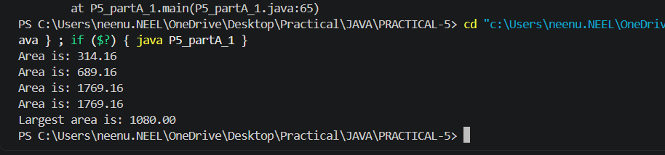

2. Payroll: an abstract Employee with abstract monthlySalary(); FullTime (fixed), PartTime (hours × rate) and Intern (stipend), each calling super for the shared name/id. Loop a mixed array to print each salary and the total; use instanceof to add a note only for interns.

Code:

abstract class Employee{
protected String name;
protected int id;

public Employee(String name,int id){
this.name=name;
this.id=id;
}

public abstract double monthlySalary();
}

class FullTime extends Employee{
private double salary;

public FullTime(String name,int id,double salary){
super(name,id);
this.salary=salary;
}

public double monthlySalary(){
return salary;
}
}

class PartTime extends Employee{
private double hours;
private double rate;

public PartTime(String name,int id,double hours,double rate){
super(name,id);
this.hours=hours;
this.rate=rate;
}

public double monthlySalary(){
return hours*rate;
}
}

class Intern extends Employee{
private double stipend;

public Intern(String name,int id,double stipend){
super(name,id);
this.stipend=stipend;
}

public double monthlySalary(){
return stipend;
}
}

public class P5_partA_2{
public static void main(String[] args){
Employee[] employees={
new FullTime("Neel",101,5000),
new PartTime("Selvy",102,80,300),
new Intern("Kavy",103,15000),
};

double total=0;

for(Employee employee:employees){
double salary=employee.monthlySalary();
total+=salary;

System.out.printf("%s Salary: %.2f\n",employee.name,salary);

if(employee instanceof Intern){
System.out.println("Note: This employee is an Intern.");
}
}

System.out.printf("Total Payroll: %.2f\n",total);
}
}
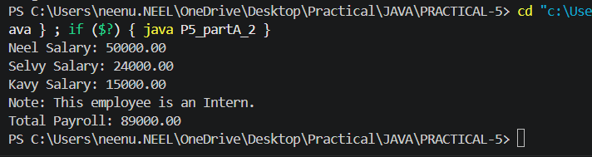

Part B — Project Work (Hour 2): MiniBank
A real bank has different account types. Building on the single Account class, this lab makes
Account abstract and adds three subclasses — SavingsAccount, CurrentAccount and
FixedDepositAccount — each with its own interest and withdrawal rules chosen
automatically by polymorphism. This lets the rest of MiniBank treat every account through one common type.
1. Make Account an abstract class. Add two abstract methods: double interestRate() and boolean canWithdraw(long amount).
2. Create a class SavingsAccount that extends Account with a long field minBalance;
interestRate() returns 4.0; canWithdraw() returns true only if the balance stays greater than or equal to minBalance.
3. Create a class CurrentAccount that extends Account with a long field overdraftLimit;
interestRate() returns 0; canWithdraw() allows the balance to fall to minus
overdraftLimit.
4. Create a class FixedDepositAccount that extends Account; interestRate() returns 7.0;
canWithdraw() returns false (the deposit is locked).
5. Call super(...) from each subclass constructor to initialise the inherited fields.
6. In main, place objects of the three types in an Account[] array, loop through it and call interestRate() on each (this demonstrates run-time polymorphism); use a pattern
instanceof check to handle one type specially.

Code:

abstract class Account{
protected String name;
protected long accountNumber;
protected long balance;

public Account(String name,long accountNumber,long balance){
this.name=name;
this.accountNumber=accountNumber;
this.balance=balance;
}

public abstract double interestRate();

public abstract boolean canWithdraw(long amount);
}

class SavingsAccount extends Account{
private long minBalance;

public SavingsAccount(String name,long accountNumber,long balance,long minBalance){
super(name,accountNumber,balance);
this.minBalance=minBalance;
}

public double interestRate(){
return 4.0;
}

public boolean canWithdraw(long amount){
return balance-amount>=minBalance;
}
}

class CurrentAccount extends Account{
private long overdraftLimit;

public CurrentAccount(String name,long accountNumber,long balance,long overdraftLimit){
super(name,accountNumber,balance);
this.overdraftLimit=overdraftLimit;
}

public double interestRate(){
return 0.0;
}

public boolean canWithdraw(long amount){
return balance-amount>=-overdraftLimit;
}
}

class FixedDepositAccount extends Account{

public FixedDepositAccount(String name,long accountNumber,long balance){
super(name,accountNumber,balance);
}

public double interestRate(){
return 7.0;
}

public boolean canWithdraw(long amount){
return false;
}
}

public class P5_partB{
public static void main(String[] args){
Account[] accounts={
new SavingsAccount("Neel",101,5000,100),
new CurrentAccount("Selvy",102,6000,1500),
new FixedDepositAccount("Kavy",103,3000)
};

for(Account account:accounts){
System.out.println("Account Holder: "+account.name);
System.out.println("Interest Rate: "+account.interestRate()+"%");

if(account instanceof FixedDepositAccount){
System.out.println("Note: Fixed Deposit is locked.");
}

System.out.println();
}
}
}
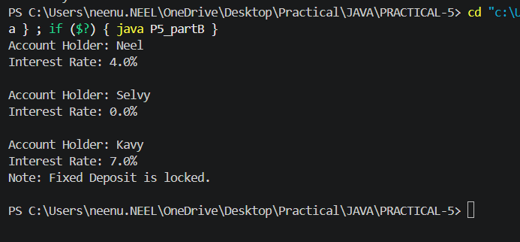

KEY QUESTION:

- What is the difference between an abstract class and a concrete class?
=>An abstract class cannot be instantiated and may contain abstract methods, while a concrete class can be instantiated and has implemented methods.

- What is dynamic method dispatch (run-time polymorphism)?
=>Dynamic method dispatch is when Java decides at run time which overridden method to call based on the actual object.

- What does the super keyword do in a subclass constructor?
=>The super keyword calls the parent class constructor to initialize the inherited fields and properties.

