PRACTICAL-6

Part A — Practice Programs (Hour 1)
Work these in your lab-NN/ folder before the project: do the first one or two in the lab.

1.Remote control: an interface Switchable with on()/off() and a default toggle(); Fan and
Light implement it. Loop over a Switchable[] toggling each. Then add a functional
interface that decides, given a device and an hour, whether it may switch on, and supply it
once as an anonymous class and once as a lambda.

Code:

interface Switchable
{
void on();
void off();

default void toggle()
{
System.out.println("Device toggled");
}
}

class Fan implements Switchable
{
public void on()
{
System.out.println("Fan ON");
}

public void off()
{
System.out.println("Fan OFF");
}
}

class Light implements Switchable
{
public void on()
{
System.out.println("Light ON");
}

public void off()
{
System.out.println("Light OFF");
}
}

@FunctionalInterface
interface SwitchRule
{
boolean canSwitchOn(Switchable device,int hour);
}

public class P6_partA_1
{
public static void main(String[] args)
{
Switchable fan=new Fan();
Switchable light=new Light();

Switchable[] devices={fan,light};

for(Switchable device:devices)
{
device.toggle();
}

SwitchRule rule1=new SwitchRule()
{
public boolean canSwitchOn(Switchable device,int hour)
{
return hour>=6&&hour<=22;
}
};

System.out.println("Anonymous Class: "+rule1.canSwitchOn(fan,10));

SwitchRule rule2=(device,hour)->hour>=6&&hour<=22;

System.out.println("Lambda: "+rule2.canSwitchOn(light,23));
}
}

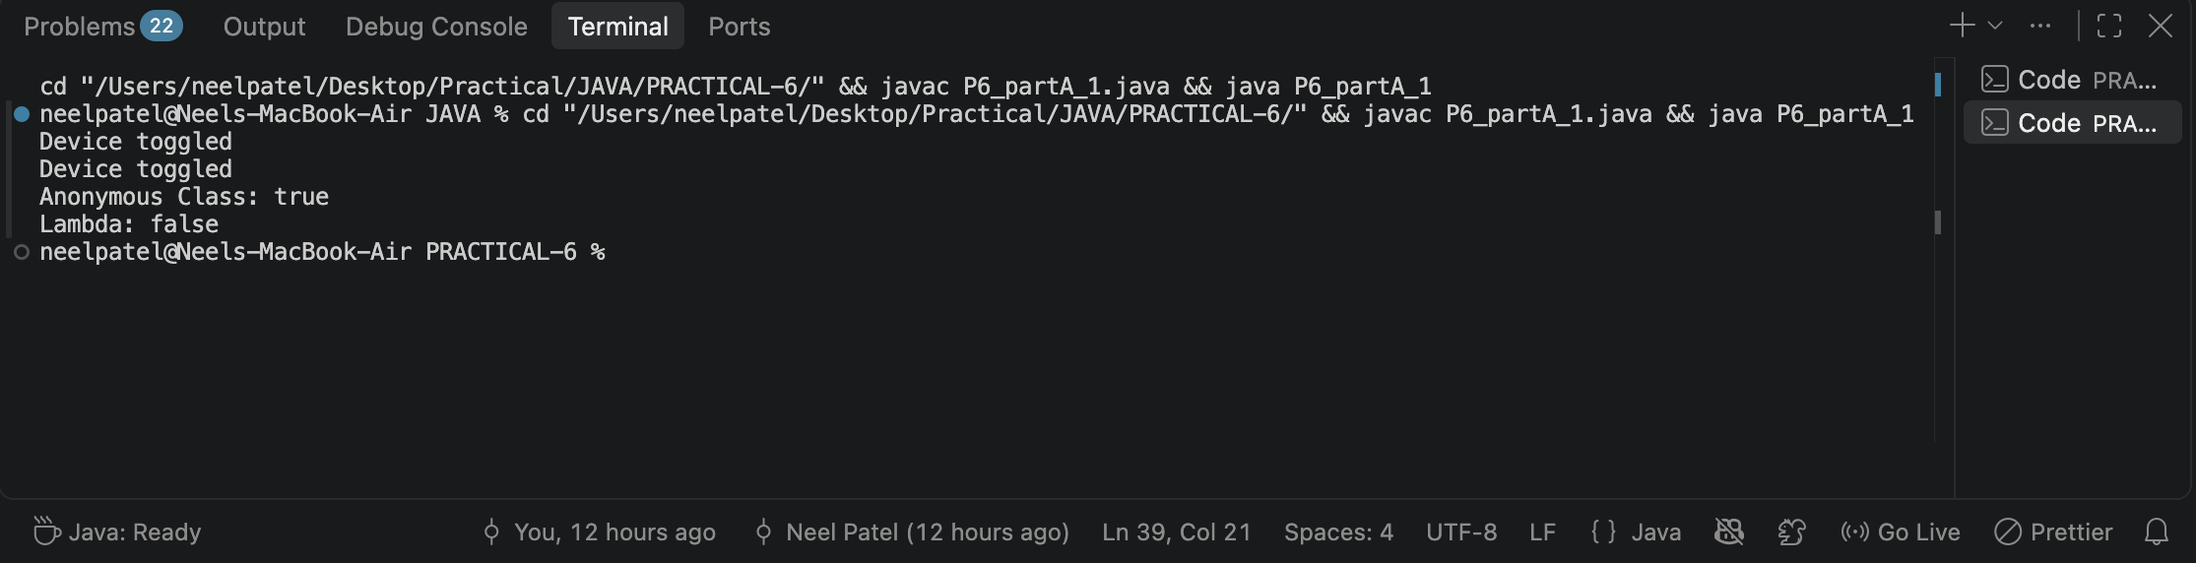

2.Notification senders: a functional interface Notifier with send(String); make email and
SMS senders as lambdas, hold them in an array, and broadcast one message through all.
Add a marker interface Urgent and send twice for senders marked urgent.

Code:

interface Notifier
{
void send(String message);
}

interface Urgent
{
}

class EmailSender implements Urgent
{
void sendEmail(String message)
{
System.out.println("Email: "+message);
}
}

class SMSSender
{
void sendSMS(String message)
{
System.out.println("SMS: "+message);
}
}

public class P6_partA_2
{
public static void main(String[] args)
{
EmailSender email=new EmailSender();
SMSSender sms=new SMSSender();

Notifier[] senders={
message->email.sendEmail(message),
message->sms.sendSMS(message)
};

String message="Emergency notification";

for(Notifier sender:senders)
{
sender.send(message);
}

email.sendEmail(message);
}
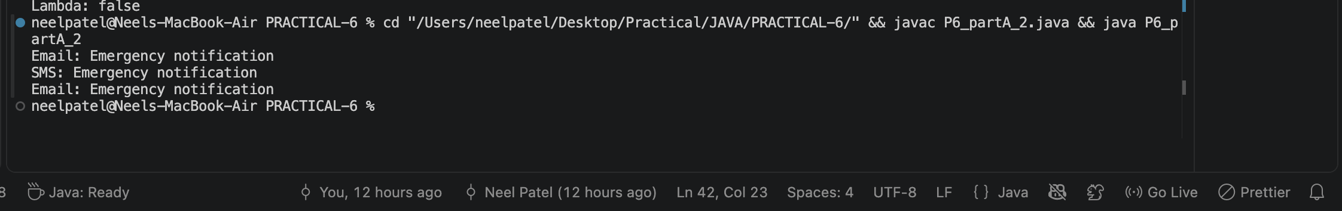
}

Part B — Project Work (Hour 2): MiniBank
With several classes now in place, this lab gives MiniBank a clean structure. You express
account capabilities as interfaces, organise the code into model, util and service packages,
and build a runnable JAR — the form in which the finished application will actually be
delivered and run.
1. Create an interface named Transactable with methods void deposit(long amount) and
boolean withdraw(long amount); make Account implement it.
2. Create an interface named InterestBearing with a default method double yearlyInterest()
that uses interestRate() and the balance.
3. Create a functional interface named WithdrawRule with a single method boolean
allow(Account account, long amount). Use it two ways in main: first with an anonymous
class, then with a lambda expression.
4. Create a marker interface named Premium (an interface with no methods).
5. Move all classes into the packages model, util and service (add package statements and
fix the import statements). Use one static import.
6. Build a runnable JAR file with a manifest whose Main-Class is the MiniBank class, and
run it with the command java -jar.

Code:

interface Transactable
{
void deposit(long amount);
boolean withdraw(long amount);
}

interface InterestBearing
{
double interestRate();
double balance();

default double yearlyInterest()
{
return balance()*interestRate()/100;
}
}

@FunctionalInterface
interface WithdrawRule
{
boolean allow(Account account,long amount);
}

interface Premium
{
}

class Account implements Transactable,InterestBearing,Premium
{
private long balance;
private double rate;

public Account(long balance,double rate)
{
this.balance=balance;
this.rate=rate;
}

public void deposit(long amount)
{
balance+=amount;
}

public boolean withdraw(long amount)
{
if(amount<=balance)
{
balance-=amount;
return true;
}

return false;
}

public double interestRate()
{
return rate;
}

public double balance()
{
return balance;
}

public long getBalance()
{
return balance;
}
}

public class P6_partB
{
public static void main(String[] args)
{
Account account=new Account(10000,5);

account.deposit(5000);

WithdrawRule rule1=new WithdrawRule()
{
public boolean allow(Account account,long amount)
{
return amount<=account.getBalance();
}
};

WithdrawRule rule2=(acc,amount)->amount<=acc.getBalance();

System.out.println("Balance: "+account.getBalance());
System.out.println("Anonymous Class: "+rule1.allow(account,3000));
System.out.println("Lambda: "+rule2.allow(account,12000));

if(rule1.allow(account,3000))
{
account.withdraw(3000);
System.out.println("Withdrawal successful");
}
else
{
System.out.println("Withdrawal denied");
}

System.out.println("New Balance: "+account.getBalance());
System.out.println("Yearly Interest: "+account.yearlyInterest());
System.out.println("Premium Account: "+(account instanceof Premium));
}
}
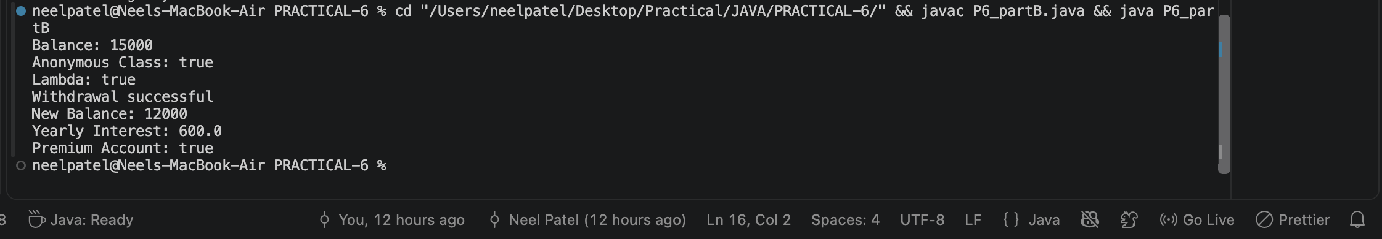

KEY QUESTION:

1.What is the difference between an interface and an abstract class?
=>An interface defines a contract that a class implements, while an abstract class provides a common base that can contain both abstract and concrete methods.

2.What is a functional interface, and how does a lambda use it?
=>A functional interface has exactly one abstract method, and a lambda expression provides its implementation directly.

3.Why is a default method useful in an interface?
=>A default method provides a ready-made implementation in an interface, allowing new methods to be added without breaking existing implementing classes.

