PRACTICAL-7

Part A — Practice Programs (Hour 1)
Work these in your lab-NN/ folder before the project: do the first one or two in the lab.

1.Form validator: define @NotBlank and @MaxLength(int) for fields and annotate a
SignupForm. Write a checker that uses reflection to read each field’s annotations and
returns the list of validation errors for a given object.

Code:

import java.lang.annotation.*;
import java.lang.reflect.*;
import java.util.*;

@Retention(RetentionPolicy.RUNTIME)
@Target(ElementType.FIELD)
@interface NotBlank{}

@Retention(RetentionPolicy.RUNTIME)
@Target(ElementType.FIELD)
@interface MaxLength
{
int value();
}

class SignupForm
{
@NotBlank
String name;

@NotBlank
@MaxLength(10)
String username;

SignupForm(String name,String username)
{
this.name=name;
this.username=username;
}
}

public class P7_partA_1
{
static List<String> check(Object obj)
{
List<String> errors=new ArrayList<>();

for(Field f:obj.getClass().getDeclaredFields())
{
try
{
f.setAccessible(true);
String value=(String)f.get(obj);

if(f.isAnnotationPresent(NotBlank.class)&&
(value==null||value.trim().isEmpty()))
{
errors.add(f.getName()+" is blank");
}

if(f.isAnnotationPresent(MaxLength.class)&&
value!=null&&
value.length()>f.getAnnotation(MaxLength.class).value())
{
errors.add(f.getName()+" is too long");
}
}
catch(Exception e)
{
System.out.println("Error");
}
}

return errors;
}

public static void main(String[] args)
{
SignupForm form=new SignupForm("","abcdefghijkl");

List<String> errors=check(form);

for(String error:errors)
{
System.out.println(error);
}
}
}

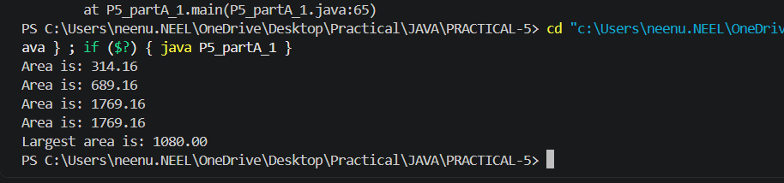

2.Mini test runner: define a @Run annotation and mark some no-arg methods of a class
with it. Use reflection to find and invoke only the @Run

Code:

import java.lang.annotation.*;
import java.lang.reflect.*;

@Retention(RetentionPolicy.RUNTIME)
@Target(ElementType.METHOD)
@interface Run{}

class TestClass
{
@Run
void test1()
{
System.out.println("Test 1 executed");
}

@Run
void test2()
{
System.out.println("Test 2 executed");
}

void test3()
{
System.out.println("Test 3 executed");
}

@Run
void test4()
{
System.out.println("Test 4 executed");
}
}

public class P7_partA_2
{
public static void main(String[] args) throws Exception
{
TestClass obj=new TestClass();
int count=0;

for(Method method:TestClass.class.getDeclaredMethods())
{
if(method.isAnnotationPresent(Run.class))
{
method.invoke(obj);
count++;
}
}

System.out.println("Total tests ran: "+count);
}
}
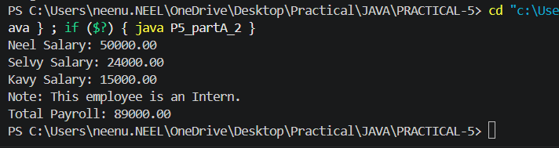

Part B — Project Work (Hour 2): MiniBank
Now that you are comfortable with classes and interfaces, you add metadata to MiniBank.
You define custom annotations (@Id, @Positive, @MaxLength) and read them at run time
with reflection to validate any object automatically — the same idea real frameworks use.
The @Id marker will later identify each record in the generic repository you build in
Practical 13.
1. Add the @Override annotation above every overridden method written so far (toString,
equals, hashCode and the subclass methods). Add @FunctionalInterface above the
WithdrawRule interface.
2. In a package named model.annotation, define three custom annotations: @Id (a marker,
with @Target(FIELD) and @Retention(RUNTIME)); @Positive with a member String
message() default “must be > 0”; and @MaxLength with a member int value().
3. Put @Id on the accountNumber field and @Positive on the balance field of Account.4. Create a class FixedDepositAccount that extends Account; interestRate() returns 7.0;
4. Create a class named AnnotationValidator with a public static method String[]
validate(Object obj) that uses reflection — getClass().getDeclaredFields(),
field.isAnnotationPresent(...), field.setAccessible(true) and field.get(obj) — to check the
@Positive and @MaxLength rules and return the error messages as a String[].
5. In main, create an Account with a negative balance and run
AnnotationValidator.validate() to print the error.

Code:

import java.lang.annotation.*;
import java.lang.reflect.*;

@Retention(RetentionPolicy.RUNTIME)
@Target(ElementType.FIELD)
@interface Id{}

@Retention(RetentionPolicy.RUNTIME)
@Target(ElementType.FIELD)
@interface Positive
{
String message() default "must be > 0";
}

@Retention(RetentionPolicy.RUNTIME)
@Target(ElementType.FIELD)
@interface MaxLength
{
int value();
}

@FunctionalInterface
interface WithdrawRule
{
boolean allow(Account account,long amount);
}

class Account
{
@Id
private long accountNumber;

@Positive
private long balance;

private double rate;

Account(long accountNumber,long balance,double rate)
{
this.accountNumber=accountNumber;
this.balance=balance;
this.rate=rate;
}

public void deposit(long amount)
{
balance+=amount;
}

public boolean withdraw(long amount)
{
if(amount<=balance)
{
balance-=amount;
return true;
}

return false;
}

public double interestRate()
{
return rate;
}

public long getBalance()
{
return balance;
}

@Override
public String toString()
{
return "Account: "+accountNumber+" Balance: "+balance;
}

@Override
public boolean equals(Object obj)
{
if(this==obj)
return true;

if(obj==null||getClass()!=obj.getClass())
return false;

Account a=(Account)obj;
return accountNumber==a.accountNumber;
}

@Override
public int hashCode()
{
return Long.hashCode(accountNumber);
}
}

class AnnotationValidator
{
public static String[] validate(Object obj)
{
String[] errors=new String[10];
int count=0;

try
{
Field[] fields=obj.getClass().getDeclaredFields();

for(Field field:fields)
{
field.setAccessible(true);
Object value=field.get(obj);

if(field.isAnnotationPresent(Positive.class))
{
if(value instanceof Number&&((Number)value).doubleValue()<=0)
{
Positive p=field.getAnnotation(Positive.class);
errors[count++]=field.getName()+" "+p.message();
}
}

if(field.isAnnotationPresent(MaxLength.class))
{
MaxLength m=field.getAnnotation(MaxLength.class);

if(value!=null&&value.toString().length()>m.value())
{
errors[count++]=field.getName()+" must have maximum "+m.value()+" characters";
}
}
}
}
catch(Exception e)
{
errors[count++]="Validation error";
}

String[] result=new String[count];

for(int i=0;i<count;i++)
{
result[i]=errors[i];
}

return result;
}
}

public class P7_partB
{
public static void main(String[] args)
{
Account account=new Account(101,-5000,5);

String[] errors=AnnotationValidator.validate(account);

for(String error:errors)
{
System.out.println(error);
}
}
}
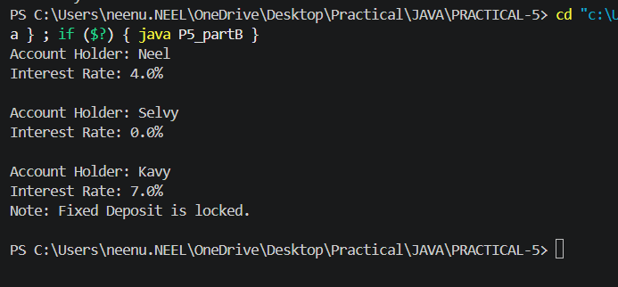

KEY QUESTION:

- What are the meta-annotations @Retention and @Target used for?
=>@Retention specifies how long an annotation is kept, while @Target specifies where the annotation can be applied (e.g., field, method, class).

2.What is reflection, and what does getDeclaredFields() return?
=>Reflection is the ability to inspect and access a class’s information at runtime; getDeclaredFields() returns all fields declared directly inside that class.

3.How do annotations plus reflection let a framework validate any object?
=>Annotations add validation rules to fields, and reflection reads those annotations at runtime to check the object automatically.

