PRACTICAL-10

Part A — Practice Programs (Hour 1)
Work these in your lab-NN/ folder before the project: do the first one or two in the lab.

1.Thread-pool runner: with a fixed pool of 3 (ExecutorService), submit about 10 Runnable
tasks that print their id and sleep briefly; shut down and await completion, observing the
few threads being reused.

Code:

import java.util.concurrent.ExecutorService;
import java.util.concurrent.Executors;
import java.util.concurrent.TimeUnit;

public class P10_partA_1 {

public static void main(String[] args) {
ExecutorService pool = Executors.newFixedThreadPool(3);

for(int i = 1; i <= 10; i++) {
final int taskId = i;

pool.submit(() -> {
String threadName = Thread.currentThread().getName();

System.out.println("Task " + taskId + " started by " + threadName);

try {
Thread.sleep(1000);
} catch(InterruptedException e) {
Thread.currentThread().interrupt();
}

System.out.println("Task " + taskId + " finished by " + threadName);
});
}

pool.shutdown();

try {
if(pool.awaitTermination(30, TimeUnit.SECONDS)) {
System.out.println("All tasks completed.");
} else {
System.out.println("Some tasks are still running.");
pool.shutdownNow();
}
} catch(InterruptedException e) {
pool.shutdownNow();
Thread.currentThread().interrupt();
}
}
}

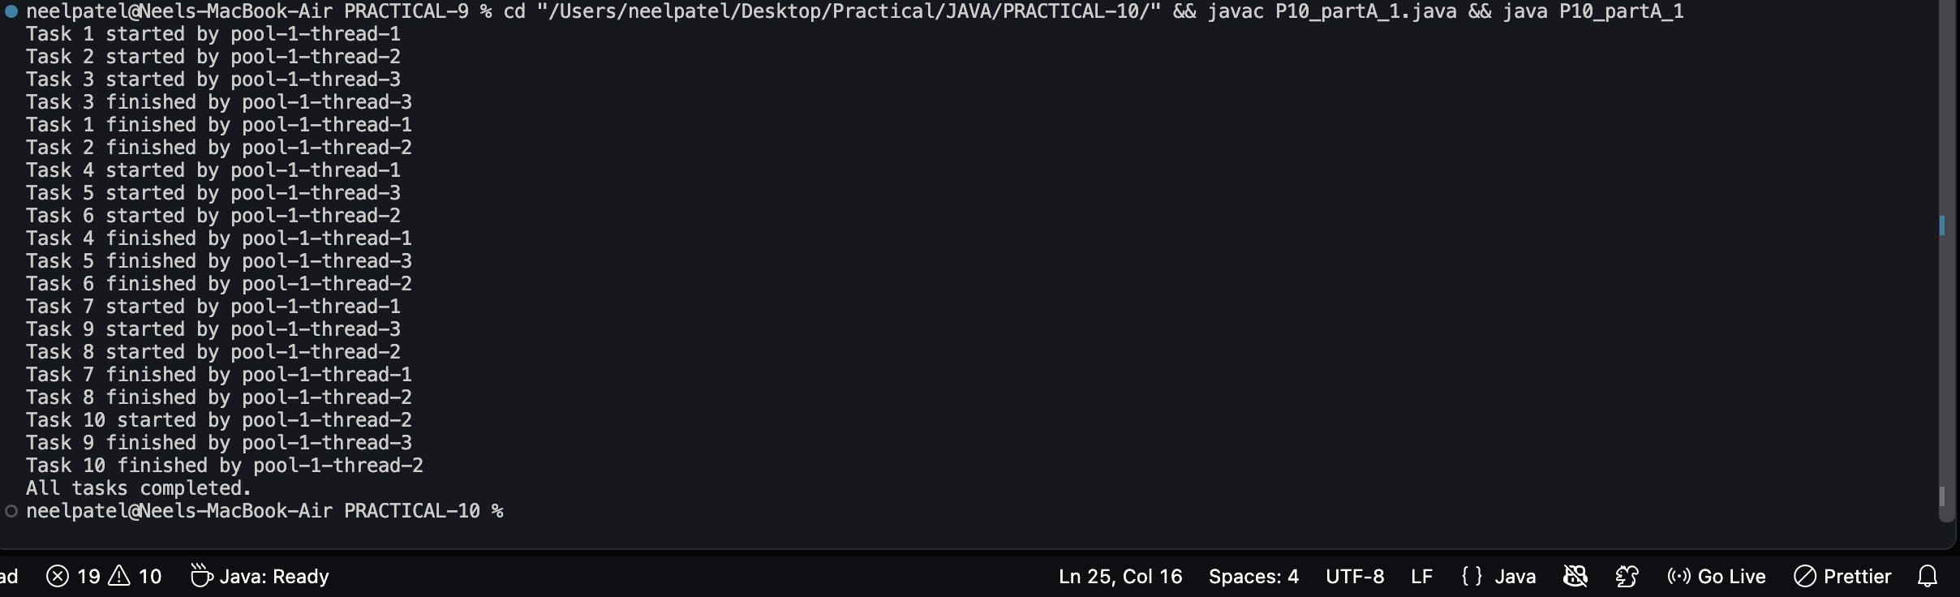

2. Producer–consumer: one thread adds numbers to a small shared buffer and another
removes them, coordinated with wait()/notify(); produce and consume a fixed number of
items in order with none lost.

Code:
class Buffer {
private int item;
private boolean available = false;

synchronized void produce(int value) {
while(available) {
try {
wait();
} catch(InterruptedException e) {
Thread.currentThread().interrupt();
return;
}
}

item = value;
available = true;

System.out.println("Produced: " + value);

notify();
}

synchronized int consume() {
while(!available) {
try {
wait();
} catch(InterruptedException e) {
Thread.currentThread().interrupt();
return -1;
}
}

int value = item;
available = false;

System.out.println("Consumed: " + value);

notify();

return value;
}
}

class Producer implements Runnable {
private Buffer buffer;
private int count;

Producer(Buffer buffer, int count) {
this.buffer = buffer;
this.count = count;
}

public void run() {
for(int i = 1; i <= count; i++) {
buffer.produce(i);
}

System.out.println("Producer finished");
}
}

class Consumer implements Runnable {
private Buffer buffer;
private int count;

Consumer(Buffer buffer, int count) {
this.buffer = buffer;
this.count = count;
}

public void run() {
for(int i = 1; i <= count; i++) {
buffer.consume();
}

System.out.println("Consumer finished");
}
}

public class P10_partA_2 {
public static void main(String[] args) throws InterruptedException {

Buffer buffer = new Buffer();

int items = 10;

Thread producer = new Thread(
new Producer(buffer, items),
"Producer"
);

Thread consumer = new Thread(
new Consumer(buffer, items),
"Consumer"
);

producer.start();
consumer.start();

producer.join();
consumer.join();

System.out.println("All items produced and consumed successfully.");
}
}
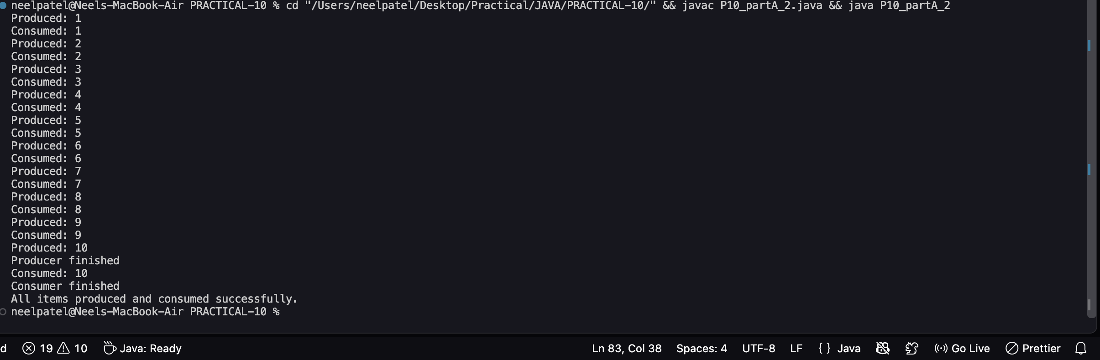

Part B — Project Work (Hour 2): MiniBank
Building on basic threads, this lab gives MiniBank a proper transaction engine. You process
a batch of transactions on a managed thread pool, coordinate two threads with wait/notify,
and learn to avoid deadlock with consistent lock ordering — the way back-office systems
process many transactions safely.
1. Create a class named TransactionProcessor that holds an ExecutorService created with
Executors.newFixedThreadPool(4). Add a method submit(Runnable task) that calls
execute(), and a method stop() that calls shutdown() and awaitTermination().
2. Create Runnable tasks that each perform a deposit or withdrawal; submit many of them,
then stop the processor and wait for completion.
3. Build a simple producer-consumer: one thread adds transactions to a shared array buffer
and another thread processes them, using wait() and notify() inside synchronized blocks.
4. Create a deadlock: two threads transfer money A to B and B to A, locking the two
accounts in opposite order. Then fix it by always locking the account with the smaller
accountNumber first

Code:

import java.util.concurrent.*;

class Account {
int accountNumber;
int balance;

Account(int accountNumber, int balance) {
this.accountNumber = accountNumber;
this.balance = balance;
}

synchronized void deposit(int amount) {
balance += amount;
}

synchronized void withdraw(int amount) {
if(balance >= amount)
balance -= amount;
}
}

class TransactionProcessor {
ExecutorService pool = Executors.newFixedThreadPool(4);

void submit(Runnable task) {
pool.execute(task);
}

void stop() {
pool.shutdown();

try {
pool.awaitTermination(10, TimeUnit.SECONDS);
} catch(InterruptedException e) {
Thread.currentThread().interrupt();
}
}
}

class Buffer {
int[] data = new int[3];
int count = 0;

synchronized void add(int value) {
while(count == 3) {
try {
wait();
} catch(InterruptedException e) {
Thread.currentThread().interrupt();
}
}

data[count++] = value;
System.out.println("Produced: " + value);
notify();
}

synchronized int remove() {
while(count == 0) {
try {
wait();
} catch(InterruptedException e) {
Thread.currentThread().interrupt();
}
}

int value = data[0];

for(int i = 1; i < count; i++)
data[i - 1] = data[i];

count--;

System.out.println("Consumed: " + value);
notify();

return value;
}
}

public class P10_partB {

static void transfer(Account a, Account b, int amount) {

Account first;
Account second;

if(a.accountNumber < b.accountNumber) {
first = a;
second = b;
} else {
first = b;
second = a;
}

synchronized(first) {
synchronized(second) {
a.withdraw(amount);
b.deposit(amount);

System.out.println(
Thread.currentThread().getName()
+ " transferred " + amount
);
}
}
}

public static void main(String[] args) throws InterruptedException {

System.out.println("=== THREAD POOL ===");

Account account = new Account(1, 1000);
TransactionProcessor processor = new TransactionProcessor();

for(int i = 1; i <= 10; i++) {
final int n = i;

processor.submit(() -> {
if(n % 2 == 0)
account.deposit(100);
else
account.withdraw(50);

System.out.println(
Thread.currentThread().getName()
+ " completed transaction"
);
});
}

processor.stop();

System.out.println("Final balance: " + account.balance);

System.out.println("\n=== PRODUCER CONSUMER ===");

Buffer buffer = new Buffer();

Thread producer = new Thread(() -> {
for(int i = 1; i <= 10; i++)
buffer.add(i);
});

Thread consumer = new Thread(() -> {
for(int i = 1; i <= 10; i++)
buffer.remove();
});

producer.start();
consumer.start();

producer.join();
consumer.join();

System.out.println("\n=== TRANSFER ===");

Account a = new Account(10, 1000);
Account b = new Account(20, 1000);

Thread t1 = new Thread(() -> {
transfer(a, b, 100);
}, "Thread-1");

Thread t2 = new Thread(() -> {
transfer(b, a, 200);
}, "Thread-2");

t1.start();
t2.start();

t1.join();
t2.join();

System.out.println("Account 10: " + a.balance);
System.out.println("Account 20: " + b.balance);

System.out.println("\nAll tasks completed.");
}
}

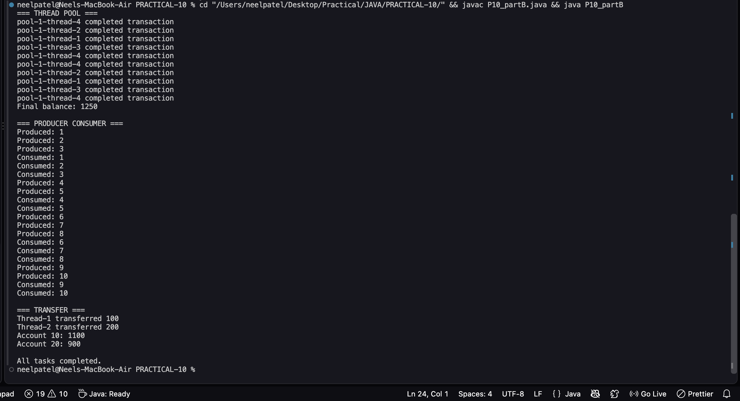

KEY QUESTION:

- Why is a thread pool better than creating a new thread per task?
=>A thread pool reuses a fixed number of threads, reducing overhead, improving performance, and preventing too many threads from consuming system resources.

- How do wait() and notify() coordinate two threads?
=>wait() makes a thread pause and release the lock, while notify() wakes a waiting thread so they can coordinate shared resources.

- What causes a deadlock, and how does consistent lock ordering prevent it?
=>A deadlock occurs when threads wait for each other’s locks; consistent lock ordering prevents it by making all threads acquire locks in the same order.

