PRACTICAL-8

Part A — Practice Programs (Hour 1)
Work these in your lab-NN/ folder before the project: do the first one or two in the lab.

1.Guarded calculator: read two numbers and an operator; throw a custom
DivideByZeroException and catch invalid-number input separately, printing a clear
message each time; loop until a valid calculation succeeds and use finally to log each
Attempt.

Code:

import java.util.Scanner;

class DivideByZeroException extends Exception
{
DivideByZeroException(String message)
{
super(message);
}
}

public class P8_partA_1
{
public static void main(String[] args)
{
Scanner sc=new Scanner(System.in);
boolean success=false;

while(!success)
{
try
{
System.out.print("Enter first number: ");
double a=sc.nextDouble();

System.out.print("Enter second number: ");
double b=sc.nextDouble();

System.out.print("Enter operator (+,-,*,/): ");
char op=sc.next().charAt(0);

double result;

switch(op)
{
case '+':
result=a+b;
break;

case '-':
result=a-b;
break;

case '*':
result=a*b;
break;

case '/':
if(b==0)
throw new DivideByZeroException("Cannot divide by zero");
result=a/b;
break;

default:
System.out.println("Invalid operator");
continue;
}

System.out.println("Result: "+result);
success=true;
}
catch(DivideByZeroException e)
{
System.out.println("Error: "+e.getMessage());
}
catch(Exception e)
{
System.out.println("Error: Invalid number input");
sc.nextLine();
}
finally
{
System.out.println("Attempt completed");
}
}

sc.close();
}
}

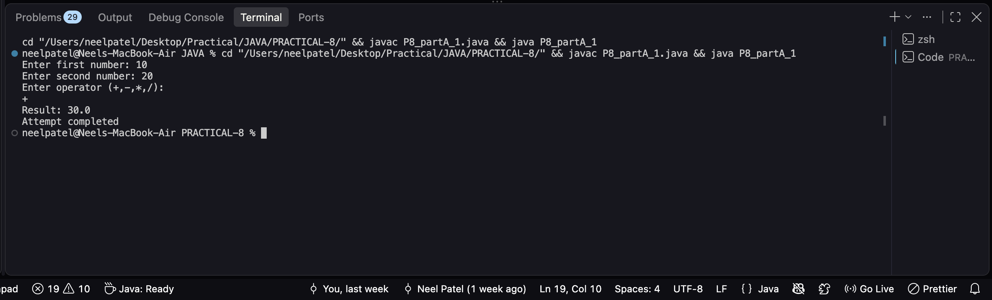

2. Stock issue: a Warehouse where issue(item, qty) throws a custom checked
OutOfStockException carrying the shortfall, and InvalidQuantityException for qty ≤ 0.
Process a list of requests, catching and reporting each failure without stopping the run.

Code:

class OutOfStockException extends Exception {
private int shortfall;

OutOfStockException(int shortfall) {
this.shortfall = shortfall;
}

public int getShortfall() {
return shortfall;
}
}

class InvalidQuantityException extends Exception {
InvalidQuantityException(String message) {
super(message);
}
}

class Warehouse {
private int stock;

Warehouse(int stock) {
this.stock = stock;
}

void issue(int qty) throws OutOfStockException, InvalidQuantityException {
if (qty <= 0) {
throw new InvalidQuantityException("Quantity must be greater than 0");
}

if (qty > stock) {
throw new OutOfStockException(qty - stock);
}

stock -= qty;
System.out.println("Issued " + qty + " items. Remaining stock: " + stock);
}
}

public class P8_partA_2 {
public static void main(String[] args) {
Warehouse warehouse = new Warehouse(50);

int[] requests = {10, 20, 30, -5, 15, 5, 0, 10};

for (int qty : requests) {
try {
System.out.println("Request: " + qty);
warehouse.issue(qty);
}
catch (OutOfStockException e) {
System.out.println("Failed: Out of stock. Shortfall: " + e.getShortfall());
}
catch (InvalidQuantityException e) {
System.out.println("Failed: " + e.getMessage());
}
}
}
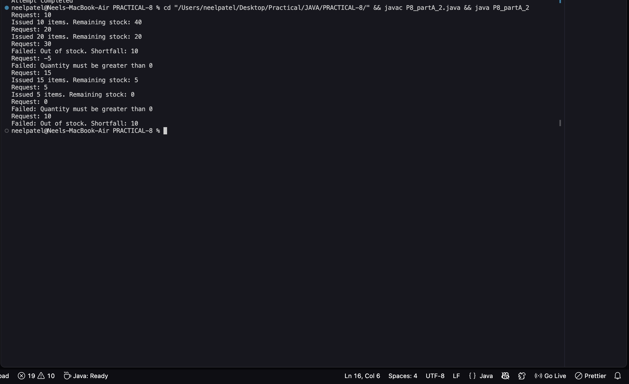
}

Part B — Project Work (Hour 2): MiniBank
Until now a failed withdrawal just returned false. In this lab you make MiniBank faulttolerant:
you replace those flags with a custom exception hierarchy so every failure is
explicit and carries information (such as the shortfall). This is the Milestone 1 checkpoint,
where the model, validation, annotations and error handling come together.
1. In a package named exception, create a checked base class BankException that extends
Exception. Then create InsufficientFundsException, AccountNotFoundException and
InvalidAmountException, each extending BankException. Give
InsufficientFundsException a long field shortfall.
2. Change withdraw(long amount) to declare throws InsufficientFundsException,
InvalidAmountException; throw InsufficientFundsException when the balance is too low
and InvalidAmountException when the amount is less than or equal to zero. Make
deposit(long amount) throw InvalidAmountException for a non-positive amount.
3. Add a method transfer(Account to, long amount) that uses try, catch and finally and rethrows
a BankException when needed.
4. In main, wrap the operations in try-catch blocks and print friendly messages; use a finally
block; and show one try-with-resources example using a small AutoCloseable class that
you create.

Code:

class BankException extends Exception {
public BankException(String message) {
super(message);
}
}

class InsufficientFundsException extends BankException {
private long shortfall;

public InsufficientFundsException(long shortfall) {
super("Insufficient funds");
this.shortfall = shortfall;
}

public long getShortfall() {
return shortfall;
}
}

class AccountNotFoundException extends BankException {
public AccountNotFoundException(String message) {
super(message);
}
}

class InvalidAmountException extends BankException {
public InvalidAmountException(String message) {
super(message);
}
}

class Account {
private String accountNumber;
private long balance;

public Account(String accountNumber, long balance) {
this.accountNumber = accountNumber;
this.balance = balance;
}

public void withdraw(long amount)
throws InsufficientFundsException, InvalidAmountException {

if (amount <= 0) {
throw new InvalidAmountException("Amount must be greater than zero");
}

if (amount > balance) {
throw new InsufficientFundsException(amount - balance);
}

balance -= amount;
System.out.println("Withdrawal successful: " + amount);
}

public void deposit(long amount) throws InvalidAmountException {
if (amount <= 0) {
throw new InvalidAmountException("Deposit amount must be greater than zero");
}

balance += amount;
System.out.println("Deposit successful: " + amount);
}

public void transfer(Account to, long amount) throws BankException {
try {
withdraw(amount);
to.deposit(amount);
System.out.println("Transfer successful.");
}
catch (BankException e) {
throw e;
}
finally {
System.out.println("Transfer operation completed.");
}
}

public long getBalance() {
return balance;
}
}

class BankResource implements AutoCloseable {
public void open() {
System.out.println("Bank resource opened.");
}

public void close() {
System.out.println("Bank resource closed.");
}
}

public class P8_partB {
public static void main(String[] args) {

Account a1 = new Account("A101", 100000);
Account a2 = new Account("A102", 3000);

try {
a1.withdraw(7000);
}
catch (InsufficientFundsException e) {
System.out.println("Withdrawal failed.");
System.out.println("Shortfall: " + e.getShortfall());
}
catch (InvalidAmountException e) {
System.out.println("Invalid withdrawal: " + e.getMessage());
}
finally {
System.out.println("Withdrawal attempt finished.");
}

try {
a1.deposit(-500);
}
catch (InvalidAmountException e) {
System.out.println("Deposit failed: " + e.getMessage());
}
finally {
System.out.println("Deposit attempt finished.");
}

try {
a1.transfer(a2, 1000);
}
catch (BankException e) {
System.out.println("Transfer failed: " + e.getMessage());
}
finally {
System.out.println("Transfer attempt finished.");
}

try (BankResource resource = new BankResource()) {
resource.open();
System.out.println("Using bank resource...");
}

System.out.println("Final balance A101: " + a1.getBalance());
System.out.println("Final balance A102: " + a2.getBalance());
}
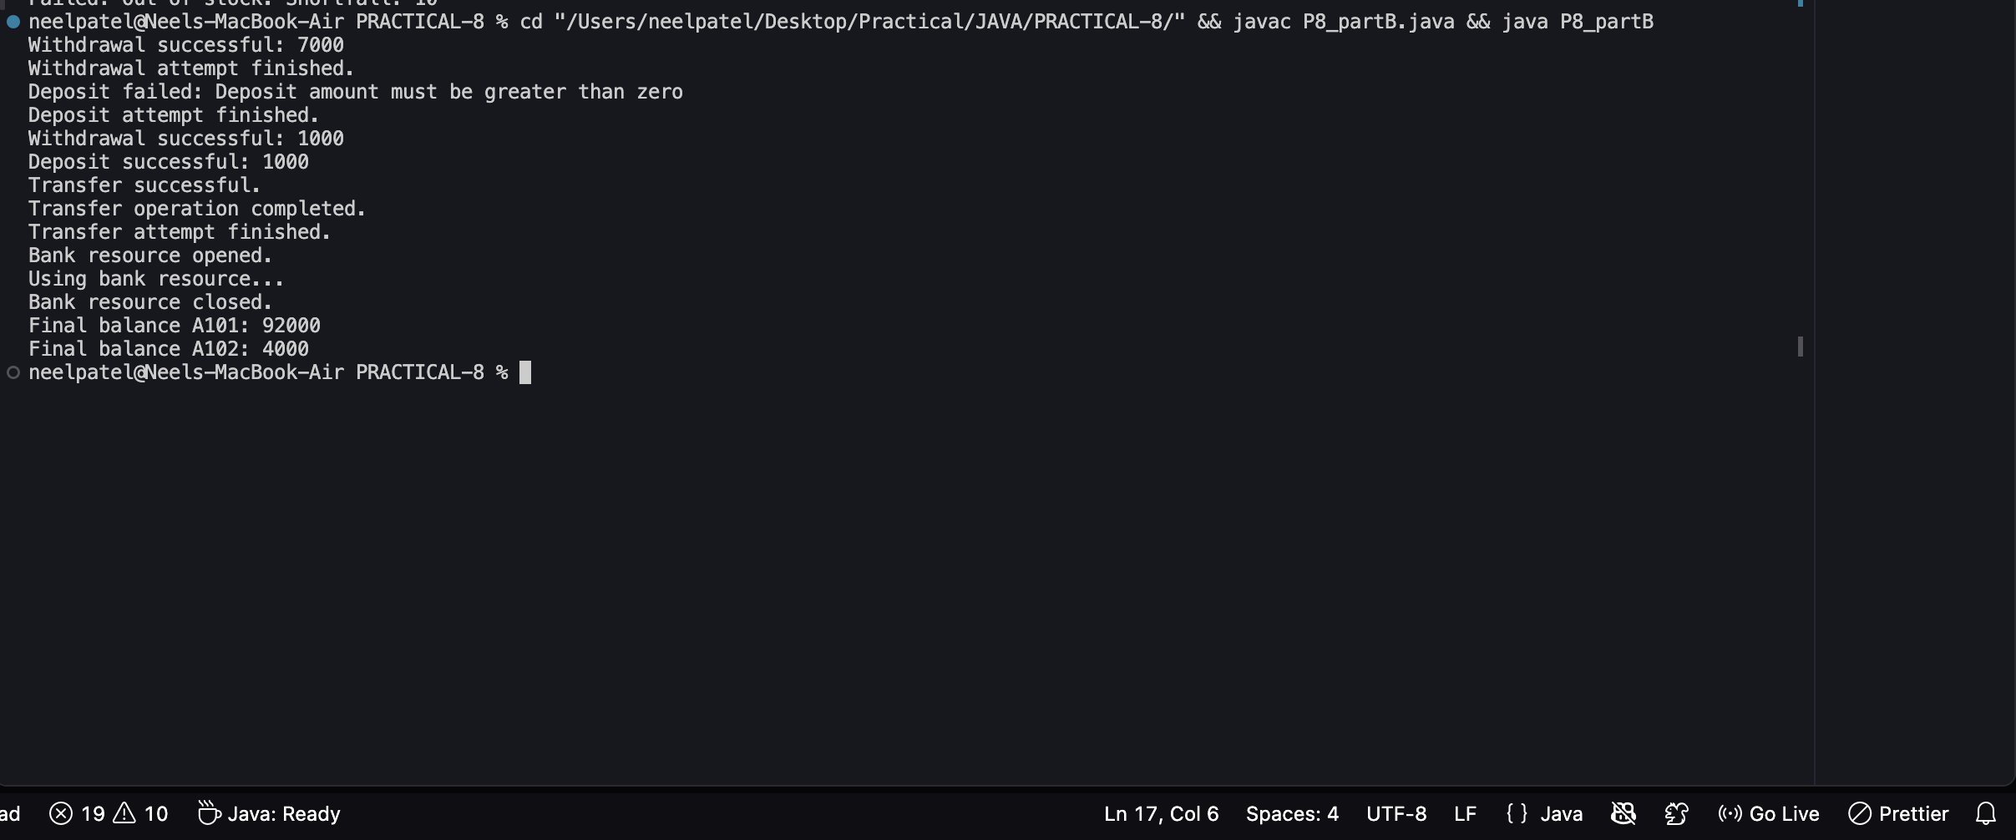
}

KEY QUESTION:

- What is the difference between a checked and an unchecked exception?
=>A checked exception must be handled at compile time, while an unchecked exception occurs at runtime and doesn’t require mandatory handling.

- What is the purpose of the finally block, and when does it run?
=>The finally block is used for cleanup code and runs whether an exception occurs or not.

- How does try-with-resources guarantee a resource is closed?
=>Try-with-resources automatically calls close() on resources implementing AutoCloseable after the try block, even if an exception occurs.

