PRACTICAL-9

Part A — Practice Programs (Hour 1)
Work these in your lab-NN/ folder before the project: do the first one or two in the lab.

1.Counter race: several threads each increment a shared counter many times. Run it
without synchronization to watch the total come out too low, then make the increment
synchronized and confirm it is exactly right every run.

Code:

class P9_partA_1 {
static int counter = 0;

static void increment() {
counter++;
}

public static void main(String[] args) throws InterruptedException {
int threads = 10;
int increments = 100000;

Thread[] t = new Thread[threads];

for(int i = 0; i < threads; i++) {
t[i] = new Thread(() -> {
for(int j = 0; j < increments; j++) {
increment();
}
});
t[i].start();
}

for(int i = 0; i < threads; i++) {
t[i].join();
}

System.out.println("Without synchronization:");
System.out.println("Expected: " + (threads * increments));
System.out.println("Actual: " + counter);

counter = 0;

for(int i = 0; i < threads; i++) {
t[i] = new Thread(() -> {
for(int j = 0; j < increments; j++) {
synchronized(P9_partA_1.class) {
counter++;
}
}
});
t[i].start();
}

for(int i = 0; i < threads; i++) {
t[i].join();
}

System.out.println("\nWith synchronization:");
System.out.println("Expected: " + (threads * increments));
System.out.println("Actual: " + counter);
}
}

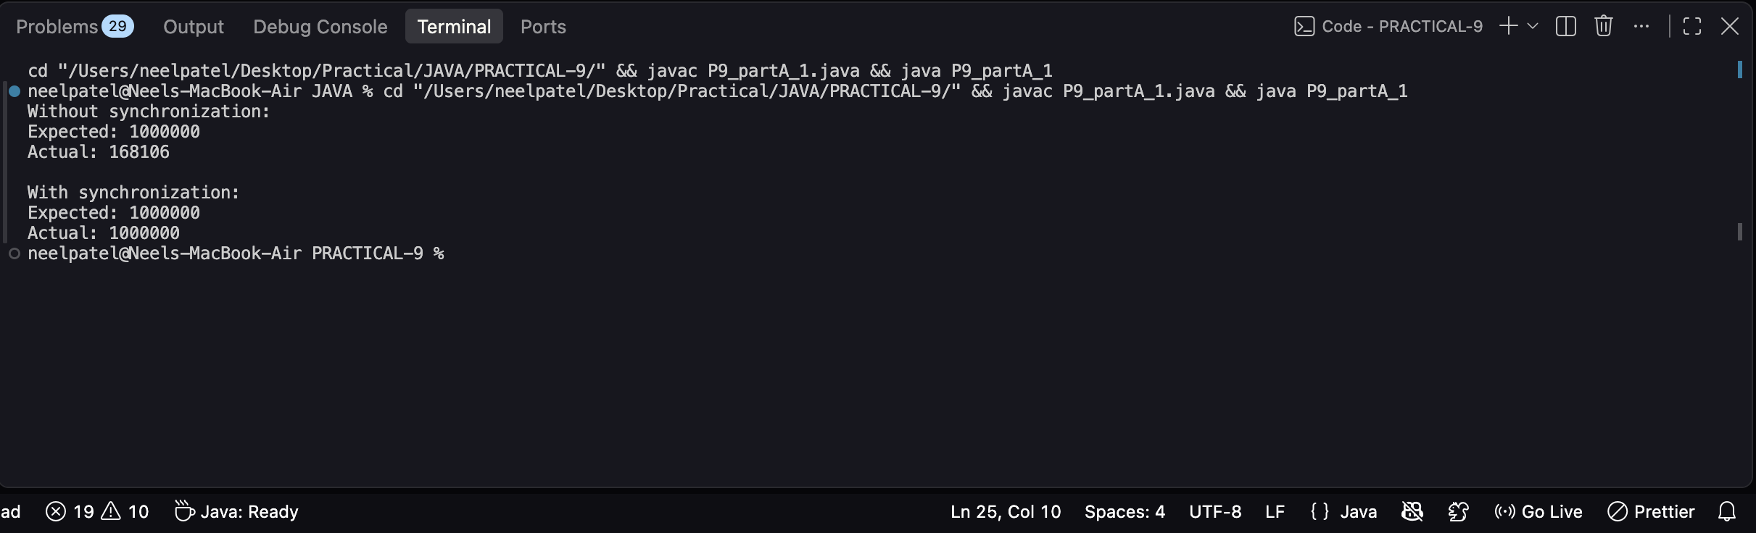

2. Seat booking race: a shared seatsLeft of 5 with about 10 threads each trying to book one
seat. Without synchronization show that more than 5 can succeed (oversell); with a
synchronized book() exactly 5 do.

Code:
class P9_partA_2 {
static int seatsLeft = 5;
static int booked = 0;

static void bookWithoutSync() {
if(seatsLeft > 0) {
try {
Thread.sleep(10);
} catch(InterruptedException e) {
}

seatsLeft--;
booked++;
System.out.println(Thread.currentThread().getName() + " booked a seat");
}
}

static synchronized void book() {
if(seatsLeft > 0) {
seatsLeft--;
booked++;
System.out.println(Thread.currentThread().getName() + " booked a seat");
}
}

public static void main(String[] args) throws InterruptedException {
Thread[] threads = new Thread[10];

System.out.println("Without synchronization:");

seatsLeft = 5;
booked = 0;

for(int i = 0; i < 10; i++) {
threads[i] = new Thread(() -> bookWithoutSync(), "User-" + (Thread.currentThread().getId()));
threads[i].start();
}

for(int i = 0; i < 10; i++) {
threads[i].join();
}

System.out.println("Seats left: " + seatsLeft);
System.out.println("Total booked: " + booked);

System.out.println("\nWith synchronization:");

seatsLeft = 5;
booked = 0;

for(int i = 0; i < 10; i++) {
final int user = i + 1;

threads[i] = new Thread(() -> book(), "User-" + user);
threads[i].start();
}

for(int i = 0; i < 10; i++) {
threads[i].join();
}

System.out.println("Seats left: " + seatsLeft);
System.out.println("Total booked: " + booked);
}
}

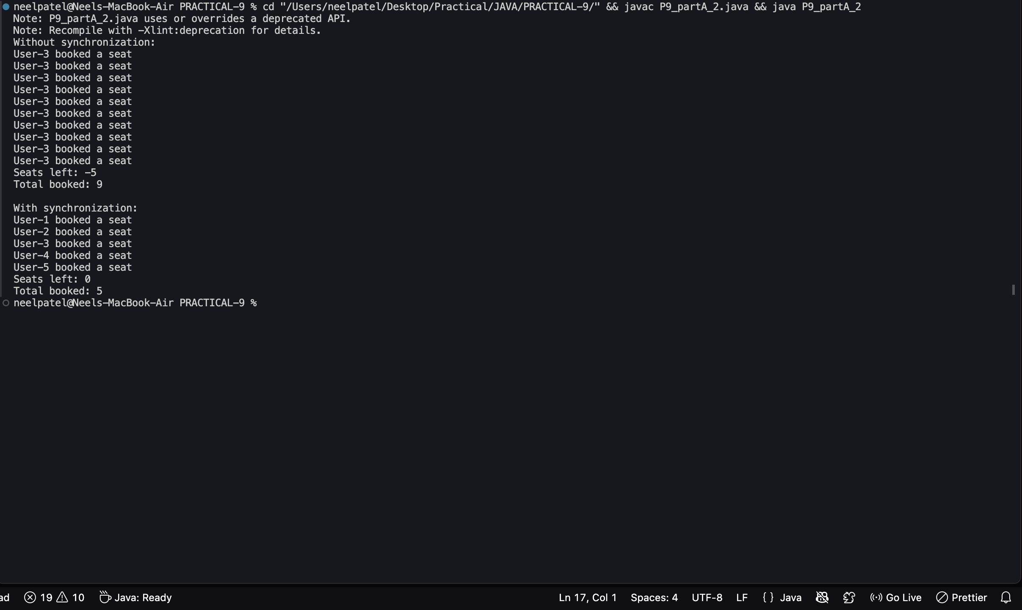

Part B — Project Work (Hour 2): MiniBank
A real bank serves many users at once. With the single-user logic working, this lab runs
many threads against one account, lets you watch the balance come out wrong (a race
condition), and then makes deposit and withdraw thread-safe with synchronization —
protecting MiniBank’s shared data.
1. Create a class named AccountWorker that implements Runnable with fields Account
account, int times and long amount; in run(), loop times times and call
account.deposit(amount).
2. In main, create one account, start about 10 threads using AccountWorker, call join() on
each, then print the final balance — it will be wrong because of the race condition.
3. Make deposit and withdraw synchronized (or use a synchronized block on a private lock
object) and run the program again — the balance is now correct.
4. Print the thread names to observe the thread lifecycle.

Code:

class Account {
private long balance;

Account(long balance) {
this.balance = balance;
}

void deposit(long amount) {
long temp = balance;

try {
Thread.sleep(1);
} catch (InterruptedException e) {
Thread.currentThread().interrupt();
}

balance = temp + amount;
}

synchronized void depositSafe(long amount) {
long temp = balance;

try {
Thread.sleep(1);
} catch (InterruptedException e) {
Thread.currentThread().interrupt();
}

balance = temp + amount;
}

synchronized void withdraw(long amount) {
if(balance >= amount) {
balance -= amount;
}
}

long getBalance() {
return balance;
}
}

class AccountWorker implements Runnable {
Account account;
int times;
long amount;
boolean safe;

AccountWorker(Account account, int times, long amount, boolean safe) {
this.account = account;
this.times = times;
this.amount = amount;
this.safe = safe;
}

public void run() {
System.out.println(Thread.currentThread().getName() + " started");

for(int i = 0; i < times; i++) {
if(safe) {
account.depositSafe(amount);
} else {
account.deposit(amount);
}
}

System.out.println(Thread.currentThread().getName() + " finished");
}
}

public class P9_partB {
public static void main(String[] args) throws InterruptedException {

int threadCount = 10;
int times = 100;
long amount = 100;

long expected = threadCount * times * amount;

System.out.println("===== WITHOUT SYNCHRONIZATION =====");

Account account = new Account(0);
Thread[] threads = new Thread[threadCount];

for(int i = 0; i < threadCount; i++) {
threads[i] = new Thread(
new AccountWorker(account, times, amount, false),
"BankThread-" + (i + 1)
);
threads[i].start();
}

for(int i = 0; i < threadCount; i++) {
threads[i].join();
}

System.out.println("Expected balance: " + expected);
System.out.println("Actual balance: " + account.getBalance());

System.out.println("\n===== WITH SYNCHRONIZATION =====");

account = new Account(0);
threads = new Thread[threadCount];

for(int i = 0; i < threadCount; i++) {
threads[i] = new Thread(
new AccountWorker(account, times, amount, true),
"BankThread-" + (i + 1)
);
threads[i].start();
}

for(int i = 0; i < threadCount; i++) {
threads[i].join();
}

System.out.println("Expected balance: " + expected);
System.out.println("Actual balance: " + account.getBalance());
}
}

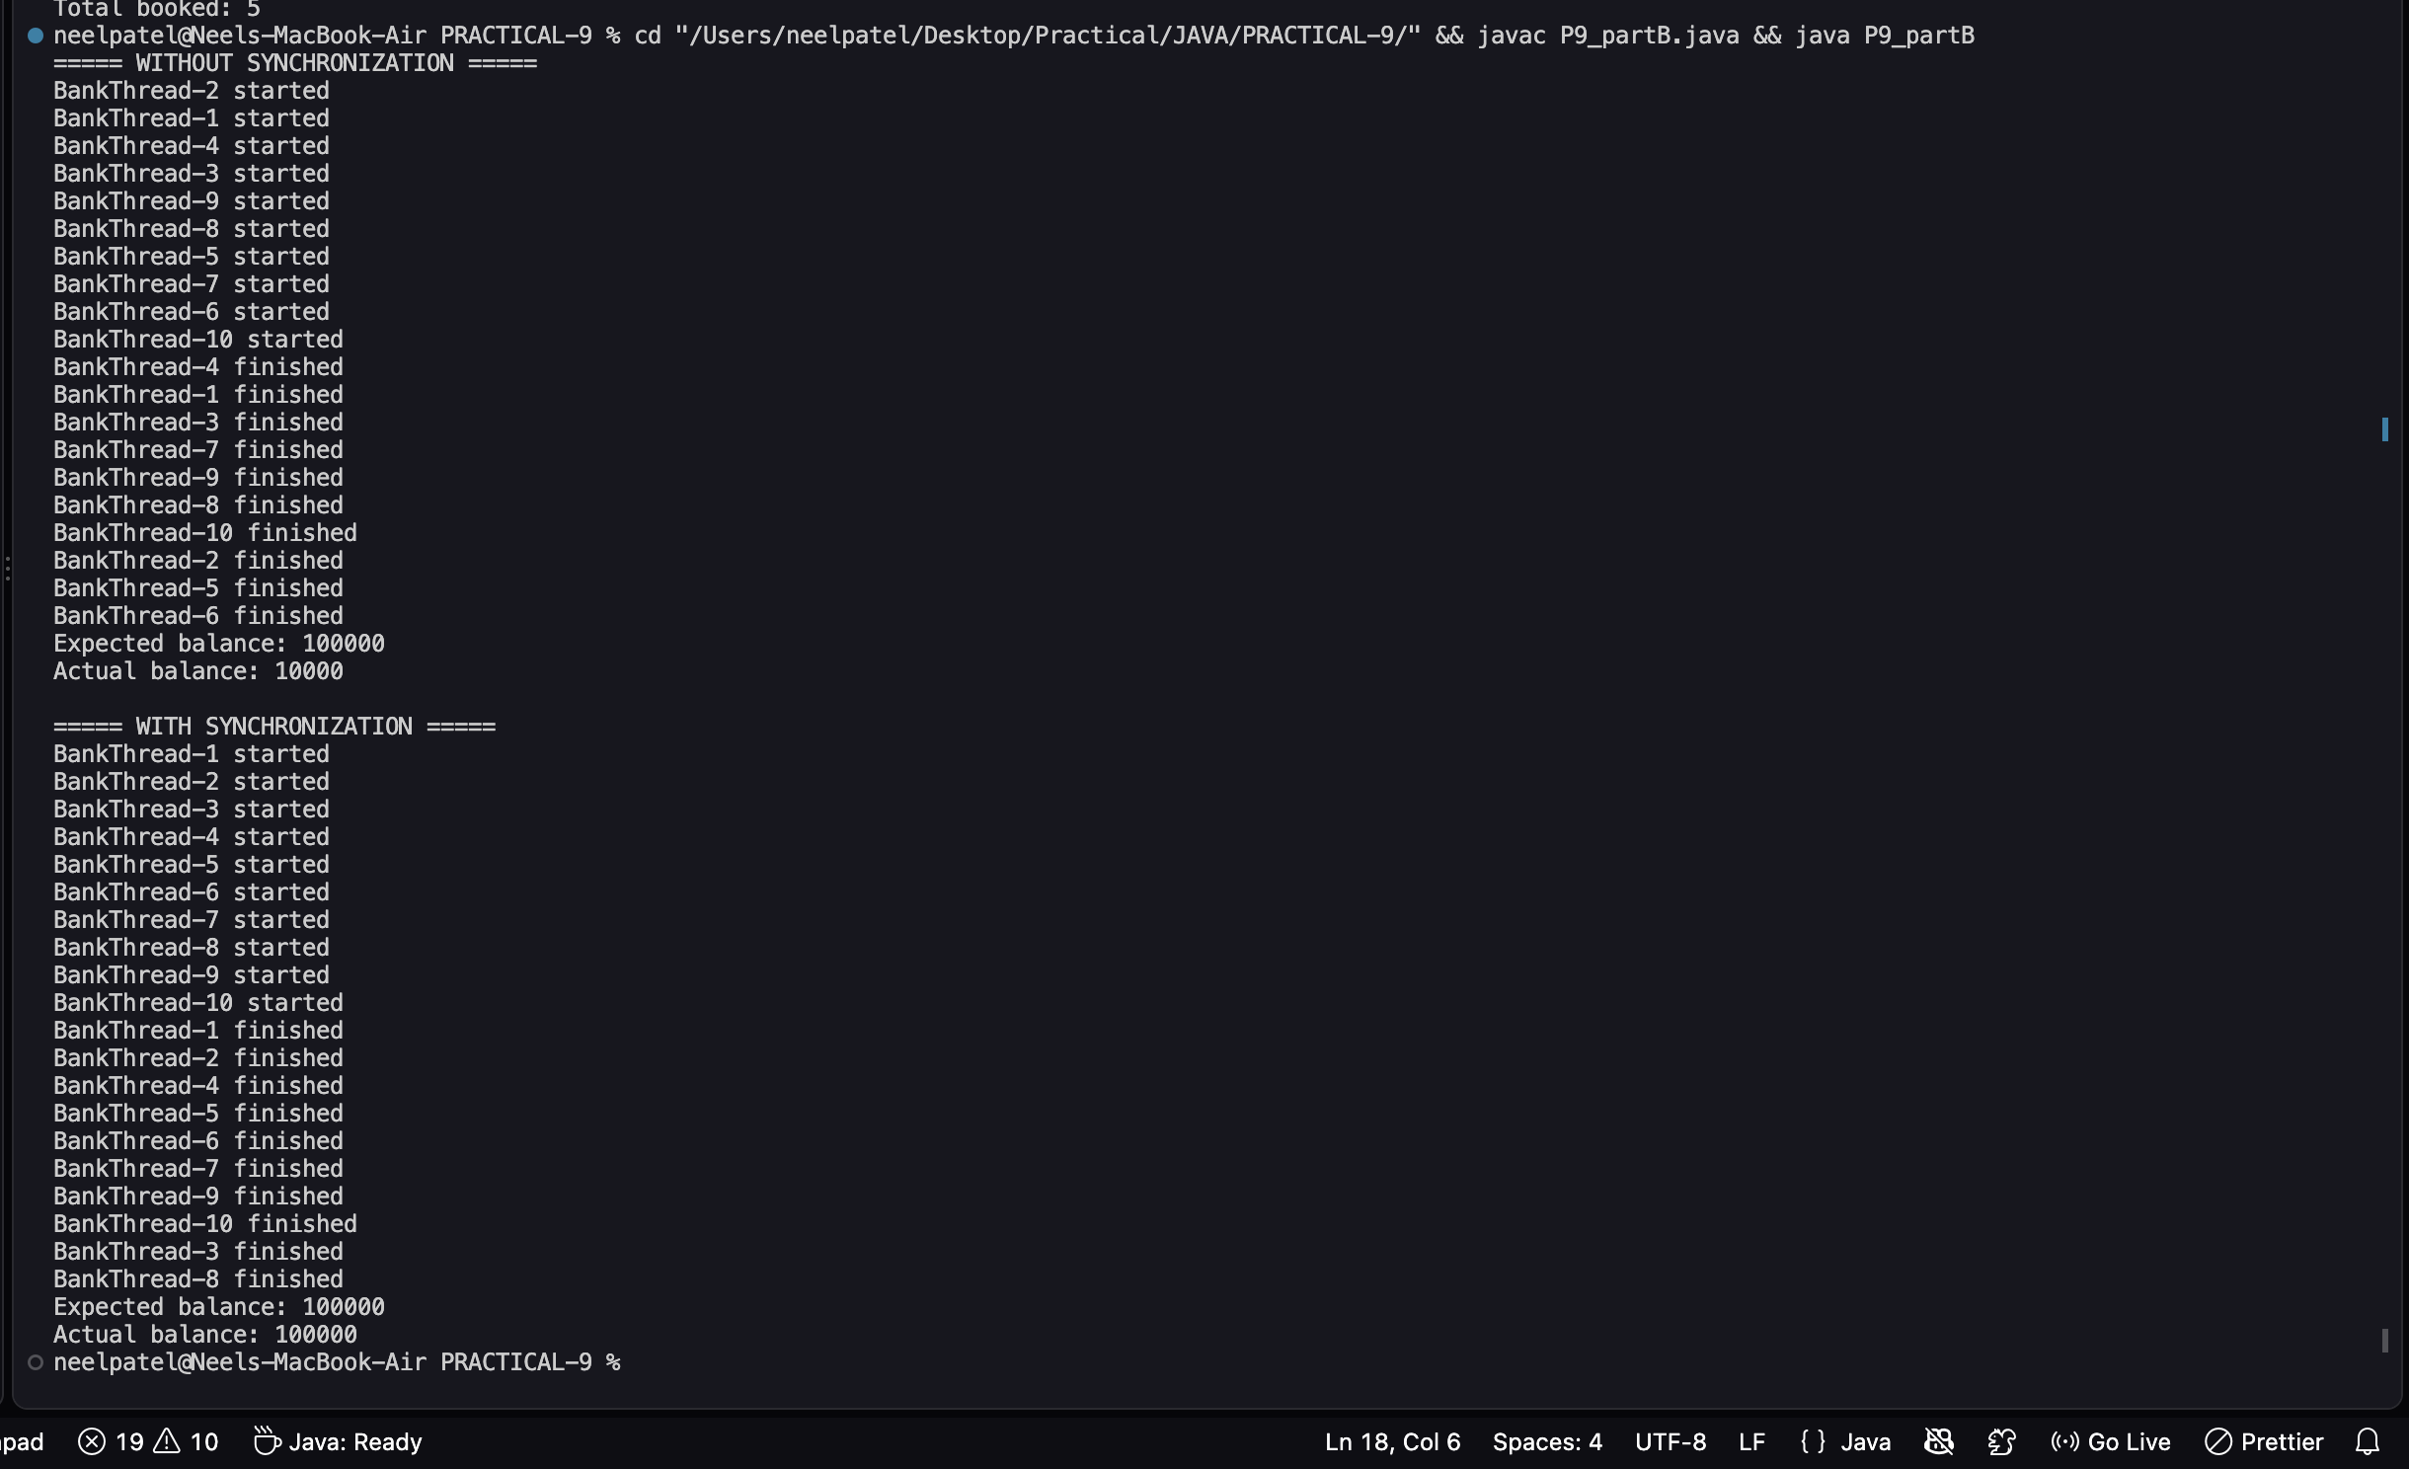

KEY QUESTION:

- What is a race condition, and why does it occur here?
=>A race condition occurs when multiple threads access shared data at the same time, causing unpredictable or incorrect results because their operations interfere with each other.

- What does the synchronized keyword do?
=>The synchronized keyword ensures that only one thread at a time can access a shared resource, preventing race conditions.

- What are the states in a thread’s life cycle?
=>A thread’s life cycle states are New, Runnable, Running, Blocked/Waiting, Timed Waiting, and Terminated.

