First Progress Report, ML Project -Neel Patel (MS24BTECH11024) 18-04-26

Project 3 - Microstructure Doppelgängers

Starting the project by learning what this topic is about, it is not an actual submission in my project rather it is just for my better understanding.
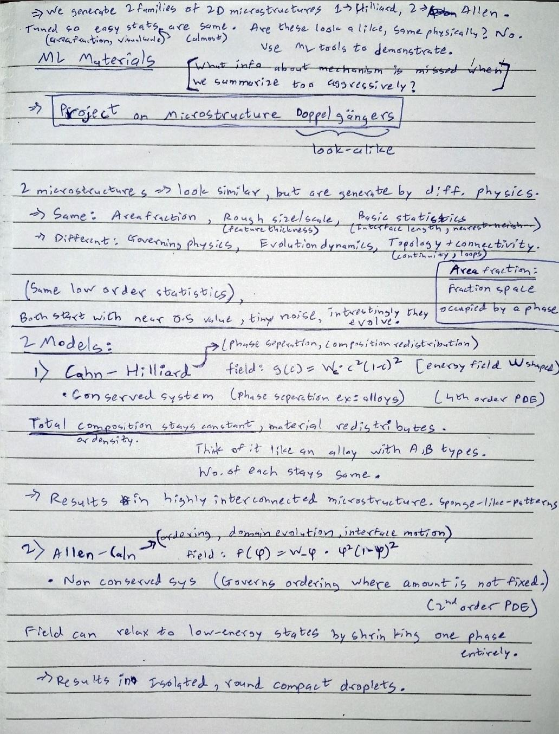
Then we should be asking a question, do we really need to perform PCA or SVD? Can’t we just use basic properties to differentiate between Cahn-Hilliard and Allen-Cahn microstructures?

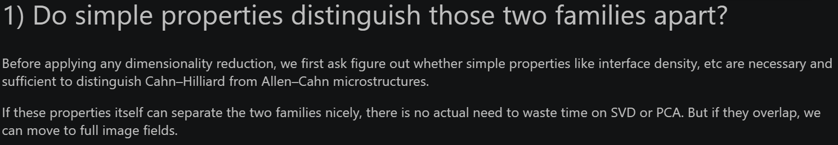

The code plots (shown at the end) clearly show that Interface Density is not discrete and overlaps. So this alone is not sufficient, thus we require ML tools for deeper analysis.
These are PCA and SVD.
Using python, the graph is generated for visualization.
