Second Progress Report, ML Project -Neel Patel (MS24BTECH11024) 24-04-26

Project 3 - Microstructure Doppelgängers
In previous report I had proved that we actually are in the need of using PCA and SVD, and cannot differentiate microstructure families by just simple properties.
Part 2) - Here we flatten each image into a row vector and stack these vectors into a matrix X. We then compute the mean and subtract it from every row, basically centering, and it is what turns plain SVD into PCA.
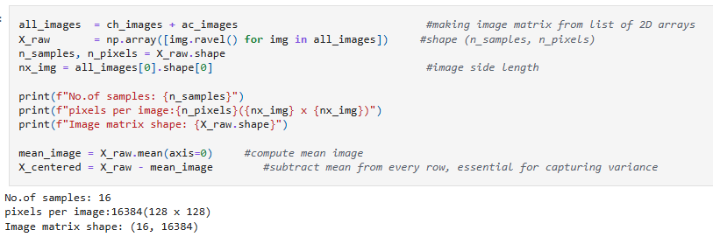
The resulting centered microstructure:
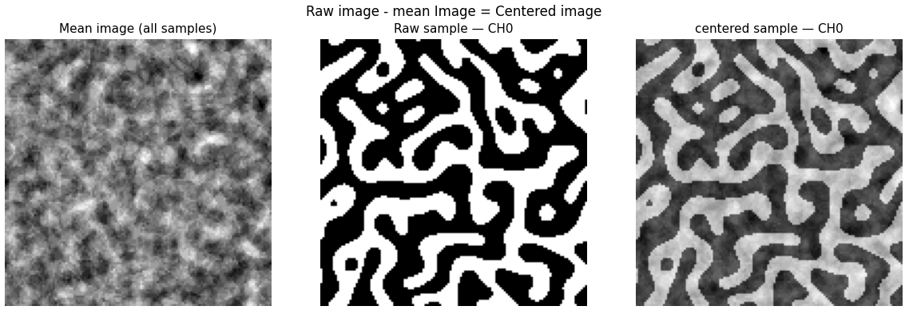

Part 3) – Here we basically visualize the percentage of information (variance) captured by progressing modes.
Also, a cumulative variance plot is made to get information about 90% and 95% of the variance.

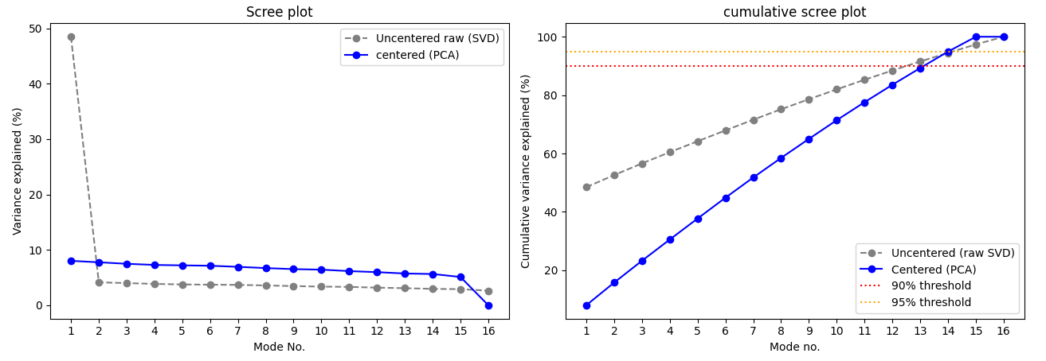
Before centering: We see that the very first mode captures about 50% of the variance. This is misleading as this basically captures information about the mean value and not the actual usable variance.

Next, I will try to regenerate the microstructure by using only the top modes and compare the results.

