**Theme** Technology to achieve reliability

**Track 1: Modern Trends in Power Electronic Converters**

Power Electronics, Electrical Machines and Drive System Electrical Traction Systems and Control, Industrial Process Control and Automation, Application of Microprocessor based Technologies in Power Electronics, Magnetic Heating, Wireless power transfer, Induction heating, High Voltage Engineering and Insulation Technology, Electronic Materials

**Track 2: Advancements in Power Systems**

Electric Power Generation, Power System Reliability and Security, Power Systems Communication, Power System Protection, Operation and Control, Transmission & Distribution Systems and Apparatus, Power system restructuring, HVDC and FACTS, Power System Planning and Scheduling, Applications of Soft Computing and AI in Advanced Power System, Economic aspects of power quality and cost of supply, Reliability and continuity of supply, Energy efficiency in industry, Power quality

**Track 2:** **Roll of Renewable Energy in sustainable development**

Power quality in grids with distributed generation and renewable energies, Converter based distributed generation,Renewable Energy technologies –solar, wind, wave, tidal, geothermal, bioenergy, hydropower, Energy storage concepts and materials, Renewable energy integrations and energy networks, Innovation in energy efficiency and architecture, Economics social and environmental and policy aspects, Energy and climate change.

**Track 4: Electric Vehicle and Battery management**

Hybrid and Electric Vehicles, EV system architecture, concepts for passenger, service and utility vehicles (BEV, PHEV, HEV, FCEV)**,** Innovations in EV component design**,**  EV motor drives and controllers**,** EV high voltage wiring**,**  Heating and cooling systems for EV’s**,** Innovations in EV energy storage solutions (e.g. battery chemistry, ultra-capacitor, fuel cell, battery management system). EV systems modelling, simulation and testing,**,** AC and DC conductive charging, wireless charging, smart charging, fast charging**,** Power grid and renewable energy resource interfacing for EV mass deployment**,** . Design for manufacturing for EV mass production.

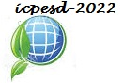

International Conference on Power Electronics & Sustainable Development (ICPESD-2022)

March 26-27, 2022

**Organised by**

Department of Electrical

Engineering

National Institute of Technology, Jamshedpur

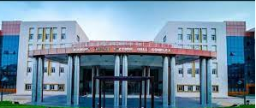

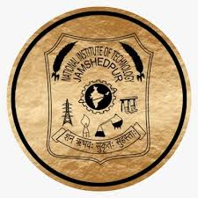

**In Collaboration with**

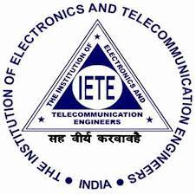 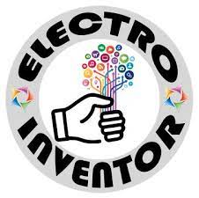

**Welcome to ICPESD-2022**

International Conference on Power Electronics and Sustainable Development (ICPESD-2022) is a premier platform to present and discuss the different aspects of modern power electronics, power system and the research trends in the domain employing soft computing techniques. The conference is organized by the Department of Electrical Engineering, National Institute of Technology, Jamshedpur, India during 26th-27th March, 2022. The conference will feature various plenary talks, panel discussion and paper presentation on state of art technologies in the domain of power electronics, soft computing and modern power systems.

**About the Institute**

The National Institute of Technology Jamshedpur (NIT Jamshedpur), is an Institute of National Importance located at Jamshedpur, Jharkhand, India. Established as a Regional Institute of Technology in 1960, it was upgraded to National Institute of Technology (NIT) on 27 December 2002 with the status of Deemed University. It is one of the 31 NITs in India, and as such is directly under the control of the Ministry of Human Resource Development (MHRD). It is the third in the chain of eight NITs established as a part of the Second Five Year Plan (1956–61) by the Government of India. The Institute has twelve departments including engineering, science and humanities. The institute offers a 4-year Bachelor of Technology degree in the various streams. The institute also offers Master and Ph.D degrees in various streams. The institute is bound to the quest for academic excellence and good governance, growth of institute, admired and respected institute for students, employees and industry, innovative leader.

**About the Department**

The Department of Electrical Engineering was started in 1960. The Department has been consistently producing quality Engineers since its inception and is also involved in research and development activities. The alumni of the department are well placed in both public and private sectors. In addition to the UG programme the department runs PG programme in Power Systems and Power Electronics and Drives and Ph.D. programme in different areas of specialization.

**Theme**

Technology to achieve reliability

**Theme** Technology to achieve reliability



**Dr. Ratan Mondal**

Dean of Energy Science,

Jadavpur University

**Dr. Akshay Rathore**

Concordia University

Montreal Canada

**Dr. Rajesh Gupta**

Professor, EED, MNNIT, Allahabad,Prayagrj, India

**Dr. Celia Shahnaz**

Professor, Bangladesh University of Engineering & Technology

***Registration Fees***

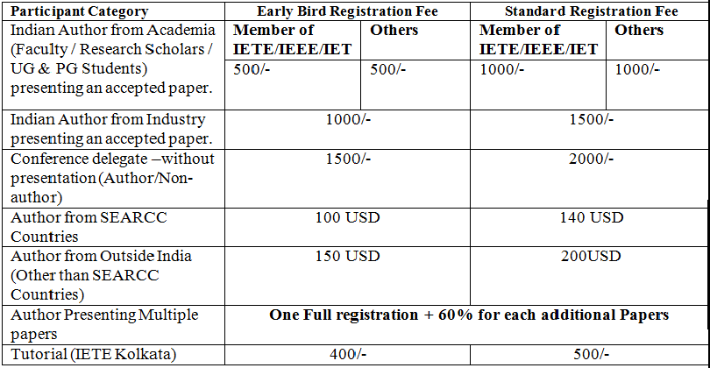

*Please Note*

All the papers must be submitted through online paper submission link at the conference website.

The conference will have oral and poster sessions. High quality original papers will be accepted.

Details of Paper Submissions and Author instructions will be posted at appropriate time on the conference website. Please keep visiting:  [**https://icpesd.org/**](%20https://icpesd.org/)

**Important Dates:**

Paper submission opens: **30.10.2021**

Paper submission closes: **28.01.2022**

Paper Acceptance notification: **07.03.2022**

Last date of Registration : **14.03.2022**

Camera-Ready Paper Submission: **21.03.2022**

**Contact Us:**

Secretariat ICPSED- 2022

Manoj Kumar Kar +91-7008542619

Anamika Das +91-9934300370

Lalit Kumar +91 8676029065

Munna Kumar +918271154350

Arpita Basu +919874330014

Deepak Kumar +919074442201

***\*\*The Conference kit will not be provided. The e-copy of the paper presentation certificate will be sent via email.***

***Publication Chair(s)***

Dr. Arceloni Neusa Volpato, Unifavest Transcultural Practices Master, Brazil

Dr. Rajesh Dey, Brainware University

Dr. Ananyo Bhattacharya, NIT Jamshedpur

Dr. Rajeev Bhushan, NIT Jamshedpur

Dr. Sanjay Kumar, NIT Jamshedpur

***Finance Chair:***

Dr. Madhu Singh, EED, NIT Jamshedpur

Dr. Ananyo Bhattacharya, EED, NIT Jamshedpur

Dr. Jitendra Kumar, EED, NIT Jamshedpur

Dr. Om Hari Gupta, EED, NIT Jamshedpur

***Conference Organizing Secretary (s)/ Chair(s):***

Dr. A.K.Akella, HOD, EED, NIT Jamshedpur

Dr. Ananyo Bhattacharya, EED, NIT Jamshedpur

Dr. Sanjay Kumar, EED, NIT Jamshedpur

Dr. Madhu Singh, EED, NIT Jamshedpur

Keynote Speakers

 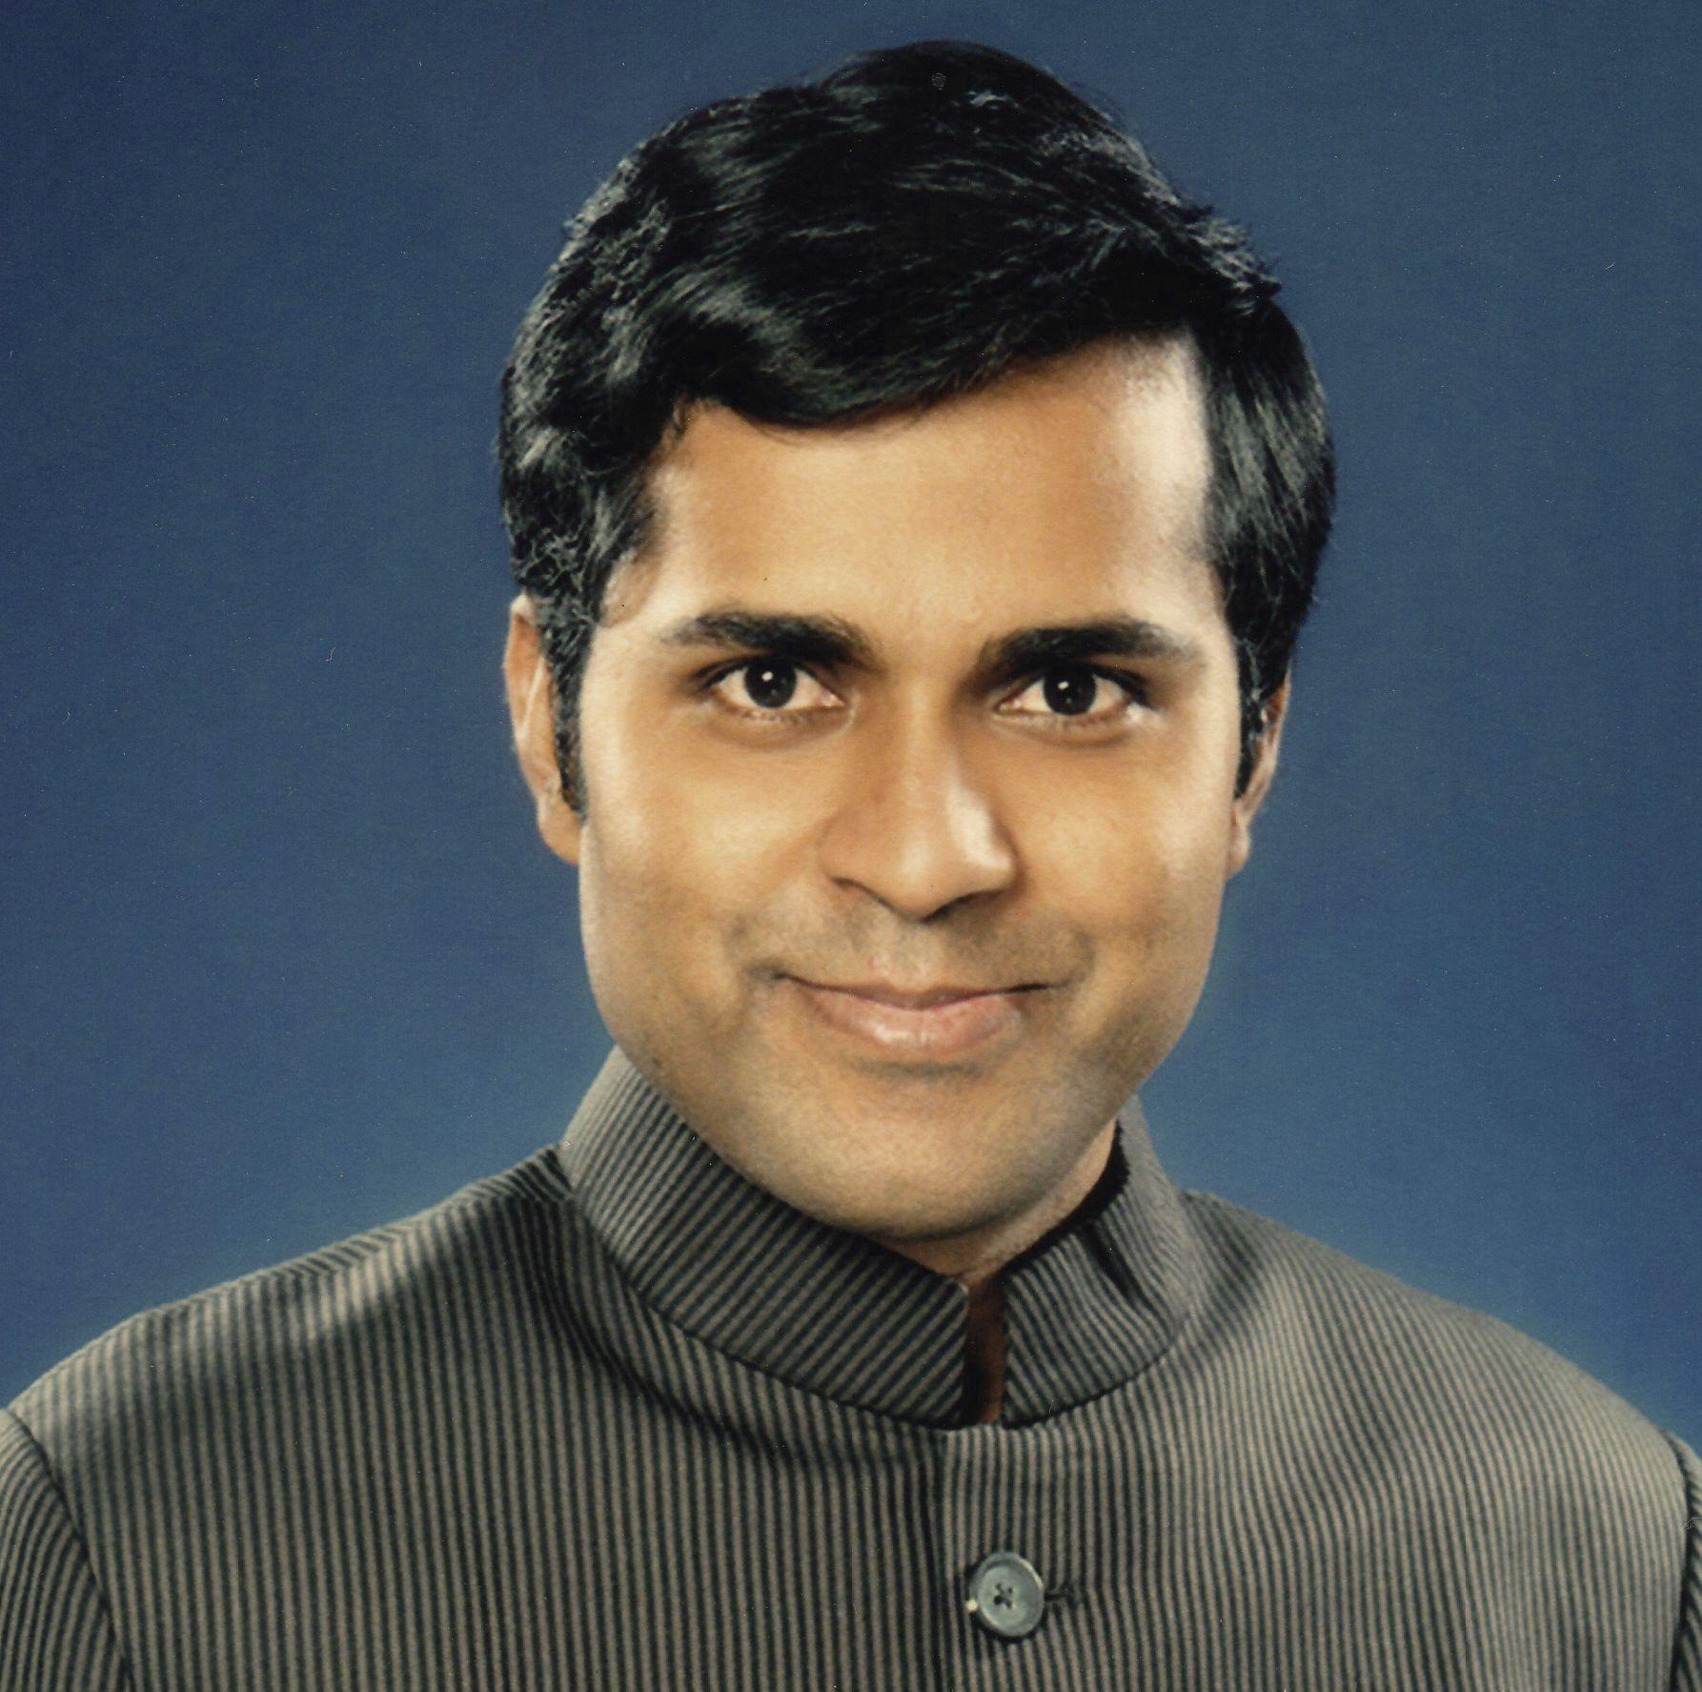

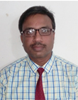 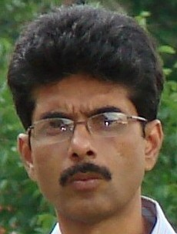

Keynote Speakers

***Conference Committee***

***Chief-Patron:***

Prof. K.K. Shukla, Director, NIT Jamshedpur

***Patron:***

Prof. R.V.Sharma, Deputy Director, NIT Jamshedpur

***Honorary General Chair(s):***

Prof. Sanjay, Dean (Reasearch & Consultancy), NIT Jamshedpur

Prof. J K Mandal, University of Kalyani, WB

Prof. P.K. Sadhu, IIT (ISM ), Dhanbad

Prof.. Celia Shahnaz, Professor, Bangladesh University of Engineering & Technology

Prof. Niranjan Kumar ,Dean, Industry and Alumni Relations, NIT Jamshedpur

***International Advisory Committee:***

Prof. Bhim Singh, IIT Delhi

Dr. Akshay Rathore, EED, Concordia University , Montreal Canada

Dr. Ratan Mondal, Dean of Energy Science, Jadavpur University

Dr. Marta Zurek-Mortka, Lukasiewicz Research Network, Institute for Sustainable Technologies, Radom, Poland

Prof. A K Singh, EED, NIT Jamshedpur

Dr. A N Thakur, Visiting Professor, NIT Jamshedpur

Dr. Nilanjan Sen Roy, EED, IIT Delhi

***Technical Program Committee Chairs***

Dr. J K Mandal, University of Kalyani, WB

Dr. P K Sadhu, IIT (ISM ), Dhanbad, India

Prof. R N Mahanty, NIT Jamshedpur

Dr. Ritesh Kesari, VNIT Nagpur

Dr. Niranjan Kumar, NIT Jamshedpur, India

***Technical Program Committee***

Dr. K B Yadav EED, NIT Jamshedpur

Dr. U K Sinha, EED, NIT Jamshedpur