# A

**Summer Internship Report On**

# "Fitness Area: Gym Website"

(Summer Internship - I)

## Prepared by

Neel Aldrin Thomas (20CS095)

## Under the Supervision of

Prof. Vidisha Pradhan

## Submitted to

Charotar University of Science & Technology (CHARUSAT) for the Partial Fulfillment of the Requirements for the Degree of Bachelor of Technology (B.Tech.)

for Semester 5

### Submitted at



**Accredited with Grade A+ by NAAC Accredited with Grade A by KCG**



### DEPARTMENT OF COMPUTER SCIENCE AND ENGINEERING

**Chandubhai S. Patel Institute of Technology (CSPIT) Faculty of Technology & Engineering (FTE), CHARUSAT At: Changa, Dist: Anand, Pin: 388421.**

### July 2022



**Accredited with Grade A+ by NAAC Accredited with Grade A by KCG**

## CERTIFICATE

This is to certify that the report entitled “**Fitness Area**” is a bonafied work carried out by **Neel Thomas(20CS095)** under the guidance and supervision of Prof. Vidisha Pradhan/ Mr. Raj Akhani for the subject **Summer Internship – I** of 5th Semester of Bachelor of Technology in **Computer Science and Engineering** at Chandubhai S. Patel Institute of Technology (CSPIT), Faculty of Technology & Engineering (FTE) – CHARUSAT, Gujarat.

To the best of my knowledge and belief, this work embodies the work of candidate himself, has duly been completed, and fulfills the requirement of the ordinance relating to the B.Tech. Degree of the University and is up to the standard in respect of content, presentation and language for being referred by the examiner(s).

|  |  |
| --- | --- |
| Under the supervision of,  Prof. Vidisha Pradhan Assistant Professor  Dept. of Computer Science and Engineering  CSPIT, FTE, CHARUSAT, Changa, Gujarat | Mr. Raj Akhani Founder and CEO Wiz Developers Vadodara, Gujarat |
| Dr. Amit Thakkar  Head - Department of Computer Science and Engineering,  CSPIT, FTE, CHARUSAT, Changa, Gujarat. | |

**Chandubhai S. Patel Institute of Technology (CSPIT) Faculty of Technology & Engineering (FTE), CHARUSAT At: Changa, Ta. Petlad, Dist. Anand, Pin: 388421. Gujarat**

**Certificate of Completion**

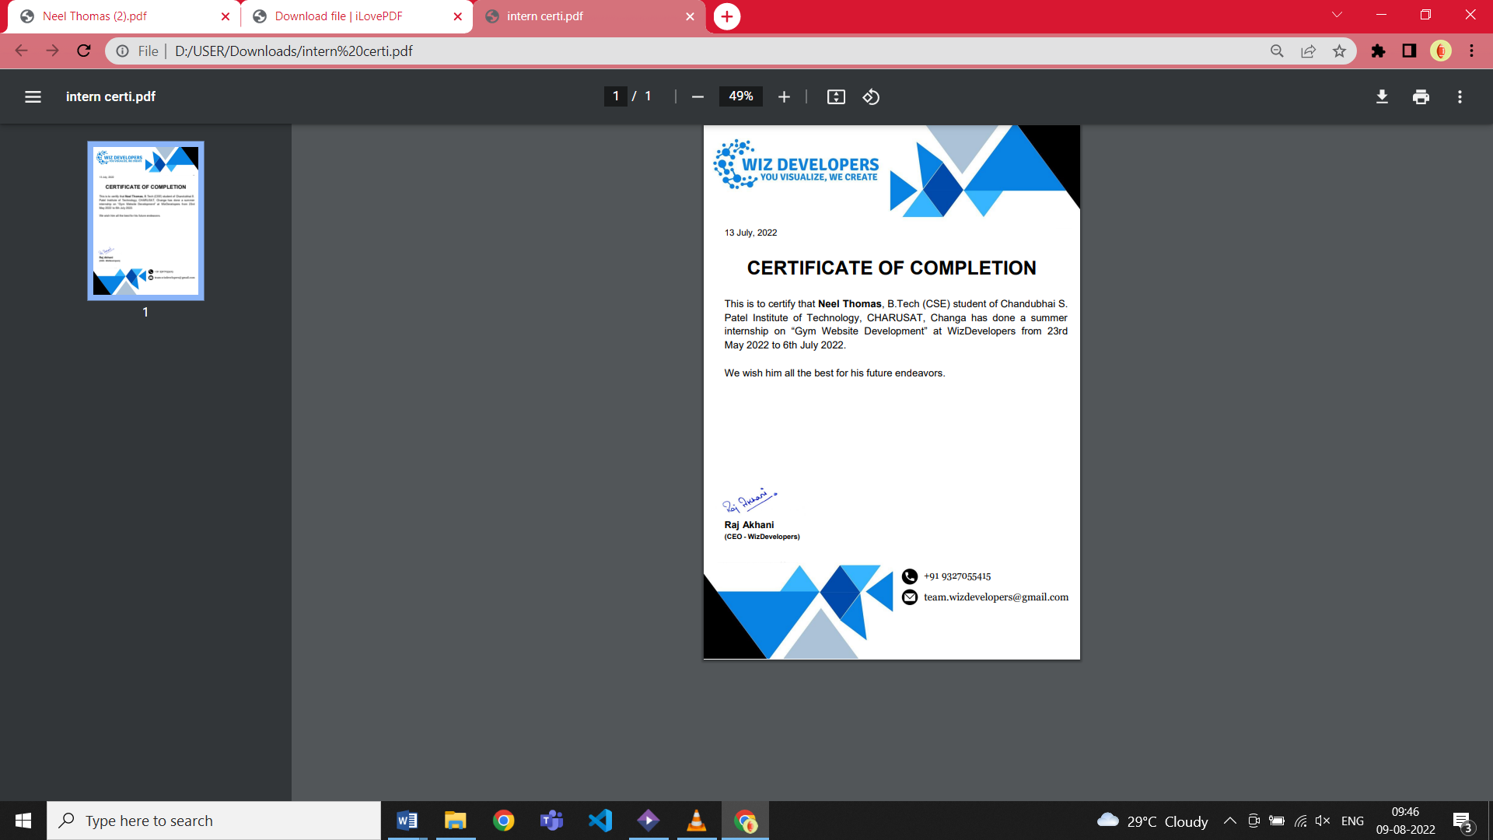

# ABSTRACT

During this internship, I was segregated individually for development of website. I was given the task to make a website for Gym. I used HTML, CSS and JAVASCRIPT to develop the website and PHP and MySql as the backend to develop required features. This website aimed to provide the user to know about gym, specialties about the gym and also user can register for the gym.

**ACKNOWLEDGEMENT**

Its gives me immense pleasure and gratification to present my presentation on Summer Internship -2022, that has been completed after Fourth semester of 2nd year CSE. Every work that one completes successfully stands on the constant encouragement, good will and support of the people around.

On this note, I would like to thank all people who were behind and along with me and who constantly guided me during the time of difficulties I faced while developing the project for my internship with Wiz Developers.

First and foremost, I would like to thank the faculties of Chandubhai

S. Patel Institute of Science and Technology, Changa to whom I am highly indebted towards.

A very special thanks to each person who always were ready with their suggestions and advices to help through this with through their complete perseverance. Next, I would acknowledge my colleagues who have contributed their part of help with their active suggestions to the development of our project, which were assigned together as a team, which provided to be of great help.

Lastly, I would express our wholehearted appreciation to the CSPIT family for the continuous support, encouragement and invaluable tips. They altogether provided us a favorable environment, and without them, it would not have been possible to achieve my goal.

Thank you, Neel Thomas

(20CS095)

**Company description**



Wiz Developers, best and quality Software development, Training and mentoring provider from India, for web and mobile app development requirements. We customize client’s product considering as our products. Wiz Developers knows the worth of customers.

We provide innovative and unique ideas within the customer’s budget. Where you take care of your business and we take care of your IT needs. Customer’s time is our most pressing matter therefore Wiz Developers ensures to deliver the client’s product as earlier as possible.

The objective of Wiz Developers is to enable a large number of youths to take up industry-relevant skill training that will help them in securing a better livelihood.

Their sole aim is to nurture the youth impressively and to prepare practitioners who are globally competitive as well as committed towards their profession and who can thrive well in this volatile economy.

Table of Contents

Abstract i

Acknowledgement ii

Description of company / organization……………………………………………. iii

Chapter 1 Introduction 1

1.1 Purpose of Internship 1

1.2 Overview of Project 1

1.3 Objective 1

1.4 Scope 1

1.5 Roles and Responsibilities 1

1.6 Internship plan (Week wise) 2

Chapter 2 System Analysis 4

2.1 Study of existing system & its limitations 4

2.2 Requirement of new system 4

2.2.1 Functional Requirements 4

2.2.2 Non-functional Requirements 4

2.3 Hardware Requirements 4

2.4 Software Requirements 4

Chapter 3 Development Environment 5

Chapter 4 System Design 6

4.1 Data Dictionary 6

Chapter 5 Implementation Screenshots 7

Chapter 6 Limitations and Future Work 10

Chapter 7 Conclusion 11

References 12

**List of Tables**

Table 1.1 Internship Plan (Week Wise) 2

Table 1.2 Data Dictionary 6

**List of Figures**

Fig 1.1 Home Page 7

Fig 1.2 About Us 8

Fig 1.3 Contact Details 9

Fig 1.4 Registration Page 9

## Chapter – 1 Introduction

### Purpose of Internship

This project is a website developed using HTML, CSS, JAVASCRIPT, PHP and MYSQL. The main objective of the website was to create a gym website and giving it different styles.

### Overview of project

Looking from a broad perspective, this project is useful to the user for very efficient and hassle-free creation. It basically provides an easy way of knowing about the gym and for more details you can even contact the gym owner through mail or can call them with just one click.

### Objective

This application was developed for the user so that they can know about the gym from their home and don’t need to personally go to the location.

### Scope

The main aim of the application is to provide the user with an interactive platform to handle. The scope of this stretches wide from providing an easy- to-use user interface.

### Roles and Responsibility

I was considered as a front end and backend developer. The frontend developer further acted as a tester and the backend developer acted as the debugger. The creation of the test and release application was done by the backend designer. The beautification and the increase in the user friendliness of the application was done by the frontend designer.

### Internship plan (Week wise)

|  |  |  |  |
| --- | --- | --- | --- |
|  | Date | Day | Name of Module |
| Week 1 | 23/5/2022 | Monday | 1. Learn about HTML and it’s modules 2. Surveying some gym website 3. Making GUI |
| 24/5/2022 | Tuesday | 1. Installing VS Code 2. Creating Home page using HTML 3. Learn about HTML and it’s modules |
| 25/5/2022 | Wednesday | 1. Learn about HTML and it’s modules for About Us page 2. Creating About Us page |
| 26/5/2022 | Thursday | 1. Learn about HTML and it’s modules for Registration page 2. Creating Registration page |
| 27/5/2022 | Friday | 1. Learn about HTML and it’s modules for contact details 2. Creating contact details |
|  |  |  |
| Week 2 | 30/5/2022 | Monday | 1. Learn about HTML and it’s modules for contact details 2. Creating contact details |
| 31/5/2022 | Tuesday | 1. Learning about CSS 2. Applying CSS in homepage |
| 1/6/2022 | Wednesday | 1. Learning about CSS 2. Applying CSS in About Us |
| 2/6/2022 | Thursday | 1. Learning about CSS 2. Applying CSS in Registration page |
| 3/6/2022 | Friday | 1. Learning about CSS 2. Applying CSS in contact details |
|  |  |  |
| Week 3 | 6/6/2022 | Monday | 1) Learning Javascript |
| 7/6/2022 | Tuesday |
| 8/6/2022 | Wednesday |
| 9/6/2022 | Thursday |
| 10/6/2022 | Friday | 1) Learning Php |
|  |  |  |
| Week 4 | 13/6/2022 | Monday | 1) Done meeting and rechanging CSS and HTML of all pages |
| 14/6/2022 | Tuesday | 1) rechanging CSS and HTML of all pages |
| 15/6/2022 | Wednesday | 1) rechanging CSS and HTML of all pages |
| 16/6/2022 | Thursday | 1) rechanging CSS and HTML of all pages |
| 17/6/2022 | Friday | 1) rechanging CSS and HTML of all pages |
|  |  |  |
| Week 5 | 20/6/2022 | Monday | 1)learning PHP and Mysql |
| 21/6/2022 | Tuesday | 1) Doing practice on Php and mysql exercise from sources |
| 22/6/2022 | Wednesday | 1. Learning php and mysql 2. Doing practice on Php and mysql exercise from sources |
| 23/6/2022 | Thursday | 1)Installing xampp server |
| 24/6/2022 | Friday | 1) Trying to link database |
|  |  |  |  |
| Week 6 | 27/6/2022 | Monday | 1) Trying to link database |
| 28/6/2022 | Tuesday | 1) Visiting some links and watching videos to rectify the error |
| 29/6/2022 | Wednesday | 1) Visiting some links and watching videos to rectify the error |
| 30/6/2022 | Thursday | 1) Trying to make dropdown menu for contact details instead of single page. |
| 1/7/2022 | Friday | 1) Trying to make dropdown menu for contact details instead of single page. |
|  |  |  |  |
| Week 7 | 4/7/2022 | Monday | 1)Getting success in linking the database. |
| 5/7/2022 | Tuesday |
| 6/7/2022 | Wednesday |

### Table 1.1 Internship plan (Week wise)

**Website Specifications :**

* Home page
* About Us page
* Contact Details
* Registration Form

## CHAPTER – 2

**System Analysis**

### Study of existing system & its limitations

The current websites of gym are not different from the one which I created. To differentiate I added some different stylings and animation.

### Requirement of new system

* + 1. **Functional Requirements**

User Interface Requirements: The easy-to-use UI enables a user-friendly environment so that the user can easily navigate through modules.

Storage and Database: The use of MySql as a database enables to store information of user who fills out the registration form.

Security: This website doesn't require any security.

### Non-functional Requirements

* + - * The app has a very well performance with no bugs.
      * The modular interface gives user an easily understandable environment.

### Hardware Requirements

* Min Ram: 2GB
* Min Disc Space: 13 MB
* Laptops/PCs with a decent internet connectivity

### Software Requirements

* Windows Version: (Recommended) – 10
* Works on any operating system: (Compatible) - 7 onwards

## CHAPTER – 3

**Development Environment**

This app has been developed using **Visual Studio Code** as the development tool.

**Visual Studio Code**, also commonly referred to as **VS Code**,is a source code editor made by Microsoft for [Windows](https://en.wikipedia.org/wiki/Windows), Linux and macOS. Features include support for [debugging](https://en.wikipedia.org/wiki/Debugging), [syntax highlighting](https://en.wikipedia.org/wiki/Syntax_highlighting), [intelligent code completion](https://en.wikipedia.org/wiki/Intelligent_code_completion), [snippets](https://en.wikipedia.org/wiki/Snippet_(programming)), [code refactoring](https://en.wikipedia.org/wiki/Code_refactoring), and embedded [Git](https://en.wikipedia.org/wiki/Git). Users can change the [theme](https://en.wikipedia.org/wiki/Theme_(computing)), [keyboard](https://en.wikipedia.org/wiki/Keyboard_shortcut) [shortcuts](https://en.wikipedia.org/wiki/Keyboard_shortcut), preferences, and install extensions that add additional functionality.

In the Stack overflow 2021 Developer Survey, Visual Studio Code was ranked the most popular developer environment tool, with 70% of 82,000 respondents reporting that they use it.

Visual Studio Code was first announced on April 29, 2015, by Microsoft at the 2015 Build conference. A preview build was released shortly thereafter.

On November 18, 2015, the source of Visual Studio Code was released under the [MIT License](https://en.wikipedia.org/wiki/MIT_License), and made available on [GitHub](https://en.wikipedia.org/wiki/GitHub). Extension support was also announced. On April 14, 2016, Visual Studio Code graduated from the [public](https://en.wikipedia.org/wiki/Beta_software) preview stage and was [released to the Web](https://en.wikipedia.org/wiki/Software_release_life_cycle#Web_release). Microsoft has released most of Visual Studio Code's source code on Github under the permissive [MIT License](https://en.wikipedia.org/wiki/MIT_License),while the releases by Microsoft are proprietary [freeware](https://en.wikipedia.org/wiki/Freeware).

**Features of Visual Studio Code:**

* + All language support
  + API
  + Bug Tracking
  + Change Management
  + Custom Development
  + Search/Filter
  + Third Party Integeration
  + Application Management
  + Build Automation
  + Code Review
  + Drag & Drop
  + Text Editing

## CHAPTER – 4

**System Design**

### Data Dictionary

|  |  |  |  |
| --- | --- | --- | --- |
| **Attributes(tbl_user)** | **Required** | **format** | **max field size** |
| First Name | yes | Text | 20 |
| Last Name | yes | Text | 20 |
| Email | yes | Varchar | 30 |
| Contact Number(primary key) | yes | Int | 10 |
| Gender | yes | Radio(Choice) | - |

**Table 1.2 Data Dictionary**

## CHAPTER – 5

**Implementation Screenshots**

### Home Page

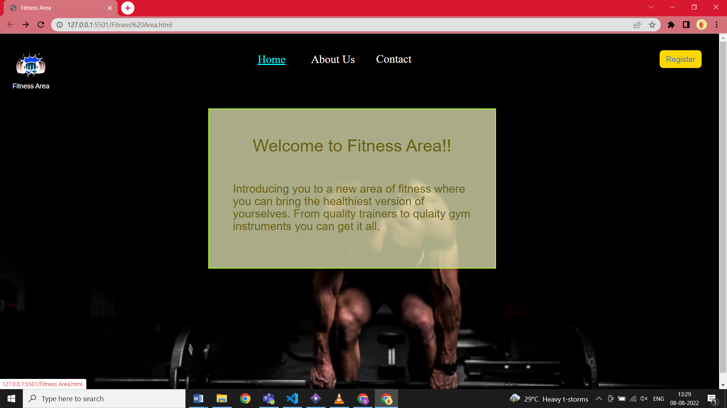

### Fig 1.1 Home Page

### About Us

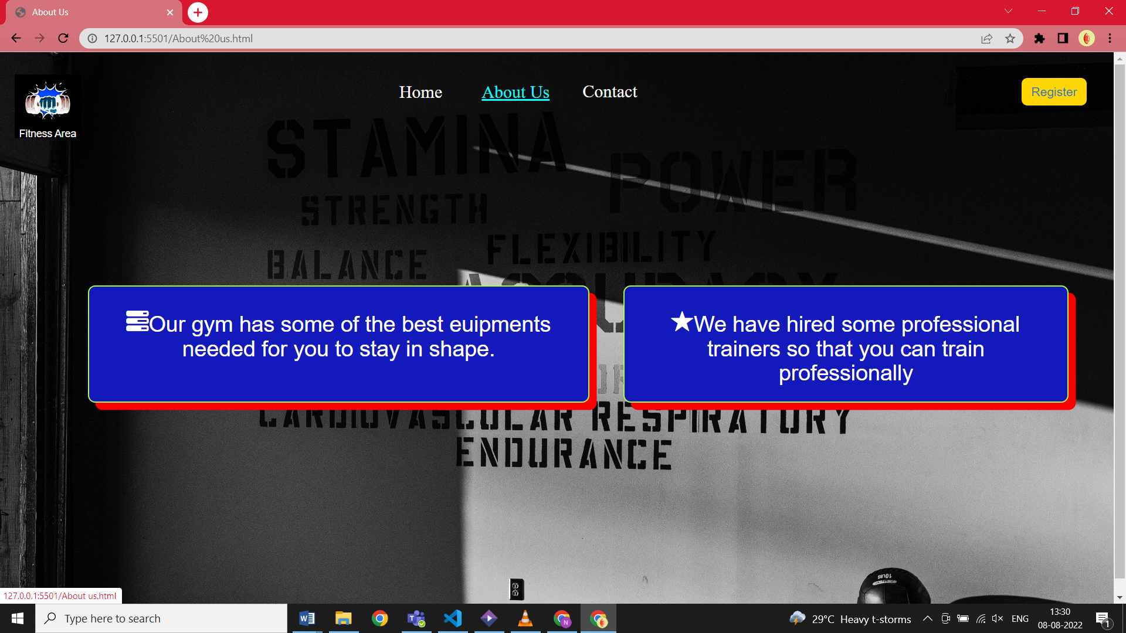

### Fig 1.2 About Us

1. **Contact Details**

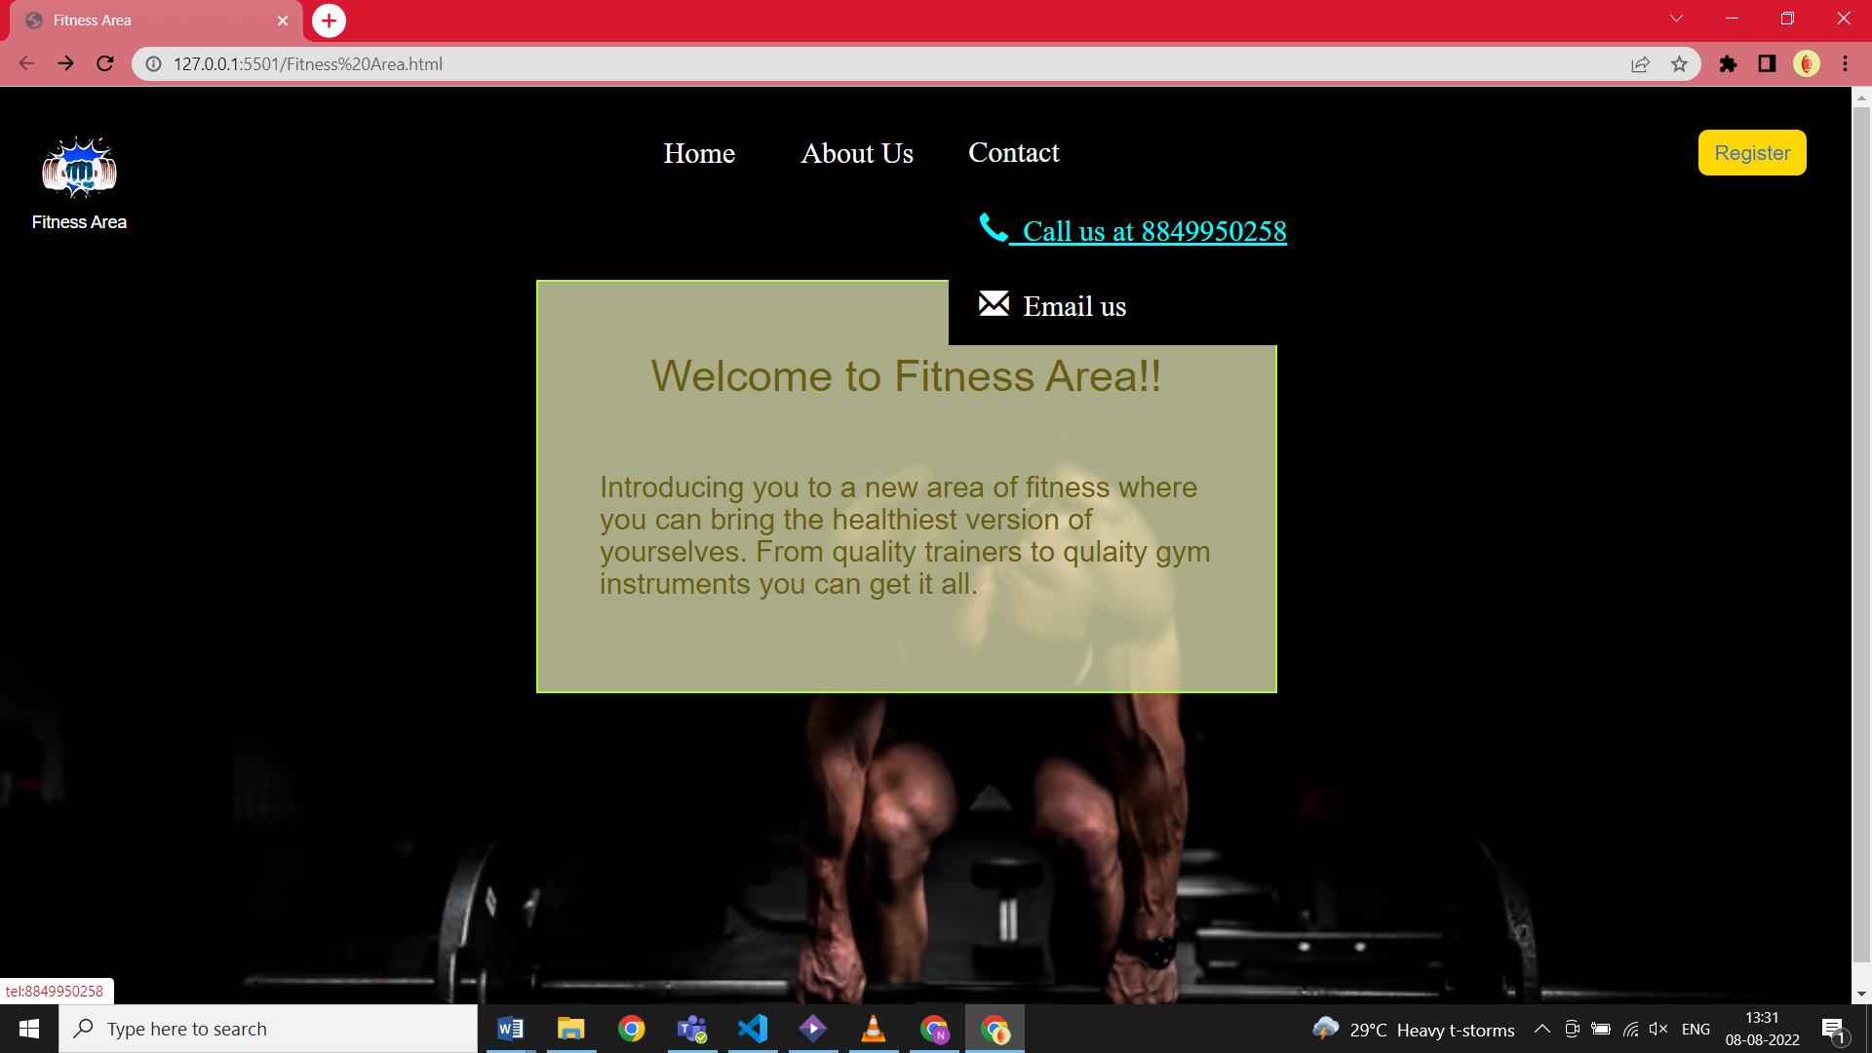

### Fig 1.3 Contact Details

### Registration Page



### Fig 1.4 Registration Page

## CHAPTER – 6

**Limitation and Future Work**

The current website has a very basic yet understandable UI. It needs to be improved to make the application more attractive to the eye.

Future Work:

1. To make an attractive UI using the “Material Design” Library.
2. Adding the option of live location or Google Maps.
3. Adding the instructors’ list and more.

## CHAPTER – 7

**Conclusion**

First time internship with a company (Wiz Developers) for 6 weeks was an overwhelming yet educated experience. It gives an inside view of how the knowledge and skills which we learn in our classes are implemented for solving actual real-life problems for certain people.

This whole experience also shows us a glimpse of the aspect of life after we graduate and helps us to sharpen our skills to use them resourcefully.

## References

* 1. HTML,CSS and JAVASCRIPT - <https://www.coursera.org/learn/html-css-javascript-for-web-developers/home/week/1>
  2. HTML - [HTML Tutorial (w3schools.com)](https://www.w3schools.com/html/default.asp)
  3. CSS - [CSS Tutorial (w3schools.com)](https://www.w3schools.com/css/default.asp)
  4. JAVASCRIPT - [JavaScript Tutorial (w3schools.com)](https://www.w3schools.com/js/default.asp)
  5. PHP - <https://www.youtube.com/watch?v=1SnPKhCdlsU>