Assignment

Topic: Network Fundamentals and Building Networks

Subtopic: Introduction to Networks

1. Simple Diagram: Phone Connecting to Instagram
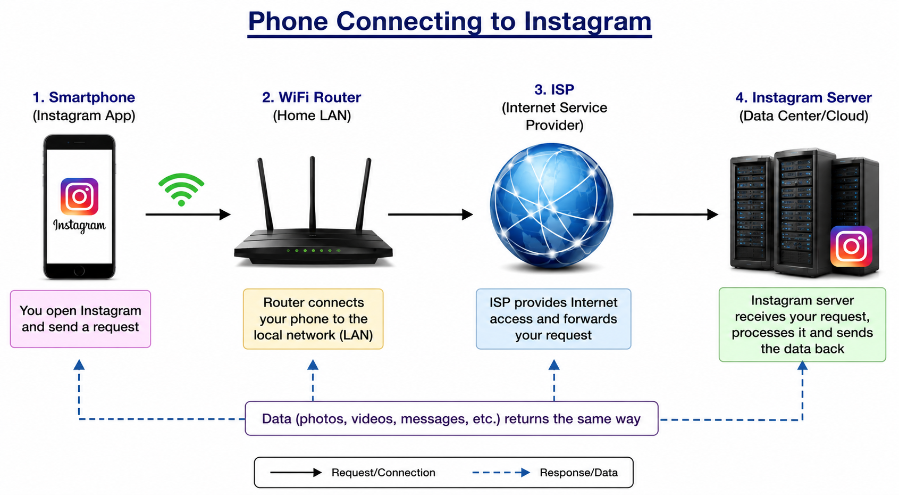
Labels:
• Smartphone: Sends requests using the Instagram app.
• WiFi Router: Connects the phone to the local network (LAN).
• ISP: Provides Internet access.
• Instagram Server: Processes the request and sends data back.

2. Five Network Devices Used Daily
Device | Network Type | Purpose
Smartphone | WAN, LAN, PAN | Uses mobile data, WiFi, and Bluetooth.
Laptop | LAN, WAN | Connects to WiFi and the Internet.
Smart TV | LAN, WAN | Streams online content.
WiFi Router | LAN | Connects devices to the Internet.
Smartwatch | PAN | Connects to smartphone via Bluetooth.

3. Difference Between the Internet and an Intranet
The Internet is a global public network that anyone can access to browse websites and use online services. An intranet is a private network used within an organization to securely share information among authorized users.
Example: My college intranet allows students to access attendance, study materials, and notices. When I use public WiFi to browse Google or Instagram, I am using the Internet.

4. How Data Travels When Searching in WhatsApp
When I type a contact or message in WhatsApp and press Search, my smartphone sends the request through WiFi or mobile data. If connected to WiFi, the request goes to the WiFi router, then to the ISP, and over the Internet to WhatsApp's servers. The server processes the request, finds the required information, and sends the results back through the Internet, ISP, and router to my phone. Finally, the WhatsApp application displays the matching chats or contacts.

