Assignment

Topic: Networking Fundamentals and Building Networks

Network Topologies

1. Star, Bus, Mesh Topologies
Draw these diagrams in your notebook or using a drawing tool.
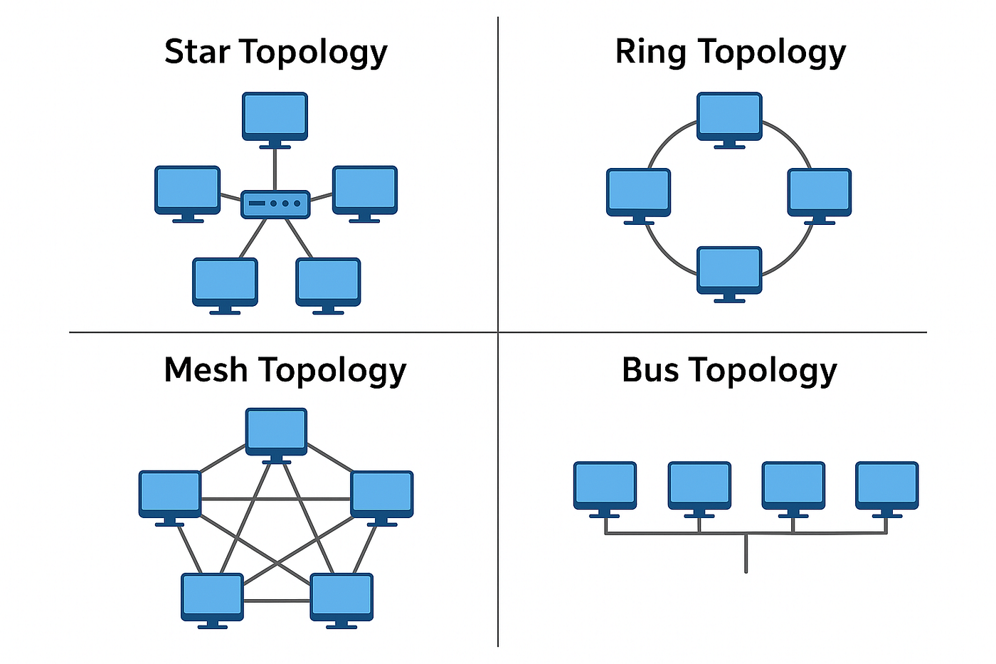
STAR:
Example: WhatsApp servers use a star-like client-server model because all users communicate through central servers.
BUS:
Example: Small temporary lab networks due to low cost.
MESH:
Example: Internet backbone because multiple paths improve reliability.

2. Comparison Table
Topology | Pros (4) | Cons (4) | Best Use Case | Example
Star | Easy to manage; Easy troubleshooting; Fast; Expandable | Central failure; More cable; Switch cost; Setup cost | Offices | Instagram
Bus | Cheap; Simple; Less cable; Easy small setup | Slow traffic; Cable failure; Limited size; Difficult troubleshooting | Small labs | Zomato
Ring | Orderly transmission; No collisions; Equal access; Predictable | One failure affects network; Hard expansion; Costly; Delay | Industrial networks | Paytm
Mesh | Highly reliable; Multiple paths; Fault tolerant; High performance | Expensive; Complex; More cables; Difficult maintenance | Data centers | Cloud gaming

3. Multiplayer Game Topology
A star topology is the best choice. All players connect to central game servers, making synchronization fast and easier to manage. It provides good reliability and low latency while keeping costs lower than a full mesh. Servers can be upgraded as the number of players grows.

4. Warehouse Recommendation
Diagram:
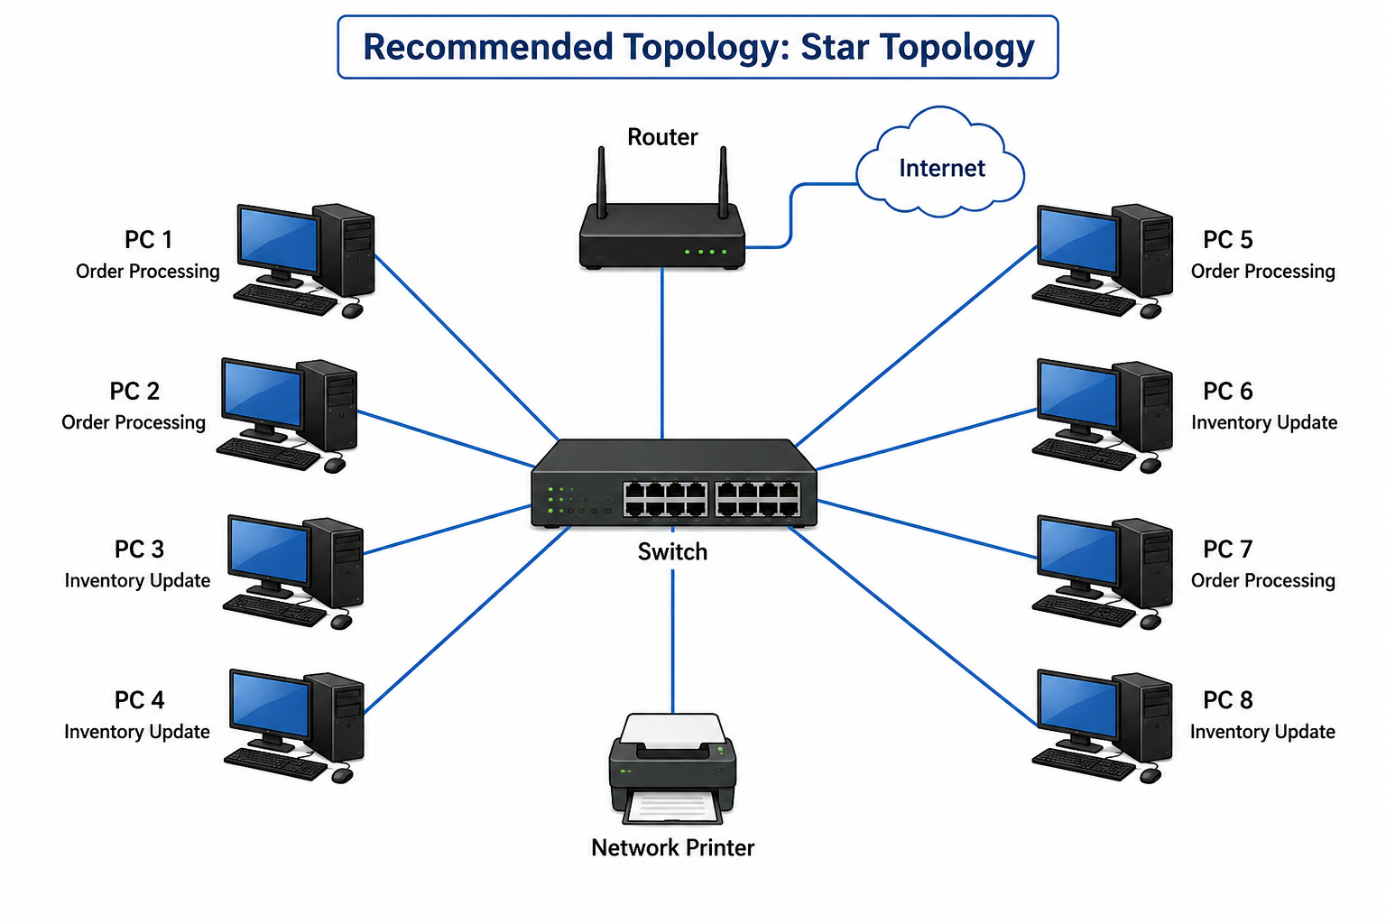
Recommendation: Use a star topology with a network switch. It is affordable, easy to troubleshoot, and allows additional computers to be connected in the future without disrupting the existing network.

