Assignment: Network Cables and Connectors

1. Cat6 Ethernet Cable (T568B Standard)
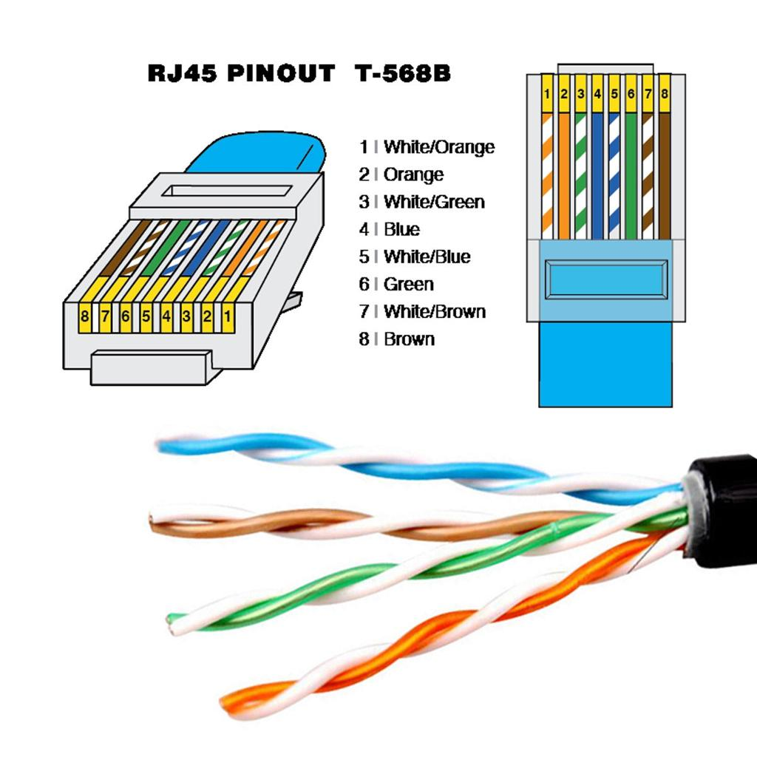
Pin order:
1 White/Orange
2 Orange
3 White/Green
4 Blue
5 White/Blue
6 Green
7 White/Brown
8 Brown
RJ-45 connectors have 8 pins and are commonly used with Cat6 Ethernet cables.

2. Types of Network Cables
Cat5e: Used with home Wi-Fi routers for up to 1 Gbps.
Cat6: Used for gaming PCs, switches, and POS terminals because it supports higher speeds and lower interference.
Fiber Optic: Used by ISPs and streaming servers for long-distance, high-bandwidth communication.

3. Crimping RJ-45
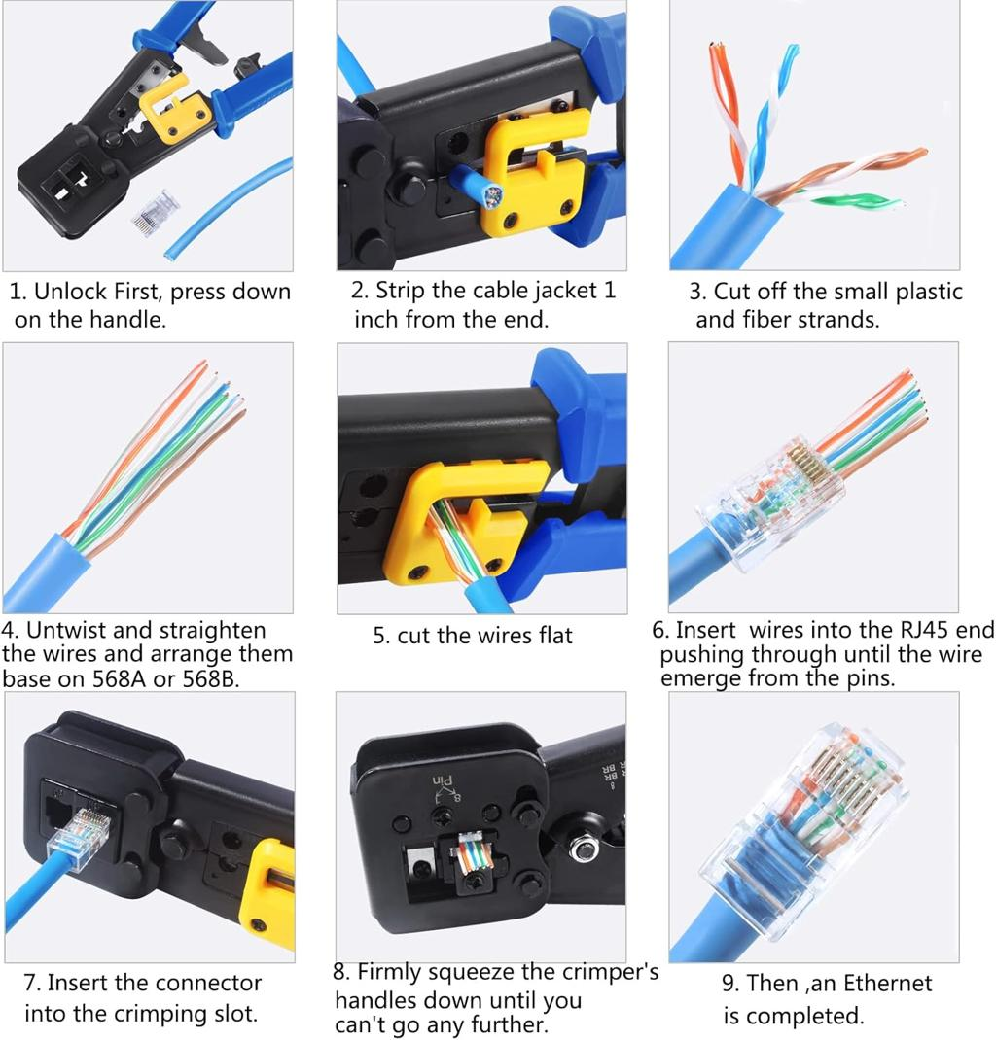
Steps: Cut cable, strip jacket, untwist pairs, arrange wires in T568B order, trim evenly, insert into RJ-45, crimp using tool, test with cable tester.
Mistakes: Wrong wire order; wires not fully inserted.

4. Gaming Zone Scenario
Use Cat6 cables with RJ-45 connectors to connect switches, gaming consoles, and displays because they provide reliable, high-speed, low-latency communication. Use fiber optic cable for the ISP backbone connection.

5. Network Cable Example
Example: A Cat6 Ethernet cable with an RJ-45 connector plugged into a Wi-Fi router, connecting the router to a desktop PC or network switch for stable wired Internet.

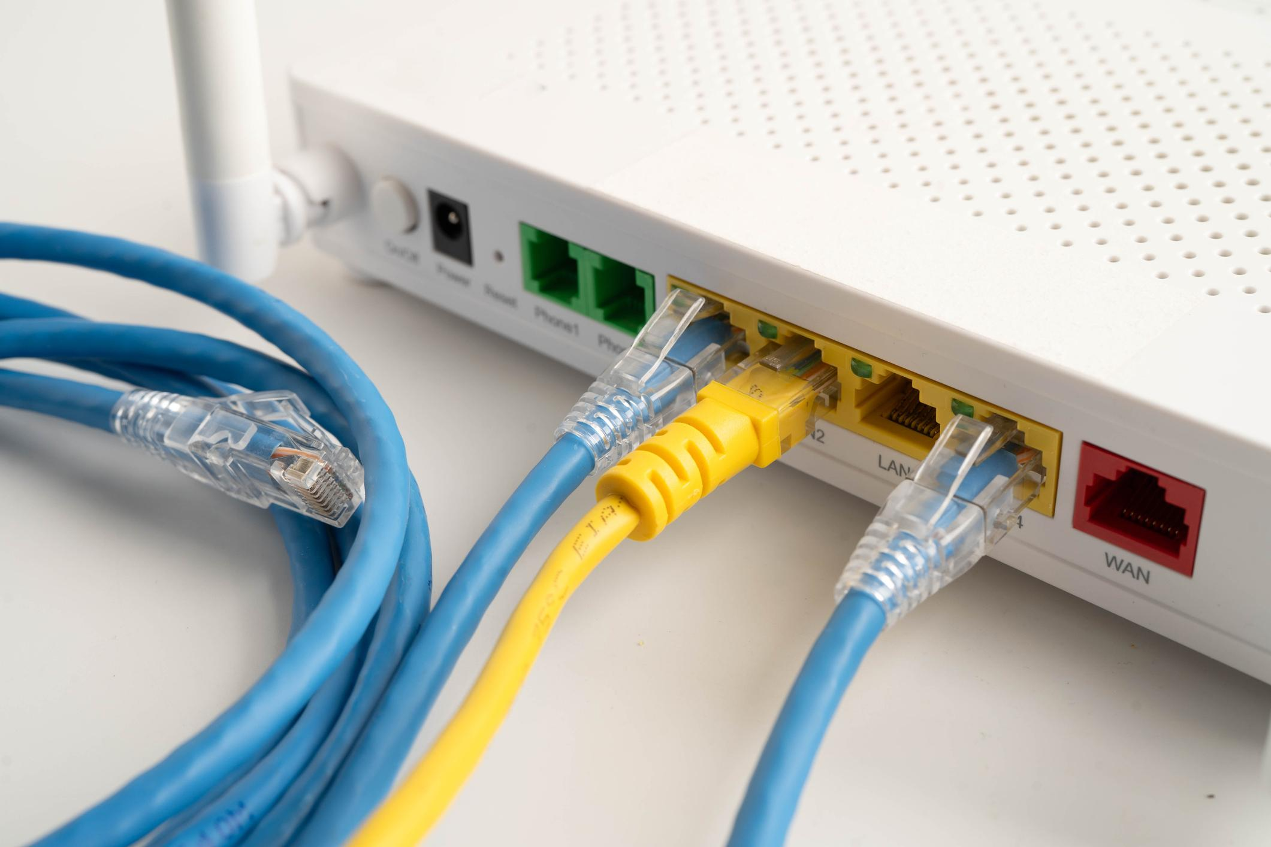
• T568B RJ-45 pinout
• Cat5e, Cat6, and Fiber Optic cables
• RJ-45 crimping process
• Ethernet cable connected to a Wi-Fi router

