Assignment: OSI 7-Layer Model

1. OSI 7-Layer Model
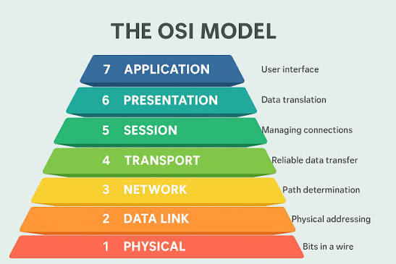
Layer 7 Application: Provides services to end users. Examples: HTTP, HTTPS, FTP, SMTP, DNS.
Layer 6 Presentation: Translates, encrypts/decrypts, compresses data. Examples: SSL/TLS, JPEG, PNG.
Layer 5 Session: Establishes, manages and terminates communication sessions. Examples: NetBIOS, RPC.
Layer 4 Transport: Reliable end-to-end delivery, segmentation, flow control. Examples: TCP, UDP.
Layer 3 Network: Routing using IP addresses. Examples: Router, IP, ICMP.
Layer 2 Data Link: Frame delivery, MAC addressing, error detection. Examples: Switch, Ethernet.
Layer 1 Physical: Transmission of bits through cables or wireless signals. Examples: Hub, Ethernet cable, Fiber, Wi‑Fi.

2. Scenario Matching
- Encrypting data before sending: Presentation Layer (Layer 6)
- Routing packets across networks: Network Layer (Layer 3)
- Converting data to electrical signals: Physical Layer (Layer 1)
- Opening a web page in your browser: Application Layer (Layer 7)
- Detecting and correcting errors in frames: Data Link Layer (Layer 2)

3. WhatsApp and the OSI Model
Application: User sends messages.
Presentation: End-to-end encryption and compression.
Session: Maintains login and communication session.
Transport: TCP ensures reliable delivery.
Network: IP routes packets.
Data Link: Uses MAC addresses on the local network.
Physical: Sends data as radio/electrical/optical signals.

4. Troubleshooting Scenario
If a website cannot be opened but its IP address can be pinged, Layers 1–3 are working. The problem is most likely at the Application Layer (HTTP/HTTPS service or browser), though Session or Presentation layer issues such as SSL/TLS certificate errors may also prevent access.

