**SPRING BLOSSOM USER MANUAL**

**ABOUT :**

Spring Blossoms Bouquet Shop in Madurai. Established in the year 2000, Spring Blossoms Bouquet Shop in K.K Nagar, Madurai is an acknowledged flower decorators. This brand of florists specializes in designing exquisite flower arrangements that are made up of exotic, beautiful and fresh flowers. On board its team, is a group of floral design experts and artists, who are masters in the art of flower arrangements and customized bouquets. Each arrangement is an arresting display created using a combination of fresh and exotic flowers. This florist in K K Nagar has been delighting citizens to a beautiful display of flowers and designs

Here ,We present a mobile application to facilitate sales and marketing of the shop. It consists of the following sections.

**HOME PAGE:**

It shows the various services provided by the spring blossom bouquet shop such as Stage decoration , car decoration , bouquets , gifts , fresh and artificial flowers

Clicking a button will navigate the user to that page .

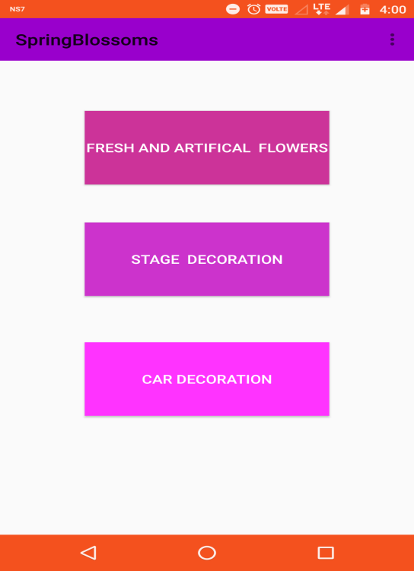

**BOUQUET PAGE:**

This page contains the gallery of images showing various bouquets available. Clicking the image of a bouquet displays the description about it such as name of the product , price , material used quantities available etc. The user if desires to make an order has to login into her account and make an order.

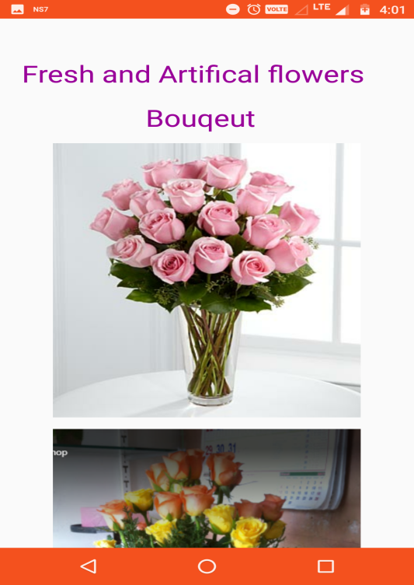

**OTHER SERVICES:**

Similar to bouquet other products and services offered have the same features and the screenshots are given below.

**Car decoration:**

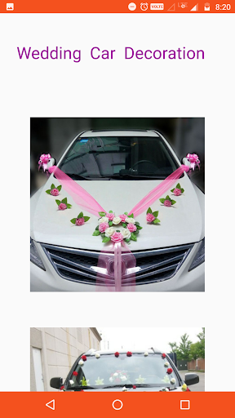

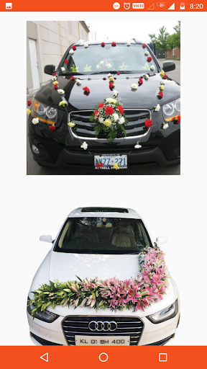

**Stage decoration:**

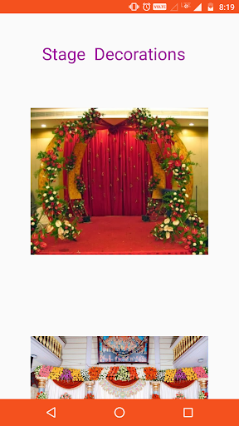

**Gifts:**

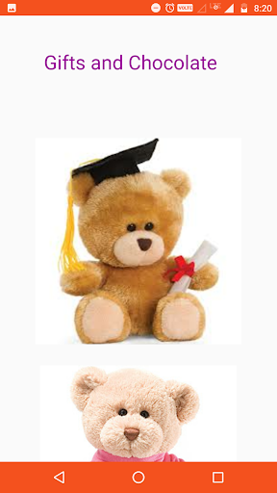

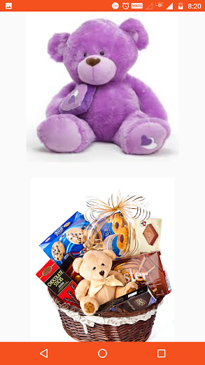

**MENU:**

The menu on long press shows options like gallery , videos etc . On selecting a option redirects it to the respective page.

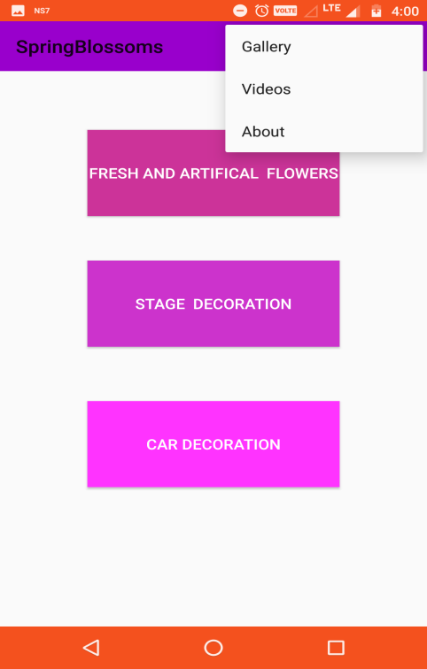

On selecting **Videos** option it redirects you to that video page.

