1.Question

SELECT * FROM c WHERE ARRAY_CONTAINS(c.tags, 'database')

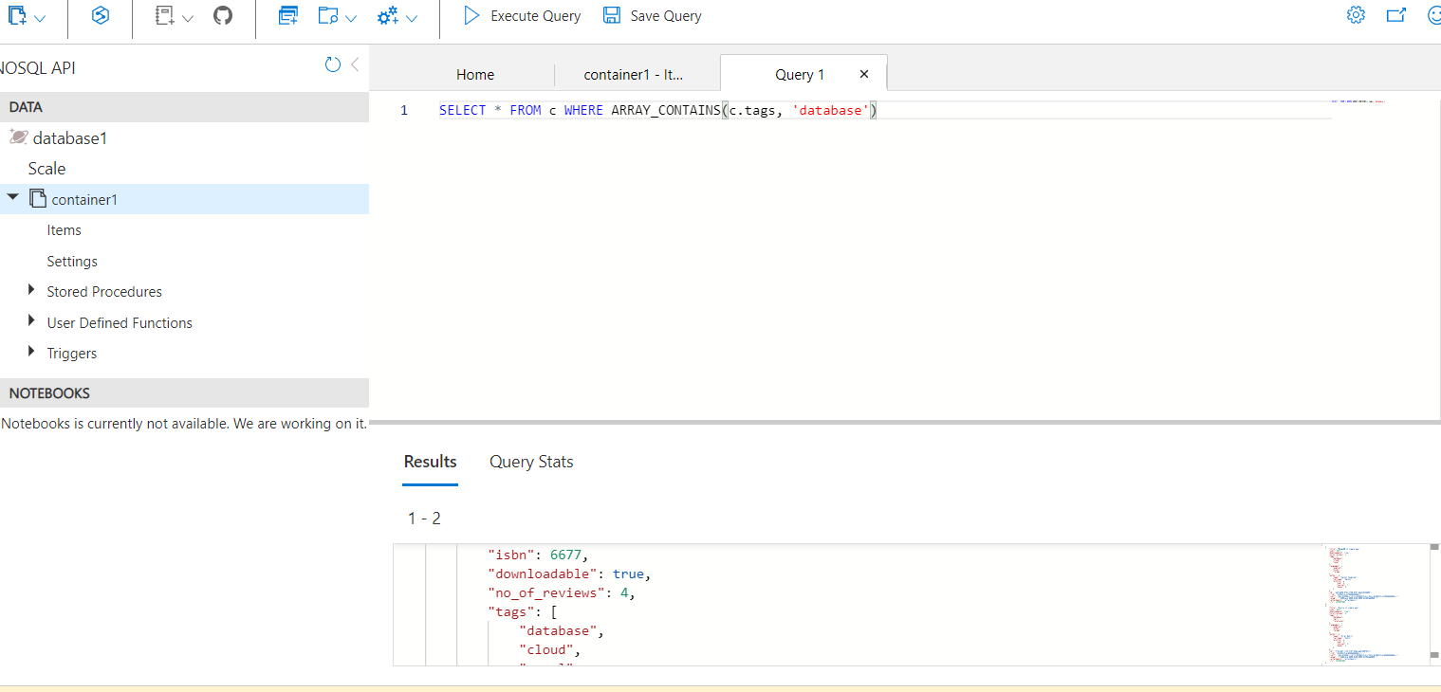

2.Question

SELECT * FROM c WHERE c.author.profile.courses = 2

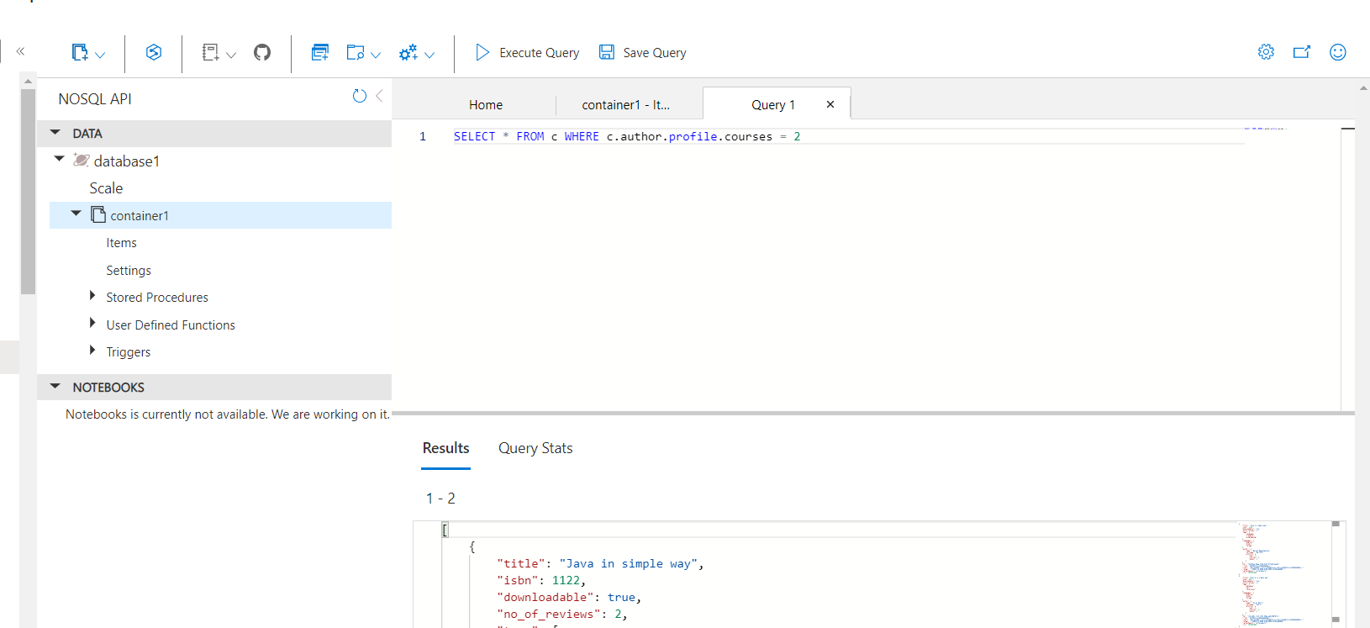

3.Question

SELECT * FROM c WHERE c.tags = ["language","freeware","programming"]

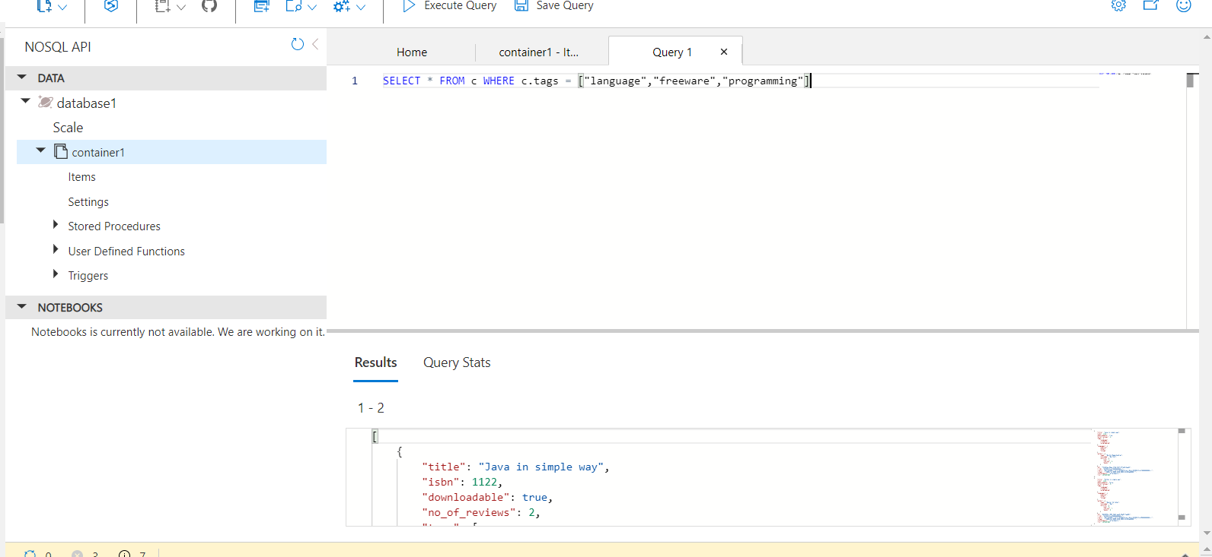

4.Question

SELECT * FROM c WHERE ARRAY_CONTAINS(c.tags, 'programming')

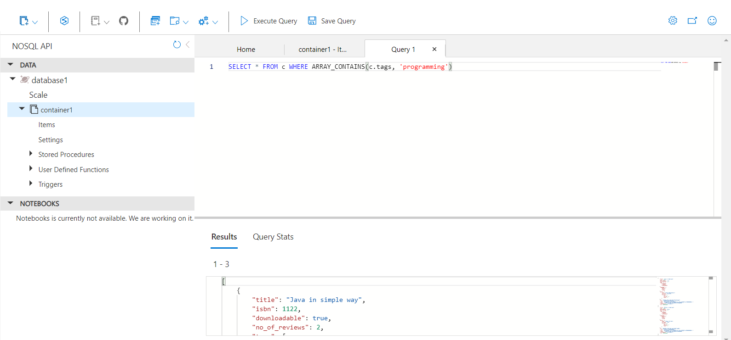

Question 5.

SELECT * FROM c WHERE ARRAY_CONTAINS(c.languages, 'telugu')

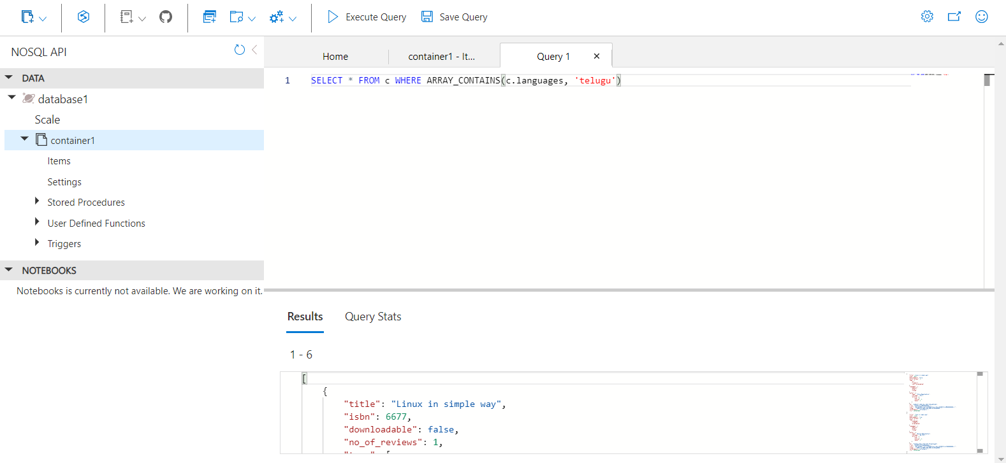

Question 6.

SELECT * FROM c

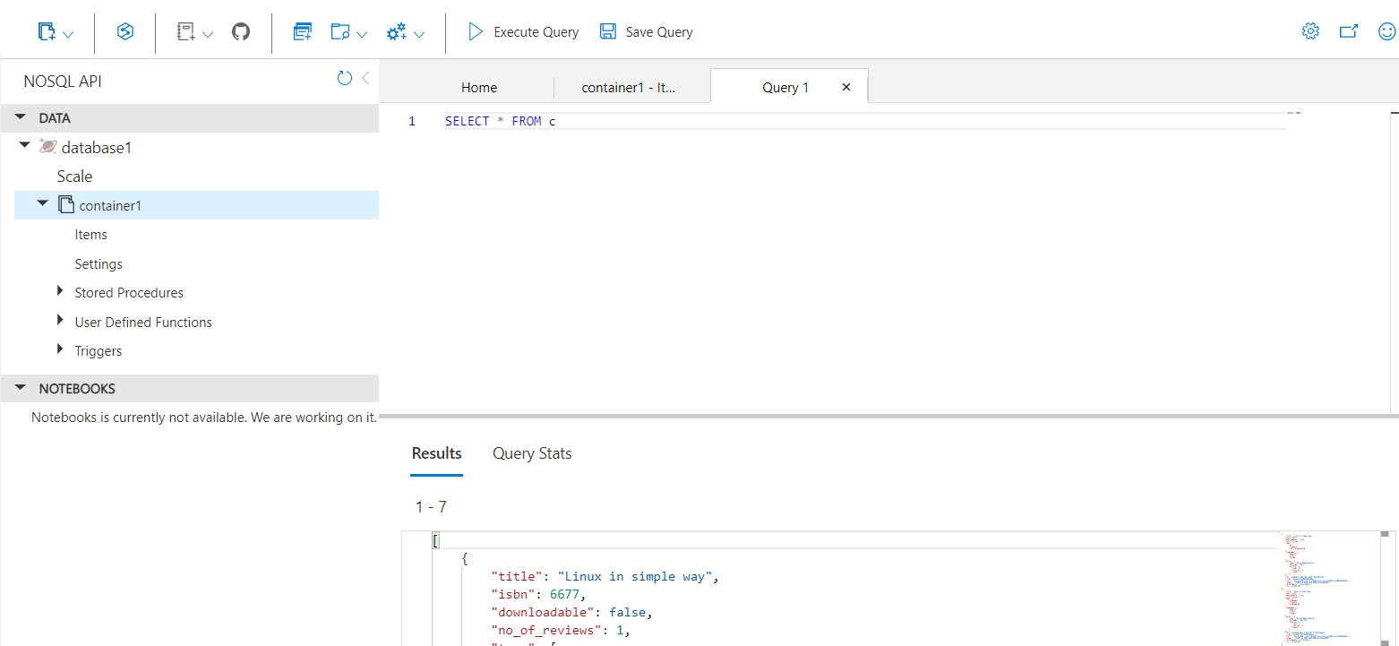

Question 7.

SELECT VALUE COUNT(1) FROM c

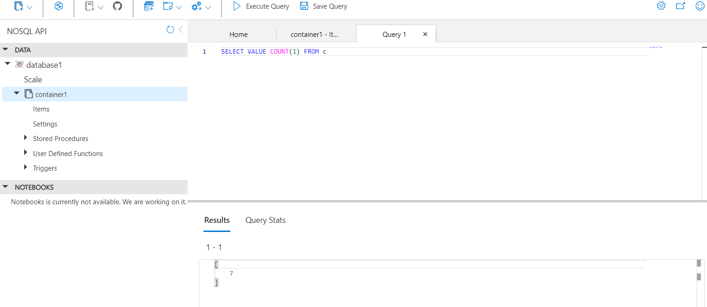

Question 8.

SELECT TOP 1 * FROM c

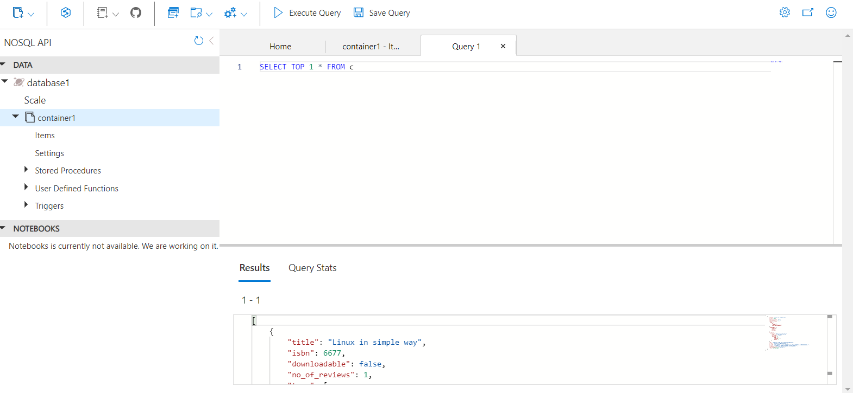

Question 9.

SELECT * FROM c WHERE ARRAY_CONTAINS(c.tags, 'programming') OR c.no_of_reviews > 3

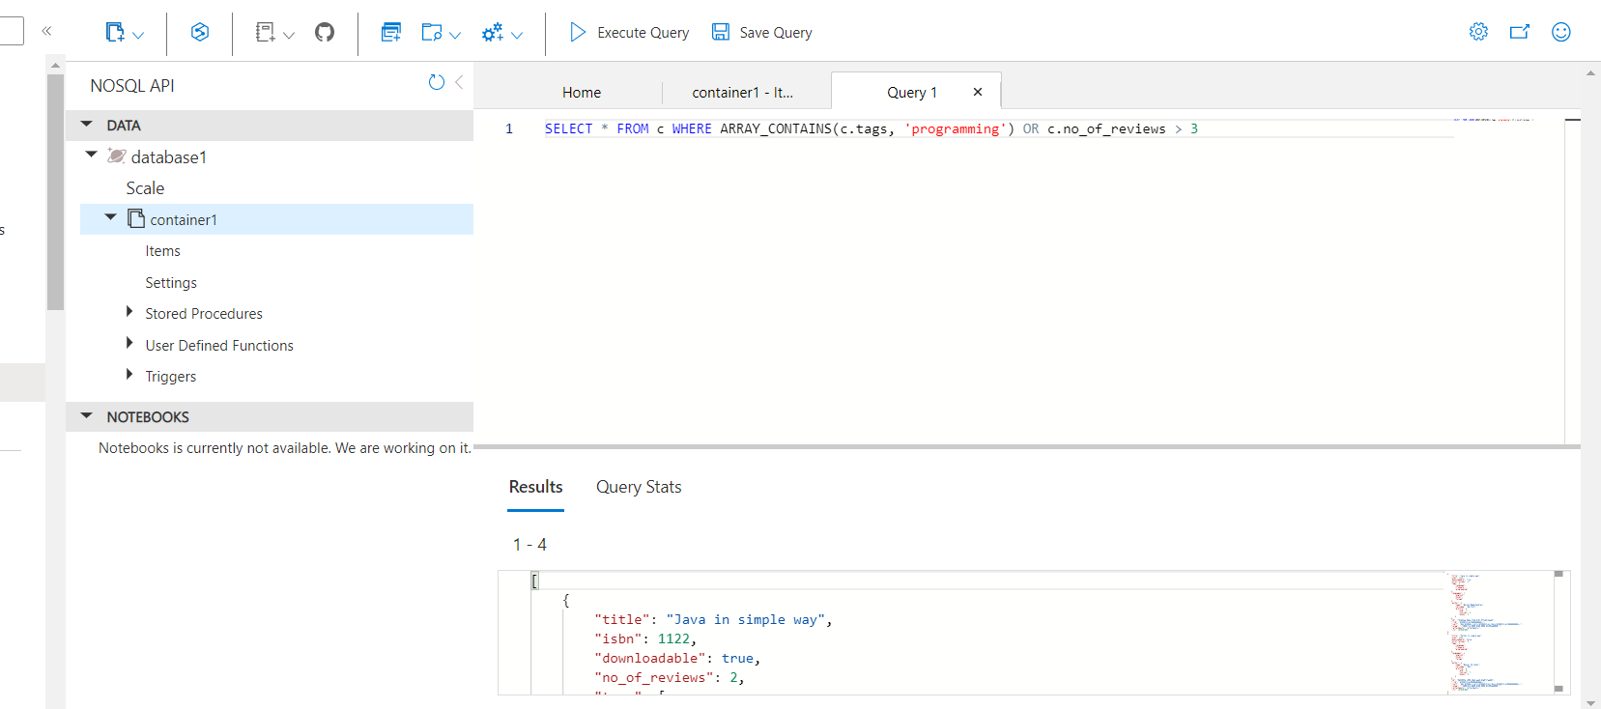

Question 10.

SELECT * FROM c WHERE c.downloadable = true OR c.no_of_reviews < 3 OR c.author.profile.books >= 2

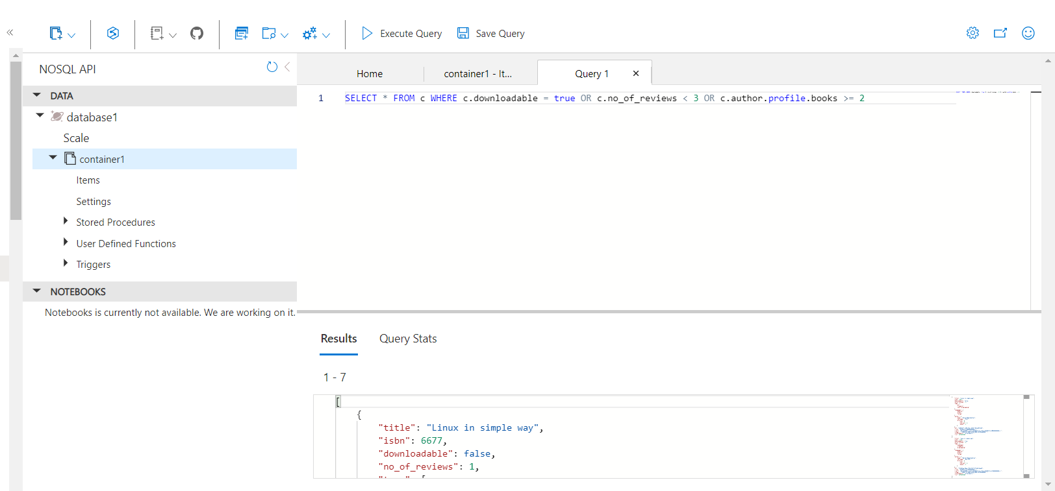

Question 11.

SELECT * FROM c WHERE c.no_of_reviews > 3

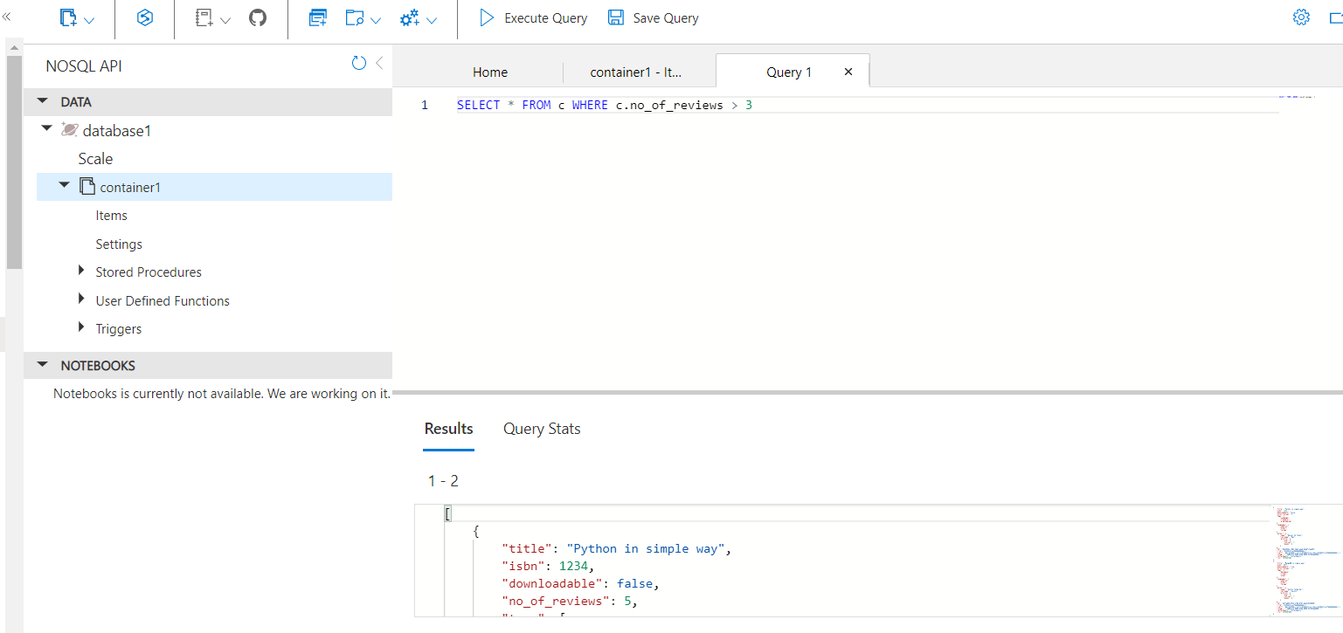

Question 12.

SELECT * FROM c WHERE c.no_of_reviews != 3

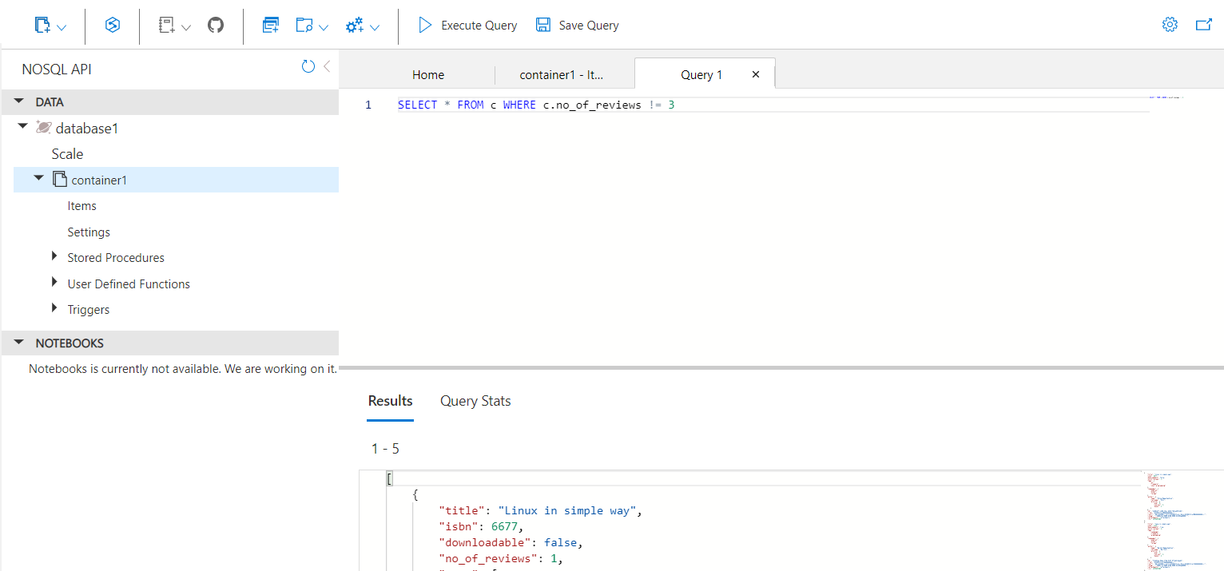

Question 13.

SELECT * FROM c WHERE c.no_of_reviews >= 3 AND c.downloadable = true

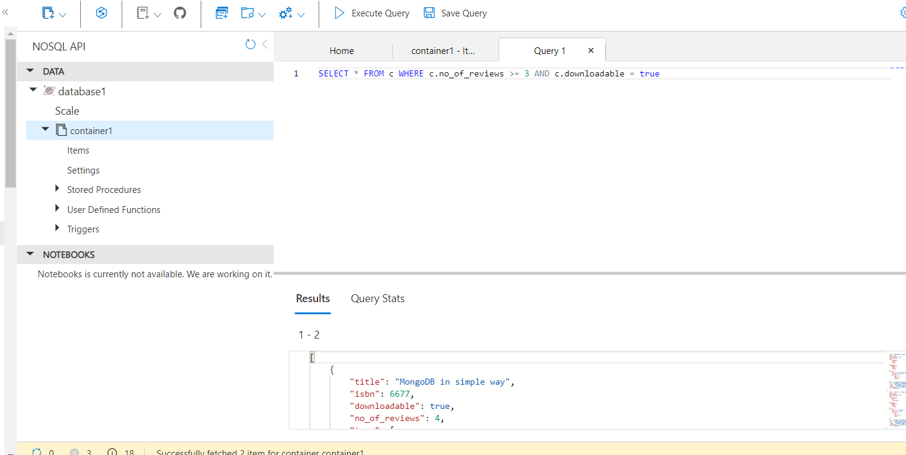

Question 14.

SELECT * FROM c WHERE ARRAY_CONTAINS(c.tags, 'database') OR ARRAY_CONTAINS(c.tags, 'programming')

