Impact of Market Sentiment on Trader Profitability and Closed PnL
 | closed_pnl |  |  | is_profit
 | mean | median | std | mean
sentiment_binary
Fear | 49.212077 | 0.0 | 990.875398 | 0.407871
Greed | 53.882281 | 0.0 | 976.964281 | 0.420311
Neutral | 34.307718 | 0.0 | 517.122220 | 0.396991
Analysis shows that trader performance varies across market sentiment conditions. Greed sentiment results in the highest average profit and profitability rate, indicating favorable trading opportunities during bullish market conditions. Fear sentiment also produces high average returns but with significantly higher volatility, suggesting higher risk. Neutral sentiment shows the lowest profitability and volatility, indicating fewer strong trading opportunities. Additionally, the median profit being zero across all sentiments suggests that overall profitability is driven by fewer large winning trades rather than consistent gains.

Total Closed PnL Generated Across Different Market Sentiments
sentiment_binary
Fear 4.096266e+06
Greed 4.865301e+06
Neutral 1.292921e+06
Name: closed_pnl, dtype: float64
The analysis shows that the majority of profits are generated during Greed and Fear market conditions, with Greed contributing the highest total closed PnL. Neutral sentiment contributes significantly less profit, indicating fewer trading opportunities. This suggests that traders and trading strategies perform better in volatile or strongly trending markets. Trading systems can improve profitability by adapting strategies based on market sentiment and increasing activity during high-volatility sentiment conditions.

Average Trade Size (USD) Across Different Market Sentiments
Sentiment | Avg Trade Size | Risk Level
Fear | Highest ($7,182) | Highest Risk
Neutral | Medium ($4,783) | Moderate Risk
Greed | Lowest ($4,574) | Lower Risk

The analysis shows that traders take significantly larger positions during Fear sentiment, indicating higher risk-taking behavior in volatile markets. Despite smaller average trade sizes during Greed sentiment, total profitability is highest, suggesting more efficient and consistent profitable trading. Neutral sentiment shows moderate trade sizes and lower profitability, reflecting fewer trading opportunities. This indicates that sentiment influences trader risk appetite and position sizing decisions.

Proportion of Long Positions Across Different Market Sentiments
Sentiment | Long Ratio
Neutral | 50.33%
Fear | 49.50%
Greed | 47.09%
The proportion of long positions remains close to 50% across all market sentiments, indicating that traders maintain balanced directional strategies regardless of sentiment conditions. Neutral sentiment shows slightly higher long activity, reflecting mild optimism, while Greed sentiment surprisingly shows lower long ratios, suggesting profit-taking and anticipation of reversals. This highlights the importance of balanced trading strategies and risk management rather than relying solely on market sentiment direction.

Distribution of Closed PnL Across Market Sentiments (Fear, Greed, Neutral)
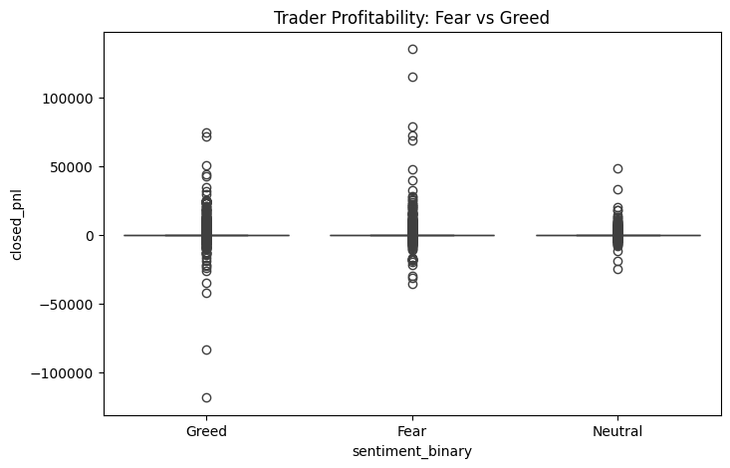
The distribution of closed PnL shows that Fear sentiment creates the highest volatility, resulting in both the largest profits and losses. Greed sentiment also produces strong profitability but with relatively lower extreme variations, indicating more stable profit opportunities. Neutral sentiment shows the lowest variability and profit potential, reflecting fewer strong market movements. Additionally, most trades cluster around zero profit, indicating that overall trader profitability is driven by fewer large winning trades rather than consistent small gains.
Distribution of Trade Size (USD) Across Market Sentiments (Fear, Greed, Neutral)
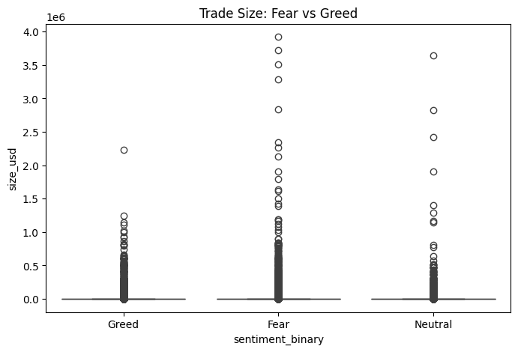
The analysis shows that traders take significantly larger positions during Fear sentiment, indicating higher risk-taking behavior in volatile market conditions. Greed sentiment shows relatively smaller and more consistent trade sizes, suggesting more controlled trading strategies despite higher overall profitability. Neutral sentiment shows moderate trade sizes with fewer extreme values. This indicates that trader position sizing and risk exposure are strongly influenced by market sentiment and volatility levels.
Trader Profitability Rate Across Market Sentiments (Fear, Greed, Neutral)
is_profit
sentiment_binary
Fear | 0.407871
Greed | 0.420311
Neutral | 0.396991
The analysis shows that trader profitability is highest during Greed sentiment and lowest during Neutral sentiment. This indicates that trending market conditions provide more favorable opportunities for profitable trades. Fear sentiment also shows strong profitability due to increased volatility. However, profitability remains below 50% across all sentiments, suggesting that overall trading success depends on effective risk management and capturing high-return opportunities rather than achieving a high win rate.

Distribution of Market Sentiment Across Trading Dataset

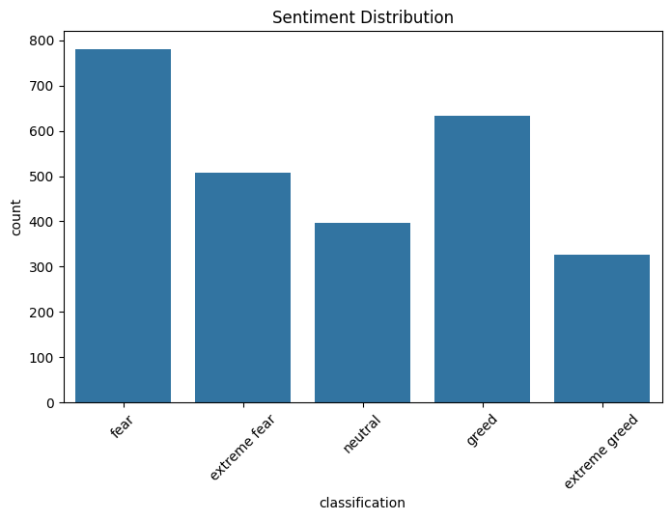
The sentiment distribution shows that Fear and Greed are the most frequent market conditions, indicating that the dataset is dominated by volatile and emotionally driven market phases. Extreme sentiments occur less frequently but represent critical turning points in the market. Neutral sentiment is less common, suggesting fewer stable market periods. This distribution highlights the importance of sentiment analysis in understanding trader behavior and profitability.
Distribution of Closed PnL Across All Trades
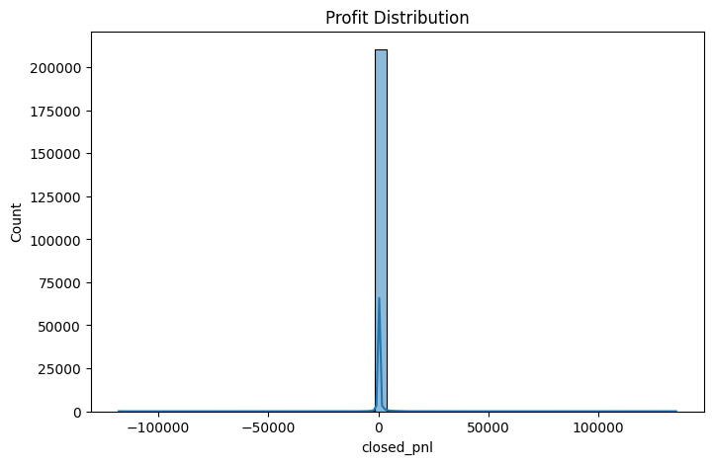
The profit distribution shows that most trades result in small profits or losses, with values clustered around zero. However, the distribution contains heavy tails, indicating rare but significant profit and loss events. These extreme values contribute disproportionately to overall trader profitability. This suggests that successful trading strategies rely on capturing large profitable opportunities while minimizing losses through effective risk management.

Correlation Analysis Between Trading Features and Profitability
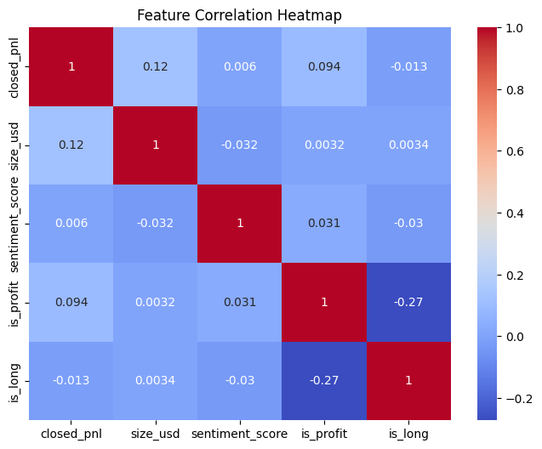
The correlation analysis shows that no single feature strongly predicts trader profitability. Trade size has a weak positive correlation with profit, indicating that larger trades may generate higher returns, but risk is also involved. Sentiment score shows minimal direct correlation with profitability, suggesting that sentiment influences market conditions indirectly rather than determining individual trade outcomes. The strongest relationship observed is a negative correlation between long positions and profitability, indicating that short positions may perform better in certain conditions. Overall, profitability depends on multiple interacting factors, highlighting the importance of machine learning models for prediction.

Daily Closed PnL Trend Over Time
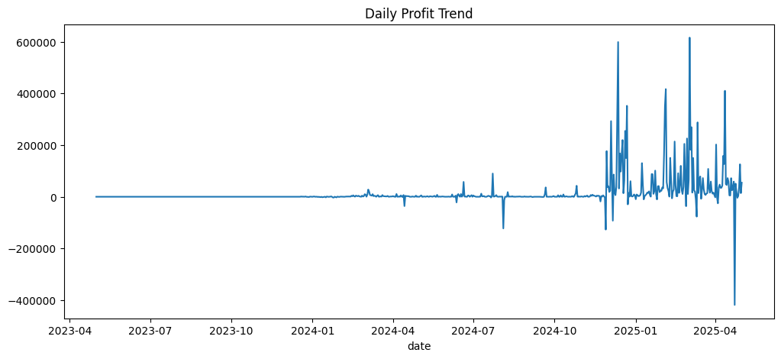
The daily profit trend shows that trading profitability remained relatively stable in earlier periods but became highly volatile over time. Large profit spikes contributed significantly to overall returns, while occasional large losses indicate increased risk exposure. This pattern suggests that trader profitability depends on capturing high-return opportunities during volatile market conditions. Effective risk management is essential to minimize losses while maximizing gains during high-volatility periods.
Trader Win Rate Across Different Market Sentiments
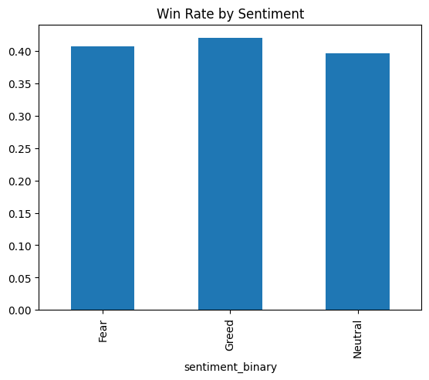
The win rate analysis shows that traders achieve the highest success rate during Greed sentiment, followed closely by Fear sentiment, while Neutral sentiment shows the lowest win rate. This indicates that trending and volatile market conditions provide better profit opportunities. However, win rates remain below 50% across all sentiments, suggesting that overall profitability depends more on capturing high-return trades and effective risk management rather than maintaining a high win rate.
Trade Count by Profit Segment

Profit Segment | Count | Percentage
High Profit | 11 | 34.38%
Medium Profit | 10 | 31.25%
Low Profit | 11 | 34.38%
Total | 32 | 100%
• The High Profit and Low Profit segments have equal counts (11 trades each), indicating a balanced distribution between strong gains and weaker performance.
• The Medium Profit segment has a slightly lower count (10 trades), suggesting that moderately profitable trades occur less frequently compared to high and low profit trades.
• This distribution indicates that profitability is somewhat polarized, with trades more likely to fall into either high-profit or low-profit categories rather than consistently generating moderate profits.
• This pattern suggests that overall trader profitability depends more on capturing strong market opportunities that result in high returns, rather than relying on consistent moderate gains across trades.
Trade Count by Activity Segment
Activity Segment | Count | Percentage
High Activity | 11 | 34.38%
Medium Activity | 10 | 31.25%
Low Activity | 11 | 34.38%
Total | 32 | 100%
• The High Activity and Low Activity segments have equal counts (11 trades each), indicating a balanced distribution between periods of intense trading and lower trading activity.
• The Medium Activity segment has a slightly lower count (10 trades), suggesting that trading activity tends to occur more frequently at either high or low levels rather than remaining consistently moderate.
• This distribution indicates that trader behavior is dynamic, with activity levels fluctuating between high and low extremes instead of maintaining a steady, moderate level.
• This pattern suggests that trading activity is influenced by market conditions, where traders increase activity during volatile or opportunity-rich periods and reduce activity during stable or uncertain market phases.
Trade Count by Win Rate Segment

Win Rate Segment | Count | Percentage
High Winrate | 11 | 34.38%
Medium Winrate | 10 | 31.25%
Low Winrate | 11 | 34.38%
Total | 32 | 100%
• The High Winrate and Low Winrate segments have equal counts (11 trades each), indicating a balanced distribution between strong and weak trading performance.
• The Medium Winrate segment has a slightly lower count (10 trades), suggesting that traders are more likely to fall into either high-performance or low-performance categories rather than maintaining consistent moderate performance.
• This distribution indicates that trading success is not evenly distributed and tends to be polarized, with traders achieving either relatively high or relatively low win rates.
• This pattern suggests that trader performance may depend on strategy effectiveness, market timing, and risk management, where successful traders consistently apply effective strategies while others experience lower success rates.

STREAMLIT DASHBOARD
