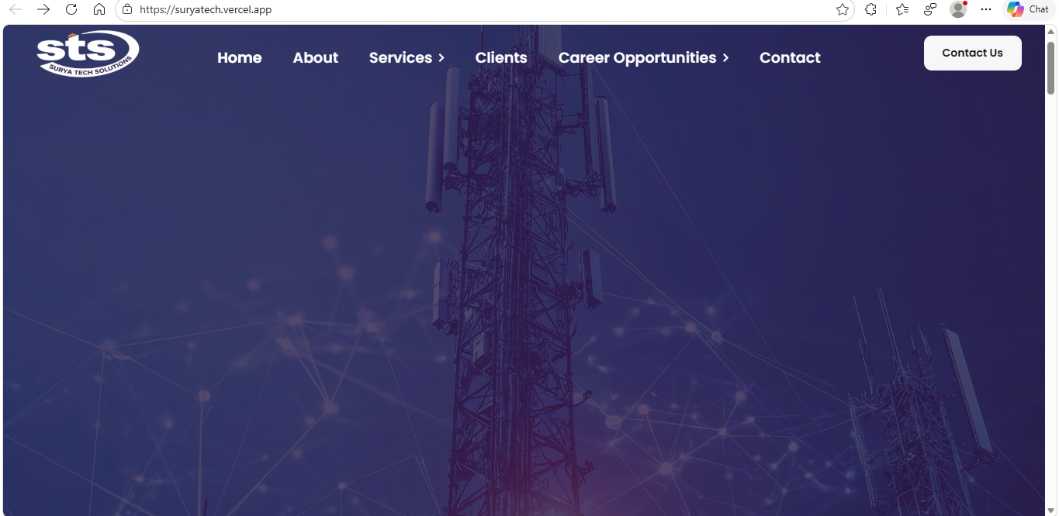
🏠 HOME PAGE (High Conversion Structure)

Top Banner
Headline:
Powering Infrastructure. Building Skilled Workforce. Delivering Reliable Solutions.
Sub-headline:
Delivering integrated telecom, renewable energy, electronics manufacturing, data center infrastructure, and workforce management solutions across India.
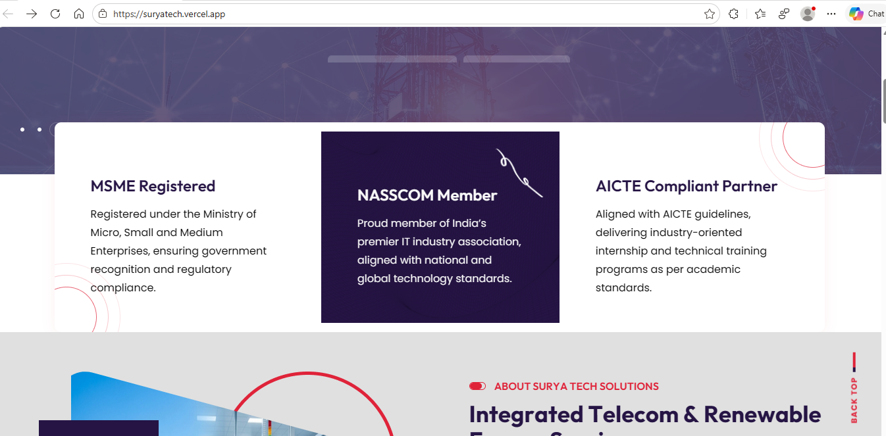
*Background photos related to all services should be change one after one*

*remove nasscom* and place NATS and NAPS

Corporate Positioning Statement
Surya Tech is a technology-driven infrastructure solutions company focused on execution precision, compliance standards, and scalable project delivery. We serve telecom operators, renewable energy integrators, educational institutions, and enterprise clients with structured project management and field expertise.

🔹 Key Capabilities
- Infrastructure Deployment & Maintenance
- Renewable Energy System Integration
- Technical Project Execution
- Skilled Workforce Development
- Payroll Activity

🔹 Why Organizations Choose Surya Tech
- Structured Project Planning
- On-Time Delivery Framework
- Quality & Compliance Focus
- Experienced Technical Teams
- Multi-Domain Capability

ABOUT PAGE (Corporate Authority Version)
🔹 Company Overview
Surya Tech is an infrastructure execution and technical solutions company committed to delivering high-performance projects. Our operational model emphasizes disciplined execution, risk management, and technical precision.

🔹 Mission
To deliver the best solutions with measurable reliability, efficiency, and long-term value creation.

🔹 Vision
To be recognized as a trusted execution partner in multiple sectors.

🔹 Core Values
- Integrity & Transparency
- Technical Excellence
- Accountability
- Operational Discipline
- Continuous Capability Development

🔹 Leadership Approach
Our leadership integrates field expertise with structured operational planning, ensuring every project aligns with client objectives and regulatory standards.

🔹 Our Core Services (Preview Section)
Cellular Network
Installation and Commissioning, BTS Maintenance and Power backup setup.
Fiber Infrastructure
Network deployment, maintenance, upgradation and electrical services.
Electronics Manufacturing & Technical Services
Electronics assembly, soldering, quality control, testing and project-based execution support.
Production
assembly, machine operating, quality control, testing and project-based execution support.
Sales & Services
Product promotion, technical consultation, client relationship management, after-sales support, AMC management, complaint handling and field service execution.
Solar Energy Solutions
Residential & commercial solar installation with system integration, site survey& planning and (AMC) Maintenance.
Data center Infra Services
Rack installation, UPS installation, fiber patching, preventive maintenance, and project-based data center deployment support.
Payroll Management services
Employee data management, attendance processing, salary computation, statutory compliance management (PF, ESI, PT), tax deductions, payslip generation, reimbursement processing, payroll reporting, documentation management, and regulatory coordination.
Careers
Technical skill training, industrial workshop execution, hands-on practical sessions, certification programs, internship training, curriculum development, corporate training programs, assessment & evaluation, placement support coordination, and industry collaboration initiatives.
🔹 Industries We Serve
- Telecom Operators
- Solar Integrators
- Educational Institutions
- Corporate Clients
- Infrastructure Projects

🔹 Call to Action
Looking for a reliable execution partner?
🔵 Contact Us Today

🛠 SERVICES PAGE (Structured & Clear)
Divide into clear categories.

- Cellular Network
Note: information as per the website
- Fiber infrastructure
2.1 Network Deployment Services
Surya Tech Solutions provides professional Network Deployment services for telecom, enterprise, and infrastructure projects. Our team ensures structured installation of active and passive network components, proper configuration, and seamless system integration.
Each deployment is executed following standardized technical procedures to ensure performance stability, scalability, and compliance with industry norms.
Benefits of This Service
- Accurate installation of routers, switches, and network equipment
- Structured cabling and labeling standards
- Seamless integration with existing infrastructure
- Optimized network performance
- Reduced deployment errors
- Future-ready scalable architecture
- Experienced technical team support
We provide end-to-end support from site survey and installation to configuration, testing, and final commissioning — ensuring reliable network performance.

2.2 Network Maintenance Services
Surya Tech Solutions delivers preventive and corrective Network Maintenance services to ensure uninterrupted operations and long-term system reliability.
Our maintenance approach focuses on proactive monitoring, fault detection, and rapid resolution to minimize downtime.
Benefits of This Service
- Reduced network downtime
- Early fault detection and correction
- Improved system lifespan
- Performance optimization
- Scheduled preventive maintenance plans
- Detailed maintenance reporting
- 24/7 technical support availability
We ensure consistent monitoring and systematic maintenance to maintain optimal network health and operational continuity.

2.3 Network Upgradation Services
Surya Tech Solutions offers structured Network Upgradation services to enhance capacity, improve performance, and support technological advancements.
We evaluate existing infrastructure and implement scalable upgrade solutions with minimal service disruption.
Benefits of This Service
- Increased bandwidth and capacity
- Improved network efficiency
- Seamless integration of new technologies
- Minimal operational disruption
- Enhanced security features
- Future expansion readiness
- Compliance with updated standards
Our team ensures careful planning, phased execution, and complete testing to deliver smooth network transitions.

2.4 Electrical Services
Surya Tech Solutions provides specialized Electrical Services supporting telecom, fiber, data center, and industrial infrastructure.
Our engineers ensure safe power distribution, grounding systems, and backup power integration as per regulatory standards.
Benefits of This Service
- Reliable power distribution systems
- Proper earthing and grounding
- UPS and battery integration
- Compliance with electrical safety standards
- Load optimization and protection
- Reduced risk of electrical faults
- Long-term operational reliability
We deliver complete electrical setup from installation and testing to documentation and compliance verification.

2.5 Fiber Splicer
Surya Tech Solutions deploys certified Fiber Splicers responsible for precise optical fiber jointing, termination, and signal validation. Our splicers ensure minimal signal loss, high transmission stability, and long-term network reliability.
Each splicing activity is performed using calibrated fusion splicing equipment and OTDR testing tools, following telecom industry standards and safety protocols.
Benefits of This Role
- Low insertion loss and high signal quality
- Accurate fiber jointing and protection
- Reliable network backbone stability
- Reduced signal attenuation
- Quick fault localization and restoration
- Compliance with telecom standards
- Long-term connectivity performance
Our Fiber Splicers ensure precision execution from cable preparation to final signal validation, delivering dependable and high-performance fiber connectivity.

2.6 Network Engineer
Surya Tech Solutions assigns experienced Network Engineers to design, validate, and optimize fiber network infrastructure. They ensure proper configuration, integration, and performance alignment with client requirements.
Each deployment follows structured design methodology and performance benchmarking to guarantee seamless connectivity and scalable architecture.
Benefits of This Role
- Optimized network architecture
- Seamless system integration
- Reduced deployment errors
- Enhanced bandwidth performance
- Scalable network planning
- Compliance with industry best practices
- Improved operational efficiency
Our Network Engineers ensure structured implementation, performance validation, and smooth integration of fiber infrastructure systems.

2.7 Field Engineer
Surya Tech Solutions deploys Field Engineers to supervise and coordinate on-site fiber installation, testing, and commissioning activities. They ensure quality execution, safety compliance, and timely project completion.
Field Engineers act as the link between project management and ground-level execution teams.
Benefits of This Role
- Controlled on-site execution
- Improved quality assurance
- Reduced rework and delays
- Efficient resource coordination
- Compliance with safety regulations
- Timely project delivery
- Structured site documentation
Our Field Engineers ensure disciplined execution from initial site preparation to final testing and handover, maintaining operational standards and project timelines.

- Electronics Manufacturing
  - Electronics Assembly Services
Surya Tech Solutions delivers precision Electronics Assembly services including PCB assembly, soldering, and integration support.
All processes follow strict quality protocols to ensure high product reliability.
Benefits of This Service
- Accurate SMT & THT assembly
- High-quality soldering standards
- Reduced assembly defects
- Structured workflow management
- Consistent production output
- Technical compliance verification
- Skilled assembly technicians
We ensure smooth coordination from component placement to final inspection and testing.

3.2 Quality Control
Surya Tech Solutions delivers structured and process-driven Quality Control services to ensure that all products, installations, and project executions meet defined technical specifications and industry standards.
Our Quality Control framework is integrated across electronics manufacturing, production operations, telecom infrastructure, solar installations, and data center deployments. We focus on systematic inspection, compliance verification, defect prevention, and continuous improvement.
Each quality stage follows standardized procedures, documented checkpoints, and compliance guidelines to maintain consistency, reliability, and operational excellence.

Benefits of This Service
- Reduced defects and rework
- Improved operational reliability
- Compliance with industry and safety standards
- Enhanced customer satisfaction
- Consistent output quality
- Risk mitigation during project execution
- Transparent quality documentation and reporting

Our Quality Control team ensures disciplined monitoring from initial execution stages to final approval, delivering dependable results and maintaining high standards across all services.

3.3 Testing Services
Surya Tech Solutions provides comprehensive Testing Services to validate the performance, safety, reliability, and compliance of products, systems, and infrastructure deployments.
Our testing procedures are designed to identify defects, verify technical specifications, and ensure operational readiness before final commissioning or delivery. We follow standardized testing protocols and use calibrated instruments to maintain accuracy and consistency across all projects.
Testing activities are integrated across electronics manufacturing, telecom infrastructure, fiber networks, solar installations, production systems, and data center deployments.

Benefits of This Service
- Early detection of system defects
- Reduced operational failures
- Improved system reliability and stability
- Compliance with technical standards
- Verified performance before handover
- Reduced maintenance costs
- Detailed test documentation and reporting

Our Testing Services ensure every system and product is thoroughly verified before deployment or delivery, guaranteeing performance accuracy and long-term operational confidence.

- Production
4.1 Assembly Technician – Production Services
Surya Tech Solutions employs skilled Assembly Technicians responsible for precise component placement, mechanical assembly, and sub-system integration. They ensure products are built accurately and efficiently according to design specifications.
Benefits of This Role
- Accurate and reliable product assembly
- Reduced component damage or assembly errors
- Consistency across production batches
- Efficient coordination with testing and QC
- Supports timely project completion

  - Machine Operator – Production Services
Machine Operators oversee the safe and efficient operation of production machinery and automated systems. They ensure equipment runs optimally, minimizing downtime and maximizing output.
Benefits of This Role
- Optimized machine utilization and productivity
- Reduced operational downtime
- Safe and compliant machine operations
- Improved consistency in production output
- Supports high-quality and timely delivery

4.3 QC Inspector – Production Services
QC Inspectors are responsible for in-process and final inspection of products to ensure they meet quality standards and client specifications. They prevent defects and ensure compliance with industry standards.
Benefits of This Role
- High-quality output with minimal defects
- Early identification of issues to reduce rework
- Consistent adherence to client and industry standards
- Improved customer satisfaction
- Reliable documentation for audits and quality tracking

4.4 Testing Engineer – Production Services
Testing Engineers validate the functionality, performance, and reliability of products before delivery. They ensure that products operate safely and meet design specifications.
Benefits of This Role
- Reliable and functional products delivered to clients
- Reduced field failures and warranty issues
- Accurate testing ensures compliance with specifications
- Detailed test reports for traceability
- Supports continuous product improvement

4.5 Project Execution Coordinator – Production Services
Project Execution Coordinators oversee production projects from start to finish, ensuring timely delivery, quality compliance, and coordination across teams.
Benefits of This Role
- Efficient project execution with minimal delays
- Smooth coordination between production teams
- Timely identification and resolution of bottlenecks
- Ensures production meets quality and client standards
- Clear documentation for accountability and reporting
- Sales & Services
5.1 Sales Executive – Product Promotion
Sales Executives are responsible for promoting Surya Tech Solutions’ products and solutions to potential clients. They focus on generating leads, presenting offerings, and expanding market reach.
Benefits of This Role
- Increased product visibility and market penetration
- Timely conversion of leads to sales
- Strengthened brand presence
- Enhanced customer engagement
- Supports revenue growth

5.2 Technical Consultant – Technical Consultation
Technical Consultants provide expert guidance on product selection, system design, and implementation to clients. They bridge the gap between client requirements and technical solutions.

Benefits of This Role
- Accurate technical solutions delivered to clients
- Reduced implementation errors
- Strong client trust and satisfaction
- Efficient pre-sales and solution planning
- Streamlined integration with internal teams

5.3 Client Relationship Manager – Client Relationship Management
Client Relationship Managers ensure long-term client satisfaction and foster repeat business. They act as the primary point of contact for ongoing relationships.
Benefits of This Role
- Improved client retention and loyalty
- Better understanding of client needs
- Increased repeat business and referrals
- Effective communication between client and organization
- Long-term revenue growth

5.4 After-Sales Support Engineer – After-Sales Support
After-Sales Support Engineers ensure clients receive technical assistance and support after product delivery. They address system issues, provide solutions, and maintain operational efficiency.
Benefits of This Role
- Rapid issue resolution and minimal downtime
- Enhanced customer satisfaction
- Reliable operational support
- Reduced escalation to higher management
- Strengthened trust in company solutions

5.5 AMC Coordinator – AMC Management
AMC Coordinators manage Annual Maintenance Contracts, ensuring clients receive scheduled maintenance and services as per agreements.
Benefits of This Role
- Timely maintenance ensures system reliability
- Transparent communication with clients
- Reduced system failures and downtime
- Increased client satisfaction
- Streamlined AMC operations

5.6 Complaint & Service Coordinator – Complaint Handling
Complaint & Service Coordinators manage client complaints, ensuring issues are addressed promptly and effectively. They act as a liaison between clients and technical teams.
Benefits of This Role
- Swift resolution of client issues
- Reduced client dissatisfaction and escalations
- Improved operational efficiency
- Feedback-driven process improvement
- Strengthened client confidence

5.7 Field Service Engineer – Field Service Execution
Field Service Engineers handle on-site implementation, troubleshooting, and maintenance of products and systems. They ensure installations are functional and meet client expectations.
Benefits of This Role
- Reliable on-site support and issue resolution
- Ensures proper system operation
- Enhances client trust and satisfaction
- Reduces downtime and operational disruptions
- Professional representation of the company in the field

6. Solar Energy Solutions
6.1 Installation Services
Surya Tech Solutions specializes in residential and commercial Solar Installation and system integration.
Our engineers ensure proper mounting, wiring, inverter configuration, and safe grid connectivity.
Benefits of This Service
- Optimized solar system design
- Professional panel mounting
- Safe electrical integration
- Improved energy efficiency
- Compliance with safety norms
- Performance testing and commissioning
- Long-term AMC support
We execute solar projects from feasibility study to commissioning and maintenance.

6.2 Site Survey & Planning – Solar Energy Solutions
Surya Tech Solutions provides comprehensive Site Survey & Planning services for residential and commercial solar projects. Our experts evaluate site conditions, energy requirements, and installation feasibility to design optimal solar systems.
Every survey is conducted using standardized procedures and tools, ensuring accurate measurements, efficient system layout, and compliance with safety and regulatory norms.
Benefits of This Service
- Accurate solar system sizing and performance prediction
- Optimized panel placement for maximum efficiency
- Reduced installation errors and rework
- Safe and compliant site preparation
- Cost-effective design and material planning
- Enhanced long-term system reliability
- Clear documentation for approvals and permits
Our Site Survey & Planning team ensures precise project groundwork, setting the stage for efficient installation and optimal energy generation.

6.3 AMC & Maintenance – Solar Energy Solutions
Surya Tech Solutions provides comprehensive Annual Maintenance Contract (AMC) and Maintenance services for residential and commercial solar installations. Our services ensure optimal system performance, reliability, and longevity throughout the lifecycle of the solar system.
Maintenance activities are performed following standardized protocols, safety guidelines, and manufacturer recommendations to guarantee uninterrupted energy generation and reduce downtime.
Benefits of This Service
- Sustained high energy output
- Reduced operational faults and downtime
- Extended system lifespan
- Compliance with safety and electrical standards
- Cost-effective preventive maintenance
- Early detection of potential issues
- Transparent reporting and performance records

Our AMC & Maintenance team ensures reliable system operation, proactive issue resolution, and consistent performance, giving clients peace of mind and maximizing return on investment.

  - Data Center Infrastructure Services
7.1 Rack Installation Technician – Data Center Infra Services
Surya Tech Solutions deploys skilled Rack Installation Technicians responsible for setting up server racks, enclosures, and associated hardware in data centers. They ensure precise alignment, proper grounding, and organized layout for optimal airflow and safety.
Benefits of This Role
- Accurate and secure rack installation
- Efficient space utilization
- Reduced risk of equipment damage
- Organized cable and hardware management
- Supports maintenance and future scalability

7.2 UPS Installation Engineer – Data Center Infra Services
UPS Installation Engineers handle the installation and commissioning of Uninterruptible Power Supply systems in data centers. They ensure reliable power backup, correct integration with servers, and compliance with safety standards.
Benefits of This Role
- Reliable power continuity for critical systems
- Reduced risk of downtime due to power failures
- Safe and compliant installation practices
- Optimized UPS performance and efficiency
- Supports long-term operational stability

7.3 Fiber Patch Technician – Data Center Infra Services
Fiber Patch Technicians are responsible for structured fiber optic patching, cable management, and testing of optical connections within the data center. They maintain signal integrity and organized network infrastructure.
Benefits of This Role
- Accurate fiber connections with minimal signal loss
- Organized patching for efficient troubleshooting
- Reliable network performance
- Scalable infrastructure for future expansions
- Supports seamless network operations

7.4 Preventive Maintenance Engineer – Data Center Infra Services
Preventive Maintenance Engineers ensure all data center infrastructure, including servers, cooling, UPS, and network systems, are regularly inspected and maintained to prevent failures.
Benefits of This Role
- Reduced unplanned downtime
- Extended lifespan of equipment
- Early detection of potential faults
- Optimized system efficiency and performance
- Ensures compliance with operational standards

7.5 Data Center Project Coordinator – Project-Based Deployment Support
Data Center Project Coordinators oversee the planning, execution, and deployment of data center projects. They coordinate between technical teams, ensure adherence to timelines, and maintain documentation for quality assurance.
Benefits of This Role
- Streamlined project execution
- Improved team coordination and communication
- Timely completion of deployment projects
- Maintains quality and compliance standards
- Supports client satisfaction and operational efficiency

  - Payroll Management Services
Surya Tech Solutions provides structured Payroll Management Services covering employee data handling, attendance processing, salary computation, statutory compliance, tax deductions, reporting, and documentation management.
We ensure accurate, compliant, and timely payroll execution aligned with regulatory standards.
Benefits of This Service
- Accurate salary processing
- Timely statutory compliance (PF, ESI, PT, TDS)
- Transparent payroll reporting
- Secure employee data management
- Reduced administrative workload
- Error-free payslip generation
- Regulatory audit support
Our payroll system ensures confidentiality, compliance, and smooth coordination with regulatory bodies and management stakeholders.

Session: Careers
1. Industrial Training
Surya Tech Solutions offers structured Industrial Training programs to provide students and fresh graduates with real-world, hands-on experience in industry-relevant technologies.
Highlights:
- Work on live projects under experienced mentors
- Exposure to modern tools, equipment, and industry workflows
- Understanding of professional standards, documentation, and reporting
- Opportunity to learn practical problem-solving and technical decision-making
- Stipends Provided to eligible participants to encourage engagement
- Programs conducted under AICTE, NATS, NAPS, and MSME registered framework
- Certification awarded upon successful completion
Benefits:
- Bridge the gap between theory and practice
- Build professional competence and confidence
- Enhance employability for placements and internships

2. Internship Program
Our Internship Program bridges academic knowledge with professional experience. It is designed to help students and graduates gain industry exposure while developing career-ready skills.
Highlights:
- Short-term and long-term internship options based on project requirements
- Mentorship from industry professionals
- Opportunities to work on emerging technologies such as Embedded Systems, Python, Networking, and Cyber Security
- Stipends Provided based on duration and performance
- Access to AICTE, NATS, NAPS, and MSME registered programs
- Certification and recommendation letter upon completion
Benefits:
- Real-world experience in corporate and industrial environments
- Exposure to teamwork, reporting, and professional standards
- Enhances employability and future career opportunities

3. Mini & Major Projects
Surya Tech Solutions supports students and trainees in executing Mini and Major Projects that demonstrate technical understanding, innovation, and problem-solving skills.
Highlights:
- Mini Projects – Small-scale projects to reinforce theoretical knowledge
- Major Projects – Large-scale, industry-relevant projects simulating real-world scenarios
- Guidance provided on project planning, design, implementation, and documentation
- Mentorship ensures quality output and practical learning
- Projects conducted under AICTE, NATS, NAPS, and MSME approved framework
- Certification awarded for successful project completion
Benefits:
- Hands-on experience in project execution
- Strengthens technical knowledge and practical skills
- Prepares students for industrial challenges and placements

4. Skill Development Programs
1.1. Embedded Systems & C Programming
Scope: Learn microcontroller programming, hardware interfacing, IoT applications, and real-time embedded system design using C language. Gain hands-on experience with devices like Arduino, ESP32, and 8051.
Benefits:
- Practical experience with microcontrollers and IoT devices
- Ability to design and implement real-time embedded systems
- Enhanced problem-solving and technical skills
- Prepares for roles in electronics, automation, and IoT industries

1.2. Python Programming
Scope: Master Python for automation, scripting, application development, and data processing. Explore libraries for practical solutions in software, AI, and data-driven projects.
Benefits:
- Develop automation and software solutions efficiently
- Acquire skills for data analytics and AI applications
- Industry-ready programming expertise
- Strong foundation for future software development and tech roles

1.3. Business Analytics
Scope: Learn to collect, analyze, visualize, and interpret data to support informed business decisions. Training includes reporting, forecasting, and performance analysis using modern analytics tools.
Benefits:
- Ability to interpret and use data effectively
- Improved decision-making and reporting skills
- Prepares for roles in data analytics, operations, and management
- Enhances employability in business intelligence and analytics domains

1.4. Cyber Security
Scope: Understand network security, threat detection, ethical hacking, and risk management. Learn security protocols, vulnerability assessment, and practical cybersecurity strategies.
Benefits:
- Protect networks and systems from cyber threats
- Gain hands-on experience in ethical hacking and security assessment
- Prepare for cybersecurity roles in IT and corporate environments
- Enhance knowledge of security standards and best practices

1.5. Networking
Scope: Gain expertise in LAN/WAN setup, network configuration, troubleshooting, fiber optics, and maintaining reliable IT infrastructure. Hands-on training with modern networking equipment.
Benefits:
- Practical skills in network setup, maintenance, and troubleshooting
- Knowledge of fiber optic and wired/wireless networks
- Preparedness for roles in IT support, network administration, and telecom
- Strengthened problem-solving and technical competence

Why Choose Our Core Skill Programs:
- Hands-on, project-based learning for real-world experience
- Certification under AICTE, NATS, NAPS, and MSME
- Stipends provided for eligible participants
- Mentorship by industry experts
- Prepares students for internships, projects, and professional roles

5. placements:
note: as per the website

📞 CONTACT PAGE
🔹 Get in Touch
Have a project or training inquiry? Let’s connect.
Contact Information:
- Phone:
- Email:
- Office Address:

🔹 Contact Form
Fields:
- Name
- Email
- Phone
- Service Interested In (Dropdown)
- Message
Button: Submit Inquiry

