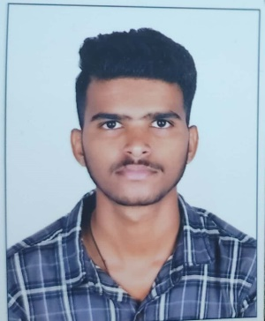**Resume**

**Candidate Name:** NEELAKANTH CHAPI

**Mobile No. :** 7337624678

**Email ID:** chapineelakanth@gmail.com

**CAREER OBJECTIVE**

A passionate, creative & organized Engineer aiming to secure a responsible career opportunity in order to fully utilize as well as expand my interpersonal & technical skills to achieve the goals of a dynamic & stable Organization.

**ACADEMICS**

|  |  |  |  |  |
| --- | --- | --- | --- | --- |
| **Course** | **INSTITUTION** | **University/Board** | **Year Of Passing** | **CGPA** |
| B.E (E & C Egg.) | Dayanand Sagar Academy Of Tech And Mngt,Banglore | Visvesvaraya  Technological university, Belgaum | 2023 | 7.2 |
| Diploma College | Govt Polytechnic Rbk-Bnt | Department Of Technical Education | 2020 | 75.13% |
| SSLC | SRA high school, Banahatti Karnataka | Karnataka  Secondary  Education  Examination Board | 2017 | 68% |

**INTERNSHIPS & PROJECTS**

* **Project 1:** Surveillance And Fire-Fighter Drone.

**Description:** This project aims to revolutionize firefighting operations, making them safer, more efficient, and better equipped to handle challenging wildfire scenarios, ultimately protecting lives, property, and the environment.

* **Project 2:** Image Mathematics Using Lab VIEW software.

**Description:** Basically In this project we are solving equations by images.



**TECHNICAL SKILLS**



* **Skills:** Basics of Lab VIEW and MATLAB Software.

* **Known Programming Languages :**C language, HTML,css,JavaScript,Bootstrap

**CERTIFICATIONS**

* **MAT JOURNALS,** Publication certificate offered by arvind sharma Managing Director, MAT Journals Pvt. Ltd.

**PERSONAL DETAILS**

* **Date of Birth** : 09/06/2001
* **Father’s Name :** Prakash Chapi
* **Mother’s Name :** Kavita Chapi
* **Current Address :** #641, Katagi Lane, Rabkavi – 587314 D:Bagalkot, State : Karnataka
* **Permanent Address:** #641, Katagi Lane, Rabkavi – 587314 D: Bagalkot, State: Karnataka

● **Hobbies:** Drawing and Trekking, Travelling, Playing Cricket, Watching movies, learning new languages.

* **Nationality :** Indian
* **Languages Known :** English, Kannada, Hindi
* **Any kind of disability :** No
* **Willingness to Relocate :** Yes

**DECLARATION**

**I hereby declare that all the above-mentioned information is true and correct to the best of my knowledge.**

**Place:** Bangalore **Signature/E-signature:**

