**Introduction**

Inspired by the original KBC, which awards knowledge and passion to educate oneself, we decided to make our own version of KBC. It has the same structure and has four lifelines as well. As for the functions, we have only used the functions in the syllabus apart from delay(). As the name suggests, it is used to cause a time delay. Header file for this function is <dos.h>.

The user will answer 15 multiple choice questions in total which are in random order. He/she has 4 lifelines to assist him/her: 50-50, expert advice, double dip, audience poll. Questions are stored in array of structures.

**CODE**

Documentation

This is the list of the user defined functions in the program, their purposes and arguments.

1. **Questions que1[]**

It’s an array of objects, used for storing questions and their options in the program.

1. **Correct(int ,int )**

Used for showing the amount of money received after every correct answer.

1. **Rules()**

Used for displaying rules.

1. **Loading()**

Used for showing loading message.

1. **Kbc()**

To display Kaun Banega Crorepati logo.

1. **Wrong(char,int)**

Used for showing amount of money credited according to checkpoint after giving the wrong answer.

1. **Expert and audience**

Both are invoked when the player seeks these lifelines.

1. **Lifeline(int flag)**

This is a function which provides user the menu with his remaining lifelines in the game.

To decide which lifelines have already been availed by the user previously, we assign a fixed integer to each lifeline.

* 2 for 50-50
* 4 for expert advice
* 7 for double dip
* 12 for audience poll

Whenever a particular lifeline is used, its constant is added to flag. By flag’s unique values, we decide how many and which all lifelines have already been used.

For example,

1. Let for ques 2 the player used 50-50 (‘n’=1 in this case).
2. This increments the value of flag(earlier==0) by 2.
3. Now when the player wishes to use another lifeline , the resultant values displayed will be same as when flag is 2,ie the program shows all the available lifelines other than 50-50.

* Suppose at a particular time the value of flag is not same as its default value (let’s say 14), then the program eliminates lifelines as follows: -

1. It finds the value of flag in terms of its default values, like 14 can be calculated as sum of 2+12.
2. This will include the conditions of flag (when it is 2 as well as 12), and provide with the available lifelines , ie 50-50 and audience poll will be eliminated.
3. **Fiftyfifty(int, int)**

In this function, the question is called and then one wrong option is displayed along with the right option (which is called using the if-else condition statement).

1. **Expert(int, int, char)**

This function either provides with the right answer or suggests the player two possible options according to the difficulty of the question.

1. **Doubledip(int, int ,int)**

This function gives the player two chances to choose the correct answer for a particular question. If the player still answers the question wrongly then wrong() function is invoked.

1. **Audience(int)**

This function shows the audience polling result for a particular question.

1. **Play(char)**

This function generates random question for a particular player which proceeds only when the player has answered a particular question correctly.

It also calls the lifeline function and assigns a new value for flag. There are 15 questions in total a player has to answer correctly in order to become a winner.

Output

**Start-up screen which inputs name**

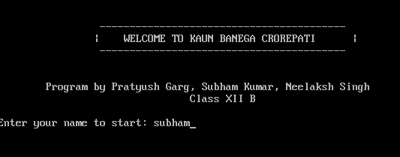

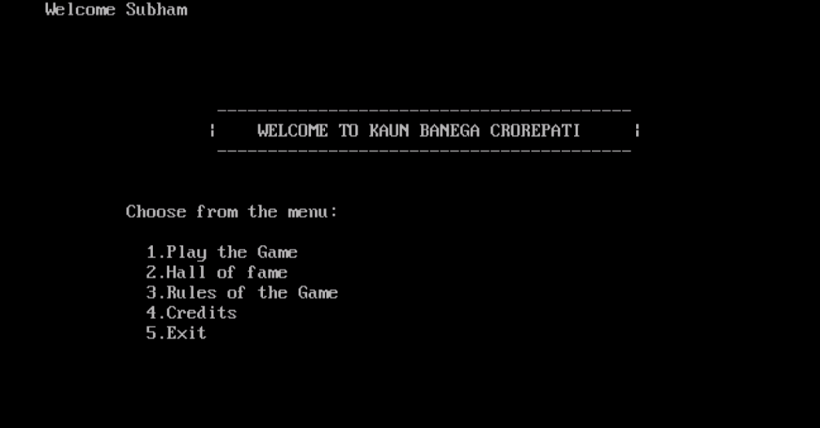

**Menu screen**

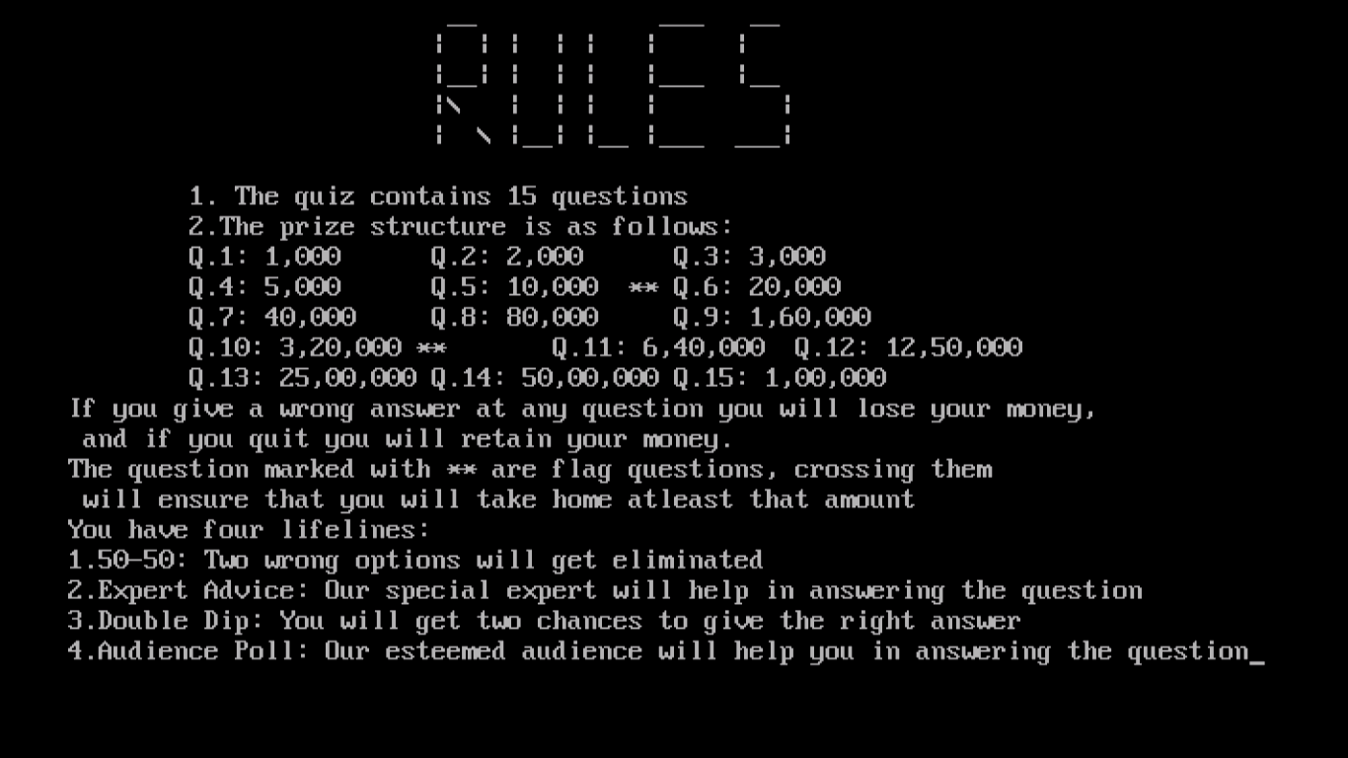

**Rules screen**

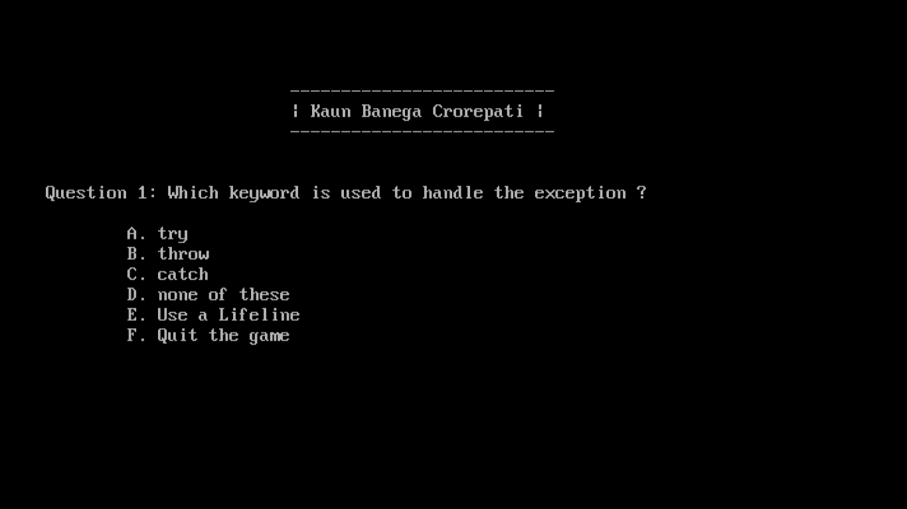

**First question**

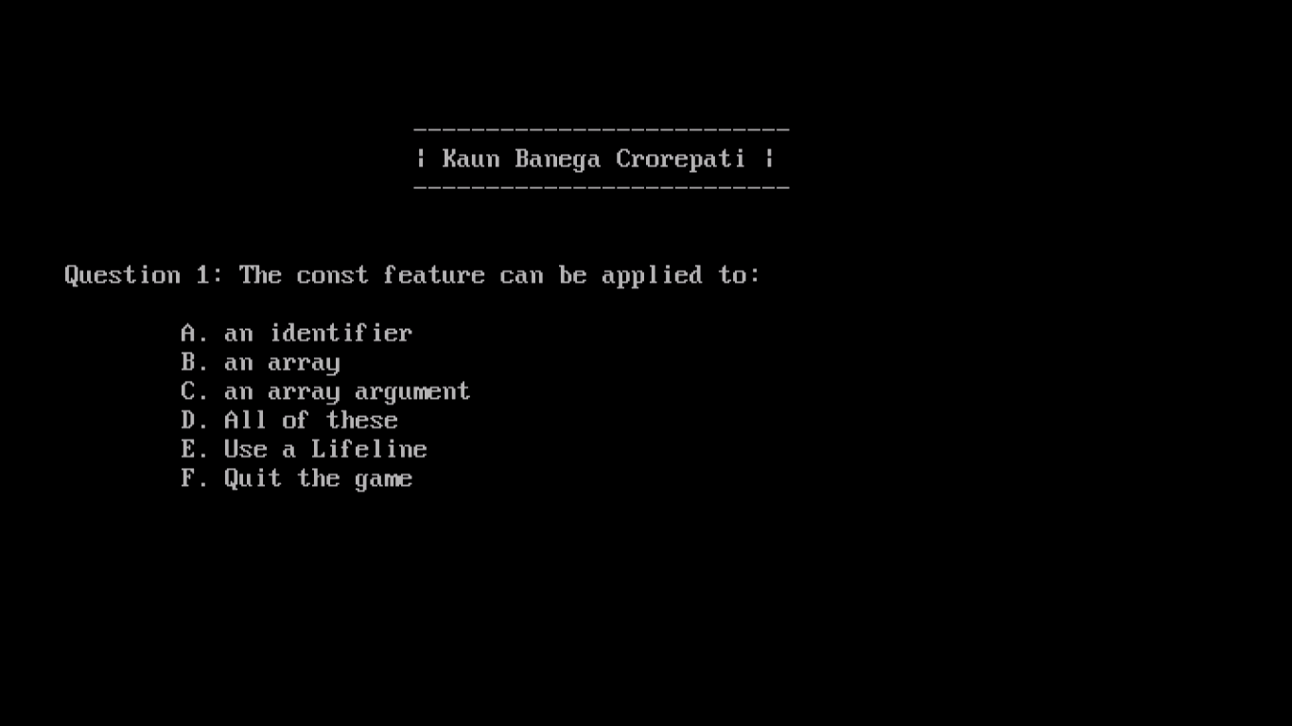

**Screen illustrating Random Effect of questions**

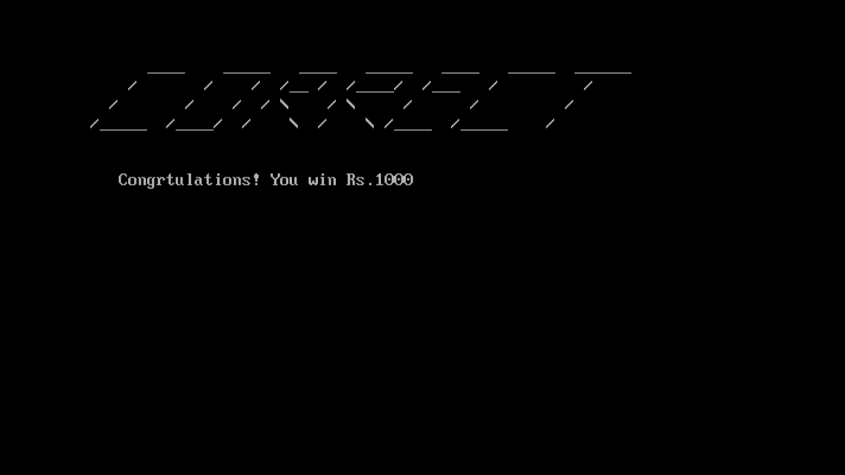

**Correct Answer Screen for first question**

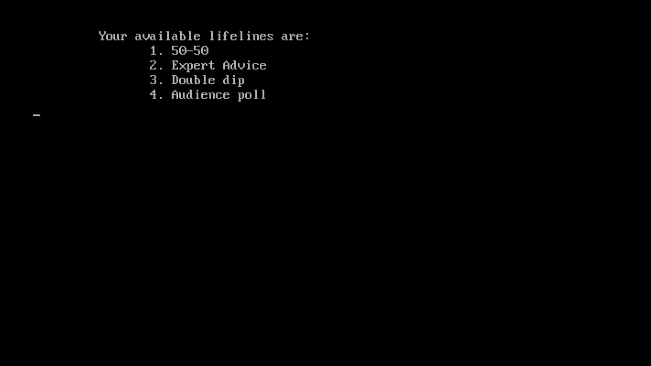

**Lifelines screen**

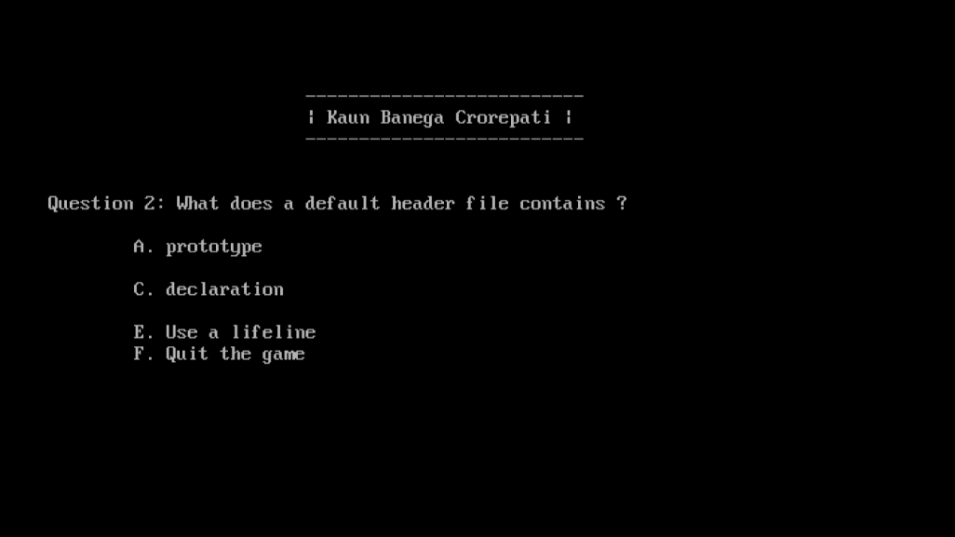

**50-50 in effect: Notice that two wrong options have been eliminated**

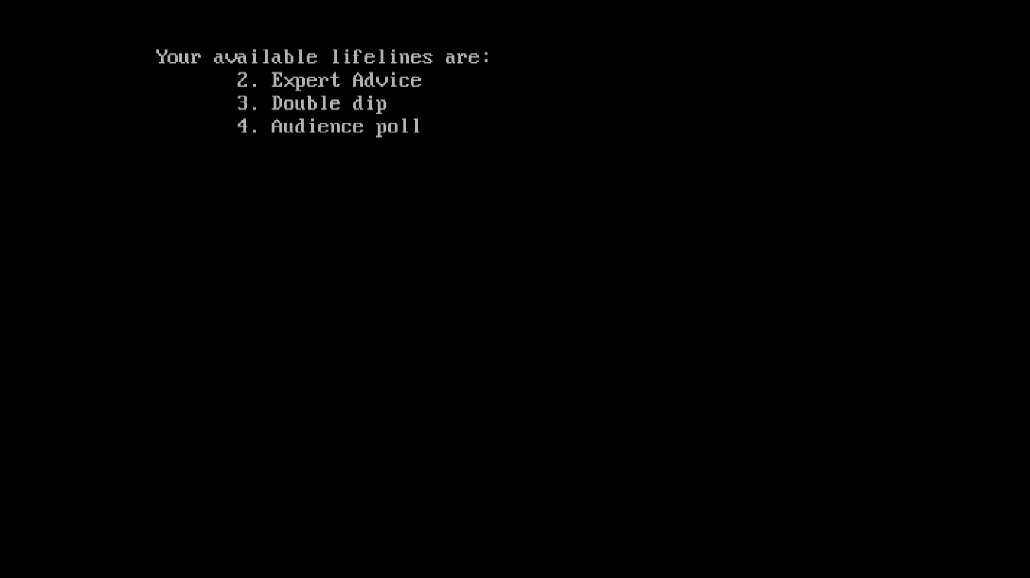

**Lifeline screen after using 50-50, it will not accept 1, a similar thing will happen after using any lifeline**

**Wrong answer output after question 5, it displays “You take home Rs. 10,000”, because you passed a checkpoint**

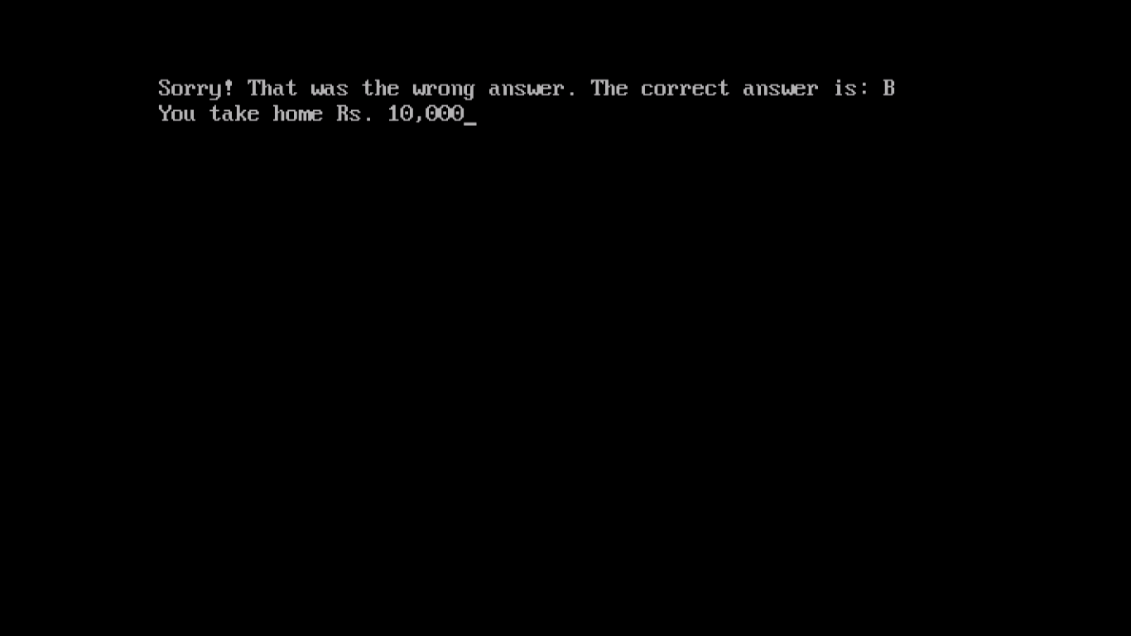

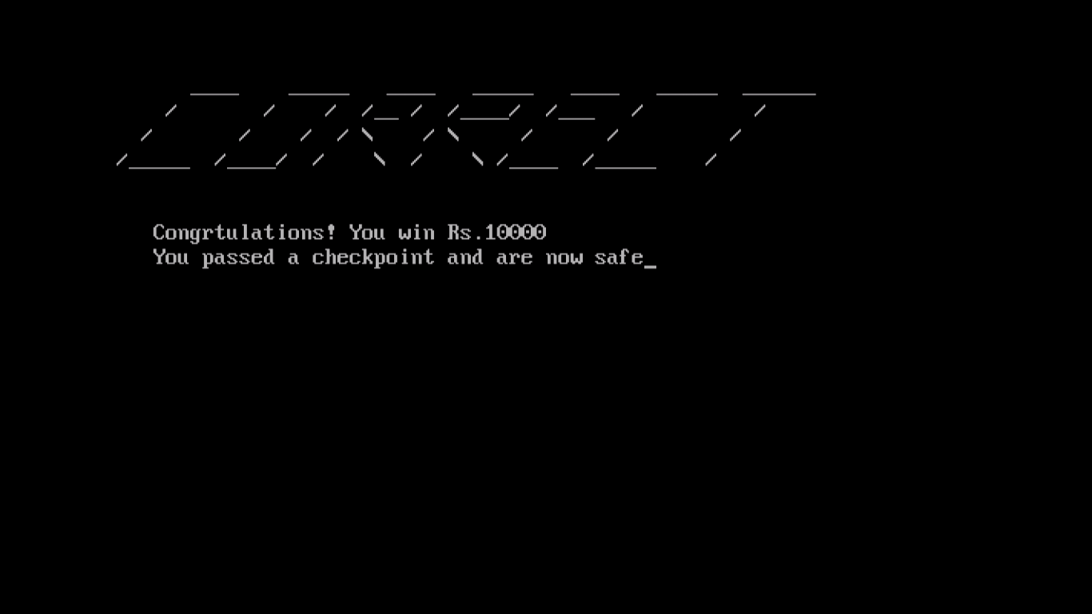

**Similarly, correct answer output for question 5**

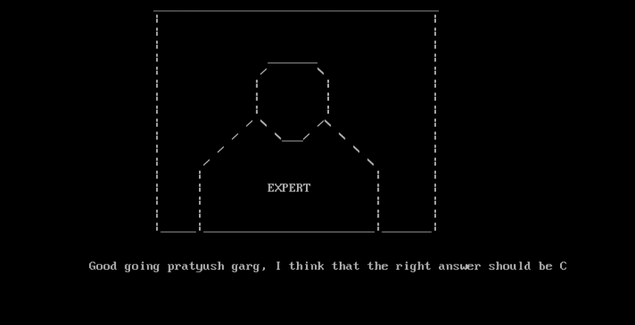

**Expert advice**

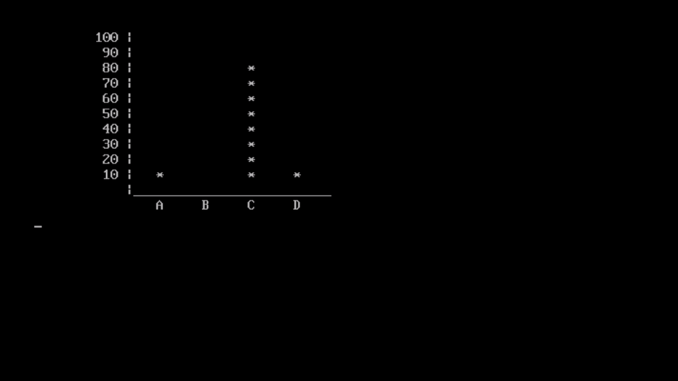

**Audience poll**

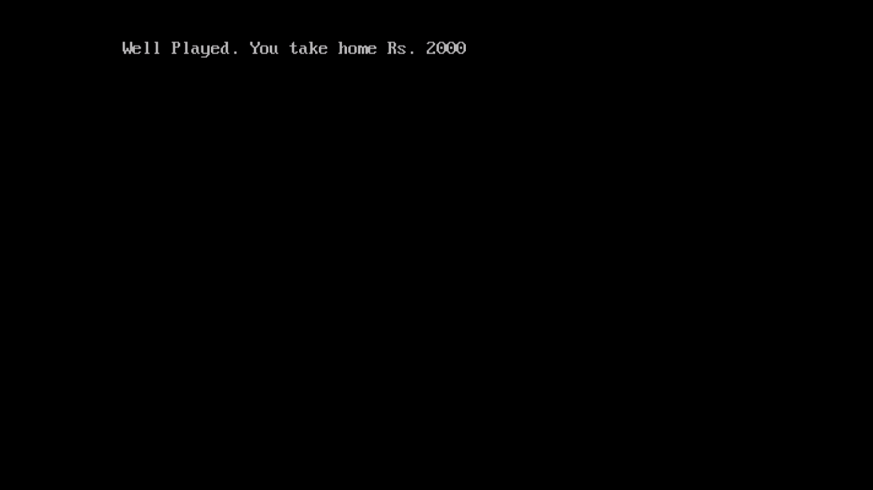

**“Quit the Game” output for question 3**

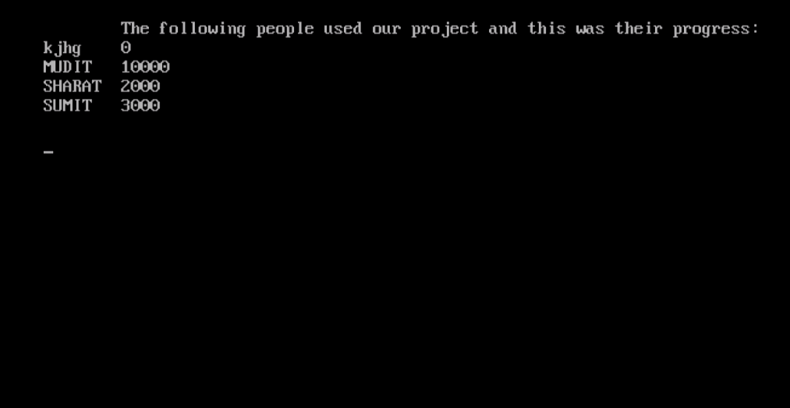 **Hall of fame**

**Scope of the Project**

1. We wish to add a timer to the questions as in the original KBC, as we cannot do it now.
2. We wish to possibly add a voiceover of everyone’s favorite host in the future and improve the UI with sounds and graphics.