**S2I**

We can implement s2i for creating our docker image and also leverage its power for incremental builds, since the build artifacts are stored and can be used for future builds of the same image.

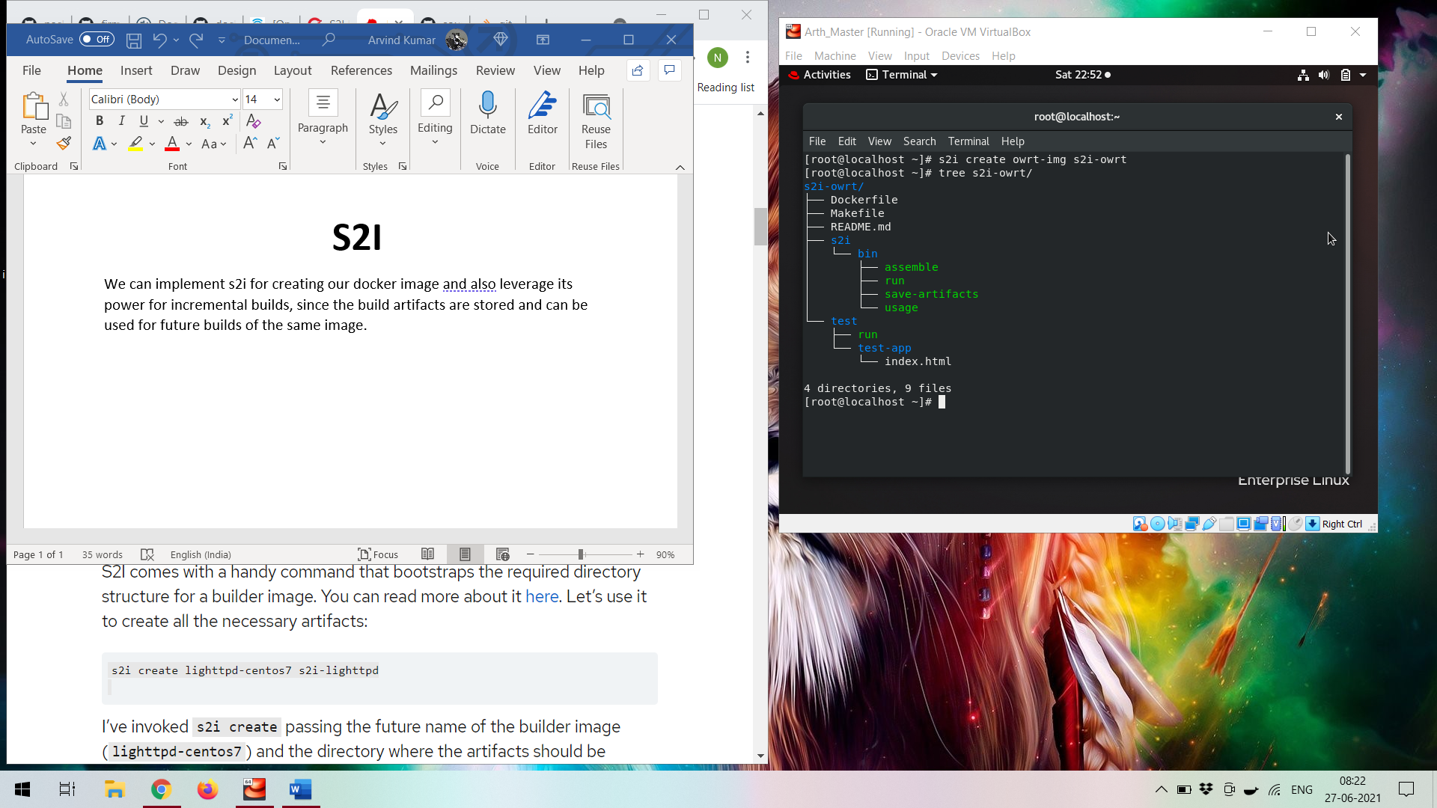

Here **owrt-img** will be our future name of the builder image and the directory where the artifacts should be created (s2i-owrt).