Scanify: A Simple Document Scanner and Image Enhancement System
Project Report | Image Processing and Computer Vision | October 2026

Abstract

Scanify is a document-scanning application that turns photographs of paper documents into clearer, straighter digital copies. A photo taken with a phone may be tilted, shadowed, noisy, or difficult to read. Scanify uses Python, OpenCV, NumPy, and Streamlit to address these problems through a sequence of image-processing steps. It detects the paper boundaries and corrects perspective, reduces noise, improves contrast, adjusts uneven lighting, and can turn a page into a black-and-white image. Users can view the original and processed images and combine multiple pages into a PDF. The project demonstrates how basic computer-vision techniques can solve a practical everyday problem. Testing described in the project report showed useful improvements for tilted pages, shadows, faded receipts, and noisy images. The system can still struggle when the paper edge is hard to distinguish from the background or when a page is curved or blurred.

1. Introduction

People often use mobile phones to take pictures of notes, receipts, forms, and other documents. However, a phone photograph is not always easy to read or share. The page may look like a trapezoid because the camera was held at an angle. A hand or lamp may create shadows, the text may appear faint, and image noise may make the page look grainy. A document scanner should correct these problems while keeping the text readable.
Scanify was developed to make this process easier. Instead of requiring a separate scanner or a large deep-learning model, it uses established image-processing methods that are relatively lightweight and easier to understand. The application has a processing part that handles the image and a Streamlit interface through which users select tools, adjust settings, and view results.

Project objectives
- Straighten tilted document images into rectangular, properly aligned pages.
- Reduce common image noise while keeping text edges clear.
- Improve contrast and reduce uneven lighting or shadows.
- Create a black-and-white version when that makes text easier to read.
- Allow users to compare results and save multiple pages together as a PDF.
The main idea is to process a document in stages. Each stage addresses a different problem, and the user can inspect the result rather than relying on a single hidden operation.

2. Methodology

The application is written in Python. OpenCV performs most image-processing operations, NumPy handles image data, and Streamlit provides the interactive interface. The processing functions are kept separate from the interface so that the image-processing logic is easier to maintain.

2.1 Image input and preparation
The user starts by uploading a document image, such as a JPEG or PNG. The application corrects image orientation when needed and reduces very large images to a manageable size. This helps keep processing reasonably fast and avoids using unnecessary memory.

2.2 Detecting and straightening the page
The document is displayed on the screen with four draggable points representing its corners: top-left, top-right, bottom-left, and bottom-right. The user can move these points to align them with the actual corners of the document. Once the corners are selected, the application applies a perspective transformation using OpenCV to correct the tilt and convert the document into a straight, rectangular image. This makes the document appear as if it were scanned directly from the front, improving its alignment and readability. The process also works when the document and its background have similar colors, as long as the corners can be identified correctly.

2.3 Removing image noise
Noise appears as unwanted grain or scattered dots. Scanify provides two filtering approaches. Gaussian filtering smooths nearby pixel values and can reduce general grain, but too much smoothing may blur letters. Median filtering replaces a pixel with the middle value from its surrounding pixels. It is especially useful for isolated black or white specks and tends to preserve text edges better.

2.4 Improving contrast and lighting
Some documents have faded text or uneven brightness. Scanify improves the difference between text and paper and attempts to reduce shadows. For text pages, it estimates the background lighting and adjusts the image to make the paper more even. It can also sharpen fine text details. For images with colour, local contrast enhancement is applied mainly to brightness rather than independently changing every colour channel, helping colours remain more natural.
The application includes CLAHE (Contrast Limited Adaptive Histogram Equalization). This method improves contrast in small areas instead of treating the entire image as one area. This can help reveal faint details without excessively brightening the whole page.

2.5 Converting the page to black and white
Thresholding separates darker text from the lighter paper. Otsu's method chooses one threshold for the whole image and is useful when lighting is fairly even. Adaptive thresholding calculates thresholds from nearby pixels, so it can work better when one part of the page is shadowed and another part is bright. The user can compare the available outputs and choose the clearest one.

2.6 Interface and PDF output
The Streamlit interface provides a simple way to view original and processed images side by side. Users can save or revert changes at each stage, and saved results are used for further processing. Scanify handles color and grayscale images smoothly, displays image intensity histograms, and allows users to combine processed pages into a single PDF for download.

3. Results and Discussion

The supplied project report describes tests on images with different problems. The results below are a plain-language summary of those reported observations, rather than a claim that every image will produce the same outcome.
Test situation | Technique used | Reported result
Page photographed at an angle | Interactive 4-point perspective homography rectification | The page was straightened into a rectangular view.
Shadow across part of a page | Adaptive thresholding | Text remained easier to separate from the paper than with one global threshold.
Faded receipt | Local contrast enhancement (CLAHE) | Faint characters became more visible while avoiding some of the problems seen with global equalization.
Image with scattered black and white specks | Median filtering | Noise was reduced while text edges stayed relatively clear.
Several document images | Batch processing and PDF creation | The pages were processed and combined into a single PDF.
Multi-stage processing | Pipeline state memory (Keep & Revert system) | Users chained straightening, noise reduction, and thresholding sequentially into a finished scan without losing steps.

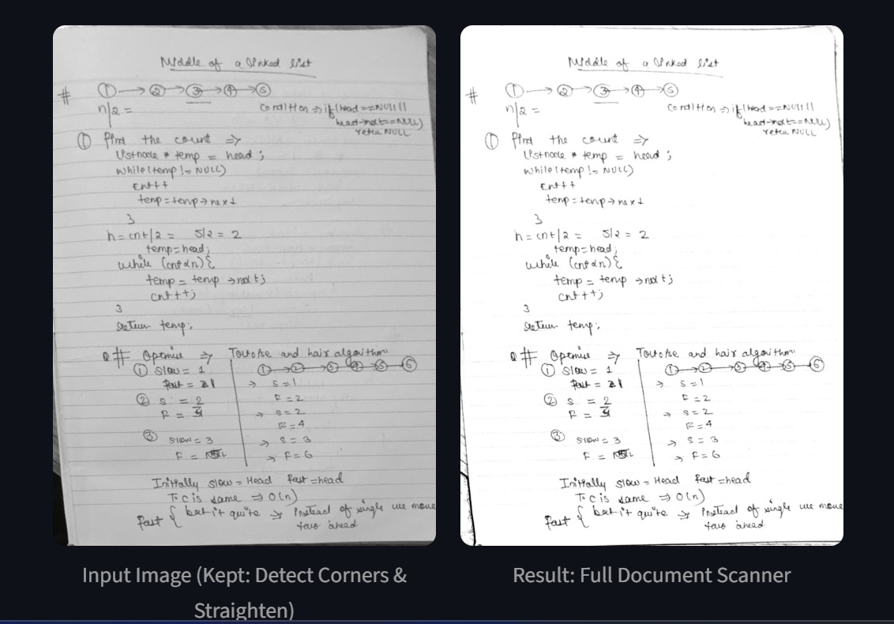 | 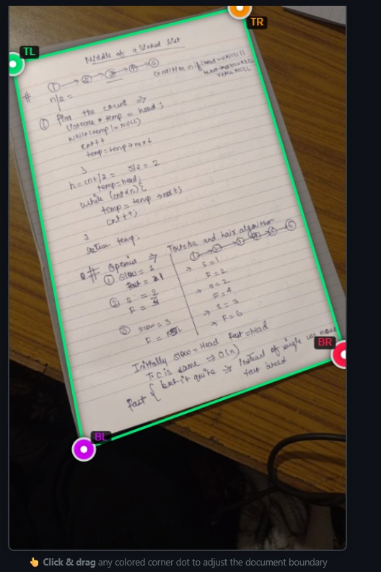
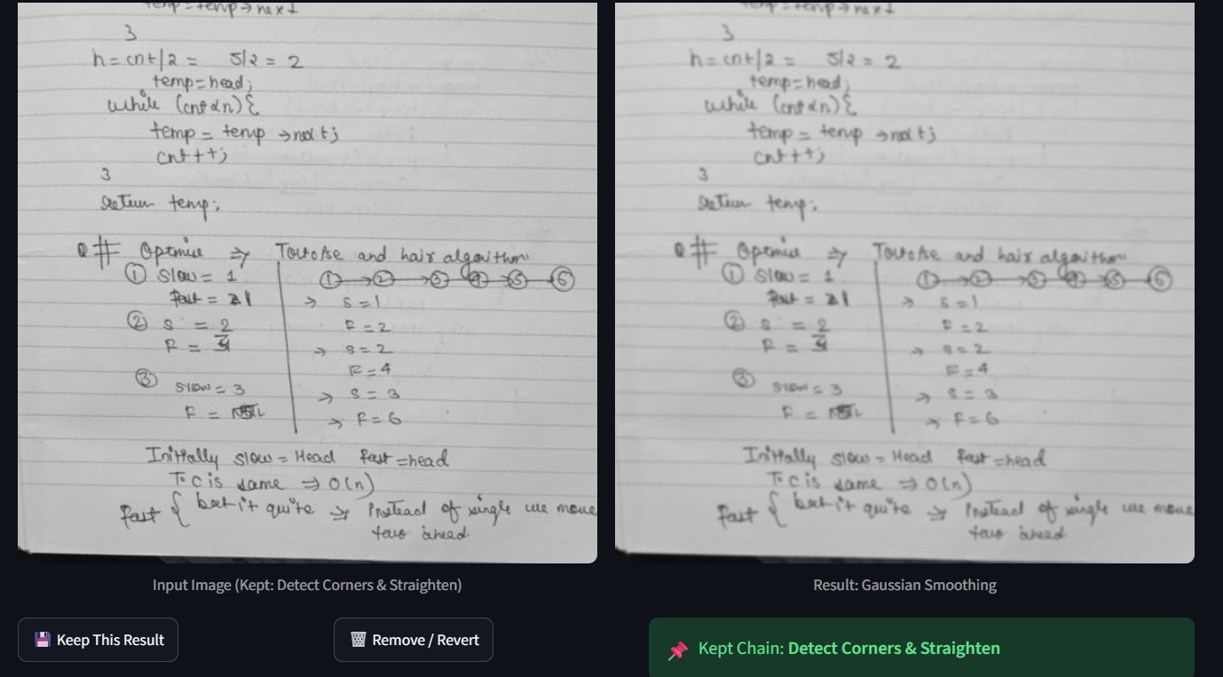 | 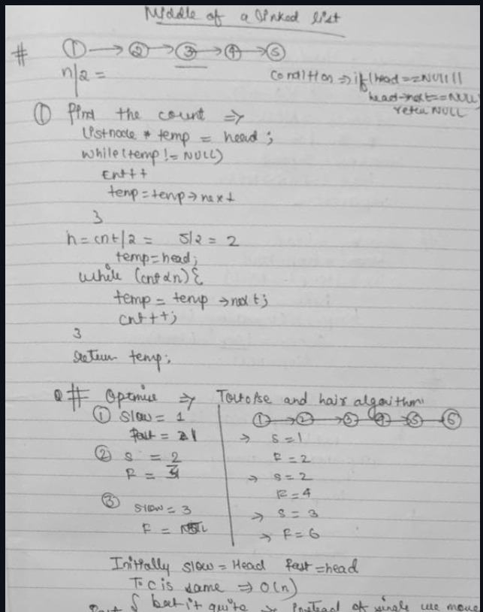

What the comparisons tell us
The tests illustrate that no single technique is best for every problem. Gaussian filtering is useful for general smoothing, whereas median filtering is often better for isolated specks. A single threshold works well when lighting is even, but adaptive thresholding is more suitable when shadows vary across the page. Local contrast enhancement can also be more balanced than applying contrast changes to the whole image at once.
The reported tests suggest that the application can respond quickly enough for interactive use on the tested computer. However, processing time depends on image size and hardware, so the reported timing should not be treated as a guarantee for every device.

Limitations
- No automatic edge detection is used; users manually select the document's four corners.
- Curved, folded, or crumpled pages may not become completely flat because the perspective correction assumes a mostly flat page.
- Strong motion blur can remove important edge details, making detection and sharpening less effective.
These limitations are important because image processing can improve the information present in a photo, but it cannot always recover details that were never captured clearly.

4. Conclusion
Scanify demonstrates how image-processing techniques can turn ordinary document photographs into clearer and more useful digital copies. It combines page-boundary detection, perspective correction, noise reduction, contrast enhancement, lighting correction, and thresholding in one application. A Streamlit interface makes these operations accessible, and PDF generation helps users store multiple pages together.
The main lesson from the project is that different image problems require different methods. Perspective correction fixes the shape of a page, filters reduce noise, contrast enhancement helps reveal faint text, and adaptive thresholding handles uneven lighting. The project is a practical introduction to computer vision because the purpose of each step can be observed directly by comparing the input and output images.
Possible future improvements include adding Optical Character Recognition (OCR) so that text can be searched or copied from scanned documents, and improving corner detection for difficult backgrounds or curved pages. Overall, Scanify provides a useful foundation for learning and applying basic image-processing concepts.

References
- GeeksforGeeks. (n.d.). Image Smoothing Techniques – Gaussian and Median Filtering. GeeksforGeeks
- PyImageSearch. (2021). Adaptive Thresholding with OpenCV. PyImageSearch
- LearnOpenCV. (2020). Otsu’s Thresholding with OpenCV. LearnOpenCV
- PyImageSearch. (2021). OpenCV Histogram Equalization and Adaptive Histogram Equalization (CLAHE). PyImageSearch
- OpenCV. (n.d.). Image Thresholding using OpenCV. OpenCV Blog

