NEARSTAY — Official Product & Technical Documentation
The 100% Verified Student Accommodation & Live Hostel Matrix Platform
Live Web URL: https://nearstay-74ad6.web.app | Target Region: Warangal, Kazipet & Expanding Student Cities

1. What is NearStay? (Executive Overview)
NearStay is a modern, verified student residence and hostel booking web platform engineered to solve the chronic difficulties students, parents, and working professionals face when searching for accommodation near colleges, universities, and coaching hubs.
Unlike general classifieds or map tools, NearStay is a dedicated accommodation engine providing real-time room-level availability (Live Room Matrix), hygienic weekly mess food schedules, verified warden credentials, transparent rental pricing with zero brokerage commission, and instant official digital boarding passes.
💡 Core Mission
To ensure that every student moving to a new educational city can find, verify, and reserve a safe, hygienic, and affordable hostel room in under 2 minutes — with zero street-wandering, zero middleman broker fees, and complete peace of mind.
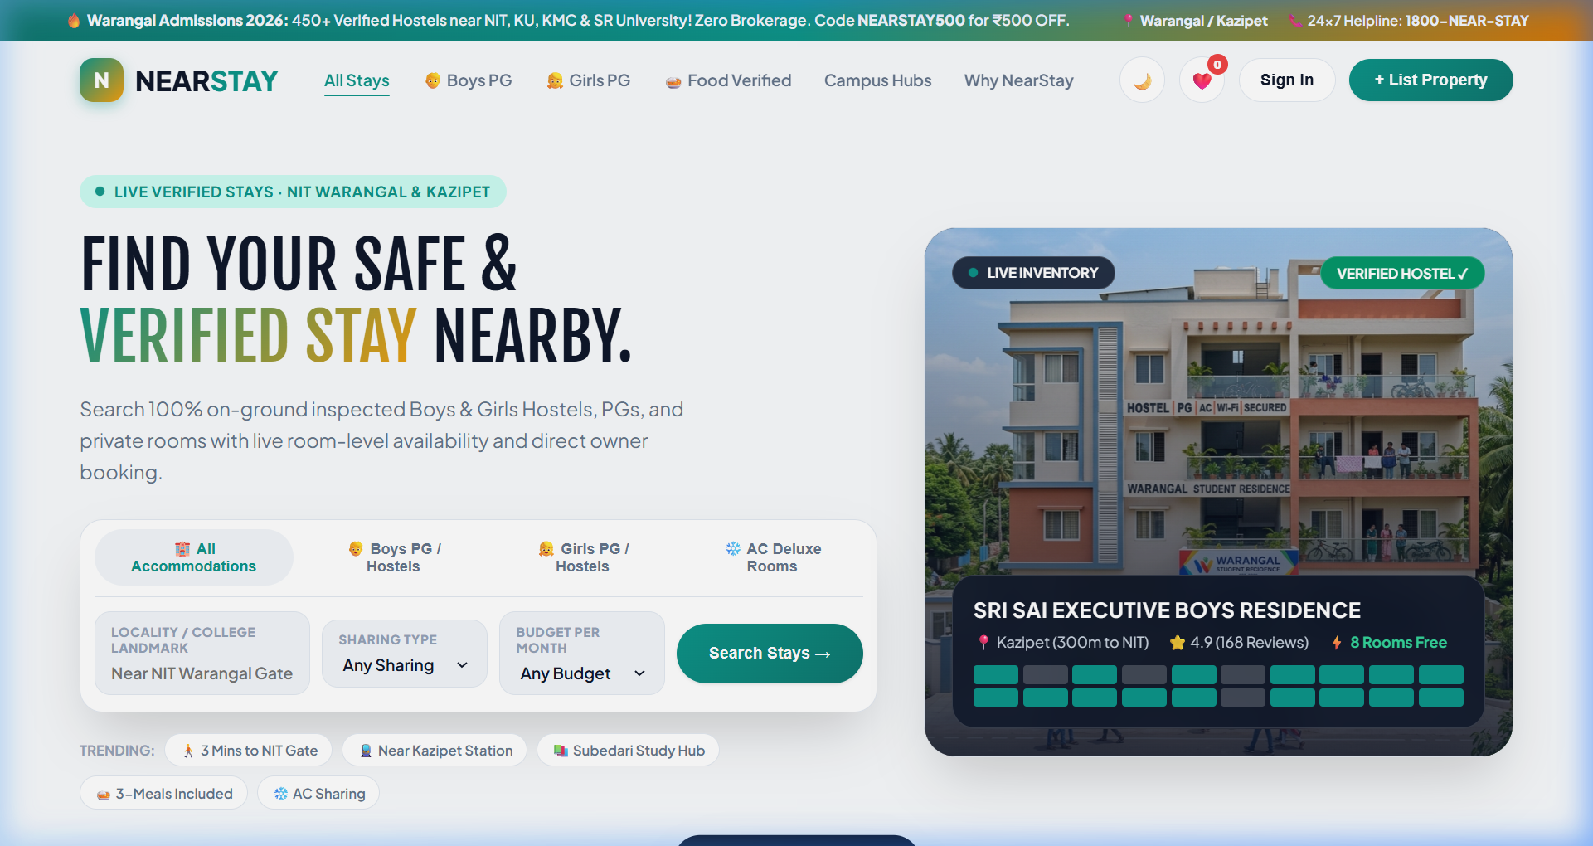
Figure: NearStay Homepage, Hero Showcase & Smart Search Console

2. The Problem with Traditional Hostel Hunting
Finding a hostel or PG in cities like Warangal (near NIT Warangal, Kakatiya Medical College, Kakatiya University, etc.) has traditionally been a painful, confusing, and costly experience:
- Physical Exhaustion & Time Waste: Students and elderly parents spend days walking from lane to lane in scorching heat or rain, looking for "To-Let" signs and wall posters.
- Hefty Brokerage Fees: Local brokers and agents charge students ₹1,000 to ₹3,000 just for showing addresses, with no accountability.
- No Live Room Vacancy Visibility: Students travel long distances only to discover that single or double sharing rooms are completely full.
- Uninspected Food & Broken Promises: Hostel owners often promise North/South Indian meals, high-speed WiFi, and 24/7 geysers, but reality is poor quality food and broken amenities.
- Safety Concerns for Girls Hostels: Female students and their parents have no reliable way to verify biometric security, resident wardens, and curfew rules in advance.

3. The Big Question: "Why NearStay when Google already exists?"
Many people ask: "Why do we need a separate website when we can just search on Google Maps or Google Search?" Here is the crystal-clear answer:
Google is a general search engine, NOT an accommodation booking & management system. Google Maps only shows a pin on a map with a random phone number. It does NOT manage room inventories, does NOT inspect kitchens, and cannot issue official room allocation passes.
Feature / Capability | Searching on Google / Maps | Using NearStay Platform
Live Room Availability | ❌ None. You must call or visit in person. | ✅ YES. Real-time floor & room matrix showing available vs occupied rooms.
Weekly Food / Mess Menu | ❌ No food schedule or meal details. | ✅ YES. Detailed 7-day breakfast, lunch, snack, and dinner breakdown.
Middleman & Brokerage Fee | ❌ High risk of reaching brokers who demand commission. | ✅ ZERO Brokerage. Direct warden contact with price lock.
Official Allocation Pass | ❌ None. Verbal promises only. | ✅ YES. Instant Digital Boarding Pass with QR verification.
Girls Hostel Safety Verification | ❌ Unverified claims. | ✅ YES. 100% verified biometric gates, female wardens, and CCTV checks.
Warden Live Dashboard | ❌ Wardens cannot manage bed-level occupancy. | ✅ YES. Wardens can toggle room availability in 1 click.
💡 Key Takeaway
Google tells you that a building exists. NearStay tells you which room on which floor is vacant right now, what is being cooked for lunch on Wednesday, how much the exact rent is, and locks your room with an official confirmation pass.
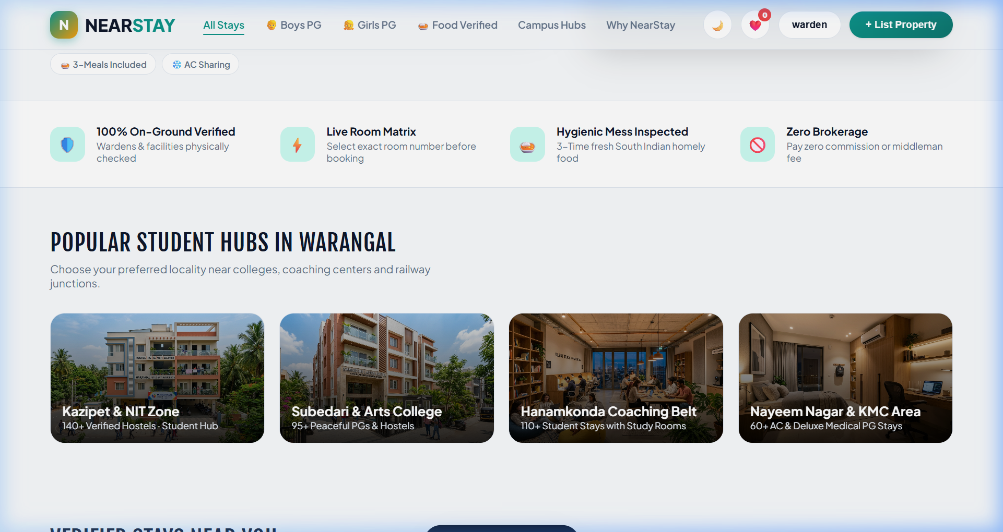
Figure: Verified Property Listings with Live Vacancy Indicators

4. Key Features & How NearStay Works

A. Smart Search Console & Quick Filters
Students can search instantly by typing their college landmark (e.g., "NIT Warangal", "Kazipet", "Subedari", "Kakatiya Medical College") and filtering by:
- Accommodation Type: Boys Hostel / PG, Girls Safe Hostel, Co-living PG, and AC Deluxe Rooms.
- Room Sharing: Single occupancy, 2-sharing, or 3-sharing options.
- Budget Per Month: Under ₹4,500, ₹4,500 - ₹6,000, and Luxury ₹6,000+ brackets.
- Campus Chips: Trending tags for rapid 1-click filtering ("3 Mins to NIT", "Near Kazipet Station", "Food Included").
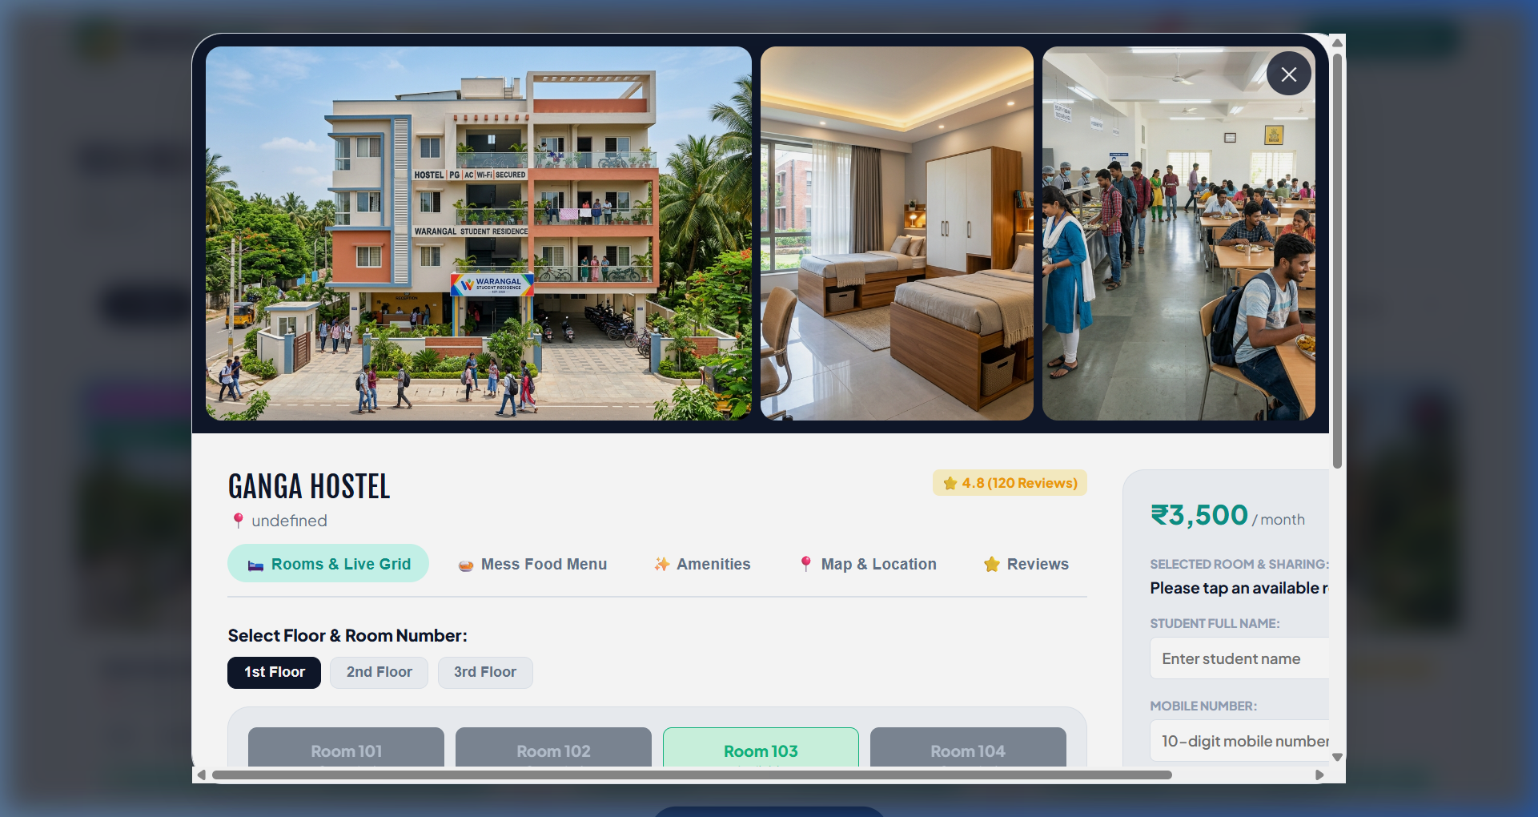
Figure: Interactive Property Detail Modal with Live Room Grid

B. Interactive Live Room Grid (Floor Matrix)
When a student clicks any hostel card, a full-screen interactive modal opens displaying:
- Floor Selector: Students can switch between 1st Floor, 2nd Floor, and 3rd Floor to see all room numbers.
- Visual Color Codes: Green rooms are available; dark slate rooms are occupied.
- Instant Room Selection: Clicking any green room (e.g., Room 103) highlights it in teal and updates the booking sidebar immediately with the selected room number and pricing.
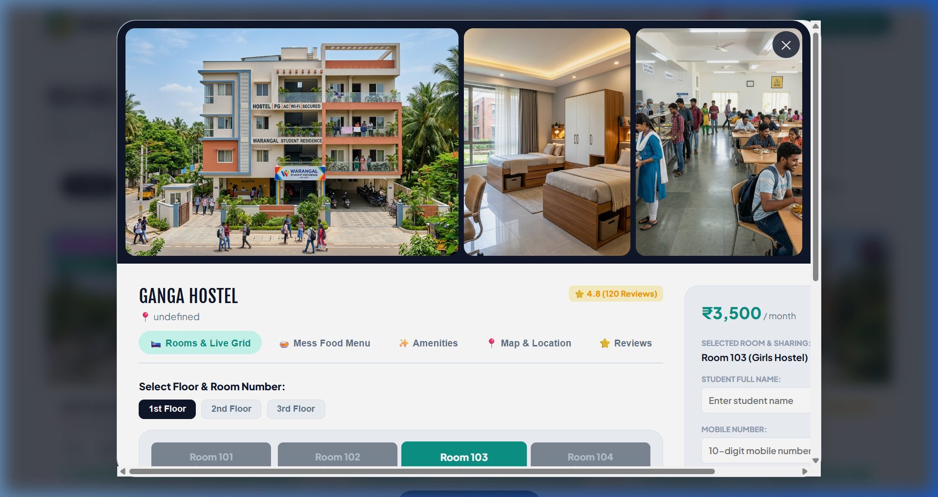
Figure: Room 103 Selected with Dynamic Price & Coupon Calculation

C. Transparent Weekly Mess Menu
NearStay displays the full weekly dining schedule audited during on-ground physical inspection:
- Breakfast: Idli Sambar, Masala Dosa, Puri Bhaji, Upma & Fresh Tea.
- Lunch: Unlimited Steamed Rice, Sambar, Rasam, Veg Curry, Curd & Crispy Papad.
- Evening: Tea / Coffee with hot snacks (Mirchi Bajji / Samosa).
- Dinner: Special Chicken Biryani / Curry (Sundays & Wednesdays), Paneer Butter Masala.
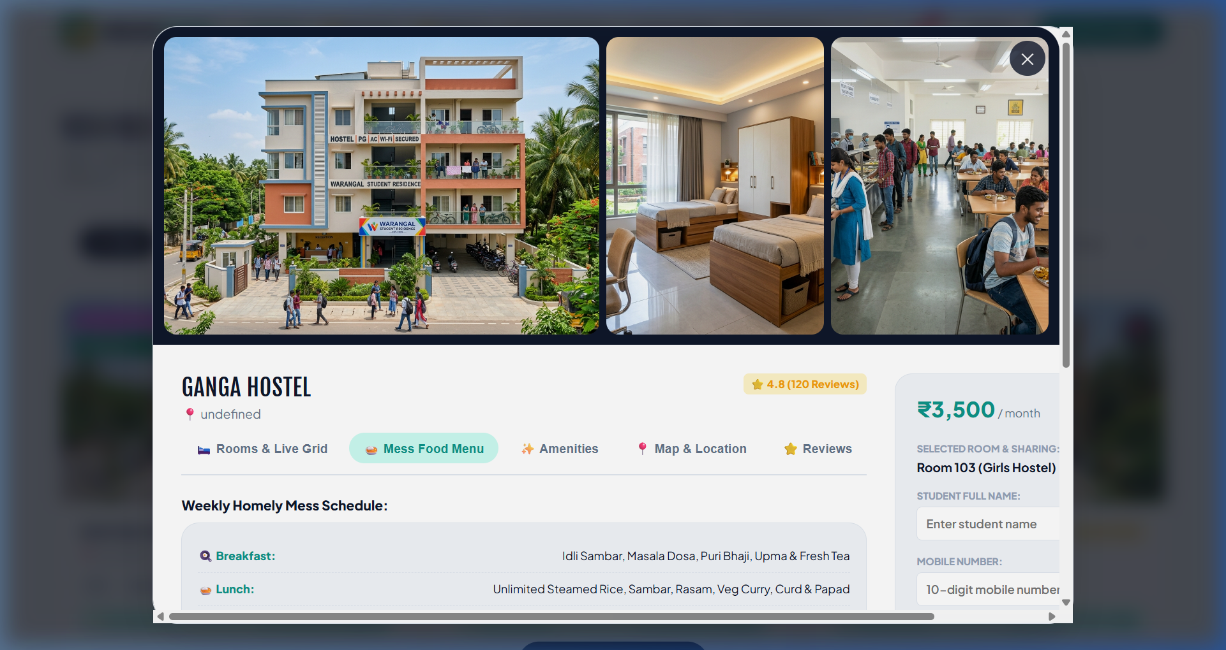
Figure: Verified Weekly Mess Food Schedule

D. Dynamic Google Maps Embed & Student Reviews
The modal includes an interactive Google Map calculating exact walking distance to NIT Warangal Gate and transit stations. Students can read peer reviews and post their own verified student reviews directly on the platform.

E. Instant Digital Boarding Pass
Upon entering name, phone number, and check-in date (with optional discount coupon code NEARSTAY500), NearStay generates an Official Digital Boarding Pass:
- Pass Identifier: Unique allocation pass ID (e.g. #NS-WAR-2026-9842).
- Student Details: Hostel name, allocated room number, student name, and locked check-in rate.
- Clean Printing: One-click print button formatted with dedicated @media print CSS for printing or PDF saving.
- Call Warden: Direct 1-tap phone dialer to speak with the warden immediately.
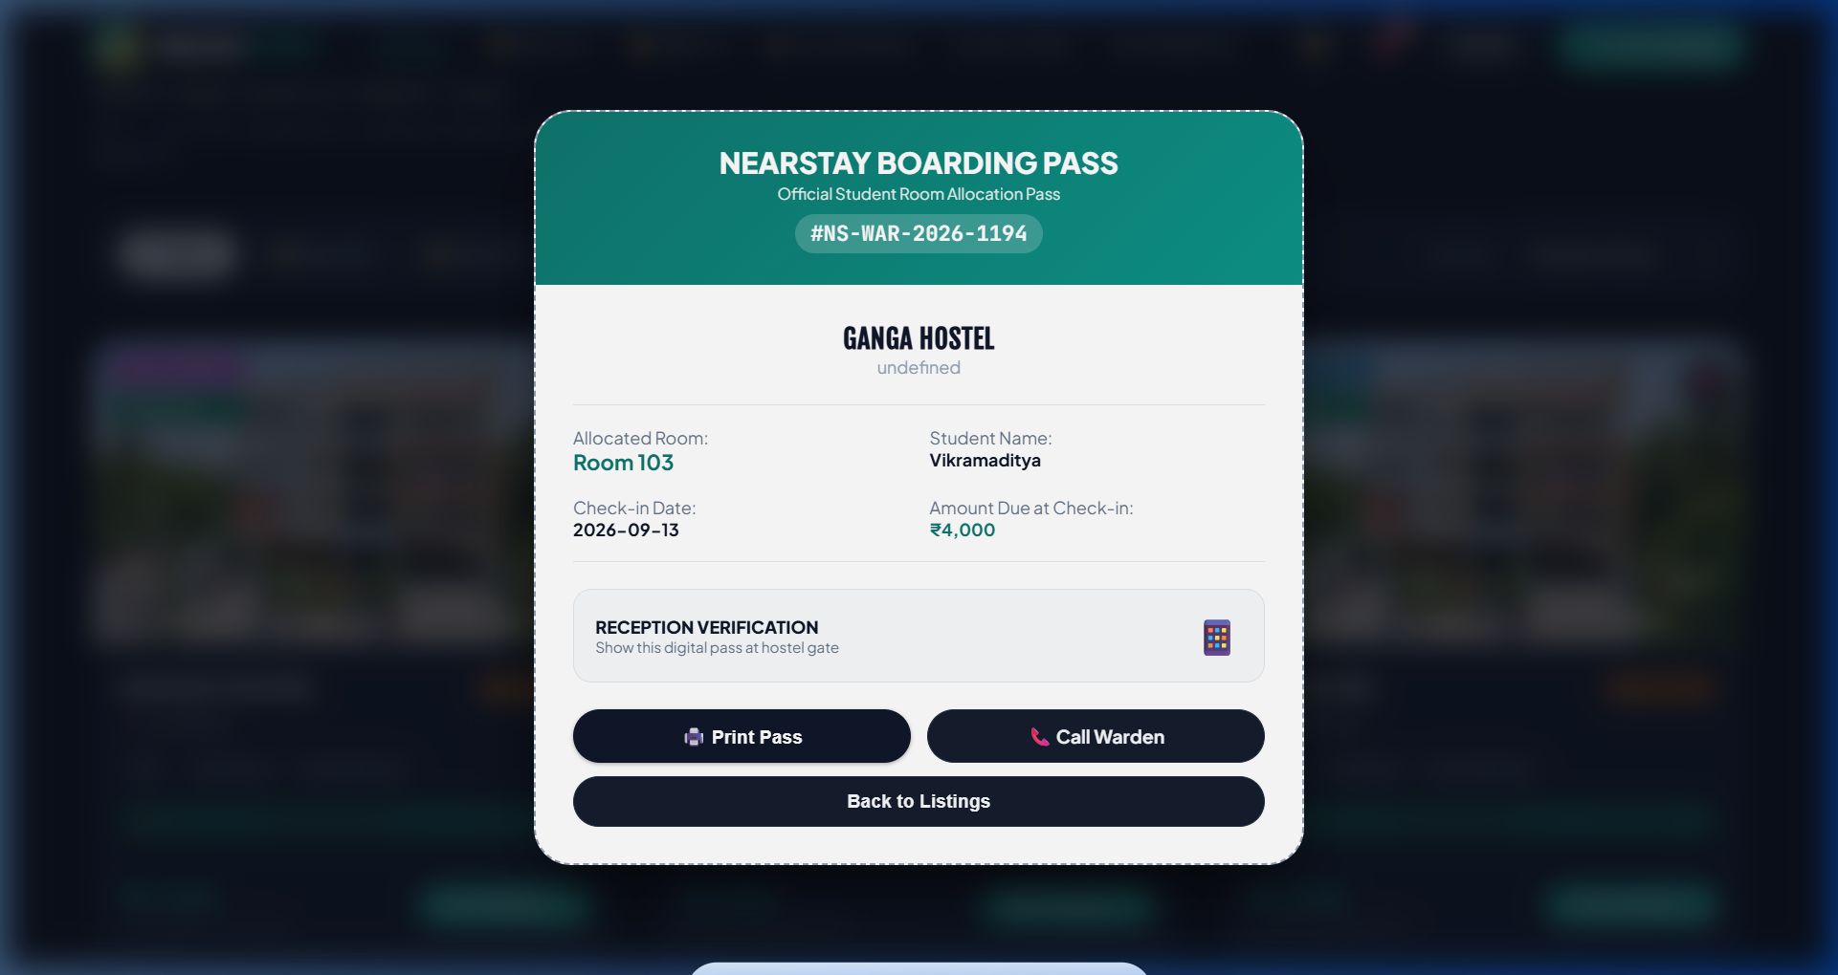
Figure: Official NearStay Digital Student Boarding Pass

F. Sleek Dark / Light Theme & Saved Wishlist
Students can switch seamlessly between a crisp Light Mode and an eye-friendly Dark Mode tailored with high-contrast colors and zero layout flickering.
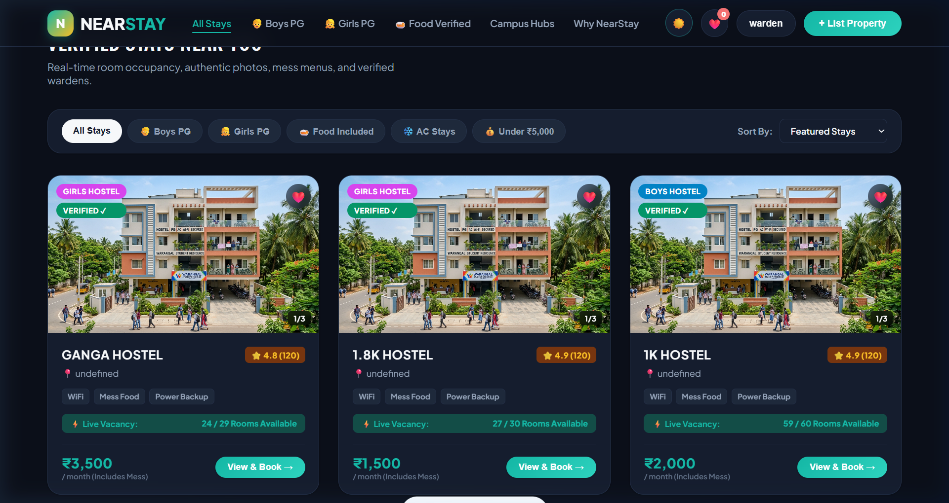
Figure: NearStay Dark Theme for Night Browsing

5. Warden & Hostel Owner Portal
NearStay provides property wardens with a dedicated self-service listing portal accessible via the "+ List Property" button:
- Easy Registration: Hostel name, type (Boys/Girls/Co-living), locality, monthly rent, and phone number.
- Automated Room Grid Generator: Wardens select their floor count (e.g., 3 Floors) and rooms per floor (4-6 rooms). NearStay automatically builds the interactive live room grid!
- One-Tap Room Status Toggle: Wardens can log in and click on any room in their hostel grid to toggle its status between Available and Booked in real-time.
- Cloud Sync: Direct real-time cloud synchronization with Google Cloud Firebase Firestore.

6. Technical Architecture & Tech Stack
NearStay is built using high-performance, robust web technologies to ensure sub-second page loads and zero crashes during peak admission rush:
- Frontend: HTML5 structure with accessible ARIA tags, custom modern CSS design tokens, and modular ES6+ JavaScript.
- Database & Cloud: Google Firebase Firestore for real-time live vacancy updates and Firebase Authentication for student/warden sign-in.
- Production Hosting: Firebase Hosting CDN delivering assets globally with automated SSL certificates.
- Local Dev Server: Lightweight ES module HTTP streaming server for zero-dependency local development.

7. Frequently Asked Questions (FAQ)
Q1: How does a student book a room on NearStay?
A: The student searches by college landmark, opens a hostel, picks an available room from the live floor grid, enters their name and mobile number, applies coupon NEARSTAY500, and receives an official Digital Boarding Pass instantly with ₹0 platform fee.
Q2: Is NearStay only for Warangal or other cities too?
A: NearStay is launched in Warangal (covering NIT Warangal, Kazipet, Subedari, Hanamkonda, KMC) as its primary launchpad and is built to scale across Hyderabad, Bengaluru, Chennai, and other major educational hubs.
Q3: How do wardens benefit from NearStay?
A: Wardens receive direct student admissions without paying commissions to local brokers, and their room vacancy is showcased live to thousands of incoming students 24/7.

