Food delivery management system

**DATA BASE MANAGEMENT SYSTEM PROJECT**

**SUBMITTED BY:** **Neelam Mahapatro**

**Roll no: 116cs0200**

**Abstract: -**

Modern businesses across the globe are using technology to improve eﬃciency and increase sales. We see that most food ordering system in some area of india are still not using any computerization in their functioning.

This project aims to address that need. The project will mainly be an inventory management system for food delivery system which would keep record of available food, order of the user and handle changes that has been made .

**Funtionality of the project:-**

Adding new Food details

Editing the food details

Display of the food details

Restaurant details

Display of restaurants

Enquiry for any user

Contact us option

Sign up for user

Login for user

Change password for user

Adding new customer registration

Enquiry for login users

Online ordering system for the user

Recording the order in database

Feedback of the users

Display of delivery report of individual customer

**Entity- Relationship Model:-**

The extended entity relationship model of this project is given below.

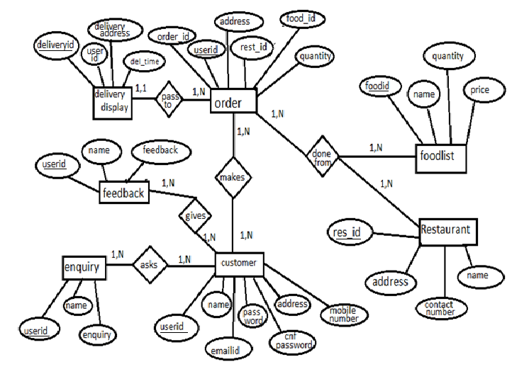

**Functionality in details :-**

**The customer once visit the site, there are many options in the navigation bar. In the FOODS AND DRINKS list all the lists available in the restaurants are published i.e. those are fetched from data base. From here, customer can know the foodid of different foods. There are separate tables in the database for main course, breakfast, snacks, soup, drinks etc. Then in the RESTAURANT list there is the lists of all the restaurants with their id , name, address and contact number. In the enquiry form, customer gives his/her enquiry and this is stored in ENQUIRY table.**

**Customer orders any food after signing up i.e. after log in. All the details of the customer is stored in the SIGNUP table. After logging in, user can give order which will be recorded in the ORDER_NEW table. In that table, delivery address, restaurantid, foodid, quantity, date of order are entered. This information was also passed to the DELIVERY_DISPLAY table which was stored in the database. Thus the user also can know about the delivery of food. In this table, deliveryid, address, time were displayed.**

**Thus this project deals with the management of food delivery by recording the order that was done from different restaurants and keep the information about delivery of the food in the database.**

**Domain types:-**

Userid int(4)

name varchar(60)

emailid varchar(40)

mobileno int(10)

address varchar(40)

password varchar(20)

foodid int(4)

name varchar(20)

quantity int(5)

price int(5)

restaurantid(4)

name varchar(20)

address varchar(20)

contactno int(11)

enquiry varchar(50)

feedback varchar(50)

delivery_address varchar(30)

deliveryid int(4)

delivery_time varchar(10)

orderid int(4)

TABLES:-

SIGNUP :-

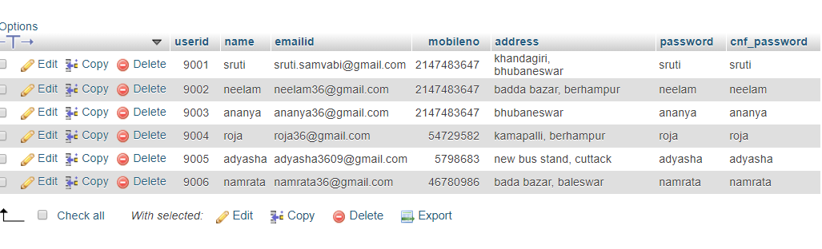

ENQUIRY:-

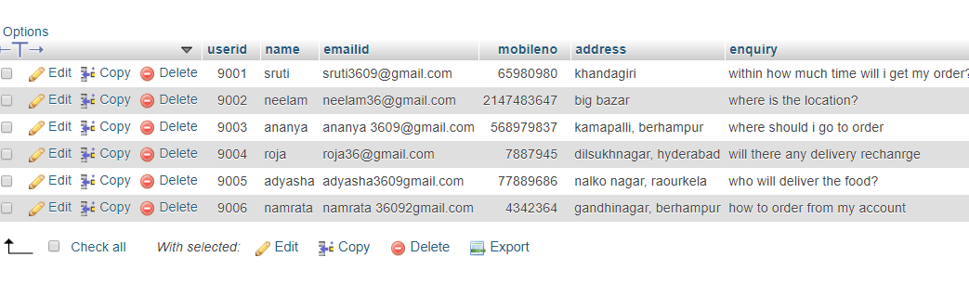

MAINCOURSE_LIST

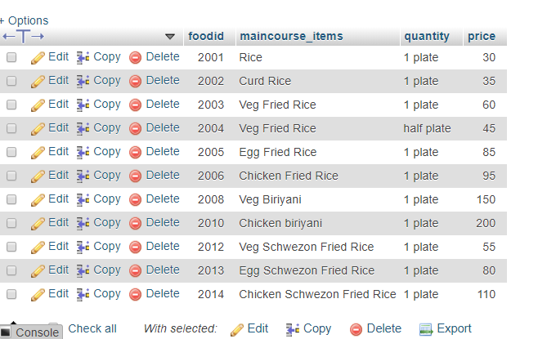

RESTAURANT_LIST:-

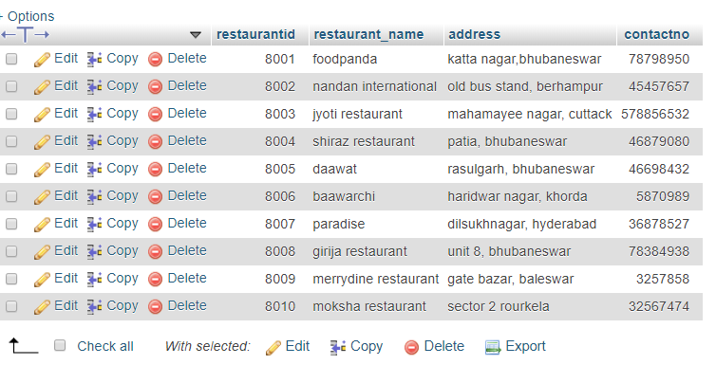

ORDER_NEW:-

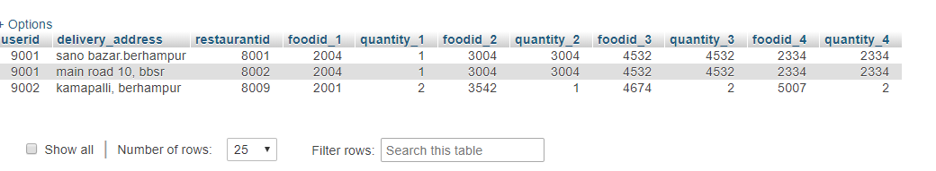

DELIVERY_DISPLAY

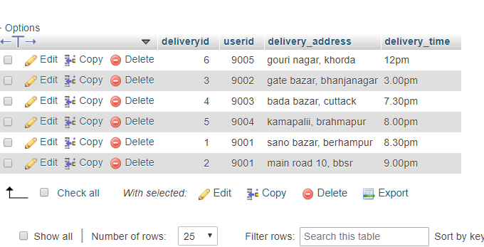

BREAKFAST_LIST

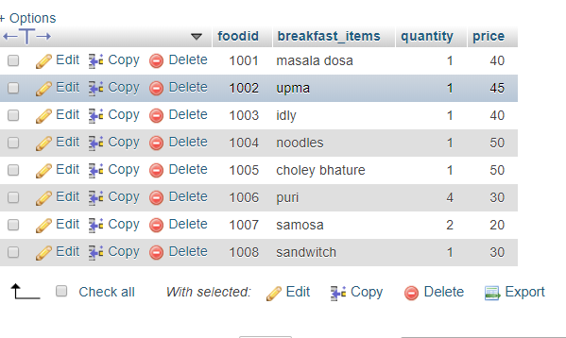FEEDBACK

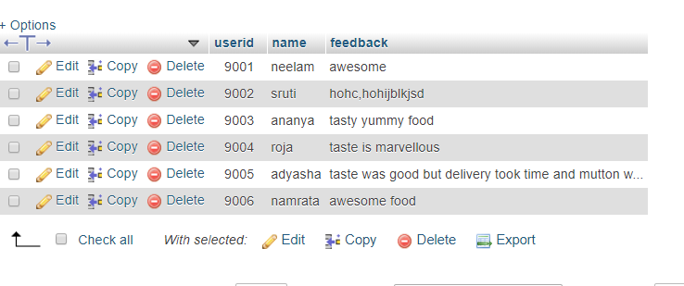

CONCLUSION:-

This project thus aim to manage a food delivery system.