Docker Assignment
Github link: https://github.com/NeelamPl/user-auth-project/tree/main
docker compose up --build
✔ Builds frontend image
✔ Builds backend image
✔ Creates containers
✔ Creates network
✔ Starts everything together
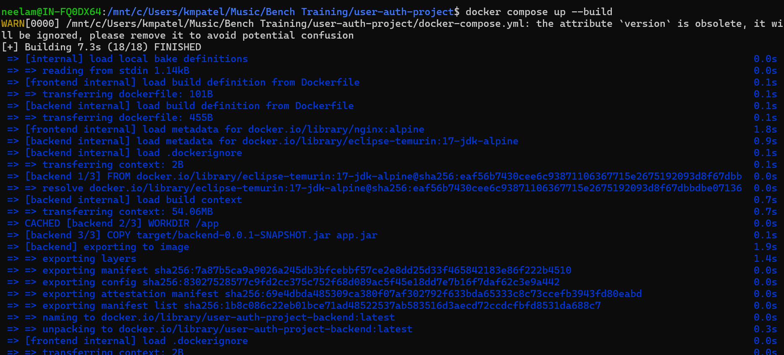
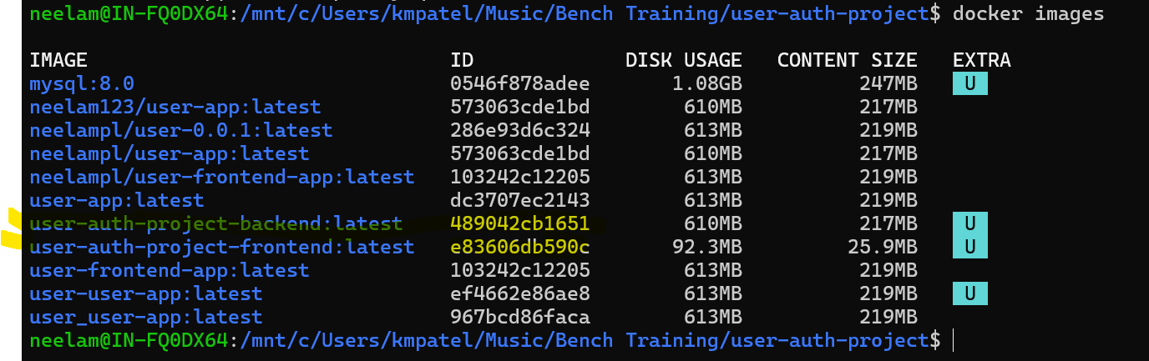
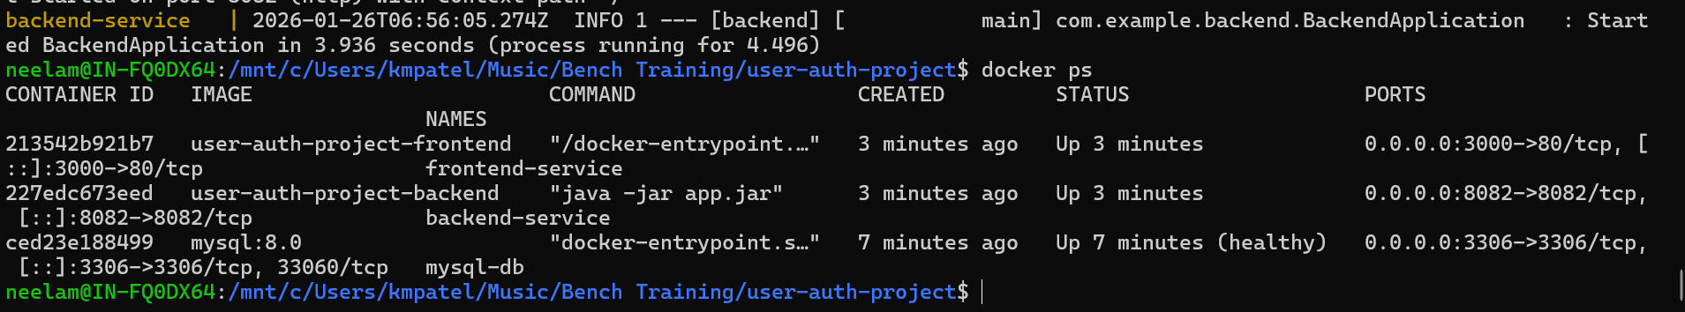

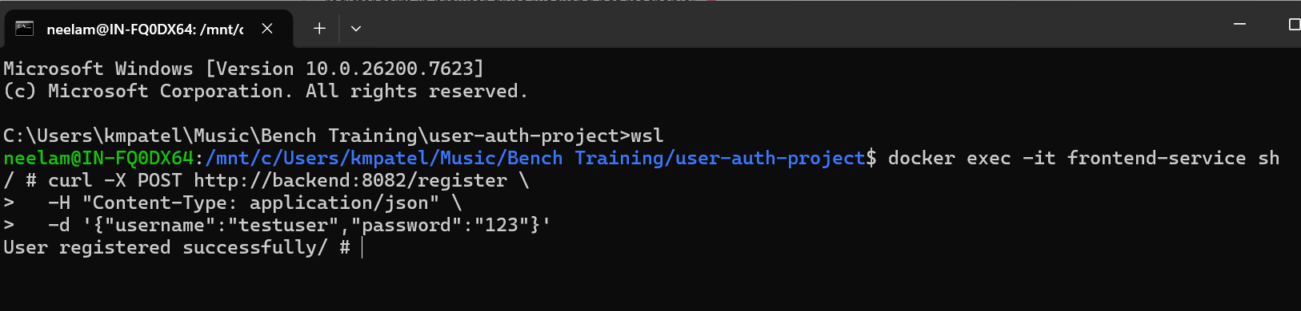
Before you push an image to Docker Hub, you should ensure that it is properly tagged with the repository name and version.
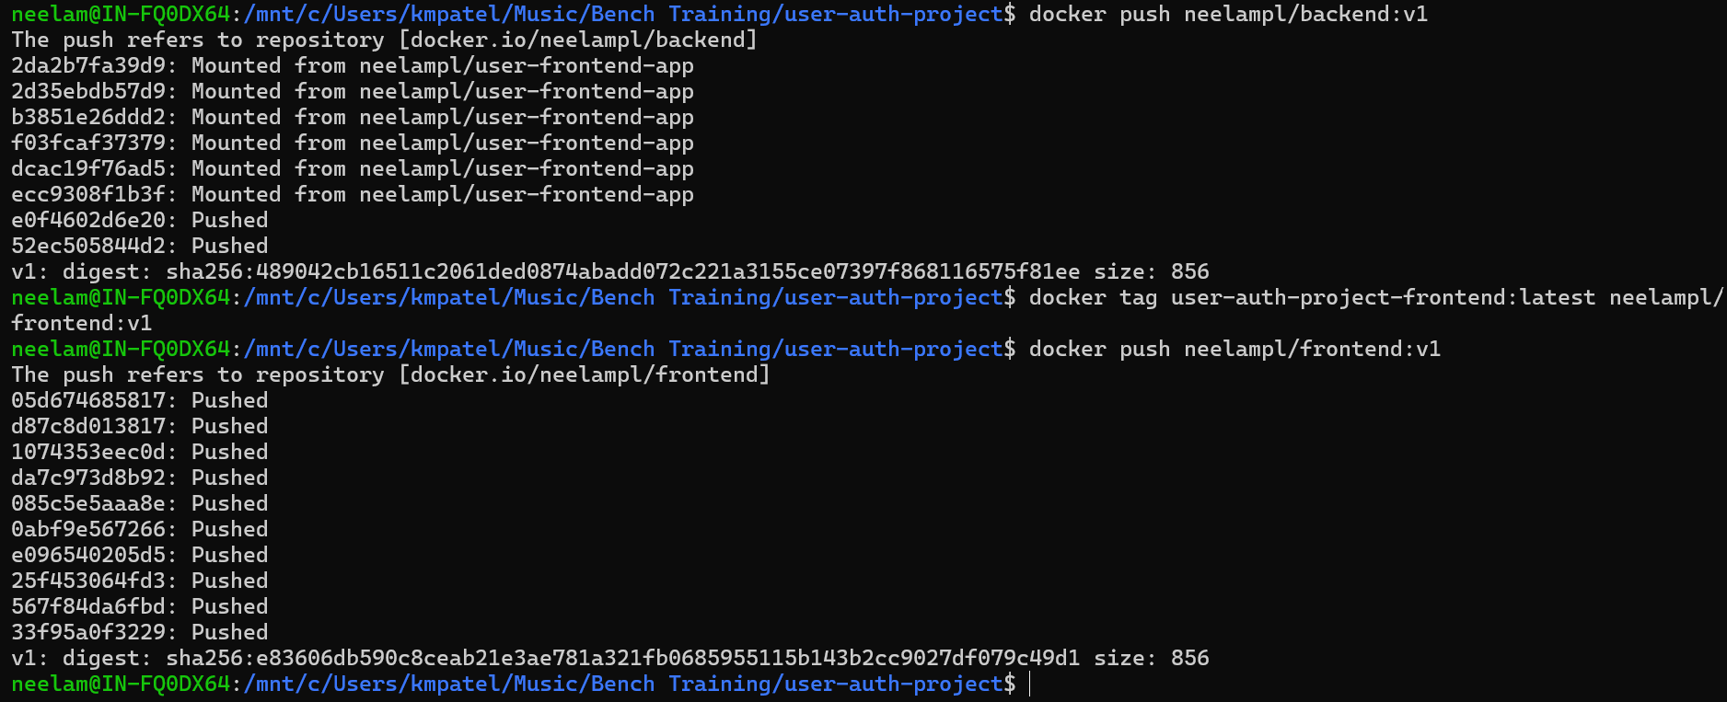
Frontend url: http://localhost:3000/register.html

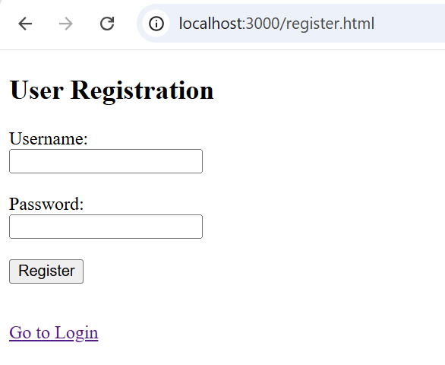
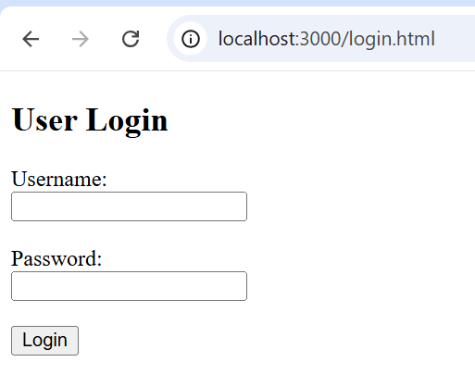
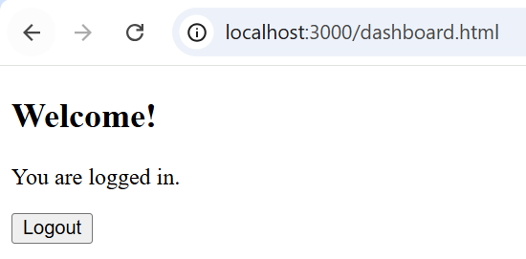
Backend url: http://localhost:8082/register
