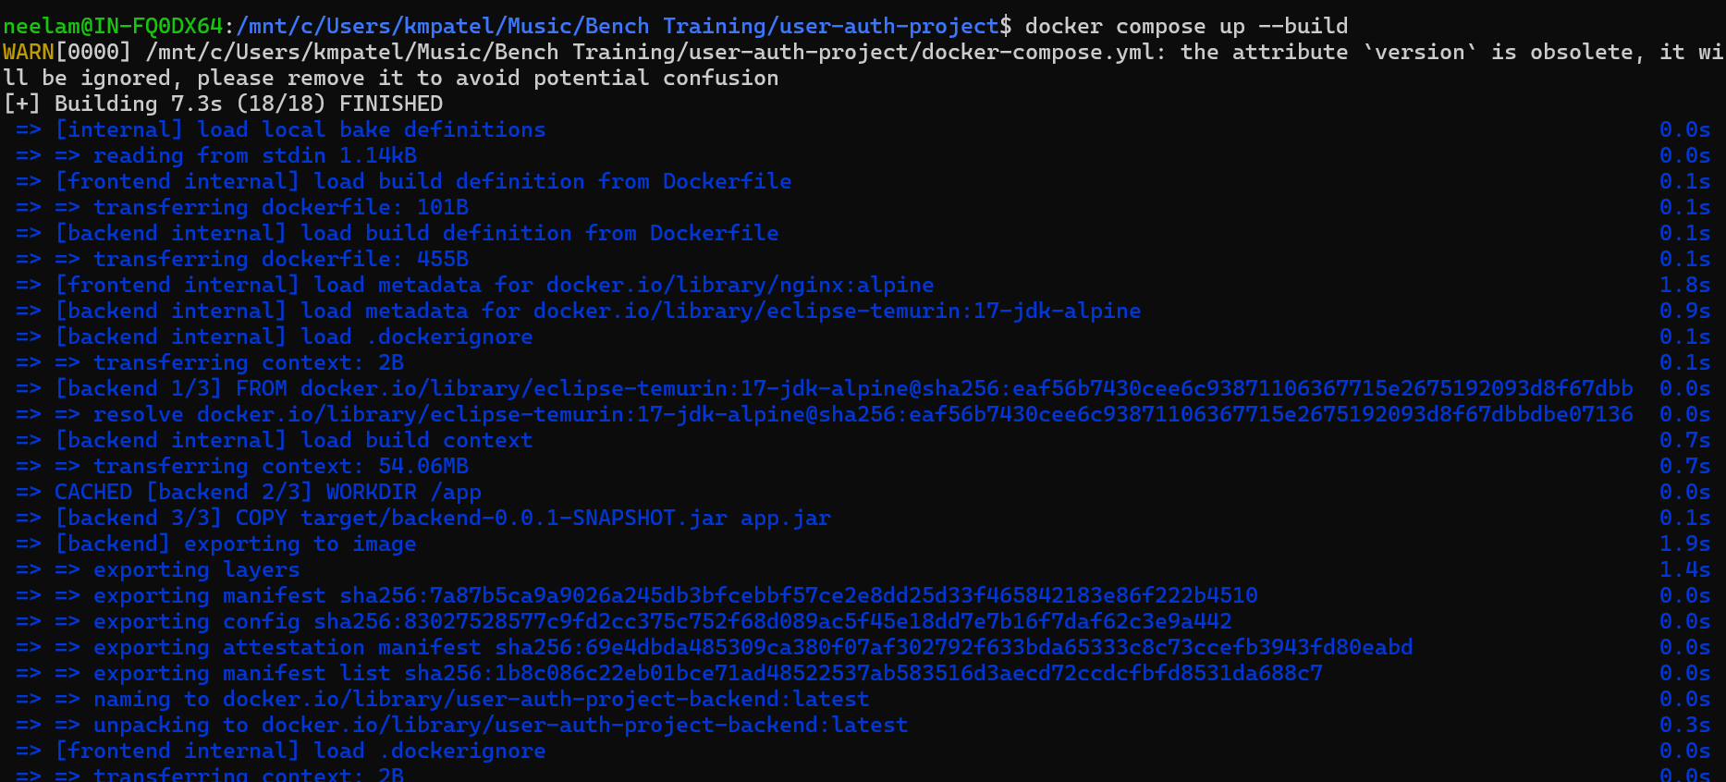
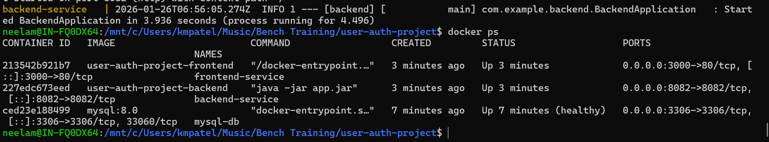
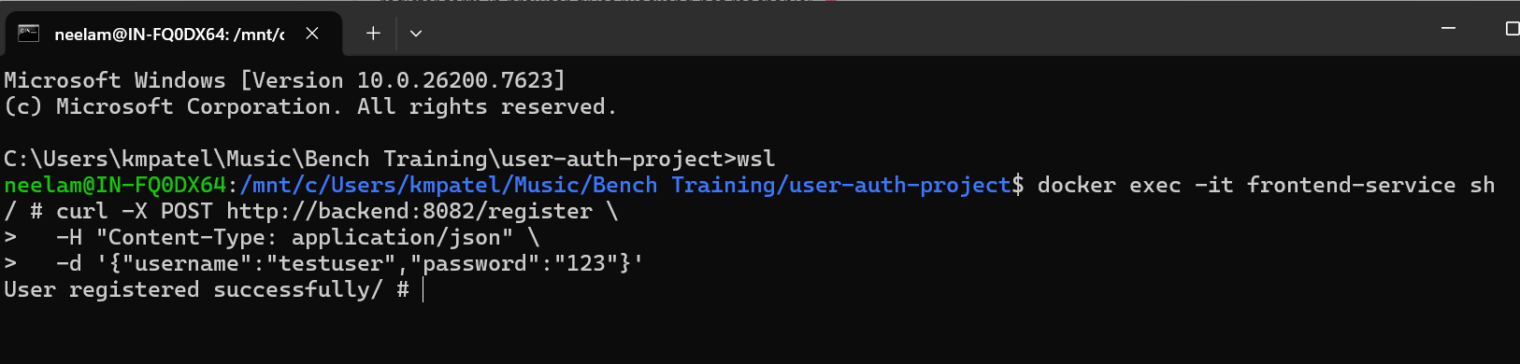
Frontend url: http://localhost:3000/register.html
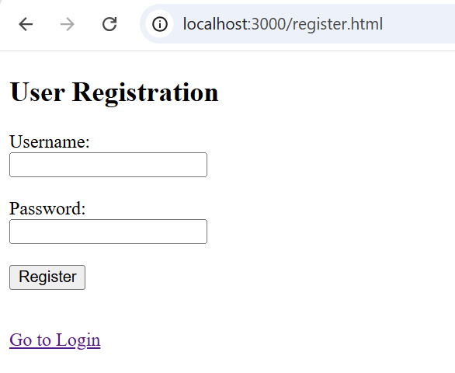
Backend url: http://localhost:8082/register

