MDS572B: QUANTUM MACHINE LEARNING

OBSERVATION NOTEBOOK

Name: Neelanjan Dutta
Roll No: 2448040
Class: 5MDS

LAB No. 1: Installing Qiskit and Setting Up the Environment

Question:
Install Qiskit and do a small sample program of your choice.

Objective:
The objective of this lab was to set up a functional quantum computing development environment using Qiskit. This involved installing the necessary Python libraries, verifying the installation by checking the version, and confirming the environment's readiness by successfully creating, executing, and visualizing a fundamental one-qubit quantum circuit that demonstrates the action of a Pauli-X (NOT) gate.

Draft Plan:
Program description:
This program is designed to set up and verify the Qiskit development environment. The main objective is to ensure the Qiskit library is correctly installed and to run a simple introductory example: creating a circuit, applying a NOT gate (X-gate), and performing a measurement.
Program logic:
- Installation: Used the pip package manager to install the qiskit library.
- Verification: Verified the installation by importing the Qiskit library in Python. A successful import without errors indicated a correct setup.
- Version Check: Printed the installed version of Qiskit using qiskit.__version__ to confirm the specific release.
- Circuit Construction: A QuantumCircuit was built with one quantum bit (qubit) and one classical bit for storing the measurement result.
- Gate Application: An X-gate was applied to the qubit at index 0. This flips the qubit's state from its initial state of |0> to |1>.
- Measurement: A measurement operation was added to map the final state of the qubit to the classical bit.
- Visualization: Used the display() function with qc.draw('mpl') to generate and explicitly render a visual representation of the circuit.
Program:
Installing Qiskit and checking its version:
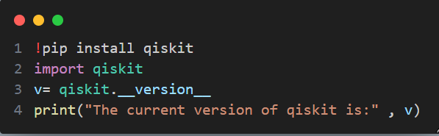
Sample Program:
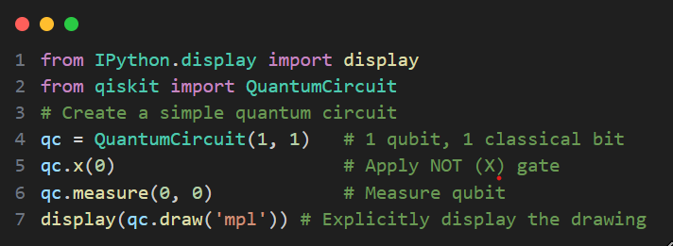
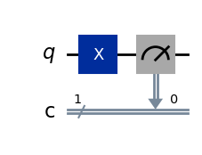
Output:

Interpretation:
- Quantum Register (q): This is the top line, representing your single quantum bit (qubit).
- X Gate: The blue box labeled 'X' on this line is the Pauli-X gate. It acts like a classical NOT gate, flipping the qubit's state from its initial state of (spin up) to (spin down).
- Measurement: The grey box with the meter symbol is the measurement operation. It measures the final state of the qubit and sends that information down to a classical bit.
- Classical Register (c): This is the bottom double line, representing a standard classical bit that can store either a 0 or a 1. The '1' next to it indicates it's a classical register of size 1.
- Arrow: The arrow from the measurement on the quantum register to the classical register shows that the result of the qubit measurement (will be '1' in this case, because of the X gate) is stored in this classical bit.

Test Cases:
Test Case 1: Environment Setup
- Input: Ran the installation and import commands.
- Expected Output: Successful installation message and no errors upon import. The correct version number is printed.
Test Case 2: Circuit Execution
- Input: Ran the sample program code.
- Expected Output: A matplotlib diagram showing a single qubit line (q) and a single classical bit line (c). An 'X' gate is shown on the qubit line, followed by a measurement operation connecting the qubit to the classical bit.
Conclusion:
In conclusion, the Qiskit environment was successfully installed and configured, as validated by the error-free execution of the setup commands and a sample quantum program. The lab successfully demonstrated the basic workflow of building a quantum circuit, applying a gate, and visualizing the architecture. This foundational exercise confirms that the system is prepared for developing and running more complex quantum algorithms in future experiments.
****************************************************************

