RAKSHIKA (रक्षिका)
COMPLETE PRODUCT SPECIFICATION & MARKET-LAUNCH HANDBOOK
Comprehensive Feature Breakdown, Live UI Screenshots, Architecture, Future Roadmap, Regulatory Compliance & Team Execution Matrix

1. Executive Vision, Crisis Analysis & Commercial Strategy
In India, safety concerns severely restrict women’s freedom of movement, education, and career advancement. Crimes ranging from street harassment and stalking to physical and sexual assault remain major barriers to female independence. Traditional safety apps rely on passive "SOS SMS alerts" sent after an incident begins, offering zero physical intervention or real-time tactical defense.
Rakshika (meaning The Shield) is India’s first integrated, on-demand physical security escort and real-time telemetry network. Rakshika connects female students, working professionals, and guardians with Police-Verified, Background-Vetted Female Security Officers ("Lady Bouncers / Escorts") for active physical deterrence, cryptographic handoff locks, real-time WebSocket route streaming, and multi-tier Police Control Room (PCR) emergency dispatch.

Problem Metric vs. Rakshika Solution Blueprint
Metric / Capability | Traditional Safety Apps / Cabs | Rakshika Escort Network
Physical Protection | None. Driver un-vetted for tactical defense. | Police-verified female protection officers accompany clients.
Identity Verification | Basic phone registration (high fraud risk). | Aadhaar KYC linking with AES-256-CBC field encryption.
Handoff Security | Oral name confirmation (impersonation risk). | Cryptographic 4-digit PIN lock & escrow deposit holding.
Underground Coverage | Fails when cellular signal drops in metro basements. | Offline BLE Mesh Fallback via Bluetooth RSSI sensing.
Emergency Dispatch | Generic SMS to contacts after delay. | Multi-tier: PCR Police Relay + Silent Audio + Guardian SMS.

2. Phase 1 Core Production Features & UI Screenshots

Module 1: Police-Verified Lady Guard Registry & Dynamic Discovery Radar
Displays available verified female security personnel with background check badges, police registration numbers, tactical skills, body-cam status, and dynamic proximity radar.
- Police Verification Badge: Verified badge registration numbers (e.g. POL-DEL-8941, POL-NOI-3412).
- Tactical & Self-Defense Specs: Martial arts qualifications (Blackbelt Judo, Krav Maga, Tactical Baton).
- Equipment Transparency: Live body-camera streaming capability indicator.
- Location Radar: Dynamic map radar showing nearby guards within a dynamic radius.
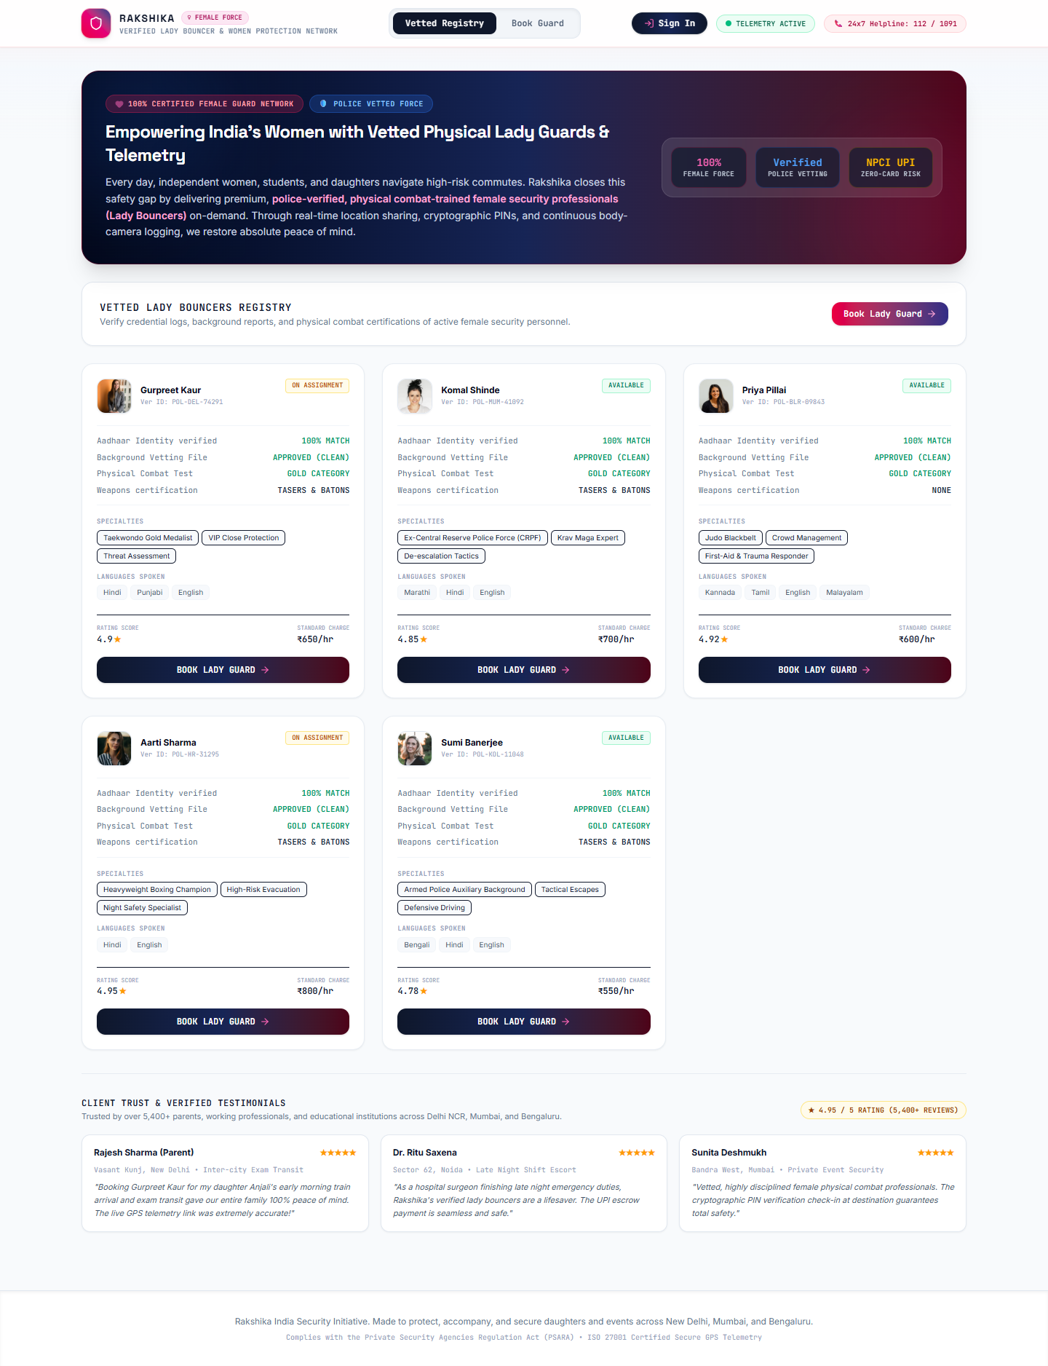
Figure: Module 1 - Police-Verified Lady Escort Registry & Discovery UI

Module 2: Booking Wizard & Cryptographic Escrow Engine
A 4-step wizard supporting scheduling for Inter-City Exam Commutes, Late-Night Corporate Transit, and VIP Crowd Protection with cryptographic handoff verification.
- Service Modes: Hourly Transit, Inter-City Exam Escort, VIP Crowd Escort.
- Cryptographic 4-Digit PIN: Generates a unique 4-digit PIN required for physical guard handoff.
- Escrow Deposit Lock: Holds booking fees in digital escrow until journey completion is verified.
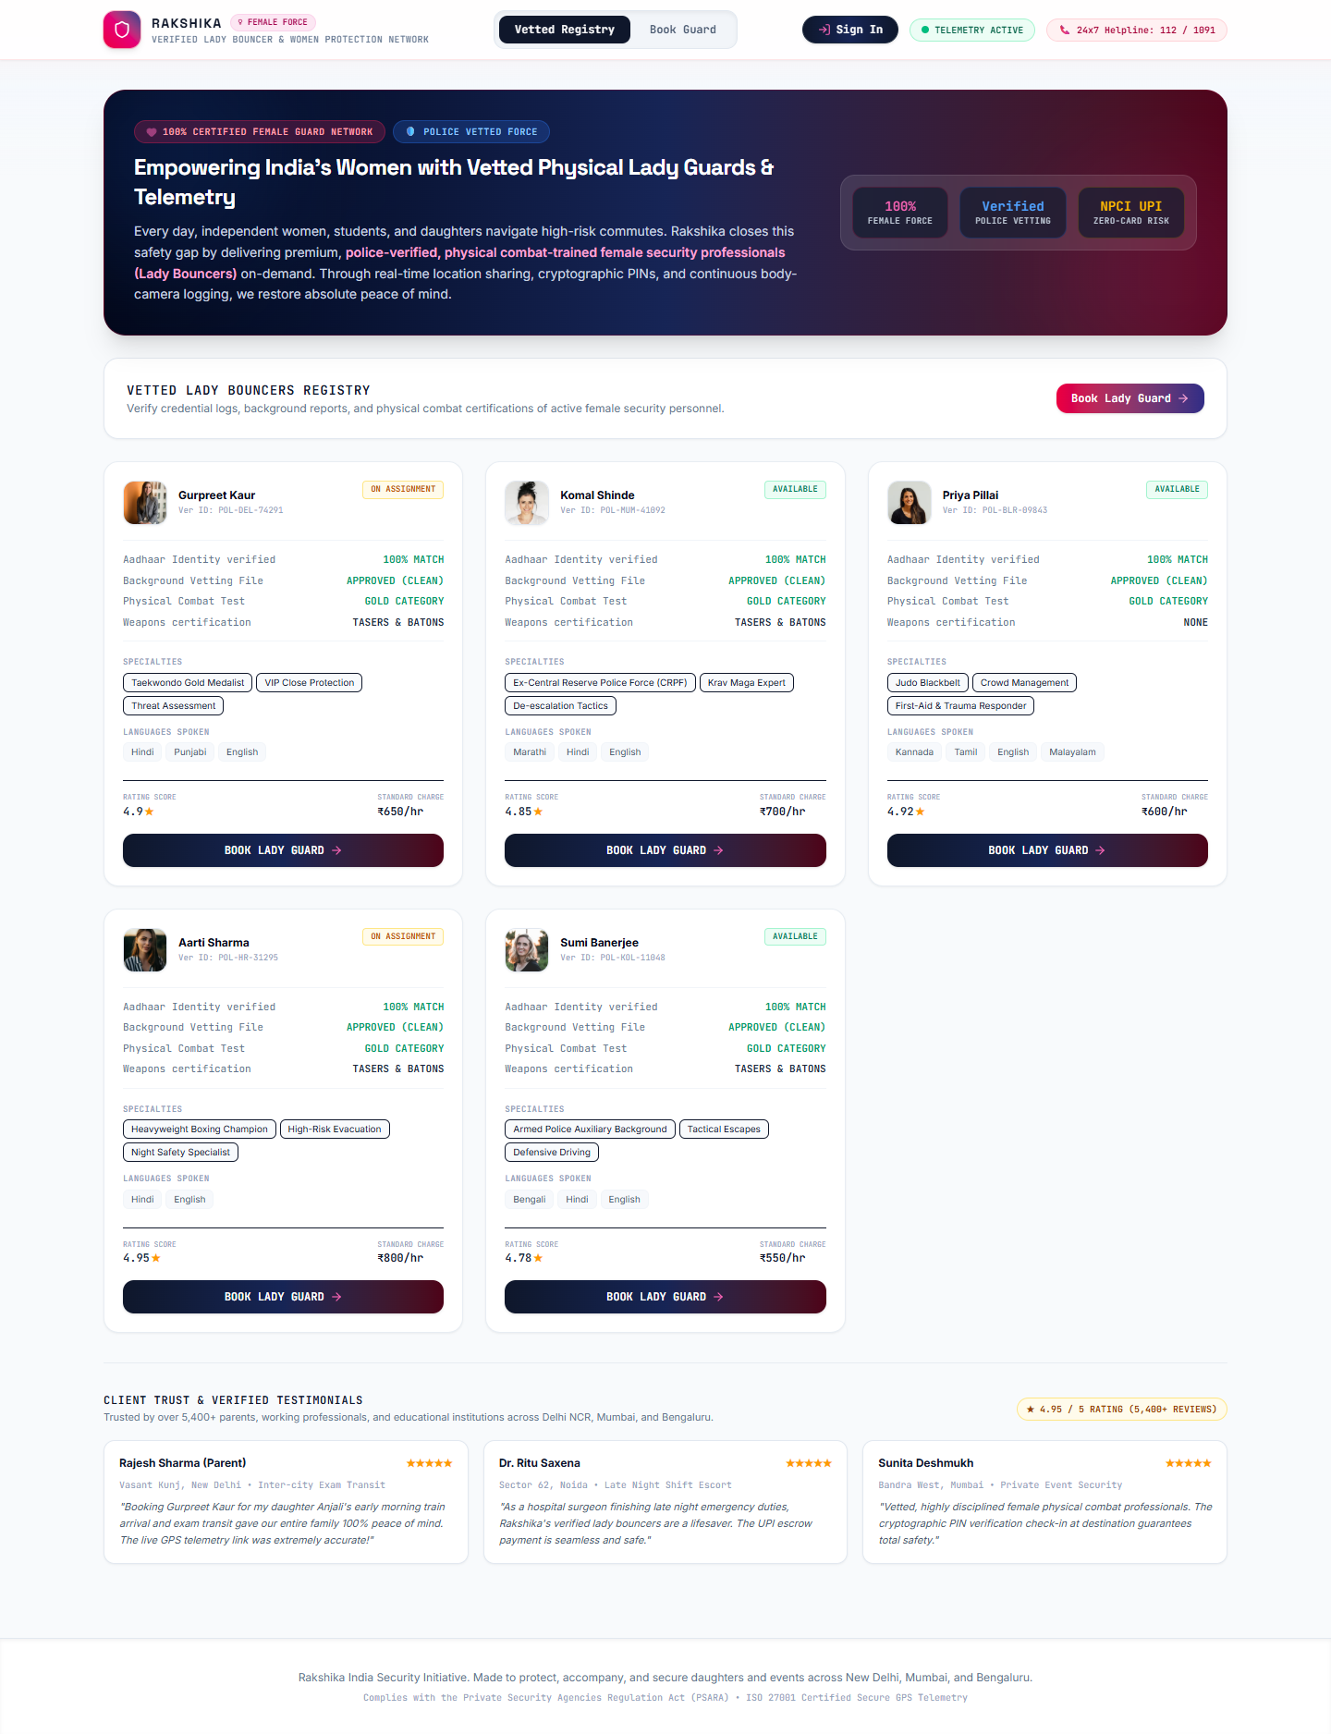
Figure: Module 2 - 4-Step Booking Wizard & 2FA Handoff Security Lock UI

Module 3: Live Telemetry & Escort Tracking Dashboard
Provides real-time route monitoring, vehicle speed telemetry, guard device battery monitoring, 500m geofence alerts, and quick guardian sharing.
- Live Route Monitoring: Sub-second location streaming over WebSockets (Socket.IO).
- Device Health Metrics: Monitors speed, ETA, device battery %, and connection health.
- Instant SOS Trigger: One-swipe panic beacon accessible from all active journey views.
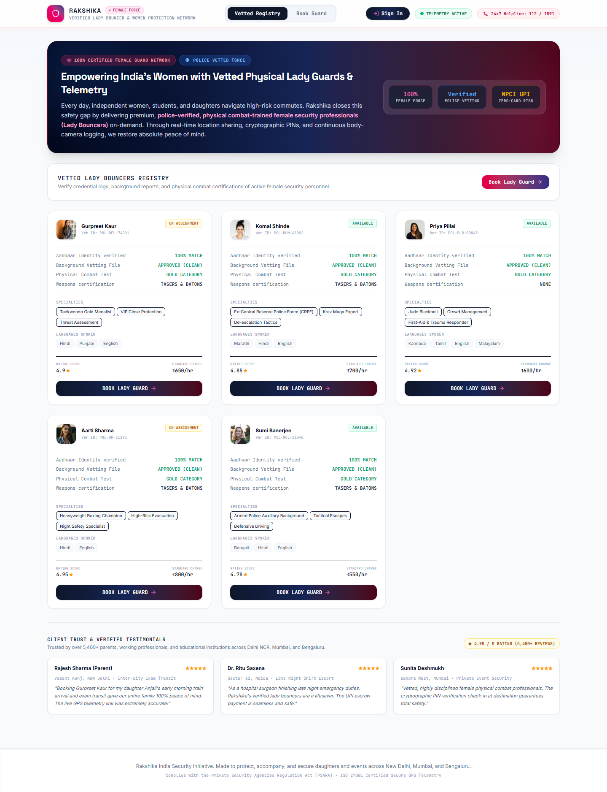
Figure: Module 3 - Real-Time Telemetry & Escort Tracking Dashboard UI

Module 4: PCR Command Center & Telemetry Control Center
Control room interface for police and Rakshika command operators to monitor active distress signals, receive ambient mic audio, and execute device telemetry simulations.
- PCR Emergency Incident Feed: Real-time incident log showing live GPS coordinates and emergency status.
- Ambient Mic Receiver: Automatic audio stream reception upon client SOS panic trigger.
- Telemetry Simulator: Simulates route deviation, rapid battery drain, and signal blackouts.
- Underground BLE Mesh Fallback: Bluetooth RSSI peer-to-peer sensing during cellular loss in subterranean metro corridors.
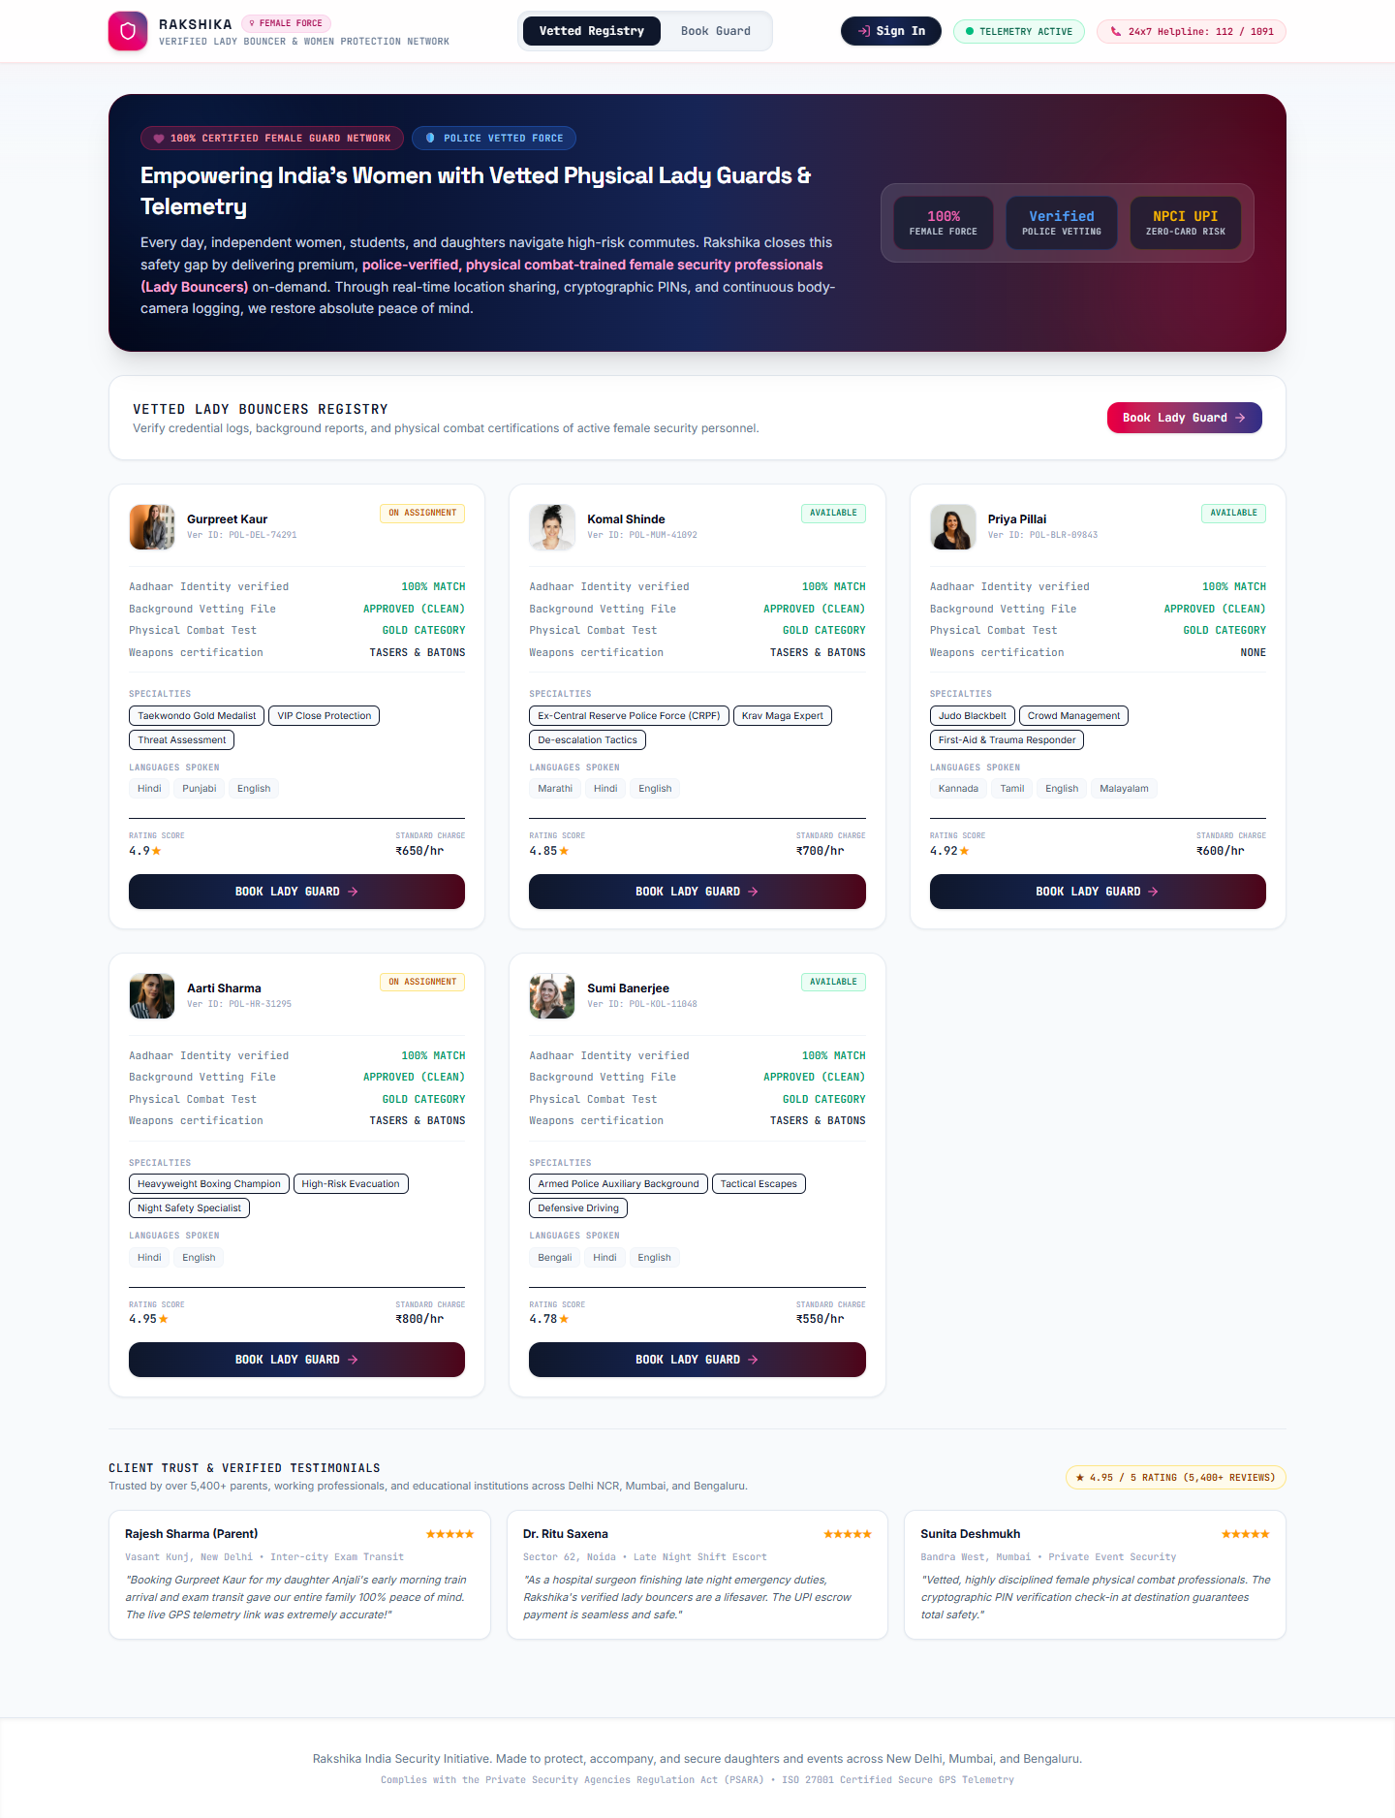
Figure: Module 4 - Police Control Room (PCR) & Telemetry Simulator UI

Module 5: Identity KYC & User Security Profile Hub
Manages client identity verification, emergency contact networks, address shortcuts, and security credentials.
- Aadhaar KYC Verification: Validates 12-digit Aadhaar number and encrypts it using AES-256-CBC at rest.
- Emergency Contact List: Registers family emergency contacts for instant SMS dispatch.
- Saved Location Shortcuts: Pronto/Urban Company style address shortcuts (Home, College, Work).
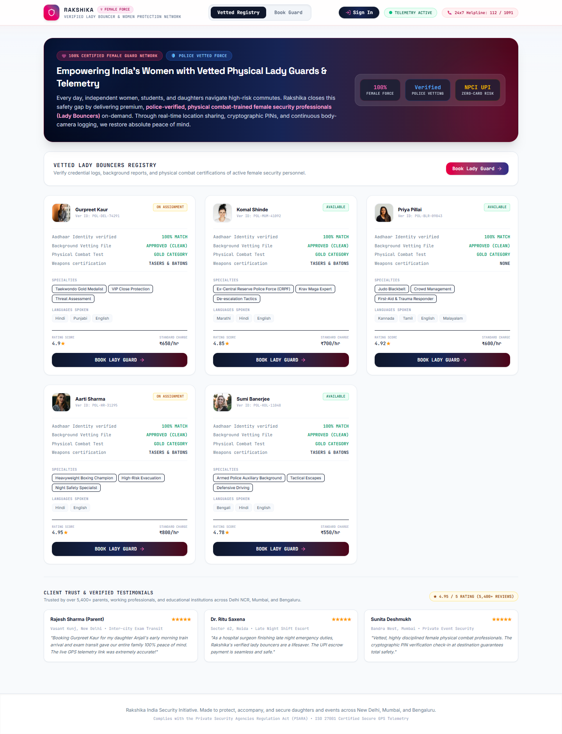
Figure: Module 5 - Identity KYC & User Profile Hub UI

3. Phase 2 & Phase 3 Market-Launch Roadmap & Future Features
To achieve pan-India market dominance and transform women’s physical security, Rakshika will deploy the following advanced Phase 2 & Phase 3 roadmap features:

Future Feature 1: AI Predictive Anomaly & Threat Detection (Gemini & Edge AI)
- Route Anomaly AI: Uses Gemini AI models to compare real-time route trajectory against historical safety heatmaps, flagging unscheduled stops or vehicle deviations within 15 seconds.
- Ambient Audio Keyword Detection: Real-time natural language processing on device audio to detect distress keywords ("Help", "Bachao", screams) and trigger silent PCR dispatch without manual user interaction.
- Biometric & Motion Sensor AI: Analyzes smartphone accelerometer data to detect sudden falls, vehicle impacts, or forced running.

Future Feature 2: Wearable Smart Hardware Integration (Rakshika SOS Band & Ring)
- Smart Wearable Hardware: Pairing with discrete Bluetooth Low Energy (BLE 5.3) wearable rings, smart bracelets, and keychains.
- One-Press Silent Trigger: Allows users to trigger silent emergency panic alerts by pressing a hidden button on their ring or band, without retrieving their phone.
- Biometric Panic Detection: Monitors PPG optical heart-rate sensors for sudden physiological panic spikes (e.g. heart rate jumping from 70 to 150 BPM rapidly).

Future Feature 3: Autonomous Drone Escort & Aerial Surveillance Fleet (Rakshika SkyShield)
- Aerial Drone Escort: Deployment of autonomous tethered and untethered aerial drones for high-risk, unlit transit corridors or campus perimeter escort.
- Thermal Night Vision Feed: Streams thermal IR night vision video directly to the assigned lady guard’s terminal and the local Police Control Room.

Future Feature 4: Pan-India B2B Corporate Enterprise Safety Portal
- Corporate Night Shift Portal: Dedicated enterprise dashboard for IT, BPO, healthcare, and corporate firms (e.g. Infosys, TCS, Wipro, Accenture) to automatically schedule and track late-night female employee drops.
- POSH Compliance & Audit Engine: Generates automated POSH (Prevention of Sexual Harassment) and corporate safety compliance reports for annual audits.

Future Feature 5: Decentralized Escrow Smart Contracts & Micro-Insurance Protocol
- Instant Trip Insurance: Provides automated micro-insurance coverage per transit booking (covering medical emergency & emergency transit expenses).
- UPI 2.0 Auto-Escrow Payout: Automated escrow settlement via UPI 2.0 / smart contract ledgers upon verified geofence drop-off.

Future Feature 6: Campus & University Safety Network (Rakshika Campus Guard)
- University Safety Hubs: Dedicated student safety networks in major education hubs (Kota, Delhi University, Pune, Manipal, Bengaluru).
- Group Escort Pooling: Allows multiple female students returning late from libraries or laboratories to pool a shared lady escort at subsidized student rates.

4. Regulatory Compliance, Legal & Police Integration Blueprint

Data Protection & Regulatory Alignment in India
- DPDP Act 2023 Compliance: Full compliance with India’s Digital Personal Data Protection (DPDP) Act 2023. User data is minimized, consent-gated, and stored in AES-256 encrypted form.
- Aadhaar Act Compliance: Verification aligns with UIDAI Aadhaar offline XML / QR verification without storing plain 12-digit numbers.
- PSARA Licensing Standards: Lady Protection Officers are certified under PSARA guidelines with mandatory police clearance certificates (PCC).

Police Control Room (PCR) Dial 112 API Integration
- State Police Dial 112 Integration: Direct Webhook & REST API connectivity to state police emergency command centers (Delhi Police Dial 112, UP Police 112, Karnataka Namma 112).
- Standard Emergency JSON Payload: When an SOS is activated, Rakshika transmits JSON payloads containing live GPS coordinates, vehicle details, guard phone number, and client emergency profile.

5. Database Schema & Expanded Data Model Reference
Complete Prisma ORM schema incorporating Phase 1 entities and Phase 2/3 future models:
model User {
id String @id @default(uuid())
email String @unique
passwordHash String
fullName String
phone String
kycVerified Boolean @default(false)
aadhaarEncrypted String?
aadhaarIv String?
emergencyContacts EmergencyContact[]
addresses AddressShortcut[]
bookings Booking[]
smartDevices SmartDevice[]
}
model Bouncer {
id String @id @default(uuid())
name String
policeBadgeId String
verified Boolean @default(true)
experienceYears Int
rating Float @default(4.9)
hourlyRate Int
specialization String
languages String
location String
lat Float
lng Float
avatarUrl String
bodyCamStatus String @default("ACTIVE")
bookings Booking[]
}
model Booking {
id String @id @default(uuid())
userId String
bouncerId String
clientName String
type String // hourly_transit, intercity_exam, event_protection
status String @default("CONFIRMED")
date String
timeSlot String
hours Int
pickupLocation String
destinationLocation String
amountPaid Int
escrowStatus String @default("HELD")
securityPin String // 4-digit handoff PIN
createdAt DateTime @default(now())
}
model SmartDevice {
id String @id @default(uuid())
userId String
deviceType String // sos_ring, smart_band, panic_button
macAddress String
batteryLevel Int
status String @default("PAIRED")
}
model CorporateShift {
id String @id @default(uuid())
companyName String
employeeEmail String
shiftDate String
dropLocation String
escrowStatus String @default("CORPORATE_LOCKED")
}

6. Comprehensive Team Development Handoff Matrix
Team Role | Phase 1 Deliverables | Phase 2 & 3 Launch Deliverables
Product Manager | Finalize Phase 1 UI/UX & guard onboarding criteria. | B2B Corporate portal specs & university safety pass offerings.
Mobile Engineers | React Native / Web app, WebSocket location streaming. | BLE 5.3 SDK for Smart Ring pairing & background geolocation.
Backend Engineers | Express REST APIs, Socket.IO server, AES-256 Aadhaar encryption. | Police Dial 112 Webhooks, B2B corporate scheduling, Kafka queue.
AI / ML Team | Geofence anomaly logic & telemetry simulator. | Gemini audio scream detection & route deviation prediction.
Compliance & Legal | Aadhaar KYC privacy policy & user consent terms. | DPDP Act 2023 compliance audit & PSARA guard licensing.

7. System Launch & Verification Commands
Commands to initialize, verify, and launch the complete platform:
- 1. Setup: Install npm packages: npm install
- 2. DB Push: Sync Prisma SQLite DB: cmd /c npx prisma db push
- 3. Launch App: Run Backend + Frontend dev servers: cmd /c npm run dev:all
- 4. Verify Suite: Run 9-Step E2E Verification Suite: cmd /c npx tsx e2e_verification_demo.ts
- 5. Build Docx: Re-generate Word Specification Document: cmd /c npx tsx scripts/create_word_document.js

