**Acknowledgment**

We are highly indebted to all the Technical report-writing professors for their valuable guidance and encouragement.

We are also grateful for their advice regarding survey techniques and analysis.

We also express gratitude to our IC, Professor Mohan Kumar Bera, for his support and time to get acquainted with important structures of report writing.

Last but not least, we would like to express our immense gratitude to our peers and mentors, who have been the constant pillars of support during the preparation of this report.

**Chapter 1: Introduction**

Climate-induced disasters create problems for communities worldwide while aggravating pre-existing vulnerabilities caused by relentless corruption, exploitation, inequality and lack of resources. Poverty and inequality require radical reduction, requiring adaptive strategies for resilience and economic prosperity, which is essential to develop. Social, political and economic problems are important factors in a comprehensive approach to economic problems. Besides the need to better understand the underlying drivers of vulnerability, complex interactions with climate change, natural disasters, and sociopolitical developments reveal disproportionate impacts on marginalized communities and sociopolitical aspects of recovery outcomes.

***Background***

Vulnerable populations face an increasing risk of climate-induced hazards, especially in coastal areas such as the Solomon Islands (Vaike & Salili, 2020) Risk increases due to sea level rise and climate due to extreme weather occurences. The variety of recovery outcomes following disasters highlights the important role of socioeconomic variables in determining resilience.

***Research problem***

The main theme is "the impact of socioeconomic differences on differential recovery outcomes for rural and urban residents following climate disasters." This is due to the need to better understand the challenges rural residents face in recovery compared to their urban counterparts

***Rationale***

This research project addresses a gap in the literature by examining the complex socio-economic variables that lead to various developments. Understanding such nuances is important for focused treatment, reducing socioeconomic disparities during post-disaster recovery.

***Objective***

The main objective of this study is to systematically examine how socioeconomic differences affect how communities recover from climate change-induced disasters. Strong data analysis methods and current literature seek to provide variables that determine community response and reconstruction in the face of climate-induced disasters, and recovery planning will be situated in the macro socio-economic context

**Chapter 2: Issue Identification**

***Overview of Climate-Induced Disasters***

Extreme weather, floods, hurricanes, droughts, and other natural disasters are increasing and pose risks around the globe that cut across nations The physical effects of these disasters are worsened by climate change, leading to a lack of communities further threatens security, ecosystems and economies worldwide

Coastal communities affected by climate change, necessitate adaptation strategies. Given the central role of local knowledge in providing effective responses to environmental problems, it emphasizes the importance of understanding the local environment and the importance of community involvement in decision-making processes (---Solomon Islands) emphasis.

According to the UNFCCC, defining losses and damages is essential to quantify, identify and manage climate-related risk and this is particularly important given the frequency of these risks and stronger in the world. Some mitigation of loss and damage requires complex strategies that take into account the diverse perspectives of affected communities—especially those already socioeconomically disadvantaged—(---UNFCCC).

Policies that recognize adaptation and mitigation must be implemented as mandatory efforts in creating comprehensive responses to climate change. These specify growing requirements in socially vulnerable regions as they are well aligned with establishing sustainable resilience.

The concept of local adaptation prioritizes the knowledge and priorities of local communities, as they are often the most vulnerable and affected by the consequences of climate change This concept implies that successful transformation requires detailed planning to align with the specific constraints faced by communities.

Building resilience requires a comprehensive approach. This includes investments in infrastructure, social security, early warning systems and mitigation measures. The implementation of such measures is necessary to enhance disaster preparedness and capacity, thereby controlling multiple interdependencies in climate-related risk intensifying mitigation (---building resilience and reducing risks).

As one article suggests, measuring growth via a gender lens is critical to reflecting the numerous reviews, wishes, and alternatives of men and women. Particular information of the socioeconomic disparities following weather-brought catastrophes is made viable by using gender-sensitive signs and techniques (Adaptation and Measuring Development via a Gender Lens).

Recovery solutions have a real-world context thanks to the state of affairs in Bangladesh. The aforementioned pillars, particularly fitness, livelihoods, resilience, and transformation, highlight the necessity of adopting a comprehensive strategy that not only tackles urgent troubles but additionally establishes the foundation for equitable, sustainable, and lengthy-term development (---Short Overview of the Situation in Bangladesh).

As discussed in different piece, comprehending the susceptibility of coastal groups highlights the necessity of an incorporated framework that takes into account both the biophysical and human factors. Understanding the susceptibility of Coastal Communities permits the identity of adaptive capability factors and answers, which are important in lowering susceptibility and boosting resilience.

The intersection of financial, social, and cultural rights with weather trade poses a widespread assignment to financial development inside the Asia-Pacific area. To correctly address those challenges, complete methods grounded in human rights ideas that prioritize both edition and mitigation are essential (Economic, Social, and Cultural Rights and Climate Change).

Shifting the focal point, the difficulty profits a brand new attitude while examining the vulnerability of metropolitan regions to climate change. Acknowledging the distinct challenges faced through city residents turns into vital in formulating inclusive guidelines that bridge socioeconomic gaps and ensure equitable recuperation effects (Climate Change, Vulnerability, and Adaptation in Urban Areas).

In summarizing those articles, it will become evident that the complexities springing up from weather-related disasters demand a holistic and interconnected strategy. Addressing various groups' unique circumstances, socioeconomic disparities, and ranging influences necessitates collaborative efforts, inclusivity, and a steadfast dedication to building a more sustainable and resilient destiny for all.

***Identification of Socio-Economic Disparities***

In conclusion, the evidence from various sources underscores the urgent need to address the widening rich-poor disparity exacerbated by climate change. Concrete steps, regulatory changes, and collective efforts are essential to build more equitable communities while effectively tackling the challenges posed by climate-induced disasters. The interconnectedness of socioeconomic factors and climate impacts necessitates a comprehensive and inclusive approach to ensure that no one is left behind in the pursuit of a sustainable and resilient future.

**Chapter 3: Literature Review**

The literature review emphasizes how essential it is that policies integrate mitigation and adaptation techniques in a cohesive way, acknowledging their mutually advantageous relationship. Tackling the intricate problems brought on by climate change requires a comprehensive approach. Scalable policies may be carefully developed to support a comprehensive approach to resilience development by recognizing adaptation and mitigation as complementary undertakings (Locatelli, 2011). This acknowledges the interconnectedness of mitigation and adaptation initiatives and lays the groundwork for a nuanced analysis of interrelated solutions.

Building upon this basis, the encouragement for locally-led adaptation tactics is in line with the overall research issue, emphasizing the need to consider local settings when addressing socioeconomic differences in recovery results (Vaike & Salili, 2020). This provides a useful perspective on the dynamics of community-driven resilience and promises an in-depth analysis of the advantages and limitations present in locally-led adaptation solutions.

Understanding vulnerability and recovery outcomes is further complicated by turning attention to the topic of adaptation to the gender viewpoint. Fisher (2014) highlights the importance of gender-sensitive indicators and approaches in capturing the varying experiences of different gender groups following climate-related disasters.Our forthcoming analysis of socioeconomic disparities gains depth from this crucial approach, which acknowledges that a thorough understanding must be taken into consideration the distinct implications on different gender groups.

The contextual lens improves the understanding of the intricacies involved in recovering from climate-related disasters by using real-world examples. The suggested recovery strategy highlights resilience, transformation, livelihoods, and health, highlighting the multifaceted nature of recovery activities (Golub, 2016). This contextual case study will enhance our understanding of the disparate results between rural and urban populations by providing a useful real-world perspective. It highlights the necessity of flexible rehabilitation plans adapted to the unique difficulties encountered by various communities.

The analysis of socioeconomic inequalities is based on a systematic framework for understanding the vulnerability of coastal communities. This approach helps identify adaptive capacity drivers and solutions to minimize vulnerability by taking institutional, social, physical, and economic factors into account (Dolan et al.; I. J., 2006). It supports the idea that tackling the multitude of factors involved in disasters resulting from climate change requires an intelligent and all-encompassing strategy.

In summary, this synthesis of articles forms a cohesive narrative that underscores the interconnectedness of various aspects in addressing climate change challenges. Each piece contributes to a holistic understanding, from the integrated policies to the locally driven strategies and the gender-sensitive lens. The real-world context and the structured framework further enrich the discourse, paving the way for a comprehensive analysis of socio-economic disparities and recovery outcomes in the face of climate-induced disasters.

**Chapter 4: Data Analysis**

***Methodology:***

***Analysis of Socio-Economic Data***

Socioeconomic data is provided and examined in this way of analysis in order to find trends and connections with the results of recovery. The objective is to identify the socioeconomic variables that have a significant impact on the resilience and recovery of both rural and urban communities by looking at income levels, access to opportunities for education, and opportunities for employment.

***Comparison of Rural and Urban Recovery Outcomes***

Evaluation of recovery results between rural and urban locations based on the data analysis. Comprehending the differences in the paths of recovery will illuminate the significance of socioeconomic elements and assist in pinpointing particular obstacles that each group encounters.

***Identification of Factors Influencing Recovery***

There will be a thorough investigation of the variables affecting rehabilitation, such as social support systems, resource accessibility, and governmental initiatives. This study will link theories to actual recovery experiences by utilizing findings from the literature research.

***Findings:***

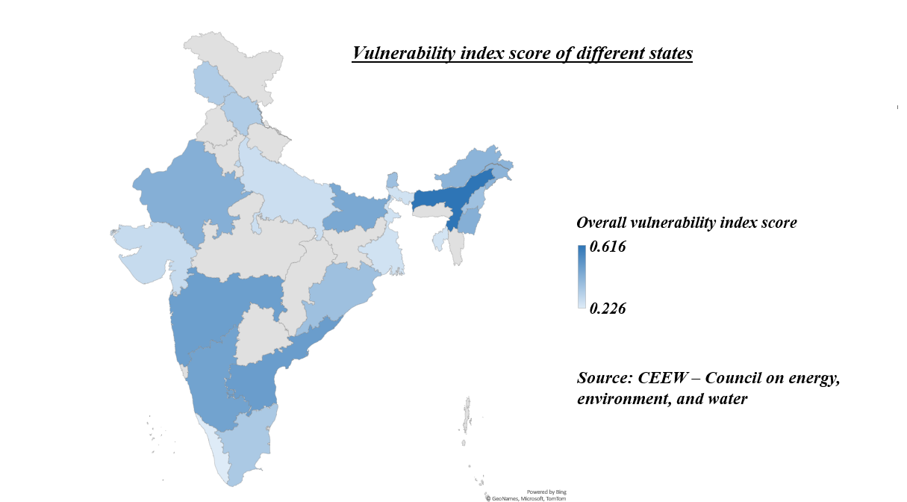

The pattern of extreme events is found to be changing across regions and more than 40 percent of Indian districts exhibit a swapping trend as is evident from the above Indian map. There is a clear color contrast across different states along the length and the breadth of the country which indirectly necessitates the need to tackle these complex, varying patterns with concerted risk mitigation strategies at the sub-national level. The above analysis suggests that the CVIs (Climate Vulnerability Index) of Assam, Andhra Pradesh, Maharashtra, Karnataka, and Bihar are in the high range (The above five states being the dark-shaded states on the map) making them the five most vulnerable states in India. This asserts that adaptive capacity and the district’s climate vulnerability depend upon a complex nexus of a wide set of socio-economic indicators such as population density, GDDP (Gross district domestic product), literacy ratio, sex ratio, availability and accessibility of shelters, and robustness of district disaster management plans (DDMP’S). The above Indian map also discloses that more than 27 out of 35 states and Union territories combined as a whole are highly vulnerable to disasters and compounding impacts. The analysis is not only on par with the drought, flood, and cyclone-prone regions of the country but also with the financial inequalities spread over India.

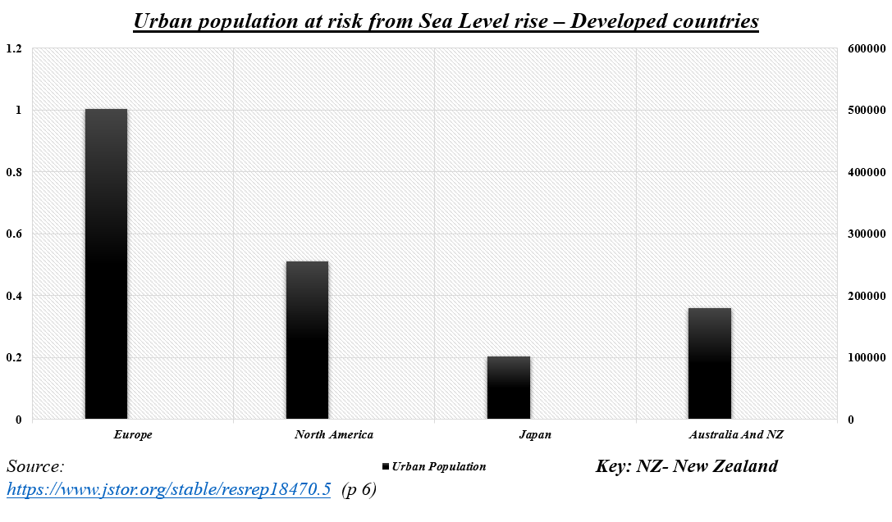

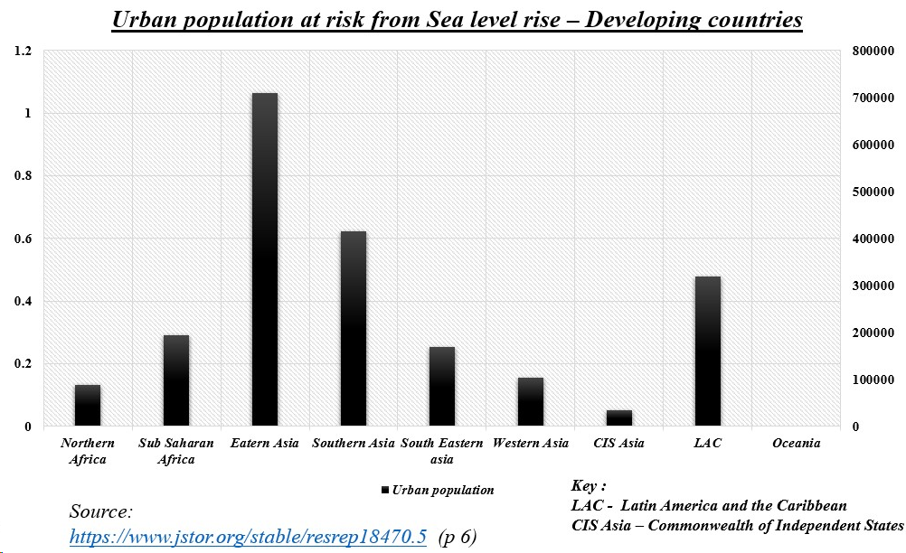

The above two graphs draw a striking difference in the urban population at risk from the sea level rise between developed and developing countries. Developed countries depict a comparatively low number of populations under threat as to developing countries, a fact which is inevitably in line with the conclusions drawn from the report. The above survey published in the UN-Habitat, 2008 states that about 2,034,706 people of the urban developing countries and 876, 627 people of the urban developed countries are vulnerable. The number count skyrockets substantially if the rural developing population and the rural developed population are to be contrasted. The data also reveals that the settlements in deltas and coastal areas in low- and middle-income countries, essentially the developing countries, are likely to suffer greater impacts due to cumulative environmental stress, weak infrastructure, lack of urban development characteristics, and economic constraints to adaptation planning. In a nutshell, this data unveils that urban developing populations are at greater risk due to inadequate infrastructure, limited resources, and population density, exacerbating vulnerabilities than the developed ones. Moreover, rural populations face heightened danger with reliance on agriculture, exposure to extreme weather, and limited access to adaptive measures, intensifying climate change impacts.

Climate change hazards in any geographical region will lead to stress on infrastructure and threaten livelihoods, especially for vulnerable groups. As a whole, the threats and impacts of climate change differ according to the geographic location and features, as well as the quality of urban development. A given city’s degree of risk depends on a number of characteristics, including but not limited to its proximity to the sea, topography, and physical attributes, as well as social and institutional factors.populations are at greater risk due to inadequate infrastructure, limited resources, and population density, exacerbating vulnerabilities than the developed ones. Moreover, rural populations face heightened danger with reliance on agriculture, exposure to extreme weather, and limited access to adaptive measures, intensifying climate change impacts.

**Chapter 5: Discussion and Recommendations**

***Policy Recommendations***

This section will provide specific policy suggestions based on the study. By addressing the noted socioeconomic gaps, these suggestions hope to build a disaster recovery framework that is more inclusive and equitable.

***Community-Based Interventions***

Suggesting community-based interventions tailored to the unique needs of rural and urban populations is essential. This section will explore strategies that empower communities to actively participate in their recovery, leveraging local knowledge and resources.

***Integration of Gender-Sensitive Approaches***

Given the importance of gender-sensitive approaches highlighted in the literature, recommendations will emphasize incorporating gender perspectives into policy and intervention design. This ensures a more nuanced and effective response to the differential needs of women and men.

***Future Research Directions***

* Planning Suggestions:

This phase proposes particular rules based at the studies to address socioeconomic disparities and develop inclusive catastrophe restoration plans.

* Community-primarily based interventions:

It is vital to advocate network-based interventions tailor-made to the precise wishes of rural and concrete populations. This section will discover approaches to enable communities to actively take part in restoration by means of drawing on local information and assets.

* Integrating gender-unique strategies:

Given the importance of gender-sensitive views, the hints would emphasize integrating gender views into policy and intervention layout for nuanced responses and powerful for the unique needs of ladies and men.

* Future studies instructions:

Future studies is wanted to boost our understanding of the complex interplay between socioeconomic inequality and recovery outcomes. Ideas for future research consist of:

* Long-time period effect analysis:

Examine the catastrophe influences of weather-caused failures in rural and urban regions, and spot how socioeconomic variations maintain to have an effect on recuperation over the years.

* Comparative analysis throughout industries:

Comparatively have a look at healing results throughout geographic regions, examining how socioeconomic factors interact with neighborhood contexts, governance systems, and cultural affects.

* Community Based Resilience Building:

Examine the effectiveness of network building resilience and spot how empowering groups in their restoration can lessen socioeconomic disparities and growth ordinary resilience.

* System Management and Effectiveness:

Examine the implementation of existing rules on socioeconomic disparities in healing , testing its effectiveness and identifying potential barriers to successful implementation.

* The active insecurity:

Examine the evolution of the socioeconomically strong over time, assess the dynamics of the weak and explore ways to deal with changing circumstances during periods of recovery . . . .

* The role of technology in recovery:

Examine the role of technology in bridging socioeconomic gaps during recovery, examining how new technologies and data-driven approaches can increase access to resources and support for rural and urban communities . . . .

* Participatory Action Research:

Using participatory research methods to engage communities directly in the research process, thereby providing nuanced insights into the socio-economic factors that affect outcomes the results of relief.

* Weather displacement and resettlement:

Analyze the socio-economic consequences of climate-induced displacement and resettlement, and explore how different types of migration contribute to or reduce socio-economic disparities in well-being.

* Interdisciplinary Approaches:

Encourage interdisciplinary research that integrates insights from environmental science, sociology, economics, and other fields for a more complete understanding of complex relationships.

* A comparative study of urban growth models:

Examine the impact of urban development models on rehabilitation outcomes, and compare experiences in accelerating urbanization with those adopting sustainable urban development strategies and includes everyone.

* Examples of governance included:

Examine the role of governance models in addressing socioeconomic inequalities and how inclusive, participatory governance structures contribute to equitable development.

* Psychosocial factors of recovery:

Examine the psychosocial dimensions of healing, thinking about the mental health impact of climate-precipitated disasters and investigating how socio-monetary factors impact psychological resilience during the recuperation method.

**Conclusion**

In conclusion, this comprehensive exploration serves as a foundation for comprehending the varied recovery outcomes and illuminates the intricacies involved in the aftermath of climate-induced disasters. It lays the groundwork for an in-depth investigation into the nuanced interplay between socioeconomic factors and recovery trajectories. By delving into the complexities of how different communities navigate and respond to the challenges posed by climate change, this exploration paves the way for a more holistic understanding of the factors influencing recovery in the post-disaster landscape. The stage is set for a thorough examination that considers the multifaceted nature of socioeconomic dynamics in shaping resilient and equitable recovery processes.