**Maven Project**

1.Start with Eclipse IDE

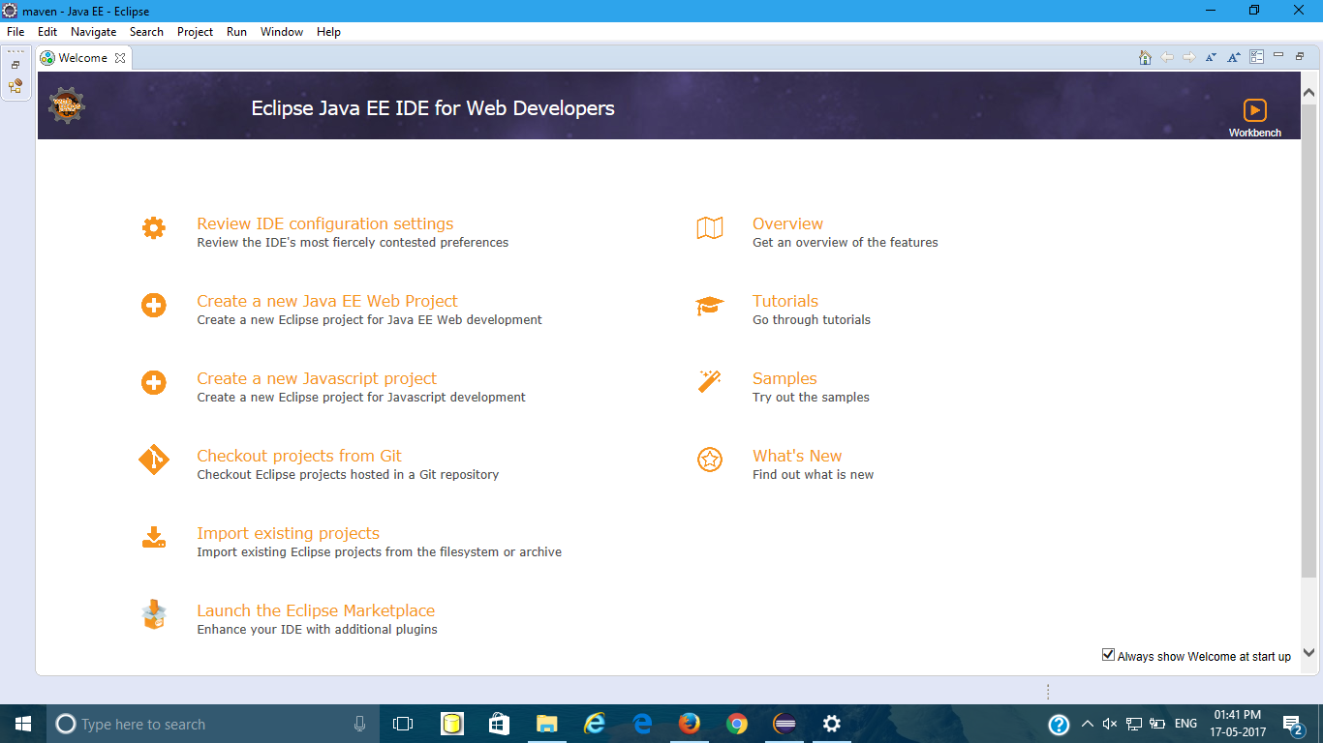

2.Select file🡪New🡪Maven Project.

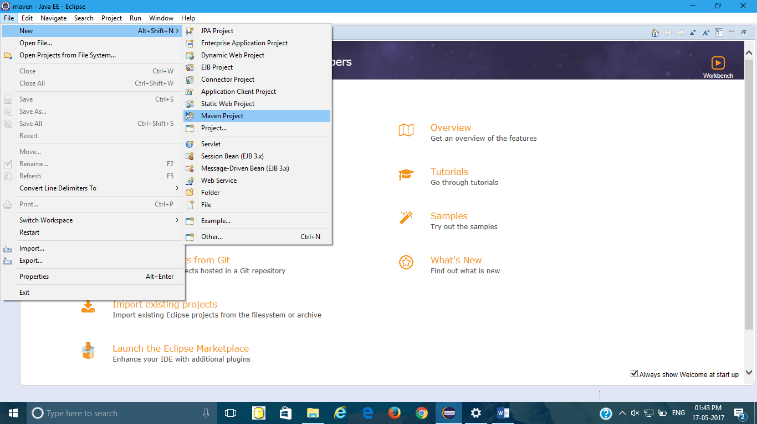

3.Select Next

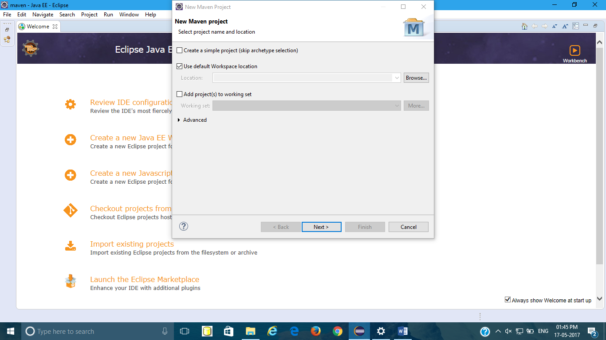

4.Select An archetype which contains a sample Maven Webapp project and click on Next. 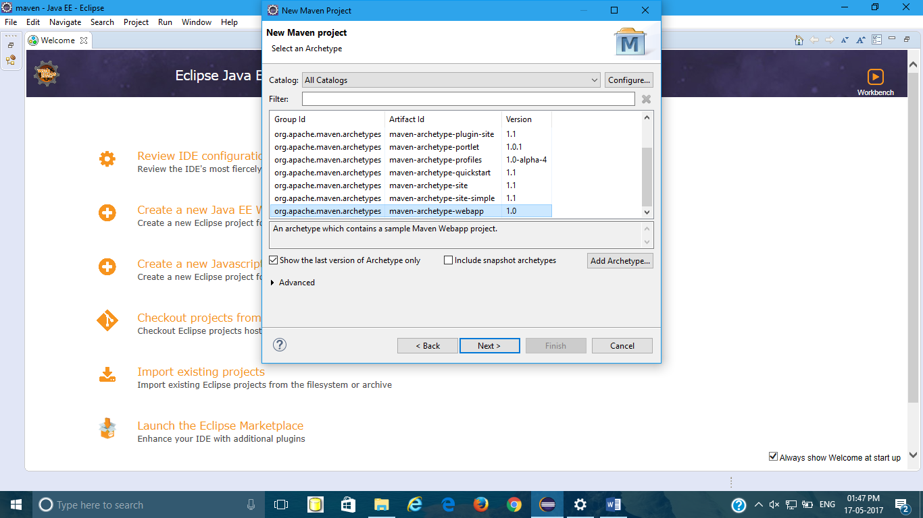

5.Enter groupId,artifact id and version and select finish.

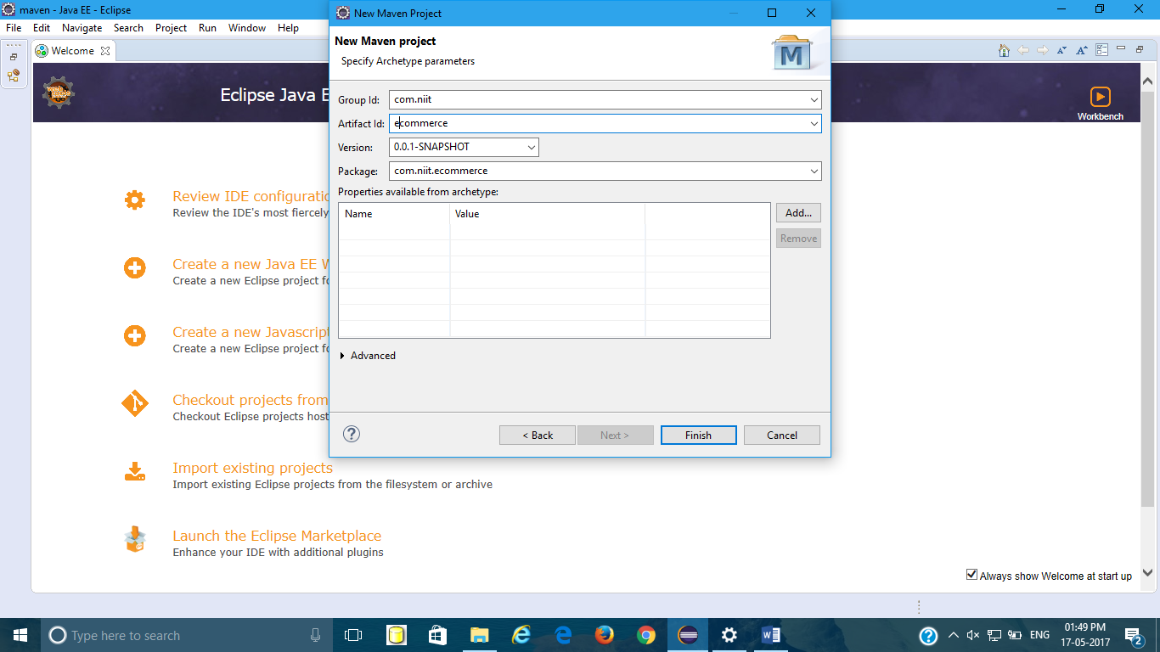

6.Then you can see your project like this in Project Explorer.

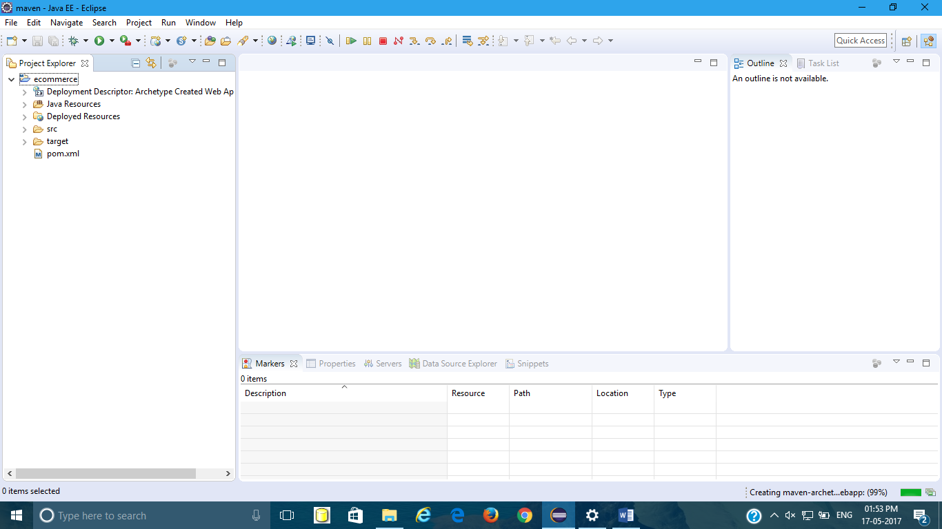

7.Adding tomcat server to project

Windows🡪preferences🡪server🡪Runtime Environment🡪Add🡪Apache tomcat 8🡪Next🡪browse tomcat folder🡪Finish

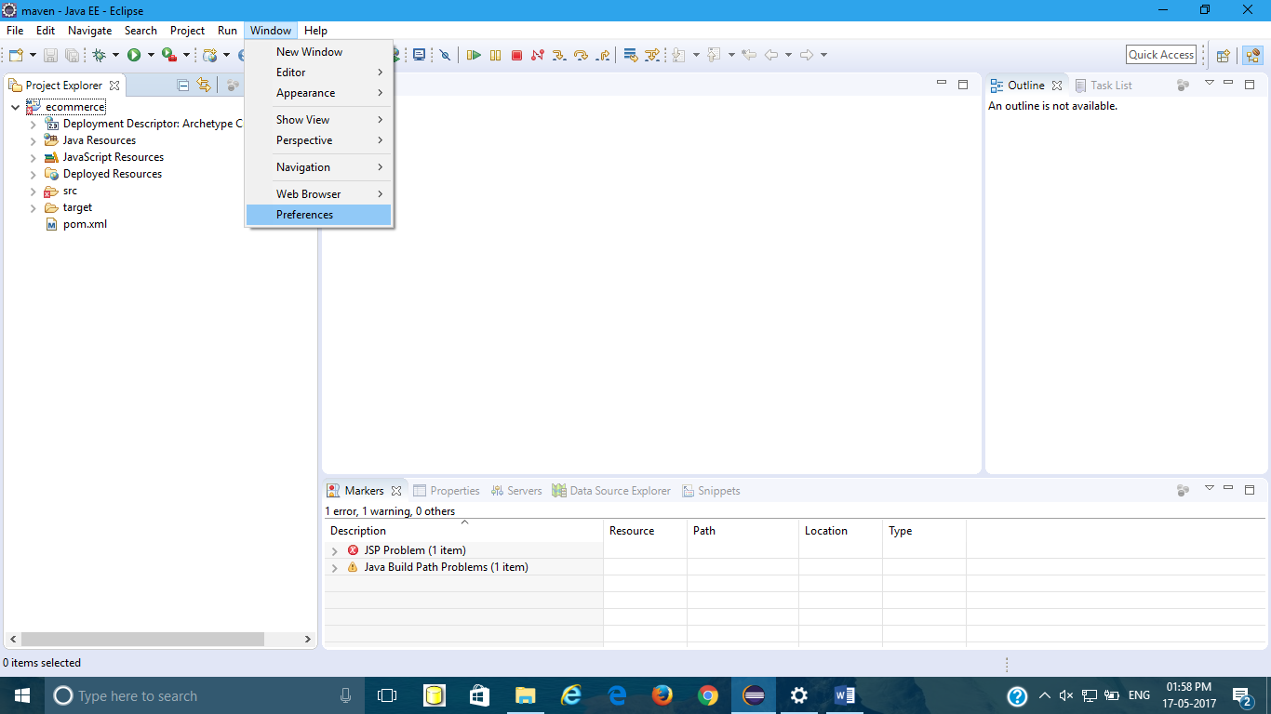

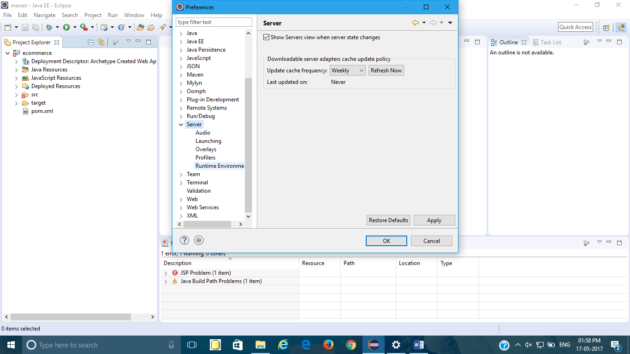

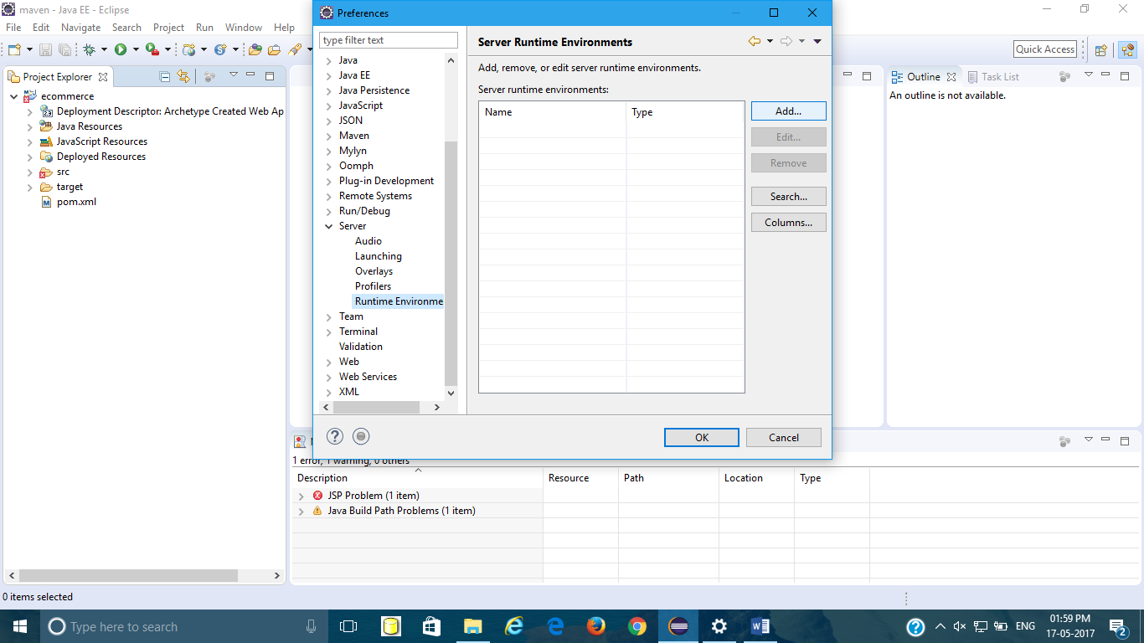

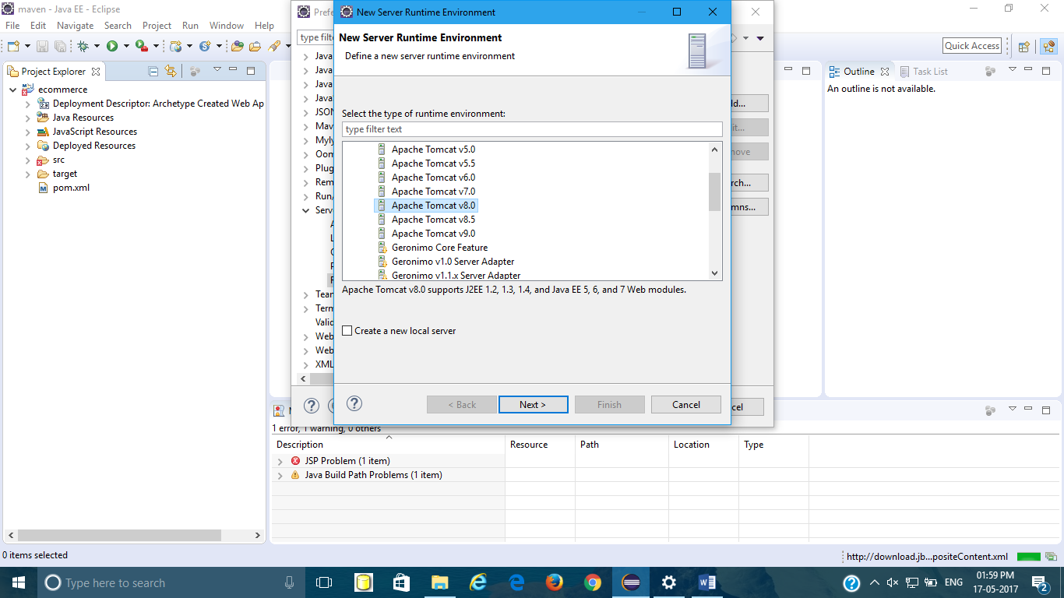

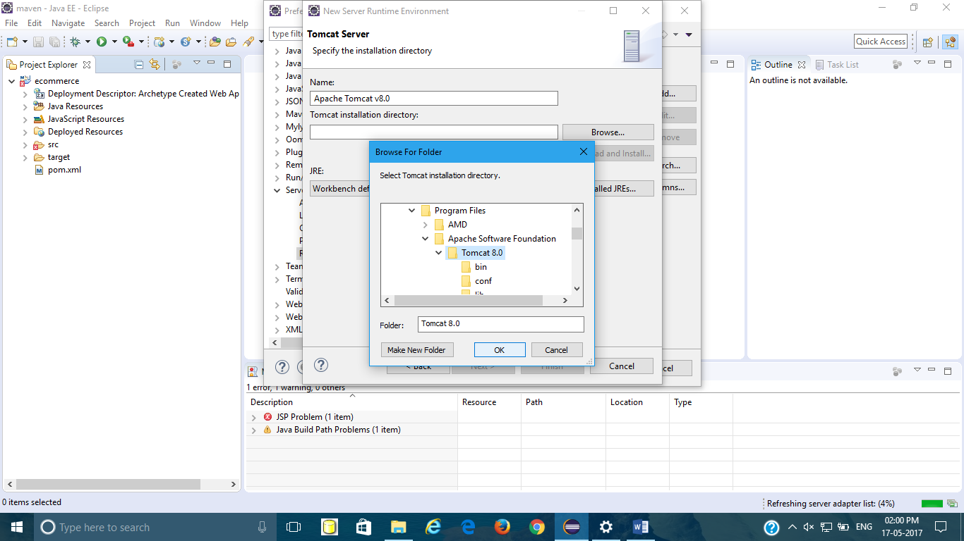

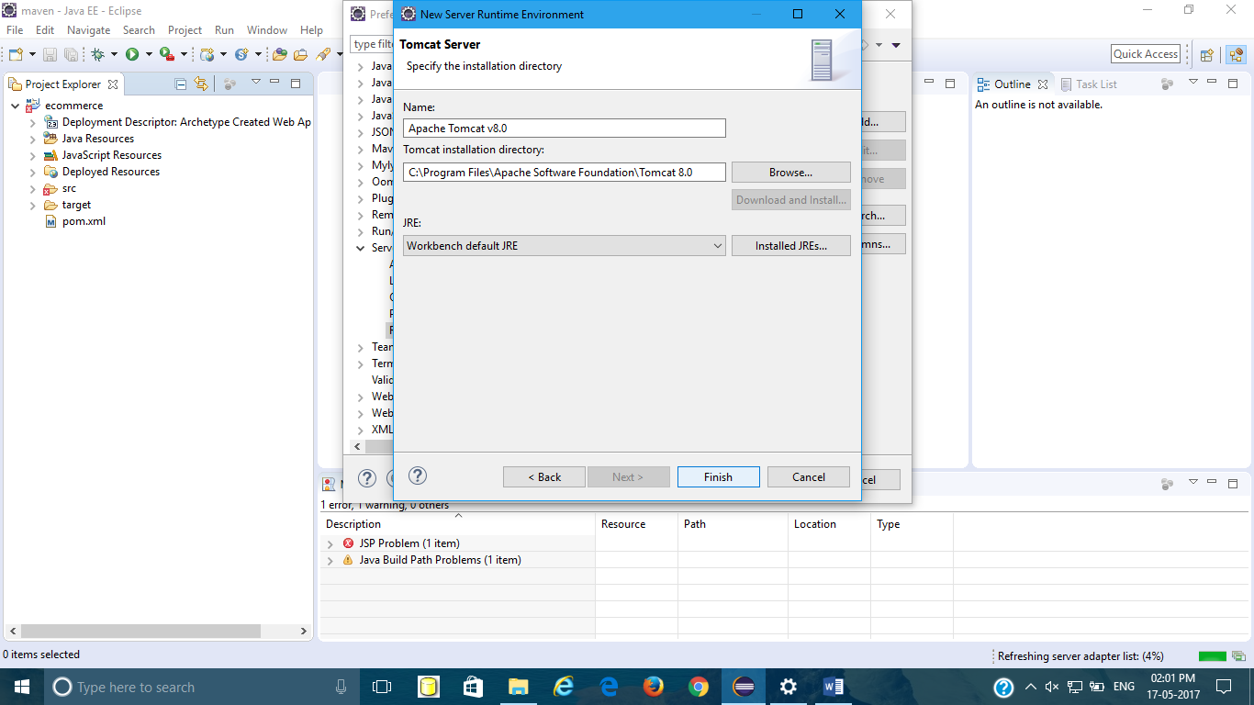

Add server as shown🡪click this to create a new server🡪tomcat8🡪Finish

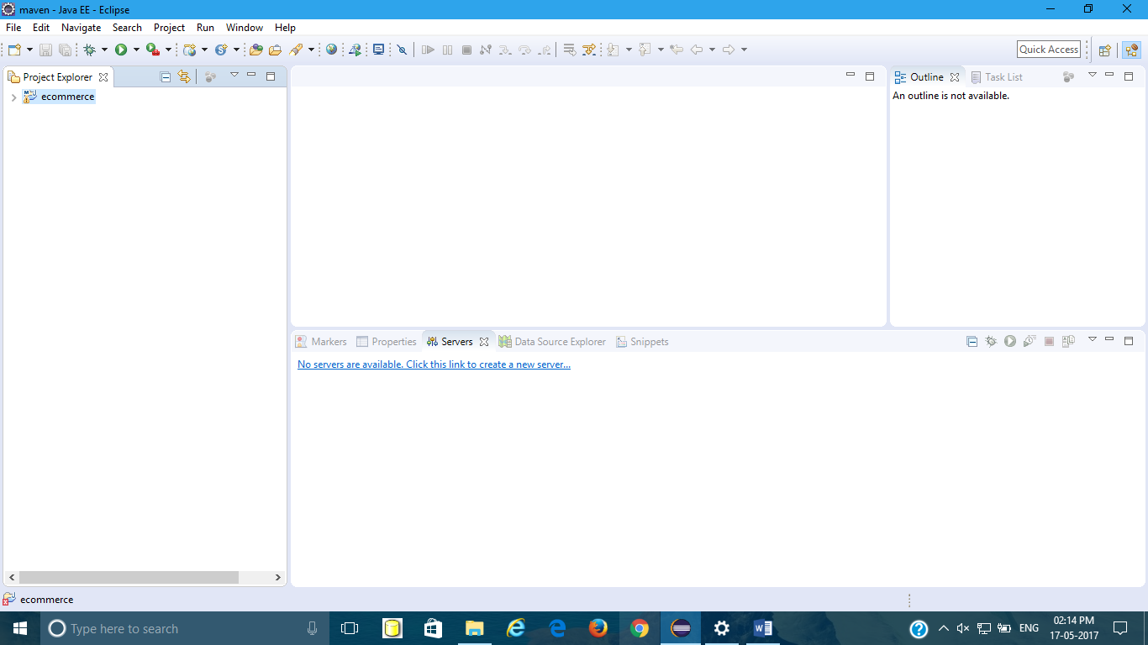

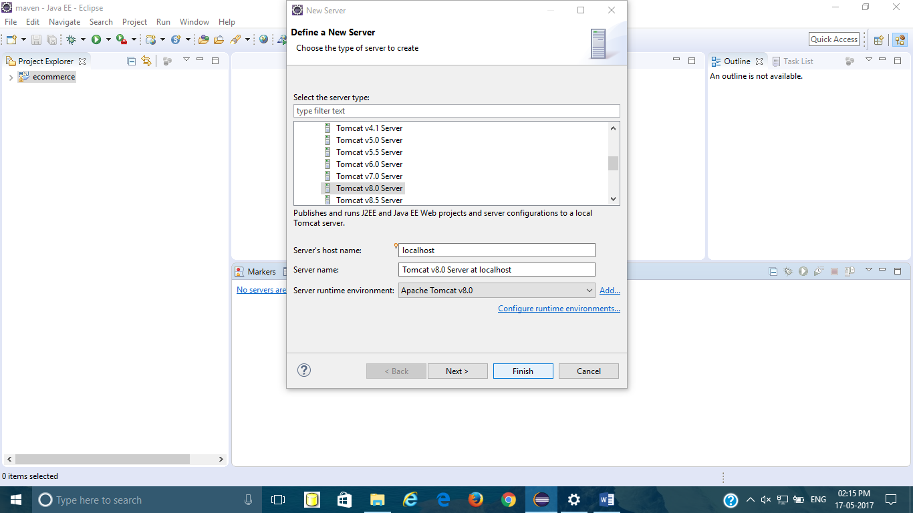

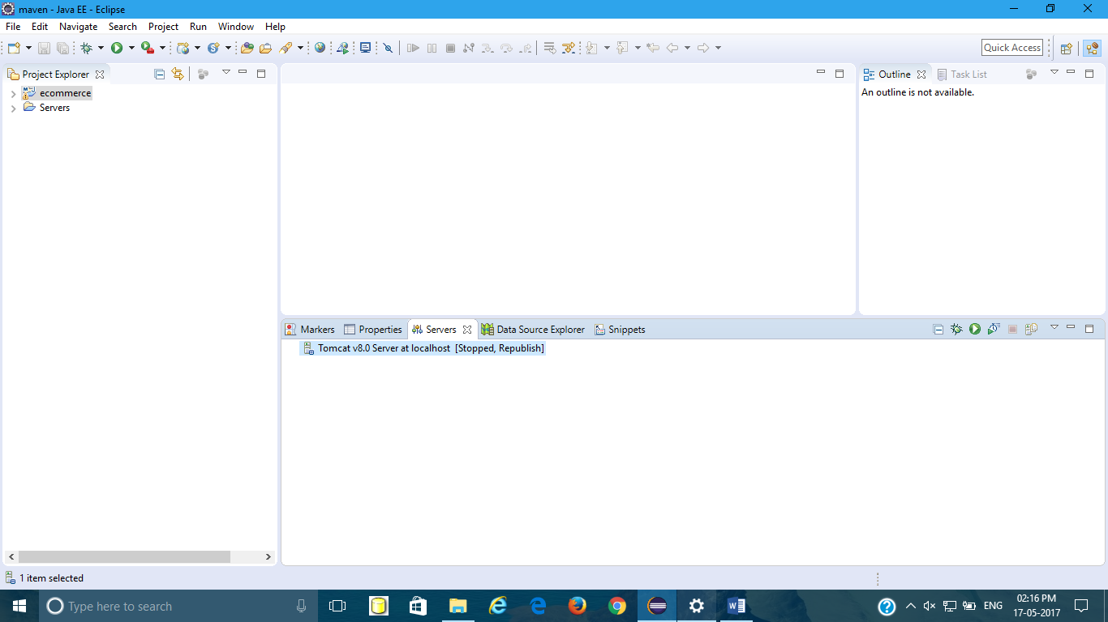

8.Adding JDK

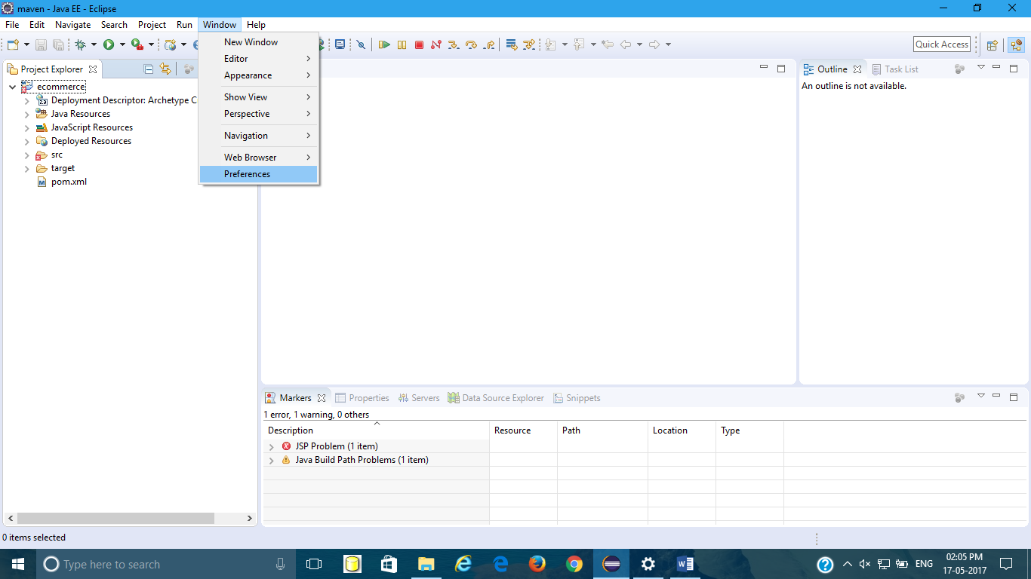

Preferences🡪Java🡪Installed JREs🡪Double click on Shown Part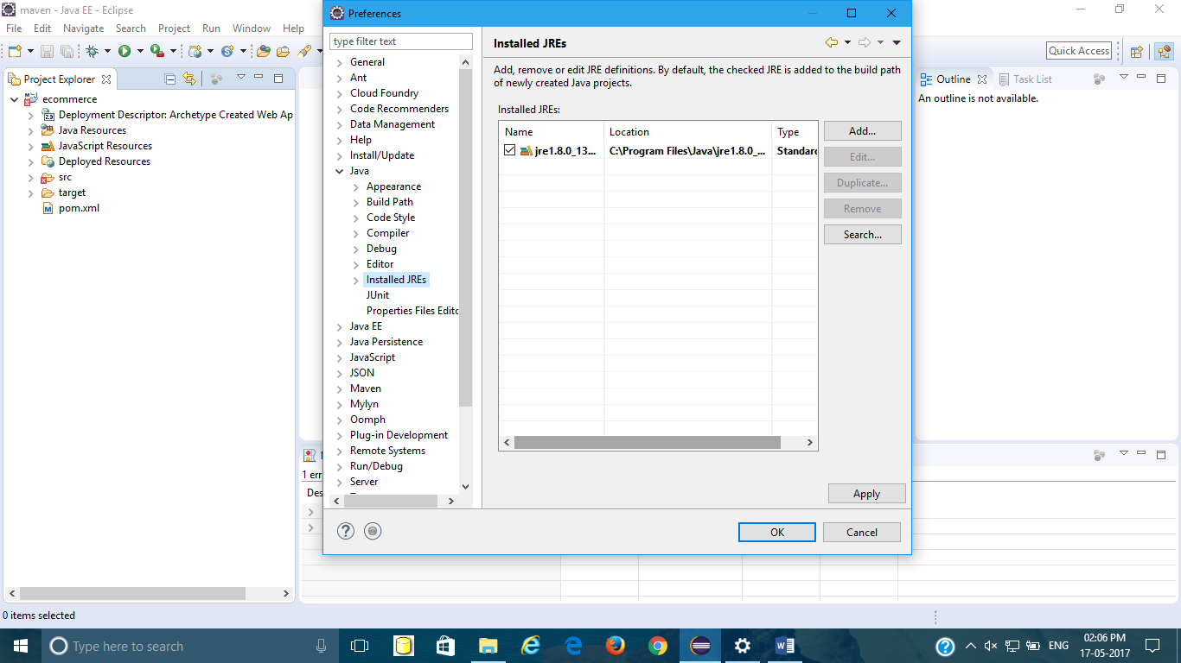

Directory🡪Browse your jdk folder🡪finish🡪Apply🡪Ok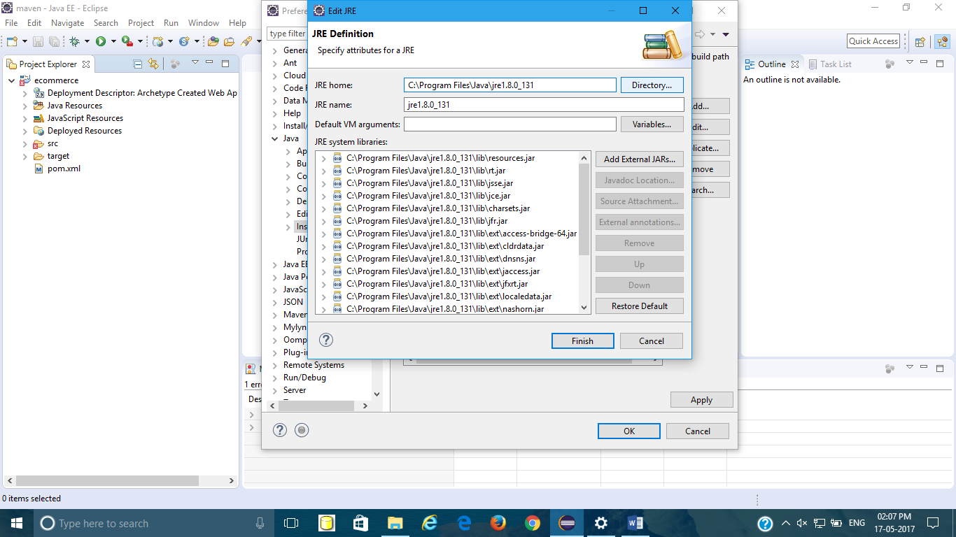

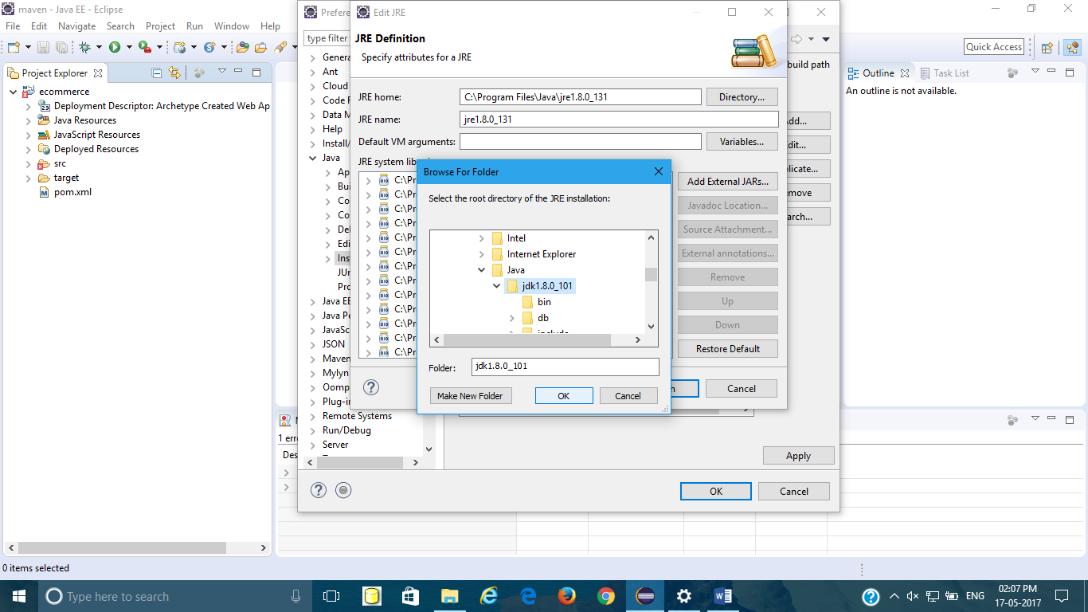

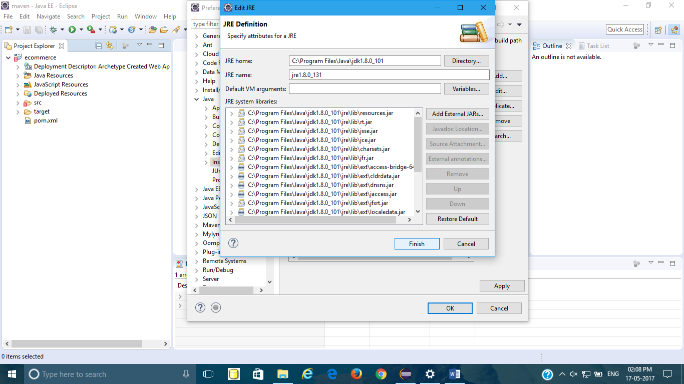

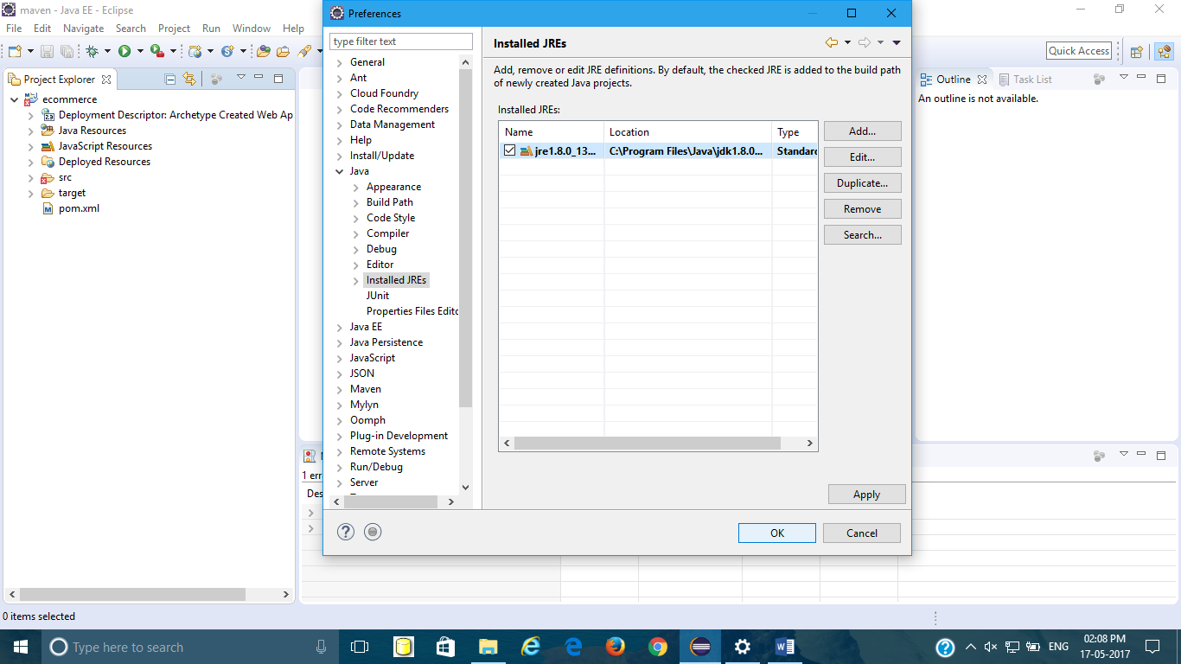

9.Inorder to rectify following Error

Description Resource Path Location Type

The superclass "javax.servlet.http.HttpServlet" was not found on the Java Build Path index.jsp /ecommerce/src/main/webapp line 1 JSP Problem

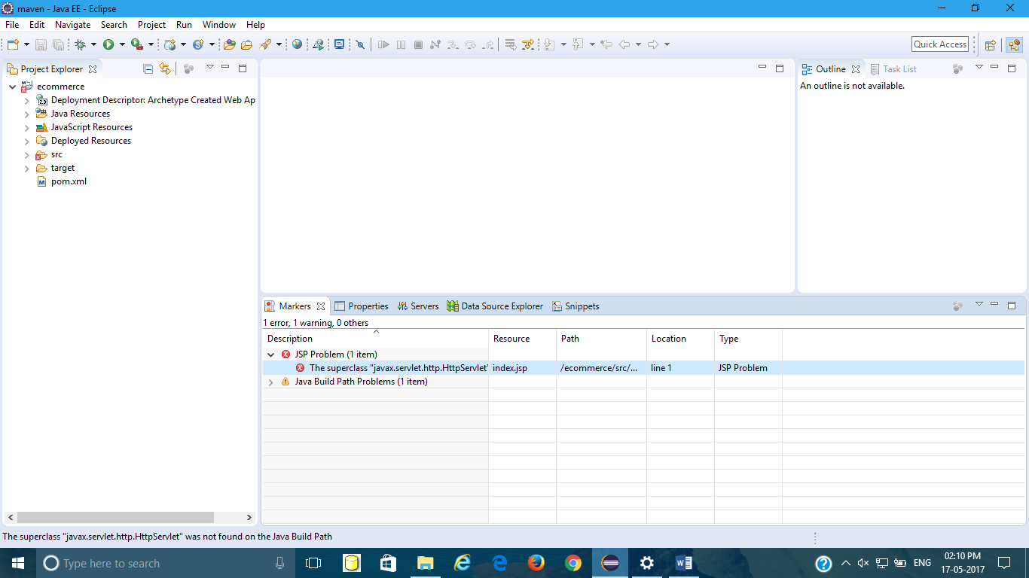

Do following Steps

Right click on project🡪Build Path🡪configure Build Path🡪Add Library🡪Server runtime🡪Select Apache tomcat8🡪Finish.

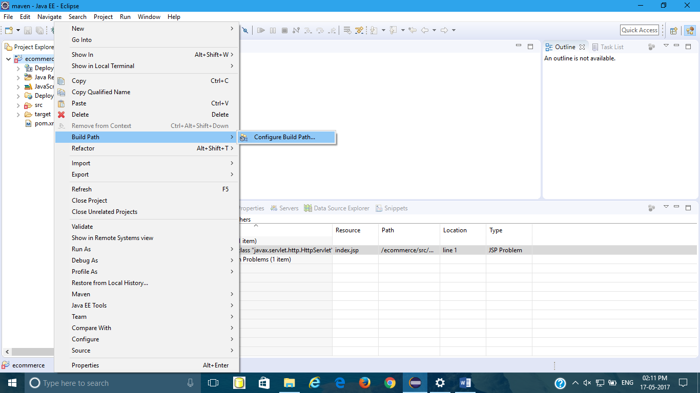

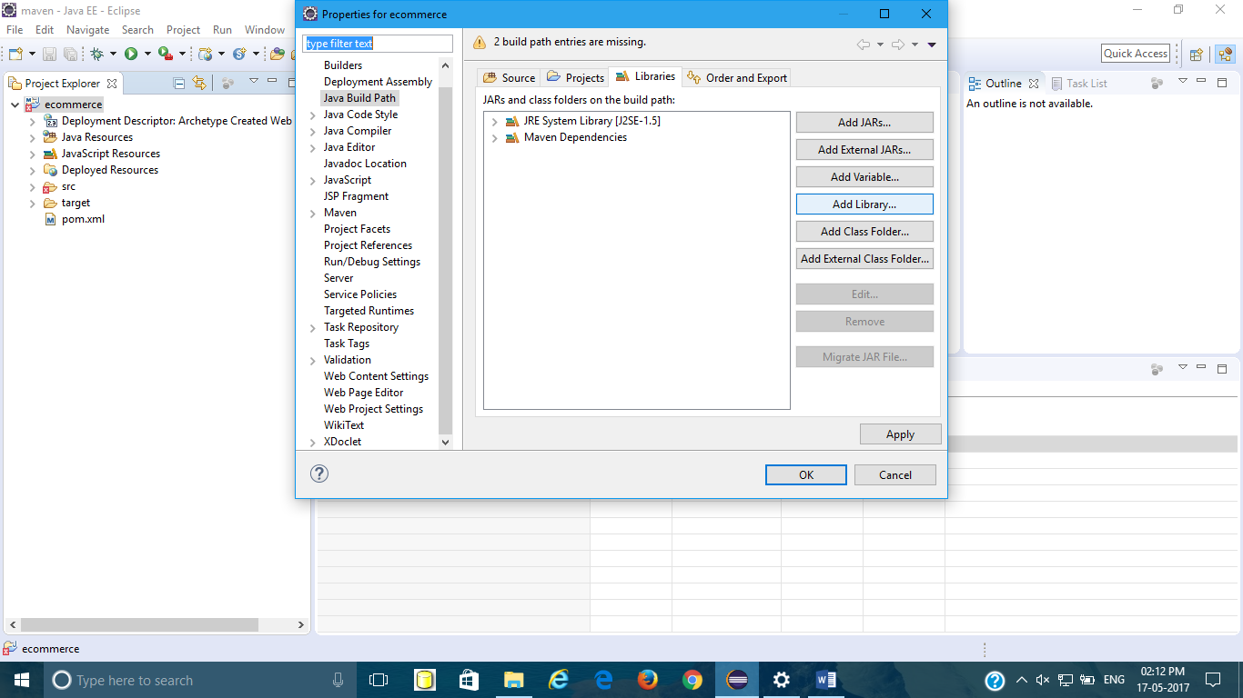

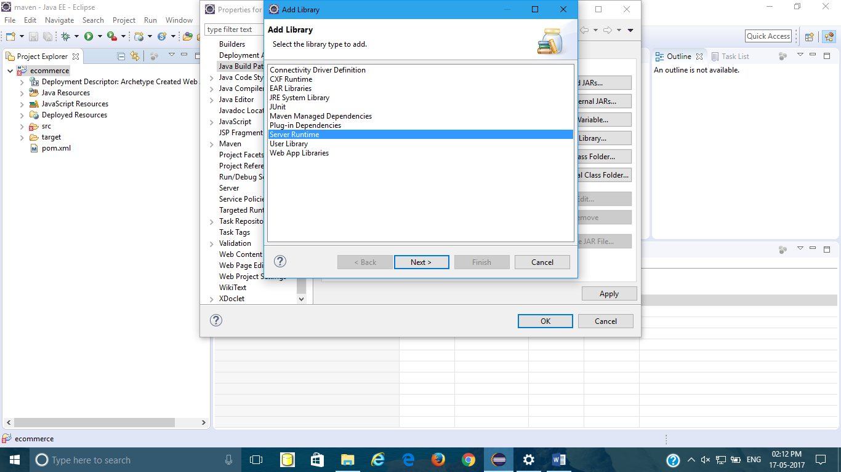

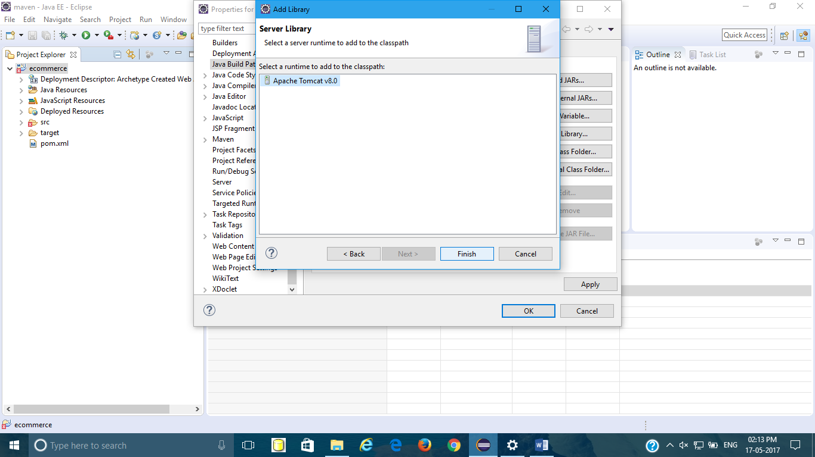

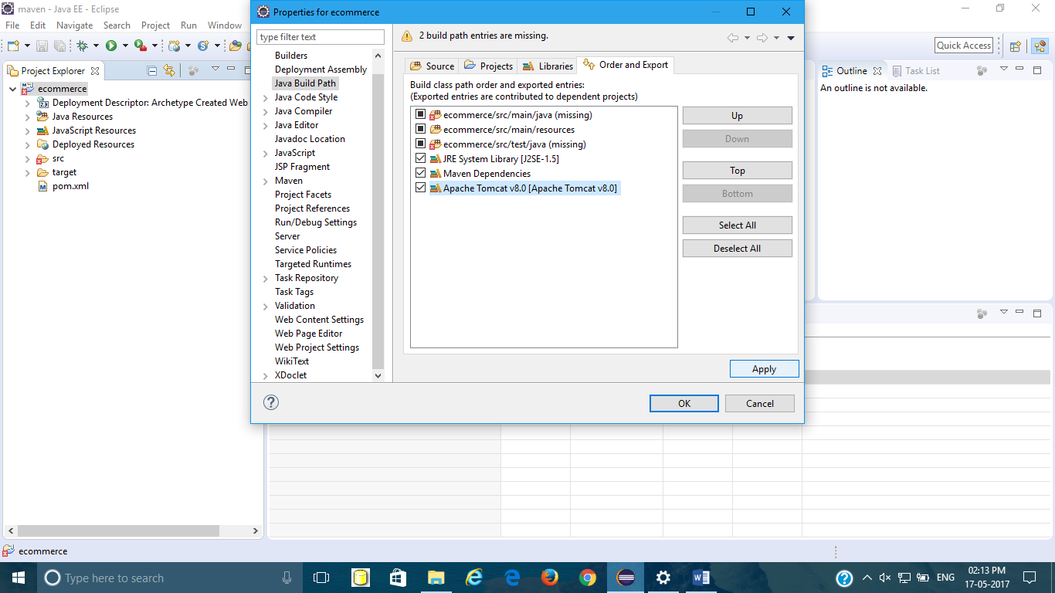

10.Configure project facets🡪Right click on project🡪properties🡪project facet🡪java 1.8🡪apply🡪Finish

