**Sign Language Interpreter**

**A Minor Project Synopsis Submitted to**

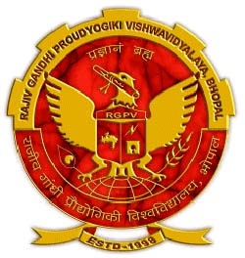

**Rajiv Gandhi Proudyogiki Vishwavidyalaya, Bhopal**

**Towards Partial Fulfillment for the Award of**

**Bachelor of Technology**

**(Computer Science and Engineering)**

**Submitted By**

**Mahak Chittoda(0827CS191141)**

**Mayuri Balchandani(0827CS191149)**

**Neelesh Vaishnav(0827CS191164)**

**Pranav Bhardwaj(0827CS191171)**

**Under the Supervision of**

**Prof. Krupi Saraf**

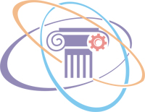

**Department of Computer Science and Engineering**

**Acropolis Institute of Technology & Research, Indore**

**Jan-May 2022**

# Abstract

Sign language is one of the oldest and most natural form of language for communication, but since most people do not know sign language and interpreters are very difficult to come by, we have come up with a real time method using neural networks for fingerspelling based American sign language.

In our method, the hand is first passed through a filter and after the filter is applied the hand is passed through a classifier which predicts the class of the hand gestures. Our method provides 95.7 % accuracy for the 26 letters of the alphabet.

# Introduction of the Project

In our project we primarily focus on producing a model which can recognize Fingerspelling based hand gestures in order to form a complete word by combining each gesture. The gestures we aim to train are as given in the image below.

American sign language is a predominant sign language Since the only disability Deaf and Dumb (hereby referred to as D&M) people have is communication related and since they cannot use spoken languages, the only way for them to communicate is through sign language.

# Objective

The main objective is to translate sign language to text/speech. The framework provides a helping-hand for speech-impaired to communicate with the rest of the world using sign language.

This leads to the elimination of the middle person who generally acts as a medium of translation.

This would contain a user-friendly environment for the user by providing speech/text output for a sign gesture input.

# Scope

We are planning to achieve higher accuracy even in case of complex backgrounds by trying out various background subtraction algorithms.

We are also thinking of improving the Pre Processing to predict gestures in low light conditions with a higher accuracy.

This project can be enhanced by being built as a web/mobile application for the users to conveniently access the project. Also, the existing project only works for ASL; it can be extended to work for other native sign languages with the right amount of data set and training. This project implements a finger spelling translator; however, sign languages are also spoken in a contextual basis where each gesture could represent an object, or verb. So, identifying this kind of a contextual signing would require a higher degree of processing and natural language processing (NLP).

# Study of Existing System (200 words)

In existing system the module was developed for dumb person using flex sensor, there user hand is attached with the flex sensors.

On this module the flex sensor reacts on bend of each finger individually. By taking that value controller starts to react with speech, each flex sensor holds unique voice stored in APR Kit and for each sign it will play unique voice.

And in other existing system, the work is done only for some alphabets and not for the words or sentences, and accuracy obtained is very low.

# Project Description

American sign language is a predominant sign language Since the only disability D&M people have is communication related and they cannot use spoken languages hence the only way for them to communicate is through sign language.

Communication is the process of exchange of thoughts and messages in various ways such as speech, signals, behavior and visuals.Deaf and Mute(Dumb)(D&M) people make use of their hands to express different gestures to express their ideas with other people.

Gestures are the nonverbally exchanged messages and these gestures are understood with vision. This nonverbal communication of deaf and dumb people is called sign language.

# Methodology/Planning of the Project work

1. The first Step of building this project was of creating the folders for storing the training and testing data. As, in this project we have built our own dataset.
2. The second step, after the folder creation is of creating the training and testing dataset.

3. We captured each frame shown by the webcam of our machine

1. In each frame We defined a region of interest (ROI) which is denoted by a blue bounded square .
2. After capturing the image from the ROI, we applied gaussian blur filter to the image(to mute noises) which helps for extracting various features of the image.
3. After the creation of the training and testing data. The third step is of creating a model for training. Here, We have used Convolutional Neural Network(CNN) for building this model(CNN is a deep learning neural network sketched for processing structured arrays of data.)
4. The final step after the model has been trained is of creating a GUI that will be used to convert Signs into text and form sentence, which would be helpful for communicating with D&M people.

# Expected Outcome

We have improved our prediction after implementing two layers of algorithms wherein we have verified and predicted symbols which are more similar to each other.

This gives us the ability to detect almost all the symbols provided that they are shown properly, there is no noise in the background and lighting is adequate

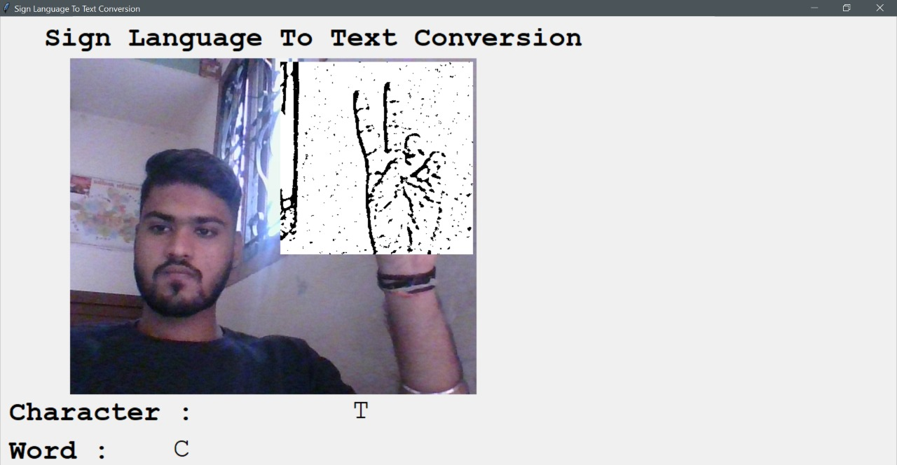

# Resources and Limitations

There are various resources (hardware, software and services) to successfully deploy the system. These are mentioned below :

**Software**

* Python 3.6.6
* Tensorflow 1.11.0
* OpenCV 3.4.3.18
* NumPy 1.15.3
* Matplotlib 3.0.0
* Hunspell 2.0.2
* Keras 2.2.1
* PIL 5.3.0

**Hardware**

* 32-bit, x86 Processing system
* Windows 7 or later operating system
* High processing computer system without GPU or with GPU(high performance)
* High- definition Camera

# Conclusion (100-150 words)

We achieved final accuracy of **90.0%** on our data set. We have improved our prediction after implementing two layers of algorithms wherein we have verified and predicted symbols which are more similar to each other.

This gives us the ability to detect almost all the symbols provided that they are shown properly, there is no noise in the background and lighting is adequate.

.

# References

[1] T. Yang, Y. Xu, and “A., Hidden Markov Model for Gesture Recognition”, CMU-RI-TR-94 10, Robotics Institute, Carnegie Mellon Univ., Pittsburgh, PA, May 1994.

[2] Pujan Ziaie, Thomas M uller, Mary Ellen Foster, and Alois Knoll “A Na ̈ıve Bayes Munich, Dept. of Informatics VI, Robotics and Embedded Systems, Boltzmannstr. 3, DE-85748 Garching, Germany.

[3]<https://docs.opencv.org/2.4/doc/tutorials/imgproc/gausian_median_blur_bilateral_filter/gausian_median_blur_bilateral_filter.html>

[4] Mohammed Waleed Kalous, Machine recognition of Auslan signs using PowerGloves: Towards large-lexicon recognition of sign language.

[5]aeshpande3.github.io/A-Beginner%27s-Guide-To-Understanding-Convolutional-Neural Networks-Part-2/

[6] <http://www-i6.informatik.rwth-aachen.de/~dreuw/database.php>

[7] Pigou L., Dieleman S., Kindermans PJ., Schrauwen B. (2015) Sign Language Recognition Using Convolutional Neural Networks. In: Agapito L., Bronstein M., Rother C. (eds) Computer Vision - ECCV 2014 Workshops. ECCV 2014. Lecture Notes in Computer Science, vol 8925. Springer, Cham

[8] Zaki, M.M., Shaheen, S.I.: Sign language recognition using a combination of new vision-based features. Pattern Recognition Letters 32(4), 572–577 (2011).

[9] N. Mukai, N. Harada and Y. Chang, "Japanese Fingerspelling Recognition Based on Classification Tree and Machine Learning," *2017 Nicograph International (NicoInt)*, Kyoto, Japan, 2017, pp. 19-24. doi:10.1109/NICOInt.2017.9

[10] Byeongkeun Kang, Subarna Tripathi, Truong Q. Nguyen” Real-time sign language fingerspelling recognition using convolutional neural networks from depth map” 2015 3rd IAPR Asian Conference on Pattern Recognition (ACPR)