A1.

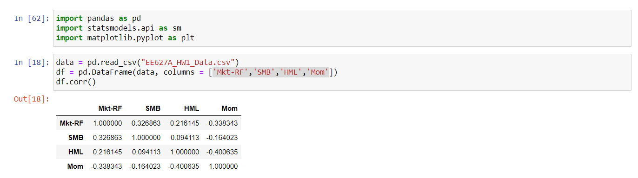

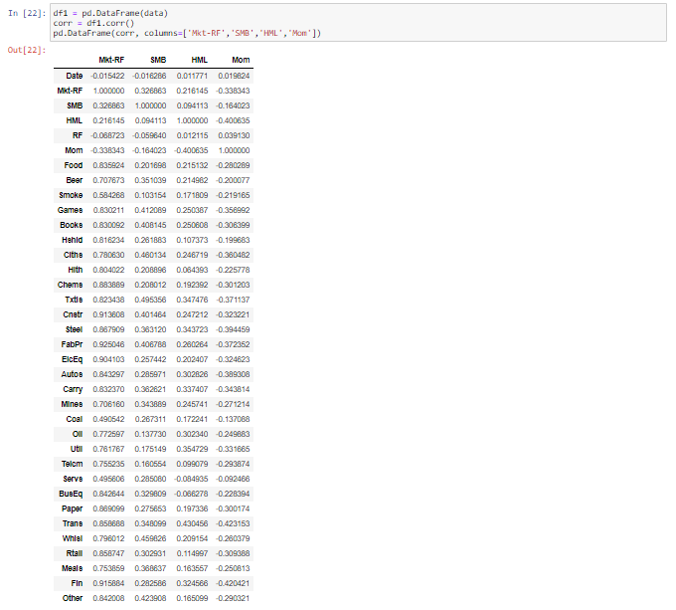

**From the above correlation matrix, I infer that market risk free factor correlates highly with every industry. Momentum correlates most negatively with every industry. While RF (risk free rate) correlates negatively for most of the industries**

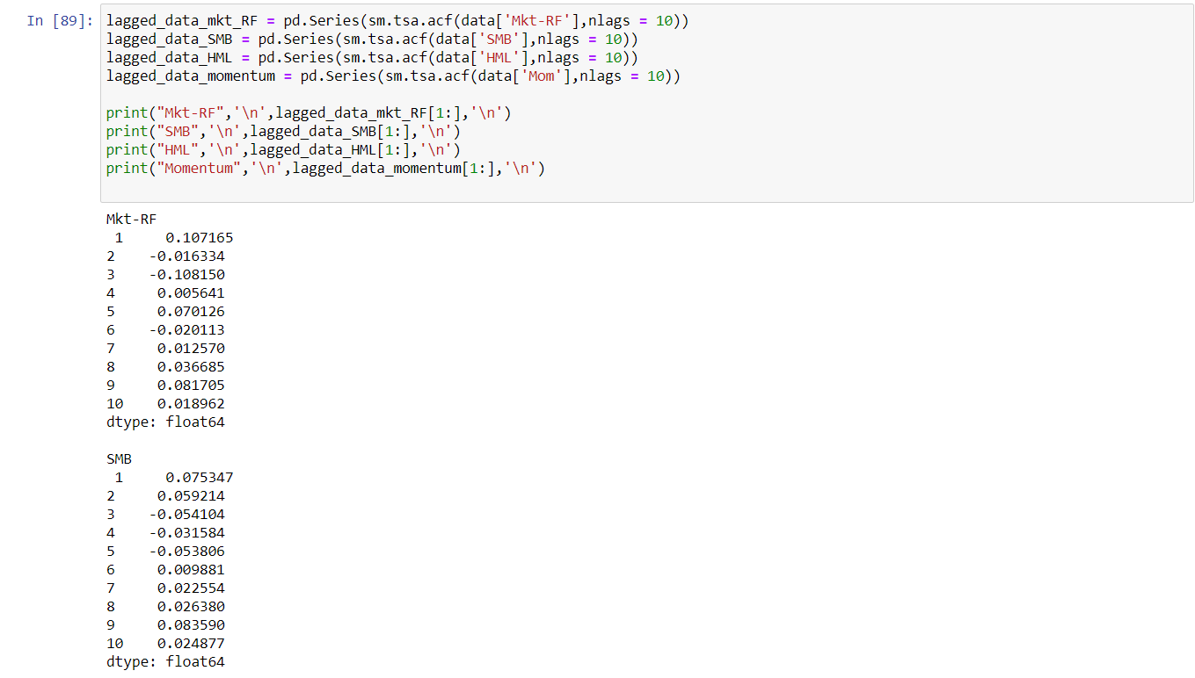

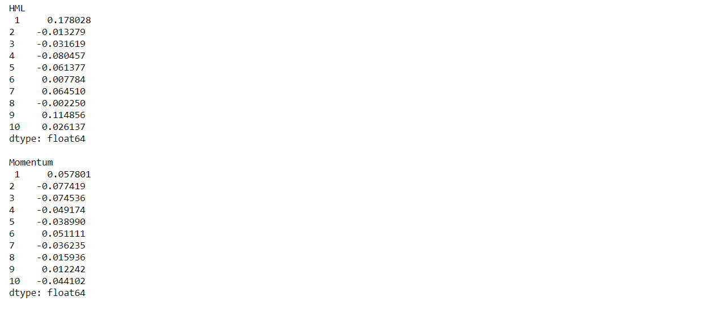

**Referring the above Autocorrelation vs lag for each factor. I conclude Momentum factor to be AR (1) model. Also, I observed that higher the correlation, higher will be the order of ACF. That is, we can consider more observations from the past to predict present of the highly correlated features.**

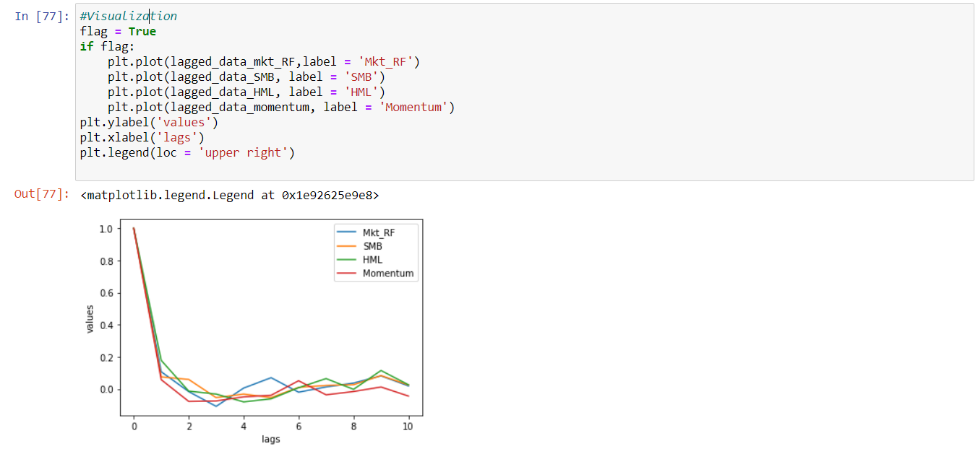

A2.