Q2 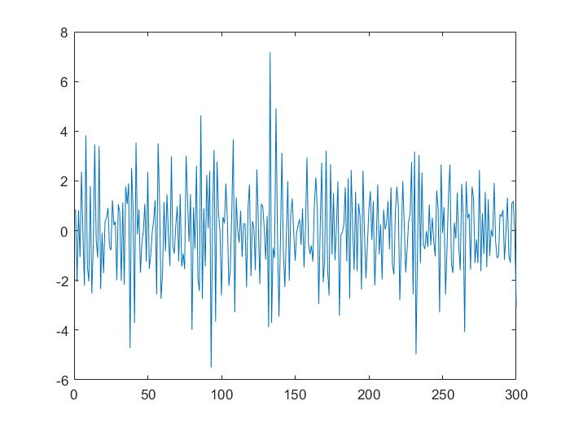

MATLAB Commands Used:

Time series for Q2 is imported to MATLAB. Timeseries is imported as a table, which needs to be converted into an array.

**B = table2array(EE627AHW2Q2);**

**plot(B)**

B is imported to Econometric toolbox to plot PACF and ACF.

Following which a model is created.

The models I created are given below with residual auto correlation:

1. AR(3)

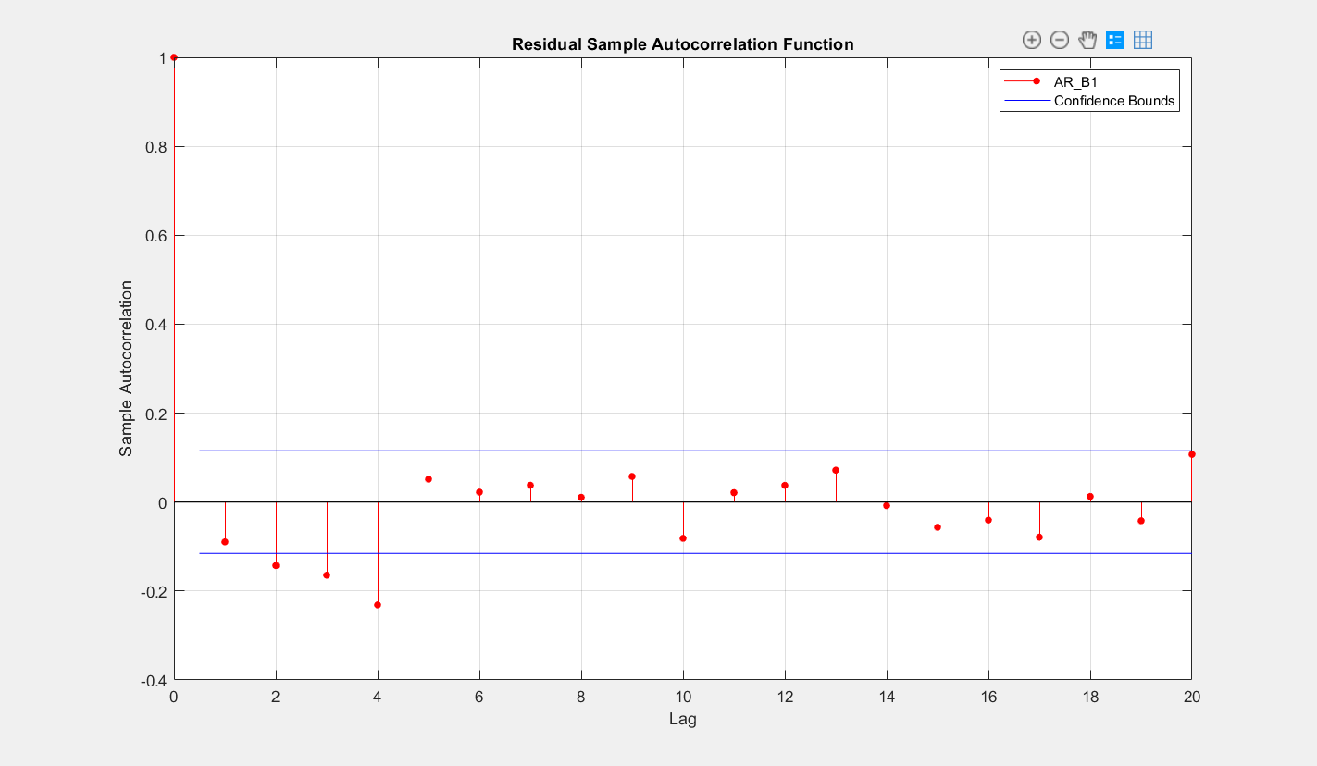

1. AR(20)

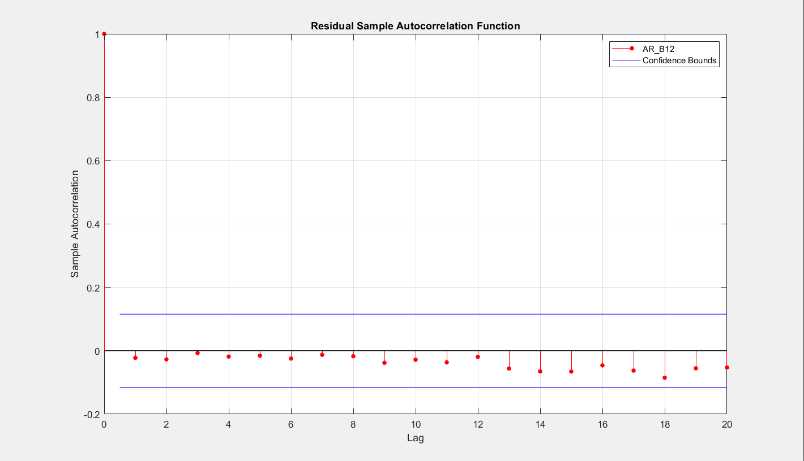

1. MA(3)

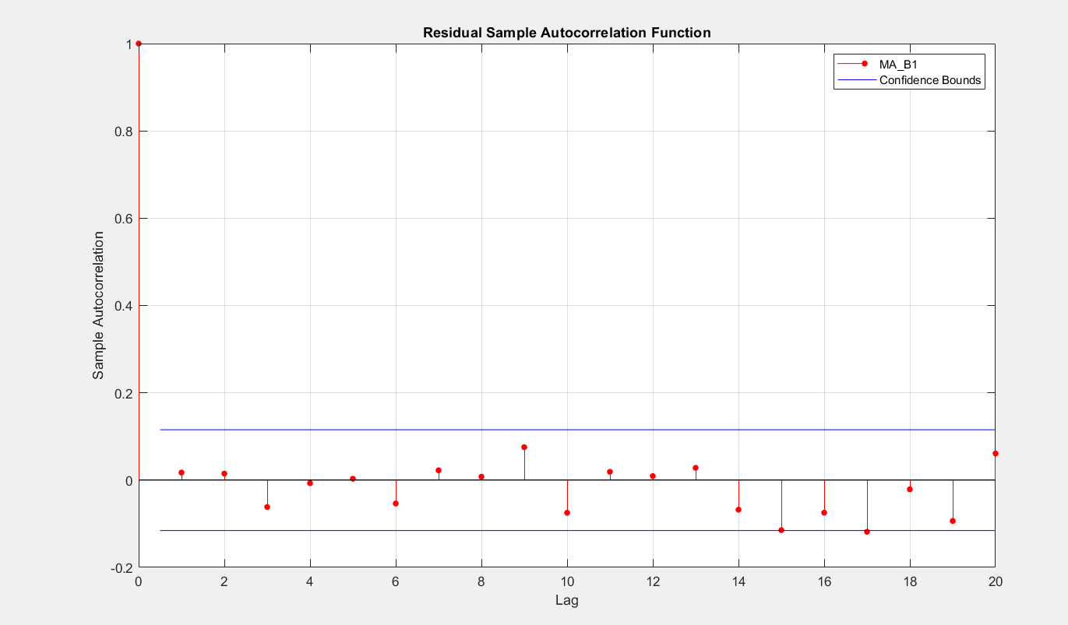

1. ARMA(3,3)

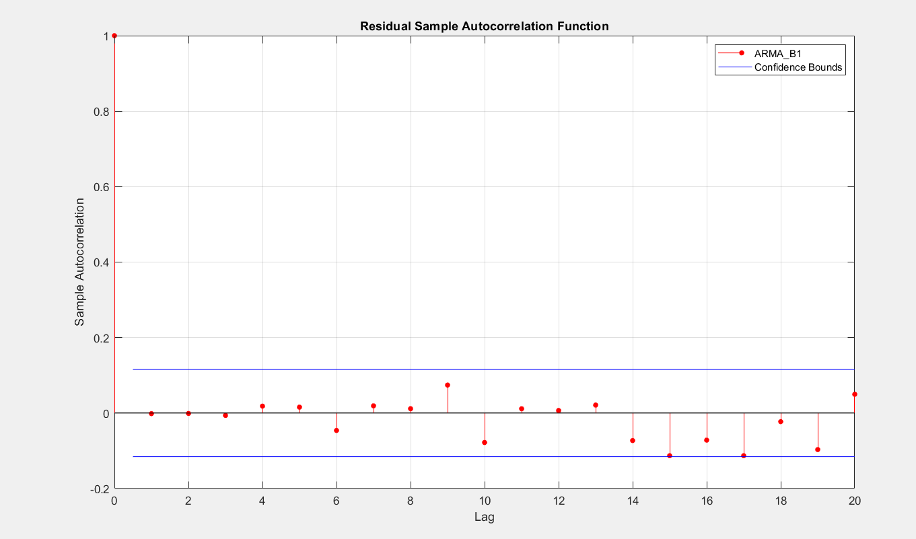

According to observation AR(20), MA(3) and ARMA(3) are best fit models. But since the one with least error terms are considered MA(3) would be a preferred model.

Q3

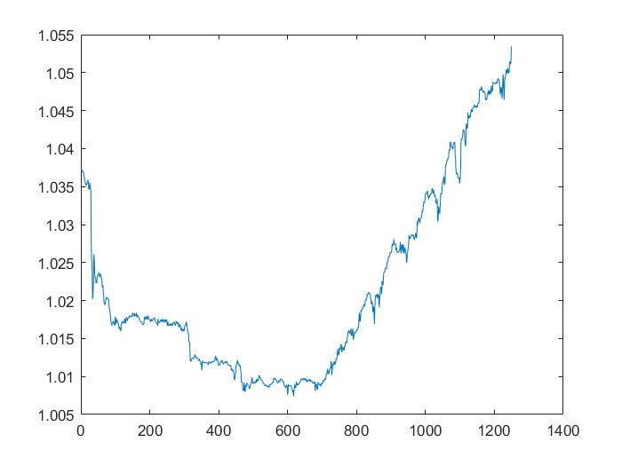

The time series is non – stationary thus, convert into stationary by taking difference. Using **diff(xt)** in MATLAB.

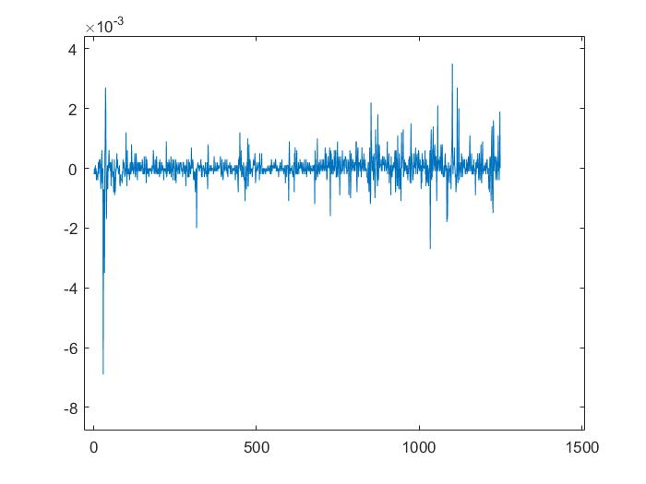

The Un-stationary signal is converted to Stationary Signal.

1. PACF

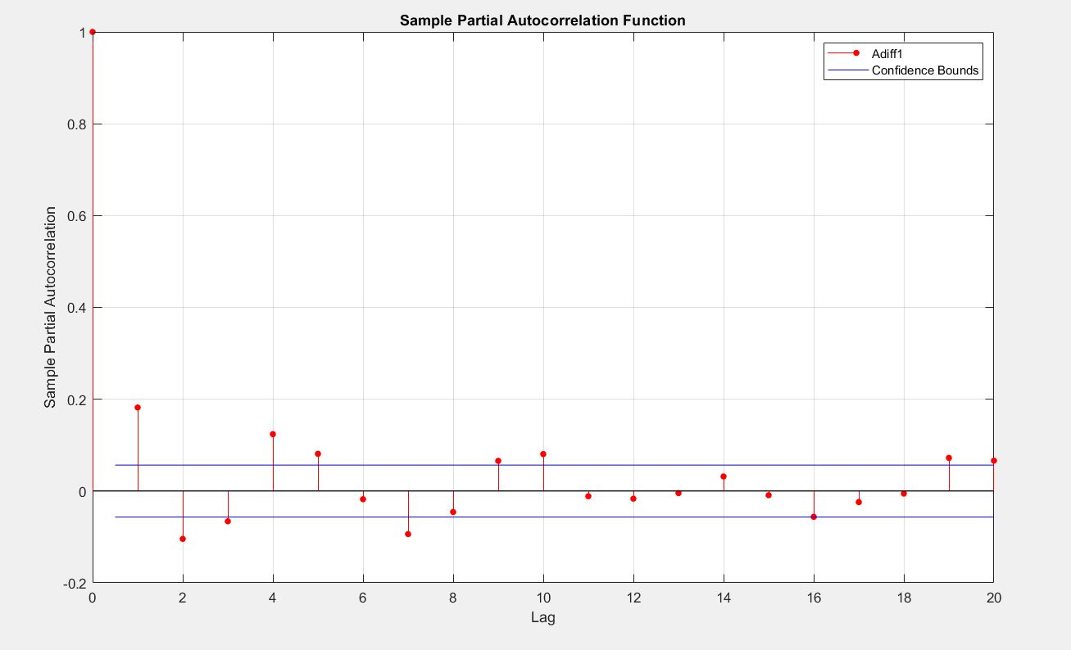

1. ACF

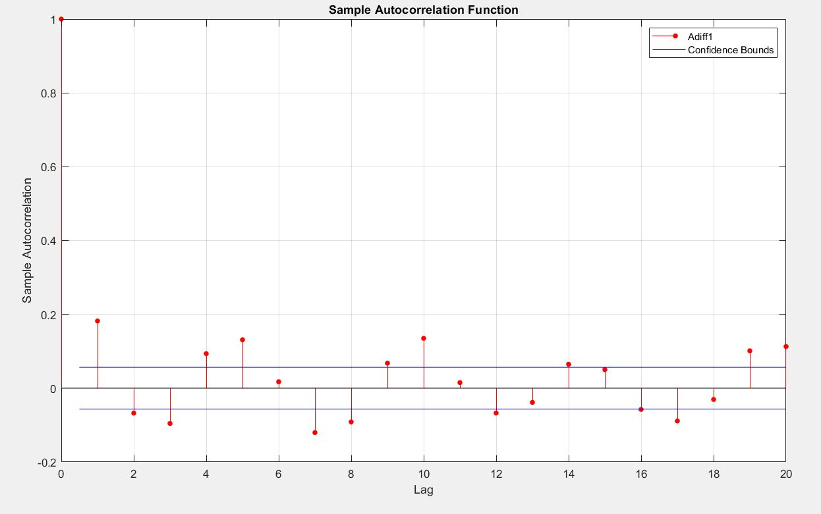

Models:

1. AR(3)

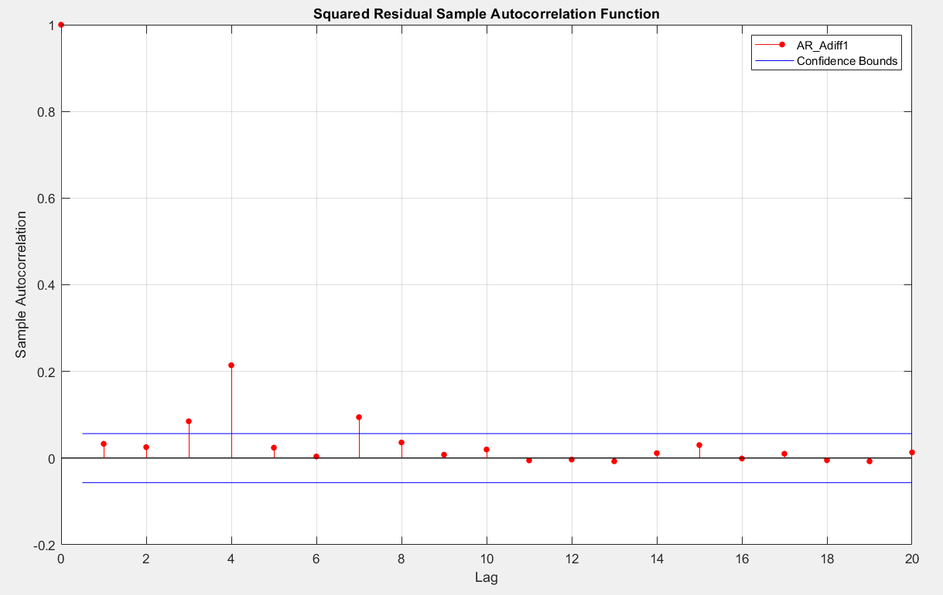

1. MA(3)

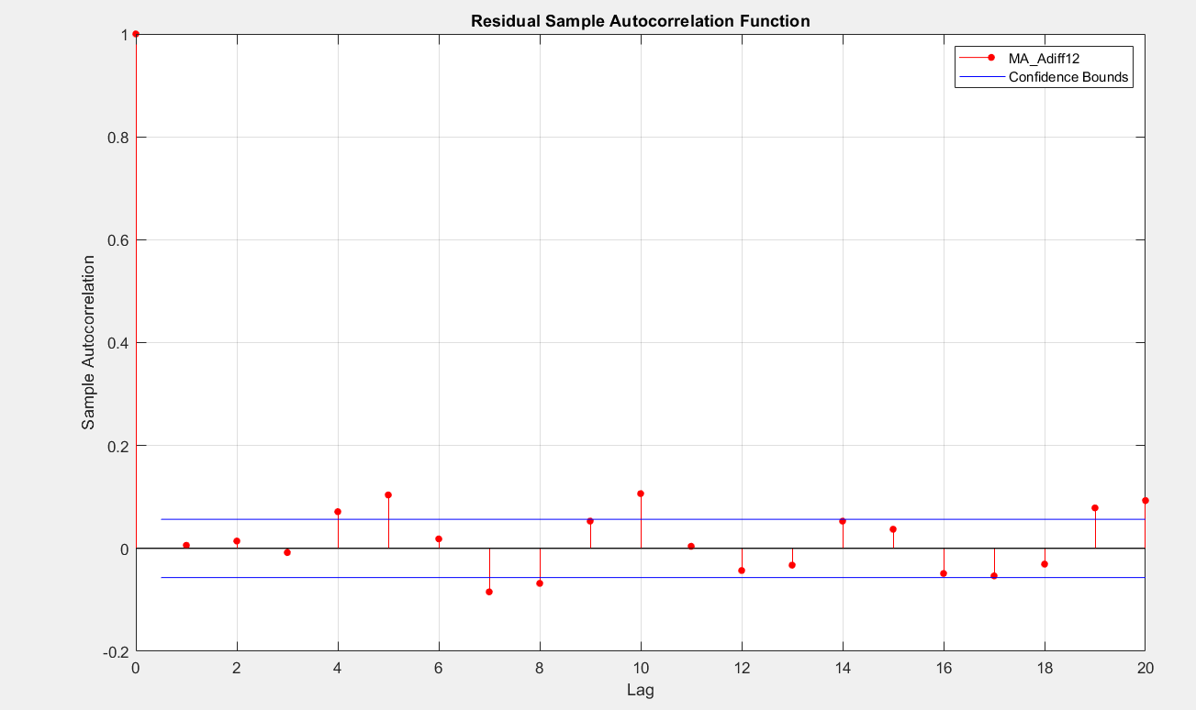

1. ARMA(3,3)

