Home-work 3- Report

Name: Neel Haria

1. **Rectangular.py**

**Code:**

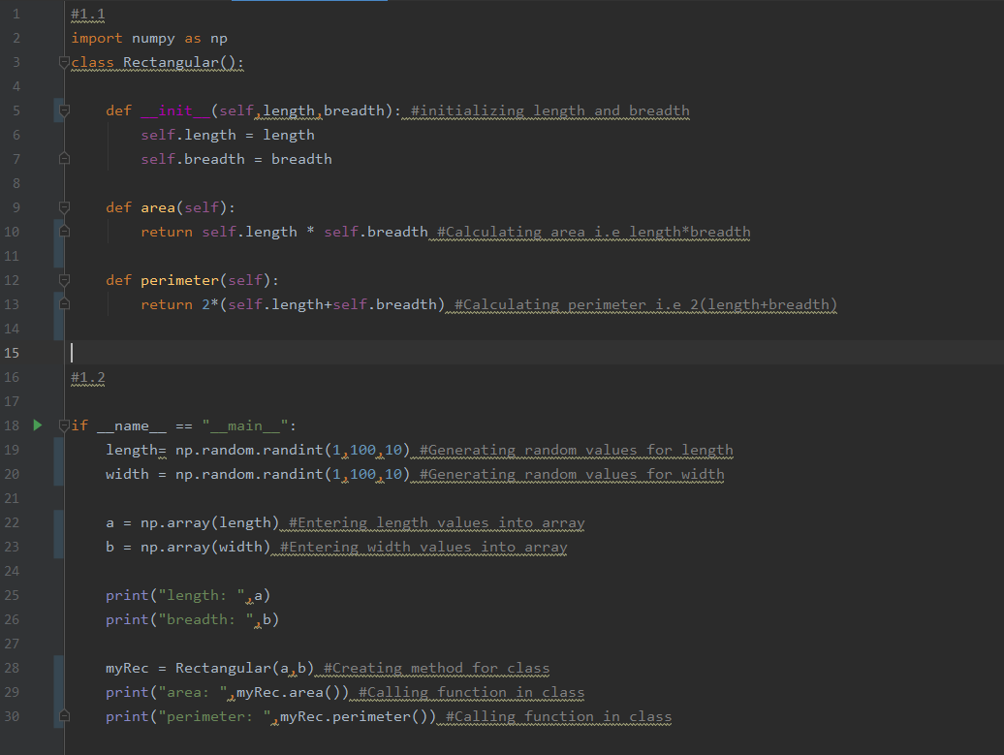

**Output:**

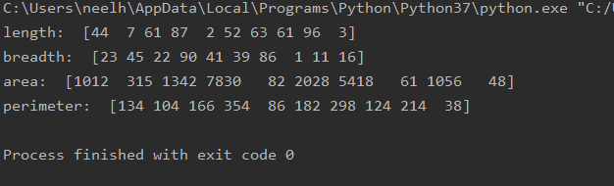

1. **Time.py**

**Code:**

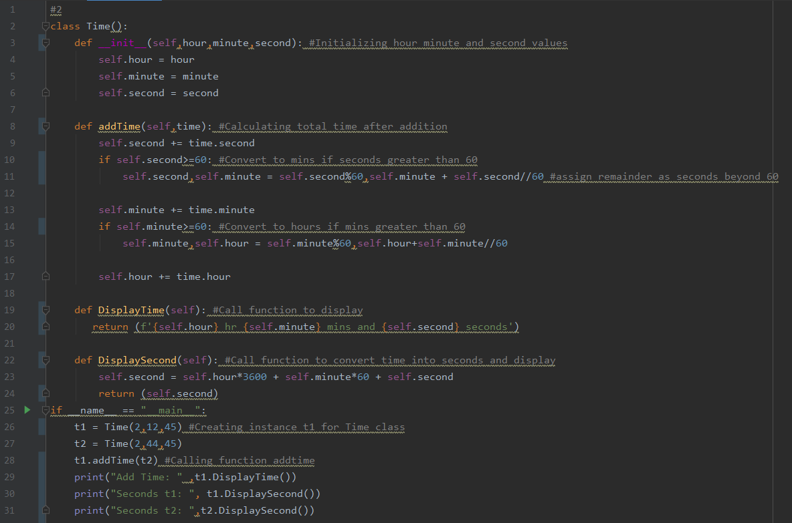

**Output:**

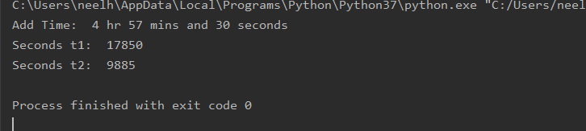

1. **Random Number Generator**

**Code:**

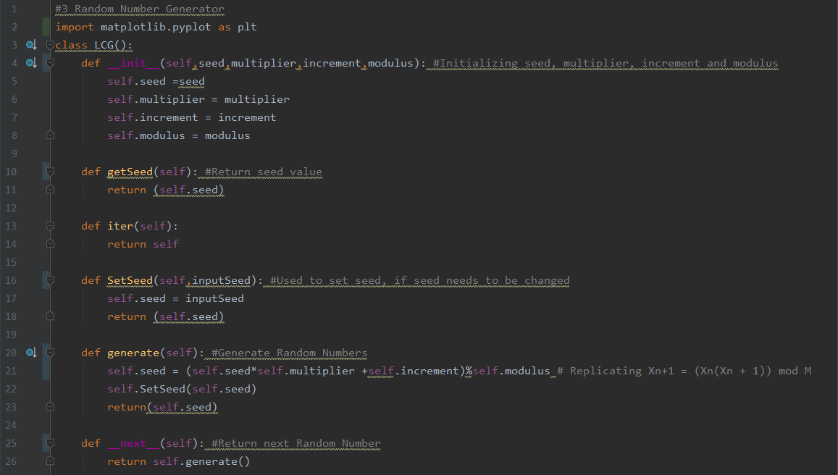

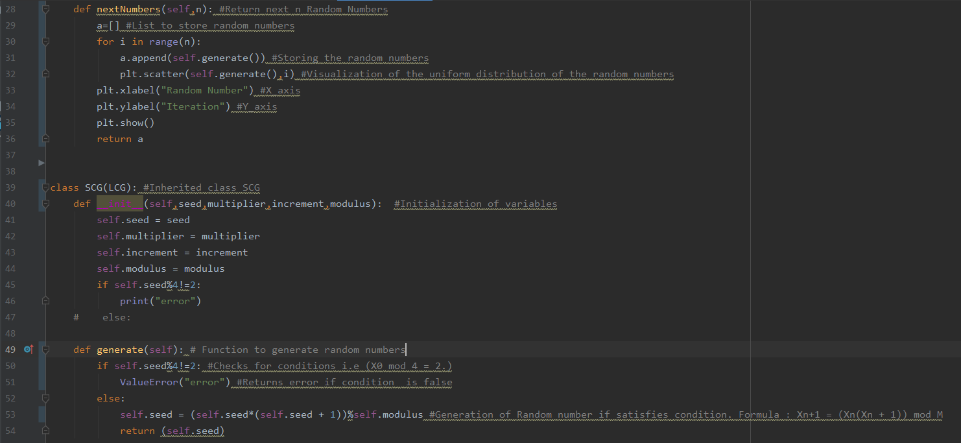

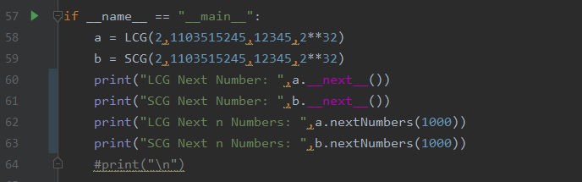

**Output:**

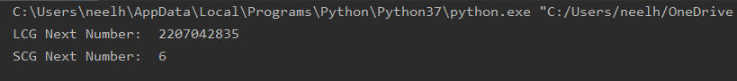

**LCG Next n Numbers:**

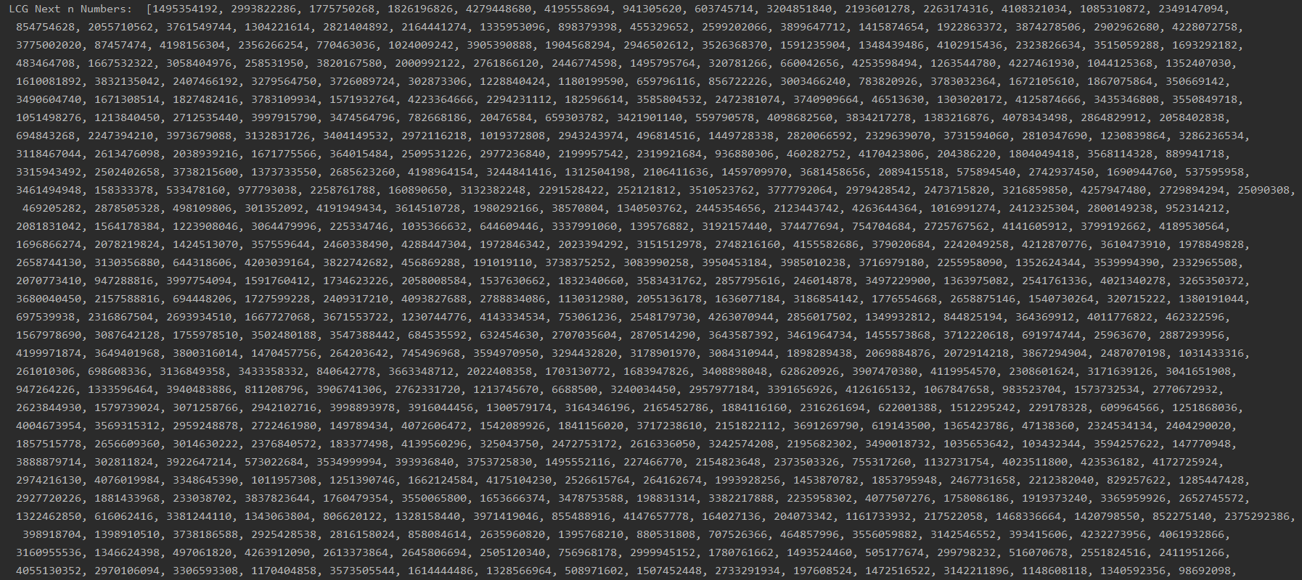

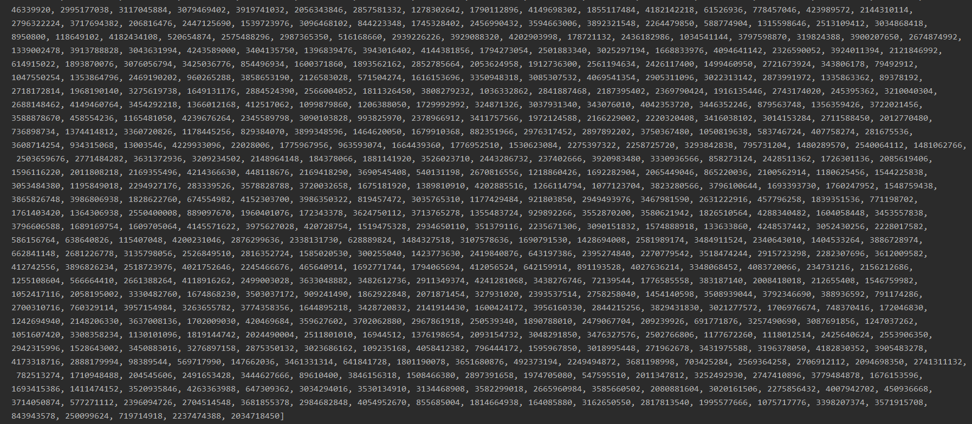

**Visualization of LCG Uniform Distribution of Random n(n =1000) Numbers**

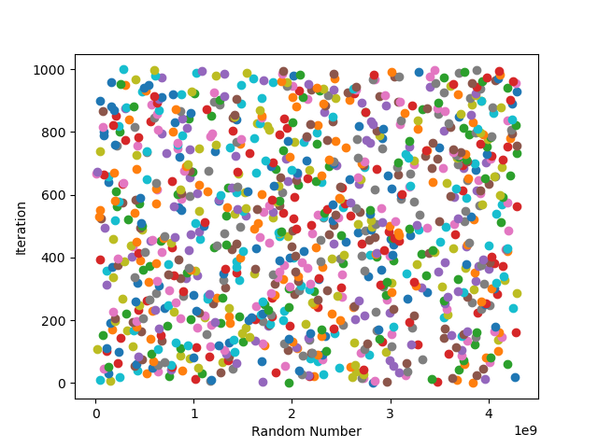

**SCG Next n Numbers:** 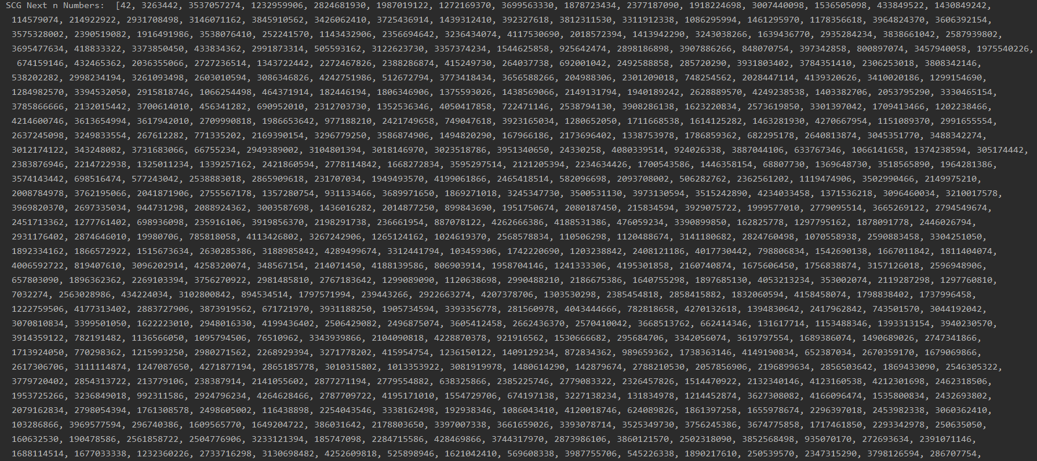

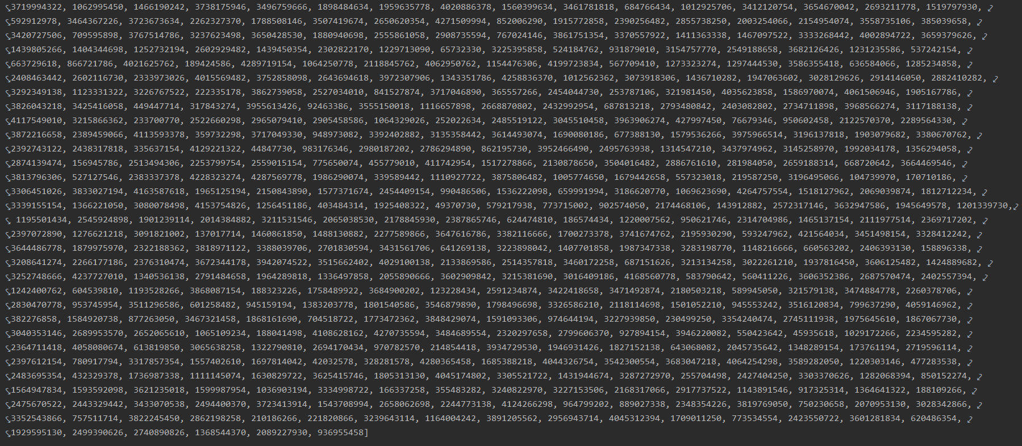

**Visualization of SCG Uniform Distribution of Random n(n =1000) Numbers**

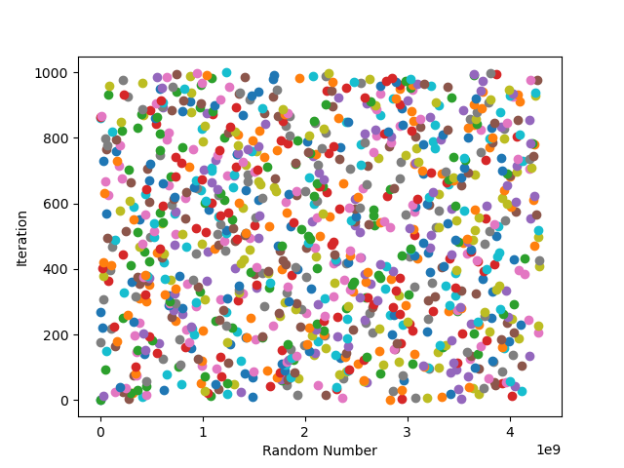

1. **point.py**

**Code:**

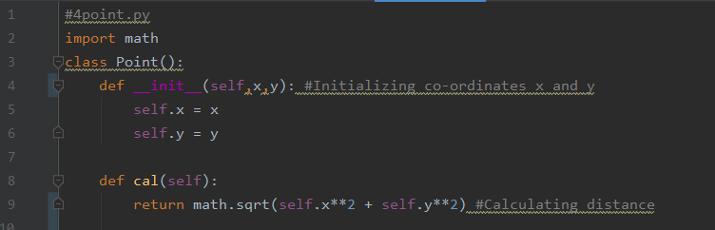

1. **MCTest.py**

**Code:**

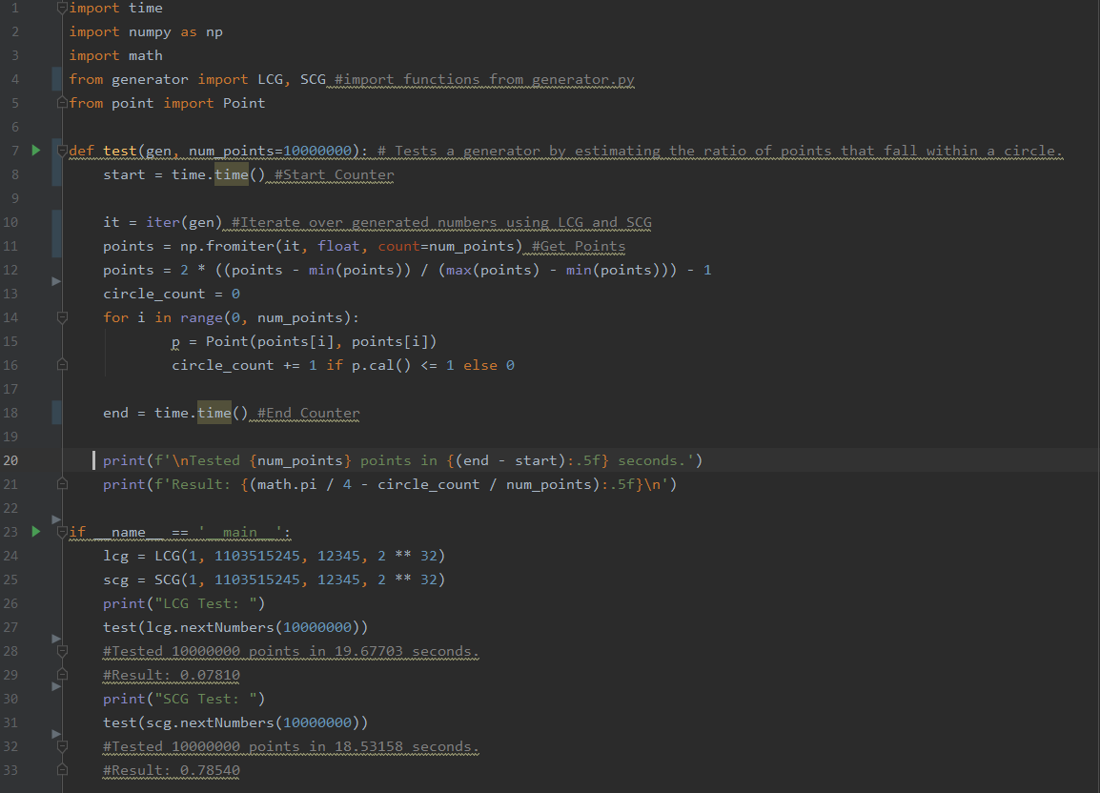

**Output:**

