Project – 1
Title: Railway_Guages.
Question:
Here are 5 well-structured, end-to-end scenarios (with preprocessing → analysis → visualization), balanced by difficulty as you requested:
Scenario 1: Basic Data Loading & Cleaning.
First, we have to import this CSV file into Pandas library. Pandas is a powerful data analysis library providing flexible way to do data manipulation. There are many mathematical and scientific computational features can be leveraged using this library. Let us see some of the features in our exercise.
In order to load the CSV file using Pandas, we need to do the following step.
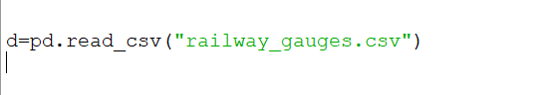
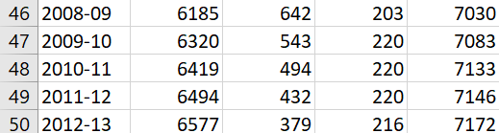
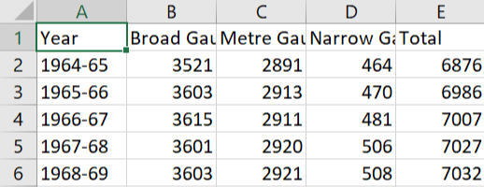
Pandas returns as Data frame object. Using data frame object, we can see the top 5 rows using head() function and tail() function to display last 5 rows in a CSV file. In our above example, we have used df.head(), it displays first 5 rows in the loaded CSV. Here I am displaying first 5 & last 5 rows and columns.
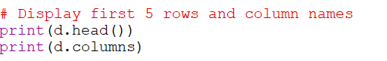

Now I am replacing missing values with 0 and converting all gauge columns like Broad Gauge, Metre Gauge, and Narrow Gauge and Total Gauge. to numeric types.
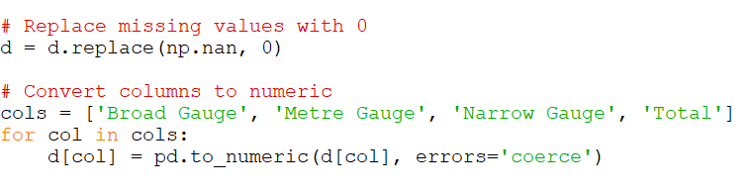
Scenario 2: Simple Visualization

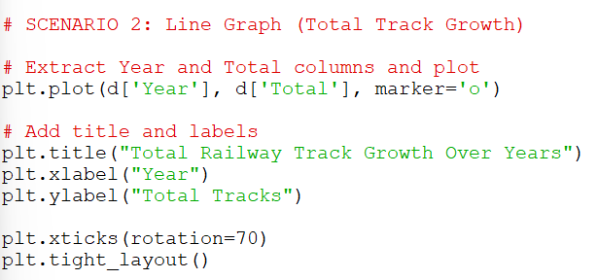
Here, I am Extracting year and total columns from the Railway Dataset and plotting line graph. That Line graph shows “Total tracks over the years”. And the graphs contains Title and X & Y labels in the graphs.

Scenario 3: Filtering + Bar Chart
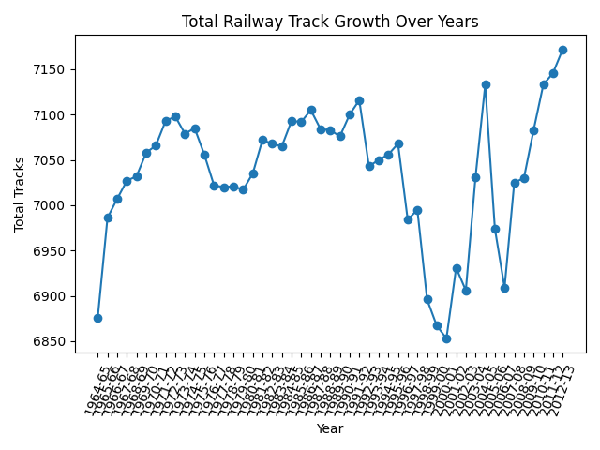
Here, I am filtering data after 2000 from Railway dataset.
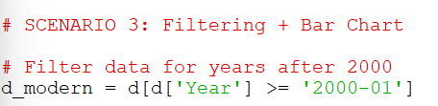

Now I am plotting bar chart comparing Broad Gauge, Metre Gauge, and Narrow Gauge. From dataset. And adding legend to the chart. A legend is the small box that tells you what each colour, line, or bar represents.
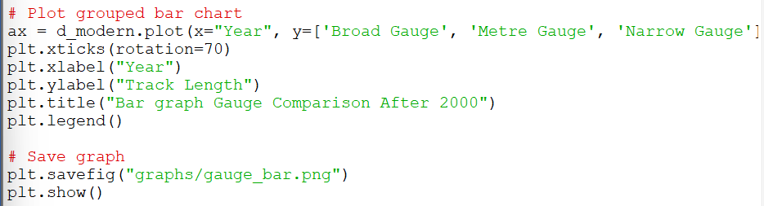

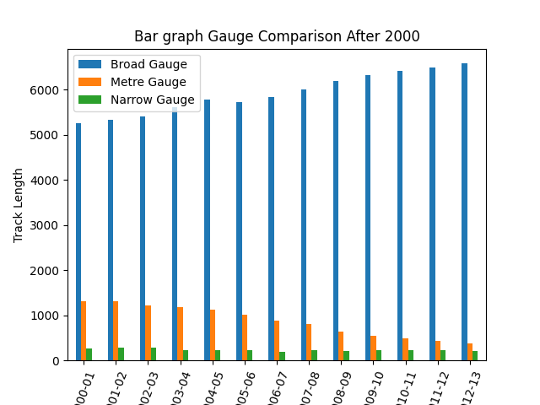

Scenario 4: Feature Engineering + Pie Chart
Here, I am Calculate total sum of each gauge across all years using sum( ) . And plotting Pie Chart showing percentage contribution and showing percentage labels using autopct. Using shadow and explode. These are styling options used in plt.pie() to make your chart clearer and more attractive .
autopct - autopct is used to automatically display percentage values on each slice.
Shadow - Adds a shadow effect behind the pie chart.
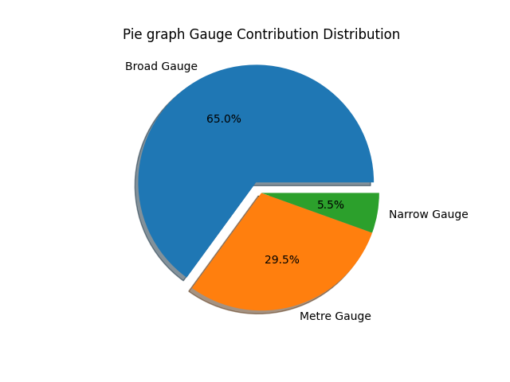
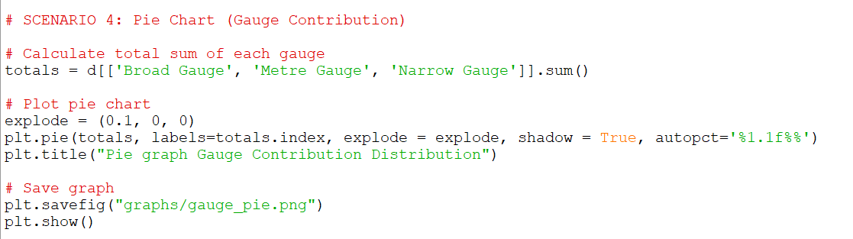
Explode - Separates (pulls out) one or more slices from the pie chart.

Scenario 5: Advanced Analysis + Multiple Graphs
Here, I am creating new percentage columns for Broad Gauge, Metre Gauge, and Narrow Gauge. And using numpy as np.diff( ).
np.diff( ) - to computes the difference between consecutive values.
iloc [ ] - is primarily an integer based location search — iloc[0]
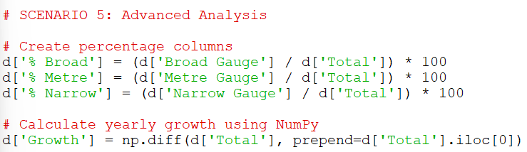

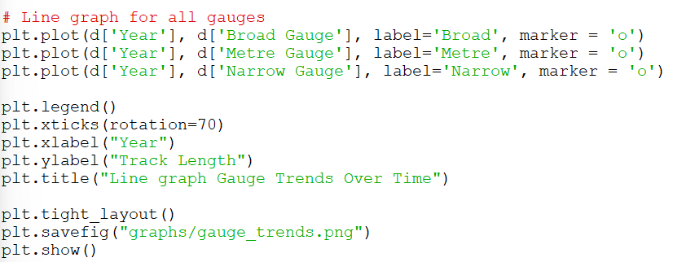
- And plotting Line Graph for all Gauges.

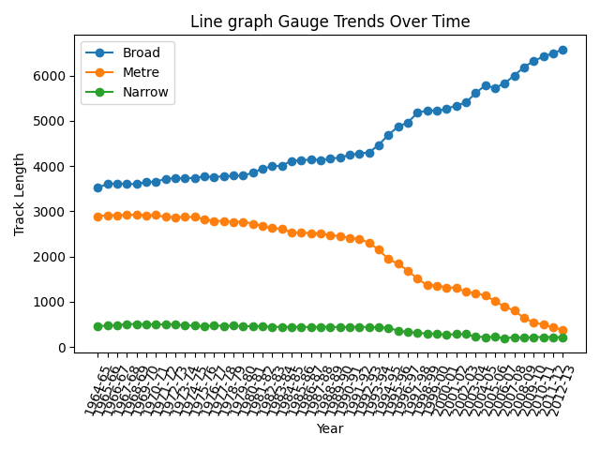
And the output graph look likes in below.
- Stacked Bar chart for showing composition.

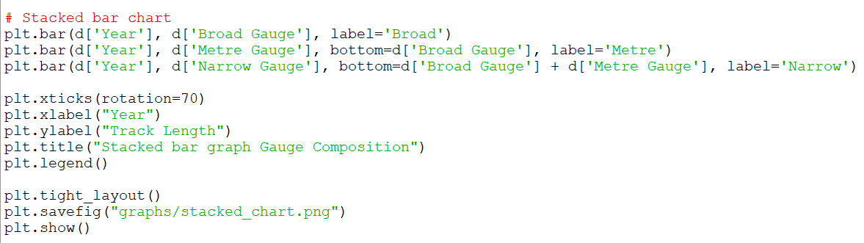
- And the output graph look likes in below.
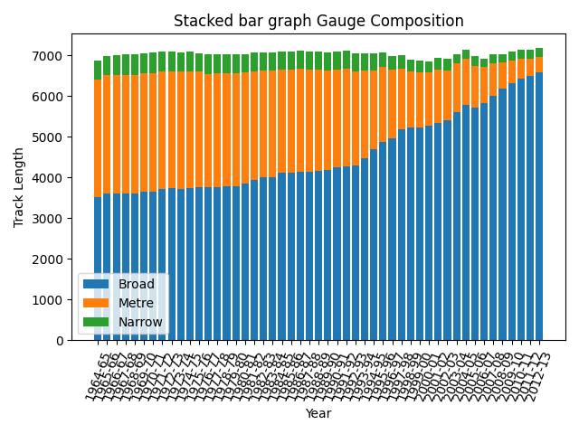
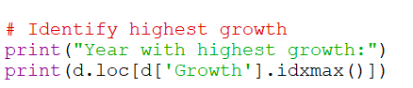

Yes, the railway system is clearly shifting towards a single dominant gauge, which is the Broad Gauge.
Over the years, the data shows a steady and continuous increase in Broad Gauge track length, while both Metre Gauge and Narrow Gauge are consistently declining. This trend indicates a systematic effort to convert and standardize railway tracks.
The reduction in Metre and Narrow Gauge is not random—it reflects a planned modernization strategy. Broad Gauge offers several advantages such as:
- Higher speed and stability
- Greater load-carrying capacity
- Better compatibility across regions
Because of these benefits, railway authorities have been gradually replacing older gauges with Broad Gauge to improve efficiency and connectivity.

