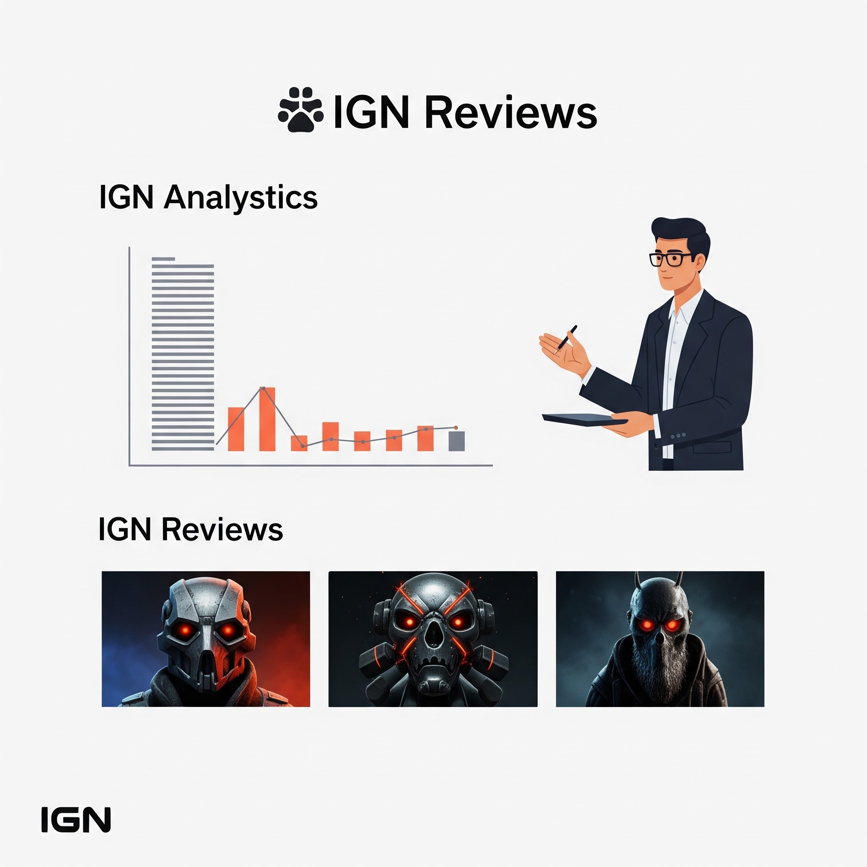

Data Analytics Project: IGN_Game_Reviews_Analysis
Dataset Used: ign

This document outlines a structured, end-to-end data analysis project based on game reviews from the IGN dataset. The project is divided into five scenarios, increasing in difficulty from basic data handling to advanced analysis and visualization, ensuring comprehensive skill coverage.

Project Goal: To analyze game review scores, platform popularity, and genre distribution over time using the ign.csv dataset.

The primary libraries/modules required for this project are:
- Pandas: For all data manipulation, filtering, aggregation, and feature engineering tasks.
- NumPy: Specifically for numerical calculations like yearly growth (np.diff).
- Visualization Library (e.g., Matplotlib): For generating all required plots (Line Graphs, Bar Charts, Pie Charts, Stacked Bar Charts).

🎯 Project Coverage

Category | Skills Covered
Data Preprocessing | Data Loading, Missing Value Handling (Mean/Mode), Type Conversion, Column Removal
Pandas Operations | Grouping, Filtering, Aggregation, Feature Engineering (score_category, editors_choice conversion)
NumPy Calculations | Array conversion, Yearly score growth calculation (np.diff)
Visualization | Line Chart, Bar Chart, Pie Chart, Histogram, Stacked Bar Chart, Saving Plots

Scenario 1: Basic Data Loading & Cleaning (🟢 Easy)

Description:
We load the IGN reviews dataset using Pandas and look at the first and last few rows to understand the data. Then we check the size (rows and columns) of the dataset. We remove the extra column "Unnamed: 0" because it is not useful. After that, we check for missing values in score, genre, and platform and fill them using mean and mode. Finally, we make sure the data types are correct for analysis

Task | Description
1. | Load the ign.csv dataset using Pandas.
2. | Display the first 5 rows (head()), last 5 rows (tail()), and the shape of the dataset.
3. | Remove the unnecessary column: "Unnamed: 0".
4. | Check for missing values in score, genre, and platform.
5. | Handle missing values: Fill the numeric column score with the mean, and the categorical column genre with the mode.
6. | Ensure correct data types: Convert score → float and release_year, release_month, release_day → integer.

Output Screen:

- head() - means showing the first few rows of a dataset (by default, first 5 rows). It helps you quickly see how the data starts and understand its structure.

- tail() - means showing the last few rows of a dataset (by default, last 5 rows). It helps you check how the data ends and verify if everything looks correct.

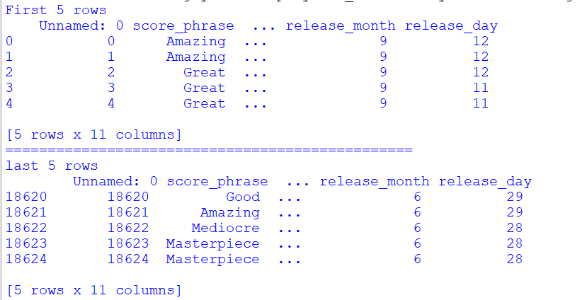

Conclusion:

After cleaning, the dataset becomes more accurate and easy to use. Missing values are handled properly, so there are fewer errors. Unnecessary columns are removed, and data types are corrected. Now the dataset is ready for analysis or visualization.

Scenario 2: Line Graph (Score Trend) + Save (🟢 Easy)

Description:
We group the dataset by release year to see how scores change over time. Then we calculate the average score for each year using Pandas. The results are converted into NumPy arrays for plotting. We create a Line graph with years on the X-axis and average scores on the Y-axis. Finally, we add a title, labels, and save the graph as an image.

Task | Description
1. | Group data by release_year.
2. | Calculate the average score per year using Pandas.
3. | Convert the resulting average scores and years into NumPy arrays.
4. | Plot a line graph with release_year on the X-axis and average score on the Y-axis.
5. | Add the title: "Average Game Score Over Years" and proper axis labels.
6. | Save the graph: plt.savefig("avg_score_trend.png").

Output screen:

- Here, I am displaying yearly_average score by grouping all the scores.
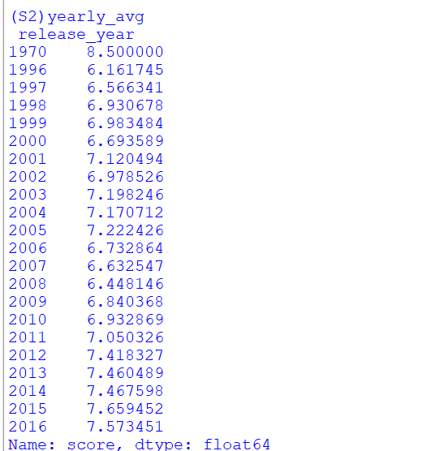
Graph: Line Graph

- Line Graph - A line graph shows data points connected by lines. It is used to see changes or trends over time, like how game scores increase or decrease each year.
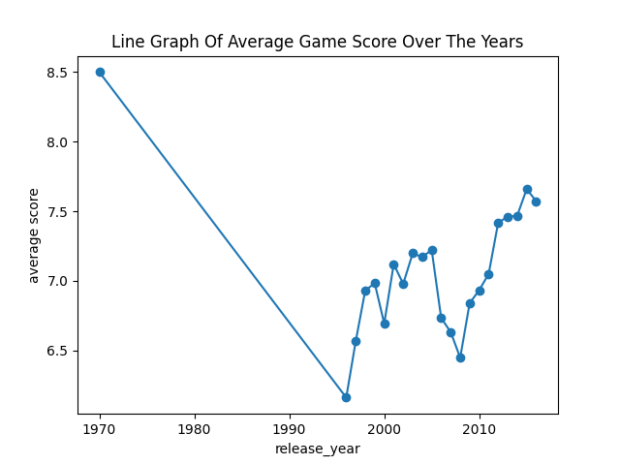

Conclusion:
The graph helps us clearly see how game scores change over the years. We can notice trends like increases or decreases in average ratings. This makes it easier to understand patterns in game quality over time. The saved graph can be used for reports or presentations.

Scenario 3: Filtering + Bar Chart + Save (🟡 Medium)

Description:
We first filter the dataset to keep only games with a score greater than 7. Then we count how many high-rated games each platform has. Using Pandas, we select the top 10 platforms with the most high scores. The data is converted into NumPy arrays

Task | Description
1. | Filter the dataset to include only games where score > 7.
2. | Count the number of high-rated games per platform.
3. | Select the top 10 platforms using Pandas.
4. | Convert the platform counts into NumPy arrays.
5. | Plot a bar chart with platform on the X-axis and count of games on the Y-axis.
6. | Rotate x-axis labels for readability.
7. | Save the graph: plt.savefig("top_platforms_bar.png").

Output Screen:
- Here, I am displaying dataset of score which is greater then 7 and counting the numbers of high-rated games per platform of top 10 platforms

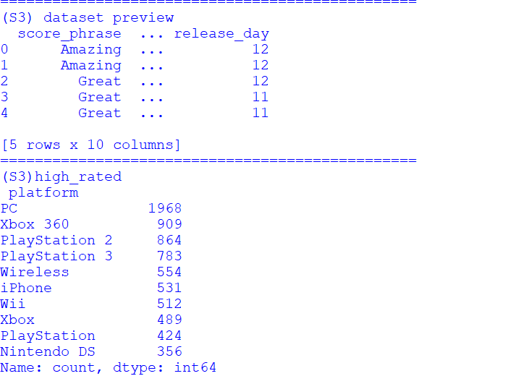
Graph: Bar Chart

- Bar Chart - A bar chart uses rectangular bars to represent values. It is used to compare different categories, like comparing the number of high-rated games on each platform.

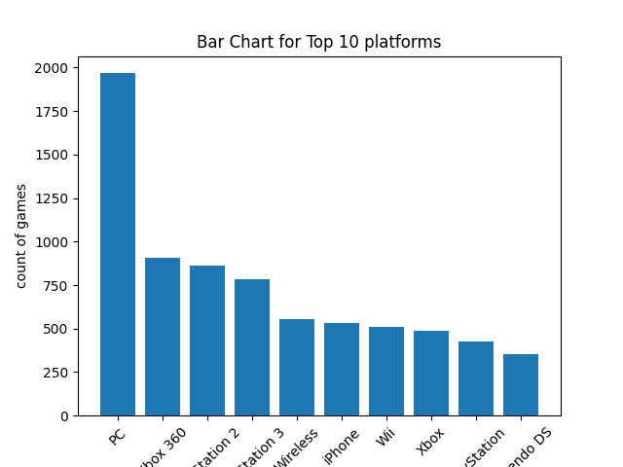

Conclusion:

The chart clearly shows which platforms have the most high-rated games. This helps us understand which platforms perform better overall. It also makes comparison between platforms easy. The saved graph can be used for analysis or presentations

Scenario 4: Aggregation + Pie Chart + Save (🟡 Medium)

Description:
We count how many games are in each genre using the dataset. Then we select the top 5 genres with the highest number of games. We prepare labels (genre names) and values (counts) for visualization. A pie chart is created to show the distribution, with percentage labels added. Finally, we save the chart as an image.

Task | Description
1. | Count the total number of games per genre.
2. | Select the top 5 genres using Pandas.
3. | Prepare labels (genres) and values (counts) for the pie chart.
4. | Plot a pie chart using genre as labels and count as values.
5. | Add percentage labels using autopct (e.g., '%.1f%%').
6. | Save the graph: plt.savefig("genre_distribution.png").

Output Screen:
- Here, I am counting the number of games per genre. And Selecting top 5 genres using Pandas.

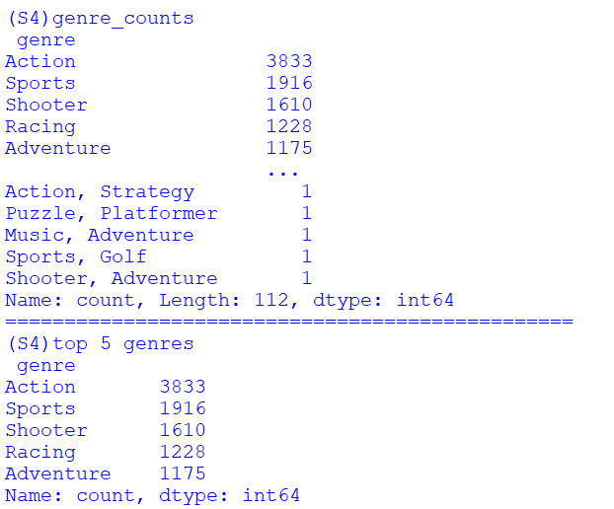
Graph: Pie Chart

- Pie Chart - A pie chart is a round graph. It is divided into slices, and each slice shows a part of the total data.

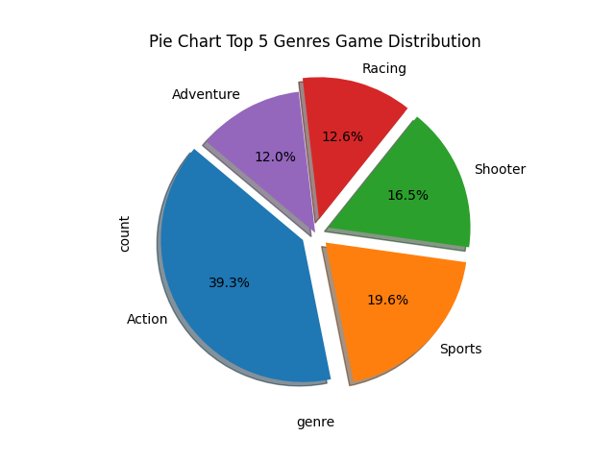

Conclusion:

The pie chart helps us easily see which genres are most popular. It shows the proportion of each genre compared to others. This makes understanding the dataset simple and clear. The saved chart can be used for reports or presentations.

Scenario 5: Advanced Analysis + Multiple Graphs (🔴 Hard)

Description:
We create a new column score_category to group scores into Excellent, Good, and Average. Then we convert editors_choice into numbers for easy analysis. Using NumPy, we calculate how scores change each year. We plot different graphs like a line graph, stacked bar chart, and histogram to understand trends and distributions. Finally, we save all graphs as image files.

Task | Description
1. | Create a new column score_category: "Excellent" for score $\ge 9$, "Good" for $7 \le$ score $< 9$, and "Average" for score $< 7$.
2. | Convert the editors_choice column: 'Y' $\rightarrow 1$, 'N' $\rightarrow 0$.
3. | Use NumPy's np.diff() to calculate the yearly score growth based on the average yearly scores from Scenario 2.
4. | Plot a Line Graph showing the trend of average score per release_year.
5. | Plot a Stacked Bar Chart showing the count of score_category per release_year.
6. | Plot a Histogram showing the distribution of score.
7. | Save the graphs:  plt.savefig("score_trend.png"), plt.savefig("score_category_stacked.png"), plt.savefig("score_distribution.png").
8. | Identify: Which years had the highest scores, whether high scores increased over time, and if editors_choice correlates with high scores.

Output Screens:
- Here, I am displaying scores by categorizing the result as Excellent, Good And Average.
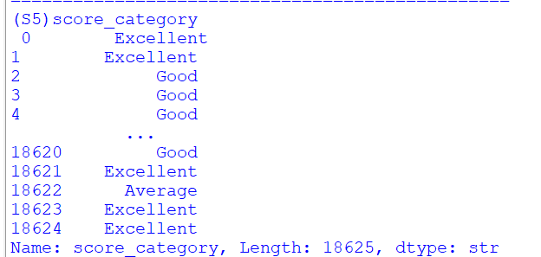
Graphs:
- Line chart: A graph that connects data points with a line to show trends or changes over time.
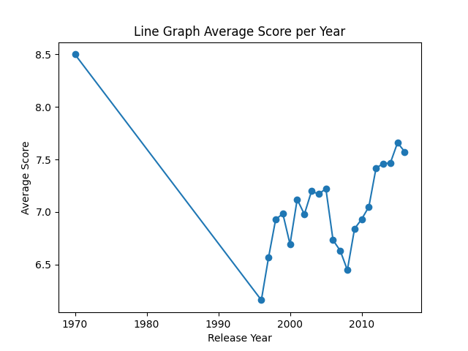

- Stacked bar chart: A bar chart where multiple categories are stacked on top of each other to show parts of a whole.

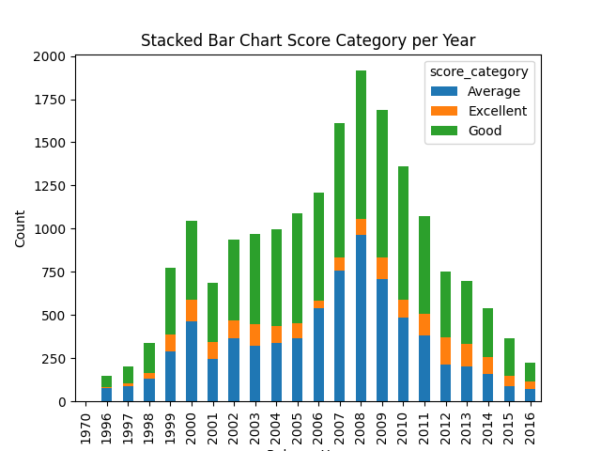
- Histogram: A chart that shows how data is distributed by grouping values into ranges (bins) and counting how often they occur.

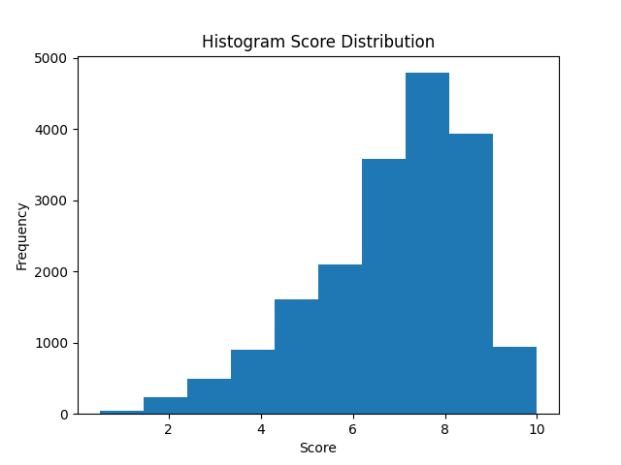

Conclusion:
This analysis helps us understand game review patterns clearly. We can see score trends, category distribution, and overall score spread. It makes complex data easy to understand using graphs. The saved graphs can be used for reports or further study.

Final Conclusion:

This project helped analyze game review data from the IGN dataset using Python. We cleaned and prepared the data by handling missing values, fixing data types, and creating new useful features like score categories. We then explored trends using different visualizations such as line charts, bar charts, pie charts, and histograms. NumPy was used to study score growth over the years, which helped understand changes in game ratings over time.

What you have learned

I learned how to load and clean real-world data using Pandas. I understood how to handle missing values and convert data types correctly. I also learned how to use Matplotlib to create different types of graphs for data analysis. Finally, I learned how NumPy can be used to perform simple statistical calculations like yearly growth trends.

